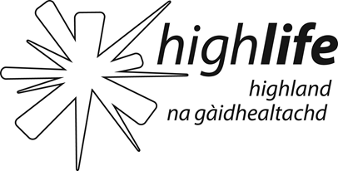 | HLH purpose, key business objectives and corporate values as extracted from the HLH Business Plan 2015-19  Updated 19 March 2015

Purpose

High Life Highland (HLH) is a charity registered in Scotland and a company, Limited by Guarantee, wholly owned by The Highland Council (THC), whose purpose is to develop and promote opportunities in culture, learning, sport, leisure, health and wellbeing. The Company was established on 1 October 2011 to deliver a suite of Community Learning and Leisure Services on behalf of THC.

The main business of HLH is the delivery of a Service Delivery Contract (SDC) for THC across the Company’s nine areas of work:

- Adult Learning  - Archives  - Arts  - Leisure Facilities  - Libraries | - Museums  - Outdoor Education  - Sport  - Youth Work

Key Business Objectives

HLH has eight business outcomes which form the basis of the work of the Company:

- To advance sustainable growth and financial sustainability
- Deliver the Service Delivery Contract with THC
- Improving staff satisfaction
- Improving customer satisfaction
- A positive company image
- Services designed around customers and through market opportunities
- Sustain a good health and safety performance
- A trusted partner

Corporate Values

HLH’s ambition is to be acknowledged and respected as the leading organisation for developing and promoting opportunities in culture, learning, sport, leisure, health and wellbeing and to grow the business in a sustainable way by providing services that the public value and by being used as a trusted partner. It has the following core values:
- To act legally
- To be non-discriminatory
- To be a good employer
- To have a safe environment for staff and users
- To take steps to reduce our environmental impact

Establishing a positive company ethos, where staff at all levels exhibit positive ‘role model behaviour’ is a vital tool to: (i) ensure the positive consolidation of the company; and (ii) as a focus on the importance of the users of services.

