HIGH LIFE HIGHLAND  REPORT TO BOARD OF DIRECTORS  27 September 2012 | AGENDA ITEM 6 REPORT No HLH 21/12

HIGH LIFE HIGHLAND SUCCESSES - Report by Chief Executive

Summary

The purpose of this report is to present Directors with a selection of items from submissions from staff teams on the successful work being carried out by High Life Highland throughout the Highlands and across all areas of work.

It is recommended that Directors comment on the items presented and note that the selected items will form part of a long list for the staff award system, if approved elsewhere on this agenda.

1. | Background
1.1  1.2  1.3  1.4  1.5 | Previous board meetings have considered approximately 15 ‘successes’ selected by the Chief Executive as representative of a balance of activity across the 9 areas of High Life Highland’s (HLH) operation.  The alignment of these successes to the Staff and Volunteer Awards Scheme is proposed elsewhere on this agenda. As part of the Awards scheme it is proposed that the shortlist for awards be drawn from successes presented to each board meeting.  The 13 successes presented to this meeting in Appendix A are therefore the first to have been selected as ‘best of’ submissions rather than as a balance of activity. The full list of all 30 submissions received appears at Appendix B.  The criteria used to select the successes presented to this meeting are distilled from the nine outcomes which form the basis of the HLH Business Plan.  - increased internal collaboration & new partnership working;  - doing what we do, but better;  - contributing toward a growing company; and  - contributing toward a positive company image.  All previous successes submitted will be reassessed against the criteria outlined above, up to a maximum of 15 per quarter to form the year long list for the annual staff award system, if approved elsewhere on the agenda.

Recommendation

It is recommended that Directors comment on the items presented and note that the selected items will form part of a long list for the staff award system, if approved elsewhere on this agenda.

Signature:

Designation: Chief Executive

Date: 12 September 2012
APPENDIX A


Area of work (e.g. Arts) | Adult Learning
Location | 29 Associated School Group Areas
Title of piece of work | Adult Learning Commissioned Courses and Classes
Description of event  (the purpose / targets) | A new model for Adult Learning was developed following budget reductions in 2009 when there was a shift from direct delivery to commissioning adult learning courses and classes using Learning Centres and other adult learning providers.  Over the three years that the model has been in operation there has been an increase in the number/ range of classes and participants. In 2011/12, 2933 people participated in adult learning which was an increase of 81% on the previous year. The number of courses, classes and workshops also rose, from 853 in 2010-2011 to 1254 last year (an increase of 47%).  There was Highland wide coverage with adult learning opportunities being offered in every one of the twenty nine secondary school catchment areas through thirty seven partner organisations delivering a total of 25,900 hours of tuition. This gave people the opportunity to learn where they live.  Enthusiasm for learning grew with 77% of learners indicating that they wanted to take more courses in the future.  Forty-four workshops relating to employability were delivered which gave learners the chance to increase their skills and confidence and in some cases receive accreditation. Local economies were supported by up-skilling local people, exemplified by learning centres running rural skills workshops, and people with small businesses taking courses in web design and social media. The link between health and well-being and learning is well documented and there were examples of courses aimed at specific groups of people such as Carers of people with dementia and people who have mental health issues, as well as general classes such as healthy cooking.
Which staff were / are involved | Julie Simmons, Adult Learning Strategy Officer  Staff of 37 Partner Organisations, including Learning Centre's, Third Sector Organisations, Charities and Community Centre’s
What were the results /  numbers involved /  Feedback | - 2933 people participated in adult learning (2011-2012)  - Adult Learners reported that learning had a positive impact on their lives  - People had the opportunity to learn in the communities they live in  - 37 Partner organisation received financial support to deliver courses and classes  HMIE gave positive feedback about this model of delivery
Attach photos or web links | 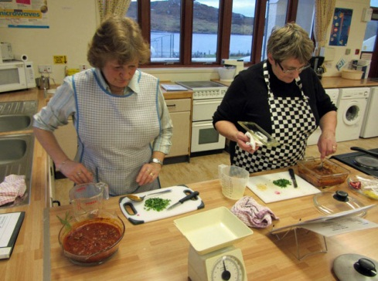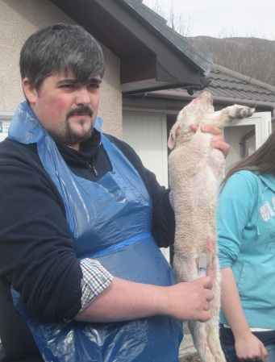
Name & email of staff member submitting news item | Julie Simmons, Adult Learning Strategy Officer  Julie.simmons@highlifehighland.com


Area of work (e.g. Arts) | Adult Learning / Healthy & Well-being
Location | Wick
Title of piece of work | Come Dine With Me (Week Style), Masterchef, Ready Steady Cook.
These sessions came as a follow-on from a computer class for young mums. In their evaluations they said they were interested in learning more about cooking for their families. As a result a programme of cookery classes, integrating literacy and numeracy, was developed.

In the first class “Come Dine With Me”, each mum took it in turn to cook their favourite recipe. The Adult Learning Co-ordinator was there to support them, and all other mums and Sure-Start Workers were to taste the end result. The achieved outcomes were to help with numeracy (work out weights, measures, etc.), learn about the nutritional value of fresh ingredients and to have the feel good factor at end because of what they had accomplished. At first they were apprehensive but as the weeks went on they all wanted a turn at making the dishes. At the end of the course a booklet with all the photos and recipes was printed and a copy given to each participant. Evaluations stated that they wanted more of the same.

Next was the Masterchef class, which included going online and finding recipes from around the world. All meals were cheap, tasty and nutritional, made within a time limit, and could feed a big family. Between them the seven mums who took part had twenty children. Again, when the course finished a booklet with recipes and photos was produced. They were continually trying more adventurous and healthy eating dishes and were not afraid to let the other mums and workers taste their cooking.

Evaluations repeated that they again wanted more of the same.

A Ready Steady Cook class is currently being delivered. The Adult Learning Co-ordinator brings a bag of food and the mums make their own dishes. There is a mixture of spices and herbs available that they can use when they want. It is really amazing how they have grown in confidence and are now able to make their own dishes each week without knowing what the main ingredients might be. There is also a competitive edge too, to see who can make the best dish, but it is all done with good humour and in a supportive way.

Which staff were / are involved | Libby Cook Adult Learning Co-ordinator, High Life Highland  Staff from Sure-Start
What were the results /  numbers involved /  Feedback | Come-Dine-With-Me: Feedback excellent from 7 mums and 3 Sure-Start Workers  Masterchef- Feedback excellent from 6 mums and 3 Sure-Start workers  Ready Steady Cook ongoing.  All the young mums gained confidence, practiced their literacy and numeracy skills, and learned about healthy cooking and eating
There are many more photos but this is just a sample | 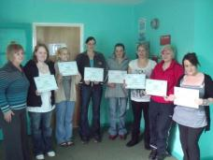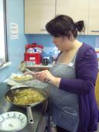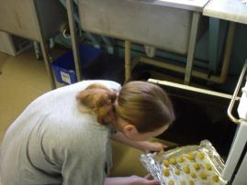  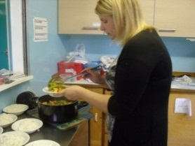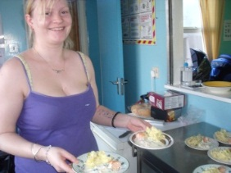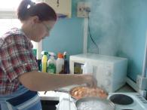  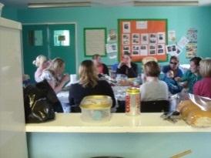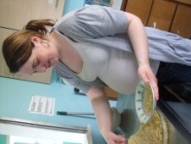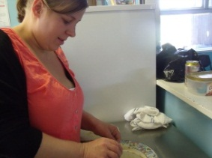
Name & email of staff member submitting news item | Libby Cook  Libby.cook@highlifehighland.com

Area of work (e.g. Arts) | Archives, Museums & Libraries
Location | The four Highland Archive Centres, Inverness Museum & Art Gallery, Highland Folk Museum, Inverness Library
Title of piece of work | The Centenary of the Dewar Report into Health Care Provision in the Highlands and Islands.
Description of event  (the purpose / targets) | In 1912 a committee led by Sir John Dewar was formed with the purpose of investigating health care provision in the Highlands and Islands. The findings and recommendations of the committee became known as the Dewar Report.  Staff from High Life Highland heritage services came together in order to organise events to mark the anniversary: details as follows: -  An exhibition consisting of banners displaying photographs and archival material documenting the collection of evidence in 1912, a display of medical artifacts and the screening of the 1940s film “Highland Doctor” .  An online version of the exhibition for inclusion in the Am Baile website.  A series of talks for members of the public in the Highland Archive Centre and in Inverness Museum & Art Gallery.  The purpose in organising the events was to raise awareness locally throughout the Highlands and Islands and nationally throughout Scotland, of the importance of the Dewar Report as a milestone in the provision of basic health care provision to people living in the Highlands and to celebrate the new partnership between NHS Highland and The Highland Council. The Dewar Report led to the establishment of the Highlands & Islands Medical Service, the first state funded health service in the world, considered to be the precursor to the NHS.
Which staff were / are involved | Janet Baker , Rachel Chisholm , Sian Coodye, Julie Corcoran , Jamie Gaukroger, Lesley Junor, Cait McCullagh, Jeanette Pearson, Colin Waller
What were the results /  numbers involved /  Feedback | The banners were taken to the Scottish Parliament in May where a debate on Dewar was held. See accompanying photograph of Dave Thompson, MSP, looking at the banners.  The exhibition was launched at a one day conference on the centenary of the Dewar Report organised by the Royal Society of General Practitioners and held at Raigmore Hospital on 19 May.  The exhibition is currently touring the Highlands and Islands and is available for members of the public to view at archive centres, museums and Inverness Library, throughout 2012.  The events organised as part of the celebration attracted over 100 people.
Attach photos or web links | 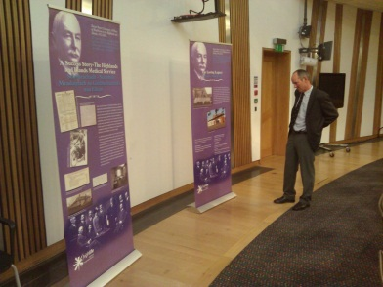  One photograph taken inside the Scottish Parliament showing Dave Thompson MSP looking at the Dewar banners.
Name & email of staff member submitting news item | Janet Baker

Area of work (e.g. Arts) | Health and Wellbeing/Facilities
Location | Lochaber Leisure Centre
Title of piece of work | Cardiac Rehabilitation Phase 3 Programme
Description of event  (the purpose / targets) | High Life Highland and NHS Highland are working together to deliver a new service, which is happening as a result of the partnership between the NHS and High Life Highland.  The service is called “Cardiac Rehabilitation Phase 3 Programme” and offers Cardiac patients, after they experience a cardiac event (e.g. heart surgery), the opportunity to undertake a Cardiac Rehabilitation Programme within the Leisure Centre in Fort William.  Traditionally Cardiac Rehabilitation has been delivered by Physiotherapists in a clinical setting such as a hospital or Doctor’s surgery, which can be intimidating for patients and does not offer any obvious sustainable mechanism for self-management for the patients. This new partnership between High Life Highland and NHS Highland is facilitating a seamless transition for the patients from a Rehabilitation Programme, facilitated by Physiotherapists, towards self-management supported by the Leisure Centre.  For the duration of the Cardiac Rehabilitation Programme, patients participate in a weekly session, over a period of 12 weeks, led by Physiotherapists with input from an Occupational Therapist. The patients will also have unlimited access to the Leisure Centre facilities out-with the weekly Rehabilitation sessions. At the end of the 12 week Programme, the patients will be encouraged and supported, where appropriate and possible, to maintain a level of self-led physical activity beyond the Rehabilitation Programme, within the Leisure Centre.  The pilot commences on the 4th September 2012 and will run for 1 year. The pilot has the potential to be replicated in other HLH Leisure Centre’s, beyond the initial phase in Lochaber.
Which staff were / are involved | Lynn Johnson, Health and Wellbeing Manager  Gary Davidson, Facilities Manager, Lochaber Leisure Centre  Emma Thomson, Area Facilities Officer  Philip Hughes, Leisure Supervisor, Lochaber Leisure Centre
What were the results /  numbers involved /  Feedback | Up to 48 cardiac patients/service users will benefit in the first year.  The level of physical activity that the patients undertake during the Cardiac Rehab Programme and sustained beyond the Programme will be tracked and fed back to NHS Highland.
Attach photos or web links
Name & email of staff member submitting news item | Lynn Johnson, Health & Wellbeing Manager  Lynn.johnson@highlifehighland.com

Area of work (e.g. Arts) | Libraries
Location | Fort William Library
Title of piece of work | Connecting Carers Coffee Morning
Description of event  (the purpose / targets) | Connecting Carers Event and Coffee Morning at Fort William Library  Connecting Carers Events are hosted by Fort William Library and Health and Wellbeing Centre in conjunction with Connecting Carers. Other organisations also feed into these sessions for example Adult Basic Education, Citizen’s advice Bureau and local alternative therapists. These sessions look to ensure that the carers in the area have access to the services that they require to keep them healthy and fulfilled. The sessions are a social event for carers but also allow them to access information about the services that are there for them in the local area. These services, if accessed, allow them to access other public services in the area for example library services and leisure services.  The event was organised primarily between the Health and Wellbeing staff and Connecting carers with other services feeding in. This allowed for a wide ranging event with many different aspects being represented and the attendees gaining a broad view of the services available to them. The event was publicised widely and aimed to reach the majority of carers in the area.  Attendees seemed to benefit from a greater level of information regarding services available to them in their area, they had the opportunity to socialise and share experiences with each other as well as having the opportunity to speak to CAB and have a treatment from local therapists.  Those involved in the planning and delivery of the session were: Cancer Information and Support Service coordinator, Macmillan nursing staff, Connecting Carers staff, Library staff, Adult Basic Education staff, CAB advisers and local therapists.
Which staff were / are involved | Anna Strachan CISS Coordinator  Sandra MacLean Library Supervisor  Anne Nicholson Network Librarian  Amy McDougall Network Librarian  Ann-Marie Donoghue Adult Learning Coordinator
What were the results /  numbers involved /  Feedback | Feedback was positive with 4 carers attending accessing services they would otherwise not have accessed.
Attach photos or web links | 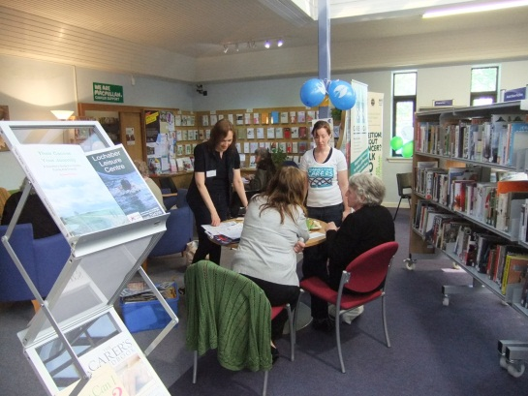
Name & email of staff member submitting news item | Amy McDougall, Network Librarian

Area of work (e.g. Arts) | Libraries
Location | The Sunart Centre, Strontian
Title of piece of work | First Residential Writing Weekend for Ardnamurchan
Description of event  (the purpose / targets) | Creative writing experience for adults from Friday 27th July evening to Sunday 29th July lunchtime with tutor John Glenday, accommodation and meals provided.  Ardnamurchan Library (HLH) and Strontian Learning Centre (West Highland College) worked in partnership to organise this weekend, using Ardnamurchan High School residence, the Sunart Centre and Ardnamurchan Library facilities, and the services of a local caterer to provide adults with the opportunity to develop their creative writing ability in a comfortable but stimulating and challenging learning environment. Suitable for beginners and more experienced writers but particularly those wishing to boost their skills, confidence, motivation and enjoyment of the  writing process.  £120 residential, £90 without B&B but all meals included. (Cost pitched low to attract people to a new unproven event.) Suppers were brought in (e.g. tatties for boiling, casserole for heating, vegetarian option and desserts) and provisions supplied for other meals (freshly baked bread delivered each morning to go with home-made jams and marmalade). The social bonding involved in meal preparation was a significant feature in the success of the weekend. Target: 6-10 participants. Purpose: to provide an event of good quality, enhancing the Sunart Centre profile and utilising facilities not otherwise in use at this time of year.
Which staff were / are involved | Network Librarian, Ardnamurchan Library;  Centre Manager & Development Officer, The Sunart Centre;  Strontian Learning Centre Manager;  Ardnamurchan High School Residence Manager
What were the results /  numbers involved /  Feedback | 8 participants (plus tutor) - optimum number for the facilities.  Feedback extracts from 6 returns, all positive: Great venue – well done. Excellent. Exercises forced me to use my brain. The food was amazing. By far the best writing course I’ve been on. Could we have gone on longer? Please repeat the event.
Attach photos or web links | www.sunartcentre.org
Name & email of staff member submitting news item | Jane Johnstone, Network Librarian

Area of work (e.g. Arts) | Active Schools/Youth Work
Location | Alness
Title of piece of work | Commonwealth Youth Exchange Hosting Phase
Description of event  (the purpose / targets) | In Summer 2010, 8 young women from Alness Academy and 1 from Dingwall Academy, took part in the Visiting Phase of a Commonwealth Youth Exchange. Their partner organization was an orphanage near Cato Ridge in Kwazulu Natal, South Africa. The relationship between the 2 groups had begun in 2009 when the Young Zulu Warrior choir toured the UK and put on a wonderful concert in Alness Academy. From receiving the invitation to go and visit them at Gods Golden Acre Orphanage the Alness group began fundraising and planning their trip. Grants were awarded from the CYEC towards their flights and from Awards for All for the planning stages. All in all we raised £20,000. Phase 1 was a hugely successful project where the Alness group gained so many skills and also learnt so much about Zulu culture and tradition. Their project theme came under the Fit for Girls Initiative and was titled Health & Wellbeing focusing on Young Women’s Issues. The 2 year gap between phases involved raising awareness of the Aids/HIV pandemic which has left millions of children and young people as orphans. We did this by giving presentations in our communities about the difficult lives our Zulu friends were challenged with every day; fundraising; making grant applications and planning for our South African peers to come to Scotland to experience life with us. The project came together after raising about £10,000, and on 27th June, we met the South African group at Glasgow Airport and took them up the A9 in an absolute downpour to live in our homes for the next 3 weeks. During that time we entertained them with many outings and activities. One of the highlights was spending a week at Badaguish Outdoor Centre as part of the Alness Summer Programme. Not only did our visitors spend time with the girls they knew from 2010 but they met many other Alness youngsters who are now very much a part of the project and possibly will be the next group involved in a trip to Cato Ridge next year. This was our target so we are delighted it was made possible. We also joined up with Cromarty Youth Club and some of the Invergordon youth group. This involved a camping night at Cromarty where they danced on the links led by Amy Mullen, they had their meal under the Gazebos and sat around a camp fire in the darkening on the beach melting marshmallows, singing and dancing to the beat of Henry’s drum. The end of that week involved a 3 day trip to Durness where they were overwhelmed with the scenery, the beaches, the hospitality and the relaxed way of life……which really sums up our Highland culture. Unfortunately the 16th of July was looming and final parties and farewells were taking place between the Zulu girls and all the young people of Alness whom they had made friends with.  The South Africa Girls Exchange group became a group in its own right during the preparation time for Phase 2 in 2011/12. Since doing so, the girls who have been involved in the project since its beginning are now committee members and office bearers. We hope that the future of the group is to continually attract new members who are interested in youth exchange and global citizenship.
Which staff were / are involved | Wilma Kelt, Active Schools Coordinator, Alness  Jen Taylor, Youth Worker, Alness  Brian Ross, Janitor at Alness Academy
What were the results /  numbers involved /  Feedback | Results – a very successful Commonwealth Youth Exchange between 2 groups of girls where the theme was Health & Wellbeing focusing on Young Women’s Issues.  Numbers involved were 18 in core groups and another 50 young people were involved at some of the time.  Feedback  – ‘when can we go back to South Africa’  - ‘how can we help the African communities again  - ‘I’ll save up and fundraise everyday so that I can go out next year’  - ‘I have gained so much by spending time with the girls in South Africa and when they were here’  - Really, girls and young women are the same across the world it’s just how fortunate you are or aren’t that makes the differences between us.  - We’ve not only been welcomed by friendly and wonderful Scottish people but the beauty of this country surrounded by mountains, green trees and plants and clear waters in he seas. I cannot find enough words to describe such beauty.  - Then came the following week, which I have to admit that it brought something I truly enjoyed and was a good experience for me – Badaguish Outdoor Centre. I can now raise my head and proudly face my fears myself that I can do most things I was afraid of doing such as swimming in a river, lots of amazing things some which I thought I would never do in my lifetime.
Attach photos or web links | 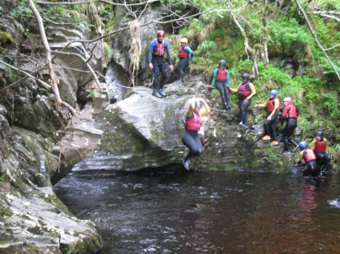  Jumping off the rocks whilst Gorge Walking at Brig O Brown  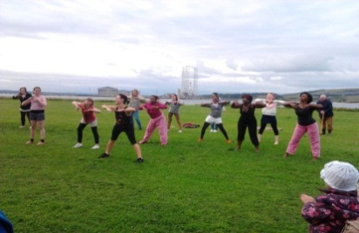  Dancing to music from “Chicago” on Cromarty Links  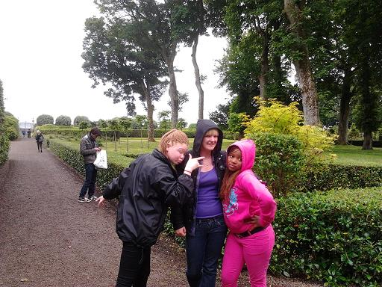  Jen with Zama and Nompilo in the gardens at Dunrobin Castle
Name & email of staff member submitting news item | Wilma Kelt  Wilma.kelt@highlifehighland.com

Area of work (e.g. Arts) | Sport
Location | Tain
Title of piece of work | Community Sport Hubs
Description of event  (the purpose / targets) | Tain is leading the way in High Life Highland’s Community Sport Hub initiative. High Life Highland is delivering upon sportscotland’s contribution to the Scottish Governments 2014 Legacy Plan through the development of community sport hubs throughout the Highlands. Within the Highlands we are taking this concept and adapting it to suit the needs and resource contained within our local communities. In Tain our very first community engagement meeting about the project had a fantastic reception with six local clubs being represented, along with representatives from our sports development team, the local school, the local Sports Council, Active-schools, facilities and sportscotland. At this engagement meeting we highlighted our focus to support the local community clubs and outlined the support mechanism we have in place to help clubs provide fantastic opportunities for everyone within their local community. The meeting was then opened up to the clubs to discuss their current issues and ambitions with the emphasis being on what through this project we can do to overcome barriers to participation that currently exist. Ultimately the focus of the meeting was about starting to realise the collective potential there is within the local community to provide an excellent sporting system in Tain.
Which staff were / are involved | Darren Reid – Community Sport Hub Officer  Elissa Steven - Sports Coaching Administrator  Kelly Skinner – TRACC Facility Manager  Julie Cleghorn – Active-Schools Co-ordinator  Peter Budge – Football Development Officer  Angus Gray – Depute Rector Tain Royal Academy
What were the results /  numbers involved /  Feedback | The meeting generated a focused list of priorities that will help strengthen the local clubs in Tain based around coaching and volunteering, their facility and equipment needs, programming, communication and funding. This has already lead to TRACC tailoring their equipment to suit the needs of the local clubs – the installation of a bowling mat and the potential for multi-purpose indoor nets also to be put into the centre to cater for the local golf and athletics clubs. It has also lead to focusing our sports development support to meet the needs of the community clubs. The follow up meeting will take place on the 22nd of August where the group will follow up on the priorities set out at this initial meeting.
Attach photos or web links
Name & email of staff member submitting news item | Darren Reid – Community Sports Hub Officer

Area of work (e.g. Arts) | Active Schools
Location | Dingwall
Title of piece of work | Dingwall P7 Transition group
Description of event  (the purpose / targets) | All of the P7s in the cluster are invited into the academy for a week during the summer holidays in an attempt to help familiarize themselves with the building, each other and the senior helpers/buddies.  There were 190 moving up to secondary and we offer them a range of different activities. Each day the children are registered by the seniors, and then split into 4 different groups who are then sent off to the 4 different activities each day. This year we offered them Frisbee, omnikin, computing sessions, gardening session, cooking, digital scavenger hunt, clay modeling, t-shirt design, basketball, dodgeball, swimming, friendship workshop, and Landmark trip.  We use the digital Scavenger hunt as a method for the children to begin to navigate themselves round the school building. We split the group into smaller groups of 4/5, give them the sheet with the rooms and various noticeboards/units/departments to find (such as standing on the 2nd floor – take a photo of your team lying in the centre circle of the gym hall) and a camera, and ask them to find the things on the list by taking a photo with their group in it. The photos are then used to show the following year group what the transition group does.  Volunteers are sought in the way of seniors from the academy. Seniors are very keen now, to add to their CV to help in their applications to University. We also put forward the number of hours that they volunteer for, which for many this summer totaled 32 hours, for their Saltire award, which is nationally recognised. Having the seniors’ help the P7s during the week also means that they are the familiar face when it comes to that dreaded day when they have their ‘first’ day as an S1 pupil.  As the week progresses it’s great to see the change in them all from being very timid and scared, almost unable to go into the hall alone; to quite the opposite by the end of the week. We find that although the children from the smaller schools are more scared at the start of the week, by the end they are the most confident as they feel they have to make friends, and this provides the platform for them.
Which staff were / are involved | Dawn Taylor, Fiona Richardson (Youth), Kirsty Hunter (Youth), Gregor Neil (Youth), Pat Adam (CSW social work) Judith Brissenden (CSW social Work) Jamie Richards (CSW Social Work) Lisa MacDonald (Dingwall Facilities Manager)
What were the results /  numbers involved /  Feedback | 120 P7 children booked on to the week with 114 attending each day. 190 are moving up to the academy so we reached almost 65% of all the P7s.  20 senior helpers volunteered for the week. Without the help of these young people, the transition week wouldn’t happen.  The feedback from parents is fantastically positive. One comment from a parent on the feedback form states “Overall a really worthwhile week. So much so his sister can’t wait to go in three years’ time!” Another states “A Huge Thank You for an extremely enjoyable and worthwhile week”.
Attach photos or web links | 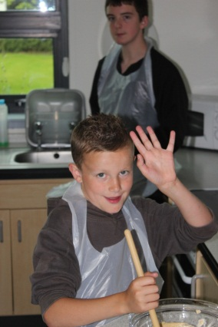  In the cooking session making Carrot cakes  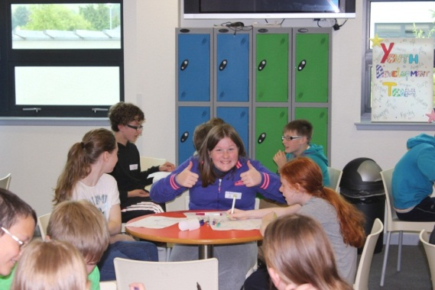  In the friendship workshop writing down their hopes and fears in the academy  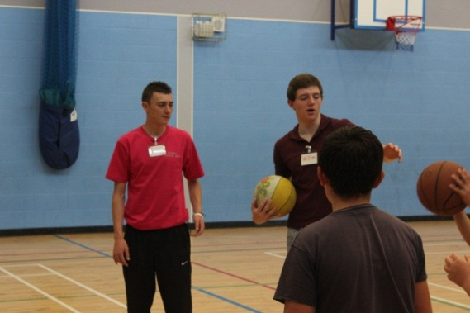  Two of the senior pupils leading a basketball session  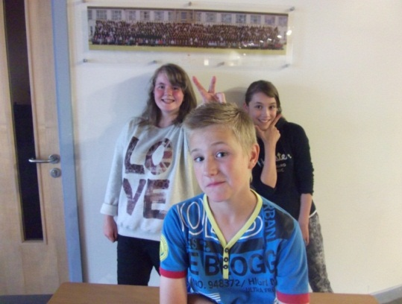  Using their imagination during the scavenger hunt  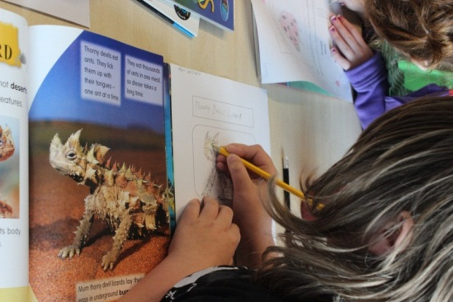  During the library session  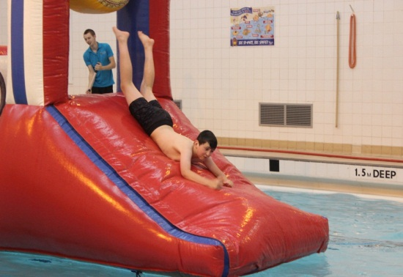  In the swimming pool  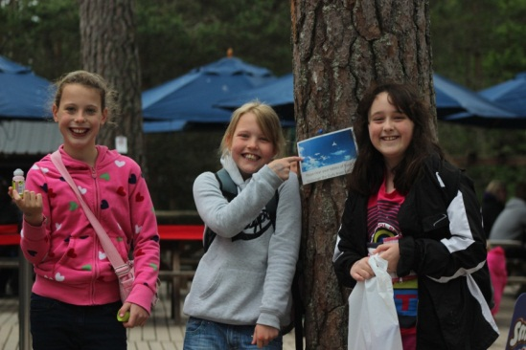  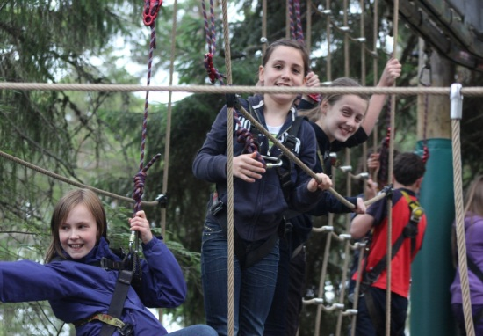  At Landmark with new friends
Name & email of staff member submitting news item | Dawn Taylor– Dawn.Taylor@highlifehighland.com

Area of work (e.g. Arts) | Sport
Location | Inverness/Highland
Title of piece of work | Highland Coaching Awards 2012
Description of event  (the purpose / targets) | High Life Highland, in partnership with sportscotland, has launched the Highland Coaching Awards. The awards will recognise and reward the dedicated and motivational coaches in Highland. We are appealing to staff, coaches, clubs and volunteers to complete a nomination form as we know there are many coaches out there doing sterling work. The categories are:  - Young person’s coach of the year  - Community coach of the year  - Development coach of the year  - Performance coach of the year  - Young coach of the year  - Disability coach of the year  Also building on the success of last year’s awards (run solely sportscotland) where a Highland coach, Frazer Grant, won the Highland & Islands ‘Young Coach of Year’ award and went on to win the National ‘Young Coach of the Year’ award.  This year HLH have introduced an on-line nomination form which will hopefully encourage more people to take 10 minutes and complete a form!  The awards will be judged by a panel after the closing date of Tuesday 2nd October and coaches will be notified then awarded their title at ‘FIT to Coach’ conference on the 28th October (also gaining free entry!).
Which staff were / are involved | Elissa Steven
What were the results /  numbers involved /  Feedback | The results will be collated and a press-release sent around the Highland papers with pictures.
Attach photos or web links
Name & email of staff member submitting news item | Elissa Steven – elissa.steven@highlifehighland.com
Area of work (e.g. Arts) | Sport
Location | Olympic Village – Stratford London
Title of piece of work | Visit to Olympic Village
Description of event  (the purpose / targets) | HLH Craigmonie Centre Coordinator Fran Davidson received an Invitation to the Olympic Village Commissioning Event at the Olympic and Paralympic Village in Stratford, London on Friday 29 June 2012 as a result of work undertaken to organize local events as a ‘local leader’ to celebrate the Olympic Torch passing through the Great Glen area (and specifically Drumnadrochit).  It was a unique opportunity to experience the Olympic and Paralympic Village just four weeks before 16,000 athletes and team officials arrive in July.  Starting in the afternoon, the event included a tour of the Village, reception & dinner, live music and an overnight stay (in shared apartments in the Olympic and Paralympic Village which will be used by the athletes) and breakfast.  The Olympic and Paralympic Village will be a ‘home from home’ for athletes and team officials during the Games, and I was invited to comment on the facilities.
Which staff were / are involved | Craigmonie Centre Co-ordinator Fran Davidson
What were the results /  numbers involved /  Feedback | As one of 400 invited guests that included other Local Leaders from around the UK, representatives from the public and private sector, local and national government, the media (and of course a few Olympians and Paralympians) I had the opportunity to talk to some of them about High Life Highland and what I do for them, (and perhaps raise awareness of life north of Watford).
Attach photos or web links | 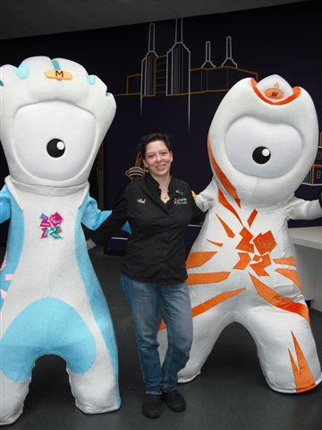  Fran Davidson with the Olympic Mascots at the Olympic Village  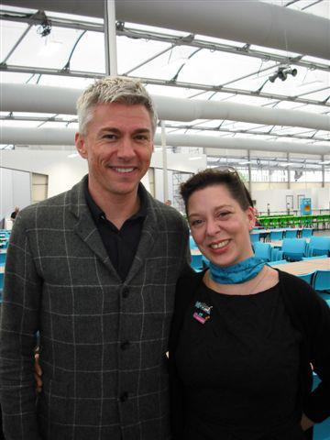  Fran Davidson with Gold Medalist and Olympic organisers’ committee member Jonathan Edwards CBE  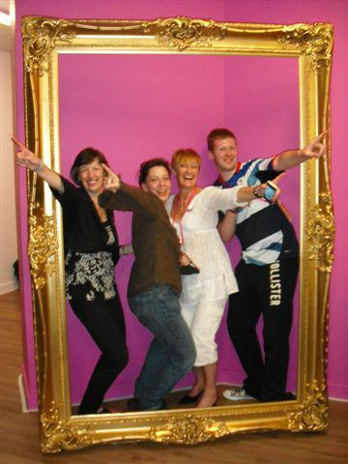  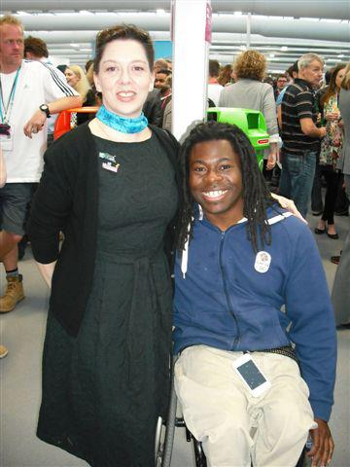  Fran Davidson with Bronze Medalist & BBC Presenter Ade Adepitan OBE  Doing the “Bolt” with other “Local Leaders” after dinner  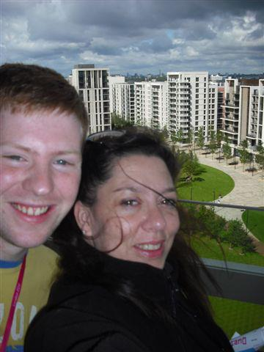  With Brian Borland Youth Worker from South Ayr on the Balcony overlooking the Olympic Village  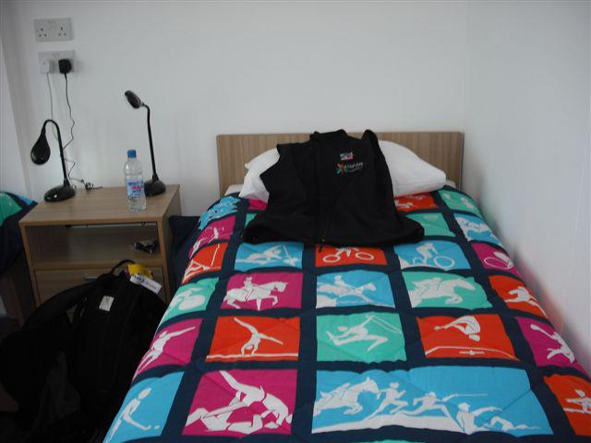  My Olympic Bed (they gave us strict instructions not to steal the duvet covers)
Name & email of staff member submitting news item | Fran Davidson – Centre Co-coordinator

Area of work (e.g. Arts) | Youth
Location | Culloden Learning Community
Title of piece of work | Support from Youth Worker
Description of event  (the purpose / targets) | Youth Workers across Highland work to 5 priorities. These are: -  - Direct work with, and support of young people in need  - Ensuring that a mix of Council work and work with partners is co-ordinated to ensure local provision for all young people  - Supporting to partner organisations to deliver local services to young people  - Working with young people to ensure that they have a voice in decisions that affect them, both Highland wide and locally  - Support and develop achievement frameworks such as Youth Achievement Awards, The Duke of Edinburgh Award etc  Lita’s work in the Culloden learning community covers all areas of these priorities. She has worked hard to set up a local youth forum, supporting young people to get involved in decision making which affects them. As well as supporting the running for youth clubs in the area, she actively encourages the young people to play a significant role in the running of these.  As the school does not want to be involved in The Duke of Edinburgh Award, Lita has worked with Isobel Gray to support young people from the area to access the Inverness Open DofE Centre. In addition she is involved in delivering ASDAN awards in the school, and uses other award frameworks to ensure that young people’s achievements are recognised.  During the summer of 2012 Lita delivered a range of activities which were targeted at young people who required extra support for a variety of reasons.  As a result of the work which she has delivered she was contacted by one of the parents – her feedback is below.
Which staff were / are involved | Lita Leslie, Youth Development Officer  Isobel Gray, DofE Development Officer
What were the results /  numbers involved /  Feedback | “I would like to thank you for the ongoing support, time and encouragement you have given my daughter, Eithne. Eithne’s confidence has greatly benefited from being a volunteer at the Culloden Youth Club; she has enjoyed volunteering as a peer mentor, and helping to arrange events such as the trip to Landmark and the Murder Mystery evening. Eithne has most definitely “risen to the challenge” when you have given her tasks to undertake and worked hard to achieve her Saltire Award and Youth Achievement Award. Her confidence has most certainly improved and she is rightly very proud of her achievements.  As there is no Duke of Edinburgh Award group at Culloden Academy, thank you for providing information about this, and encouraging Eithne to participate in the scheme. Eithne used the volunteering opportunities you provided at Culloden Youth Club towards her Bronze Award, and is now looking forward to being a member of the Highland Youth Voice on Mondays after school, using this as volunteering towards her Silver Duke of Edinburgh Award.  As you are aware, I have recently contacted the new Parent Council at Culloden Academy and asked that they meet with you, in order that the excellent service you provide can be widely advertised to both teenagers and their parents. Thank you for making the time to speak with parents who I direct from the library, telling them about the awards and services you provide. As you have asked that Eithne’s awards are presented to her at assembly (she is totally delighted with this), some of her friends have even emailed me during the holidays asking for information about the awards.  Where do I begin with all of the activities Eithne has had the opportunity to participate in during the summer holidays, and the fun that she had (apart from the travel sickness)? Abseiling, weasling, ceramics, girls day out, mosaics, white water rafting. In particular Eithne loved the abseiling and white water rafting, activities she would never normally have had the chance or even the inclination to participate in. All of this has encouraged her to work as part of a team, meet with other young people, challenge herself and her inhibitions and overall give her a much needed boost to her confidence.  Without your assistance and help I would never have known about the numerous opportunities available to young people in this area. Would you have any objections to me contacting the Inverness Courier asking them to write an article about your involvement with the young people in the Culloden area and what you do? I really feel that your valuable service should be promoted, especially with the new Curricular for Excellence Awards.  Once again, thank you for “being there” for Eithne and providing her with so many positive experience and opportunities.  Many thanks  Karen Philip
Attach photos or web links | 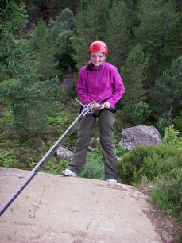  Eithne abseiling at Duntelchaig  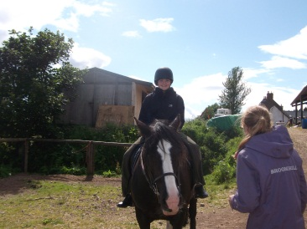  Eithne horse riding at Broomhill Riding School  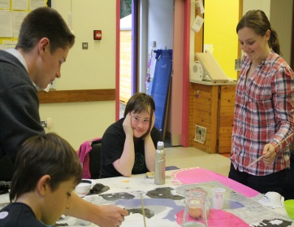  Eithne supporting a young person with Downs Syndrome at the Graffiti Art Project
Name & email of staff member submitting news item | Rebecca Raynes, Youth Services Strategy Officer

Area of work (e.g. Arts) | Company-wide
Location | Throughout the Highlands
Title of piece of work | Summer Activity Programme
Description of event  (the purpose / targets) | The first “Summer Activity Programme” under the auspices of High Life Highland took place across the Highlands over the 6-week school holiday period. This was an ideal opportunity for company staff across the services to work together to augment and enhance the services delivered in previous years.  - More than 3000 children took park in a broad range of activities  - 13,000 booking were made  - On offer were “active” things like kayaking, football, BMXing and shinty, “arty” things like pottery, painting and stamp designing, and “out there” things like laser tag and “wow balls” (big plastic balls you go inside)  - A new HLH online booking & payment system was introduced  - 30% of bookings were made online through this new system  - A new brochure layout was devised and used to enhance the readability and presentation of the programme information  - The same format was introduced to the website  - New distribution channels were successfully identified and used to target the distribution of the brochures to the home of every school child in the Highlands  - The Summer Activity Programme has been a great success with many customers offering positive feedback and constructive comment
Which staff were / are involved | Staff at all levels and across all 9 services throughout the company were involved in delivering the programme.
What were the results /  numbers involved /  Feedback | More than 3,000 children took part  13,000 individual bookings were received  30% of sales were online  Online booking and payment system introduced  More effective design and distribution of programme information via mail and website channels
Attach photos or web links
Name & email of staff member submitting news item | Laurie Piper, Marketing & Communications Manager – laurie.piper@highlifehighland.com

APPENDIX B

AREA OF WORK | TITLE
Adult Learning | CRY Heart Screening
 | Commissioned Courses & Classes
 | Cooking Sessions
Archives, Museums and Libraries | The Centenary of the Dewar Report
Health & Wellbeing | Knowing Me, Knowing You
(Incl Facilities) | Cardiac Rehabilitation
Leisure | Golden Jubilee Celebrations
 | Tree of Tranquility
Libraries | Olympic 2012 Summer Crafts
 | Story Lab Craft Workshop
 | Connecting Carers Coffee Morning
 | Residential Writing Weekend
Museums | Ambassadors Programme
Sport | Drum Community Event Olympic Torch Relay
 | Golf Successful Pathway
 | Millburn Multi Sports Summer Camp
 | Netball Transition Day
 | Special Olympic Award
 | Golf at Muir
(incl Youth Work) | Commonwealth Youth Exchange Hosting Phase
 | Community Sports Hub
 | Dingwall P7 Transition Group
 | Highland Coaching Awards 2012
 | Visit to Olympic Village
Youth | Duke of Edinburgh Award & Northern Constabulary
 | Respect Me Art Project
 | Young Peoples Achievement Group Work
 | Support from Youth Worker
Human Resources | Modification Order
Company Wide | Summer Activity Programme

