HIGH LIFE HIGHLAND  REPORT TO BOARD OF DIRECTORS  22 March 2017 | AGENDA ITEM 9 REPORT No HLH 3 /17

Performance Report - Report by Chief Executive

Summary

The purpose of this report is to present performance information for the period October to December 2016.

It is recommended Directors:-

- comment on the report and agree that the overall health check on the Company for the period is assessed as green;
- note that the delivery of the business plan is assessed as green; and
- note the information contained in Appendix B on customer surveys.

1. | Business Plan Contribution
1.1 | This report supports all the Business Outcomes from the High Life Highland (HLH) Business Plan:  - To advance sustainable growth and financial sustainability  - Deliver the Service Delivery Contract with THC  - Improving staff satisfaction  - Improving customer satisfaction  - A positive company image  - Services designed around customers and through market opportunities  - Sustain a good health and safety performance  - A trusted partner
2. | Background
2.1 | At its meeting held on 19 March 2015, the HLH Board agreed to remit the task of developing new performance indicators based on the work by the Board at its ten year strategy workshop to the Finance and Audit Committee. At its meeting held on 26 March 2015, the Finance and Audit Committee set the performance indicators; and agreed that reporting on the delivery of the business outcomes would be by exception (i.e. reporting where managers had RAG rated the actions “red – no significant progress”). At its meeting held on 20 August 2015, the Board requested trend information for numeric performance indicators.

3. | Summary of Performance
3.1 | Appendix A contains a summary of performance against the performance indicators along with trend information for numeric PIs. There are ten performance indicators scheduled for assessment at the March 2017 Board meeting all of which have been RAG rated “green”.
4. | Delivery of Business Outcomes
4.1 | The Business Plan 2015-19 was agreed by the Board at its March 2015 meeting. The Business Plan identified eight business outcomes and the approach which the Company would take to deliver them. Operational plans were then developed for each of the nine HLH areas of work which are RAG rated every quarter.
4.2 | The RAG ratings of the operational plans has identified that delivery of the Business Plan is on target. Four of the nine areas of HLH work RAG rated all of the actions “green – on target” or complete; one area of work RAG rated one action as “amber – some slippage” three areas of work RAG rated two actions as “amber - some slippage”; and one area of work RAG rated three as “amber – some slippage”. The Board has agreed that reporting on the delivery of the business outcomes would be by exception (i.e. reporting where managers had RAG rated the actions “red – no significant progress”) and there have been no actions which have been RAG rated “red” in this quarter.
4.3 | The Senior Management team will carry out a review of the 2016/17 operational plans at its March meeting and finalise the new operational plans for 2017/18 in preparation for the new financial year.
5. | Performance Indicator for More Detailed Consideration
5.1 | The HLH Board has asked that one of the performance indicators be considered in greater detail at each board meeting. This report contains further information on customer surveys which was set as a performance indicator for business outcome four - improving customer satisfaction.
5.2 | Customer surveys are included in the operational plans for each of the nine areas of HLH work. Some of these surveys are for projects which are company wide such as the summer activity programme and the “you time” programme, others relate to specific areas of work, such as the archives customer surveys.
5.3 | Summaries of some of the surveys which have been undertaken are provided in Appendix B. They indicate that here are high levels of customer satisfaction and some key results are as follows:  - Summer Activities Programme Survey - 90.4% of customers rated the programme as good or excellent;  - Knowing Me Knowing You - 91.6% of participants found the programme helpful with 89.8% saying that they would recommend it to a friend;  - You Time - 84.7% said taking part helped them to do more exercise every week and 89.2% said taking part is giving them new opportunities to socialise  - Library Customer Survey (Adults) - 98% of respondents to the libraries customer survey said that their library improves their quality of life;  - Library Customer Survey (Children age 0-6) - 98.7% of parents agreed or strongly agreed that the library helped their child to be ready for school/nursery;  - Library Customer Survey (Children age 7 to 11) - 96.7% of children aged 7 to 11 said that their library had helpful staff;  - Library Customer Survey (Young People age 12 to 17) - 90.4% of young people rated their library as good or very good with regard to it being a good place to study;  - Inverness Museum and Art Gallery - 95% of respondents said that they would recommend the museum & gallery as a place to visit;  - Highland Archive Centre - Staff attitude was rated 9.8 out of 10;  - Highland Folk Museum - 99% of respondents rated the helpfulness and knowledge of staff as outstanding or good; and  - Youth Parliament Conferences - 91% very satisfied with quality of welcome.
6. | Health and Safety and Environmental Compliance
6.1 | There is an annual health and safety and environmental compliance report which is considered by the HLH Board at its June meeting. In addition to this, Directors have asked for an update in each performance report. The Health and Safety Strategic Group continues to meet quarterly to assess the health and safety performance of the company. At its November meeting it noted an increase in incidents and accidents involving staff and therefore reviewed these in more depth at its meeting held on 21 February 2017. It concluded that there were no actions arising which required companywide action with all accidents and incidents having been recorded as minor.
6.2 | The Board performance indicator for health and safety is RIDDOR accidents/incidents and none were reported during the period October to December 2016. (There has been one RIDDOR reported incident in the current quarter, Q4, and the investigation concluded that it was a fall attributable to normal sports participation/activity].
6.3 | There were no environmental compliance incidents reported during quarter three 2016/17.
7. | Implications
7.1 | Resource Implications – there are no additional resource implications arising from this report.
7.2 | Legal Implications - there are no new legal implications arising from this report.
7.3 | Risk Implications – there are no new risk implications arising from this report.

Recommendation

It is recommended Directors:-

- comment on the report and agree that the overall health check on the Company for the period is assessed as green;
- note that the delivery of the business plan is assessed as green; and
- note the information contained in Appendix B on customer surveys.

Designation: Chief Executive

Date: 13 March 2017
Appendix A
HLH Performance Indicators

Business Plan Outcome | Performance Indicator | Reporting Frequency | RAG* Rating Definition  (*Red/Amber/Green) | RAG Rating Q1 16/17 | RAG Rating Q2 16/17 | RAG Rating Q3 16/17 | RAG Rating Q4 16/17 | Summary of Quarter Three Performance
1. To advance sustainable growth and financial sustainability | 1. Financial monitoring. | Quarterly. | An assessment of the year end outturn where:  - Red = delivery of the SDC over budget above 2%.  - Amber = delivery of the SDC between break-even and 2% over budget.  - Green = delivery of SDC within budget. | Green | Green | Green |  | See the Finance Report elsewhere on this agenda for further information. The variance for the budget up to the end of quarter three is £14,195 and it is projected that the SDC will be delivered within budget for financial year 2016/17.

Performance Indicator 1 - Financial monitoring, variance to budget per quarter.
See the Finance Report elsewhere on this agenda for further information.
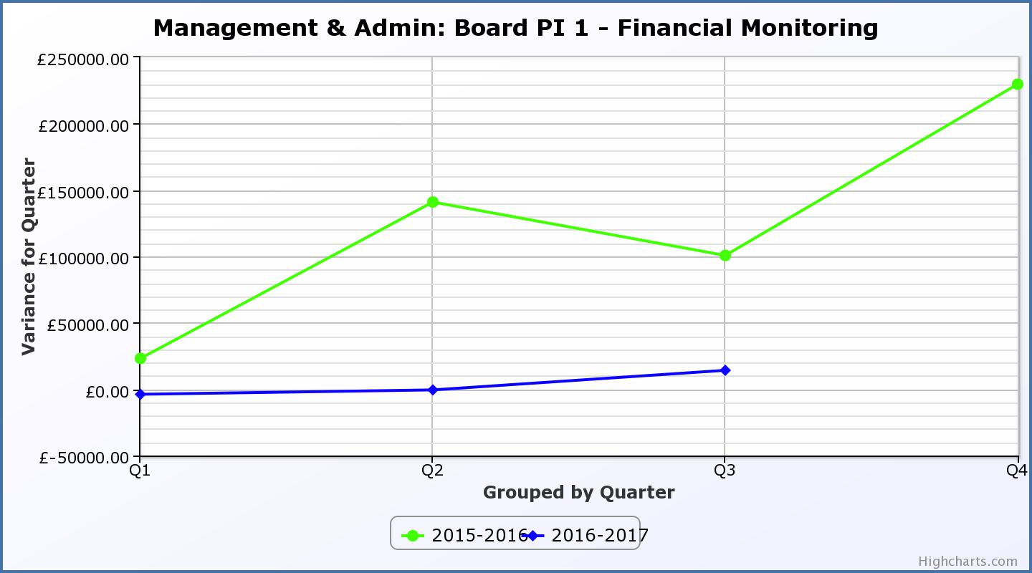
Business Plan Outcome | Performance Indicator | Reporting Frequency | RAG Rating Definition | RAG Rating Q1 16/17 | RAG Rating Q2 16/17 | RAG Rating Q3 16/17 | RAG Rating Q4 16/17 | Summary of Quarter Three Performance
1. To advance sustainable growth and financial sustainability (cont) | 2. Number of High Life subscriptions. | Quarterly. | - Red = more than 5% below target.  - Amber = up to 5% below target.  - Green = on or exceeds target. | Green | Green | Green |  | The number of subscriptions each month during Q3 exceeded the target of 17,911 (the target has been set at the level required to achieve the High Life income target) and following the re-opening of Thurso Swimming Pool is at its highest level ever.

Performance Indicator 2 - Number of High Life Subscriptions
There are two graphs shown below. The first shows High Life card subscriptions excluding Inverness Leisure to allow historic comparison, the second, subscriptions for the whole charity. Thurso swimming pool re-opened in January 2017 and subscriptions are, as of February 2017, at their highest ever at 12,586 excluding Inverness Leisure, and 19,023 overall.

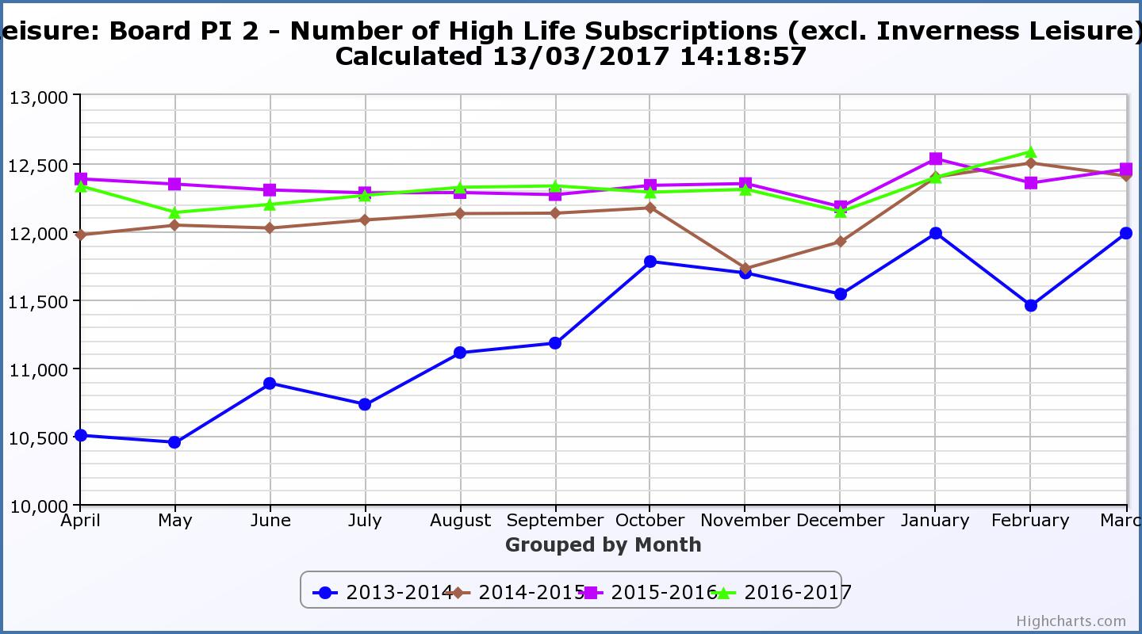
Performance Indicator 2 (contd) - Number of High Life Subscriptions
The graph below shows subscriptions for the whole Company including Inverness Leisure.
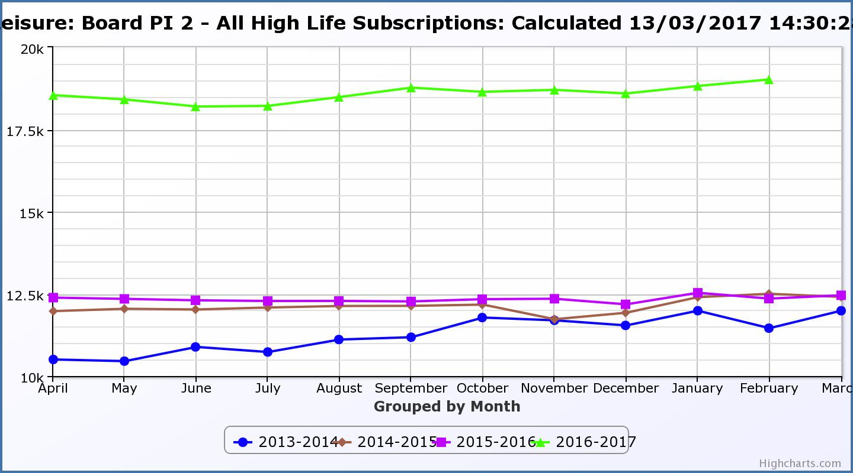

Business Plan Outcome | Performance Indicator | Reporting Frequency | RAG Rating Definition | RAG Rating Q1 16/17 | RAG Rating Q2 16/17 | RAG Rating Q3 16/17 | RAG Rating Q4 16/17 | Summary of Quarter Three Performance
1. To advance sustainable growth and financial sustainability (cont) | 3. High Life cancellation rate. | Quarterly. | - Red = cancellation rate above 6% of High Life memberships.  - Amber = cancellation rate is 3% - 6% of High Life memberships.  - Green = cancellation rate is up to 3% of High Life memberships. | Amber | Green | Green |  | The average High Life Direct Debit cancellation rate per month for Q3 was 3%.

Performance Indicator 3 - High Life Cancellation Rate
The graph below shows that the High Life subscription cancellations increased in April 2016. This is due to the partial closure of Thurso Pool. The average cancellation rate for Q3 was 3%.
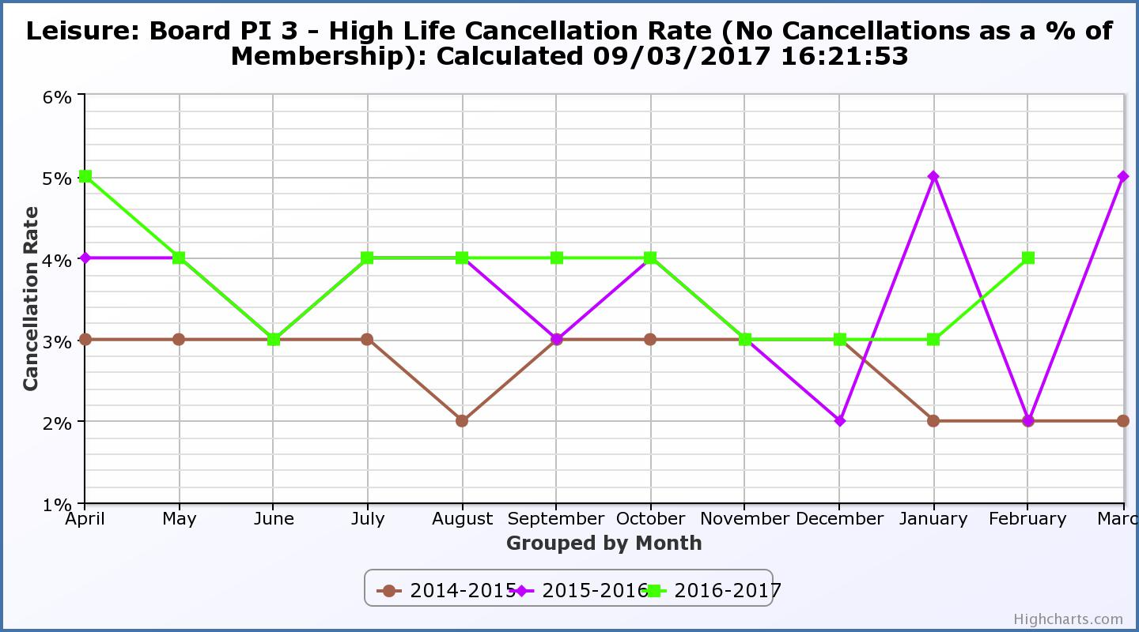

Business Plan Outcome | Performance Indicator | Reporting Frequency | RAG Rating Definition | RAG Rating Q1 16/17 | RAG Rating Q2 16/17 | RAG Rating Q3 16/17 | RAG Rating Q4 16/17 | Summary of Quarter Three Performance
2. Deliver the Service Delivery Contract with THC | 4. Delivery of the Service Delivery Contract (SDC) with the Highland Council (THC). | Six-monthly. | - Red = agreement of THC’s ECAS Committee that HLH has not met the terms of the SDC.  - Amber = agreement of THC’s ECAS Committee that HLH has met the terms of the SDC but has set some improvement targets.  - Green = agreement of THC’s ECAS Committee that HLH has met or exceeded the terms of the SDC. |  | Green |  |  | THC’s Education, Children and Adult Services Committee, at its meeting held on 26 October 2016, agreed that HLH met or exceeded the outcomes expected in the Service Delivery Contract with the Council for the period April to September 2016. It is expected that the next report to THC’s ECAS Committee will be in May 2017.

Business Plan Outcome | Performance Indicator | Reporting Frequency | RAG Rating Definition | RAG Rating Q1 16/17 | RAG Rating Q2 16/17 | RAG Rating Q3 16/17 | RAG Rating Q4 16/17 | Summary of Quarter Three Performance
3. Improving staff satisfaction | 5. Staff turnover (resignations as a percentage of posts). | Quarterly. | - Red = more than 2%  - Amber = 1.7 to 2%  - Green = 1.6% or less | Green | Green | Green |  | The average number of resignations per month as a percentage of posts in Q3 2016 was 0.29%.

Performance Indicator 5 - Staff Turnover (resignations as a percentage of posts)

The graph below shows that resignations as a percentage of the number of posts and resignations have been consistent with previous years and continue to be low (1% equates to 10.6 staff).
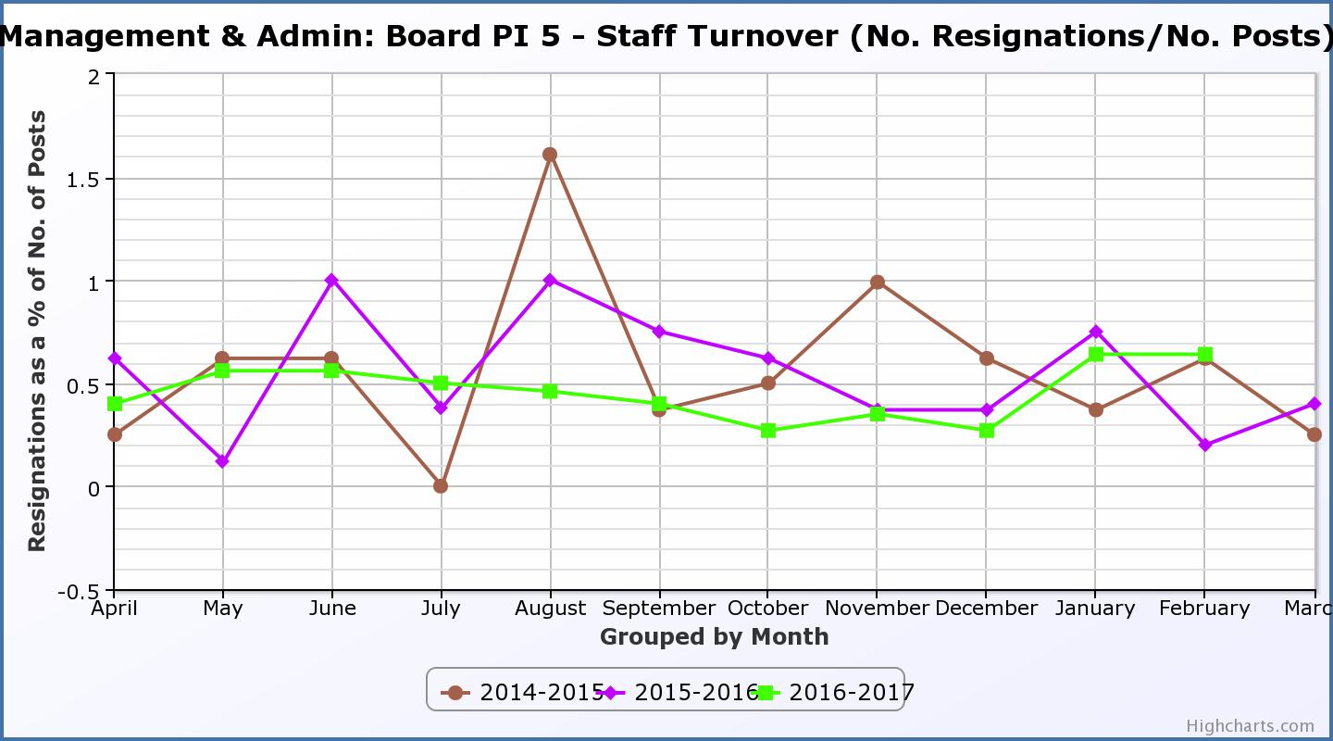
Business Plan Outcome | Performance Indicator | Reporting Frequency | RAG Rating Definition | RAG Rating Q1 16/17 | RAG Rating Q2 16/17 | RAG Rating Q3 16/17 | RAG Rating Q4 16/17 | Summary of Quarter Three Performance
3. Improving staff satisfaction (cont.) | 6. Staff absence rates. | Quarterly. | - Red = absence rate greater than 3.6%.  - Amber = absence rate between 3.4% and 3.6%.  - Green = absence rate 3.3% or less. | Amber | Green | Green |  | The absence rate for Q3 2016/17 was 3.02%.

Performance Indicator 6 - Staff Absence Rates
The graph below tracks absence rates which were RAG rated amber for Q1 2016/17 and green for Q2 and Q3 2016/17.
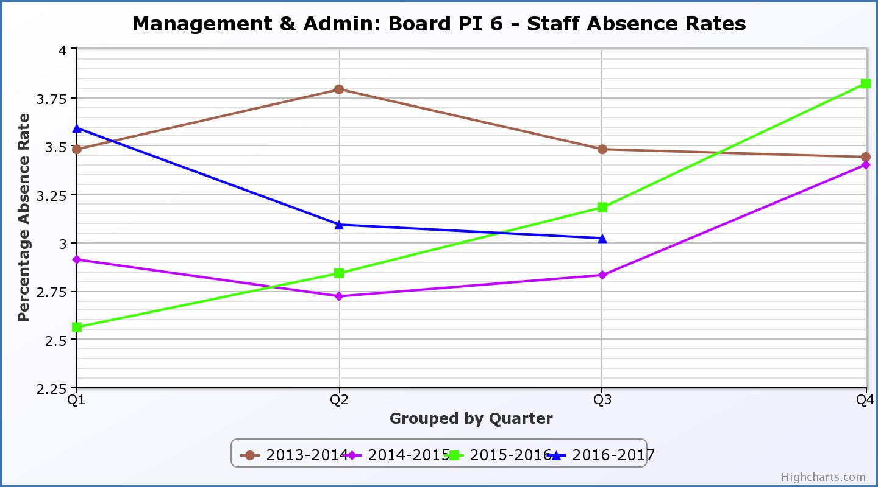
Business Plan Outcome | Performance Indicator | Reporting Frequency | RAG Rating Definition | RAG Rating Q1 16/17 | RAG Rating Q2 16/17 | RAG Rating Q3 16/17 | RAG Rating Q4 16/17 | Summary of Quarter Three Performance
4. Improving customer satisfaction | 7. Customer surveys. | Quarterly. | - Red = no staff surveys have been completed or scheduled.  - Amber = 4 to 8 of the HLH areas of work have completed or scheduled customer surveys.  - Green = all areas of HLH work have completed or scheduled customer surveys. | Green | Green | Green |  | All areas of work have included customer surveys in the operational plans for 2016/17.Please see the main report above and Appendix B for further information.

Business Plan Outcome | Performance Indicator | Reporting Frequency | RAG Rating Definition | RAG Rating Q1 16/17 | RAG Rating Q2 16/17 | RAG Rating Q3 16/17 | RAG Rating Q4 16/17 | Summary of Quarter Three Performance
4. Improving customer satisfaction (cont) | 8. Customer Numbers. | Quarterly. | - Red = customer numbers are more than 5% lower than the corresponding quarter in the previous year.  - Amber = customer numbers are less than the corresponding quarter in the previous year.  - Green = customer numbers are the same as or have increased compared with the corresponding quarter in the previous year. | Green | Green | Green |  | Customer Numbers (excl. Inverness Leisure) have increased from 1,446,184 in Q3 2015/16 to 1,462,157 in Q3 2016/17.  When Inverness Leisure customer numbers are included the Q3 total was 1,616,679.

Performance Indicator 8 - Customer Numbers
The graph below shows a year on year increase in customer numbers which are holding steady or increasing across all areas of HLH work. The second graph below shows customer numbers including Inverness Leisure.
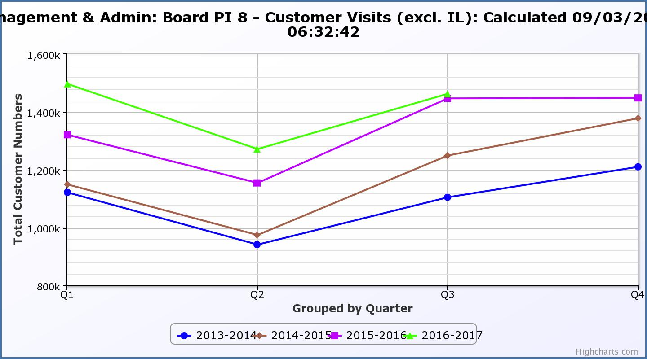
Performance Indicator 8 - Customer Numbers
This graph shows customer numbers including Inverness Leisure.
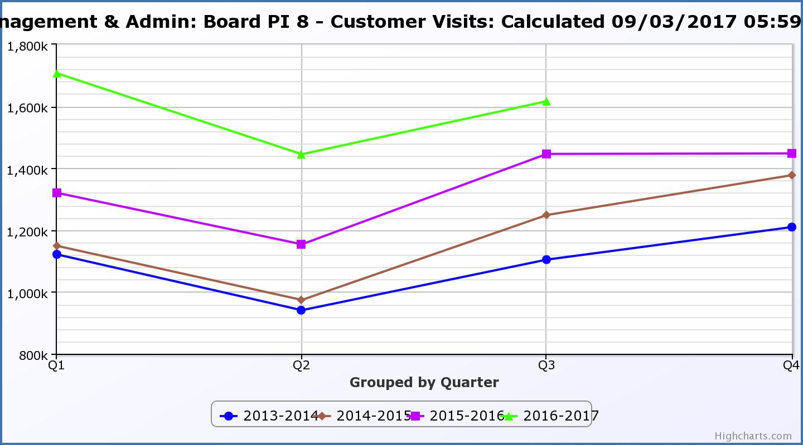
Business Plan Outcome | Performance Indicator | Reporting Frequency | RAG Rating Definition | RAG Rating Q1 16/17 | RAG Rating Q2 16/17 | RAG Rating Q3 16/17 | RAG Rating Q4 16/17 | Summary of Quarter Three Performance
5. A positive company image | 9.Media clippings. | Quarterly | - Red = number of negative press clippings outweigh neutral and positive.  - Amber = number of negative and neutral press clippings outweigh positive.  - Green = number of positive and neutral media clippings outweigh negative. | Green | Green | Green |  | Positive media clippings for Q3 totalled 28 with there having been 6 which were neutral and none which were negative.

Performance Indicator 9 - Media Clippings
The following two graphs show the numbers of positive and neutral media clippings compared with negative. The positive and neutral outweigh the negative.

Business Plan Outcome | Performance Indicator | Reporting Frequency | RAG Rating Definition | RAG Rating Q1 16/17 | RAG Rating Q2 16/17 | RAG Rating Q3 16/17 | RAG Rating Q4 16/17 | Summary of Quarter Three Performance
5. A positive company image (cont.) | 10. Formal complaints. | Quarterly. | - Red = 21 or more complaints per quarter.  - Amber = 11 to 20 complaints per quarter.  - Green = 10 complaints or fewer per quarter. | Green | Green | Green |  | There were nine complaints received during Q3 2016/17.

Performance Indicator 10 - Formal Complaints
The graph below shows the number of complaints which continue to be very low in relation to customer numbers. (Note, reporting began Q2 2014/15).
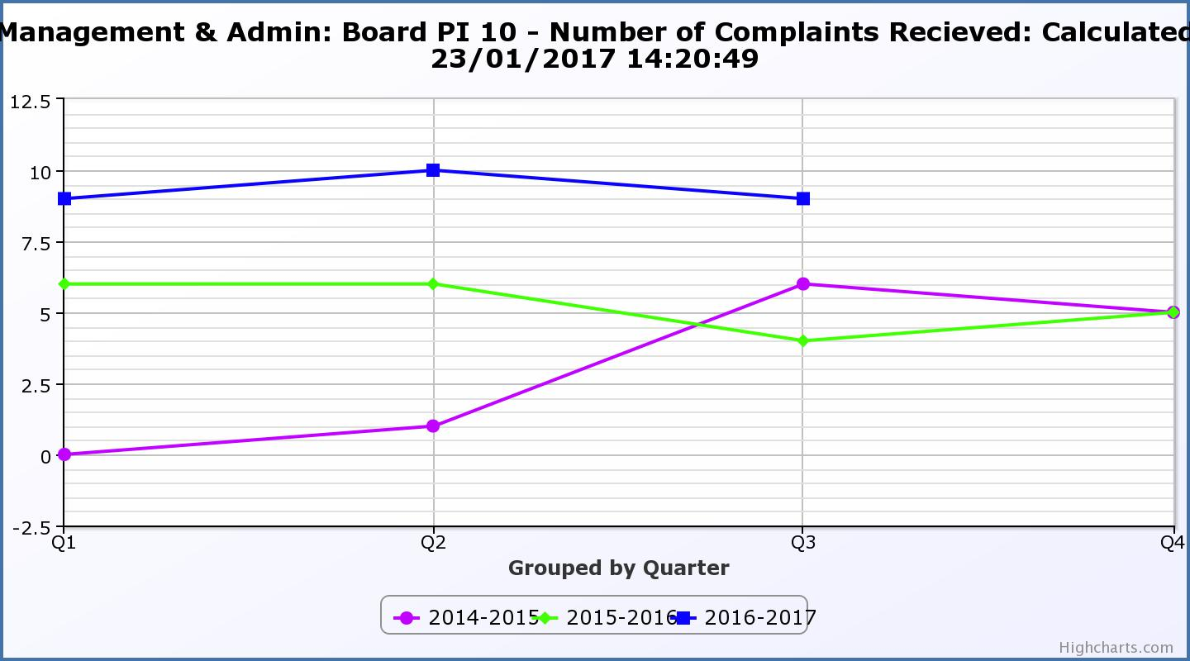
Business Plan Outcome | Performance Indicator | Reporting Frequency | RAG Rating Definition | RAG Rating Q1 16/17 | RAG Rating Q2 16/17 | RAG Rating Q3 16/17 | RAG Rating Q4 16/17 | Summary of Quarter Three Performance
7. Sustain a good health and safety performance | 11. Health and safety audit. | Annual. | - Red = the external audit raises systemic (i.e. applying across multiple sites) H&S issues.  - Amber = the external audit highlights common actions to be addressed across the company.  - Green = the external audit does not raise systemic issues. |  |  |  |  | NA – Annual performance indicator.

Business Plan Outcome | Performance Indicator | Reporting Frequency | RAG Rating Definition | RAG Rating Q1 16/17 | RAG Rating Q2 16/17 | RAG Rating Q3 16/17 | RAG Rating Q4 16/17 | Summary of Quarter Three Performance
7. Sustain a good health and safety performance  (cont) | 12. RIDDOR accidents/incidents. | Quarterly. | - Red = number of RIDDOR reports per quarter is above 20.  - Amber = number of RIDDOR reports per quarter is between 10 and 20  - Green = number of RIDDOR reports per quarter is less than 10. | Green | Green | Green |  | There were no RIDDOR accidents during Q3 2016/17.  Please see main report above for further information.

Performance Indicator 12 - RIDDOR Accidents
The graph below tracks the number of accidents and incidents reported under the RIDDOR regulations. There were none in Q 3 2016/17. Please see the main report above for information.
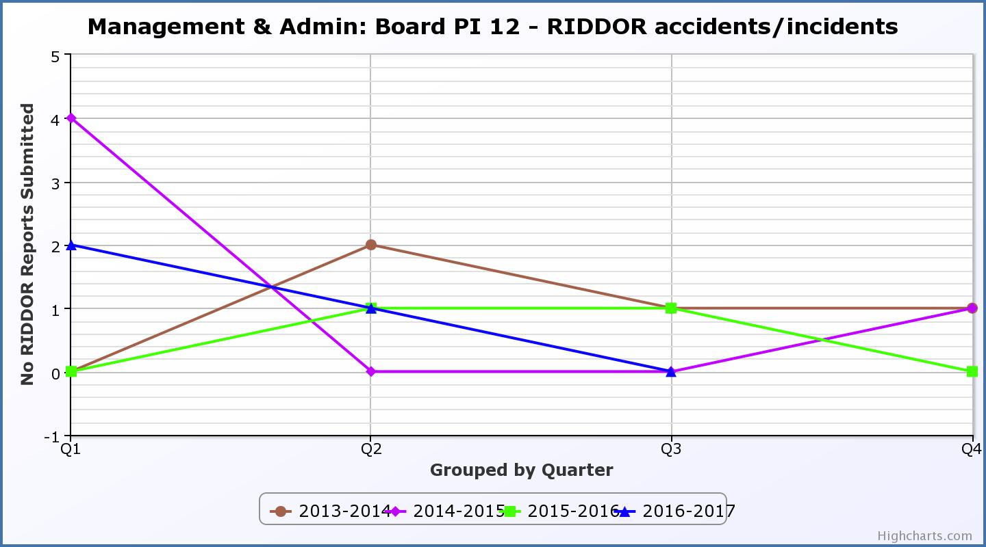
Business Plan Outcome | Performance Indicator | Reporting Frequency | RAG Rating Definition | RAG Rating Q1 16/17 | RAG Rating Q2 16/17 | RAG Rating Q3 16/17 | RAG Rating Q4 16/17 | Summary of Quarter Three Performance
8. A trusted partner | 13. THC’s annual survey of performance and attitudes. | Annual. | - Red = all HLH areas of work represented receive lower net satisfaction ratings than the previous year.  - Amber = two or more areas of HLH work receive lower net satisfaction ratings than the previous year.  - Green = net satisfaction ratings are maintained or improved for three or more areas of HLH work compared with the previous year. |  | Green |  |  | NA. This is an annual indicator.

Appendix B
Summary of Customer Surveys

Survey title | Summer Activities Programme
Areas of HLH Work | All
Survey date | August 2016
Survey objective | Assessment of customer satisfaction levels regarding programme quality, advertising/promotion and the booking process.
Number of responses | 375
Key findings | - 90.4% rated the programme good or excellent.  - 80.6% were satisfied or very satisfied with the range of activities.  - 84.8% described the pricing of activities as good or excellent value.  - 83.4% rated the information on activities provided in their areas as helpful or very helpful.  - 91.1% rated staff helpfulness as good or excellent.  - 95.4% said that they probably or definitely would use the summer activity programme again next year, with 95.2% saying that they would recommend the programme to a friend.
Changes made as a result of the survey | - Further improvement to bookings system to be made in 2017.  - Range of activities Is reviewed annually based on survey responses and uptake of programmes.

Survey title | Knowing Me Knowing You (KMKY)
Area of HLH work | Leisure Facilities
Survey date | Ongoing since 2013
Survey objective | Outcome measurement of KMKY programme
Number of responses | 225
Key findings | - 42.7% did not use a leisure centre prior to KMKY.  - 72.9% said their goal was to improve their health.  - 91.6% said they found the session helpful.  - 77.3% said since KMKY they would use their local facility more often.  - 89.8% would recommend KMKY to a friend.
Changes made as a result of the survey | Further improvements to reach non leisure participants have been made such a contacting more community groups and external organisations that HLH is not currently working with to reach more people.

Survey title | You Time
Areas of HLH work | Archives; Leisure Facilities; Libraries; Museums
Survey date | 2013 - 2016
Survey objective | Outcome measurement of You Time programme
Number of responses | 491 Baseline  172 Review
Key findings | - 84.7% said taking part helped them to do more exercise every week.  - 89.2% said taking part is giving them new opportunities to socialise.  - 62.9% said they have achieved their goals for You Time (33.3% did not have any goals).  - 58.3% are High Life members.  - 30.9% said there were activities they are interested in not offered as part of the You Time programme.
Changes made as a result of the survey | - Improvements to the range and types of activities offered have been made, taking account of activities customers have said they are interested in.  - Improvements to survey questions are also being planned (to make it more user friendly) taking account of feedback from customers and other stakeholders.

Survey title | Library Customer Survey (Adults)
Area of HLH work | Libraries
Survey date | March 2015
Survey objective | To assess customer satisfaction levels and the importance customers place on services provided by libraries.
Number of responses | 1452
Key findings | - People like their libraries, (how good is this library? – 98% satisfaction rate).  - Customers believe that High Life Highland have high quality library staff, (helpfulness - 99.8%, knowledge - 99.5% satisfaction ratings).  - Libraries play an integral part in many people’s lives, (70% of adult customers visit libraries at least once a week).  - 98% of people said that their library improves their quality of life.  - 39% of customers said that without their library they would not have access to the internet.
Changes made as a result of the survey | - Free Wi fi introduced in all libraries. New digital resources and services introduced and support delivered for customers using mobile devices.  - Local community engagement plans introduced in all libraries to further improve services for key target groups including younger and older people; and to increase participation.
Survey link | HLH Survey Adults

Survey title | Library Customer Survey (Children age 0 to 6)
Area of HLH work | Libraries
Survey date | May 2016
Survey objective | To assess how our youngest customers (and their parents) rate their library service.
Number of responses | 270
Key findings | - Overall, 99.6% of respondents think their library is very good, or good. (0.4 % fair).  - More than half visit their library at least once a week. (53%)  - All agree that the library has helpful staff. (94% agree strongly).  - 99% agreed or strongly agreed that the library helped their child to be ready for school/nursery.  - 96% agreed or strongly agreed that the library helped their child to socialise with other children.  - 99% agreed or strongly agreed that the library helped their child to read.  - 97% agreed or strongly agreed that the library helped their child to improve their speaking and listening;  - 74% agreed or strongly agreed that the library helped their child to practice writing;  - 88% agreed or strongly agreed that the library helped their child to learn to count.
Changes made as a result of the survey | - Additional Bookbug sessions provided in Libraries.  - A range of new and improved events and activities provided for children.  - Specialist designers engaged to make children’s spaces in new libraries as attractive and interactive as possible.
Survey link | HLH Survey Children 0 – 6

Survey title | Library Customer Survey (Children age 7 to 11)
Areas of HLH work | Libraries
Survey date | May 2016
Survey objective | To assess how children rate their library service.
Number of responses | 245
Key findings | - 55% of children aged 7 to 11 visit their library at least once a week  - 78% return or choose books  - 97% said their library has helpful staff  - 95% said their library has a good choice of books  - 77% said their library has good information to help with homework  - 98% said their library is nice inside 98% (83%, nice outside)  - 87% said their library helps them get better at reading  - 92% said their library helps them enjoy reading  - 72% said their library helps them find things for school  - 29% said their library helps them “make friends”  - 96% said their library is a “safe place”.  - 13% said that without their library they would not have access to a computer (outside school)
Changes made as a result of the survey | - A range of new and improved events and activities provided for children including Lego Clubs.  - Programme of improvement of children’s areas in libraries undertaken with priority given to improving study space for children, including space for group study.  - Engagement of teenage volunteers to help run the Summer Reading Challenge to promote literacy and a love of reading for young people.
Survey link | HLH Survey Children 7 – 11

Survey title | Library Customer Survey (“Teens” Young People age 12 to 17)
Area of HLH work | Libraries
Survey date | May 2016
Survey objective | To assess how teenagers rate their library service.
Number of responses | 211
Key findings | - 60% of respondents visited their library once a week or more. 19 visited daily.  - 94% rated the helpfulness of staff as Very Good / Good.  - 96% rated the library overall as Very Good / Good.  - 99% rated the library as a “safe place”.  - 40% listed “meeting friends” as the main reason for their visit.  - 79% borrowed books  - 89% can find the types of books they want to read.  - 67% use the library for study /homework.  - 15% said that without their library would not have access to a computer (outside school)
Changes made as a result of the survey | - Teens in community schools empowered to choose stock for their libraries.  - External funding secured to develop a teenage volunteer programme in libraries to further improve participation and engagement.  - Engagement sessions held with local teens and designers in developing teenage spaces in new library developments. (Designers also deliver practical sessions in schools to support the curriculum).
Survey link | HLH Survey Teens 12 – 17

Survey title | English for Speakers of Other Languages (ESOL)
Areas of HLH work | Adult Learning
Survey date | Ongoing
Survey objective | Evaluation of English for Speakers of Other Languages (ESOL) provision.
Number of responses | Verbal feedback is sought from all participants
Key findings | Customer comments include:  - “I am very happy I can study English free.”  - “I meet very nice people and learn very useful things.”  - “Teacher very good.”  - “They liked the lessons they’ve had recently about making appointments in the doctors surgery and feel they could do this now without an interpreter. They both feel they need more practice but the father said his English benefitted most from a week long work placement he did.”
Changes made as a result of the survey | Changes are made on an individual or class level as a result of the feedback, such as revising previous learning, adjusting the pace of learning, etc.

Survey title | Survey of Literacy/Numeracy participants
Areas of HLH work | Adult Learning
Survey date | Ongoing
Survey objective | Evaluation literacy/numeracy provision.
Number of responses | Verbal feedback is sought from all participants.
Key findings | Customer comments included:  - “Would have liked courses to be even longer.”  - “It has showed me I can write.”  - “Wished it lasted longer.”  - “I feel supported.”
Changes made as a result of the survey | Changes are made on an individual or class level as a result of the feedback, such as revising previous learning, adjusting the pace of learning, progression opportunities etc.

Survey title | Youth Parliament Conference Evaluation
Areas of HLH work | Youth Work
Survey date | May 2016
Survey objective | Evaluation of youth parliament conference
Number of responses | 26
Key findings | - 100% rated the conference good or very good;  - 79% rated staff good or very good;  - Average good and very good rating for the workshop content was 87%  Comments included:  - “as a parliament, we have come together to make a difference in the highlands and I am so very proud of everyone”;  - “I will cry if I write too much, it was all so amazing”;  - “being with friends loved the activities”.
Changes made as a result of the survey | The team and youth parliament executive committee make adjustments to e conference year on year based on what worked well, what was felt useful by participants and topics which young people feel are important at the time. This is based on verbal feedback from participants as well as the survey.
Survey link | http://data.surveygizmo.com/r/177257_576cef52725113.77509364

Survey title | Inverness Museum and Art Gallery
Area of HLH work | Museums and Arts
Survey date | 2016
Survey objective | Assess customer experience and satisfaction
Number of responses | 151
Key findings | - 91% of respondents rated their welcome as excellent or very good.  - 92% of respondents rated the displays & exhibitions as excellent or very good.  - 93% of respondents rated their welcome ad excellent or very good.  - 95% of respondents would recommend the museum & gallery as a place to visit.
Changes made as a result of the survey | Winter opening hours were changed to match summer opening hours.

Survey title | Highland Archive Centre (Participates in National Archives Survey)
Area of HLH work | Archives
Survey date | June 2014
Survey objective | Assess a wide range of factors, including customer experience & satisfaction.
Number of responses | 105
Key findings | - 91% very satisfied with quality of welcome  - Staff attitude rated 9.8 out of 10  - Quality of staff’s advice rated 9.7 out of 10  - Overall experience rated 9.5 out of 10
Changes made as a result of the survey | - The engagement programme was reviewed and a greater number of events are now held on Friday evenings and Saturdays;  - Electronic copies of course content is provided;  - Public Wi-Fi has been installed to allow online access to course materials;  - School resource packs have been made available on-line.

Survey title | Highland Folk Museum
Area of HLH work | Museums
Survey date | June- September 2015
Survey objective | Assess customer experience & satisfaction
Number of responses | 91
Key findings | - 96% of respondents rated their welcome as outstanding or good.  - 99% of respondents rated the helpfulness and knowledge of staff as outstanding or good.  - 89% of respondents rated the shop & café products & prices as outstanding or good.  - 97% of respondents rated the quality of service as outstanding or good.  - 100% of respondents rated their overall experience as outstanding or good.
Changes made as a result of the survey | - Increased number of family events.  - Greater number of heritage events.  - Annual outlander event extended to 2 days.  - Catering capacity increases through coffee machine in shop and BBQ.  - Grant funding applications submitted for tractor and specialist trailer to transport people round the site.  - Group catering introduced.  - Guided tours of the museum artefact store introduced.

Survey title | Highland Folk Museum Review of Trip Adviser Ratings and Facebook feedback
Areas of HLH work | Museums
Survey date | Continuous
Survey objective | Independent view of customer satisfaction
Key findings | Of 690 TripAdvisor reviews, 72% rate HFM as 5* and 17% as 4*  HFM is ranked  - #1 of 67 Museums in the Scottish Highlands (which includes Argyll, all islands , Moray and into Aberdeenshire)  - #10 of 451 Things to Do in the Scottish Highlands  The average of Facebook reviews is 4.9*  Comments include  “ Brilliant- great day out for everyone… we went 3 times on our 1 week holiday.”  “We had one of the best days here…the quality of the site was outstanding.”
Changes made as a result of the survey | Feedback from customers on the proactive donations policy was positive and reinforced the approach.

