HIGH LIFE HIGHLAND  REPORT TO BOARD OF DIRECTORS  14 June 2018 | AGENDA ITEM 12 REPORT No HLH /18

ANNUAL Health and Safety And Environmetal Compliance Report - Report by Chief Executive

Summary

An important element of the Governance structure relating to the company’s Health and Safety and Environmental Compliance performance is the annual Health and Safety and Environmental Compliance Report.

This report informs Directors about the performance of High Life Highland in terms of health and safety and environmental compliance.

It is recommended that Directors comment on and note:

- that there were no notifications for improvement or enforcement actions during 2017-18;
- that there were no environmental incidents requiring SEPA notification;
- the low number and low severity of incidents over the period, reflecting continuing good practice across the company;
- that the Health and Safety Strategic Group continues to meet quarterly to review Health and Safety performance and on reviewing accident and incident trend data it concluded that there are no issues arising from this requiring company wide action;
- that the annual external audit in 2017/18 identified that there was no company wide action required;
- that one union safety audit has been completed in 2017/18 in line with the Safety Representatives Charter; and

agree:

- to recommend to the Highland Council that the Memorandum and Articles of Association of High Life Highland be changed to require it to have a Health and Safety and Environmental Compliance Strategic Committee.

1. | Business Plan Contribution
1.1 | This report supports the highlighted Business Outcomes from the High Life Highland (HLH) Business Plan:  - To advance sustainable growth and financial sustainability  - Deliver the Service Delivery Contract with THC  - Improving staff satisfaction  - Improving customer satisfaction  - A positive company image  - Services designed around customers and through market opportunities  - Sustain a good health and safety performance  - A trusted partner
2. | Background
2.1 | The HLH Health and Safety Policy Statement requires annual and exception reporting, to the HLH Board on health and safety performance.
2.2 | At the HLH Board meeting on the 23 April 2014 Directors agreed to delegate to the Health and Safety and Environmental Compliance Strategic Group the decision on the final layout of the tables in the appendix to this report. The Group reviewed and agreed the information in this report and accompanying appendices at its meeting held on 15 May 2018.
3. | Health and Safety and Environmental Compliance Performance
3.1 | There were no enforcing officer notifications for improvement, nor enforcement action during 2017/18. There were no environmental incidents requiring reporting to SEPA in 2017/18.
3.2 | Having analysed the information in the appendices, the Health and Safety and Environmental Compliance Strategic Group identified the following information as being important to report to the HLH Board:  - there are no trends indicating that any company wide actions are required;  - the 6 acts of violence recorded were behavioural and 5 out of the 6 related to customers, 1 act of violence was against an employee outside an HLH property but this incident was not work related. All incidents have been dealt with appropriately, they have been reviewed and assessed, with no trends;  - there were three accidents reported under RIDDOR in 2017/18, all RIDDOR incidents have been dealt with appropriately, they have been reviewed and assessed, with no trends (details contained in Appendix A);  - there were two successful resuscitations during 2017/18, both within HLH locations, Tain Royal Academy Community Complex on 21 November 2017 and Craig MacLean Leisure Centre on 12 March 2018;  - the introduction of a new online reporting system in April 2017 and associated staff training has helped to improve the analysis of accidents and incidents in 2017/18;  - due to there having been seven [in the year in question] unrelated fire incidents in HLH facilities, the circumstances are being monitored separately and HLH has been working closely with THC to ensure that facilities remain safe and compliant.
3.3 | Given the size of HLH and the number of visits to our facilities (5.8M) the very small number of incidents reflects the good practice across all areas of work.
4. | Annual External Audit
4.1 | The annual external safety audit in 2017/18 examined the sites listed below. There were no company-wide issues identified during the audits and all individual actions have been completed and signed off by Principal Managers.  - Inverness Royal Academy Sports Centre;  - East Caithness Community Facility;  - Active Schools – Summer Activity;  - Thurso Leisure Centre; and  - Naver playing field (synthetic pitch and changing facility).
4.2 | Following the audit the Director and Trading Company Director on the Health and Safety Strategic Group were briefed on its findings and the resulting action plans. After the action plans were completed an internal audit was carried out by the Health and Safety and Property Officer. HLH’s external health and safety adviser has been asked to undertake a follow-up external audit in the Autumn of 2018.
5. | Safety Representatives Charter
5.1 | In line with the Safety Representatives Charter agreed in June 2016 Unison has undertaken one safety audit in 2017/18 at Portree Library. The actions arising from the audit have been completed with the staff and local managers having viewed the process as being positive. It is hoped that additional union inspections will take place as and when union resources permit.
6. | Formalisation of the Health and Safety and Environmental Compliance Strategic Group
6.1 | There was a Directors’ annual review and assessment workshop held on 13 December 2017. At the workshop, Directors expressed the view that the Strategic Group should be formalised. It is therefore recommended that it should be added to the formal committees required in the Memorandum and Articles of Association of High Life Highland. (The two existing committees are the Finance and Audit Committee and the Nominations Committee). A request to change the Memorandum and Articles of Association requires the agreement of THC and it is proposed that Directors agree to recommend this to THC.
6.2 | The following draft text is suggested for the addition to the Memorandum and Articles of Association:  The Health and Safety and Environmental Compliance Committee shall comprise:  - the Head of Performance  - two Directors;  - and such other individuals (if any) - who need not be directors of the company - as the directors may determine.
7. | Implications
7.1 | Resource Implications – there are no additional resource implications arising from this report.
7.2 | Legal Implications - there are no additional legal implications arising from this report.
7.3 | Equality Implications – there are no additional equality implications arising from this report.
7.4 | Risk Implications – there are no new risks which require to be added to the risk register arising from this report.

Recommendations

It is recommended that Directors comment on and note:

- that there were no notifications for improvement or enforcement actions during 2017-18;
- that there were no environmental incidents requiring SEPA notification;
- the low number and low severity of incidents over the period, reflecting continuing good practice across the company;
- that the Health and Safety Strategic Group continues to meet quarterly to review Health and Safety performance and on reviewing accident and incident trend data it concluded that there are no issues arising from this requiring companywide action;
- that the annual external audit in 2017/18 identified that there was no companywide action required;
- that one union safety audit has been completed in 2017/18 in line with the Safety Representatives Charter; and

agree:

- to recommend to the Highland Council that the Memorandum and Articles of Association of High Life Highland be changed to require it to have a Health and Safety and Environmental Compliance Strategic Committee.

Designation: Chief Executive

Date: 25 May 2018
Appendix A

All RIDDOR Notified Accidents/Incidents – Summary

 | 2017-18
Service Area | Q1 Apr-Jun | Q2 Jul-Sep | Q3 Oct-Dec | Q4 Jan-Mar
Adult Learning
Archives
Arts
Leisure Facilities | 1 | 1
Libraries
Museums
Outdoor Education
Sport
Youth |  |  | 1
Management & Administration
GRAND TOTAL | 1 | 1 | 1 | 0

All RIDDOR Notified Accidents/Incidents – Details Q1 – Q4 2017-18

INCIDENT 1 - RIDDOR Notified Accidents/Incidents - Q1 2017-2018
Leisure Inverness Botanic Gardens (Floral Hall) - 08 June 2017 10:15

DESCRIPTION: As the customer walked into the tropical house, a wire sprang out with a nail attached and hit her in the eye. The cornea may be scratched.

Actions Taken: All wires checked throughout the facility and any that were not secured appropriately (i.e. with a nail into the side of the building and not bound around a fixing point) were removed.

As per recommendation the main vine has been supported at the heaviest point by rubber tie straps specifically used for plants.
INCIDENT 2 - RIDDOR Notified Accidents/Incidents - Q2 2017-2018
Leisure Inverness Botanic Gardens (Floral Hall) - 31 August 2017 11:30

DESCRIPTION: The staff member was stepping out of a hired skip and tripped over a metal stand attached to the skip. He banged his left ankle on the stand causing him to fall. He said it was very painful. He was assisted walking to the office.

After having first aid applied, he then drove home. Damage caused to employee by banging his left ankle against a steel fold down area of a hired skip.

Employee attended A&E Dept the following morning. He had sustained tissue damage and could not put on any footwear.

Actions Taken: Review of working arrangements has taken place, a Safe System of Work created and staff trained.
INCIDENT 3 - RIDDOR Notified Accidents/Incidents - Q3 2017-2018
Youth Services - 07 November 2017 13:45

DESCRIPTION: Cut finger during camp craft activity.
Actions Taken: Immediate first aid provided. Taken to hospital.
Recommendations: Review indicated that safety briefing was correctly provided and correct supervision was in place. Participant failed to follow instructions. No further actions necessary.

Appendix B, Tables 1-8

Accidents and incidents compared to the previous year for staff, volunteers and contractors by HLH section

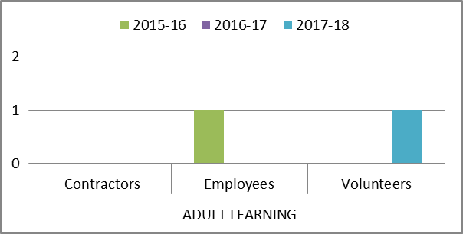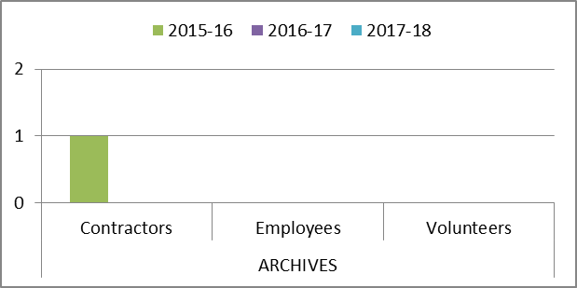

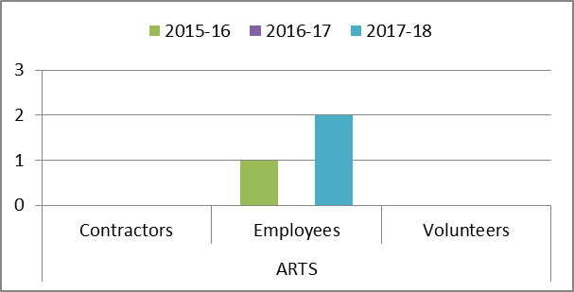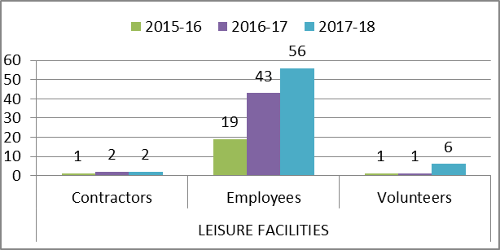

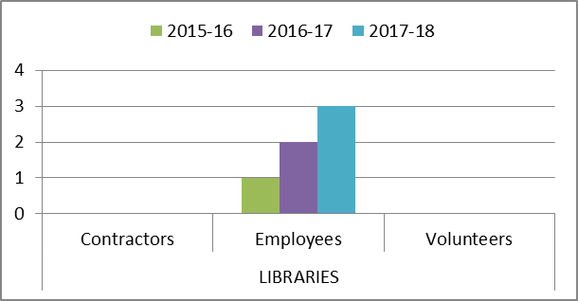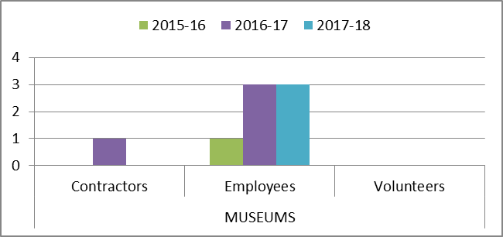

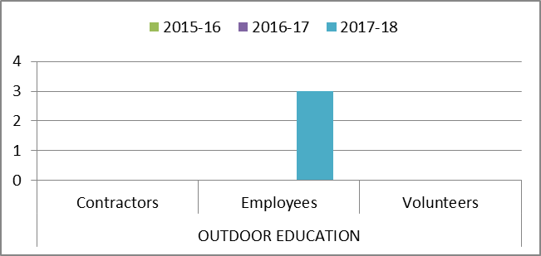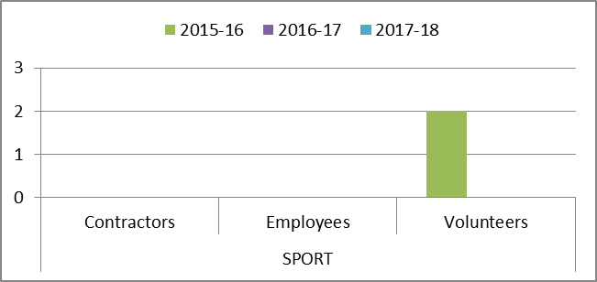

Appendix B, Tables 9-10

Accidents and incidents compared to the previous year for staff, volunteers and contractors by HLH section

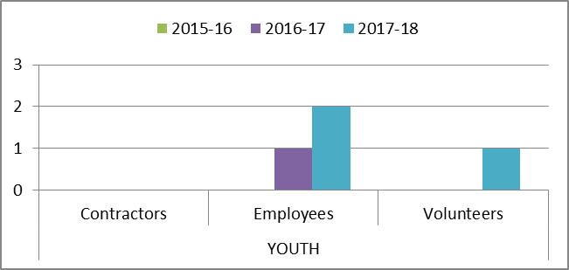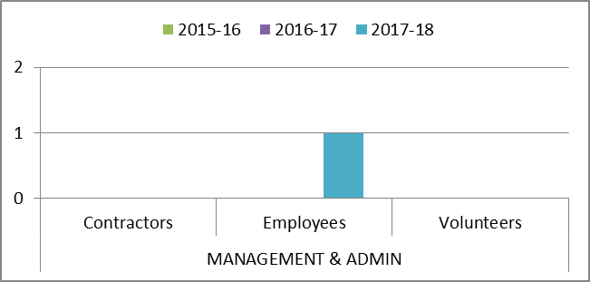

Appendix B, Tables 11-12

Accidents and incidents compared to the previous year for staff, volunteers and contractors by nature of accident

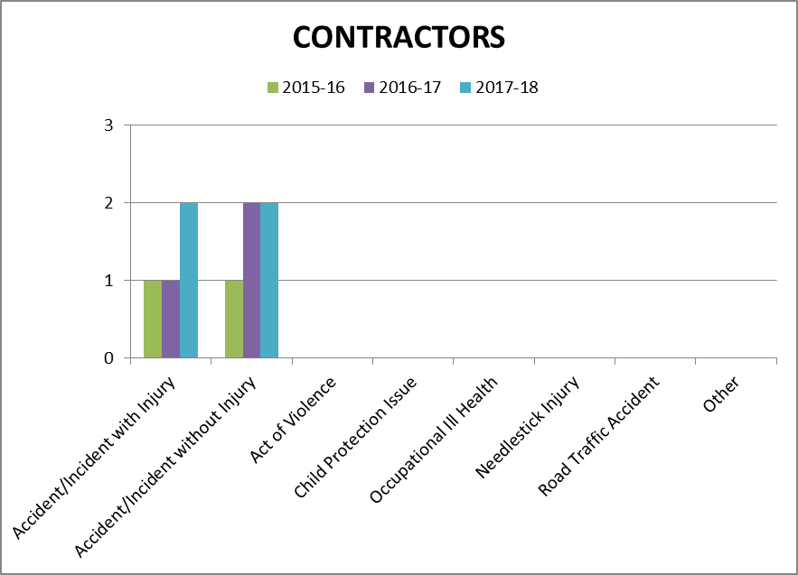

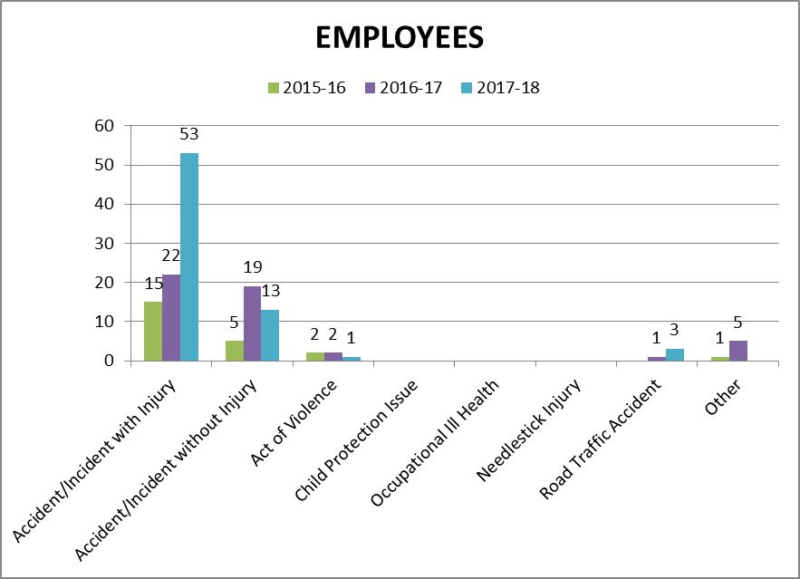

Appendix B, Table 13

Accidents and incidents compared to the previous year for staff, volunteers and contractors by nature of accident

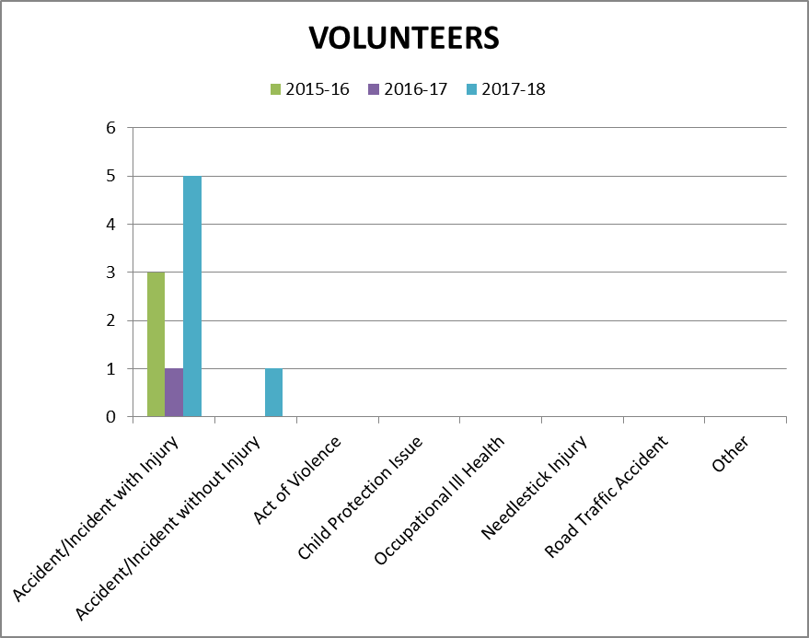

Appendix B, Table 14 – 15

Accidents and incidents compared to the previous year to staff, volunteers and contractors by type of accident/ incident

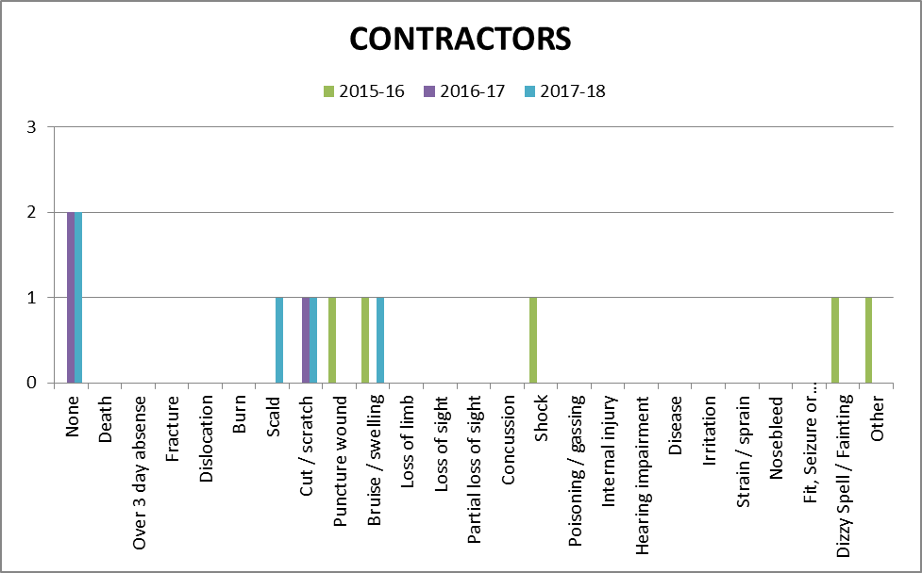

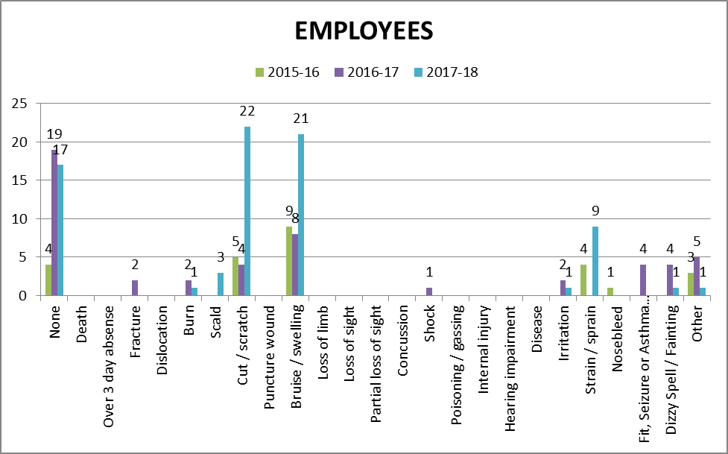

Appendix B, Table 16

Accidents and incidents compared to the previous year to staff, volunteers and contractors by type of accident/ incident

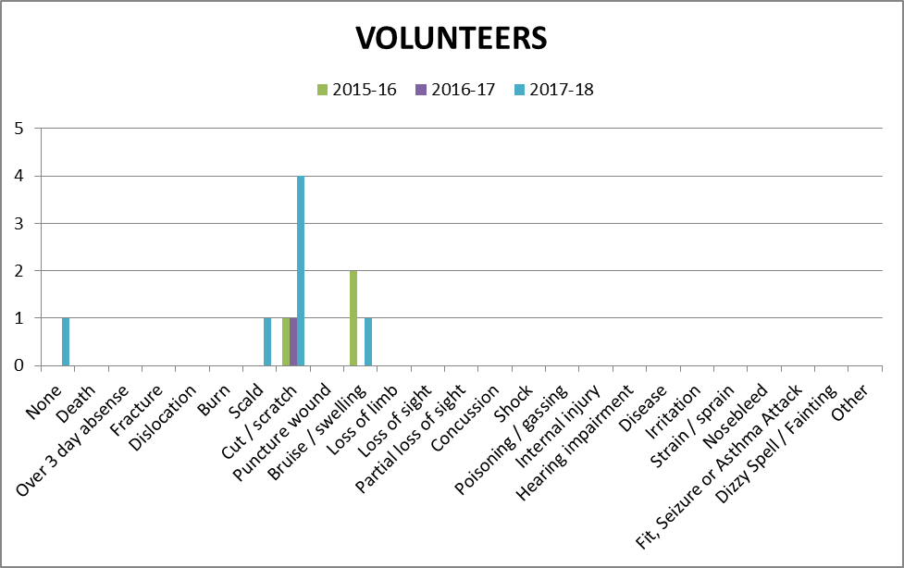

Appendix C, Table 1

Accidents and incidents compared to the previous year for users by HLH section

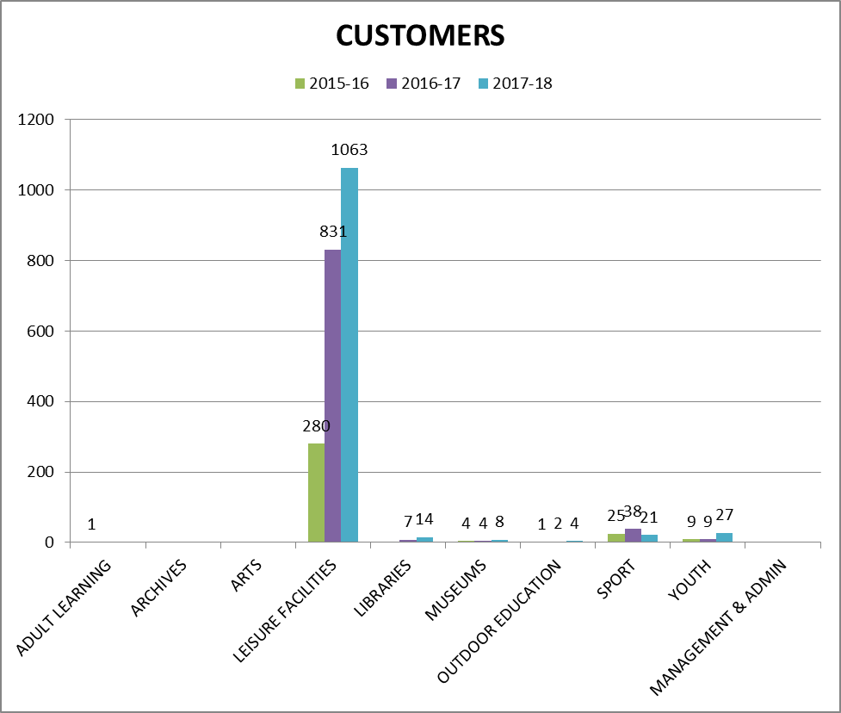

Appendix C, Table 2

Accidents and incidents compared to the previous year for users by nature of accident

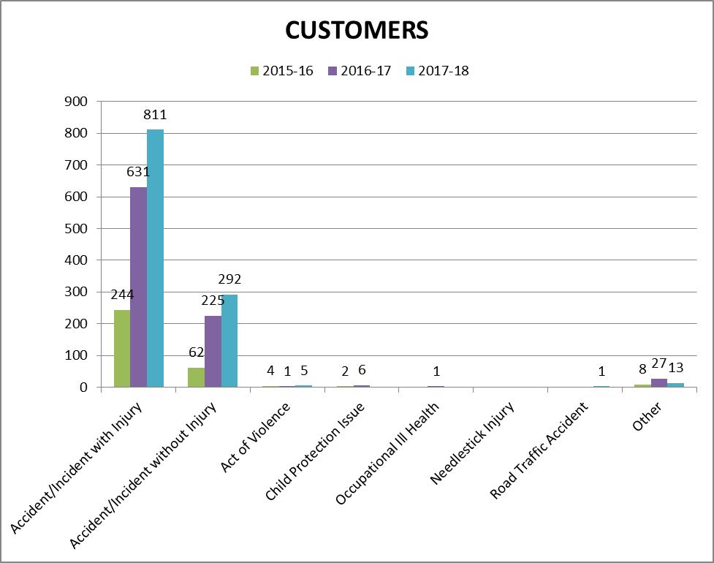

Appendix C, Table 3

Accidents and incidents compared to the previous year to users by type of accident/ incident

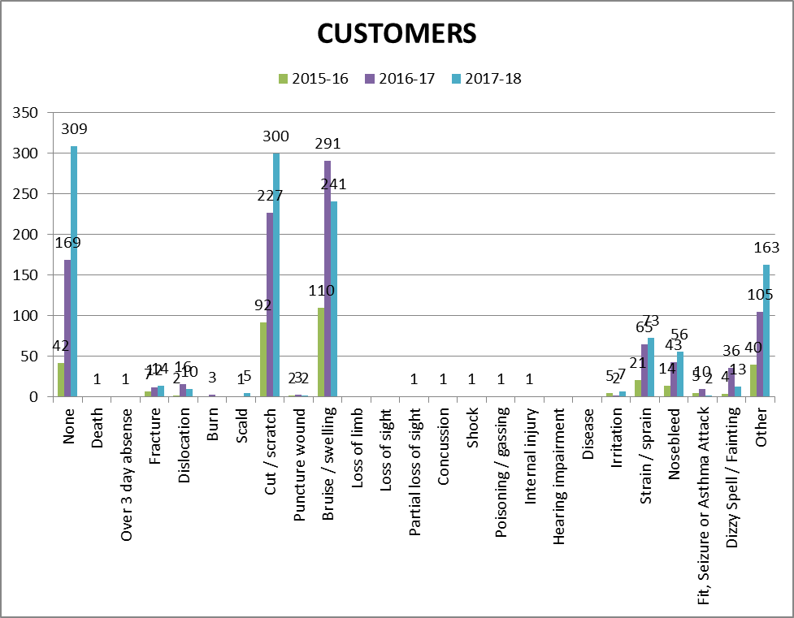

Appendix D

PERFORMANCE INDICATORS 2017-18

Number of Accidents / Incidents to Staff (Employees, Contractors & Volunteers) Against Total Number of FTE Staff.
 | FTE Staff | Accidents/Incidents | %
Q1 2016-17 | 598.130 | 21 | 3.51
Q2 2016-17 | 599.630 | 17 | 2.83
Q3 2016-17 | 602.200 | 8 | 1.33
Q4 2016-17 | 603.950 | 6 | 0.99
Q1 2017-18 | 603.880 | 16 | 2.65
Q2 2017-18 | 617.250 | 12 | 1.94
Q3 2017-18 | 623.250 | 21 | 3.37
Q4 2017-18 | 627.880 | 32 | 5.10

Number of Accidents / Incidents to customers against total number of customer visits.
 | Customer Visits | Accidents/Incidents | %
Q1 2016-17 | 1,428,311 | 228 | 0.016
Q2 2016-17 | 1,134,259 | 243 | 0.021
Q3 2016-17 | 1,291,697 | 180 | 0.011
Q4 2016-17 | 1,606,564 | 222 | 0.014
Q1 2017-18 | 1,471,879 | 234 | 0.016
Q2 2017-18 | 1,279,741 | 339 | 0.026
Q3 2017-18 | 1,517,168 | 248 | 0.016
Q4 2017-18 | 1,535,127 | 271 | 0.018

Breakdown of Accidents or Incidents by Employees, Contractors and Volunteers
 | Accidents |  |  | Incidents
 | Employees | Contractors | Volunteers | Employees | Contractors | Volunteers
Q1 2016-17 | 14 | 0 | 1 | 5 | 1 | 0
Q2 2016-17 | 10 | 1 | 0 | 5 | 1 | 0
Q3 2016-17 | 4 | 0 | 0 | 4 | 0 | 0
Q4 2016-17 | 3 | 0 | 0 | 3 | 0 | 0
Q1 2017-18 | 11 | 0 | 1 | 4 | 0 | 0
Q2 2017-18 | 11 | 0 | 0 | 1 | 0 | 0
Q3 2017-18 | 11 | 0 | 4 | 3 | 2 | 1
Q4 2017-18 | 19 | 2 | 1 | 10 | 0 | 0

Total number of Incidents that resulted or could have resulted in a fire
 | Incidents
Q1 2017-18 | 2
Q2 2017-18 | 4
Q3 2017-18 | 1
Q4 2017-18 | 0

There were no environmental incidents recorded during 2017-18

