HIGH LIFE HIGHLAND  REPORT TO BOARD OF DIRECTORS  4 September 2018 | AGENDA ITEM REPORT No HLH /18

Performance Report - Report by Chief Executive

Summary

The purpose of this report is to present performance information for the period April to June 2018.

It is recommended Directors:-

- comment on the report and agree that the overall health check on the Company for the period is assessed as green;
- note that the delivery of the business plan is assessed as green; and
- note the information provided on the performance indicators for more detailed consideration.

1. | Business Plan Contribution
1.1 | This report supports all the Business Outcomes from the High Life Highland (HLH) Business Plan:  - To advance sustainable growth and financial sustainability  - Deliver the Service Delivery Contract with THC  - Improving staff satisfaction  - Improving customer satisfaction  - A positive company image  - Services designed around customers and through market opportunities  - Sustain a good health and safety performance  - A trusted partner
2. | Background
2.1 | The performance indicators in this report were set, at the request of the Board, by the Finance and Audit Committee in March 2016. It was agreed then that reporting on the delivery of the business outcomes would be by exception (i.e. reporting where managers had RAG rated the actions “red – no significant progress”).

3. | Summary of Performance
3.1 | Appendix A contains a summary of performance against the performance indicators along with trend information for numeric PIs. There are ten performance indicators scheduled for assessment at the September 2018 Board meeting and all of them have been RAG rated as “green”.
4. | Delivery of Business Outcomes
4.1 | The current HLH Business Plan 2015-19 identifies 8 business outcomes and the approach which the charity takes to deliver them. The resultant Operational Plans for each of the nine HLH areas of work are RAG rated every quarter.
4.2 | The RAG ratings of the operational plans has identified that delivery of the Business Plan is on target. Five of the nine areas of HLH work RAG rated all of the actions “green – on target” or complete; one area of work RAG rated 1 action as “amber – some slippage”; one area of work RAG rated 2 actions as “amber – some slippage”; one area of work RAG rated 3 actions as “amber – some slippage”; and one area of work RAG rated 4 actions as “amber - some slippage”. Directors have agreed that reporting on the delivery of the business outcomes would be by exception (i.e. reporting where managers had RAG rated the actions “red – no significant progress”) and there have been no actions which have been RAG rated “red” in quarter one of 2018/19.
5. | Performance Indicators for More Detailed Consideration
5.1 | The performance indicators scheduled for more detailed consideration in this report are:  PI 2 - Number of High Life subscriptions.  PI 3 - High Life cancellation rate.  PI 5 - Staff turnover - resignations as a percentage of posts. (Please see the HR report elsewhere on this agenda for further information).
5.2 | PI 2 - Number of High Life subscriptions. The number of High Life subscriptions continues to grow and were at their highest level ever during quarter one this year as can be seen in the table below.  Average Number of Subscriptions  Q1 2016/17 18,420  Q1 2017/18 19,705  Q1 2018/19 21,376
5.3 | Subscriptions across most sites are holding steady or increasing, with there having been small reductions at only six sites comparing quarter one this year with the same quarter in 2017/18 as can be seen in the table below.  Q1 2016-17 Q1 2017-18 Q1 2018-19 Change Q1 17/18-Q1 18/19  Alness Swimming Pool 47 46 44 -2  Averon Leisure Centre 604 593 604 11  Aviemore Community Centre 570 629 674 45  Badenoch Centre 472 468 514 46  Black Isle Leisure Centre 472 456 475 18  Craig MacLean Leisure Centre 812 757 817 59  Culloden Academy Leisure Centre 507 513 500 -14  Dingwall Leisure Centre 1701 1747 1830 83  East Caithness Community Complex - Wick High School – Leisure (Former Wick Swimming Pool) 605 720 888 167  Fingal Centre 520 556 605 49  Gairloch Leisure Centre 145 155 152 -3  Invergordon Leisure Centre 1015 1002 1007 5  Inverness Leisure 6190 6501 7304 802  Inverness Royal Academy SC 0 232 239 7  Leanaig Centre - Ben Wyvis Primary School 14 11 13 1  Lochaber Leisure Centre 1700 1797 1886 89  Lochbroom Leisure Centre 311 328 321 -7  Nairn Leisure Centre 1020 1047 1018 -29  North Coast Leisure Centre 0 0 277 277  Sutherland Swimming Pool 373 349 363 15  Tain Royal Academy Community Complex (TRACC) 642 618 613 -5  Thurso Swimming Pool 700 1179 1233 55  18,420 19,705 21,376 1,671
5.4 | The graph below compares the total number of subscriptions on a monthly basis for the previous two complete financial years plus the first four months of 2018/19. Subscriptions have increased compared with previous years every month and in July were at the highest level ever at 21,657.
5.5 | PI 3 - High Life cancellation rate. The High Life card subscription cancellation rate was 3% in April and May 2018 and 1% in June. This is lower than the same quarter the previous year when the cancellation rate was 4% and lower than had previously been reported (duplicate cancellations associated with family subscriptions had been recorded in quarter four 2017/18 which have since been removed).
5.6 | The table below shows the cancellation rate (cancellations as a percentage of the number of subscriptions) per facility. Cancellation rates in Q1 2018/19 are the same as or lower than the same quarter in 2017/18 (except for North Coast Leisure which was not operated by HLH and did not operate the High Life scheme in Q1 2017/18).  Q1 2016-17 Q1 2017-18 Q1 2018-19 Difference Q1 17-18 to Q1 18-19  Alness Swimming Pool 4.7 4.3 1.7 -2.7  Averon Leisure Centre 6.0 6.3 3.0 -3.3  Aviemore Community Centre 5.7 6.3 3.0 -3.3  Badenoch Centre 3.0 3.3 1.7 -1.7  Black Isle Leisure Centre 3.7 3.0 2.0 -1.0  Craig MacLean Leisure Centre 3.3 4.3 2.7 -1.7  Culloden Academy Leisure Centre 2.3 3.3 1.7 -1.7  Dingwall Leisure Centre 2.7 3.7 2.0 -1.7  East Caithness Community Complex - Wick High School - Leisure (Former Wick Swimming Pool) 5.0 4.3 2.3 -2.0  Fingal Centre 5.0 3.0 1.7 -1.3  Gairloch Leisure Centre 2.0 3.3 2.0 -1.3  Invergordon Leisure Centre 2.7 4.3 2.3 -2.0  Inverness Leisure 3.3 2.7 2.7 0.0  Inverness Royal Academy SC 0.0 4.3 4.0 -0.3  Leanaig Centre - Ben Wyvis Primary School 2.3 11.7 2.7 -9.0  Lochaber Leisure Centre 4.7 4.3 3.0 -1.3  Lochbroom Leisure Centre 2.0 2.7 2.7 0.0  Nairn Leisure Centre 3.0 5.0 2.7 -2.3  North Coast Leisure Centre 0.0 0.0 1.3 1.3  Sutherland Swimming Pool 5.0 4.7 2.3 -2.3  Tain Royal Academy Community Complex (TRACC) 2.7 6.0 2.3 -3.7  Thurso Swimming Pool 7.3 6.0 2.0 -4.0
5.7 | People who cancel their subscriptions are surveyed to find out their reasons for cancelling and the results can be seen in the graph below. The most common reasons are:  - Moved away from the area (33.1%)  - Other (26%)  - No longer meets my needs (21.7%)  - Reduction in household income (9.6%)
 | 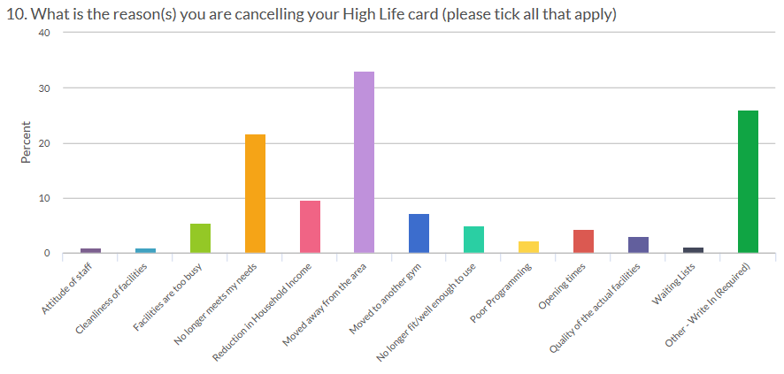
5.8 | Of the other [26%] category, 30% said that they were leaving the area and 18% gave responses which relate to the facilities no longer meeting people’s needs such as children no longer needing swimming lessons or children participating in club sport rather than leisure facility run activities. While 5% of respondents gave a reason for leaving as “Facilities are too busy”, this was higher at Inverness Leisure (14%) and Inverness Royal Academy (10%).
5.9 | It is difficult to assess what is behind the responses: “No longer meets my needs”, so this will be broken down in future surveys to provide options for people’s children no longer participating in swimming lessons and sports activities, time commitments, activity programmes changing, etc.
6. | Libraries – Increased Customer Visits Through Amendments to Opening Hours
6.1 | Libraries staff undertook a review of opening hours at three libraries in consultation with customers and communities. The opening hours were realigned (keeping the total number of opening hours the same) to meet local needs and support local groups including nurseries, schools and community groups. There was a marked increase in customer visits at no additional costs at all three sites. Based on the success of this, staff are looking for opportunities to undertake a similar process in other libraries.  Library Customer Visits Q1 2017-18 Customer Visits Q1 2018-19 Difference % Difference  Lairg 806 1,547 741 91.9%  Glenurquhart 4,290 7,293 3,003 70.0%  Golspie 1,352 1,599 247 18.3%
7. | Health and Safety and Environmental Compliance
7.1 | The Annual Health and Safety and Environmental Compliance Strategic report was considered by the HLH Board at its last meeting. The Health and Safety and Environmental Compliance Strategic Group normally provides an update in this report following its quarterly meetings which take place between HLH Board meetings. At the time of writing the Strategic Group was scheduled to meet on 21 August 2018 and it will be asked to consider whether there is anything to report verbally to the HLH Board.
7.2 | The regular Health and Safety performance indicator considered by the HLH Board is accidents/incidents reported under the RIDDOR regulations. There was one RIDDOR reported accident during quarter one which related to a child trapping their finger in a door with a slow closing mechanism. The doors and closures were in a new building which had passed its building control inspection and the investigation concluded that the doors were compliant with building control regulations. To reduce the likelihood of reoccurrence guards which minimise the risk of finger entrapment between doors and door frames have been fitted in key areas accessible by children in the facility.
7.3 | There were no environmental compliance breaches during quarter one.
8. | Implications
8.1 | Resource Implications – there are no additional resource implications arising from this report.
8.2 | Legal Implications - there are no new legal implications arising from this report.
8.3 | Risk Implications – there are no new risk implications arising from this report.

Recommendation

It is recommended Directors:-

- comment on the report and agree that the overall health check on the Company for the period is assessed as green;
- note that the delivery of the business plan is assessed as green; and
- note the information provided on the performance indicators for more detailed consideration.

Designation: Chief Executive

Date: 21 August 2018
Appendix A
HLH Performance Indicators

Business Plan Outcome | Performance Indicator | Reporting Frequency | RAG* Rating Definition  (*Red/Amber/Green) | RAG Rating Q1 18/19 | RAG Rating Q2 18/19 | RAG Rating Q3 18/19 | RAG Rating Q4 18/19 | Summary of Quarter One Performance
1. To advance sustainable growth and financial sustainability | 1. Financial monitoring. | Quarterly. | An assessment of the year end outturn where:  - Red = delivery of the SDC over budget above 2%.  - Amber = delivery of the SDC between break-even and 2% over budget.  - Green = delivery of SDC within budget. | Green |  |  |  | The variance for the budget up to the end of quarter one was £71K and it is projected that the SDC will be delivered within budget for financial year 2018/19. See the Finance Report elsewhere on this agenda for further information.

Performance Indicator 1 - Financial monitoring, variance to budget per quarter.
See the Finance Report elsewhere on this agenda for further information.

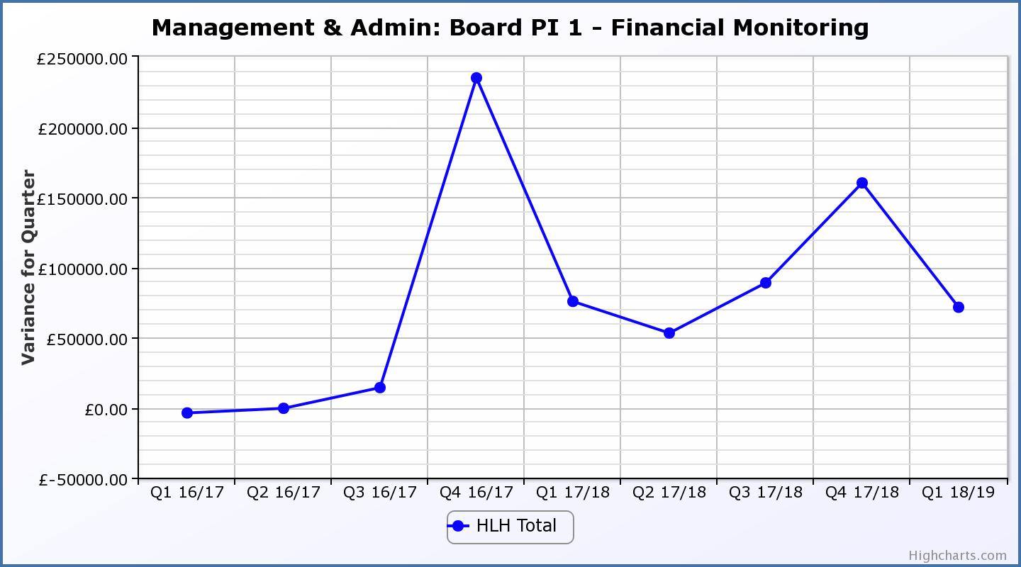
Business Plan Outcome | Performance Indicator | Reporting Frequency | RAG Rating Definition | RAG Rating Q1 18/19 | RAG Rating Q2 18/19 | RAG Rating Q3 18/19 | RAG Rating Q4 18/19 | Summary of Quarter One Performance
1. To advance sustainable growth and financial sustainability (cont) | 2. Number of High Life subscriptions. | Quarterly. | - Red = more than 5% below target.  - Amber = up to 5% below target.  - Green = on or exceeds target. | Green |  |  |  | The number of subscriptions each month during Q1 exceeded the target of 20,086 with the average number of subscriptions for the quarter having been 21,376. The target has been set at the level required to achieve the High Life Subscriptions income target.

Performance Indicator 2 - Number of High Life Subscriptions
The number of High Life Card subscriptions continues to increase and the average of 21,376 subscriptions for Q1 2018/19 was the highest they have been.

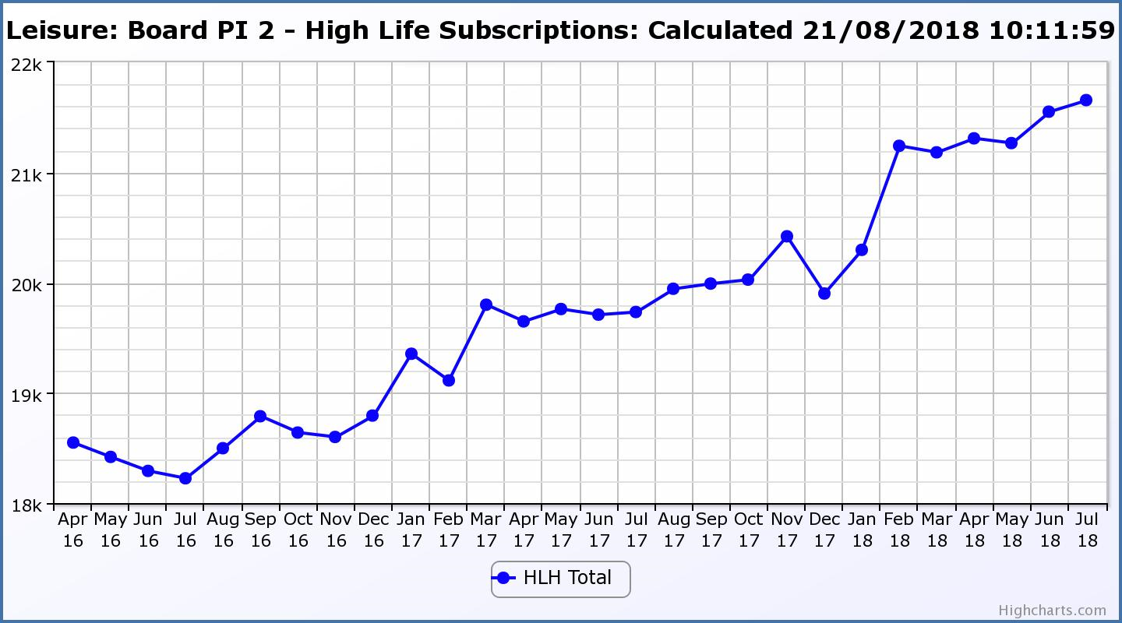

Business Plan Outcome | Performance Indicator | Reporting Frequency | RAG Rating Definition | RAG Rating Q1 18/19 | RAG Rating Q2 18/19 | RAG Rating Q3 18/19 | RAG Rating Q4 18/19 | Summary of Quarter One Performance
1. To advance sustainable growth and financial sustainability (cont) | 3. High Life cancellation rate. | Quarterly. | - Red = cancellation rate above 6% of High Life memberships.  - Amber = cancellation rate is 3% - 6% of High Life memberships.  - Green = cancellation rate is up to 3% of High Life memberships. | Green |  |  |  | The High Life cancellation rates in Q1 were 3% in April, 3% in May and 1% in June.  Please see section five of this report for further information.

Performance Indicator 3 - High Life Cancellation Rate
The overall number of subscriptions has increased and the cancellation rate was at its lowest in 16 months down to 1% of subscriptions in June 2018.
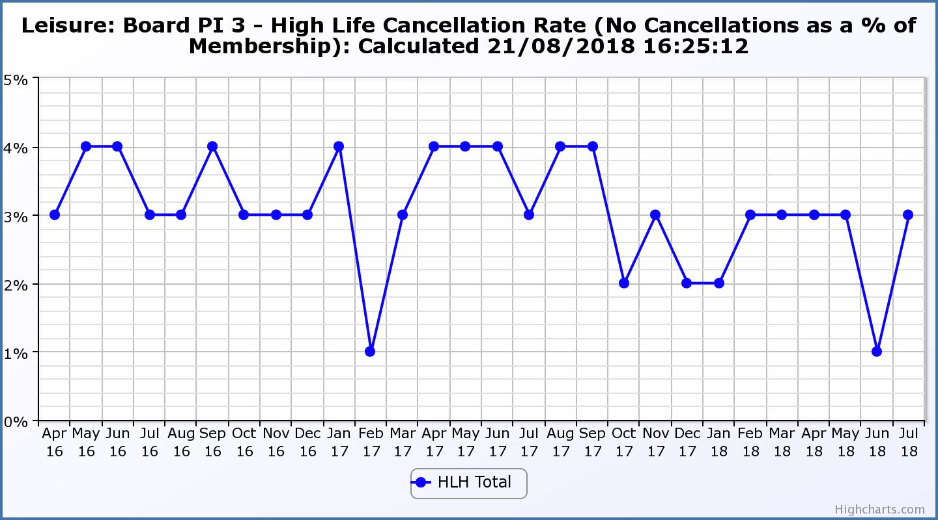

Business Plan Outcome | Performance Indicator | Reporting Frequency | RAG Rating Definition | RAG Rating Q1 18/19 | RAG Rating Q2 18/19 | RAG Rating Q3 18/19 | RAG Rating Q4 18/19 | Summary of Quarter One Performance
2. Deliver the Service Delivery Contract with THC | 4. Delivery of the Service Delivery Contract (SDC) with The Highland Council (THC). | Six-monthly. | - Red = agreement of THC’s ECAS Committee that HLH has not met the terms of the SDC.  - Amber = agreement of THC’s ECAS Committee that HLH has met the terms of the SDC but has set some improvement targets.  - Green = agreement of THC’s ECAS Committee that HLH has met or exceeded the terms of the SDC. |  |  |  |  | NA - six monthly indicator. The next HLH progress report is expected to be scheduled for THC’s Care, Learning and Housing Committee meeting in December 2018.

Business Plan Outcome | Performance Indicator | Reporting Frequency | RAG Rating Definition | RAG Rating Q1 18/19 | RAG Rating Q2 18/19 | RAG Rating Q3 18/19 | RAG Rating Q4 18/19 | Summary of Quarter One Performance
3. Improving staff satisfaction | 5. Staff turnover (resignations as a percentage of posts). | Quarterly. | - Red = more than 2%  - Amber = 1.7 to 2%  - Green = 1.6% or less | Green |  |  |  | The number of resignations per month as a percentage of posts in Q1 was 0.5% in April, 0.4% in May and 0.6% in June. Please see HR report elsewhere on this agenda for further information.

Performance Indicator 5 - Staff Turnover (resignations as a percentage of posts)
The graph below shows resignations as a percentage of the number of posts and resignations have been consistent with previous years and continue to be low (1% equates to 10.6 staff).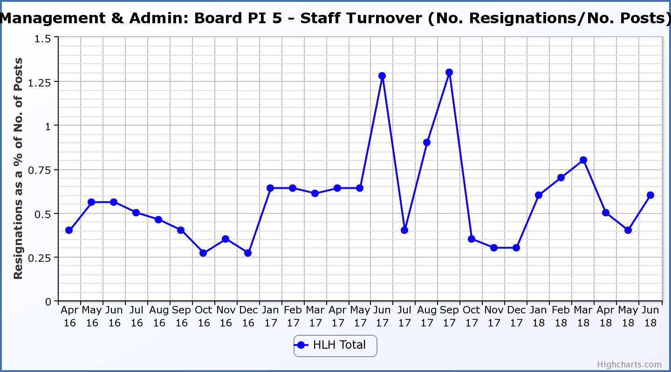
Business Plan Outcome | Performance Indicator | Reporting Frequency | RAG Rating Definition | RAG Rating Q1 18/19 | RAG Rating Q2 18/19 | RAG Rating Q3 18/19 | RAG Rating Q4 18/19 | Summary of Quarter One Performance
3. Improving staff satisfaction (cont.) | 6. Staff absence rates. | Quarterly. | - Red = absence rate greater than 3.6%.  - Amber = absence rate between 3.4% and 3.6%.  - Green = absence rate 3.3% or less. | Green |  |  |  | The absence rate for Q1 was 3.11%. Please see the HR report elsewhere on this agenda for further information.

Performance Indicator 6 - Staff Absence Rates
Following the absence rate increasing in the last two quarters in 2017/18 it decreased in quarters one 2018/19. Please see the HR report elsewhere on this agenda for further information. 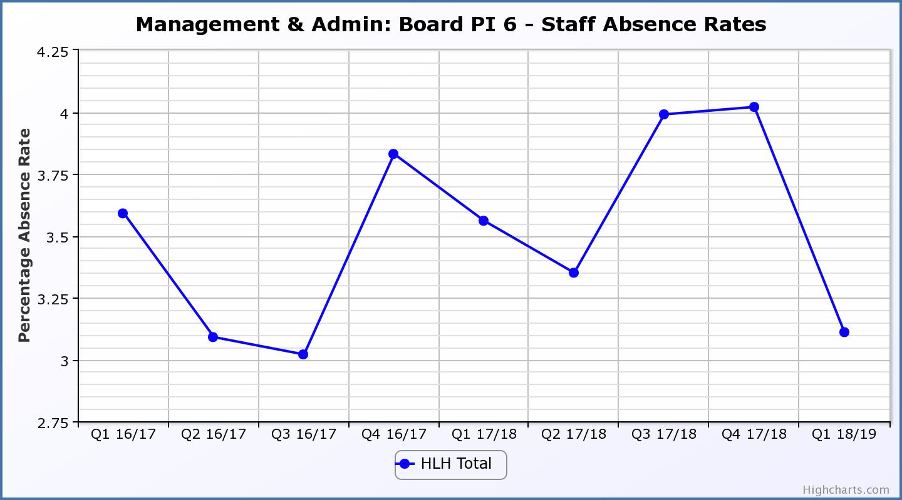

Business Plan Outcome | Performance Indicator | Reporting Frequency | RAG Rating Definition | RAG Rating Q1 18/19 | RAG Rating Q2 18/19 | RAG Rating Q3 18/19 | RAG Rating Q4 18/19 | Summary of Quarter One Performance
4. Improving customer satisfaction | 7. Customer surveys. | Quarterly. | - Red = no staff surveys have been completed or scheduled.  - Amber = 4 to 8 of the HLH areas of work have completed or scheduled customer surveys.  - Green = all areas of HLH work have completed or scheduled customer surveys. | Green |  |  |  | All areas of work included customer surveys in their operational plans for 2018/19.

Business Plan Outcome | Performance Indicator | Reporting Frequency | RAG Rating Definition | RAG Rating Q1 18/19 | RAG Rating Q2 18/19 | RAG Rating Q3 18/19 | RAG Rating Q4 18/19 | Summary of Quarter One Performance
4. Improving customer satisfaction (cont) | 8. Customer Numbers. | Quarterly. | - Red = customer numbers are more than 5% lower than the corresponding quarter in the previous year.  - Amber = customer numbers are less than the corresponding quarter in the previous year.  - Green = customer numbers are the same as or have increased compared with the corresponding quarter in the previous year. | Green |  |  |  | Customer numbers increased from 1,882,935 in Q1 2017/18 to 2,020,410 in Q1 2018/19.

Performance Indicator 8 - Customer Numbers
The graph below shows a year on year increase in customer numbers.
.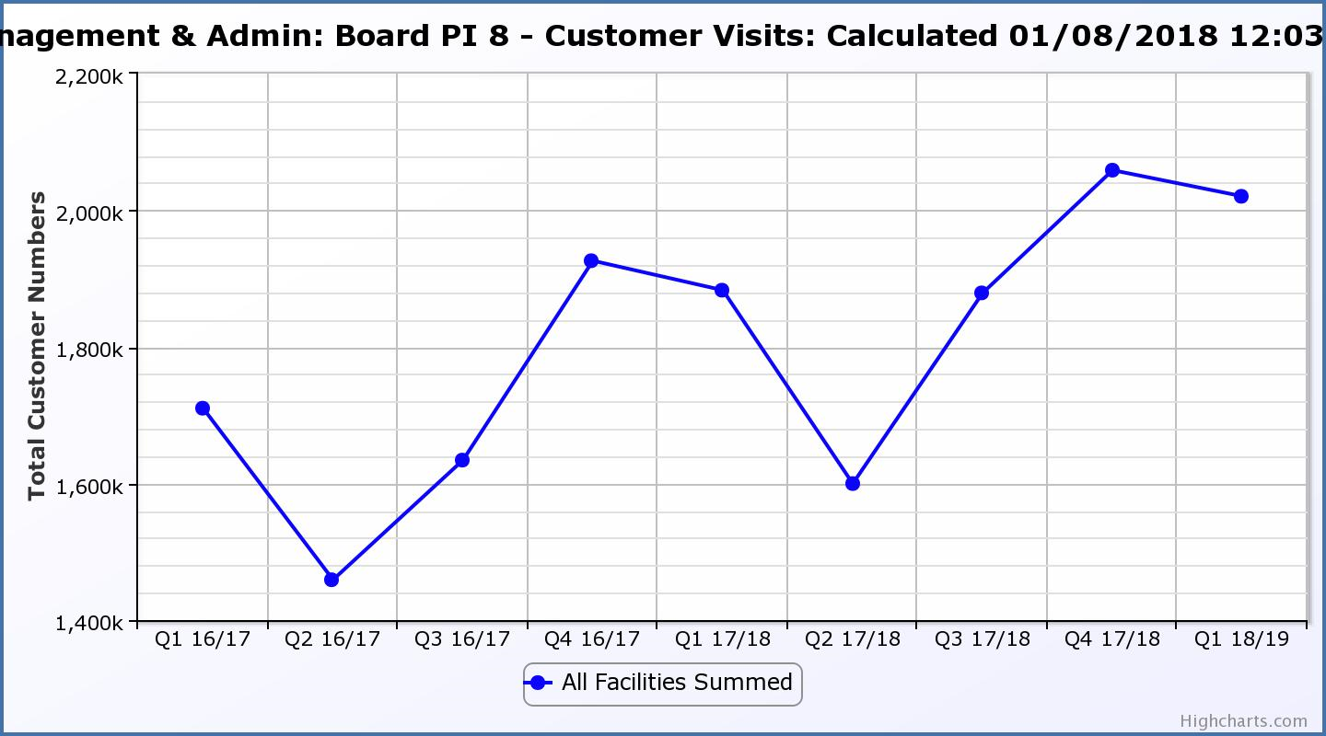

Business Plan Outcome | Performance Indicator | Reporting Frequency | RAG Rating Definition | RAG Rating Q1 18/19 | RAG Rating Q2 18/19 | RAG Rating Q3 18/19 | RAG Rating Q4 18/19 | Summary of Quarter One Performance
5. A positive company image | 9.Media clippings. | Quarterly | - Red = number of negative press clippings outweigh neutral and positive.  - Amber = number of negative and neutral press clippings outweigh positive.  - Green = number of positive and neutral media clippings outweigh negative. | Green |  |  |  | Positive media clippings for Q1 2018/19 totalled 122.  31 of these were neutral and there were none which were negative.

Performance Indicator 9 - Media Clippings
The following two graphs show the numbers of positive and neutral media clippings compared with negative. The positive and neutral outweigh the negative.

Business Plan Outcome | Performance Indicator | Reporting Frequency | RAG Rating Definition | RAG Rating Q1 18/19 | RAG Rating Q2 18/19 | RAG Rating Q3 18/19 | RAG Rating Q4 18/19 | Summary of Quarter One Performance
5. A positive company image (cont.) | 10. Formal complaints. | Quarterly. | - Red = 21 or more complaints per quarter.  - Amber = 11 to 20 complaints per quarter.  - Green = 10 complaints or fewer per quarter. | Green |  |  |  | There were seven complaints received during Q1 2018/19.

Performance Indicator 10 - Formal Complaints
The graph below shows the number of complaints which continue to be very low in relation to customer numbers.

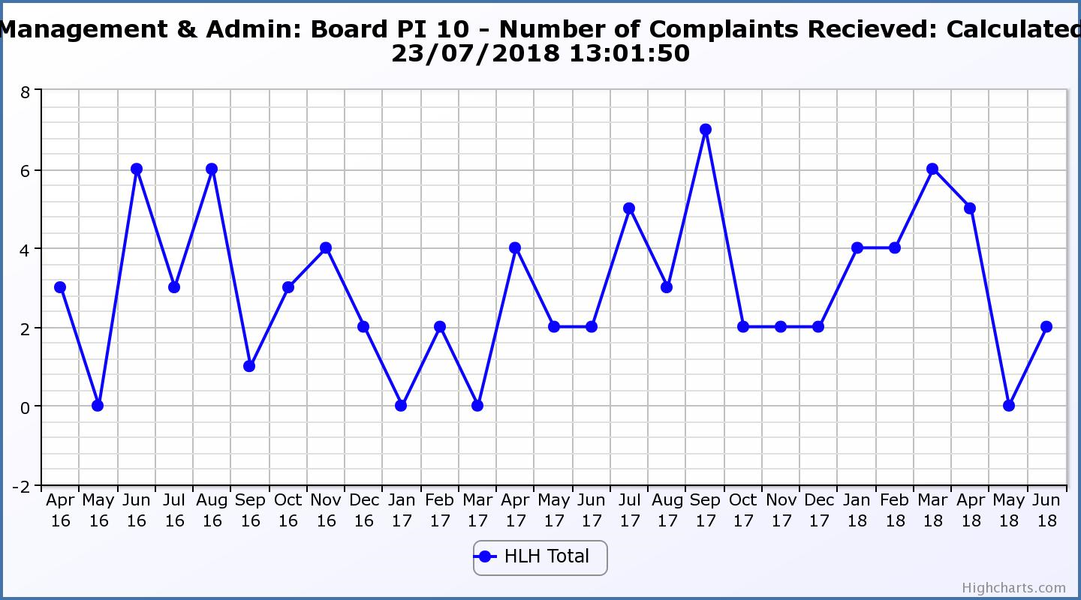
Business Plan Outcome | Performance Indicator | Reporting Frequency | RAG Rating Definition | RAG Rating Q1 18/19 | RAG Rating Q2 18/19 | RAG Rating Q3 18/19 | RAG Rating Q4 18/19 | Summary of Quarter One Performance
7. Sustain a good health and safety performance | 11. Health and safety audit. | Annual. | - Red = the external audit raises systemic (i.e. applying across multiple sites) H&S issues.  - Amber = the external audit highlights common actions to be addressed across the company.  - Green = the external audit does not raise systemic issues. |  |  |  |  | NA. This is an annual indicator.

Business Plan Outcome | Performance Indicator | Reporting Frequency | RAG Rating Definition | RAG Rating Q1 18/19 | RAG Rating Q2 18/19 | RAG Rating Q3 18/19 | RAG Rating Q4 18/19 | Summary of Quarter One Performance
7. Sustain a good health and safety performance  (cont) | 12. RIDDOR accidents/incidents. | Quarterly. | - Red = number of RIDDOR reports per quarter is above 20.  - Amber = number of RIDDOR reports per quarter is between 10 and 20  - Green = number of RIDDOR reports per quarter is less than 10. | Green |  |  |  | There was one RIDDOR reported accident during Q1 2018/19.

Performance Indicator 12 - RIDDOR Accidents
The graph below tracks the number of accidents and incidents reported under the RIDDOR regulations. There was one in Q1 2018/19.
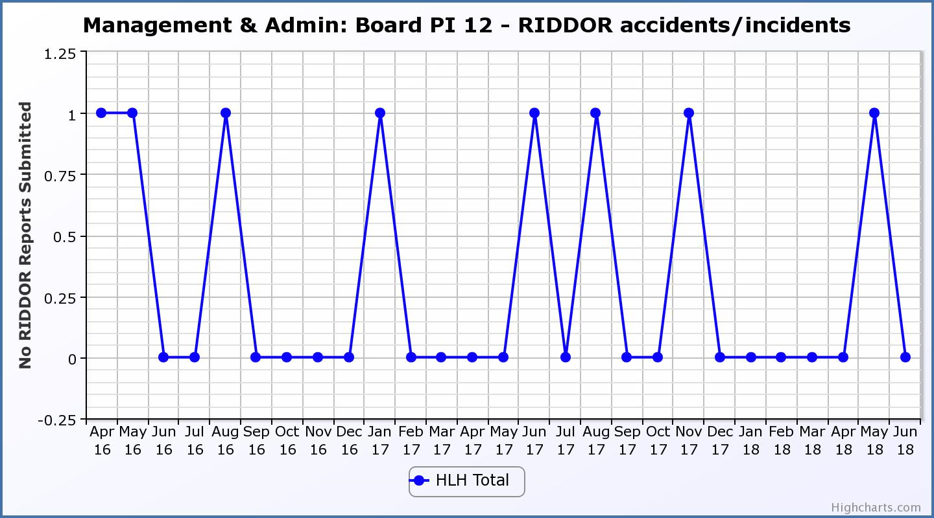
Business Plan Outcome | Performance Indicator | Reporting Frequency | RAG Rating Definition | RAG Rating Q1 18/19 | RAG Rating Q2 18/19 | RAG Rating Q3 18/19 | RAG Rating Q4 18/19 | Summary of Quarter One Performance
8. A trusted partner | 13. THC’s annual survey of performance and attitudes. | Annual. | - Red = all HLH areas of work represented receive lower net satisfaction ratings than the previous year.  - Amber = two or more areas of HLH work receive lower net satisfaction ratings than the previous year.  - Green = net satisfaction ratings are maintained or improved for three or more areas of HLH work compared with the previous year. |  |  |  |  | NA - this is an annual indicator.

