HIGH LIFE HIGHLAND  REPORT TO BOARD OF DIRECTORS  14 June 2018 | AGENDA ITEM REPORT No HLH /18

Performance Report - Report by Chief Executive

Summary

The purpose of this report is to present performance information for the period January to March 2018.

It is recommended Directors:-

- comment on the report and agree that the overall health check on the Company for the period is assessed as green;
- note that the delivery of the business plan is assessed as green; and
- note the information provided on the performance indicators for more detailed consideration.

1. | Business Plan Contribution
1.1 | This report supports all the Business Outcomes from the High Life Highland (HLH) Business Plan:  - To advance sustainable growth and financial sustainability  - Deliver the Service Delivery Contract with THC  - Improving staff satisfaction  - Improving customer satisfaction  - A positive company image  - Services designed around customers and through market opportunities  - Sustain a good health and safety performance  - A trusted partner
2. | Background
2.1 | The performance indicators in this report were set, at the request of the Board, by the Finance and Audit Committee in March 2016. It was agreed then that reporting on the delivery of the business outcomes would be by exception (i.e. reporting where managers had RAG rated the actions “red – no significant progress”).

3. | Summary of Performance
3.1 | Appendix A contains a summary of performance against the performance indicators along with trend information for numeric PIs. There are 12 performance indicators scheduled for assessment at the June 2018 Board meeting, 9 have been RAG rated as “green”; 2 “amber” and one “red”. There is further information below on the PIs which were RAG rated amber which are:  - PI 3 - High Life subscription cancellation rate; and  - PI 10 - Formal complaints.
3.2 | The PI which has been RAG rated red is PI 6, staff absence rates and there is further information on this in the Human Resources report elsewhere on this agenda.
3.3 | The High Life card subscription cancellation rate increased to 5% in March and continued at that level in April. On the other hand, the overall number of subscriptions are at their highest ever level at 21,310. There was a 10% increase in income from High Life subscriptions in 2017/18 compared with the previous year. While both of these figures are positive, the slight increase in cancellation rate points to the need for continued caution on the pricing of the High Life card and the cancellation rate will continue to be closely monitored.
3.4 | There were 14 formal complaints in quarter four. Five were upheld, 2 were partially upheld, 5 were not upheld, one could not be followed up because requests for further detail was not provided and one related to a non-HLH service. The complaints were categorised as follows:  Category No.  Parking 1  Temporary partial closure 1  Programming 4  Member of staff 2  Pricing 1  Heating failure 1  Alleged breach in privacy 1  Sports hall music level 1  Third party discount not honoured 1  Non HLH service 1  Total 14  There were over 2M customer visits in quarter four and given that context the number of complaints is very low. The individual nature/circumstances of the complaints do not indicate any patterns which require company-wide action.
4. | Delivery of Business Outcomes
4.1 | The current HLH Business Plan 2015-19 identifies 8 business outcomes and the approach which the charity takes to deliver them. The resultant Operational Plans for each of the 9 HLH areas of work are RAG rated every quarter.
4.2 | The RAG ratings of the operational plans has identified that delivery of the Business Plan is on target. Five of the 9 areas of HLH work RAG rated all of the actions “green – on target” or complete; 2 areas of work RAG rated 2 actions as “amber – some slippage”; and another 2 areas of work RAG rated 4 actions as “amber - some slippage”. Directors have agreed that reporting on the delivery of the business outcomes would be by exception (i.e. reporting where managers had RAG rated the actions “red – no significant progress”) and there have been no actions which have been RAG rated “red” in quarter four 2017/18.
5. | Performance Indicators for More Detailed Consideration
5.1 | The performance indicators scheduled for more detailed consideration in this report are:  - PI 4 - Delivery of the Service Delivery Contract (SDC) with The Highland Council (THC).  - PI 8 - Customer Numbers.  - PI 9 - Media clippings.  - PI 11 - Health and safety audit.  - PI 12 - RIDDOR accidents/incidents.
5.2 | PI 4 - Delivery of the SDC with THC - There is a 6 monthly HLH update report to THC’s Care, Learning and Housing Committee which presents information on the performance of HLH, provides general updates and information on one aspect of the work of HLH. The report to the 30 May 2018 committee meeting can be seen in full elsewhere on this agenda. At the meeting the Committee agreed that HLH had met or exceeded the outcomes expected in the Service Delivery Contract with the Council for the operating period to March 2018 and there was a range of positive contributions from Members on the work of HLH.
5.3 | PI 8 - Customer Visits - Customer visits have been increasing year on year since HLH was established (October 2011) as can be seen in the graph below. There were 7.4 million customer visits to HLH services last year. The average customer number increase over the past 3 years (excluding Inverness Leisure to allow a consistency of comparison) has been 12% or 0.6M visits per year.
5.4 | A breakdown of customer numbers by the 9 HLH areas of work for 2016/17 and 2017/18 can be seen below. Customer numbers increased across most areas and a summary is provided for each below.  Service 2016/17 2017/18 Difference % Change  Adult Learning 13,631 12,895 -736 -5%  Archives 584,629 797,653 213,024 36%  Arts 9,580 5,357 -4,223 -44%  Leisure Facilities 2,673,966 2,776,495 102,529 4%  Libraries 2,748,493 3,016,369 267,876 10%  Museums 194,811 286,903 92,092 47%  Outdoor Activities 894 6,443 5,549 621%  Sports Development 484,004 466,108 -17,896 -4%  Youth Work 84,395 78,225 -6,170 -7%  Total 6,794,403 7,446,448 652,045 10%  - Adult Learning (Literacy, Numeracy and English for Speakers of Other Languages (ESOL)) attendances reduced because there were 2 staff vacancies (out of 5 staff) throughout the year which proved difficult to fill. The remaining posts all saw increases in customer attendances. All posts have since been filled.  - Archives customer numbers increased primarily due to an increase in the number of visits to and engaged users of the Am Baile Highland History and Culture web site.  - Arts customer visits are to the 2 galleries in Thurso and Wick. The number of visits in Wick have reduced following the archive centre and library moving out of what was a shared facility leaving only the art gallery in the building.  - Leisure Facilities customer visits increased across the range of leisure and community centres operated by HLH with the new facilities in Thurso and Wick performing well.  - Libraries customer visits in person and on-line increased and this is largely due to the range of activities and events run by staff.  - Museums visits in person and uses by other means increased at both sites. Part of the increase (27,825 visits) was due to the success of the Castle Viewpoint which opened in April 2017.  - Outdoor Activities customer visits were similar to 2016/17. The increase in visits seen in the table above is attributable to the transfer of the Countryside Rangers from THC to HLH.  - Sports Development customer visits decreased slightly due to staff vacancies. While customer visits decreased, the number of distinct participants, which is a key performance measure for sportscotland, increased slightly.  - Youth Work attendances reduced compared with 2016/17. Learning hours, however, increased and this is reflective of the team responding to the policy direction set by the Council and community planning partners of focusing on doing more work with the young people who will benefit most from the service.
5.5 | PI 9 - Media clippings – there is further information on this PI in the Marketing report elsewhere on this Agenda.
5.6 | PIs 11 and 12 - Health and Safety Audit and RIDDOR accidents/incidents - there is further information on these PIs in the Health and Safety and Environmental Compliance report elsewhere on this agenda.
6. | Audit Scotland Report on ALEOs
6.1 | An Audit Scotland report on Councils’ use of Arm’s-Length Organisations (ALEOs) was published on 17 May 2018. The report provides an overview of local authority use of ALEOs including their governance and achievements. The Chief Executive of HLH participated as part of the consultative group for the report as a representative of the national body for ALEOs, SPORTA.
6.2 | The report looked at 4 elements: the reasons for using ALEOs, how councils oversee and govern them, what they have achieved along with the future direction of ALEOs. The recommendations focused on the need for options appraisals to ensure value for money, especially with the Non Domestic Rates relief changes brought about by the Barclay report; ALEOs contribution to achievement of councils’ objectives and priorities; along with risk and performance management. The report concludes that councils must keep ALEOs under review and consider alternatives. Mention of HLH within the report is positive. The full report can be found via Councils_use_of_arms-length_organisations.pdf
7. | Implications
7.1 | Resource Implications – there are no additional resource implications arising from this report.
7.2 | Legal Implications - there are no new legal implications arising from this report.
7.3 | Risk Implications – there are no new risk implications arising from this report.

Recommendation

It is recommended Directors:-

- comment on the report and agree that the overall health check on the Company for the period is assessed as green;
- note that the delivery of the business plan is assessed as green; and
- note the information provided on the performance indicators for more detailed consideration.

Designation: Chief Executive

Date: Draft 31 May 2018
Appendix A
HLH Performance Indicators

Business Plan Outcome | Performance Indicator | Reporting Frequency | RAG* Rating Definition  (*Red/Amber/Green) | RAG Rating Q1 17/18 | RAG Rating Q2 17/18 | RAG Rating Q3 17/18 | RAG Rating Q4 17/18 | Summary of Quarter Four Performance
1. To advance sustainable growth and financial sustainability | 1. Financial monitoring. | Quarterly. | An assessment of the year end outturn where:  - Red = delivery of the SDC over budget above 2%.  - Amber = delivery of the SDC between break-even and 2% over budget.  - Green = delivery of SDC within budget. | Green | Green | Green | Green | The variance to budget up to the end of quarter four was £160,068* so the SDC will be delivered within budget for financial year 2017/18. See the Finance Report elsewhere on this agenda for further information.  * Unaudited figure

Performance Indicator 1 - Financial monitoring, variance to budget per quarter.
See the Finance Report elsewhere on this agenda for further information.

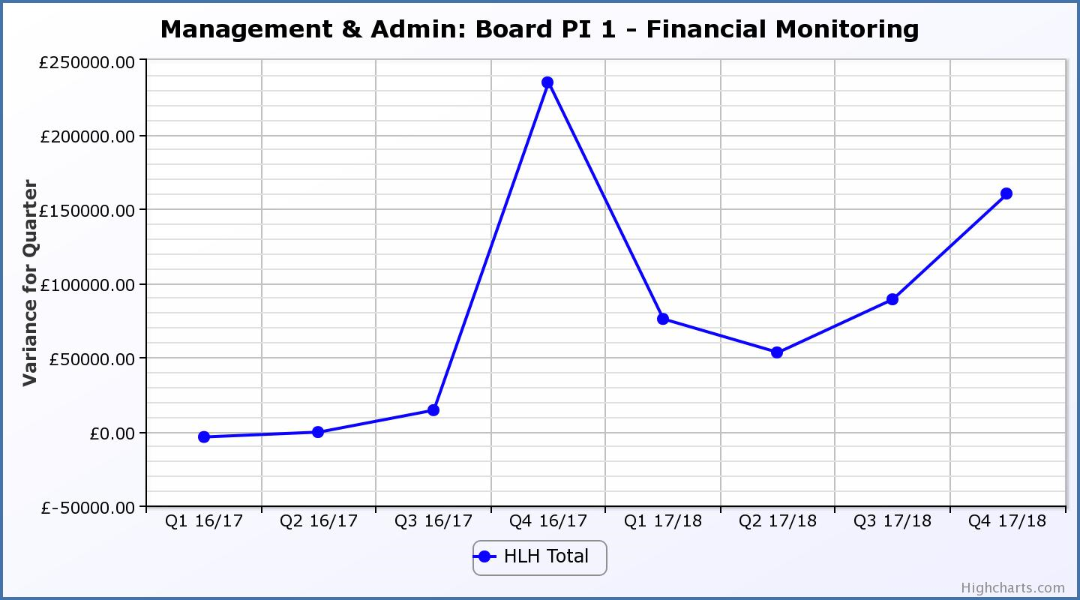
Business Plan Outcome | Performance Indicator | Reporting Frequency | RAG Rating Definition | RAG Rating Q1 17/18 | RAG Rating Q2 17/18 | RAG Rating Q3 17/18 | RAG Rating Q4 17/18 | Summary of Quarter Four Performance
1. To advance sustainable growth and financial sustainability (cont) | 2. Number of High Life subscriptions. | Quarterly. | - Red = more than 5% below target.  - Amber = up to 5% below target.  - Green = on or exceeds target. | Green | Green | Green | Green | The number of subscriptions each month during Q4 exceeded the target of 19,000 with the average number of subscriptions for the quarter having been 20,908. The target has been set at the level required to achieve the High Life Subscriptions income target.

Performance Indicator 2 - Number of High Life Subscriptions
The number of High Life Card subscriptions continues to increase and in April, further increased to 21,310.

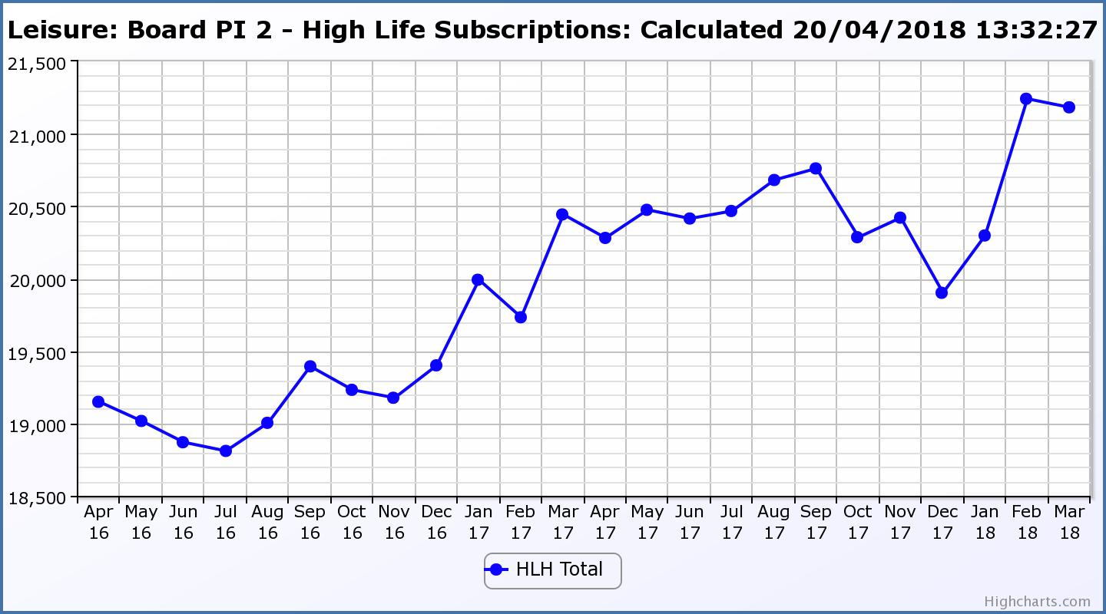

Business Plan Outcome | Performance Indicator | Reporting Frequency | RAG Rating Definition | RAG Rating Q1 17/18 | RAG Rating Q2 17/18 | RAG Rating Q3 17/18 | RAG Rating Q4 17/18 | Summary of Quarter Four Performance
1. To advance sustainable growth and financial sustainability (cont) | 3. High Life cancellation rate. | Quarterly. | - Red = cancellation rate above 6% of High Life memberships.  - Amber = cancellation rate is 3% - 6% of High Life memberships.  - Green = cancellation rate is up to 3% of High Life memberships. | Amber | Amber | Green | Amber | The High Life cancellation rates in Q4 were 2% in January, 4% in February and 5% in March.  The overall number of subscriptions has increased but this PI is being monitored.

Performance Indicator 3 - High Life Cancellation Rate
While the overall number of subscriptions has increased, this PI is being monitored as the cancellation rate continued at 5% in April.
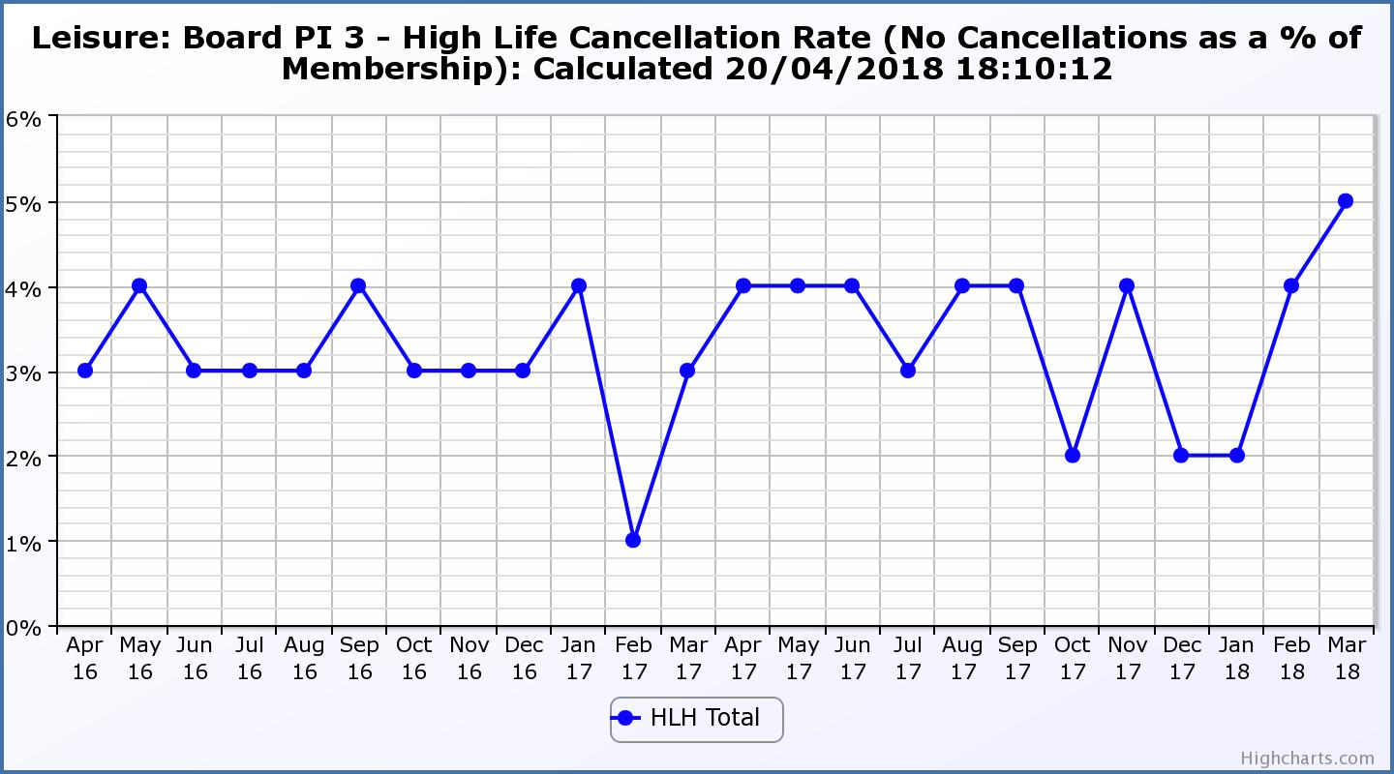

Business Plan Outcome | Performance Indicator | Reporting Frequency | RAG Rating Definition | RAG Rating Q1 17/18 | RAG Rating Q2 17/18 | RAG Rating Q3 17/18 | RAG Rating Q4 17/18 | Summary of Quarter Four Performance
2. Deliver the Service Delivery Contract with THC | 4. Delivery of the Service Delivery Contract (SDC) with The Highland Council (THC). | Six-monthly. | - Red = agreement of THC’s ECAS Committee that HLH has not met the terms of the SDC.  - Amber = agreement of THC’s ECAS Committee that HLH has met the terms of the SDC but has set some improvement targets.  - Green = agreement of THC’s ECAS Committee that HLH has met or exceeded the terms of the SDC. |  | Green |  | Green | At its meeting held on 30 May 2018 THC’s Care, Learning and Housing Committee agreed that High Life Highland had met or exceeded the outcomes expected in the Service Delivery Contract with the Council for the operating period to March 2018.

Business Plan Outcome | Performance Indicator | Reporting Frequency | RAG Rating Definition | RAG Rating Q1 17/18 | RAG Rating Q2 17/18 | RAG Rating Q3 17/18 | RAG Rating Q4 17/18 | Summary of Quarter Four Performance
3. Improving staff satisfaction | 5. Staff turnover (resignations as a percentage of posts). | Quarterly. | - Red = more than 2%  - Amber = 1.7 to 2%  - Green = 1.6% or less | Green | Green | Green | Green | The number of resignations per month as a percentage of posts in Q4 was 0.6% in January, 0.7% in February and 0.8% in March.

Performance Indicator 5 - Staff Turnover (resignations as a percentage of posts)
The graph below shows resignations as a percentage of the number of posts and resignations have been consistent with previous years and continue to be low (1% equates to 10.6 staff).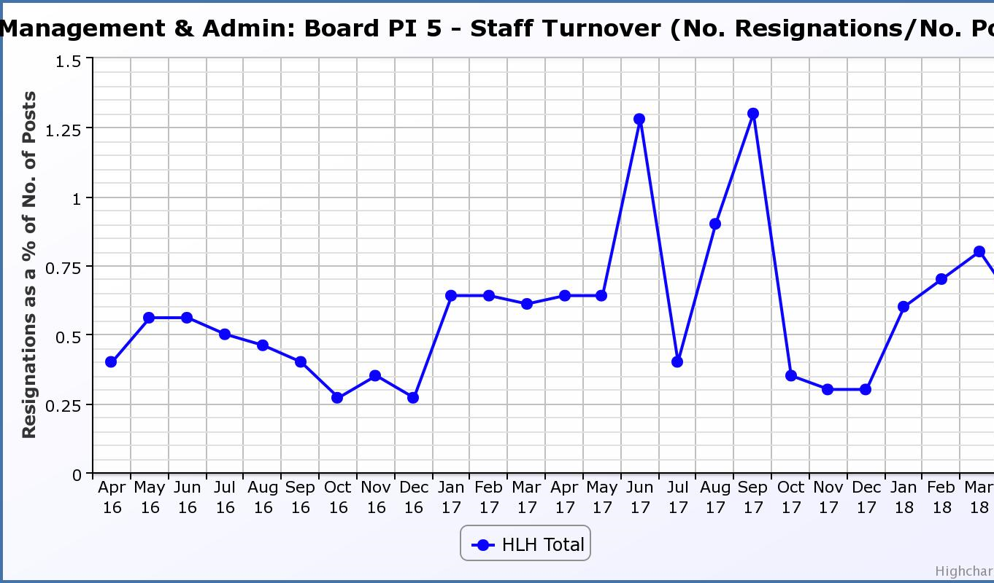
Business Plan Outcome | Performance Indicator | Reporting Frequency | RAG Rating Definition | RAG Rating Q1 17/18 | RAG Rating Q2 17/18 | RAG Rating Q3 17/18 | RAG Rating Q4 17/18 | Summary of Quarter Four Performance
3. Improving staff satisfaction (cont.) | 6. Staff absence rates. | Quarterly. | - Red = absence rate greater than 3.6%.  - Amber = absence rate between 3.4% and 3.6%.  - Green = absence rate 3.3% or less. | Amber | Amber | Red | Red | The absence rate for Q4 was 4.02%. Please see the HR report elsewhere on this agenda for further information.

Performance Indicator 6 - Staff Absence Rates
Following the absence rate reducing in the first two quarters in 2017/18 it increased in quarters three and four. Please see the HR report elsewhere on this agenda for further information. 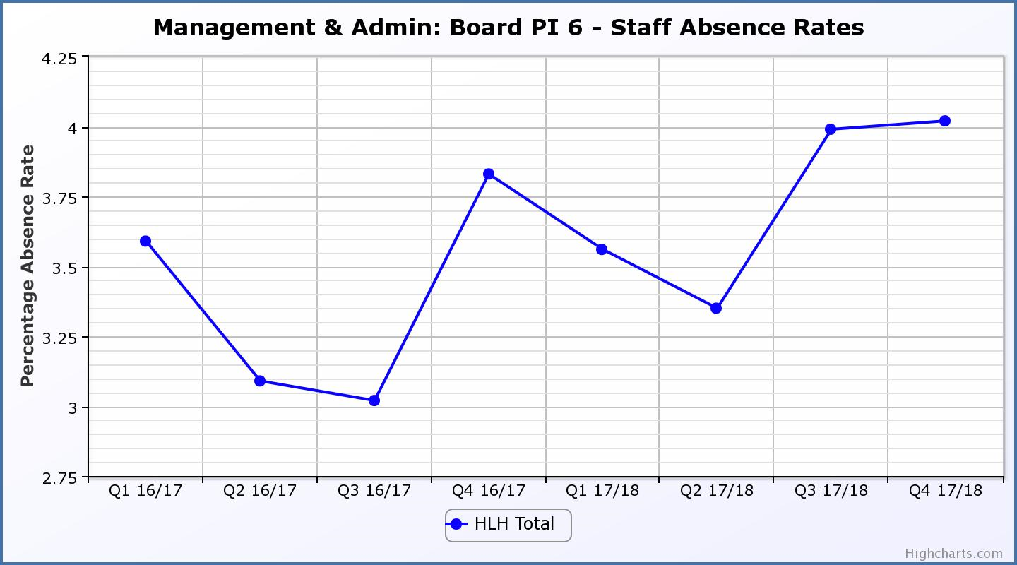

Business Plan Outcome | Performance Indicator | Reporting Frequency | RAG Rating Definition | RAG Rating Q1 17/18 | RAG Rating Q2 17/18 | RAG Rating Q3 17/18 | RAG Rating Q4 17/18 | Summary of Quarter Four Performance
4. Improving customer satisfaction | 7. Customer surveys. | Quarterly. | - Red = no staff surveys have been completed or scheduled.  - Amber = 4 to 8 of the HLH areas of work have completed or scheduled customer surveys.  - Green = all areas of HLH work have completed or scheduled customer surveys. | Green | Green | Green | Green | All areas of work included customer surveys in their operational plans for 2017/18.

Business Plan Outcome | Performance Indicator | Reporting Frequency | RAG Rating Definition | RAG Rating Q1 17/18 | RAG Rating Q2 17/18 | RAG Rating Q3 17/18 | RAG Rating Q4 17/18 | Summary of Quarter Four Performance
4. Improving customer satisfaction (cont) | 8. Customer Numbers. | Quarterly. | - Red = customer numbers are more than 5% lower than the corresponding quarter in the previous year.  - Amber = customer numbers are less than the corresponding quarter in the previous year.  - Green = customer numbers are the same as or have increased compared with the corresponding quarter in the previous year. | Green | Green | Green | Green | Customer numbers increased from 1,942,902 in Q4 2016/17 to 2,037,154 in Q4 2017/18.

Performance Indicator 8 - Customer Numbers
The graph below shows a year on year increase in customer numbers
.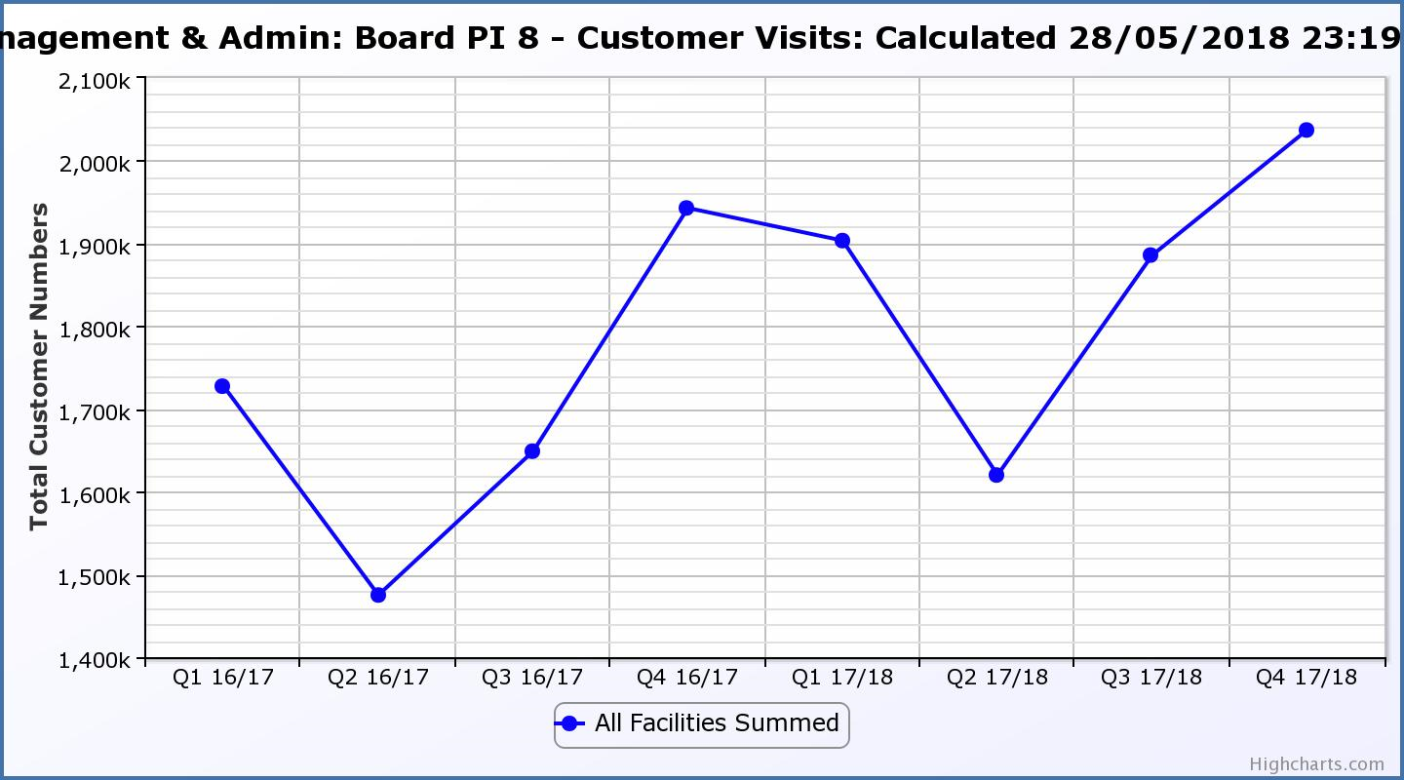

Business Plan Outcome | Performance Indicator | Reporting Frequency | RAG Rating Definition | RAG Rating Q1 17/18 | RAG Rating Q2 17/18 | RAG Rating Q3 17/18 | RAG Rating Q4 17/18 | Summary of Quarter Four Performance
5. A positive company image | 9.Media clippings. | Quarterly | - Red = number of negative press clippings outweigh neutral and positive.  - Amber = number of negative and neutral press clippings outweigh positive.  - Green = number of positive and neutral media clippings outweigh negative. | Green | Green | Green | Green | Positive media clippings for Q4 totalled 52 with there having been 10 which were neutral and 14 which were negative.

Performance Indicator 9 - Media Clippings
The following two graphs show the numbers of positive and neutral media clippings compared with negative. The positive and neutral outweigh the negative.

Business Plan Outcome | Performance Indicator | Reporting Frequency | RAG Rating Definition | RAG Rating Q1 17/18 | RAG Rating Q2 17/18 | RAG Rating Q3 17/18 | RAG Rating Q4 17/18 | Summary of Quarter Four Performance
5. A positive company image (cont.) | 10. Formal complaints. | Quarterly. | - Red = 21 or more complaints per quarter.  - Amber = 11 to 20 complaints per quarter.  - Green = 10 complaints or fewer per quarter. | Green | Amber | Green | Amber | There were 14 complaints received during Q4 2017/18. Please see paragraph 3.4 of this report for further information.

Performance Indicator 10 - Formal Complaints
The graph below shows the number of complaints which continue to be very low in relation to customer numbers.

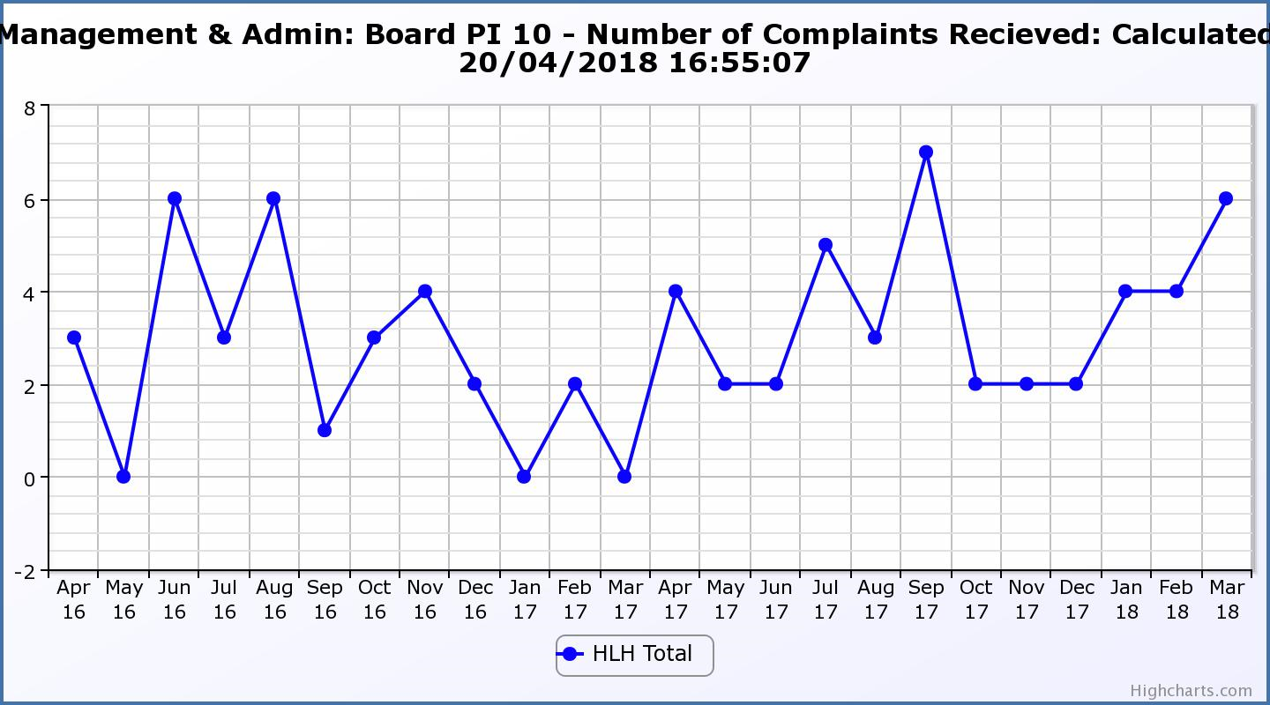
Business Plan Outcome | Performance Indicator | Reporting Frequency | RAG Rating Definition | RAG Rating Q1 17/18 | RAG Rating Q2 17/18 | RAG Rating Q3 17/18 | RAG Rating Q4 17/18 | Summary of Quarter Four Performance
7. Sustain a good health and safety performance | 11. Health and safety audit. | Annual. | - Red = the external audit raises systemic (i.e. applying across multiple sites) H&S issues.  - Amber = the external audit highlights common actions to be addressed across the company.  - Green = the external audit does not raise systemic issues. |  | Green |  | Green | The annual external safety audit in 2017/18 examined several sites and there were no company-wide issues identified during the audits. Please see the Health and Safety and Environmental Compliance report elsewhere on this agenda for further information.

Business Plan Outcome | Performance Indicator | Reporting Frequency | RAG Rating Definition | RAG Rating Q1 17/18 | RAG Rating Q2 17/18 | RAG Rating Q3 17/18 | RAG Rating Q4 17/18 | Summary of Quarter Four Performance
7. Sustain a good health and safety performance  (cont) | 12. RIDDOR accidents/incidents. | Quarterly. | - Red = number of RIDDOR reports per quarter is above 20.  - Amber = number of RIDDOR reports per quarter is between 10 and 20  - Green = number of RIDDOR reports per quarter is less than 10. | Green | Green | Green | Green | There was no RIDDOR reported accident during Q4 2017/18. Please see the Health and Safety and Environmental Compliance report elsewhere on this agenda for further information.

Performance Indicator 12 - RIDDOR Accidents
The graph below tracks the number of accidents and incidents reported under the RIDDOR regulations. There were none in Q4 2017/18.
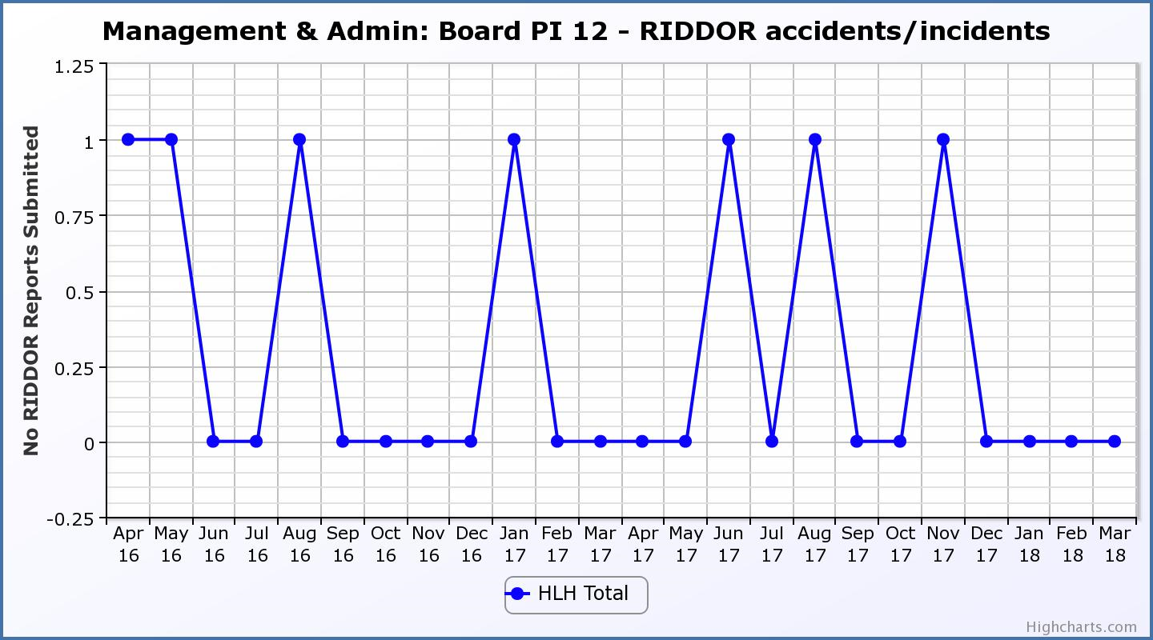
Business Plan Outcome | Performance Indicator | Reporting Frequency | RAG Rating Definition | RAG Rating Q1 17/18 | RAG Rating Q2 17/18 | RAG Rating Q3 17/18 | RAG Rating Q4 17/18 | Summary of Quarter Four Performance
8. A trusted partner | 13. THC’s annual survey of performance and attitudes. | Annual. | - Red = all HLH areas of work represented receive lower net satisfaction ratings than the previous year.  - Amber = two or more areas of HLH work receive lower net satisfaction ratings than the previous year.  - Green = net satisfaction ratings are maintained or improved for three or more areas of HLH work compared with the previous year. |  | Green |  |  | NA – this is an annual indicator.

