HIGH LIFE HIGHLAND  REPORT TO BOARD OF DIRECTORS  21 June 2012 | AGENDA ITEM 6 REPORT No HLH 12/12
GOOD NEWS ITEMS - Report by Chief Executive

Summary

The purpose of this report is to present a sample selection of items which represent the successful work being carried out by High Life Highland throughout the Highlands and across all areas of work.

It is recommended that Directors note and comment on the good news items presented.

1. | Background
1.1 | High Life Highland (HLH) staff were invited to submit good news stories which represented the successful outcomes of their work over the past three months.
1.2 | 35 good news items were submitted by staff detailing the successes and good practices being delivered. A list of all submissions is attached as Appendix A.
1.3 | Some examples of these submissions are attached at Appendix B. These examples have been selected to present to Directors the range of standard and service being provided by HLH.
1.4 | All good news items submitted will, in due course, be available for viewing on the HLH website and social networking sites.

Recommendation

It is recommended that Directors note and comment on the good news items presented.

Signature:

Designation: Chief Executive

Date: 29 May 2012

APPENDIX A
AREA OF WORK | TITLE
Adult Learning | Highland Celebration of Learning Event
 | Literacy & Numeracy Skills through Art of Craft
 | Read to Lead
 | Funding Saves Life of Lamb
Archives | Beltane Project
Arts/Community Centre | Craigmonie Centre – A Sporting Chance
Arts | Inverness Museum & Art Gallery – A Dog’s Life
Community Centres | Hilton Community Centre – Strawberry Fayre
 | Merkinch Community Centre – Celebration of Learners
Health & Wellbeing | Puddle Jumpers
Leisure | Torch Triathlon’s Super Success
Libraries | Digital Days – Dingwall
 | Portree Community Library – Digital Inclusion
Museums | Inverness Museum & Art Gallery – “Room to Discover”
Sport | European Football Tournament for Learning Disabilities
 | Sports Leaders - Ardnamurchan
 | Brora Rangers Initiative
 | Fort William Rugby Development and Festival
 | Gairloch Primary Basketball
 | Gairloch Primary Cross Country
 | Grantown Cluster Rugby
 | Grantown Golf
 | Grantown Netball
 | Grantown Sports Relief
 | East Caithness Golf
 | Nairn – Sports Leader of the Year 2012
 | Caithness RFC Rugby Tag Festival
 | Active Schools Coordinator wins UK Freeride Event
 | Ballachulish Junior Golf Festival
 | Farr First Club Golf Training
Sport/Leisure | Grantown – HMIE Learning Community Inspection
Youth | Fusion 2012 - Ardnamurchan
 | Welcome to Scotland – Black Isle
 | Asdan Bronze Award – Culloden
 | Get to Know Your Techno - Ullapool

*See Appendix B

APPENDIX B

Area of work (e.g. Arts) | Adult Learning (Literacies Partnership)
Location | Inverness (Highland wide attendance)
Title of piece of work | Highland Celebration of Learning Event
Description of event  (the purpose / targets) | The event offered short fun taster workshops throughout the day to attract new learners into provision and offer current learners options for further learning and progression.  A “marketplace” allowed providers in the Partnership to display the learning opportunities they could offer and to speak with potential learners face to face.  Highland Libraries displayed the e-readers and i-pads they will soon be deploying.  Lead Scotland demonstrated the use of Adobe Connect as a means of delivering distance learning.  The newly formed Learners’ Forum were given a platform to explain what they are doing.  An evening awards ceremony recognised the achievement of literacies learners and the contribution of tutors. There was also a presentation of prizes and certificates to winners in the recent Writing Competition.
Which staff were / are involved | Organised by Mary Rhind (HLH), Sue Mitchell (WEA), Mark Richardson and Conrad Gwyther (HLH), and Margot Henderson, Reader in Residence with Highland Libraries.
What were the results /  numbers involved /  Feedback | Over 150 people attended throughout the day, 8 organisations displayed, 37 received prizes & certificates for writing, 8 learners for achievement, 12 tutors for contribution to learning & 7 learner groups (total of 53 learners) for achievement.  All thought excellent and want a bigger event next year!
Writing competition winning entries can be found at  www.Icandothat.info  Click on Competition 2012 at top of home page | 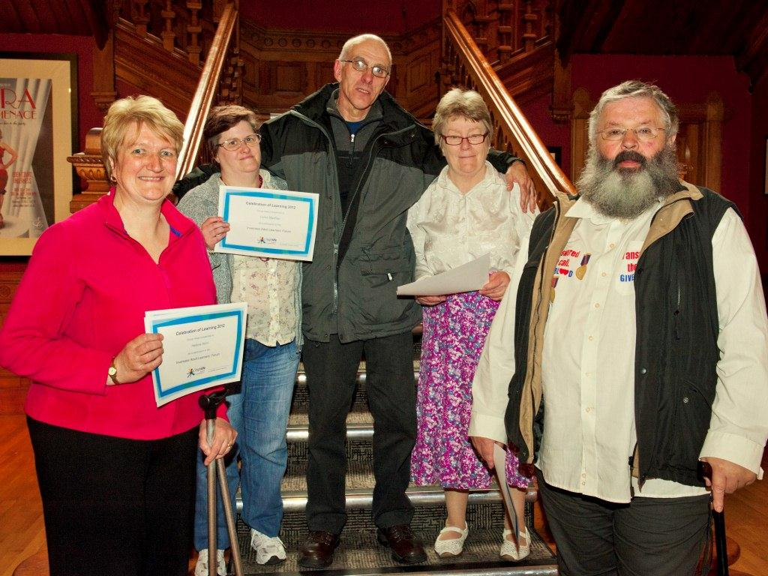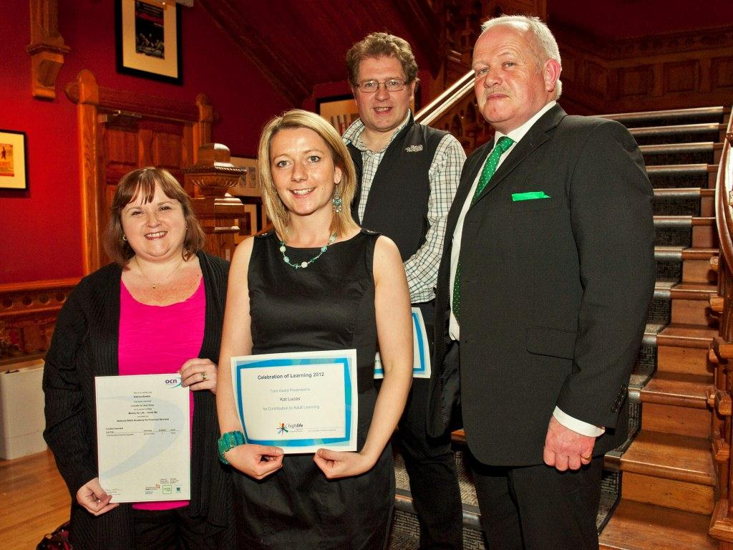  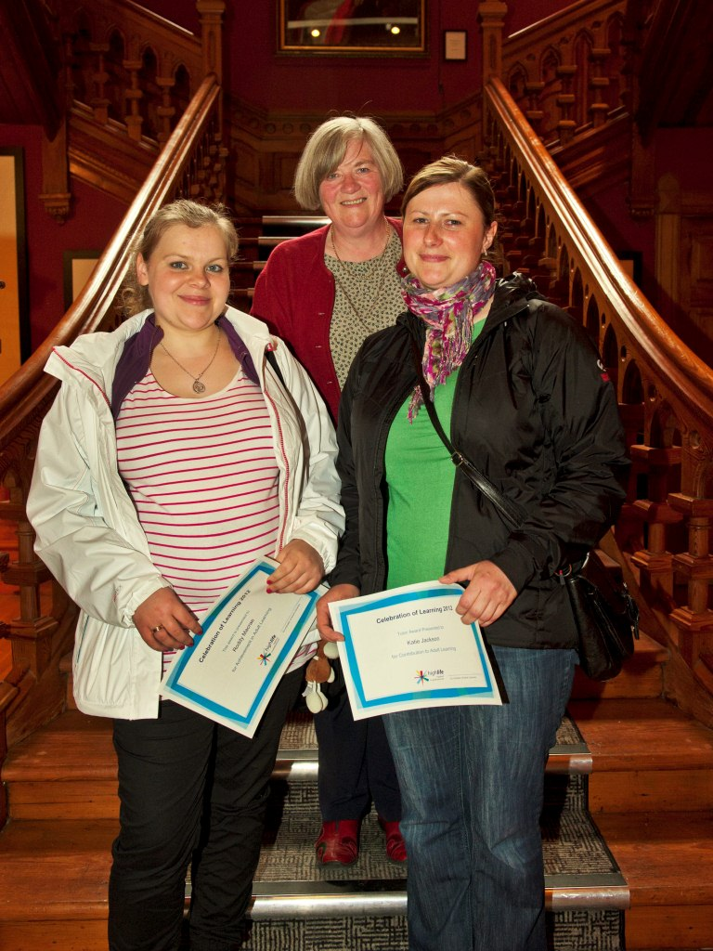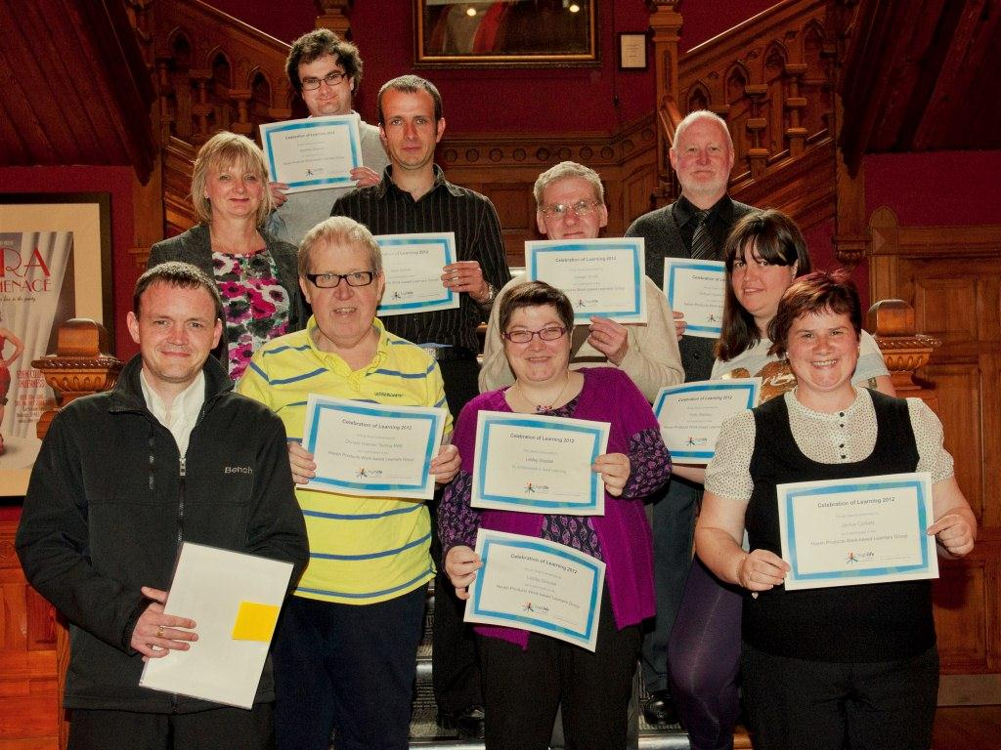  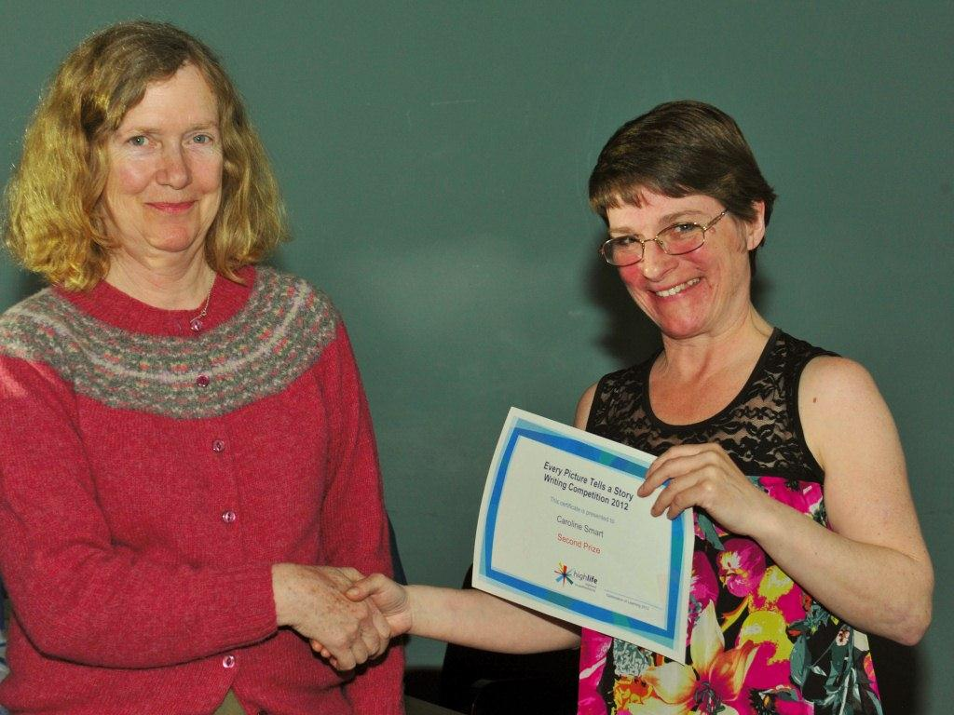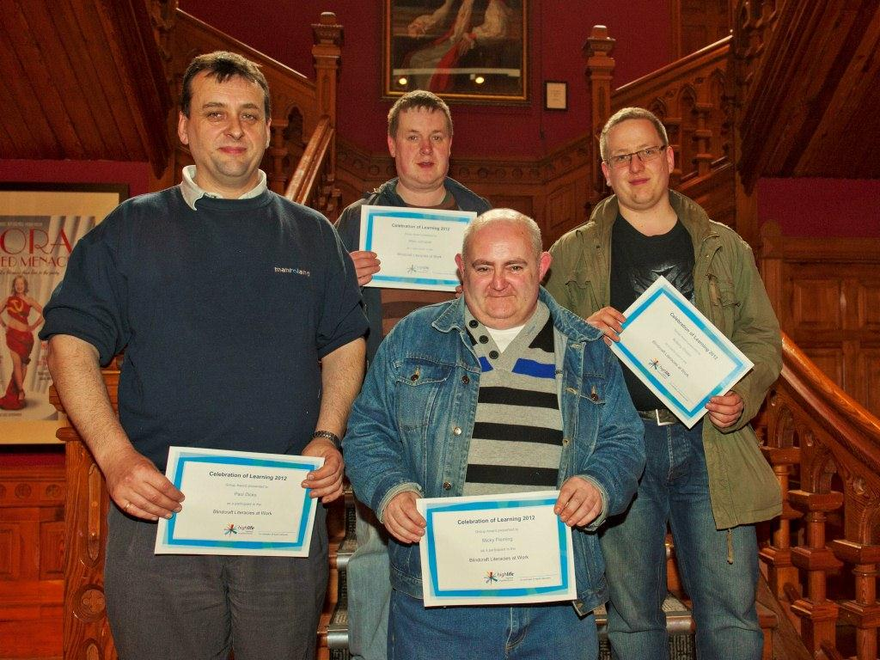
Name & email of staff member submitting news item | Mary Rhind  mary.rhind@highlifehighland.com

Area of work (e.g. Arts) | Adult Learning
Location | Auchtertyre
Title of piece of work | Using Literacy and Numeracy Skills through the art of craft
Description of event  (the purpose / targets) | This project targeted young mums to encourage the use of crafts in Family Literacy learning i.e. following a pattern, instructions, measuring, working with colours and to show an alternative use to recycling old clothes.
Which staff were / are involved | ABE Co-ordinator for Skye and Lochalsh, 1 HLH Clerical, 2 Nursery Staff and Local Primary Head teacher
What were the results /  numbers involved /  Feedback | 31 Rag Rug Xmas Wreaths were made, 3 Mums made Christmas Cards, 2 Mums hand knitted mitts, 2 Mums made a nappy cake. All improved their own literacy and numeracy skills and learnt how they could do similar craft things to develop these skills with their children.  10 adults attended the 6 week class and 21 children came from the local Primary School.
Attach photos or web links | Joey Graham Adult Learning Co-ordinator and learner  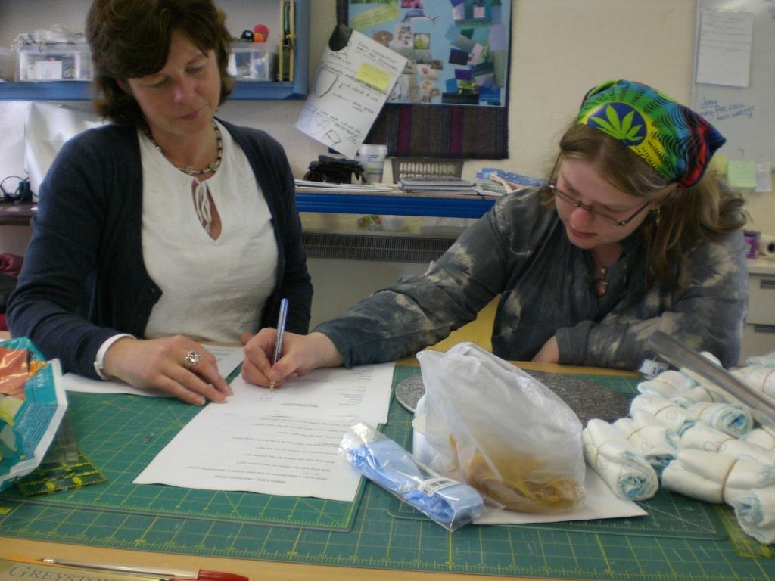  A Craft class in action  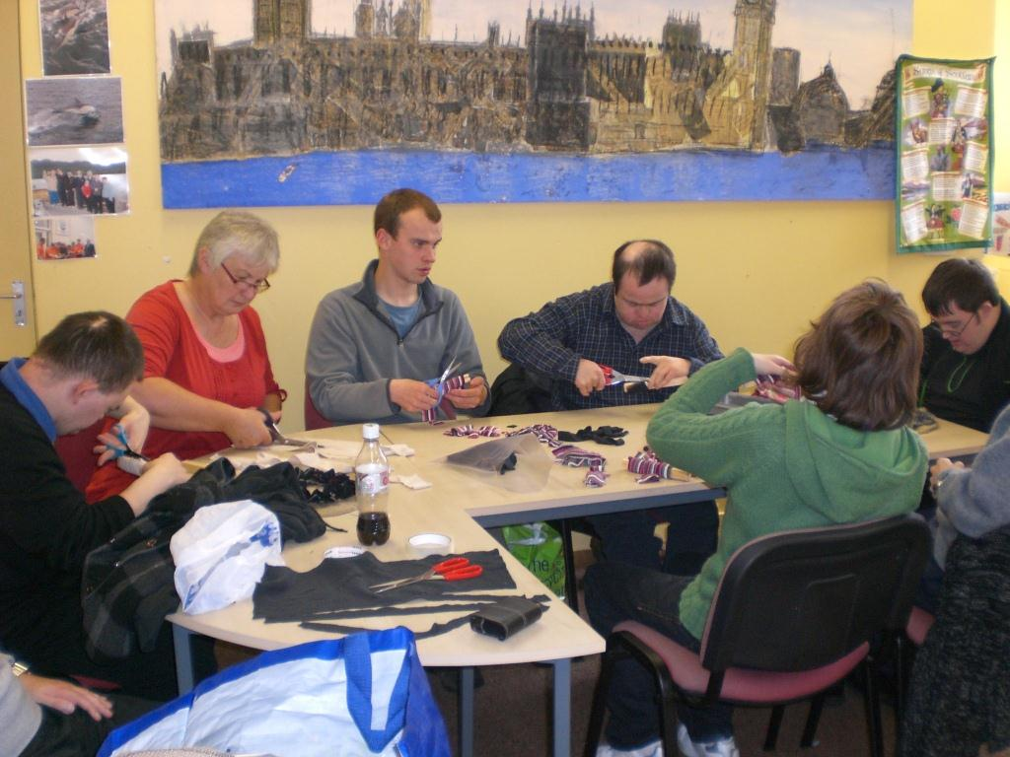
Name & email of staff member submitting news item | Joey Graham, Adult Learning Co-ordinator

Area of work (e.g. Arts) | Adult Learning
Location | Ardnamurchan
Title of piece of work | Adult Learning Funding Saves Life of Lamb in Kilchoan
Description of event  (the purpose / targets) | High Life Highland commissions adult learning classes across Highland. Partner organisations consult their communities and tailor courses to suit local needs. In Ardnamurchan a series of rural skills workshops have been delivered. They have been popular and successful, as this story exemplifies.  Just before Easter an email was received from the Kilchoan Learning Centre Manager with a web-link for a local crofter’s blog.  The story she was referring to was entitled "Back from the Dead" and recounted how the crofter brought a lamb back to life using a technique he had only learned the previous weekend on a lambing course funded by High Life Highland. Without the knowledge the crofter had learnt the lamb would certainly have died, instead it made a full recovery. Below is an extract from the website:  Tuesday 3 April: Back from the Dead.  Last week was balmy, 20C plus. Then last night we had wind sleet, rain and snow; the worst possible weather for young lambs, they soon become hypothermic. After breakfast today Nan, a neighbour who has ewes in the field next to ours, arrived at the back door with a lifeless cold lamb that couldn't hold its head up. It needed treatment and intensive care. We gave it a glucose injection then dried it off, wrapped it in a blanket with a hot water bottle and put it in front of the Rayburn. Next when it looked a bit stronger I put in a stomach tube and fed it some milk. It was still shivering, but had a 50/50 chance of surviving. It certainly wouldn't have lasted long out in the field.
Which staff were / are involved | HLH Adult Learning Strategy Officer / Kilchoan Learning Centre Staff and Tutors
What were the results /  numbers involved /  Feedback | 15 people participated in the workshop. Feedback was very positive and two thirds of the participants indicated that they would like to take further courses and classes.
Attach photos or web links | 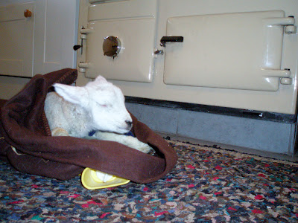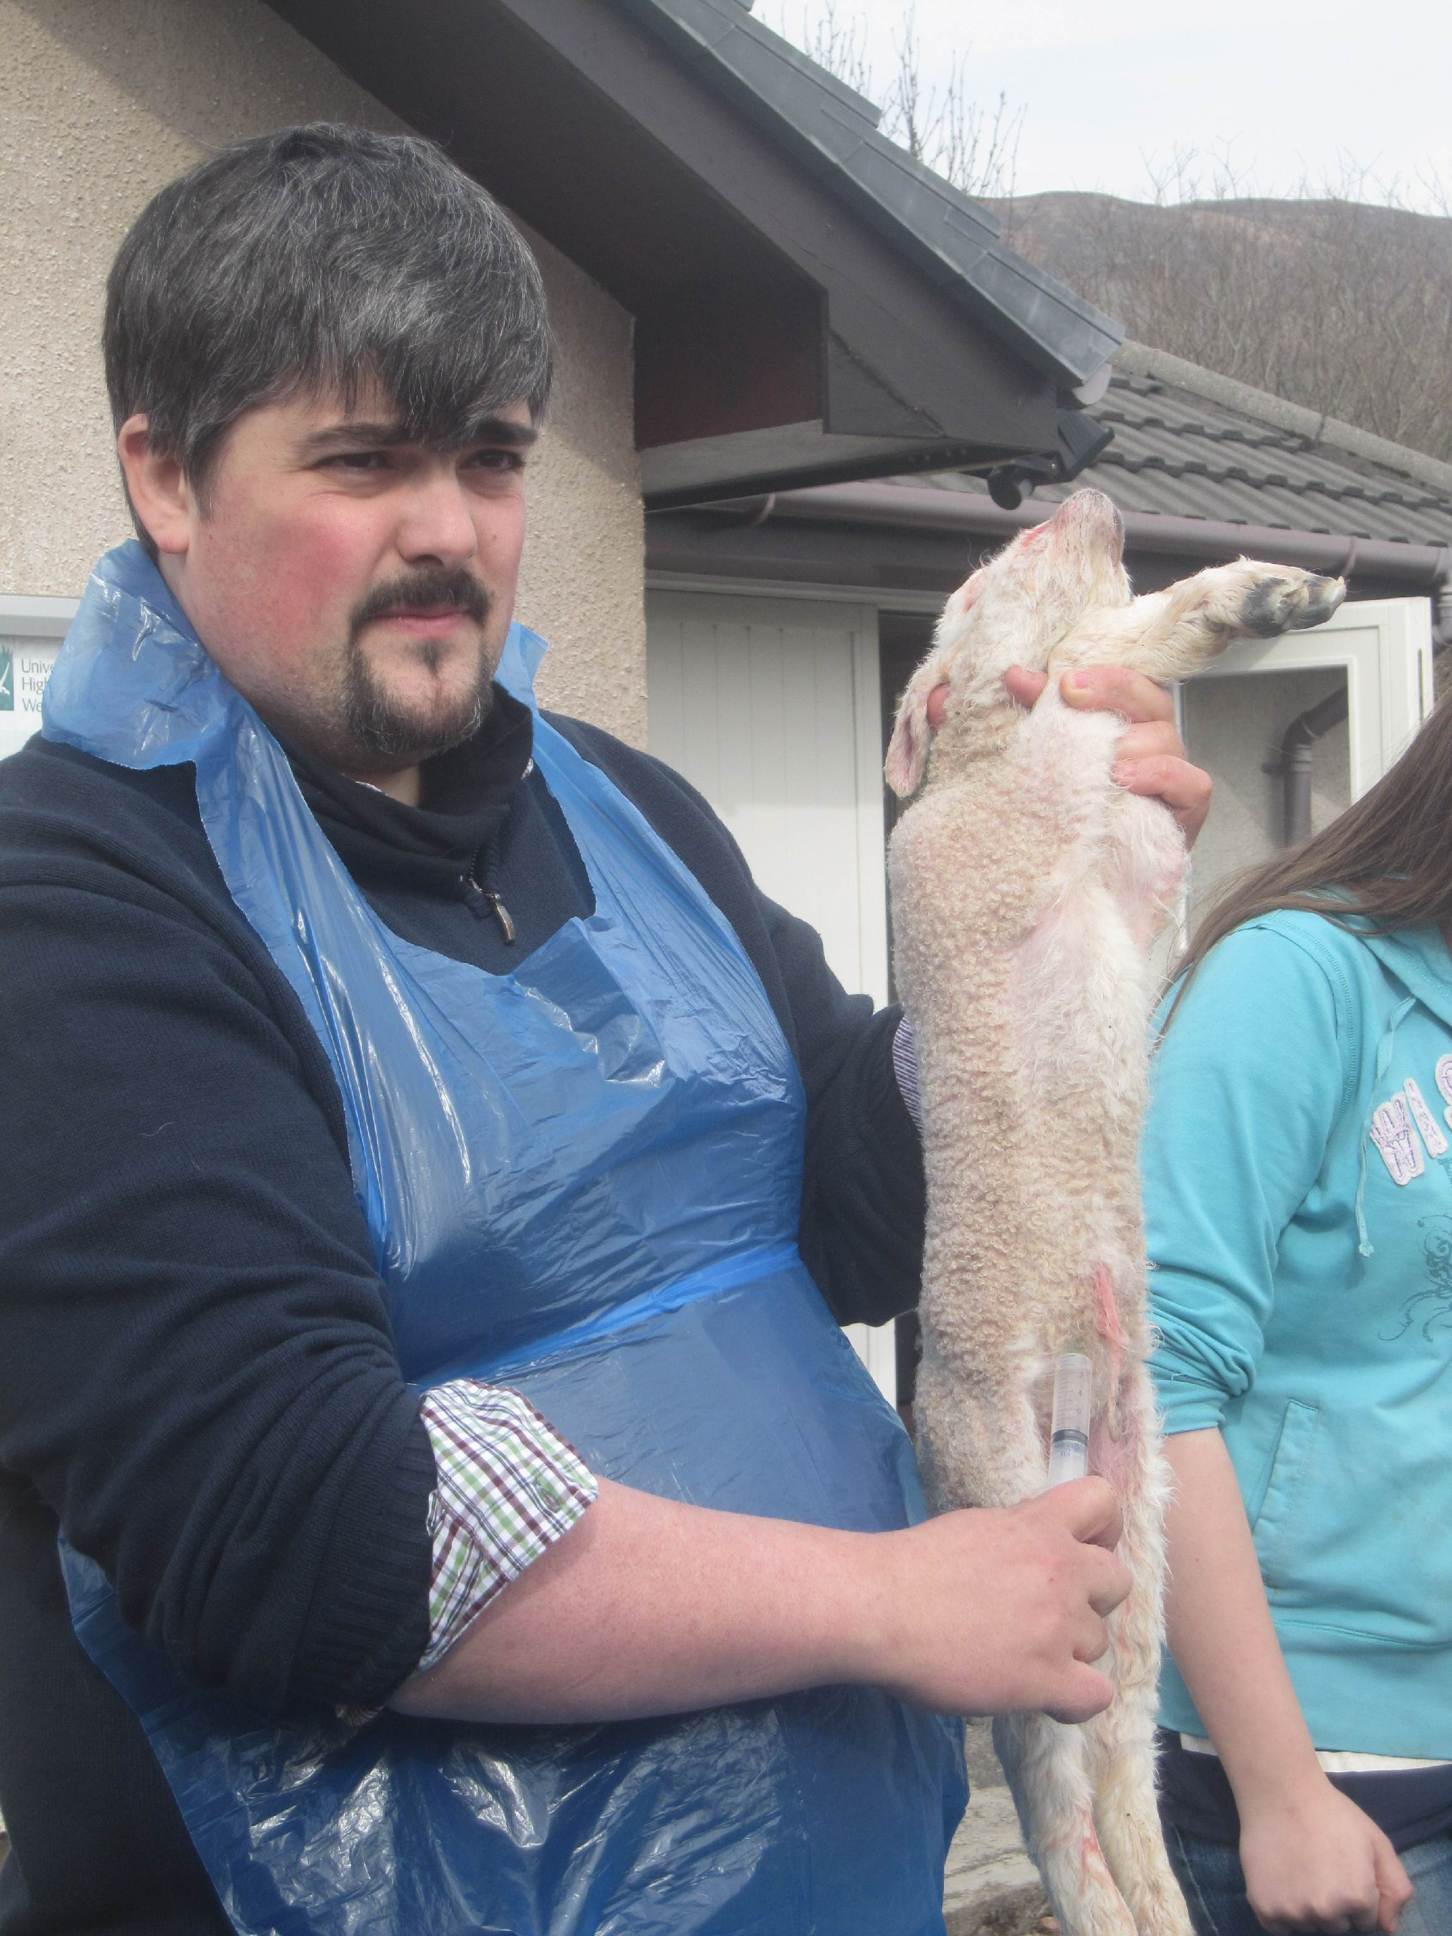  Above left: Lamb recovering Above right: Lambing workshop
Name & email of staff member submitting news item | Julie Simmons  julie.simmons@highlifehighland.com

Area of work (e.g. Arts) | Archives
Location | Highland Archive Centre
Title of piece of work | Inverness Royal Academy pupils explore the links between Highlanders and the slave trade
Description of event  (the purpose / targets) | A group of sixth year pupils from Inverness Royal Academy have been studying the links between Highlanders and the slave trade, as part of a project “Looking Back to Move Forward: Slavery and the Highlands”, which aimed to demonstrate the potential of collaboration between the spheres of archives, academia and education.  The pupils studied original documents relating to the slave trade which are deposited at the Highland Archive Centre.  The twelve week project culminated in an exhibition at the Highland Archive Centre.
Which staff were / are involved | Janet Baker, Education and Outreach Co-ordinator of the Highland Archive Service
What were the results /  numbers involved /  Feedback | Six sixth year pupils from Inverness Royal Academy, two lecturers from the University of the Highlands & Islands and one teacher from Inverness Royal Academy were involved.  The project was awarded the Edinburgh Beltane Beacon Challenge Award, which signified its success as the best project in Scotland.
Attach photos or web links | 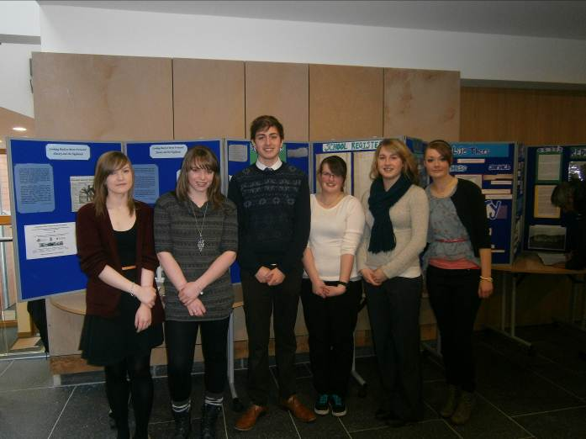
Name & email of staff member submitting news item | Janet Baker  janet.baker@highlifehighland.com

Area of work (e.g. Arts) | Arts
Location | Inverness Museum & Art Gallery
Title of piece of work | A Dog’s Life – Setting the scene with Wallace & Gromit
Description of event  (the purpose / targets) | An exhibition on the theme of stop-frame animation including original sets and characters from the Wallace & Gromit films, projections and a workshop space in the gallery with modeling clay and animation equipment for visitors to create their own models and films. Animation workshops accompanied the exhibition and the best of the animated film clips made by visitors were shown in the last week of the exhibition.  Well-attended by schools, community groups and the general public alike.  A blockbuster show to kick-off the summer season at Inverness Museum & Art Gallery.  The exhibition was supported by the Inverness Common Good Fund from which £5,000 was secured.
Which staff were / are involved | Exhibitions Unit - Cathy Shankland, Dean Melville, Lucy Woodley  Inverness Museum & Art Gallery staff.
What were the results /  numbers involved /  Feedback | 500 – 600 people per day visiting the museum – many return visits and workshops over-subscribed.
Attach photos or web links | 
Name & email of staff member submitting news item | Cathy Shankland  cathy.shankland@highlifehighland.com

Area of work (e.g. Arts) | Health and Wellbeing
Location | Tain and Dornoch
Title of piece of work | Puddle Jumpers Activity Club
Description of event  (the purpose / targets) | Puddle Jumpers Activity Club is a brand new service developed by High Life Highland staff.  An initial pilot ran as a fortnight of fun, creative, adventurous and outdoor play during the Easter holidays and was fully subscribed by primary aged children in the Easter Ross and Sutherland areas.  Organised and led by staff from High Life Highland (in partnership with Dornoch Allsorts After School Club) the packed programme took place at Dornoch Academy and TRACC where children spent between 5–6 hours outside each day in an ‘enchanted woodland’ within grounds adjacent to Dornoch Academy; exploring in all weathers, playing and making dens from straw bales, tyres, scraps of wood, willow and old pallets.  The Puddle Jumpers Activity Club activities were centred on a Peter Pan theme including activities such as making tipis and fairy wands with most of the time available to the children for free play, entirely led by them. The children, dressed as mermaids, Indians, lost boys and pirates, have created their own imaginative worlds in a safe and friendly environment with experienced staff.  Puddle Jumpers Activity Club offered 20 places per day x 10 days = 200 child places in total.
Which staff were / are involved | Fiona Hampton, Head of Business  Lynn Johnson, Health and Wellbeing Manager  Joanne Crosbie, Facilities Manager  Kelly Skinner, Facilities Manager  Eilidh Munro, Leisure Assistant, TRACC  Gordon MacKay, Leisure Assistant, TRACC  Laurie Piper, Marketing and Communications Manager
What were the results /  numbers involved /  Feedback | The two week programme was full to capacity each day (except one), with waiting lists for most days.  As a result a six week programme for the summer is being organised to meet demand.  Evaluation Results – based on returns submitted  - 100% of Parents/Guardians rated the activities as “Excellent”  - 95% of Child participants said they wanted to do the activity again
Attach photos or web links | Puddle Jumpers Climbing Trees  Puddle Jumpers Water War  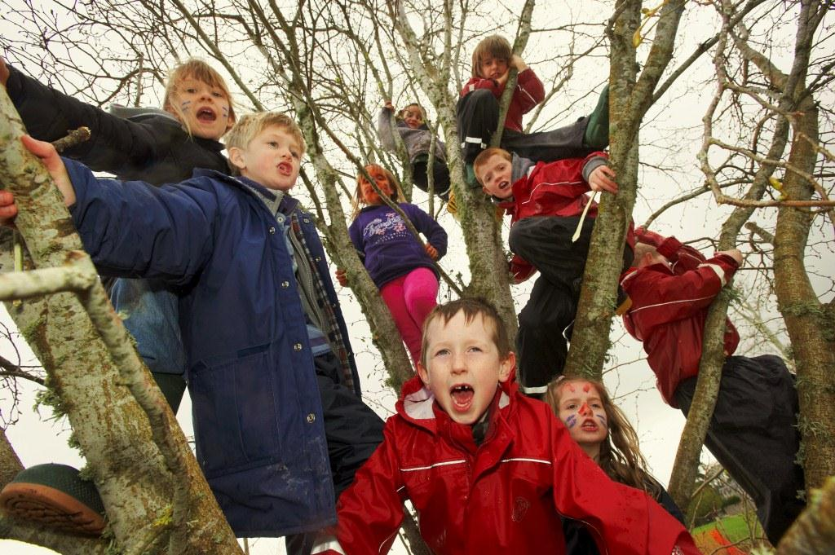  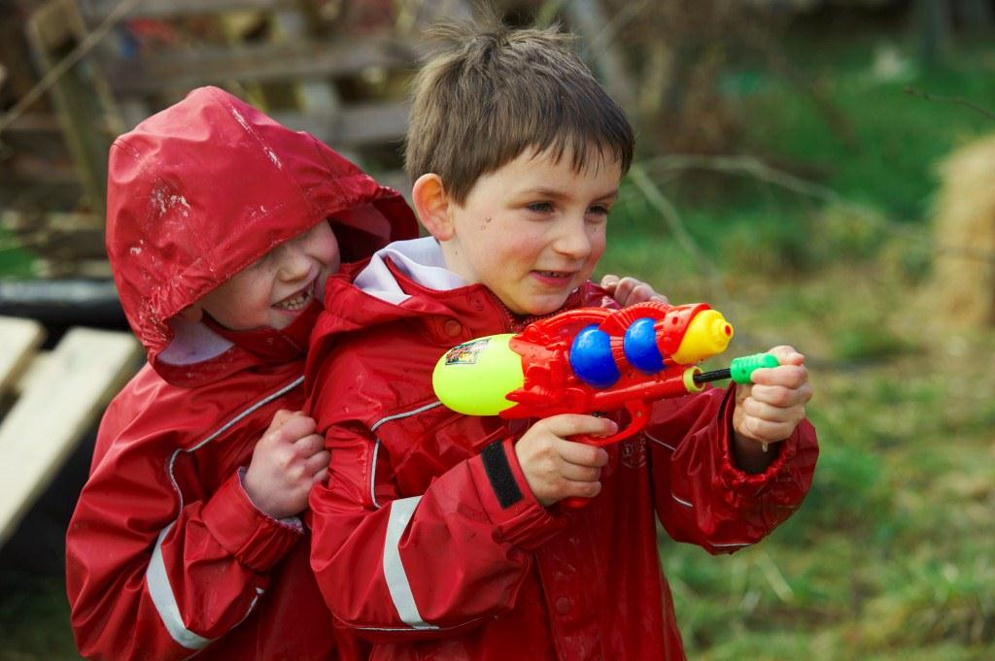  Press Cutting: Ross-shire Journal
Name & email of staff member submitting news item | Lynn Johnson  lynn.johnson@highlifehighland.com

Area of work (e.g. Arts) | Leisure
Location | Lochaber / Fort William
Title of piece of work | Torch Triathlon’s Super Success
Description of event  (the purpose / targets) | More than 200 children from across Lochaber took part in the inaugural High Life Highland ‘Torch Triathlon’ on Saturday 9th June at Lochaber Leisure Centre.  The Torch Triathlon was conceived as a fun event for kids which would tie in to the visit of the Olympic flame to Lochaber and was run by local events company No Fuss Events on behalf of HLH.  Entry was free with children aged between 4 – 16 years. The course was designed to be tackle-able by children of all abilities and consisted of a swim, a run and a cycle with different lengths for each age group.  Even on the day people were turning up to register and we more than exceeded our expectations.  Feedback from participants via No Fuss Facebook as follows:  Brilliant, great to see everyone had an excellent time  Great day, great event  A great event, well done High Life and No Fuss  What a fantastic day we all had! Great atmosphere and lots of happy people. Thank U xx  Brilliant day – children and adults alike all had a fab time
Which staff were / are involved | Gary Davidson & all Lochaber staff  Emma Thomson & staff from HLH leisure sites across the estate  Laurie Piper
What were the results /  numbers involved /  Feedback | More than 200 happy kids took part in the event. 100% positive feedback from everyone involved.
Attach photos or web links | 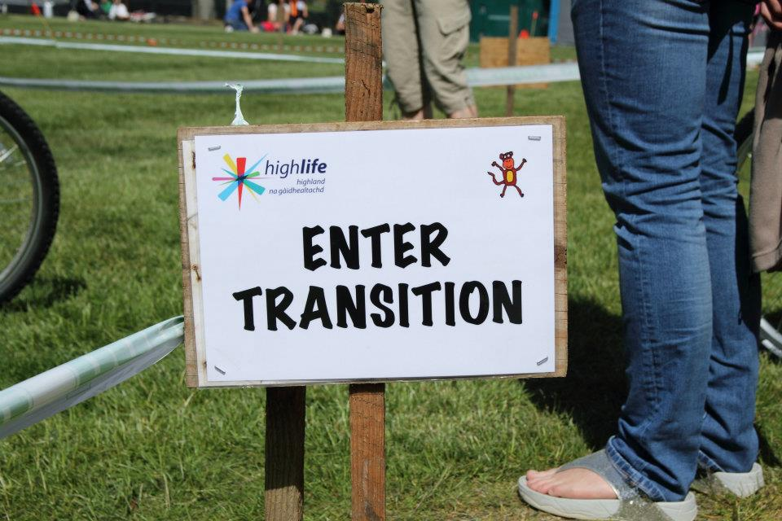  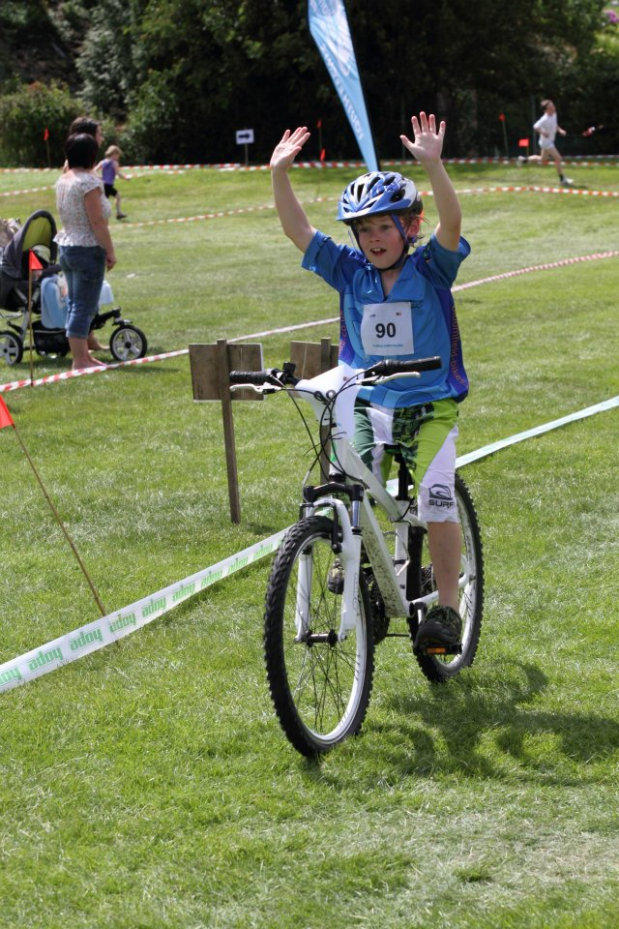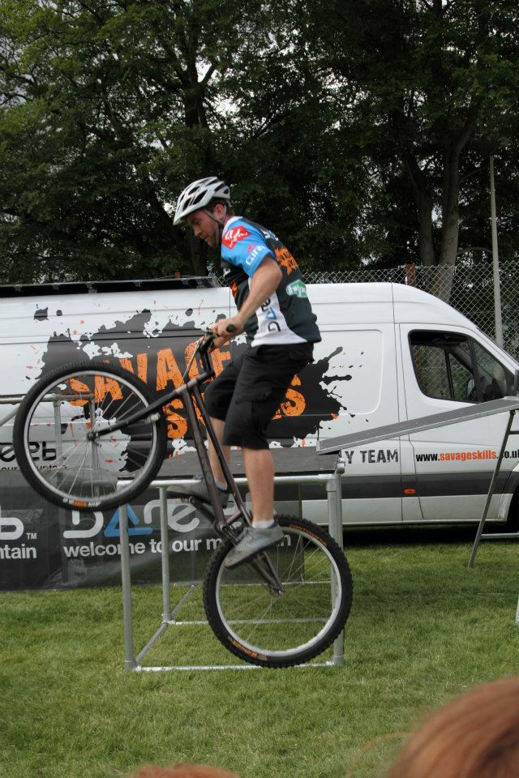
Name & email of staff member submitting news item | Laurie Piper – laurie.piper@highlifehighland.com

Area of work (e.g. Arts) | Libraries
Location | Portree Community Library
Title of piece of work | Digital Inclusion
Description of event  (the purpose / targets) | Portree Community Library’s “digital drive” has seen a steady stream of individuals turning up to find out how they can make the most of new technology.  Launched on the back of the region-wide designated Digital Day the Library offered local users the opportunity to really get to grips with everything from computers to e-books, i-pads and even mobile phones.  Seventeen people attended the first “taster day” with the first three follow-on information sessions staged at Portree attracting a total of 26 individuals, many of them new faces to Library staff and all keen to take advantage of the learning opportunity.  The key aim of the sessions was to encourage older members of the community to make friends with digital technology however there were no age barriers for those who wanted to take part and a “welcome to all” invitation went out through the local media and via Facebook.  In fact the ‘Digital Days’ project, supported by Scottish Government funding via the Scottish Libraries and Information Council (SLIC), is part of wider commitment by Highland Libraries to encourage people to access computers and digital technology, as well as to use on-line and downloadable resources.  At Portree the first follow on event was staged on 15th May with 7 turning up for an i-pad session. This was followed on the next two consecutive Tuesdays with a chance to master PC problems covering everything from downloading photos to moving documents and the use of the internet and emails. These attracted 8 and 11 people respectively.  On Tuesday 12th June there will be a two hour session covering Kindles, e-books, mobile phones and the iPod. Finally on Tuesday 19th June the series will be completed with those taking part getting the chance to find their way around Skype, Twitter, and Facebook.
Which staff were / are involved | A variety of staff members were involved and also worked in partnership with Joey Graham, ABE, John Nichols (tutor), Jane Beaton, Citizens online, Portree High School ASDAN pupils and Portree Learning Centre.
What were the results /  numbers involved /  Feedback | These were very much taster sessions and the range of skills varied from how to switch on to how to add an attachment to an e-mail. However, everyone appeared to get something of use from the sessions. It was evident that at least a couple of the more experienced users had applied what they had learnt between the sessions successfully. One of those who attended suggested that a regular gathering where people could meet, get help and exchange ideas would be good. It would appear that a Digital Club would be well received if it was possible.  One direct result of the sessions was that it again served to attract new users and further illustrated to the local community the variety of activities and information it is possible to access via Portree Community Library and Libraries service generally.
Attach photos or web links | 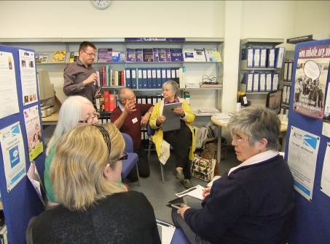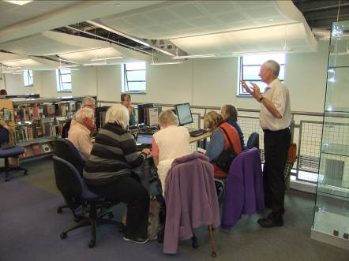  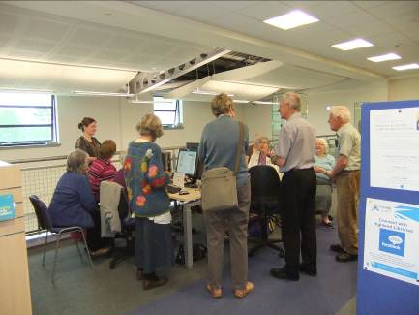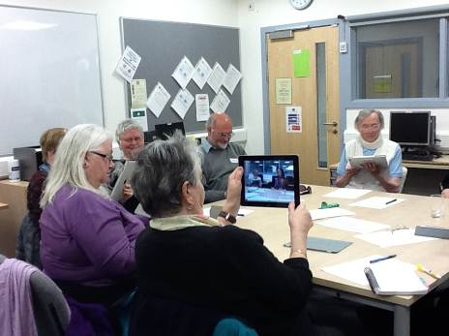
Name & email of staff member submitting news item | Gillian Siwek  gillian.siwek@highlifehighland.com

Area of work (e.g. Arts) | Museums
Location | Inverness Museum & Art Gallery
Title of piece of work | Grant for refurbishment and rebranding of Discovery Centre to “Room to Discover”
Description of event  (the purpose / targets) | Inverness Museum and Gallery was awarded a £6876 grant from Museum Galleries Scotland for the refurbishing and rebranding of the Discovery Centre to “Room to Discover”.  Room to Discover will be a flexible activity space within the Museum. It will have new and exciting range of hands-on activities, collections and learning resources in a bright well equipped space. Using this space the aim is to develop programmes and events for local community groups, schools, students and families and to encourage new audiences into the museum.
Which staff were / are involved | Jeanette Pearson, Rachel Chisholm, Lesley Junor, Sian Coodye and Cait McCullagh.
What were the results /  numbers involved /  Feedback | An on-going programme to be completed by the end of March 2013.
Attach photos or web links | http://www.museumsgalleriesscotland.org.uk/news/news-article/463/main-grant-awards-announced  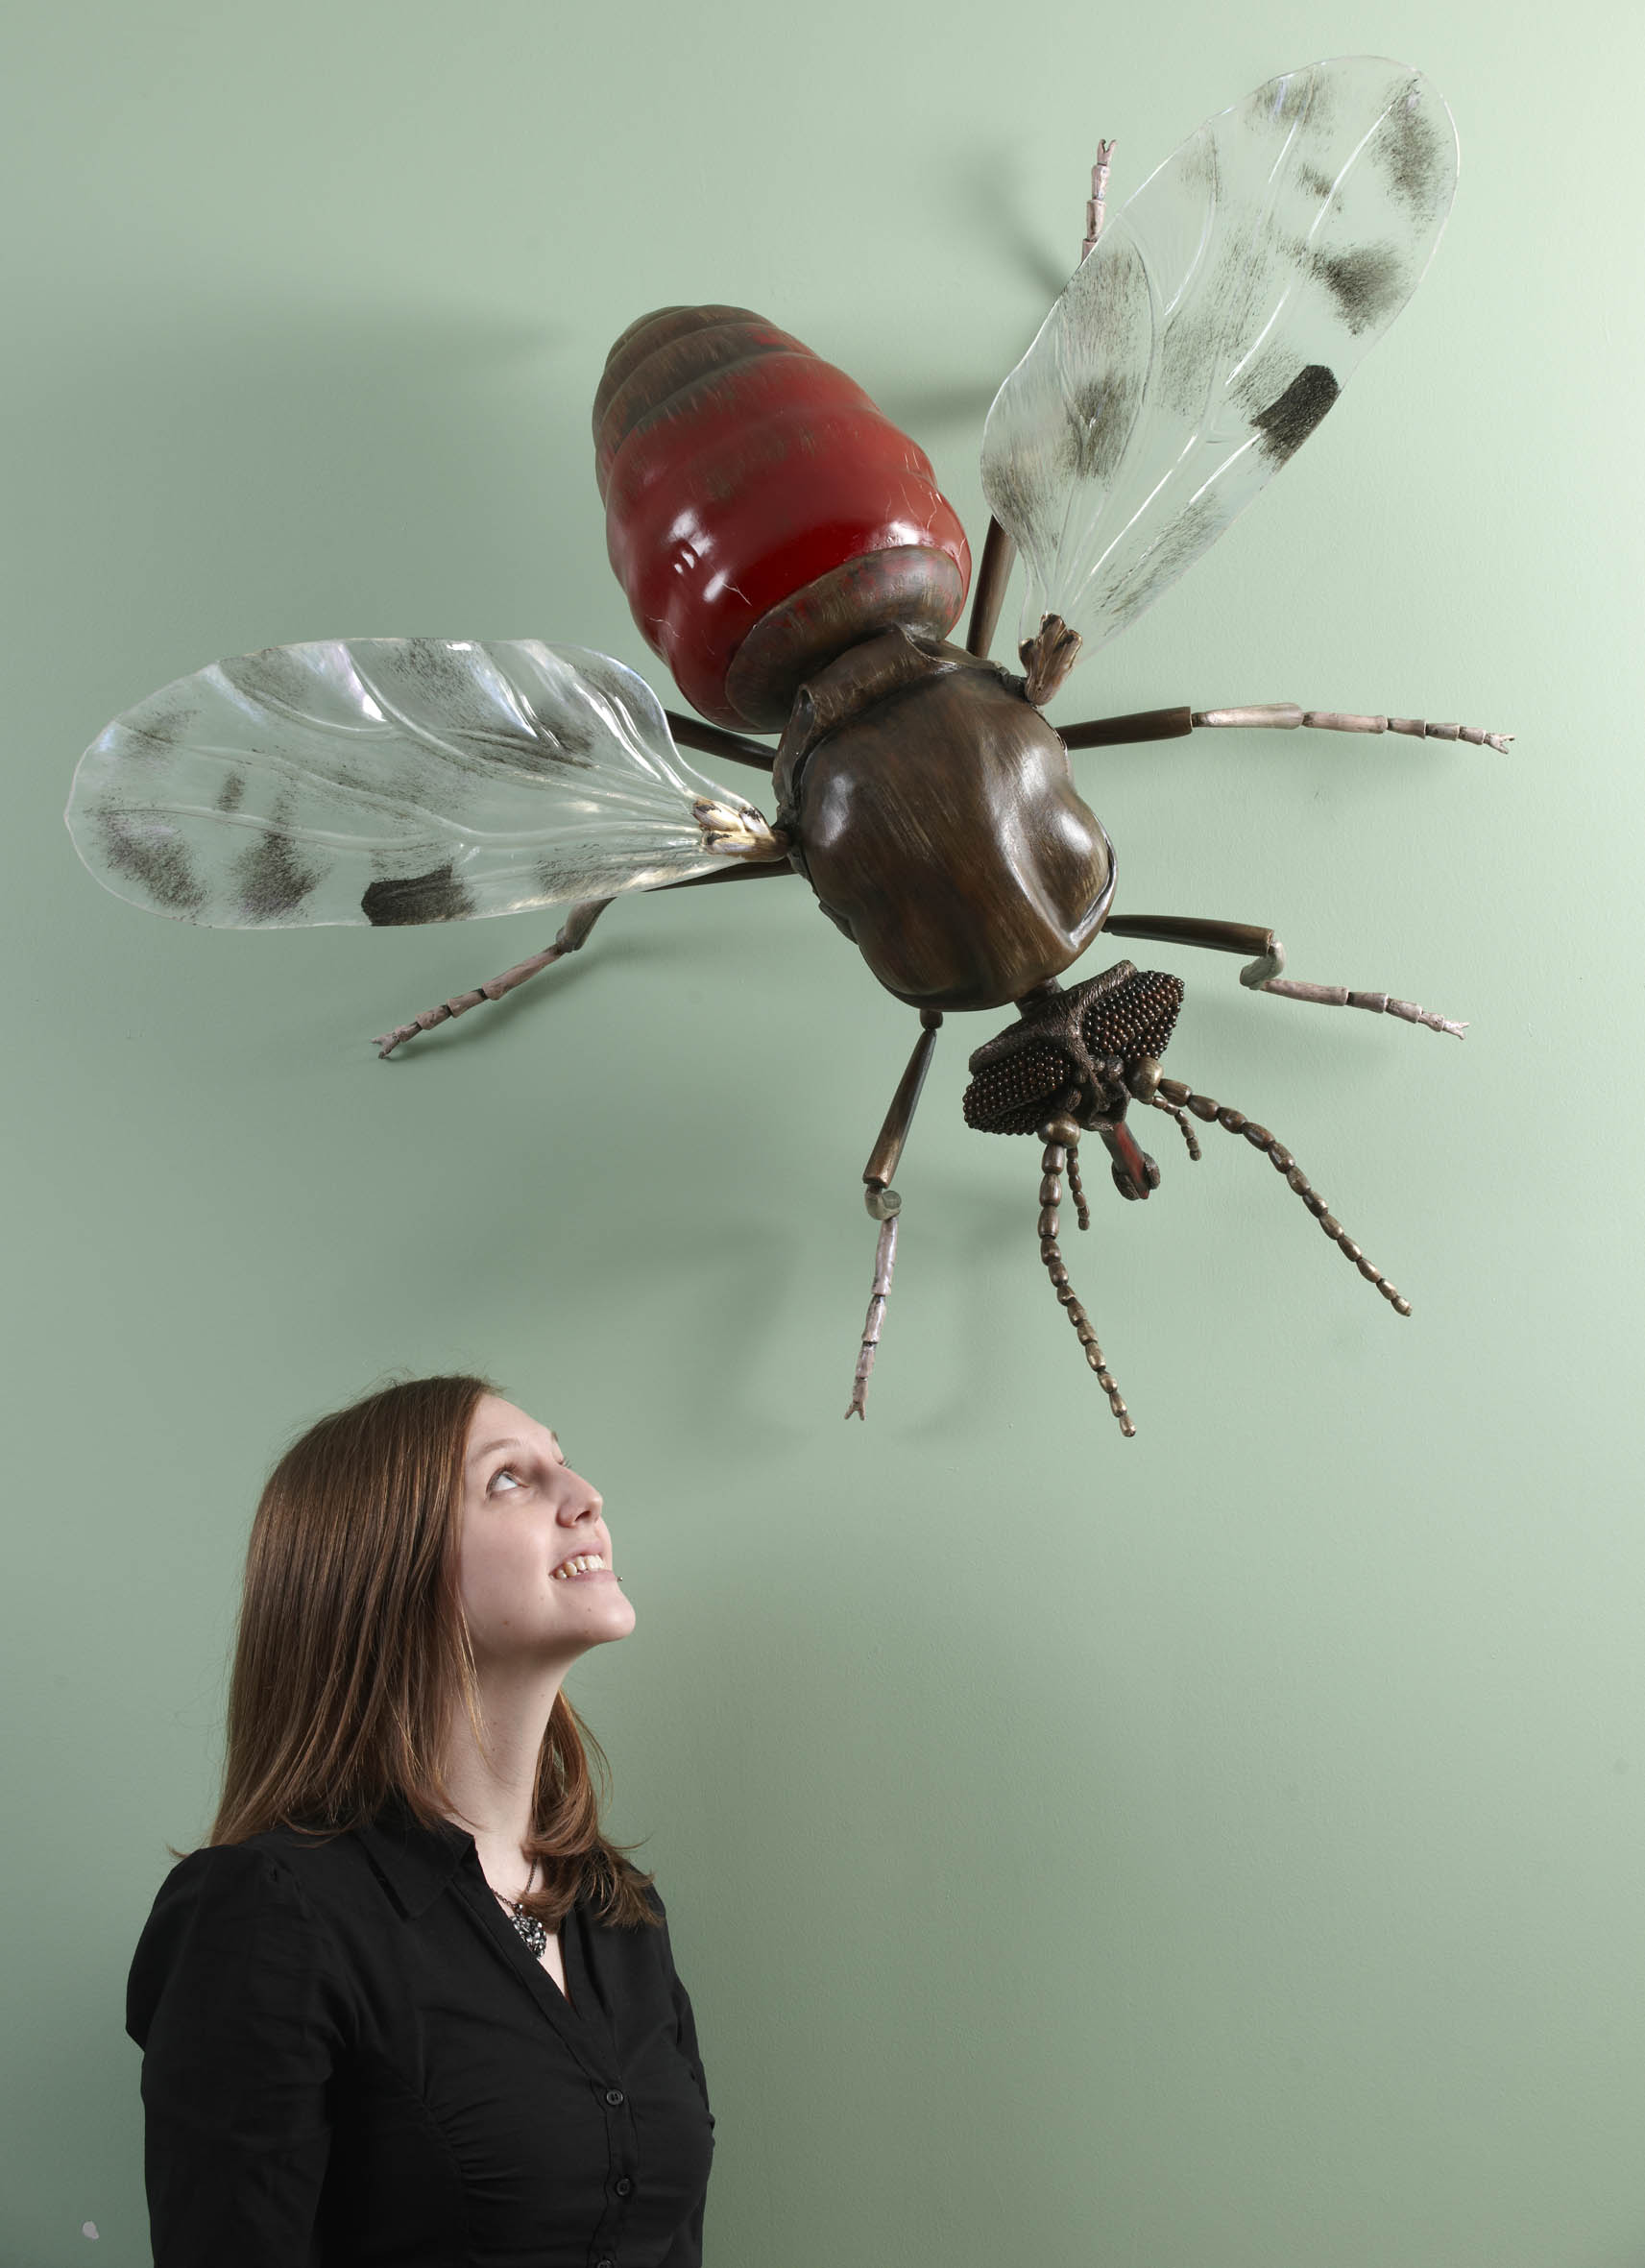
Name & email of staff member submitting news item | Lesley Junor  lesley.junor@highlifehighland.com

Area of work (e.g. Arts) | Sport
Location | Switzerland
Title of piece of work | European Football Tournament for Learning Disabilities
Description of event  (the purpose / targets) | Seven players accompanied by 3 coaches from Highland were selected for a Scottish National Squad competing in the Schtroumpfs Football Championship in Geneva, Switzerland. The event took place between 24th and 28th May in Bernex a small suburb of Geneva and hosted 20 teams from all around Europe. Scotland (Ecosse) were in the A division teams competing against the top countries in Europe such as England, Holland, Italy, Germany, Northern Ireland and France. Ecosse were unbeaten in their section finishing 3rd overall behind Holland and Italy and were unlucky not to be joint top at the end after drawing with the Belgium team which they should have won. This would have put them in a penalty shoot out with the Dutch who they held to a 0-0 draw in the group stage. If they had won the shoot out this would have given them a place for the overall final which the Holland team won comfortably. So near for the Scots but they had at least the consolation of finishing the top of the home country teams finishing 2 points clear of England and 8 clear of the Irish. Ecosse finished 5th out of the 20 teams competing.
Which staff were / are involved | Charlie Forbes – Manager  Mark Sloggie – Coach  Victor Leslie - Coach
What were the results /  numbers involved /  Feedback | They collected 2 trophies for finishing 3rd in their group and 5th overall
Attach photos or web links | 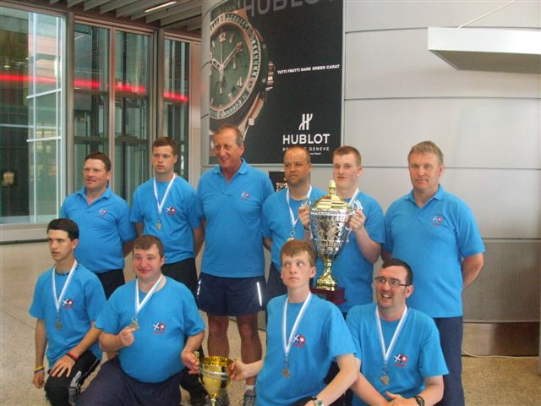
Name & email of staff member submitting news item | Charlie Forbes  charlie.forbes@highlifehighland.com

Area of work (e.g. Arts) | Sport
Location | Ardnamurchan High School/Sunart Centre
Title of piece of work | Sports Leaders
Description of event  (the purpose / targets) | We ran Sports Leaders for 18 S4’s during Health and Wellbeing time.  The aim of this award is to produce effective leaders who can then go into local youth clubs and After School clubs and deliver fun games and activity sessions.
Which staff were / are involved | Active Schools Co-ordinator and the school PE staff
What were the results /  numbers involved /  Feedback | 18 S4’s
Attach photos or web links | 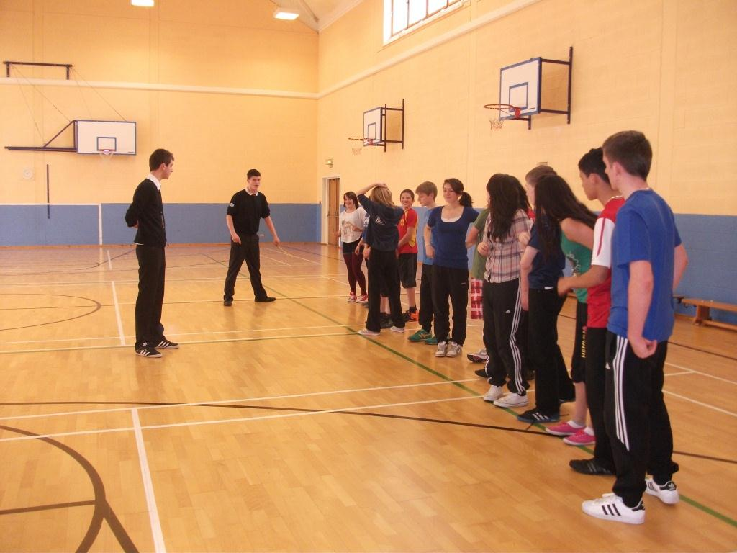  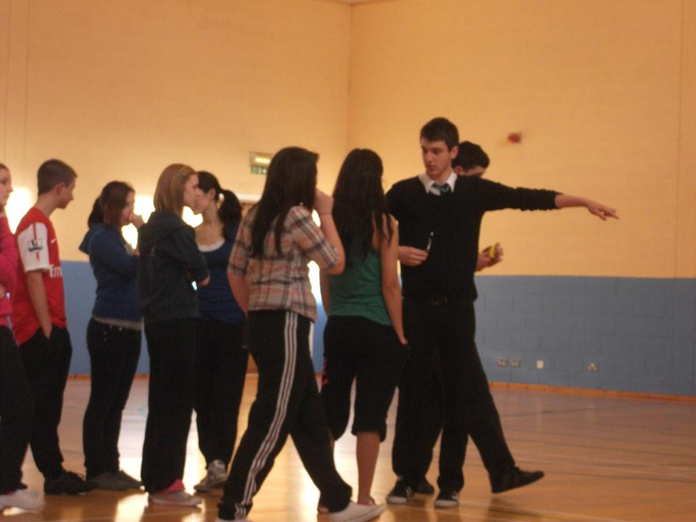
Name & email of staff member submitting news item | Dot Lynas ASC Ardnamurchan

Area of work (e.g. Arts) | Sport
Location | Grantown Cluster
Title of piece of work | Strathspey Rugby Club Links
Description of event  (the purpose / targets) | Girls rugby is going strong - under 15 Scottish champions.  Fit for girls project funding purchased the new pink strips which were selected by the girls.  Club coaches are involved in coaching and Grantown Grammar School staff are volunteering.
Which staff were / are involved | Dawn Horsburgh Active Schools Coordinator Grantown Cluster
What were the results /  numbers involved /  Feedback | Young Ospreys - players from cluster primaries  Grantown Grammar School boys  Grantown Grammar School girls – under 15 and under 18  6 Strathspey and Badenoch Herald articles
Attach photos or web links | 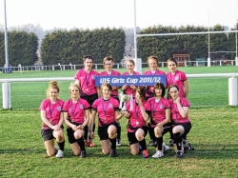
Name & email of staff member submitting news item | Dawn Horsburgh  dawn.horsburgh@highlifehighland.com

Area of work (e.g. Arts) | Sport
Location | Nether Lochaber – Glencoe
Title of piece of work | Active Schools Coordinator wins UK’s First Freeride event
Description of event  (the purpose / targets) | On 24th and 25th March 2012, Roslynn Newman Active Schools Co-ordinator for Nether Lochaber took part in the UK’s first ever freeride event at Glencoe Mountain Resort. The event had been postponed due to lack of snow on what could seem like one of the worst seasons to hit the Scottish Highlands in recent years. Despite the conditions the blue skies and limited uplift did not put off the 30 men and women to hike up to the steepest pisted face of the UK – the notorious Flypaper, at 42°, The Fly as it’s also known can make the brave and confident skier suffer from vertigo!  Despite its steepness the crowd of eager daredevils combed and shaped the face to make natural hits that would win points onto a podium finish.  Out of the 8 women who entered the combined skiing and snowboarding event, Roslynn Newman took top place in the womans with 28 points and finished 4th overall in the snowboard category.  She was the only female to venture onto the narrows of Baileys that extended to 1.5m wide and was littered with rocks. Using the ridge of radio gully like a half pipe she landed a front side 180, gaining some freestlye points to put her into top place.  The event has now been included as an official qualifying event for the freeride world tour for next year and Roslynn is hoping to re-enter and perhaps gain points onto the Freeride world tour circuit.
Which staff were / are involved | Roslynn Newman – Active Schools Co-ordinator for Nether Lochaber
What were the results /  numbers involved /  Feedback | The Scotsman lifestyle supplement and main paper  Coe cup on line – www.coecup.com  Facebook – Glencoe mountain resort & Coe cup
Attach photos or web links | www.coecup.com  http://www.scotsman.com/lifestyle/features/despite-a-disappointing-season-glencoe-delivered-thrills-and-spills-in-a-heart-stopping-freeride-event-1-2220907  http://www.flickr.com//photos/51417247@N06/sets/72157629450059862/show/  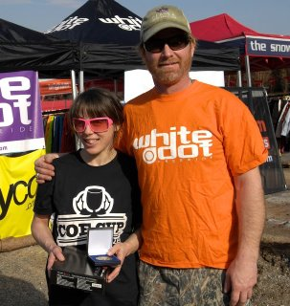  Roslynn - receiving her prize from Freeride legend Jeremy Nobis.
Name & email of staff member submitting news item | Roslynn Newman  roslynn.newman@highlifehighland.com

Area of work (e.g. Arts) | Sport/Leisure
Location | Grantown
Title of piece of work | HMIE Learning Community Inspection
Description of event  (the purpose / targets) | During the Inspection on 24th April particular strengths were noted:  - wide range of high quality sports and leisure provision, progression in sports learning and impact on health and wellbeing.  - the volunteering by children, young people and adults which is making a significant difference in their local communities.  - young people - notable numbers of young people participate in the high quality sports and leisure provision. Staff plan progression in sports development well from beginner levels to local and national levels of competition. The Fit for Girls programme funded by Sports Scotland is making a quantifiable impact on levels of health and fitness. Many young people have successfully gained employment through achieving Community Sports Leadership Awards and sports coaching qualifications.  The Skills for Work programme demonstrates strong partnership working between the school, leisure centre and Active Schools. The leisure facility provides experiential learning in a real life context which reflects the day to day demands and rewards of a recreational facility. Young people are gaining important knowledge and understanding of all the main practical activities required for employment in a leisure centre. They achieve first aid certificates and an understanding of safeguarding. They are developing a greater sense of responsibility, organisational and planning skills and improved leadership qualities.  With regards to Adults, they recognised that there was a strong emphasis on health and well-being opportunities - especially Fit Plus and Move it to Lose It where learners feel more confident and have increased mobility and emotional wellbeing.
Which staff were / are involved | Dawn Horsburgh - Active Schools Co-ordinator Grantown Cluster  Donna Reilly - Leisure Manager, Craig Maclean Leisure Centre, Grantown.
What were the results /  numbers involved /  Feedback | HMIE inspection of the learning community surrounding Grantown Grammar School  Impact on Young People – Very Good – Major strengths.
Attach photos or web links | 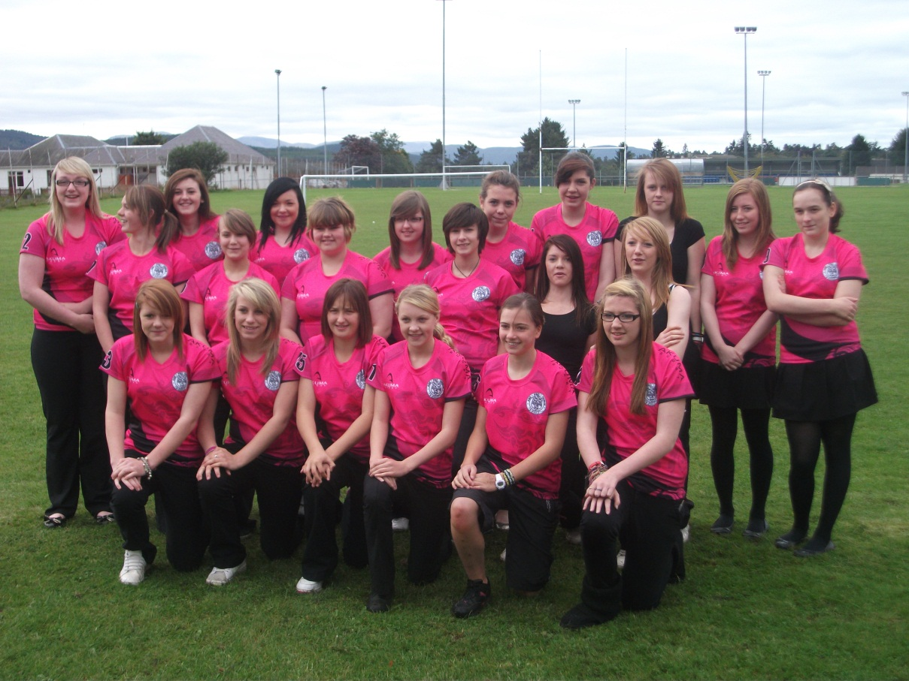
Name & email of staff member submitting news item | dawn.horsburgh@highlifehighland.com  donna.reilly@highlifehighland.com

SUCCESSES

Area of work (e.g. Arts) | Youth
Location | Ardnamurchan
Title of piece of work | Fusion 2012
Description of event  (the purpose / targets) | “Fusion 2012 is a partnership between Youth Highland, High Life Highland and Action for Children. The partnership received funding from Cashback for Communities to provide free youth work activities to young people across the Highlands” – The 2012 project ran from January 2012 to May 2012 with one Fusion event per month on average.  Fusion 2012 gave young people increased opportunities to participate in youth work activities and events which have the potential to develop their mental, social and physical skills. Fusion 2012 provided diversionary activities and events – targeting young people ages 10-19, in need or at risk of offending or anti-social behaviour.
Which staff were / are involved | Youth Development Officer- HLH, Sunart Centre Manager, Active Schools (Publicity) HLH, High School Staff.
What were the results /  numbers involved /  Feedback | Most young people stated that their confidence, self-esteem, skills and knowledge had increased due to their participation in Fusion 2012 events and activities. In addition, most young people stated that they believed that participating in youth work activities helped to improve the image of young people in Highland and helped to reduce levels of crime and anti-social behaviour.  43 males and 31 females attended the Fusion events – Note: school roll is just over 100.
Attach photos or web links | 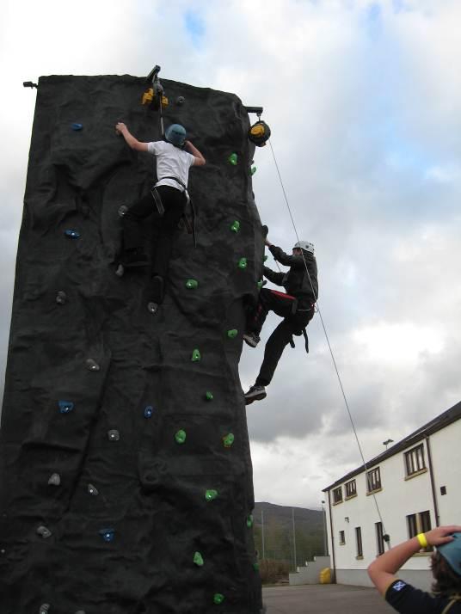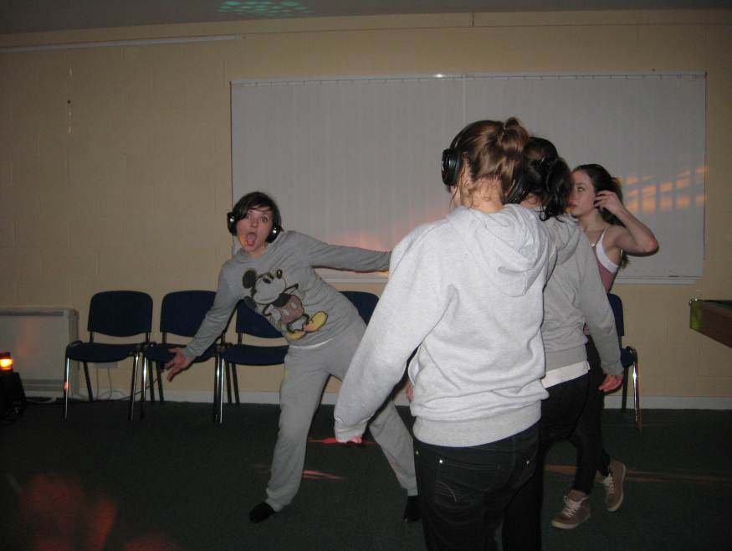  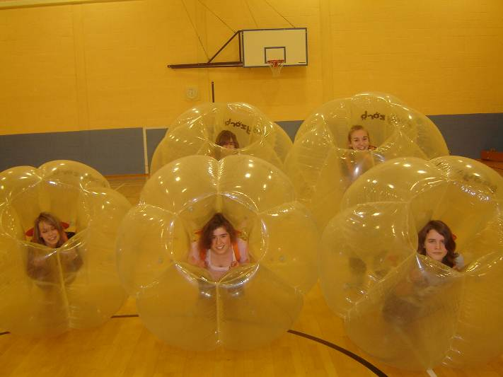
Name & email of staff member submitting news item | Stewart Malcolm  stewart.malcolm@highlifehighland.com

Area of work (e.g. Arts) | Youth
Location | Black Isle
Title of piece of work | Welcome to Scotland
Description of event  (the purpose / targets) | About one month ago I was introduced to a Latvian family, they have 2 daughters aged 3 and 16, they have no English and nor does the mum, the dad does but he is at work all day. I went to meet the family and invited them along to my Dancing Class and Youth Caf , they have been attending now for 6 weeks, further to this I took Estere the 16 year old across to Fortrose Academy to see if I could persuade her to come to school, with her being 16 she had just fallen through the net and no one was doing anything, in building a relationship with Estere I have now got her integrated in to Fortrose Academy for the first 6 weeks she is in 3rd year to get her confidence up then after the holidays we will review things and she will go in to either 4th or 5th year. Estere is now a valuable member and volunteer in Cromarty Youth Café, her English is that she understands what we are saying but as yet just has some of the words back. We take time to learn Latvian each week with her support and are still only on number 1-10 with not too much success.
Which staff were / are involved | Wanda Mackay - in school supported by Deirdre Mackenzie the guidance teacher, who has worked out a great timetable for Estere.
What were the results /  numbers involved /  Feedback | The result is by taking Estere along to the Dancing class and Youth Café I was able to build a relationship that enabled her to trust me to take her along to school and get the best timetable to which subjects she enjoys, with the help of a translator, who also told me she loves the Youth Café and the Dancing.
Attach photos or web links | 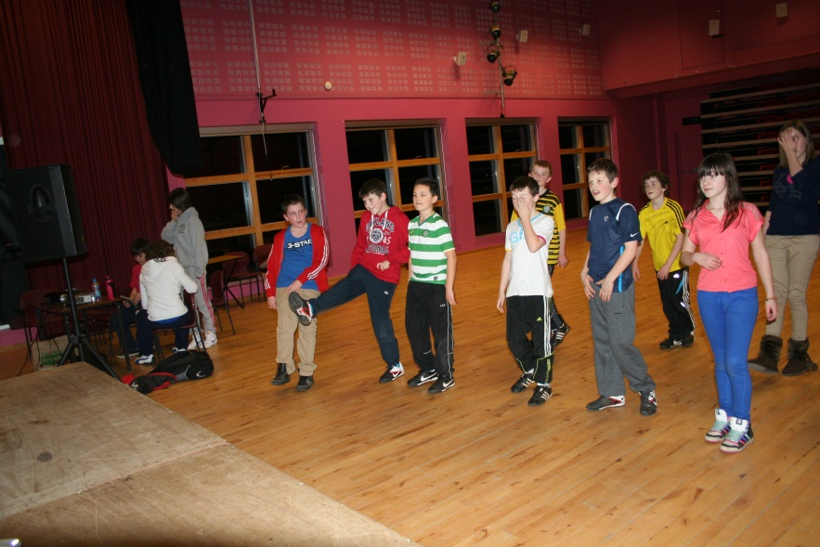
Name & email of staff member submitting news item | Wanda Mackay, Youth Development Officer, Black Isle  wanda.mackay@highlifehighland.com

