HIGH LIFE HIGHLAND  REPORT TO BOARD OF DIRECTORS  29 March 2012 | AGENDA ITEM 3 REPORT No HLH 1/12
GOOD NEWS ITEMS - Report by Chief Executive

Summary

The purpose of this report is to present a sample selection of items which represent the successful work being carried out by High Life Highland throughout the Highlands and across all areas of work.

It is recommended that Directors note and comment on the good news items presented.

1. | Background
1.1 | High Life Highland (HLH) staff were invited to submit good news stories which represented the successful outcomes of their work over the past six months.
1.2 | 45 good news items were submitted by staff detailing the successes and good practices being delivered. A list of all submissions is attached as Appendix A.
1.3 | Some examples of these submissions are attached at Appendix B. These examples have been selected to present to Directors the range of standard and service being provided by HLH.
1.4 | All good news items submitted will, in due course, be available for viewing on the HLH website and social networking sites.

Recommendation

It is recommended that Directors note and comment on the good news items presented.

Signature:

Designation: Chief Executive

Date: 19 March 2012

APPENDIX A
AREA OF WORK | TITLE
Adult Learning | Adult Education Classes
 | BBC First Click Beginner computer courses
 | Computer taster sessions
 | English for Citizenship*
Archives | ‘Archives for Beginners’ classes*
Arts | Eye-Catching Art Work
 | Inspiring Creativity Conference*
 | Mànran visit the Sunart Centre
National Theatre of Scotland – 2 Performances:-
Calum’s Road & Tall Tales for Small People and associated free family workshops
Leisure Facilities | Floral Hall to feature in BBC Scotland programme
 | Merkinch Community – Mosaic Tree
 | Move it to Lose It Campaign*
 | Pink Party
 | Sportscotland Young Persons Coach of the Year award*
Libraries | Computer Taster Sessions
 | Isle of Skye Pipe Band exhibition January –February 2012
 | Reader In Residence, Margot Henderson, based in Inverness Library
Libraries | Ullapool Cubs and Brownies visits to the Ullapool Library
 | Using e-technology in the acquisition of library materials*
Libraries | Visits to Libraries
 | World Book Day
Museums | HFM receives VisitScotland green tourism award*
Sport | Balloch Primary School enjoy four days of snowsports
 | Community Sport Hubs
 | ‘Dance’ Young Leaders Programme
 | East Caithness Primary Schools swimming Gala’s
 | Farr ILC’s first young sports leader on course award*
 | Football – Midnight Leagues
 | Highland Disability Sport – “Sportshall Agility Challenge”*
 | Interschool’s Basketball Festival
 | Lochaber Dance Platform*
 | MacDonalds Community Club Programme
 | Midnight Leagues football project WICK
 | Muirtown Primary becomes first Cycle Friendly School in the Highlands
 | Primary Schools Cross Country competition / Community Sports Leaders – Alness Academy 2 March 2012
Sport | Scottish Golf Academy Juniors*
 | Sports Leaders Project*
Youth Work | Fort Augustus Youth Club ‘No –Snow Programme
 | Girls on the Move
 | National pilot project looking at The Duke of Edinburgh Award and additional support needs*
 | Raigmore United
 | TIA (Tain, Invergordon, Alness, Youth employability project)*
 | Youth Clubs
*See Appendix B
APPENDIX B

Area of Work | Adult Learning
Location | Inverness
Title of piece of work | English for Citizenship
Description – the purpose, targets | This work enables migrants from outside of the EU to improve their levels of English while gaining a deeper and broader understating of life in the UK than they would from a regular English class.  The SQA qualification which Adult Learning offer as part of this course of study is also recognised by the UK Border Agency and is therefore included by our learners in their applications for settlement and UK citizenship.  These qualifications are an important alternative to sitting the Life in the UK test. It is in line with Scottish policy that English language learners below intermediate level have this option. Without this provision people are faced with travelling, often to London, to attend a private college for a week long intensive course. The week costing over £1000.  In short this project contributes towards a goal of supporting non EU migrants in establishing themselves and flourishing in the community.  The last 6 months saw some challenges as we went through the application procedure to become recognised by UKBA as an official provider of English plus citizenship. With support from within Highlife Highland and partners we have been successful in that and would now like to roll these courses out beyond Inverness.
Who were/are the staff involved | Adult Learning Tutors- Jennie Christie and Angela Donald-delivery and assessment  Adult Learning Volunteers- Diana Wortham, Mairi Lamont and Clare MacGillivray- supporting delivery and assessment  Adult Learning Coordinator- Mark Richardson - coordination and administration  Head of Performance- Douglas Wilby - advice and guidance  WEA ESOL Development Officer - Shona Radojkovic - advice and guidance
The results/numbers involved/feedback | Since Adult Learning started offering these classes in 2010 20 learners have been accredited from 8 countries including; China (2), Thailand (8) and Bangladesh (3).  There are also people attending the classes who have no need, or at least immediate need, for the legal aspect of the citizenship qualifications but who want to learn English in a citizenship context.  Adult Learning continue to see an increasing diversity in our English classes. Friendships between learners (across nationality and ethnicity) have emerged and a positive mix of educational and social outcomes is evident.  There have been no failed applications for settlement yet and after gaining the necessary qualification most learners come back to thank their tutors and some stay on to continue learning.

Area of Work | Archives
Location | Highland Archive Centre, Inverness
Title of piece of work | ‘Archives for Beginners’ classes
Description – the purpose, targets | A new course is running at the Highland Archive Centre in Inverness to introduce members of the public to archives. The course is for people who are unaccustomed to working with original documents and may find the prospect daunting. Subjects covered include church records, estate papers, school archives, and poor relief records. Course members are given some background to record keeping in Scotland, and to the origins of the different kinds of documents we hold. Following this, each class ends with a ‘hands on’ session where class participants can handle and interpret unique original archives for themselves.
Who were/are the staff involved | Fiona MacLeod, Colin Waller, Peter Mennie, Martin Allan, Sarah Rodriguez, and Rachael Shepherd
The results/numbers involved/feedback | 14 places per course  The course, which ends early in March, has been fully booked [with a waiting list for places], and a further series will run in the spring which is already fully subscribed
Photographs / links

Class members consulting original archives relating to the relief of the poor in the Highlands

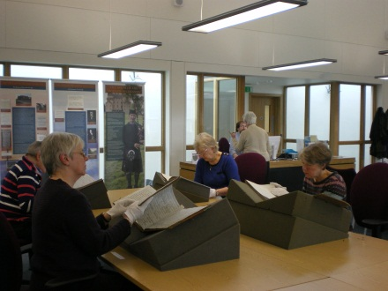

Area of Work | Arts
Location | Eden Court Theatre
Title of piece of work | Inspiring Creativity Conference
Description – the purpose, targets | The Inspiring Creativity Conference took place on 15th February 2012 at Eden Court. The event provided a focused CPD opportunity for nursery, primary and secondary teachers, and school support staff, Active School's Co-ordinators, Youth Development Officers and anyone that works with young people to be inspired and to take back practical and creative ideas to use when working with young people.  A varied and exciting programme of workshops and practical activities was offered, with an emphasis on creative learning and the expressive arts. New and exciting activities were offered that promote that arts as a tool for cross curricular learning. The programme also included an arts market place with representation from local and national organisations such as Scottish Ballet, Highland Print Studio, National Theatre of Scotland, Feis Rois, Eden Court, the Highland Music Service et.al.
Who were/are the staff involved | Lynn Johnson with Kati Kozikowska (Eden Court Creative) and other Eden Court staff
The results/numbers involved/feedback | 230 people participated in the day  Evaluation summary:  - Over 50% of participants completed an evaluation form. After attending the conference, of these 50%,  - 96.7% felt their skills in using creativity in learning had increased.  - 91.4% felt their confidence in using creativity in learning had increased.  Participant Quotes:  ‘It gave me inspiration which will help me in all subjects across the curriculum’  ‘Thank you very much for having it - We Highland teachers feel creatively starved just now and it is great to have these opportunities, even to meet up with other teachers and share practice, concerns, make arrangements to help each other etc. A great day – thanks’  ‘Will put many of the ideas and activities into practice on a regular basis as they were very suitable for the stage I work with”
Photographs / links

Active Learning through Music Workshop

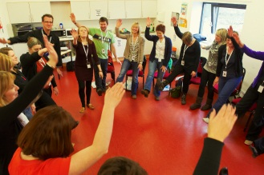

Ian Murray, Keynote speech for delegates in One Touch Theatre

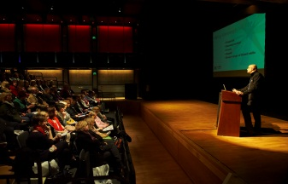

Area of Work | Facilities
Location | Craig Maclean Leisure Centre
Title of piece of work | Sportscotland Young Persons Coach of the Year award
Description – the purpose, targets | Swim Club and Leisure Centre work together to create a strong swimming pathway in Strathspey.  Rose Ash coordinates the facilities SASA Learn to Swim programme which operate under Highlife and she is also head coach for Grantown swim club.  The Learn to Swim programme and club link ensure all local children have the opportunity to learn a valuable life skill and provides the chance for talented youngsters to progress their skills to competitive level.  Partnership also creates development and employment opportunities for young persons to become lifeguards and swim teachers.
Who were/are the staff involved | Craig Maclean Leisure centre swim team  Grantown swim club  Primary schools and swimming community of Strathspey
The results/numbers involved/feedback | Rose Ash won the prestigious Sport Scotland award of Young Person’s Coach Of The Year. Rose has 500 swimmers and 12 teachers / coaches under her guidance through the centres’ learn to swim scheme, primary lessons and Grantown swim club.  Currently 48 preschool and 230 levels 1 –7 learners are in the centres Learn to Swim Scheme. Approximately 100 children achieve the National Swimming Award through primary school swim lesson provision each year.  The club has 12 of its 75 swimmers competing in the Highland Swim Team, 2 of which at national level.  Through the club centre link 8 young people have gained paid employment and development opportunities at the leisure centre in the capacity of swim teacher and lifeguards.
Photographs / links

Badenoch and Strathspey Herald – News Article published 21/12/11
A Rose Worthy of Honour

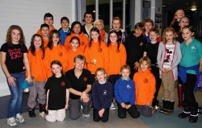

GRANTOWN'S very own "swimming superwoman" has been honoured with a top award for her work in advancing the sport in Strathspey and beyond.
Rose Ash, who has more than 500 swimmers training weekly either under her direct coaching or guidance, won sportScotland Highlands and Islands Coaching Awards Young Person's Coach of the Year 2011.
Grantown Swim Club bosses nominated Rose for her commitment and dedication in promoting swimming in the strath.
They said she not only spends an enormous amount of time poolside, but does an incredible amount of work at home.
She organises, runs and coaches young non-swimmers through to national level swimmers.
Fraser Mackellar, Grantown Swimming Club chairman, said: "Rose has been involved with the club from day one over 12 years ago when it comprised just 12 swimmers.
"Since then, the club and Rose have came a long way as we now have 75 swimmers in the club.
"She has put in an enormous amount of effort over these years and made a massive contribution to swimming within our area, and to receive the Highland Coach award is certainly merited."
Donna Reilly, leisure manager for High Life Highland in Badenoch and Strathspey, said: "I am delighted Rose's coaching skills have been recognised with this award and am pleased to have her co-ordinating our very successful Learn To Swim programme."
Rose works with parents and toddlers groups, primary schools, the Scottish Amateur Swimming Association Learn to Swim programme, Grantown Swim Club, and regional swimmers.
She also finds time to organise special training at other pools, including 50m experience at Stirling, diving practice at Inverness, and inter-club events with Nairn.
Read the full story in this week's 'Strathy'

Area of Work | Facilities
Location | All High Life Highland Leisure Facilities
Title of piece of work | Move it To Lose It Campaign
Description – the purpose, targets | Move It To Lose It (MITLI) ran in all High Life Highland Leisure Facilities in November 2011 and January 2012. The main aim of the campaign was to encourage people to participate in regular exercise, eat healthy and maintain a healthy weight or lose weight in a positive fun supported environment.  The campaign also provided High Life Highland a platform to raise the profile of High Life Highland, emphasise the value of High Life membership and showcased the services and facilities available to High Life Members.  As a new organisation it also provided the High Life Leisure Team with a shared goal and to focus on the customer driven values of HLH
Who were / are the staff involved | Leisure Centre staff
The results / numbers involved / feedback | 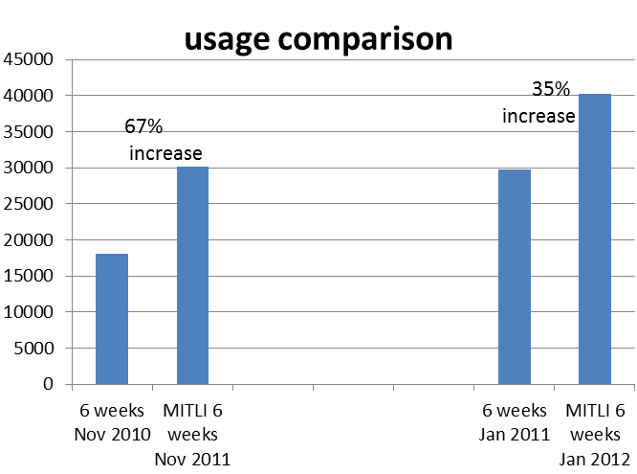  The initial MITLI programme in Nov/Dec saw a 67% increase in usage from the previous year – at a time when facilities are at their quietest  The second MITLI programme shows a 35% increase in usage from the previous year – at a time when our facilities are at their busiest.  Total number of participants for November and January Promotion was 2660  Total weight lost since Novembers is 510 stone throughout the Highlands  High Life Membership increased by 1.2% which equates to 100 new membership totalling £25,000 plus additional income of £8,500 was generate by the customers who opted to purchase the six week option  Customer feedback:  What difference has taking part in this challenge had on you?  Good motivation and degree of accountability knowing you will be getting weighed each week  Encouraged me to keep coming to exercise and stay off the sofa  Spent more time in the centre and not in front of the TV  Got rid of boredom and increased my confidence  More aware of body measurements  Improved fitness, weight and inches lost  What did you enjoy most about the challenge?  Attending new classes and meeting new people  Personal goal setting and not doing it alone  Having a laugh whilst exercising  Motivation from the staff and the good banter!
Photographs / links
THC Convenor Sandy Park presents MITLI winner Johanna Quinney with her prize

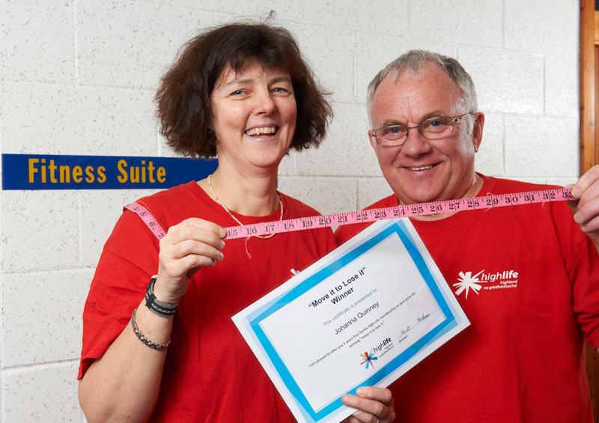

Area of Work | Libraries
Location | Library Support Unit
Title of piece of work | Using e-technology in the acquisition of library materials
Description – the purpose, targets | For the third year, Highland Libraries has achieved e4libraries accreditation, awarded by BIC (Book Industry Communication)  BIC is an independent organisation sponsored by book trade agencies including the Chartered Institute of Library and Information Professionals to promote the implementation of e-commerce and the application of international standard processes.  e4libraries encourages the use of technology in public and academic libraries, based around the belief that investment in technology can go some way towards solving the funding issues for libraries and is a real alternative to closures or book stock reductions.  The e4libraries accreditation scheme recognises the achievements of libraries, library suppliers and library management system providers who have demonstrated excellence in the use of e-technology.  Highland Libraries won accreditation for its application of electronic procedures to all aspects of the acquisitions process including the sourcing of bibliographic information, and its implementation of interoperability between the Library Management System and Oracle, and of self-service technology at a number of libraries.
Who were/are the staff involved | Senior Librarian, Systems - John Dempster  Brenda Hoare – Senior Library Assistant  Robert Reid – Librarian Data Creator  Ian Dalrymple – Assistant Network Librarian
The results/numbers involved/feedback | 23 libraries (public and academic) have achieved e4libraries accreditation for 2012, three of them in Scotland. High Life Highland Libraries is one of two Scottish public libraries to have achieved accreditation – the other is Glasgow Life.
Photographs / links

A description of the accreditation scheme is available via http://www.bic.org.uk/e4libraries/15/ACCREDITATION-SCHEME/
and a list of accredited libraries at http://www.bic.org.uk/e4librariesfiles/pdfs/1201%20accreditees%20list.pdf

Area of Work | Museums
Location | Highland Folk Museum
Title of piece of work | HFM receives VisitScotland green tourism award
Description – the purpose, targets | Following the inspection visit in October 2011 The Highland Folk Museum was considered to have met the criteria for the Gold Award.  The scheme aims to reduce environmental impact and identify cost savings through efficiencies. It also improves public image and links Quality with the Environment.  The Folk Museum achieved 85% (Gold Award starts at 80%)
Who were/are the staff involved | Former Operations Manager - Helen Powell
The results/numbers involved/feedback | Museum staff were cited as having a genuine interest in green issues and filtering these down to visitors touring the site.
Photographs / links



Area of Work | Sport
Location | Inverness Leisure (Event Location)
Title of piece of work | Highland Disability Sport - “Sportshall Agility Challenge”
Description – the purpose, targets | 108 pupils from schools all around The Highlands took part in the Sportshall Agility Challenge. The entry this year was one of the largest since it began in 2006.  This was an opportunity for pupils with physical, learning or sensory disabilities from P4 to Secondary to try out their skills in the decathlon disciplines at the renowned Sportshall Athletics Arena.  The challenge is designed to provide opportunities for large numbers of young people to participate whilst testing the individual sporting skills of the individual.
Who were/are the staff involved | Charlie Forbes - Disability Sports Officer  Lee Duff – Active Schools  Lesley Jones - Highland Disability Sport Administrator
The results/numbers involved/feedback | From the results a team of 10 was selected to compete at the National Sports hall Final in Stirling on Wednesday 29th February.  The team consists 5 athletes with learning disabilities and 5 with physical or sensory disabilities and is as follows:  Drummond School - Paul Davidson, Finlay MacLennan, Sion Wood  Hilton Primary - Leon Brown, Hannah Robertson  St Clements - Matthew Paterson  Dingwall Academy - Ruaridh Reid  Durness Primary - Ellie Jackson  Inverness Royal Academy - Megan Donaldson  Merkinch Primary – Lorna Kemp
Photographs / links

Some of the Highland participants awaiting the results from the National Final 2 years ago

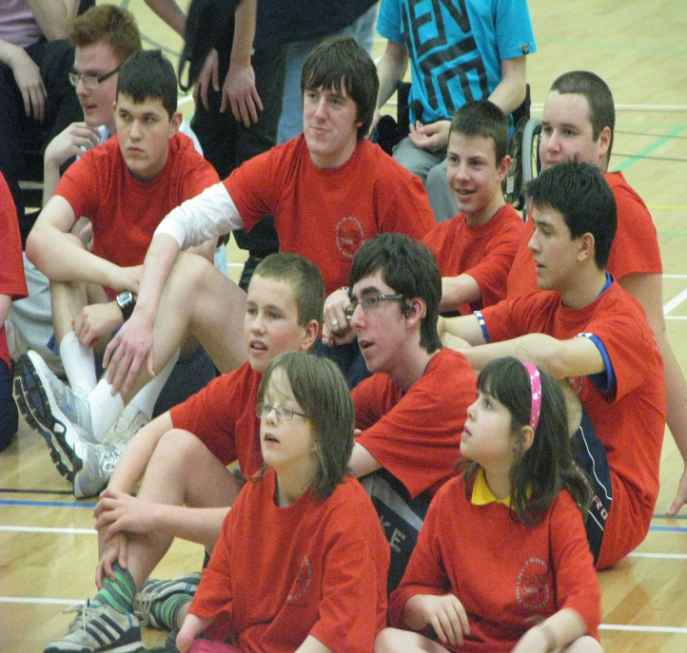

Area of Work | Sport
Location | Farr ILC, Bettyhill
Title of piece of work | Farr ILC’s first young sports leaders on course for award
Description – the purpose, targets | Melvich Primary School primary 7 pupils have been working on becoming the first to achieve their young sports leaders award.  Young Sports Leaders is the first step towards a Sports Leadership Award which young people can complete in high school.
Who were/are the staff involved | Active Schools Coordinator Sean Wyllie
The results/numbers involved/feedback | 4 primary seven pupils plus 14 primary 1-3 children.  The pupils held a practice games session with primary 1-3 classes and learnt a great deal.  Each young leader was responsible for leading one game during the session and they now feel more confident to organise games for younger children in the playground.  Following the session the P7s discussed and evaluated one other’s performance based on the six principles of Young Sports Leaders programme (Organisation, Co-operation, Communication, Responsibility, Safety and Enjoyment).  The next step will be observe their progress in the playground at break time and to award Young Sports Leaders certificates towards the end of term, as well as ensuring the Leaders continue their good work into the summer term.
Photographs / links  Photo 219 - Sean leads a game of “Time Bomb”  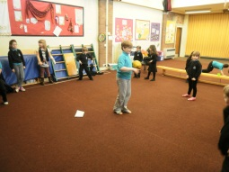 |  | Photo 217 - Lachlan leads a game “Smakball”  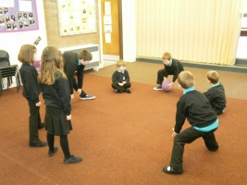

Area of Work | Sport
Location | Fort William
Title of piece of work | Lochaber Dance Platform
Description – the purpose, targets | A dance performance event, in which girls get to showcase their creativity and talents.  Encourages girls to become active when young and stay involved in activity as they go to high school and become teenagers.  High school girls get together in groups, make up dances, choose music and costumes and perform to an audience.  High school girls volunteer to run dance classes at the feeder primary schools and teach them a dance to perform.  Local professional dance teachers and groups showcase their work.  Approx. 200 young people from 5-18 years old take part.
Who were/are the staff involved | Organised by Active Schools Co-ordinator, Bridget Thomas.  Helped by volunteers, pupils, former pupils, staff and parents.
The results/numbers involved/feedback | This year approx. 200 young people took part from 3 high schools and 8 primary schools.  Tickets sold out and 600 people watched the performances over 2 nights.
Photographs / links

- Performers before the show starts (photo credit – The Write Image)
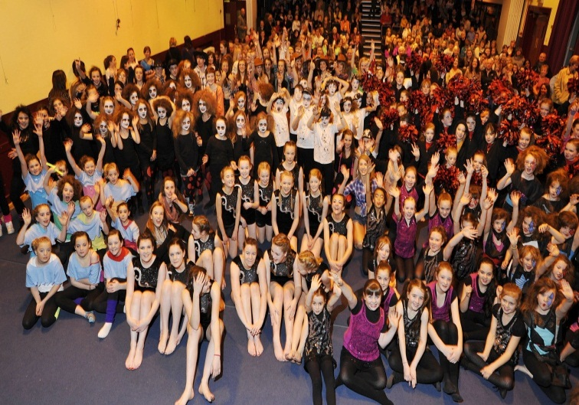

- Dancers from Upper Achintore Primary School

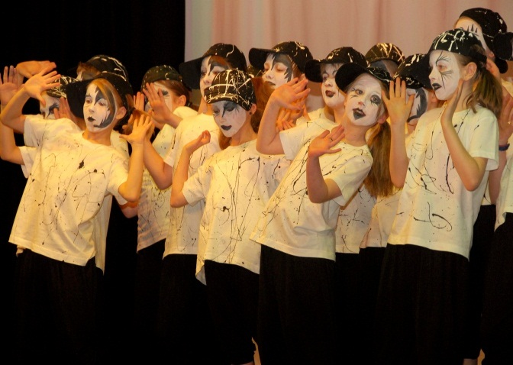

Area of Work | Sport
Location | Scottish Golf Academy Centre, Nairn Dunbar Golf Club
Title of piece of work | Scottish Golf Academy juniors
Description – the purpose, targets | Performance targets for Pathway in golf
Who were/are the staff involved | Junior Golf Manager – Willie Mackay
The results/numbers involved/feedback | 3 juniors selected for the Scottish Golf Academy.  Andrew Burgess & Sandy Scott, The Nairn Golf Club and Alasdair Ross, Fort William Golf Club.
Photographs / links

Sandy Scott & Andrew Burgess (The Nairn Golf Club)

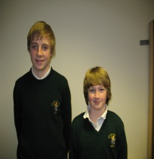
Alasdair Ross (Fort William Golf Club)

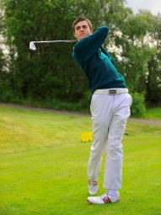

Area of Work | Sport
Location | Nairn
Title of piece of work | Sports Leaders Project
Description – the purpose, targets | Four Nairn Academy Sports Leaders have an exciting summer ahead, having secured apprenticeships on the Venue Operations team who will work in and around the Olympic Park and behind the scenes helping to deliver Coca-Cola’s London 2012 Olympic Games.  The newly appointed team members (Jamie McDonald, Deanna Lundie and Kirsty Ewen) were hand-picked from hundreds of applicants after being put through their paces at a selection weekend.  The applicants were set ‘Apprentice’ style tasks; testing their commitment to their roles and their ability to work as part of a team. A group of around 40 ‘apprentices’ will have the once-in-a-lifetime chance to be a part of London 2012 while gaining valuable training and work experience along the way.  After the Games, the Sports Leaders will be given a helping hand with their future careers, with individual employment references and the chance to apply for any relevant permanent job roles. What better legacy from Olympics 2012?  Jamie McDonald who has been at the forefront of the Young Ambassador Programme in Highland has also been selected to be one of the Torch Bearers who will carry the flame as it travels through Scotland. In 2010 Jamie was nominated Sports Leader of the Year by Coaching Highland.  Whilst Jamie, Deanna & Kirsty head off to London 2012 another of their team mates is heading for USA. Stephanie Ford - Coaching Highlands 2011 Sports Leader of the year has been selected by Sports Leaders USA to spend the summer Coaching at their Trails End Camp in Pennsylvania.  The four young people gained their vast leadership experience and coaching qualifications through the Active Schools Initiative.
Who were / are the staff involved | Elizabeth McDonald Active Schools Co- ordinator

Area of Work | Youth Work
Location | Highland wide
Title of piece of work | National pilot project looking at The Duke of  Edinburgh Award and additional support needs
Description – the purpose, targets | The purpose of the pilot project was to support development of The Duke of Edinburgh Award to include young people with additional support needs.  Targets from DofE Scotland include:-  Operating Authorities support programme delivered within a designated new centre  Use of eDofE is encouraged as an evaluation tool and young people supported to use this where appropriate  Centres to contribute and comments to the development of ASN materials  Centres to develop a specific CfE policy briefing relating to the DofE and ASN work  Centres commit to supporting an ASN seminar to help share good practice  OAs to support a virtual ASN network to share good practice  The project has received external funding from DofE Scotland of £4 000, with an additional £1 000 for an arts project.  High Life Highland has supported the creation of a new additional support needs DofE group within Nansen Highland. This will meet the following outcomes:-  - This project will support For Highland’s Children 3 outcomes to be healthy, active, achieving, and included.  - It will support outcomes related to How Good is our Community Learning & Development relating to working with others and communication.  - It will support young people to be effective contributors and confident individuals in relation to their personal development within Curriculum for Excellence  - The project supports the Education, Culture and Sport service plan performance indicators  - Most vulnerable young people will receive high quality personal support and appropriate opportunities for learning after their school leaving date  - Implement CfE in Highland  - Improved joint working between services and increase provision of high quality post school learning
Who were/are the staff involved | DofE volunteers at Nansen Highland (Clark and Dieter); Isobel Gray (DofE Development Officer); Rebecca Raynes (DofE Manager)
The results/numbers involved/feedback | Nansen has worked with a group of four young women who have all completed their expedition section and are now working on their volunteering, skills and physical sections. One participant has completed her full DofE Bronze award.  Isobel has supported the group with training, to access eDofE and through their expedition section. Resources are being shared with DofE Scotland in order to benefit other groups working with young people with additional support needs.  The progress made by the girls is beyond the expectation of themselves, as well as the Nansen staff team. The project has been so successful that Nansen is already looking to enrol their next group of young people.  Isobel describes her involvement with the project as a “privilege”. DofE Scotland is impressed with the progress which has been made in Highland on the pilot project in the timescale.  Isobel’s latest report states”As the project progresses the girls self-confidence grows, this is now rubbing off on other young people who attend Nansen Highland. A, M, B and H are going to show their completed expedition PowerPoint to the rest of their peers and talk about their experiences in taking part in the Award to encourage them to take part. For some no encouragement is required, watching the girls have given them an appetite and they are eager to enrol”.
Photographs / links

The “Nansen Cuties” team with Kevin Fawcett, DofE Scotland, at the end of their qualifying expedition.

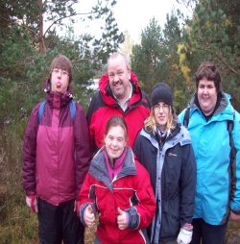

Cooking in the rain!

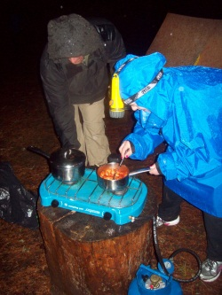

Area of Work | Youth Work
Location | Joss Street, Invergordon
Title of piece of work | TIA  (Tain, Invergordon, Alness, Youth employability project)
Description – the purpose, targets | TIA is an employability programme for young people to help them become more employable and to improve their self- esteem and confidence as well as their CV. The name has come from the fact that the 3 Youth Development Officers who have developed the programme are based in Tain, Invergordon and Alness.  With our intimate knowledge of our own local areas we were increasingly frustrated as to how many of our youngsters appeared to have no ambition or opportunities to gain work.  Our aim therefore was to develop an effective programme where we could collectively engage with a group of youngsters, we then applied and successfully secured funding to run two courses each lasting for ten weeks, twice a week. This to help them into the employment market.
Who were/are the staff involved | Rob Parkes, Tain, Robert Dineen, Invergordon and Janette Douglas Alness, Highlife Highland youth services. Along with Jen Taylor and Elizabeth Dineen (sessional youth workers) also Julie Mackay, SDS and Kelly Duncan, Lifeskills project.
The results/numbers involved/feedback | TIA aimed to keep the numbers manageable and hoped to encourage 12 youngsters to “buy in” to the project but on day 1 we had 19 youngsters.  By the end of the course 14 had been retained and support was offered to those who did not fully engage.  With the course having drawn to a close in December 2011 we have to say that it has most definitely been the most valuable piece of work we have collectively done locally as a youth project. All those youngsters that completed the course have gone on to work placements, college placements or activity agreements some of which will lead to full time employment. There has been a huge improvement in their CV’s including a 1st aid qualification and some of the lads now have a welding course, manual handling and forklift training certificates to show for their involvement in the course.  We had consistent staff each day and many youth workers involved took turns in facilitating different parts of the project. We had a number of invited guests and agencies in to deliver various parts of the course and we the staff enjoyed the course as much as the young people attending.  Feedback was positive from all and received comments such as “every part of this course was relevant for me”.  The second course will now commence on the 17th April.
Photographs / links

