HIGH LIFE HIGHLAND  REPORT TO BOARD OF DIRECTORS  12 December 2014 | AGENDA ITEM  REPORT No HLH /14

HIGH LIFE HIGHLAND SUCCESSES - Report by Chief Executive

Summary

The purpose of this report is to present Directors with the best submissions from staff teams on the successful work being carried out by High Life Highland throughout the Highlands and across all areas of work.

It is recommended that Directors comment on the items presented and note that the selected items will form part of the long list for the annual Staff and Volunteer Award Scheme for 2014/15.

1. | Business Plan Contribution
1.1 | This report supports all the Business Outcomes from the High Life Highland (HLH) Business Plan:  - A positive company image  - A growing company  - Delivery of the contract with THC  - Increased awareness of HLH products and services  - Increased customer satisfaction  - Increased financial sustainability  - Increased internal collaboration  - Increased staff satisfaction  - Safety & environmental compliance
2. | Background
2.1  2.2  2.3  2.4 | The September 2012 meeting agreed the alignment of the successes submitted on a quarterly basis with the Staff and Volunteer Award Scheme. A small assessment group comprising the Chief Executive and 2 Directors was set up to consider future submissions and select up to 15 as “best of” successes for presentation to the Board. The group assessing the submissions this time round were the Chief Executive and Directors Douglas Graham and Jaci Douglas.  The 8 successes presented to this meeting in Appendix A are those selected by the assessment group covering the period from August – November 2014. The full list of all 16 submissions received appears at Appendix B.  The criteria used to select the successes presented to this meeting are distilled from the 9 outcomes which form the basis of the HLH Business Plan:-  - increased internal collaboration & new partnership working;  - doing what we do, but better;  - contributing toward a growing company; and  - contributing toward a positive company image.  Those selected will be added to that forming the long list for the annual staff award system for 2014/15.
3. | Media Interest
3.1 | The table below details press interest relating to High Life Highland for the period August-November 2014. Each piece of coverage has been assessed as positive, neutral or negative in its coverage of HLH or its services. In addition each positive or neutral article has been assigned a financial value. Publicity/media value is calculated using a method known as Advertising Value Equivalency (AVE). AVE provides a formula to indicate the amount the editorial coverage would cost if it were purchased as an equivalent size advert. AVE varies from publication to publication, but a rough rule of thumb is that editorial coverage is worth around 2.5 times more than advertising space.
   | Positive | Neutral | Negative | Total
  No. of Articles | 214 | 20 | 33 | 267
  Financial Value | £185532.93 | £6962.74 | £19460.03 | £211955.70
3.2  3.3 | Negative coverage relates to the recent Highland Council Budget Consultation.  A full set of recent press cuttings will be available at the meeting for Directors’ perusal.
4. | Implications
4.1  4.2  4.3 | Resource Implications – there are no resource implications resulting from the recommendations of this report.  Legal Implications – there are no legal implications resulting from the recommendations of this report.  Risk Implications - there are no new risks resulting from the recommendations of this report.

Recommendation

It is recommended that Directors comment on the items presented and note that the selected items will form part of the long list for the annual Staff and Volunteer Award Scheme for 2014/15.

Signature:

Designation: Chief Executive

Date: 24 November 2014

APPENDIX A



Area of work (e.g. Arts) | Adult Learning (Literacies)
Location | Skye & Lochalsh and Ullapool (Portree, Plockton & Ullapool ILCs)
Title of piece of work | Dyslexia Scotland Skye & Lochalsh Branch: Dyslexia Roadshow
Description of event  (the purpose / targets) | The Dyslexia Scotland Skye and Lochalsh branch was set up at the end of September 2013 by the HLH Adult Learning (Literacies) Co-ordinator and Adult Learning Volunteer Tutors. The aim of the branch is to hold regular meetings and events with a view to raising awareness and offer support to adults/families/professionals with dyslexia and literacy issues.  Working in partnership with Dyslexia Scotland, a Roadshow to raise Dyslexia Awareness visited Portree, Broadford, Kyle, Auchtertyre and Ullapool in August 2014. The 5 day tour started in Ullapool and then went to the Outer Isles and finished off in Skye & Lochalsh.  Throughout the past year, 2 Dyslexia Awareness Raising Sessions have been held in Portree with a total of 41 participants (one session for partner agencies and the other for Portree High School Hostel Staff). An Information Day was also held in Portree in partnership with SLCVO where 26 connections were made.  The year ended with the Roadshow covering Skye, Lochalsh and Ullapool with a total of 125 attendees. The numbers attending the Roadshow in each area were Ullapool (25), Portree (35), Broadford (25), Kyle (25) and Auchtertyre (15) a further 65 visited the Outer Isles part of the tour.  We ran the Roadshow in this area to give partner agencies, adults, youths and professionals an opportunity to come together and openly discuss and embrace literacy issues of which dyslexia is a very common issue. Having dyslexia can leave individuals feeling confused and isolated and the Roadshow was an event run to raise the awareness of the HLH Adult Literacy Team and the Dyslexia Scotland Skye & Lochalsh Branch.  A designated van in partnership with Working on Wheels visited all the areas and a talk was held by Dyslexia Scotland Board Member, Fiona Dickinson in Portree High School.
Which staff were / are involved | Main staff organising the event:  Joey Graham, HLH, Adult Learning Co-ordinator (Literacies)  Lena Gillies, Dyslexia Scotland, National Development Officer  Partnership working with everyone below regarding use of car parks/ facilities/ advertising/ raising profile of Roadshow etc:  Maggie Macdonald, West Highland College, Portree  Colin Macdonald, WHC, Broadford  Elaine Hunter, WHC, Auchtertyre  Carol Huggan, Acting Principal of SFL, Portree High  John Finlayson, Head Teacher, Portree Primary  Helen Hunter, Fiona Gordon, John Cayley, HLH Volunteer Literacy Tutors  Chris Brotherston, HLH, Macphail Centre, Ullapool  Veronica Treanor, Support for Learning, Plockton High
What were the results /  numbers involved /  Feedback | “Bringing the van to Skye & Lochalsh is much appreciated and great for raising awareness”  “Fiona’s talk in the school was excellent – thank you!”  “Amazing turnout and just goes to show how much the service is needed” (Ullapool)  “Many thanks for arranging this roadshow to Portree High School. The feedback was excellent and we have handed out the leaflets to staff. Pupils will definitely benefit from us receiving these resources”  “Very useful and makes you feel less alone”  “I’m glad I’ve come here”  “Very worthwhile and I learnt a lot in a short space of time”  “Staff are very helpful and good to have the one to one contact to know what is available to help my daughter”  “Brilliant to have facilities locally available”  “Easy to access when short of time and in easy location by school”  “It gives people an opportunity from outlying areas to speak to someone and get information”  “Excellent range of resources on display well supported by informed staff. Thanks”  “Informative and enjoyable”  “Great chatting, spoken information helped!”  “Lady giving the talk was so helpful”  “I think there is a need for more training in assessment for dyslexia and general training in supporting people”  “Excellent idea. Lots of valuable information. Thank you”
To which of these outcomes did the project contribute (tick as many as apply)? | Increased internal collaboration and new partnership working x  Doing what we do, but better x  Contributing towards a growing company x  Contributing towards a positive company image x
Please explain (in a maximum of 250 words) how this piece of work made an “exceptional contribution” | - The Roadshow brought awareness of dyslexia to professionals, parents, children and adults with dyslexia or an interest in dyslexia.  - Partnership working from Portree Primary, Portree High, Plockton High, Ullapool High, Macphail Centre, West Highland College UHI; Portree, Broadford & Auchtertyre with the HLH Adult Learning Co-ordinator was a huge attribute to the success of the Roadshow, their support has been gratefully received and acknowledged.  - The event highlighted the extent of support and understanding that is available to all individuals who require help with literacy issues both through Dyslexia Scotland as a national network and High Life Highland within a more local context.  - Over 20 adults have shown an interest in helping out with either future branch events or becoming a tutor within the HLH Literacies Team.  - Three volunteer tutors are interested in studying the PDA Understanding and Supporting Individuals with Dyslexia through North Highland College.  - A further 7 volunteers will join the Branch committee which has now grown to 12 members. The Branch volunteers will take over the running of the Branch from the HLH Adult Learning Co-ordinator to further develop the needs of dyslexia awareness and support in this area.  - There is an excellent level of enthusiasm between all the partner agencies about being able to seek help and support both locally and nationally.  - The Roadshow was an excellent end to the first year of the Dyslexia Branch and has definitely raised the profile of both Dyslexia Scotland and the High Life Highland Literacies Team.
Attach photos or web links | 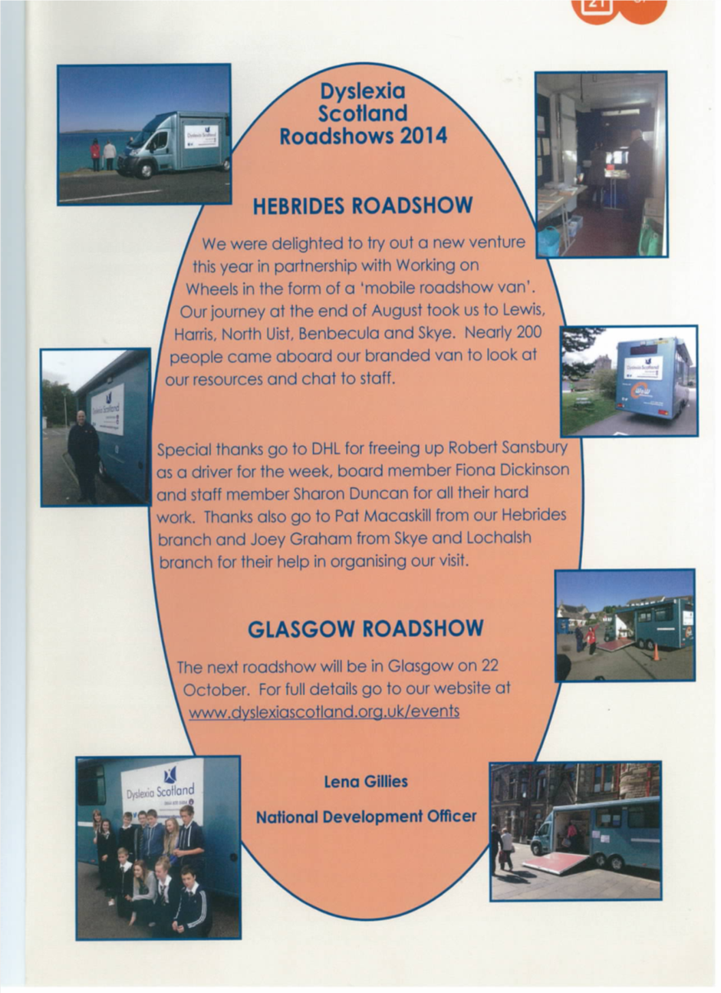  Extract above taken from the Dyslexia Voice Magazine.  Roadshow Feedback video on You Tube:  https://www.youtube.com/watch?v=iK2M_o5dQRA&list=UU1aSDfa8h-3IooqEvownR7A  Website Link to Dyslexia Scotland Skye & Lochalsh Branch:  http://www.dyslexiascotland.org.uk/your-branch/skye-and-lochalsh  Facebook Link to Dyslexia Scotland Skye & Lochalsh Branch:  https://www.facebook.com/dyslexiascotlandskyeandlochalsh?ref=hl  PDA Understanding & Supporting Individuals with Dyslexia Link:  http://www.northhighland.uhi.ac.uk/courses/pda-understanding-and-supporting-individuals-with-dyslexia
Name & email of staff member submitting news item | Joey Graham  Joey.graham@highlifehighland.com

Area of work (e.g. Arts) | Archives
Location | The Highland Archive and Registration Centre
Title of piece of work | Royal National Mòd Fringe Events 2014
Description of event  (the purpose / targets) | The 15th-16th October witnessed a programme of events taking place at the Highland Archive and Registration Centre as part of the Royal National Mòd Fringe. The aim in putting together the programme was to raise the profile of the service and to attract people of all ages who might not previously have visited the Archives:-  The first event consisted of a mock Gaelic Wedding. The bride and groom were children from the Bun sgoil Gàidhlig Inbhir Nis and the ceremony was conducted in Gaelic by Scott Russell, Assistant Registrar. Traditional Gaelic songs, music and dancing (including the Wedding march, Strip the Willow and the Dashing White Sergeant) followed the service.  The second event; a fascinating talk on the history of 2 Gaelic families as a result of research undertaken by the Family Historian: the poetess Màiri Mhòr nan Òran and the Calder family whose details are given, very unusually in Gaelic rather than English, in the 1881 Census. A recitation in Gaelic of Màiri’s poem “Òran Beinn Lì” was included.  The third event was an evening of music and song presented by Hugh Dan MacLennan, Shinty Historian about the Fallen Heroes of Shinty, including those who were killed in action during World War One. Hugh was accompanied by Duncan MacGillivray of Calrossie, Tain, former member of Battlefield Band and Northern Meeting winner who accompanied the images with pipe music, some of which has been composed on the battlefield.  The fourth event consisted of a talk on Gaelic place names in and around Inverness by Dr Jacob King of Ainmean Àite na h-Alba.
Which staff were / are involved | Alison Mason, Anne Fraser, Fiona MacLeod, Colin Waller, Peter Mennie, Debbie Potter, Lorna Steele, Richard Aitken, Grant Begg.
What were the results /  numbers involved /  Feedback | 153 children and adults attended the events.  The event featured in the 2014 Royal National Mòd Fringe Programme and was included in Moray Firth Radio’s publicity of the Fringe. The programme of events created great excitement and introduced people to the Highland Archive Service who had previously been unaware of its existence and of its work.  The feedback was universally very positive both in person and on Facebook.
To which of these outcomes did the project contribute (tick as many as apply)? | Increased internal collaboration and new partnership working ✓  Doing what we do, but better ✓  Contributing towards a growing company ✓  Contributing towards a positive company image ✓
Please explain (in a maximum of 250 words) how this piece of work made an “exceptional contribution” | This event made an exceptional contribution for the following reasons:  - It required close collaboration between the Highland Archive Service and several partners (the Royal National Mòd Organisation, the Highland Council Registration Service, the Bun sgoil Gàidhlig Inbhir Nis, TMC (High Life Highland Traditional Music Classes), Eden Court and Ainmean Àite na h-Alba in order for this to be achieved, resulting in improved understanding and stronger working relationships.  - It demonstrated the capability of the staff involved to negotiate successfully with a prestigious external national organisation, i.e. the Royal National Mòd.  - It reinforced the idea that the service was sufficiently flexible to positively embrace a new concept, i.e. making use of the facilities of the Highland Archive and Registration Centre in new ways, for example involving music and dance.  - It brought people into the building and into contact with archive staff who would not have achieved this of their own accord, the centre being regarded by many members of the public as “off-limits” to them.  - It helped change the view some members of the public still have of the old fashioned, stuffy nature of archives and archivists.  - It formed a link in the minds of those attending between archives and heritage, and therefore encouraging potential future use of the service and building.
Attach photos or web links | 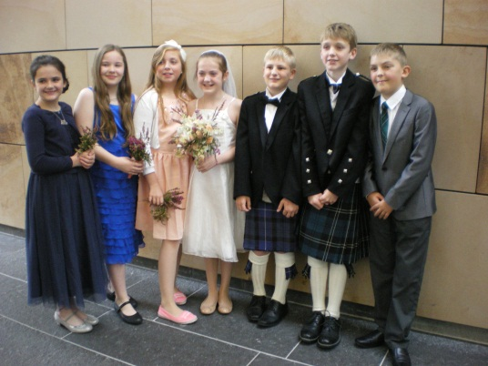 The bridal party.
Name & email of staff member submitting news item | Janet Baker  Janet.baker@highlifehighland.com

Area of work (e.g. Arts) | Facilities
Location | Badenoch & Strathspey
Title of piece of work | Boot Camp
Description of event  (the purpose / targets) | Boot Camp  4 week non-residential military inspired fitness camp at Badenoch & Strathspey Leisure Centres
Which staff were / are involved | Instructors: Sam Cairns, Ali Page, Hayden Gray  Manager: Donna Reilly  Leisure Supervisors: Gary Gray, Fraser Tulloch, Jade Longworth, Kirsteen MacDonald, Kirsti McIntyre and Ross Dudgeon
What were the results /  numbers involved /  Feedback | 95 recruits  activity levels increased; attendance increased; average weight loss of 2lbs per participant; social media interaction; press interest; positive feedback; income generation; retention for existing members and attraction for new members
To which of these outcomes did the project contribute (tick as many as apply)? | Increased internal collaboration and new partnership working ◻  Doing what we do, but better X  Contributing towards a growing company X  Contributing towards a positive company image X
Please explain (in a maximum of 250 words) how this piece of work made an “exceptional contribution” | Boot Camp tapped into the growing industry trend of outdoor fitness training and increased usage at a time of year when attendance declines as customers prefer to be exercising outdoors. The leisure teams across the 3 sites collaborated to plan fun, inventive and exciting sessions that engaged recruits across the valley and encouraged participants to get back to basics and improve their health and wellbeing in the great outdoors. This was a fresh challenge for the instructors that was exceptionally well received by all involved. There was positive customer interaction on social media and on the ground. Great community camaraderie throughout the camps and press coverage in the local herald contributing to a positive, growing company image.  Recruits received:  • fitness assessment & body composition  • Boot camp t shirt  • Boot camp blast weekly home work out plan  • Boot camp booster daily challenge  • Boot camp bible eat clean, train dirty  • Boot camp diploma certificate of achievement on graduation  • 2 x 1 hour instructed outdoor sessions per week  As boot camp was introduced as a new activity, it was an opportunity for income generation. The camp was chargeable at £40 non-member, £20 member for the 4 week Programme.  Income generated was £1740.  10 non-members participated, all of those that completed the challenge converted to all inclusive status.
Attach photos or web links | 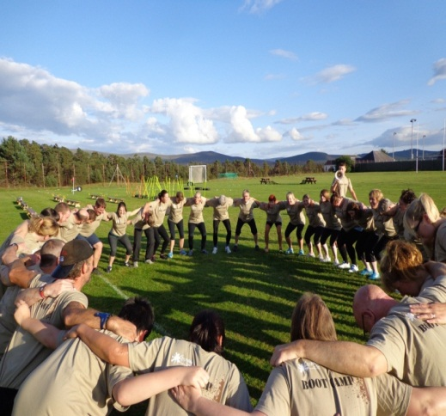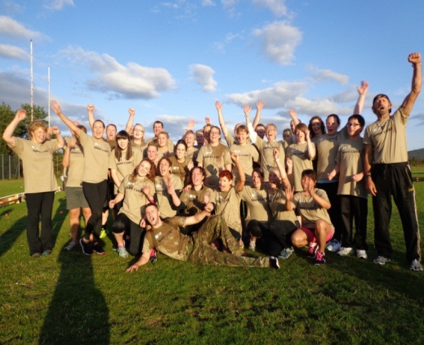  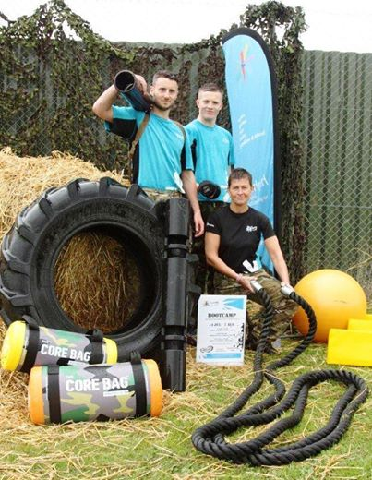
Name & email of staff member submitting news item | Donna Reilly  Donna.reilly@highlifehighland.com

Area of work (e.g. Arts) | Facilities
Location | All
Title of piece of work | Junior Try Tri and Mini Mudder
Description of event  (the purpose / targets) | Youth triathlon and family fun day to promote participation in sport and family activities
Which staff were / are involved | All leisure staff at Craig Maclean Leisure Centre  Leisure Supervisors: Fraser Tulloch, Gary Gray, Jade Longworth  Leisure Manager: Donna Reilly  Active schools: Dawn Horsburgh and Tina Gibson  Youth work: Lita Leslie
What were the results /  numbers involved /  Feedback | 140 youngsters participated from 3 to 12 years old  Press interest  Social media following  Community engagement  Partnership working - active, schools, youth, facilities, committee
To which of these outcomes did the project contribute (tick as many as apply)? | Increased internal collaboration and new partnership working X  Doing what we do, but better X  Contributing towards a growing company X  Contributing towards a positive company image X
Please explain (in a maximum of 250 words) how this piece of work made an “exceptional contribution” | The event aims to provide inspiration for 3 to 12 years old to splash, pedal and dash in a fun and safe environment using a professional timing system to get a real taste of the sport. Around 500 people were attracted to the event, which was organised by facilities and supported by actives schools and youth work. The event attracted funding from Scotmid and the Ward Discretionary fund. Participants were charged Highlife and non-member prices which generated £1630 thus the event broke even. Attractions on the day were laser tag, zorbs, bouncy castle and mini mudder obstacle course.  Participants were awarded with t- shirt, medal and trophies.  The Try Tri is an ideal way to get youngsters active and engaged in growing sports whilst having a fun day out for all the family it was deemed a great success with some excellent feedback from parents.  Andy Ford Cairngorms Nature Manager said “The whole family really enjoyed the fun day yesterday. It was one of the best events we have been to in the Strath. Niamh overcame her fear and went for it, realising that cycling on wet grass isn’t quite as much fun as she had hoped. Arran found his competitive streak, won his wave and re-enforced that he loves getting muddy.”  Rosana Lambie said “I wanted to say big thank you to all the wonderful staff and marshals who helped during the try tri event and made it such a success”
Attach photos or web links | 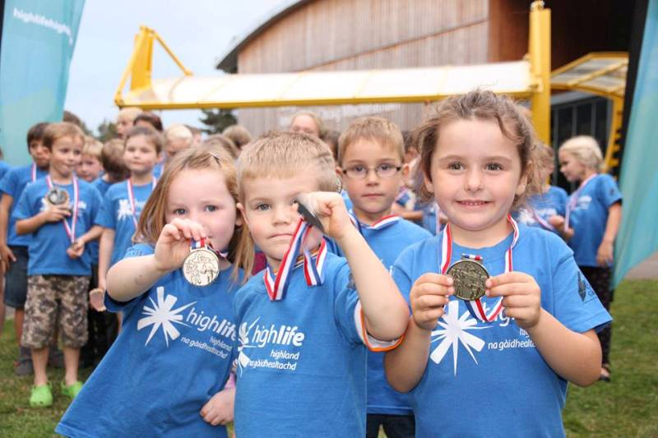  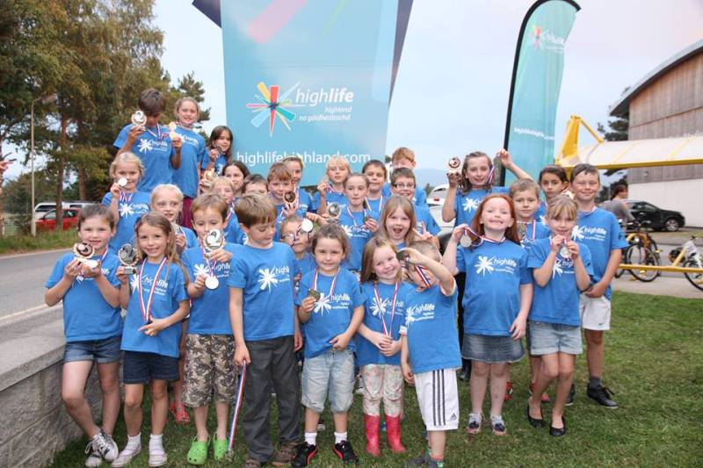
Name & email of staff member submitting news item | Donna Reilly  Donna.reilly@highlifehighland.com

Area of work (e.g. Arts) | Facilities
Location | All High Life Highland spin sites
Title of piece of work | Tour De France Challenge
Description of event  (the purpose / targets) | Utilising the Tour De France event as an in-house challenge to combat decline in attendance at indoor spinning over summer months.
Which staff were / are involved | All participating facility staff  Principal Manager: John O’Kane  Leisure Manager: Donna Reilly  Leisure supervisors: Jade Longworth and Jess Sutherland
What were the results /  numbers involved /  Feedback | 262 participants registered across 12 participating facilities.  30% increase in spinning attendance over the 3 week TDF period in comparison to last year usage over the same period (1134 to 1468)
To which of these outcomes did the project contribute (tick as many as apply)? | Increased internal collaboration and new partnership working  Doing what we do, but better X  Contributing towards a growing company X  Contributing towards a positive company image X
Please explain (in a maximum of 250 words) how this piece of work made an “exceptional contribution” | TDF challenge sought to take advantage of the existing promotion associated with this annual event in the sporting calendar to combat the decline in Indoor cycling over the summer months. The challenge was easy to administer and cost effective as the classes were already scheduled to take place. Halfords supported the challenge by providing an official Carrera TDF road bike at cost. The ethos behind the challenge was spin to win. Each attendance at a spin class generated entry into the prize draw for the grand prize and there was also a site winner who was awarded a TDF/HLH cycle top. The instructors rose to the challenge by planning the rides based on TDF landmarks, routes, techniques and race formations which livened up the usual spin class.  Customers enjoyed the change and the challenge aspect.  The desired outcome was achieved as evidenced by usage increasing by 30%.
Attach photos or web links | 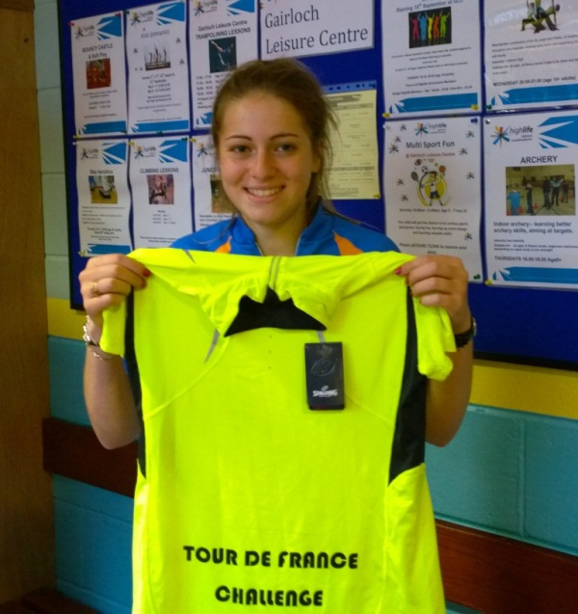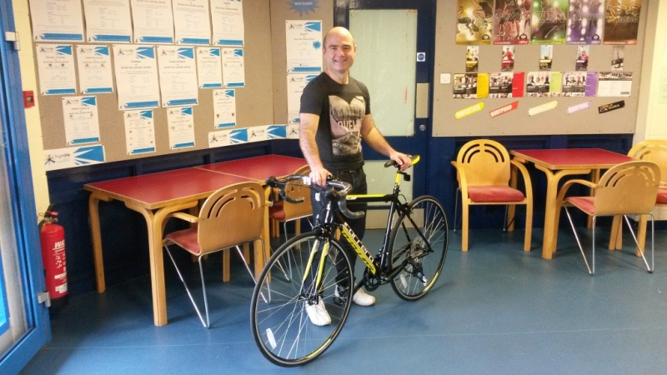
Name & email of staff member submitting news item | Donna Reilly  Donna.reilly@highlifehighland.com

Area of work (e.g. Arts) | Libraries
Location | ALL
Title of piece of work | High Life Highland Libraries submission through to finals of The Highland Council Quality Awards.
Description of event  (the purpose / targets) | Libraries submission “Delivering the best used and most cost effective library service in Scotland” is one of the final three nominations in category 6, “Working together for efficiency and Service Improvement”. The project has also been included in THC’s submission for the COSLA awards.
Which staff were / are involved | All library staff and many HLH partners.
What were the results /  numbers involved /  Feedback | Results will be announced at the Awards Ceremony on 12 November 2014.
To which of these outcomes did the project contribute (tick as many as apply)? | Increased internal collaboration and new partnership working X  Doing what we do, but better X  Contributing towards a growing company X  Contributing towards a positive company image X
Please explain (in a maximum of 250 words) how this piece of work made an “exceptional contribution” | In recent years libraries nationally have faced significant challenges including shrinking budgets and shifting priorities; this has resulted in a number of highly publicised and controversial library closures and widespread cuts to opening hours. Over the last 2 years High Life Highland, on behalf of The Highland Council, has taken the strategic decision to return to first principles and conduct a radical “top to bottom” service redesign based on the needs of customers and stakeholders. This has resulted in a dynamic, innovative and continuously improving service that addresses national priorities and leads the nation in terms of the service’s key performance indicators - visitor numbers and cost efficiency. Being nominated for this award recognises the progress that High Life Highland has made in embracing change and delivering a continuously improving library service for the 21st century.
Attach photos or web links
Name & email of staff member submitting news item | john.west@highlifehighland.com

Area of work (e.g. Arts) | Libraries/Youth Work
Location | Culloden Academy and Culloden Library, Culloden
Title of piece of work | Summer Teen Volunteers
Description of event  (the purpose / targets) | This pilot project tested the use of teen volunteers in Culloden Library over the summer to assist mainly in the administration of the annual Summer Reading Challenge. We were ideally looking for young people under the age of 16 as there are few opportunities for this age group and they often have more time to spare as they are not as tied up with paid work and other commitments.  The volunteers were then recruited, selected and trained in the school environment before being assigned a morning shift (10-1), and an afternoon shift (3-5) every week as well as two weekend shifts alongside other volunteers over the placement. This was to keep the commitment manageable and to enable them to work independently as well as alongside their peers.  The volunteers were also encouraged to use these hours as part of an achievement award such as the Saltire or Duke of Edinburgh awards and these often require group work as well as individual work.  The volunteers then completed their placement and a group activity was held in the last week to assess their thoughts on the scheme and wrap-up the program. Rather than conduct exit interviews, a group session was held to celebrate their achievement and create a piece of art to display in the library.
Which staff were / are involved | Michelle Gowans-Network Librarian;  Lita Leslie–Youth Development Officer;  Kate Gordon–Library Supervisor and the rest of the Culloden Library team.
What were the results /  numbers involved /  Feedback | The 5 young people selected were an invaluable addition to the library team over the summer and were praised not only by the staff they were working with but generally by borrowers visiting the library. The group completed a total of 174 hours of work at the library over the 6-week period.  Everyone appreciated the enthusiasm and energy they brought to the library over the summer, particularly in encouraging younger children to enjoy reading and participate in the Summer Reading Challenge.  This is important in that the younger children have the opportunity to see older children place a value on reading and therefore see it as a worthwhile and stimulating activity.  The teens themselves responded very positively to the experience stating that:  Sarah: “I enjoyed helping out at the library. It was fun talking to the children and helping them make the Chinese Dragons. It made me see how the library system works and I enjoyed watching all the tasks get done quickly and easily.”  Ellie-Louise: “I really enjoyed my summer here at Culloden Library. Getting an insight into what it is like to work in the library was very interesting and I loved it. If this opportunity opened up again next year I would definitely apply for it again. I never did the reading challenge when I was little but I now wish I did because it looked fun.”  Fraser: “Cool, can you do this next year? Great fun, interesting, challenging, good experience, there were very nice staff, friendly nonstop fun, made good friends, happy never bored, don’t want to end, gave me more confidence, it will help me for an interview.”
To which of these outcomes did the project contribute (tick as many as apply)? | Increased internal collaboration and new partnership working X  Doing what we do, but better X  Contributing towards a growing company X  Contributing towards a positive company image X
Please explain (in a maximum of 250 words) how this piece of work made an “exceptional contribution” | This project is a good example of internal collaboration in that both the Network Librarian and Youth Development Officer are working with the pupils at the Academy and have the opportunity to encourage them to engage them in their community. We jointly recruited, interviewed, trained, mentored and assessed the volunteers and were involved in submitting their hours towards achievement awards.  Many young people are interested in becoming involved but find there are often few opportunities within their local area to volunteer. By working together, we were able to create an opportunity for them to volunteer and ensure that they had appropriate support for undertaking the work. They were recruited and assessed in the same manner as our permanent members of staff so they also gained valuable interview and work experience.
Attach photos or web links | 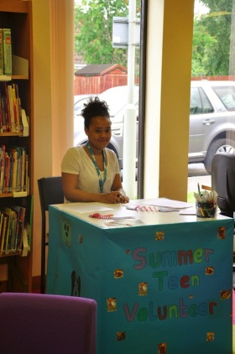 Lindiwe, a regular volunteer at the school library, prepares to receive children visiting Culloden Library during the Summer.  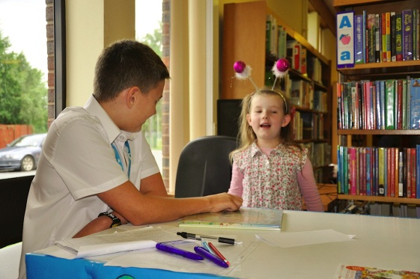 Fraser listens to an enthusiastic child report back on the books she read as part of the Summer Reading Challenge.  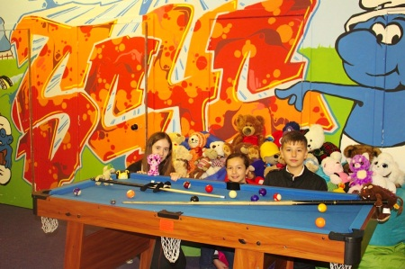 Sarah, Ellie and Fraser preparing one of the photo shoots during the Teddy Bear’s Summer Camp activity.  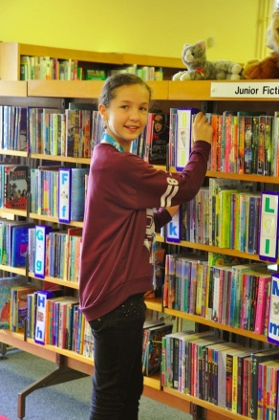 Ellie tidying shelves.  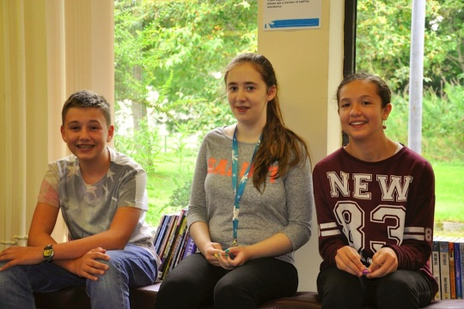 Fraser, Sarah and Ellie during the group activity held to celebrate their achievements  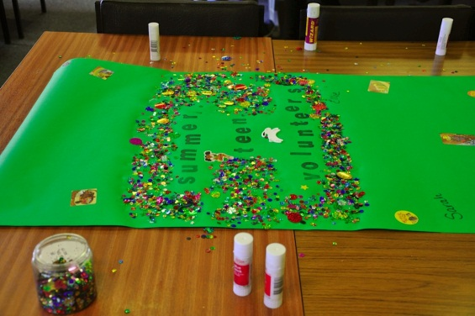 The artwork created as part of their group activity together. This was hung in the library to remind borrowers of their fantastic contribution this summer.
Name & email of staff member submitting news item | Michelle Gowans, Network Librarian – Culloden  michelle.gowans@highlifehighland.com  Lita Leslie, Youth Development Officer – Culloden  Lita.leslie@highlifehighland.com

Area of work (e.g. Arts) | Youthwork
Location | Cromarty
Title of piece of work | Man Over Board
Description of event  (the purpose / targets) | The second year of a weekly sailing and kayaking project provided by Adventures Unlimited Scotland, a Community Interest Company based in Cromarty, which operates a 21’ sailing yacht and RIB safety Boat from Cromarty harbour. This is funded by The Middleton Trust. The project runs from April to September.  The aims of the project are to introduce young people from Cromarty and the surrounding areas to the sport of sailing and to provide a greater understanding of the sea, its potential both for leisure and employment opportunities, increased environmental awareness and also an appreciation of the dangers and hazards associated with the marine environment.
Which staff were / are involved | Instructors and volunteers from Adventures Unlimited Scotland  Wanda Mackay  Fraser Thomson
What were the results /  numbers involved /  Feedback | This year we have provided 16 sailing sessions on Tuesday evenings, attended by a total of 44 young people aged between 11 and 18. Some young people have returned to sail from last year and others are new to us. We also hosted visiting groups from Invergordon.  Feedback from some of the young people: one young lad with Autism was particularly scared of the harbor, the water and everything to do with the sailing after a few weeks of showing him about and building his confidence he was persuaded to just try the sailing for 30 minutes – 3 hours later he came back in telling me one word ‘Awesome’ – only thing he was gutted at was he had forgotten his camera but could he get a slot at next week’s Sailing.  Young people loved the Rib Petrol heads (boys) in fact much preferred the rib and once they had learnt the technical skills of carefully maneuvering in and around the harbor, and the other boats, they were most proud and loved people watching them. The girls preferred it on the yacht they did helm steering, lots of team work and sharing of jobs and then changing roles they used VHF radios, used maps to guide about rigs and other boats, some weeks worked out the tides, mounting the sails as the girls discovered if you go on the yacht first you come back in on the rib so don’t have to do all the hard work of sorting all the sails back out. Going out on the Ringo was just a blast although I thought I saw a dark shadow underneath me out in the Firth – we all laughed and we later found out it was a – Basking Shark – the next week no one was so keen for the Ringo.  Young people loved seeing all the birds and dolphins, watching many a cruise liner the Ruby Princess close up and waving to the many onboard. They enjoyed boarding a Tall Ship The Ts Royalist and spending 2 days on many activities with the 30 sea cadet’s boy’s and girls and boys brigade that had sailed to Cromarty from Newcastle over one week.  Many tourists and local boat owners including the local boat club commented on the fact what a great opportunity for young people and enjoyed watching them each week. The Boat club very kindly got the yacht put in the water for us and so we provided all the home baking and teas for their boat that day all in all supporting good relations between the younger and older generations. Lots of stories and memories were told down at the harbour and many a laugh we all had, all the young people evaluated these points.  Young people as a result now have a lot more respect and responsibility down at the harbour and think about other people’s boats while they climb over and tie up.
To which of these outcomes did the project contribute (tick as many as apply)? | Increased internal collaboration and new partnership working X  Doing what we do, but better  Contributing towards a growing company  Contributing towards a positive company image X
Please explain (in a maximum of 250 words) how this piece of work made an “exceptional contribution” | The weekly sessions are always well attended (6 young people per session) and many young people return regularly. For many this has been their first experience of being out on the water, some have been apprehensive about this but quickly relax and enjoy the experience. Some participants have additional support needs and the staff from Adventures Unlimited Scotland are very experienced and willing to accommodate these youngsters and this promotes inclusion and social acceptance of these young people in our community. The young people are now becoming proficient at the various sailing and RIB manoeuvres and we hope next year to introduce some certification, hopefully from the RYA Youth Scheme, or our own ‘in house’ certificates. We also intend to try some racing next year at Invergordon and Channonry sailing clubs, and both clubs have said they would welcome the youngsters for this.  The project has also helped to promote a greater understanding and co-operation between the generations in Cromarty. The local boat club has been very supportive of the project and helps with mooring and storage of the boats.
Attach photos or web links | 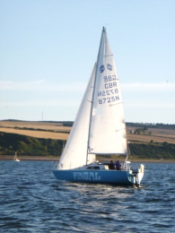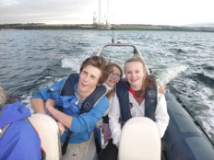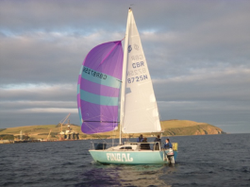
Name & email of staff member submitting news item | Wanda Mackay wanda.mackay@highland.com

APPENDIX B

Area of Work | Title
Active Schools | Dance Leaders
 | Hockey
 | Primary Soccer 7s
 | Volunteering
Adult Learning | Dyslexia Roadshow
Archives | Mod
Arts | Creative Learning Programme
Facilities | Boot Camp
 | Junior Try Tri & Mini Mudder
 | Tour De France Challenge
Libraries | HC Quality Awards
 | Schools Programme
Libraries & Youth Work | Summer Teen Volunteers
Libraries & Youth Work & Active Schools | Teddy Bears Summer Camp
Youth | Man Over Board
 | Rock School

