HIGH LIFE HIGHLAND  REPORT TO BOARD OF DIRECTORS  16 June 2016 | AGENDA ITEM REPORT No HLH /15

ANNUAL Health and Safety And Environmetal Compliance Report - Report by Chief Executive

Summary

An important element of the Governance structure relating to the company’s Health and Safety and Environmental Compliance performance is the annual Health and Safety and Environmental Compliance Report.

This report informs Directors about the performance of High Life Highland in terms of health and safety and environmental compliance.

It is recommended that Directors:-

- agree the annual Health and Safety and Environmental Compliance Report; and in doing so,
- note that there were no enforcing officer notifications for improvement, nor enforcement action during 2015-16;
- note that there were no environmental incidents reported to SEPA;
- note the low number and low severity of incidents over the period reflecting continuing good practice across the company;
- note that the Health and Safety Strategic Group continues to meet quarterly to review Health and Safety performance and on reviewing accident and incident trend data concluded that there are no issues arising from this which require companywide action;
- note that the annual external audit in 2015/16 identified that there was no company wide action required;
- note the review of pool plant rooms undertaken in 2015; and
- comment on and note the draft Safety Representatives Charter.

1. | Business Plan Contribution
1.1 | This report supports the highlighted Business Outcomes from the High Life Highland (HLH) Business Plan:  - To advance sustainable growth and financial sustainability  - Deliver the Service Delivery Contract with THC  - Improving staff satisfaction  - Improving customer satisfaction  - A positive company image  - Services designed around customers and through market opportunities  - Sustain a good health and safety performance  - A trusted partner
2. | Background
2.1 | The terms of the HLH Health and Safety Policy Statement requires annual and exception reporting to the HLH Board on health and safety performance.
2.2 | At the HLH Board meeting on the 23 April 2014 Directors agreed to delegate to the Health and Safety Strategic Group the decision on the final layout of the tables in the appendix to this report. The Group reviewed and agreed the information in the Appendices A - D at its meeting held on 12 May 2015.
3. | Health and Safety and Environmental Compliance Performance
3.1 | There were no enforcing officer notifications for improvement, nor enforcement action during 2015/16. Appropriate notification was made under the RIDDOR 2013 legislation for two incidents, one of which later proved unnecessary. There were no environmental incidents requiring reporting to SEPA in 2015/16.
3.2 | Having analysed the information in the appendices, the Health and Safety Strategic Group identified the following information as being important to report to the HLH Board:  - there are no trends indicating that any company wide actions are required;  - the four acts of violence recorded were behavioural/disability; and customer to customer issues and were dealt with via police/parents/schools as appropriate (Appendix C table 2). They have been reviewed and assessed as minor, with no trends;  - there was a total of two accidents reported under RIDDOR (Reporting of Incidents, Diseases and Dangerous Occurrences Regulations) in 2015/16. One of these amounted to over-reporting because incidents involving medical conditions are not RIDDOR reportable. RIDDOR reports are now being reviewed by managers prior to submission to avoid over-reporting;  - there was one successful resuscitation of a customer which related to a pre-existing medical condition during 2015/16;  - the combining of Inverness Leisure and HLH data in future years will impact on the trend reporting and that this would be borne in mind by the Health and Safety Strategic Group.
3.3 | Given the size of the HLH operation and the number of visits to HLH facilities (over five million per year), there has been a very small number of incidents, reflecting good practice across all areas of work.
4. | Annual External Audit
4.1 | The annual external safety audit in 2015/16 examined the sites listed below. There were no company-wide issues identified during the audits and all individual actions have been completed.  - Portree Leisure Centre;  - Portree Archive Centre;  - Portree Library;  - Gairloch Leisure Centre;  - Gairloch Library;  - Ullapool Leisure Centre.
4.2 | The Health and Safety Strategic Group has identified Easter Ross/East Sutherland as the geographic areas plus Caol Library/Youth Centre because it is a new facility, for the external audits in 2016/17 and a programme is being agreed with the external safety auditor and scheduled for August.
5. | Company Wide Action During 2015/16
5.1 | On 31 August 2015 at Wick Swimming Pool, a faulty water valve (similar in function to a cistern valve in a toilet), within an automatic pool chemical dosing machine failed resulting in an overflow of a very dilute water/chemical mix which exceed the capacity of the machine’s overflow. The incident was dealt with competently by staff with the fire service who attended as a precaution - praising their response. The fire service reported that the quantity of chemical was so small that there was no risk to anyone in the vicinity and that the leak was contained within the plant room so there was no environmental risk. The facility was re-opened the day after the incident with the following companywide action having been taken:  - chemical dosing systems; chemical mixing pumps; and chemical injection points at all pools were checked and serviced – all similar valves were replaced as a precaution;  - plant room risk assessments were reviewed and updated with a particular focus on:  - location and use of Personal Protective Equipment;  - increase of plant room inspections (hourly);  - inclusion of evacuation scenarios for reasons other than fire in staff  training;  - monitoring contractor visits to plant rooms;  - refresher training for all Pool Plant Qualified staff;  - availability and location of chemical spill kits; and  - maintenance frequency of valve changes increased to coincide with  servicing visits as a preventative measure.
6. | Health and Safety Policy Review
6.1 | The Health and Safety policy was scheduled for review at the June 2016 HLH Board meeting. Given the work on the transfer of business from Inverness Leisure this task has been delayed to allow consideration of the integration of the policies/procedures of the two organisations and the policy review will be taken forward by the Health and Safety Strategic Group at its August meeting for consideration by the Board thereafter. This will allow the good practice of each organisation to be incorporated into the new policy.
7. | Safety Representatives Charter
7.1 | The Human Resources Manager has been working with the Trade Unions to formalise their health and safety role. The draft Safety Representatives Charter, currently under discussion with the unions, is attached at Appendix E and the Board is asked to comment on and note the draft.
8. | Health and Safety Strategic Group Remit
8.1 | The Health and Safety Strategic Group has reviewed its remit and the draft for consideration by the HLH Board is included in the Board Review and Appraisal Workshop Action Plan report elsewhere on this agenda. The report reviews all of the Board working groups in the appendix entitled Committees, Working Groups and Project Boards.
9. | Implications
9.1 | Resource Implications – there are no additional resource implications arising from this report.
9.2 | Legal Implications - there are no additional legal implications arising from this report.
9.3 | Equality Implications – there are no additional equality implications arising from this report.
9.4 | Risk Implications – there are no new risks which require to be added to the risk register arising from this report.

Recommendation

It is recommended that Directors:-

- agree the annual Health and Safety and Environmental Compliance Report; and in doing so,
- note that there were no enforcing officer notifications for improvement, nor enforcement action during 2015-16;
- note that there were no environmental incidents reported to SEPA;
- note the low number and low severity of incidents over the period reflecting continuing good practice across the company;
- note that the Health and Safety Strategic Group continues to meet quarterly to review Health and Safety performance and on reviewing accident and incident trend data concluded that there are no issues arising from this which require companywide action;
- note that the annual external audit in 2015/16 identified that there was no company wide action required;
- note the review of pool plant rooms undertaken in 2015; and
- comment on and note the draft Safety Representatives Charter.

Signature:

Designation: Chief Executive

Date: 26 May 2016
Appendix A
All RIDDOR Notified Accidents/Incidents – Summary

 | 2015-16
Service Area | Q1 Apr-Jun | Q2 Jul-Sep | Q3 Oct-Dec | Q4 Jan-Mar
Adult Learning
Archives
Arts
Leisure Facilities |  | 1
Libraries
Museums
Outdoor Education
Sport |  |  | 1
Youth
Management & Administration
GRAND TOTAL | 0 | 1 | 1 | 0

All RIDDOR Notified Accidents/Incidents – Details Q1 – Q4 2015-16

INCIDENT 1
DESCRIPTION: Customer was getting changed after swimming when carer caught her and laid her on the floor. Padding placed under her head. Timed seizure lasted 5 - 7 minutes. Her medication was received & school first aider administered it. Ambulance was phoned as after seizure stopped, she never came round fully and constant twitching.
RECOMMENDATIONS: N/A
Leisure Facilities- - - - - Tain Royal Academy Community Complex (TRACC)
INCIDENT 2
DESCRIPTION: The customer was horseplaying around and jumped onto the back of another child, they both fell and the customer’s front teeth hit the floor which subsequently knocked out 1 upper central incisor and displaced the other.
RECOMMENDATIONS: Injured person taken to dentist. This accident occurred during their transition period between 1 group activity and a 2nd. The first sessions finished at 16:15 and as they were being allocated to parents by the coach the 2nd group were allowed into the building. The failure to stop the 2nd group entering before first group all allocated allowed unsupervised horseplay to occur, resulting in this accident. All relevant staff (coach/head teacher) have been notified and a new system of managing the children has been put in place. In future none of the 2nd group will be allowed access until the 1st group have been collected.
Sports- - - - - - - - - Other

Appendix B, Tables 1-10

Accidents and incidents compared to the previous year for staff, volunteers and contractors by HLH section

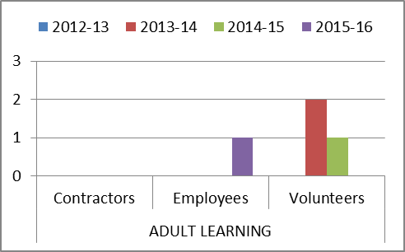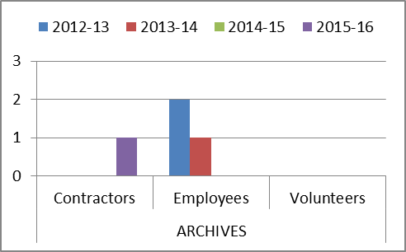

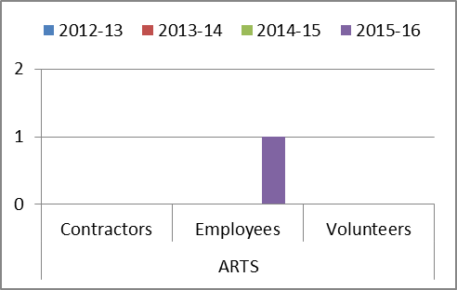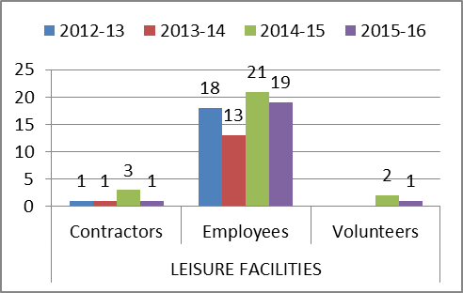

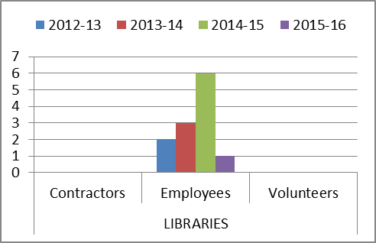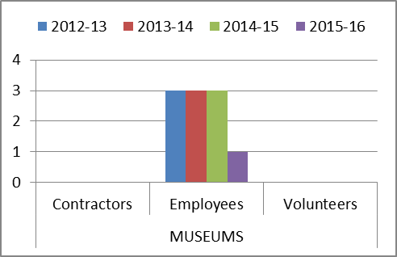

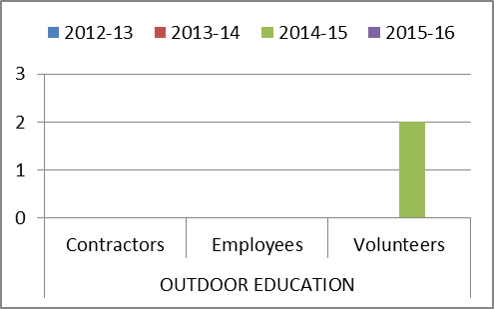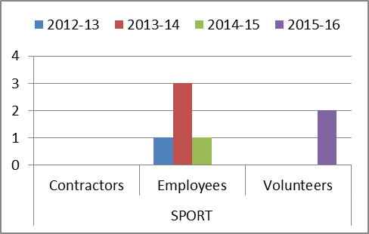

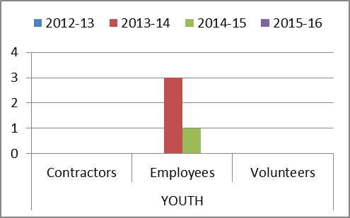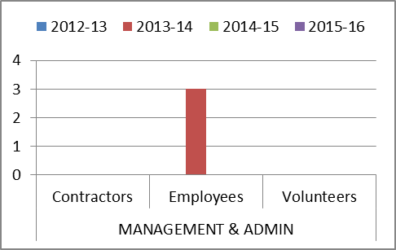

Appendix B, Tables 11-13

Accidents and incidents compared to the previous year for staff, volunteers and contractors by nature of accident

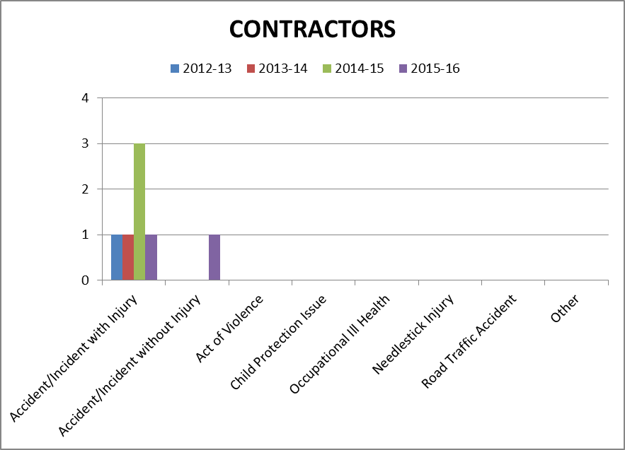

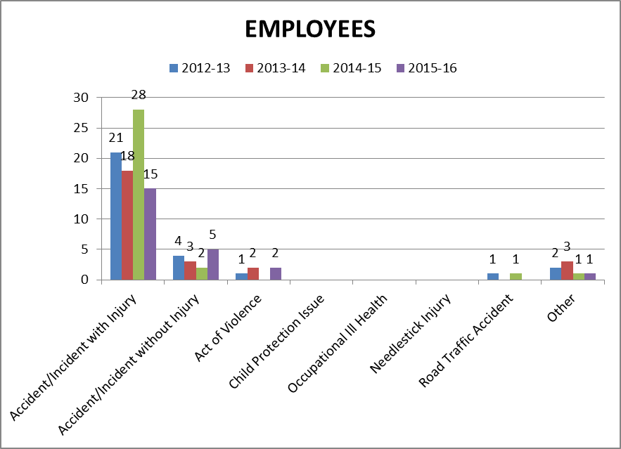

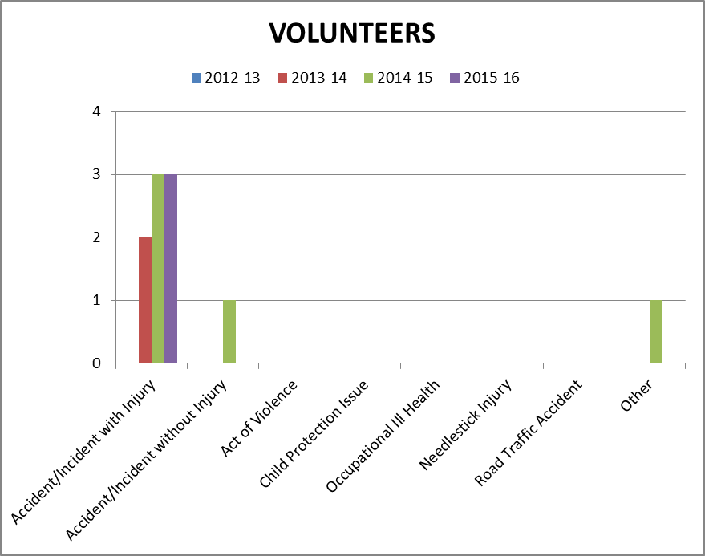

Appendix B, Table 14 - 17
Accidents and incidents compared to the previous year to staff, volunteers and contractors by type of accident/ incident

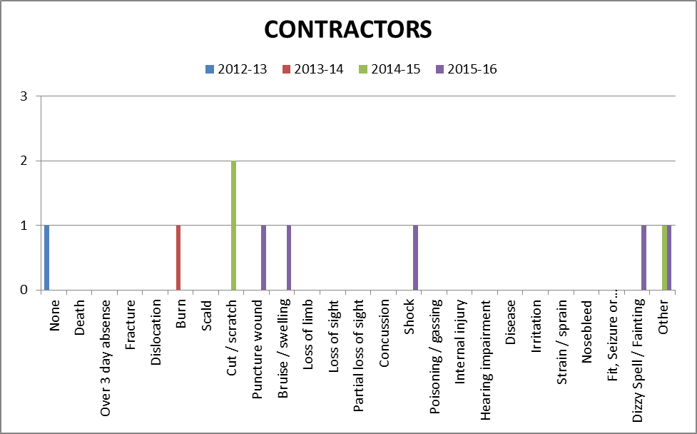

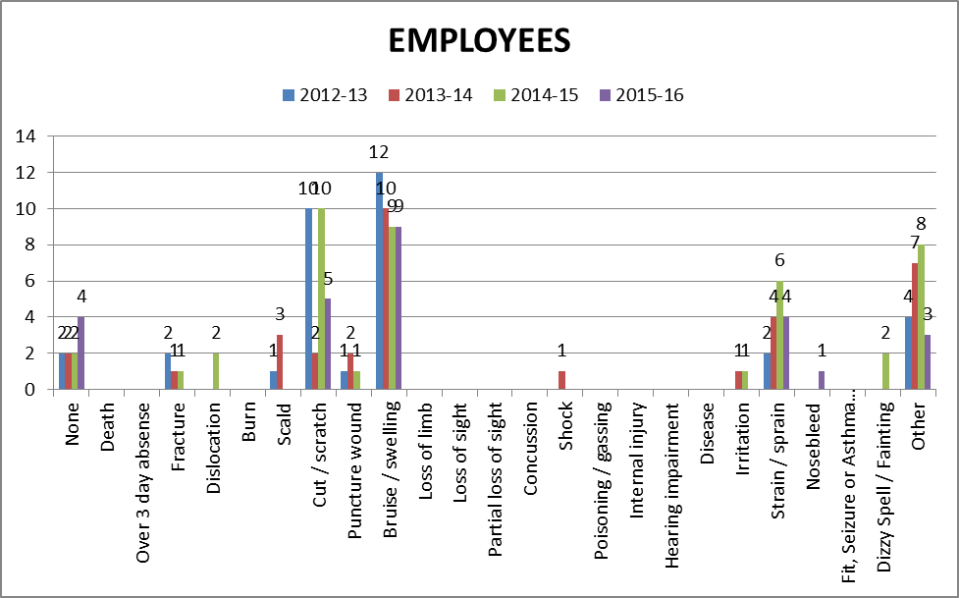

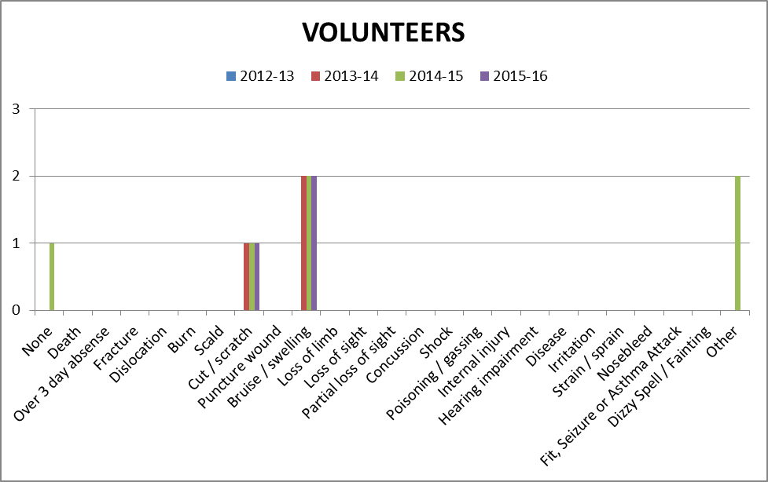

Appendix C, Table 1

Accidents and incidents compared to the previous year for users by HLH section

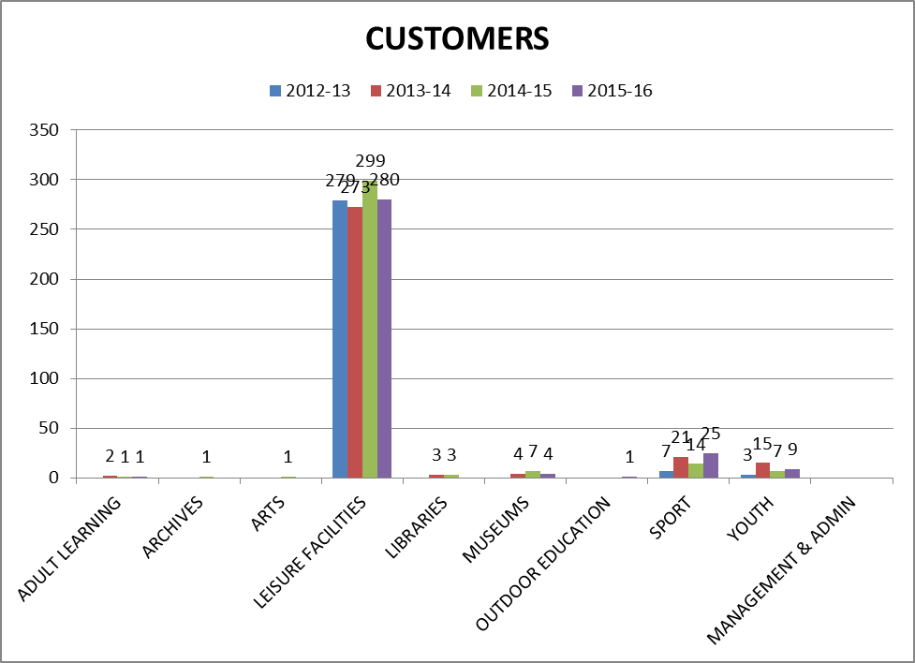

Appendix C, Table 2

Accidents and incidents compared to the previous year for users by nature of accident

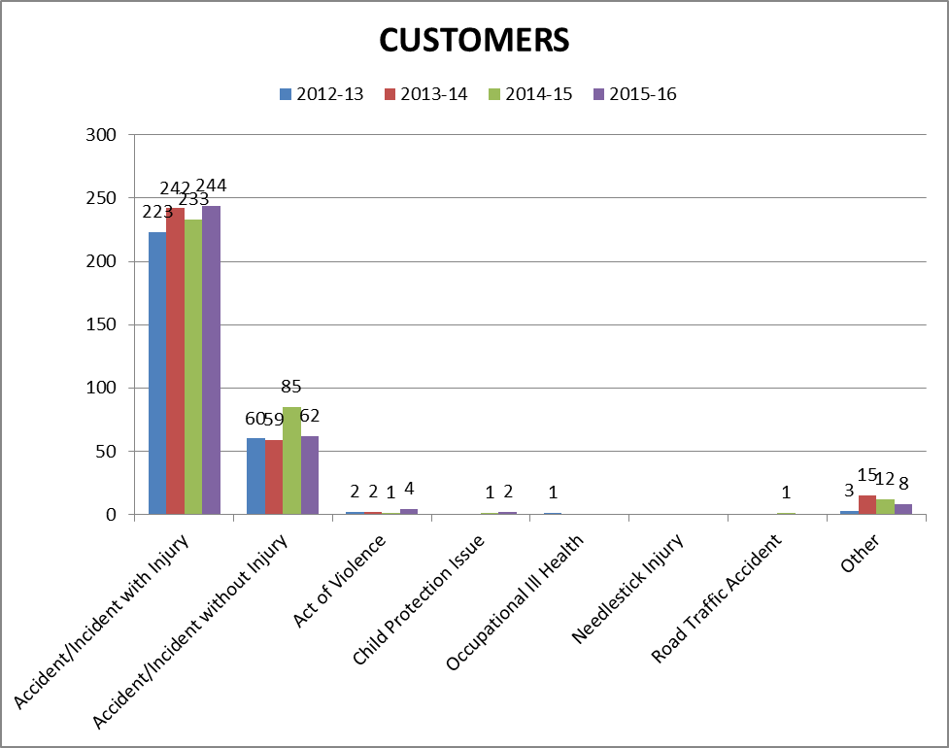

Appendix C, Table 3

Accidents and incidents compared to the previous year to users by type of accident/ incident

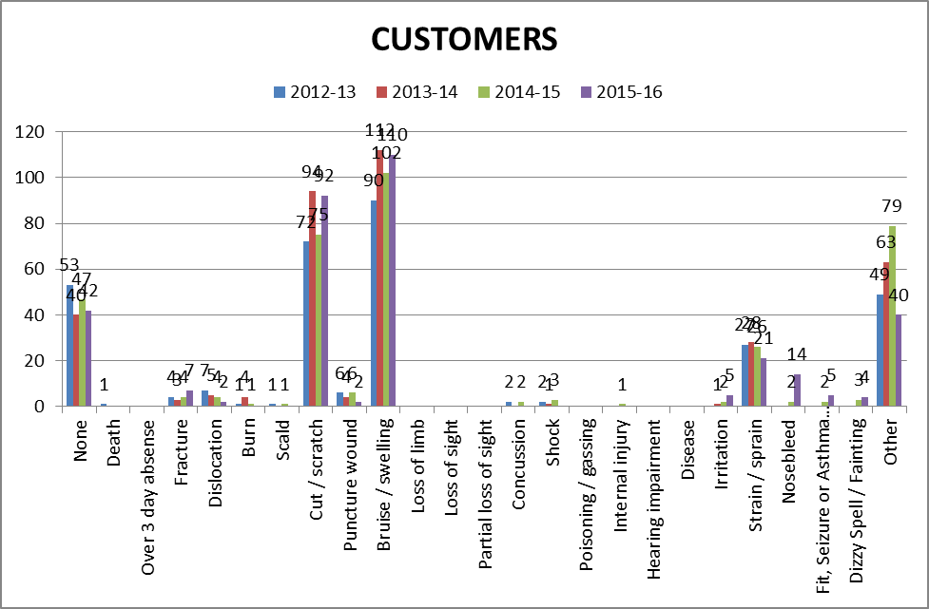
Appendix D
PERFORMANCE INDICATORS 2015-16
- Number of Accidents/Incidents to Staff (Employees, Contractors & Volunteers) Against Total Number of FTE Staff
 | FTE Staff | Accidents/Incidents | %
Q1 2015-16 | 496.10 | 5 | 1.01
Q2 2015-16 | 498.10 | 5 | 1.04
Q3 2015-16 | 499.53 | 7 | 1.40
Q4 2015-16 | 508.15 | 11 | 2.16

- Number of Accidents/Incidents to Users (Customers) Against Total Number of Users
 | Users | Accidents/Incidents | %
Q1 2015-16 | 1,299,041 | 76 | 0.006
Q2 2015-16 | 1,172,747 | 82 | 0.007
Q3 2015-16 | 1,428,031 | 85 | 0.006
Q4 2015-16 | 1,421,410 | 77 | 0.005

Appendix E

HIGH LIFE HIGHLAND

DRAFT SAFETY REPRESENTATIVES CHARTER

1. Introduction
This charter was developed from the Safety Representatives Charter between the Highland Council and the recognised trade unions in 2014. In developing the charter High Life Highland recognised the benefits of having trained trade union safety representatives and the fact that HSE research shows that workplaces with trade union safety reps have fewer injuries than those without.

One of the principal aims of the Health and Safety Partnership Agreements has therefore been to encourage the recruitment, training and development of an effective network of trade union safety representatives throughout High Life Highland. In recognising that conflict can be a barrier to the achievement, this charter and promotes the development of trusting relationships between management and safety representatives, whereby information and experience can be exchanged to the mutual benefit of both High Life Highland and its employees. The charter also aims to define the consultation process and the training and competency standards of safety representatives. It also provides formal recognition of the role and functions of trade union safety representatives and details of the facilities and assistance that High Life Highland will provide to assure that role can be fulfilled. It is designed to clarify, but in no way detract from, the statutory rights assigned to trade union safety representatives by the Safety Representatives and Safety Committees Regulations 1977 and any other health and safety legislation or codes of practice.

2. Definitions
The following definitions will apply in relation to this charter:
- Safety Representative means a Trade Union Safety Representative.
- Employer means High Life Highland.
- Employee means a person employed by High Life Highland.
- Representative of Employee Safety means a person elected by employees (non-union) in the workplace to represent them in health and safety issues.
- Workplace means any workplace owned by, or under the control of High Life Highland, both permanent and temporary, and includes any other place being a building, vehicle or vessel, open space or open water, where, for the time being, any employee or employees is required to work or be "at work".
- SRSC means The Safety Representatives and Safety Committees Regulations 1977.
- HSE means the Health and Safety Executive.
- Risk Assessment means any risk assessment required generally or specifically by the Health and Safety at Work Act and any regulations there under.

3. Scope
This charter will apply to the arrangements between High Life Highland and those safety representative appointed by the recognised trade unions in accordance with the SRSC Regulations 1977.

4. The Role and Functions of Safety Representatives
Safety representatives are appointed by trade unions to represent their members on health and safety issues. In some workplaces they may agree to represent the entire workforce. The SRSC Regulations 1977 set out their legal functions, which include:
- Representing employees in discussions with the employer on health, safety or welfare issues and in discussions with the HSE or other enforcing authorities;
- Being consulted "in good time" over a large range of health and safety issues;
- Being involved with risk assessment procedures;
- Attending safety committee meetings;
- Having access to relevant health and safety information;
- Inspecting the workplace
- Investigating potential hazards;
- Investigating notifiable accidents, cases of diseases or ill health and dangerous occurrences;
- Investigating employees' complaints;
- Receiving information from health and safety inspectors;
- Being given paid time off their normal work to carry out their functions and undergo training;
- Having access to suitable facilities and assistance to carry out their functions.

The purpose of this charter is therefore to provide further guidance and clarification in respect of these functions, as follows.

5. Appointment and Training of Safety Representatives
High Life Highland, through its partnership agreement with the recognised trade unions will:
- Encourage the recruitment of safety representatives.
- Facilitate TUC approved health and safety training for safety representatives.

In respect of these objectives, the Company will:
- Assist the recognised trade unions in the recruitment of safety representatives through the use of its intranet and other communication systems.
- Maintain a database of all safety representatives appointed by the trade unions.
- Facilitate the provision of TUC approved safety representative training in the Highland Area.
- Where necessary provide suitable training facilities and pay reasonable travel and subsistence costs for a TUC trainer to deliver courses in the Highlands.
- Ensure that safety representatives are permitted to take such time off with pay during normal working hours to undertake the appropriate training.
- Pay reasonable travel and subsistence costs incurred by safety representatives attending approved training courses, in line with the Company’s Travel and Subsistence Policy. This will be the responsibility of the employing Service.
- Consider the following to be approved training appropriate to the needs of safety representatives, with stage 1 being a mandatory level of training for all trade union safety representatives:
  - TUC Health and Safety Stage 1, 2 and 3
  - In-house health and safety related courses delivered by the Company.
  - In-house courses on the use of computers or in respect of relevant Company policies.
  - Any other courses, the content of which has been approved by the Head of Performance and the Principal Estates Manager.

In respect of these objectives the recognised trade unions will:
- Promote the role of a safety representative throughout their membership and seek to recruit new safety representatives to ensure an even distribution throughout the Company.
- Provide sufficient information to members who are interested in taking on the role of a safety representative to ensure that they are fully aware of the functions they are expected to fulfil.
- Consider the ability of part time workers in particular to undertake the role and any difficulties that may relate to the number of workplaces to be covered and the need for transport etc.
- Provide written confirmation of the appointment of trade union safety representatives to the Human Resources Manager and the Principal Estates Manager.
- Maintain accurate records of appointed safety representatives including details of the training undertaken and the workplace they are responsible for.
- Co-ordinate applications for safety representative training and arrange suitable dates for training in the Highlands in conjunction with the Human Resources Manager.
- Ensure that line managers are given adequate prior notice of proposed inspection dates to enable suitable arrangements/ adjustments to be made to ensure continued service delivery.
- Pay travel and subsistence costs of safety representatives attending any health and safety courses organised by the individual trade unions themselves.
- Provide suitable pre-course information to applicants to ensure that they are aware of the dates, times, locations and arrangements for travel and subsistence etc.

6. Consultation and Safety Committees
To ensure that effective health and safety consultation takes place, High Life Highland will:
- Maintain formal arrangements for consultation on health and safety issues including:
  - A Health and Safety staff meeting
  - Service specific health and safety groups (if applicable)
- Ensure that safety representatives are given the opportunity to attend meetings in accordance with High Life Highland's policy and guidance on Health and Safety Consultation.
- Consult with safety representatives on:
  - The introduction of new, and the review of existing health and safety related policies
  - The introduction of any measures at the workplace that may substantially affect health and safety.
  - Arrangements for appointing competent persons to assist the employer with health and safety.
  - Procedures for dealing with situations of serious and imminent danger.
  - Any health and safety information required to be provided to the employees.
  - The planning and organisation of health and safety training.
  - The health and safety consequences of introducing new equipment, technology or work methods
  - Any proposals to make substantial changes to the structure or fabric of the workplace.
  - Any proposals to deal with asbestos or materials containing asbestos discovered in the workplace.
  - The processes of risk assessment and in particular where significant risks have been identified.

The recognised trade unions will:
- Expect safety representatives to consult with the members they represent prior to attending health and safety meetings, with a view to raising issues highlighted in the consultation process at the appropriate meeting.
- Expect safety representatives to provide feedback to the members they represent on the outcome of the meetings.
- Encourage safety representatives to attend meetings in accordance with the Health and Safety Partnership Agreement
- Organise quarterly meetings to enable safety representatives from all unions to discuss issues associated with their role and the performance of their functions and encourage best practice.
- Provide responses to health and safety consultation documents within appropriate timescales.
- Encourage safety representatives to meet with line managers on a regular informal basis to promote a culture of co-operation and joint problem solving in respect of local health and safety workplaces issues.

7. Workplace Inspections and Accident Investigations

To ensure that safety representatives are given the opportunity to carry out regular inspections of workplaces they represent, High Life Highland will:
- Ensure that they are permitted to take such reasonable time off with pay during normal working hours to perform their statutory functions.
- Require prior agreement for functions performed outwith normal working hours to ensure the full protection of employment law.
- Expect prior notification to the appropriate manager and Health and Safety and Property Officer of formal inspections of the workplace. This should be a minimum of one week in advance of the planned date of inspection unless a programme of inspections has been agreed to cover an extended (recommended twelve month) period.
- Waive the requirement for prior notification where the need for inspection arises following a workplace accident.
- Reserve the right to have a representative of management in attendance during such inspections if considered necessary.
- Require prior agreement for the same workplace to be inspected more frequently than once every three months, except where changes in legislation occur following the previous inspection. It is anticipated that this arrangement will apply in respect of further inspection required to follow up actions highlighted in original inspections.
- Encourage managers to carry out joint accident investigations with safety representatives.
- Encourage managers to discuss the outcome of inspections findings with safety representatives.
- Expect managers to provide a response within an agreed timescale in respect of issues highlighted by safety representatives as requiring attention in formal inspection reports.
- Recognise that individual safety representatives will be required to carry out inspections of workplaces outwith their employing Service Area.

The recognised trade unions will:
- Ensure that safety representatives give appropriate prior notification to the manager responsible for the premises and the Health and Safety and property Officer of their intention to carry out a formal workplace inspection.
- Establish a standard format for recording the reporting on findings of inspections to ensure that information is captured and presented in a consistent manner.
- Encourage safety representatives to discuss the outcome of inspections with the line manager and submit a written copy of the report as soon as possible after completion.
- Encourage safety representatives to undertake a minimum of 4 workplace inspections per year.
- Encourage safety representatives to carry out joint inspections and accident investigations with managers whenever possible.

8. Contacting Enforcing Authority Inspectors
Safety Representatives are entitled to contact enforcing authority inspectors. For High Life Highland purposes the enforcing authority is the Health and Safety Executive (HSE). To ensure that contact takes place in accordance with HSE guidelines, High Life Highland will:
- Require prior notification if the contact relates to a formal complaint about conditions in the workplace. The HSE has indicated that it would expect an employer to be given an opportunity to rectify a problem prior to its involvement.
- Not require notification if the contact is for information, general advice or discussion in relation to any report submitted by an inspector.

The recognised trade unions will;
- Ensure that safety representatives notify the Company prior to contact with the HSE if the purpose of the contact is to raise a formal complaint about conditions in the workplace
- Encourage safety representatives to access the HSE website and contact inspectors for specialist advice where appropriate.
- Expect safety representatives to meet with HSE inspectors during inspections of workplaces they represent.

9. Facilities for Safety Representatives
To ensure that safety representatives can carry out their functions, High Life Highland will provide the following facilities:
- Arrangements within the workplace for confidential consultation with the members they represent.
- Use of a desk to prepare reports and other paperwork associated with the functions of safety representatives.
- Access to secure facilities for storing correspondence.
- Access to a computer at one or more workplaces occupied by the employing service together with the provision of an e-mail account in the name of the safety representative (where they do not already have an HLH email account). This will allow access to the High Life Highland Intranet, the Internet (union and HSE websites etc) and secure means of communication with other safety representatives. Consideration should be given to those representatives who are classed as mobile workers (communication through personal email addresses will not be permitted).
- Access to technical equipment that may assist in recording information in relation to specific workplace hazards or in the investigation of accidents. This may include digital cameras, and other specialist equipment currently owned by Services. Requests for the use of such equipment should be submitted to the Principal Estates Manager.
- Access to internal and external telephones.
- Access to duplicating, printing and fax facilities.
- A notice board or space on an existing notice board for the display of health and safety information in each workplace.
- Access to safety manuals, policy documents, workplace health and safety standards, copies of relevant statistics, regulations, approved codes of practice, safety guidance notes and relevant safety journals as appropriate.
- The payment of appropriate travel and subsistence expenses to enable safety representatives to visit workplaces for which they have a responsibility.
- Suitable personal protective equipment (PPE) necessary to reduce or eliminate exposure to hazards in the workplaces for which the safety representative has responsibility. The need for PPE must be identified through a process of risk assessment.

The recognised trade unions will:
- Ensure that safety representatives only use facilities provided by High Life Highland for the purposes of fulfilling their role and functions
- Distribute information produced by individual unions on health and safety hazards, legislative developments, good practice and other issues relevant to improving health and safety in the workplace, to their safety representatives
- Respond to enquiries and provide appropriate advice and assistance to safety representatives on matters of concern.
- Encourage the development of joint working within High Life Highland through formal partnership agreements or other methods, to improve health and safety performance in the workplace.
- Encourage trained safety representatives to use their knowledge and skills to carry out their functions in the spirit of co-operation and partnership working.
- Notify the Head of Performance and the Principal Estates Manager when one of their members indicate that they no longer wish to continue as a safety representative and arrange for any facilities supplied by the Company in support of that role to be returned.

10. Conclusion
The adoption of this charter will clarify the arrangements for the support and development of an effective network of trained trade union safety representatives from both a trade union and management perspective. It is also designed to encourage the principle of partnership working and improve the health and safety performance of High Life Highland with the aim of reducing the number of workplace accidents and incidents of ill-health. The charter is designed to avoid disputes on Health and Safety matters but should the situation arise then the normal agreed ways of resolving employment disputes will apply.

11. Implementation, Monitoring and Review
This charter will be effective from the date of approval by High Life Highland. It will be distributed to all recognised trade unions and throughout High Life Highland Services and Areas. The effect of its implementation will be monitored on an on-going basis and any issues arising from the introduction of the charter should be forwarded to the Principal Estates Manager, 12/13 Ardross Street, Inverness IV3 5NS. The charter will be subject to a formal review on an annual basis or following the introduction of new legislation which may impact on its content. The review process will involve representatives of management and the recognised trade unions.

