HIGH LIFE HIGHLAND  REPORT TO BOARD OF DIRECTORS  15 June 2017 | AGENDA ITEM 12 REPORT No HLH12/17

ANNUAL Health and Safety And Environmetal Compliance Report - Report by Chief Executive

Summary

An important element of the Governance structure relating to the company’s Health and Safety and Environmental Compliance performance is the annual Health and Safety and Environmental Compliance Report.

This report informs Directors about the performance of High Life Highland in terms of health and safety and environmental compliance.

It is recommended that Directors note:

- there were no notifications for improvement or enforcement actions during 2016/17;
- there were no environmental incidents requiring SEPA notification;
- the low number and low severity of incidents over the period reflecting continuing good practice across the company;
- the Health and Safety Strategic Group continues to meet quarterly to review Health and Safety performance and on reviewing accident and incident trend data it concluded that there are no issues arising from this requiring companywide action;
- the annual external audit in 2016/17 identified that there was no company wide action required; and
- four union safety audits have been completed in 2016/17 in line with the Safety Representatives Charter.

1. | Business Plan Contribution
1.1 | This report supports the highlighted Business Outcomes from the High Life Highland (HLH) Business Plan:  - To advance sustainable growth and financial sustainability  - Deliver the Service Delivery Contract with THC  - Improving staff satisfaction  - Improving customer satisfaction  - A positive company image  - Services designed around customers and through market opportunities  - Sustain a good health and safety performance  - A trusted partner
2. | Background
2.1 | The HLH Health and Safety Policy Statement requires annual and exception reporting to the HLH Board on health and safety performance.
2.2 | At the HLH Board meeting on the 23 April 2014 Directors agreed to delegate to the Health and Safety Strategic Group the decision on the layout of the tables in the appendix to this report. The Group reviewed and agreed the information in this report and accompanying appendices at its meeting held on 23 May 2017.
3. | Health and Safety and Environmental Compliance Performance
3.1 | There were no enforcing officer notifications for improvement, nor enforcement action during 2016/17. Notification was made under the RIDDOR 2013 legislation for four incidents, one of which later proved unnecessary. There were no environmental incidents requiring reporting to SEPA in 2016/17.
3.2 | Having analysed the information in the appendices, the Health and Safety Strategic Group identified the following information as being important to report to the HLH Board:  - there are no trends indicating that any company wide actions are required;  - the two acts of violence recorded were behavioural and one was not work related but involved a family member; and other was dealt with appropriately, they have been reviewed and assessed as minor, with no trends;  - there was a total of four accidents reported under RIDDOR in 2016/17, one of which was as a precaution pending the completion of an internal investigation (Appendix A, incident 4);  - there was one customer fatality related to a pre-existing medical condition during 2016/17;  - there was one successful resuscitation of a non HLH customer at the golf club in Grantown during 2016/17;  - the inclusion of the Inverness Leisure accident and incident data has resulted in an increase of the number of recorded accidents and incidents, (the levels of which are consistent with previous information recorded at Inverness Leisure). Annotations explaining this have been provided in the graphs in Appendices B and C; and  - the inclusion of the Inverness Leisure data into this year’s report has been closely monitored by the Health and Safety Strategic Group with no trends identified.
3.3 | Given the size of HLH and the number of visits to its facilities (over six and a half million in 2016/17), there has been a small number of incidents, reflecting good practice across all areas of work.
4. | Annual External Audit
4.1 | The annual external safety audit in 2016/17 examined the sites listed below. There were no company-wide issues identified during the audits and all individual actions have been completed.  - Lochaber Leisure;  - Caol Youth and Library;  - Dingwall Football Academy;  - Ardersier Library;  - Black Isle LC;  - Golspie pool;  - TRACC; and  - Ferrycroft Visitor Centre.
4.2 | The Health and Safety Strategic Group has identified Caithness as the geographic area for the 2017/18 audits plus Inverness Royal Academy Sports Centre because it is a new facility.
5. | Safety Representatives Charter
5.1 | In line with the Safety Representatives Charter agreed in June 2016 Unison has undertaken four safety audits in 2016/17 in the sites listed below. The actions arising from the audits have been completed with the staff and local mangers having viewed the process as being positive.  - HLH Dingwall Office (Old Library Building);  - Dingwall Town Hall;  - Inverness Botanic Garden;  - Inverness Museum and Art Gallery.
6. | Review of Emergency Action Plans/Fort William Library Incident
6.1 | Directors will be aware of the requirement to evacuate Fort William Library on 25 May 2017 with the Police having had to be called to a suspected firearms incident. All of the staff and members of the public who were in the library at the for the time were safe and well and Police Scotland issued the following statement on the day “Police can confirm that a 26 year old man has been detained following a call from a member of the public relating to a man behaving suspiciously at Fort William library. The man was compliantly detained and there was no threat to the wider public.” The staff were commended by the Police for their actions and composure.
6.2 | Prior to this, the Health and Safety Strategic Group had agreed to consider a review of emergency/event plans at is meeting scheduled for 8 August 2017. In preparation for this, a meeting with the Police Scotland Sergeant responsible for Emergency, Events and Resilience Planning has been scheduled for 31 May 2017. Any actions/information for managers and staff which require immediate action will be followed up after the meeting with Police Scotland.
7. | Implications
7.1 | Resource Implications – there are no additional resource implications arising from this report.
7.2 | Legal Implications - there are no additional legal implications arising from this report.
7.3 | Equality Implications – there are no additional equality implications arising from this report.
7.4 | Risk Implications – there are no new risks which require to be added to the risk register arising from this report.

Recommendations

It is recommended that Directors:

- note that there were no notifications for improvement or enforcement actions during 2016-17;
- note that there were no environmental incidents requiring SEPA notification;
- note the low number and low severity of incidents over the period reflecting continuing good practice across the company;
- note that the Health and Safety Strategic Group continues to meet quarterly to review Health and Safety performance and on reviewing accident and incident trend data it concluded that there are no issues arising from this requiring companywide action;
- note that the annual external audit in 2016/17 identified that there was no companywide action required; and
- note that four union safety audits have been completed in 2016/17 in line with the Safety Representatives Charter.

Signature:

Designation: Chief Executive

Date: 29 May 2017
Appendix A
All RIDDOR Notified Accidents/Incidents – Summary

 | 2016-17
Service Area | Q1 Apr-Jun | Q2 Jul-Sep | Q3 Oct-Dec | Q4 Jan-Mar
Adult Learning
Archives
Arts
Leisure Facilities | 2 | 1
Libraries
Museums
Outdoor Education
Sport |  |  |  | 1
Youth
Management & Administration
GRAND TOTAL | 2 | 1 | 0 | 1

All RIDDOR Notified Accidents/Incidents – Details Q1 – Q4 2016-17

INCIDENT 1
DESCRIPTION: Customer was within the Steam Room - exited the steam room due to feeling too hot and breathing difficulty. Opened the sauna door (glass) and leant against the far corner off the door with his full body weight. Resulting in pressure to the glass door causing it to shatter. (Safety glass).
RECOMMENDATIONS: Assessment of all HLH Full glass door panels for potential pivot points and door stops.
Leisure Facilities- - - - - Inverness Leisure- - - - - - 10/04/2016-
INCIDENT 2
DESCRIPTION: Staff member was opening the side panels of the poly tunnel/greenhouse, using the rope pulley system. The rope snapped, and the handle turned rapidly, hitting him on the wrist.
On the day of injury occurring no first aid given as staff member did not want it - it was a sore wrist. Next day it was swollen and staff member saw doctors on 16/05/2016 who said wrist was fractured and to rest it.
RECOMMENDATIONS: Rope pulley system has been repaired, 2 new systems added, staff training and inspection of equipment.
Leisure Facilities- - - - - Floral Hall & Training Centre- - - - - - 10/05/2016-
INCIDENT 3
DESCRIPTION: Customer had just finished pump fx class and was on her way out when she tripped on 2 mats on the floor in foyer. The mats are similar colour to floor and pushed up against wall and she didn't notice them. She twisted her ankles as she fell to the floor. We elevated the ankle and applied and ice pack. Customer was then taken to hospital.
Mats left in corridor on 5th and although staff on duty were not shifted until after the accident on 10th.
RECOMMENDATIONS: Investigation into incident, action plan in place for risk reduction, all HLH advised of Slip Trip Fall guidance and lessons learnt.
Leisure Facilities- - - - - Lochaber High School- - - - - - 10/08/2016-
INCIDENT 4
DESCRIPTION: The customer slipped while attending a running club session. Shoe laces were tied. No obstructions on the ground. Child was taking part in a team relay race and at the point of passing the baton the child slipped. Coaches did not see child slip but other children in session said she banged her head off the wall.
RECOMMENDATIONS: Investigation into incident, no action required, this incident was not RIDDOR reportable.
Sports- - - - - - - - - Aviemore Community Centre - - 17/01/2017-

Appendix B, Tables 1-10

Accidents and incidents compared to the previous year for staff, volunteers and contractors by HLH section

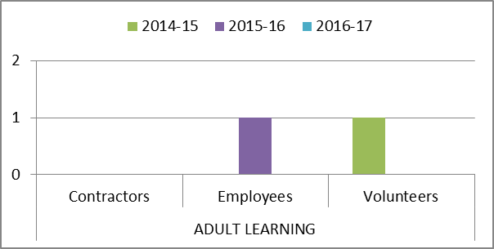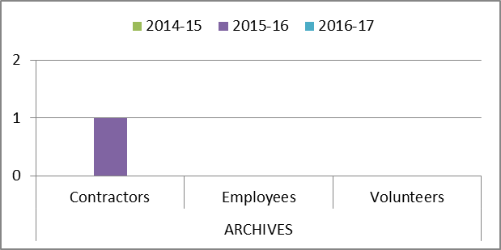

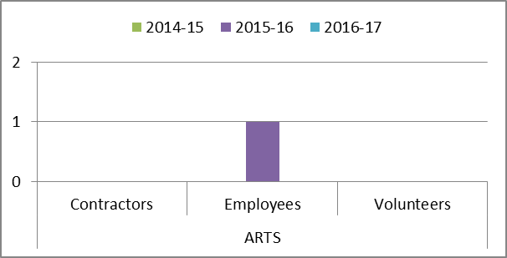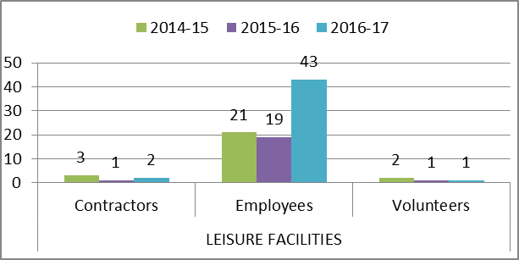

The increase in the number of accidents and incidents in Leisure Facilities in 2016/17 compared with previous years is further broken down in Appendix C tables 1-3 and is due to the inclusion of Inverness Leisure data following the amalgamation of HLH and Inverness Leisure. When Inverness Leisure data is excluded the number of accidents/incidents is in line with previous years. As can be seen in table three below, the majority of the accidents and incidents in Leisure Facilities are cuts, bruises, sprains, etc. associated with sports participation.

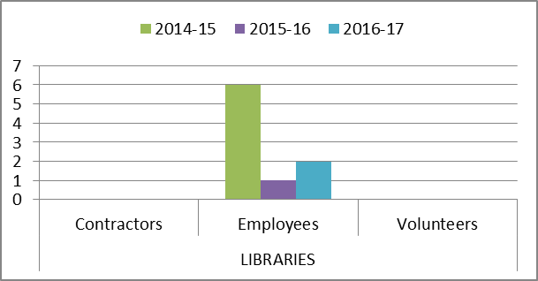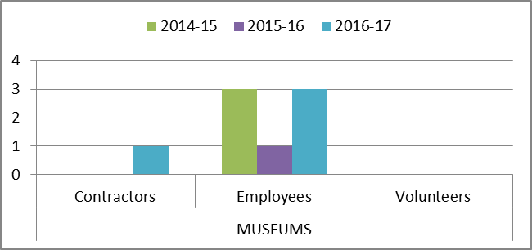

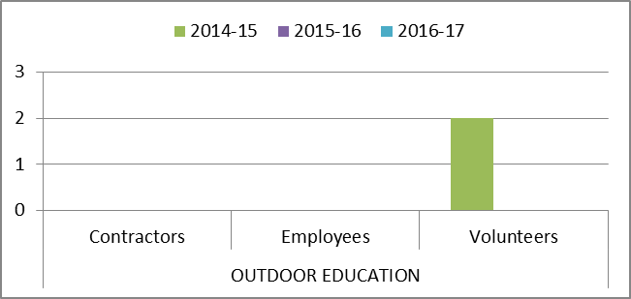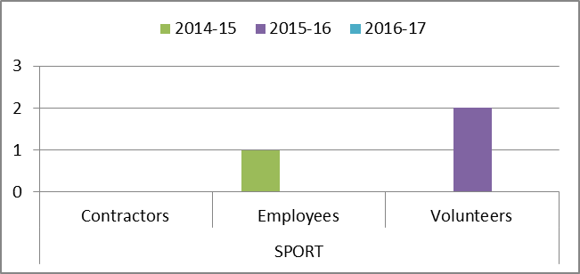

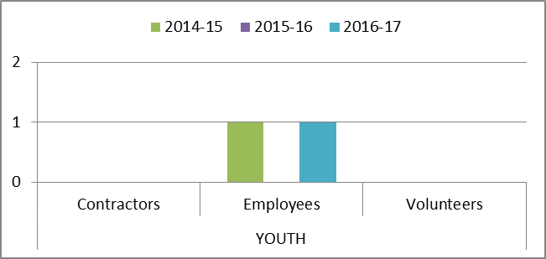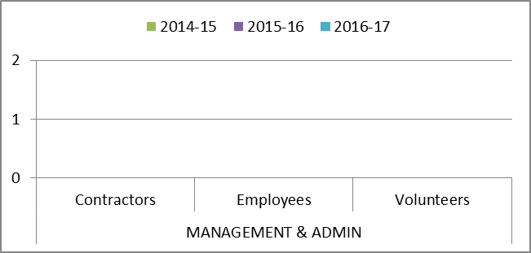

Appendix B, Tables 11-13

Accidents and incidents compared to the previous year for staff, volunteers and contractors by nature of accident

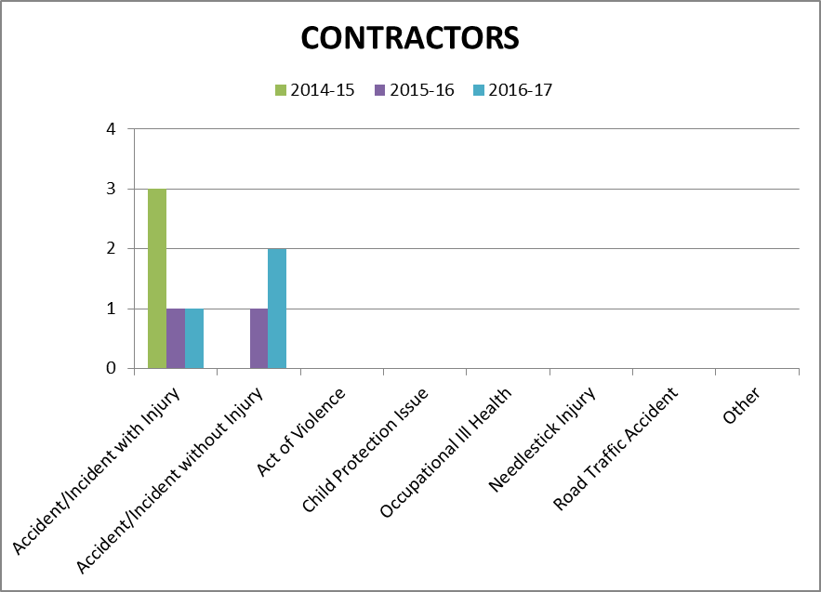

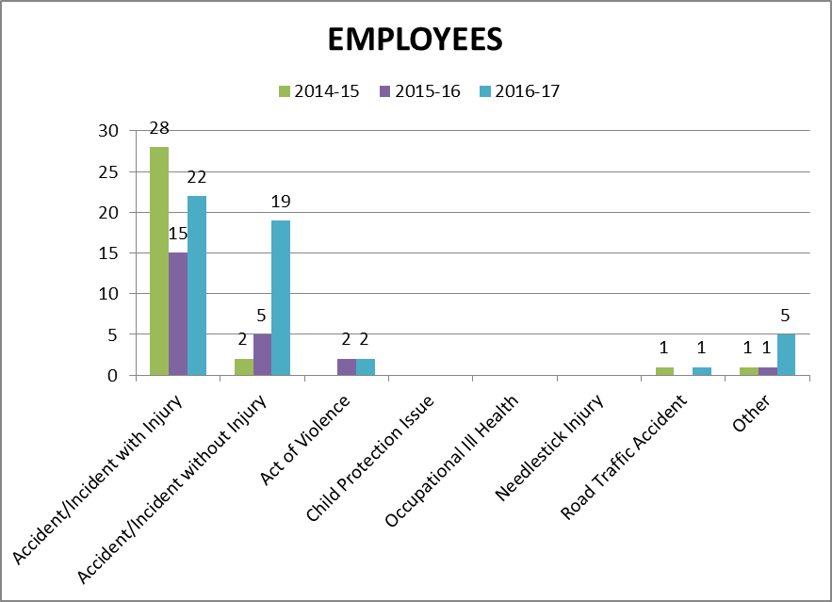

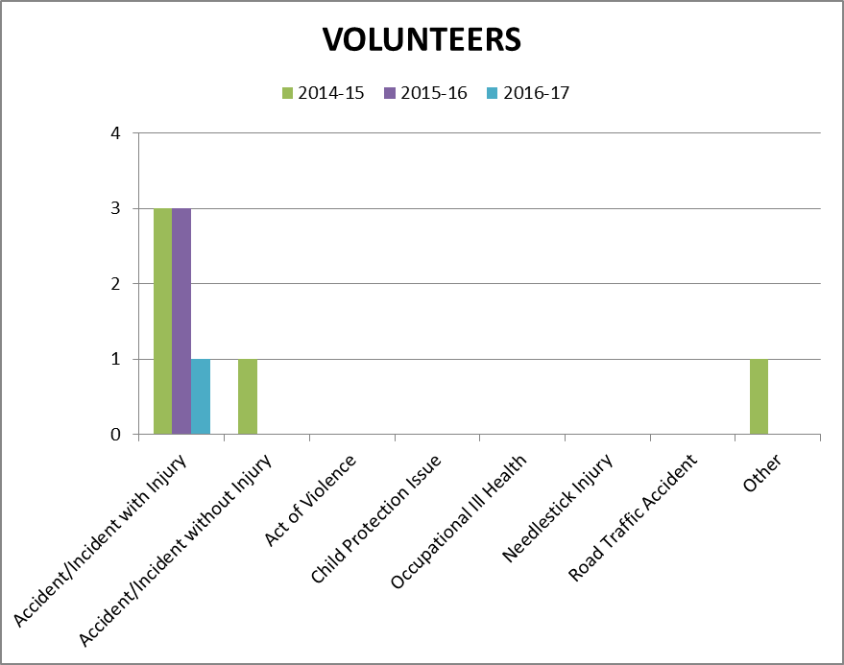

Appendix B, Table 14 - 17
Accidents and incidents compared to the previous year to staff, volunteers and contractors by type of accident/ incident

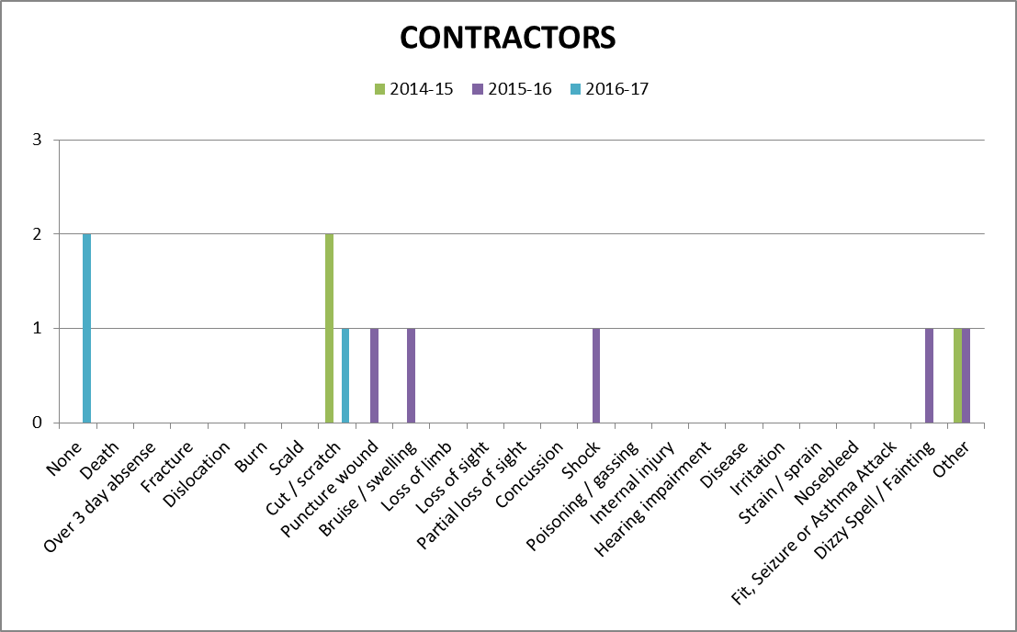
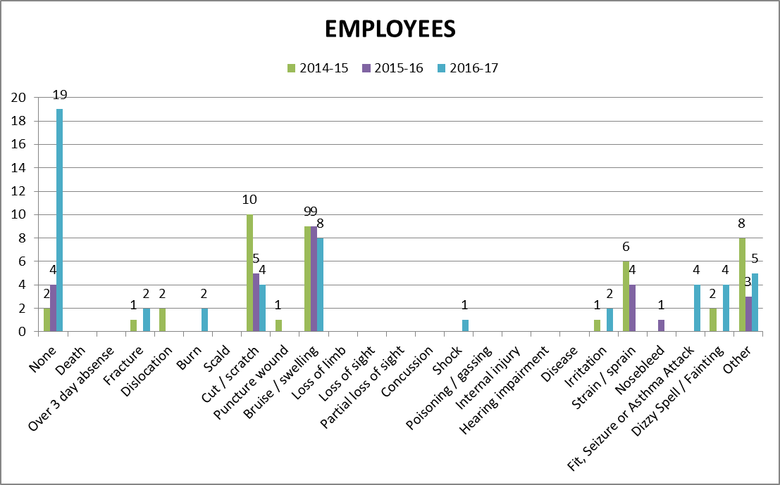
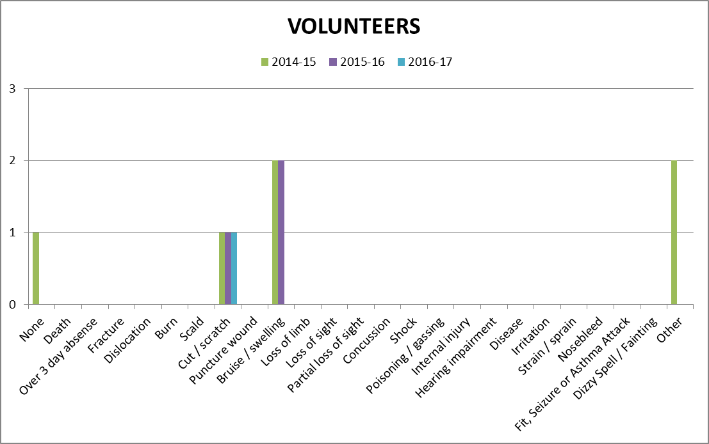

Appendix C, Table 1

Accidents and incidents compared to the previous year for users by HLH section

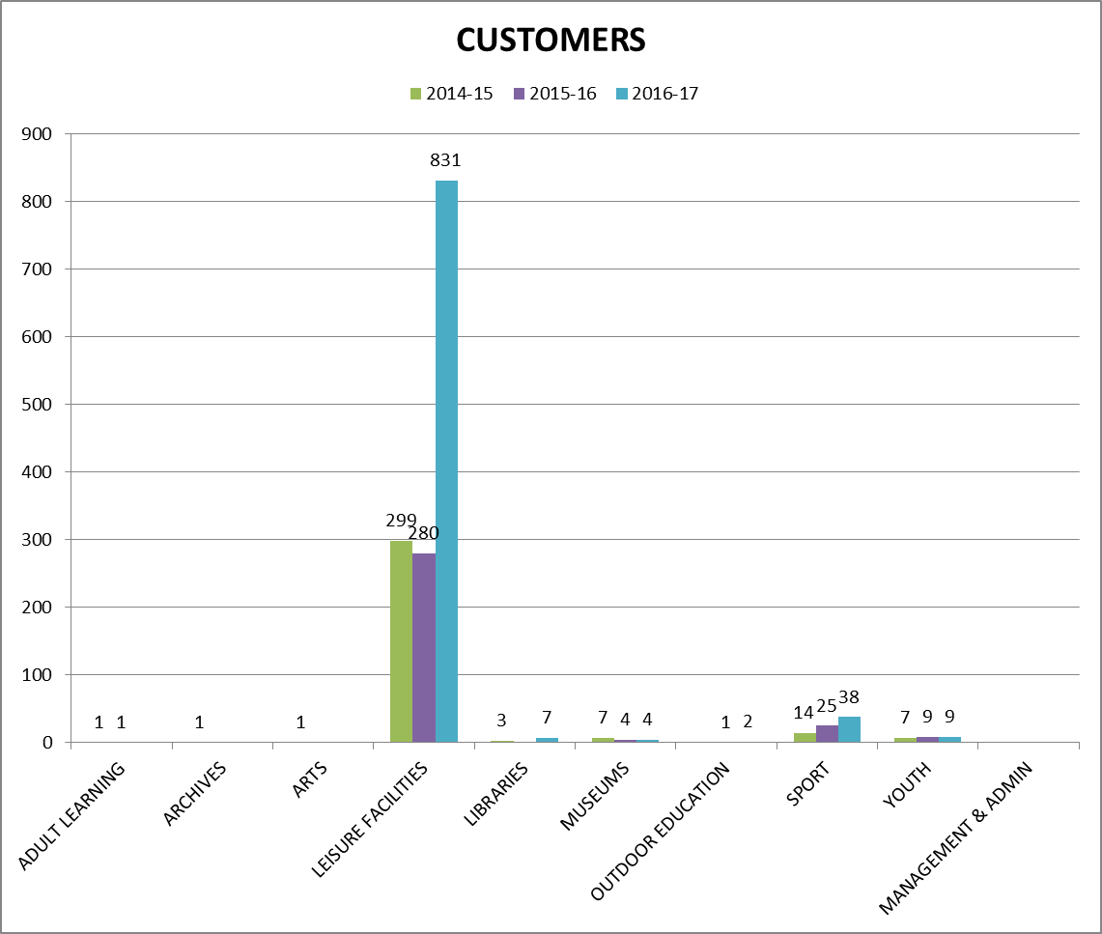

The increase in the number of accidents and incidents in Leisure Facilities in 2016/17 compared with previous years is due to the inclusion of Inverness Leisure data following the amalgamation of HLH and Inverness Leisure. When Inverness Leisure data is excluded the number of accidents/incidents is in line with previous years. As can be seen in table three below, the majority of the accidents and incidents in Leisure Facilities are cuts, bruises, sprains, etc. associated with sports participation.

Appendix C, Table 2

Accidents and incidents compared to the previous year for users by nature of accident

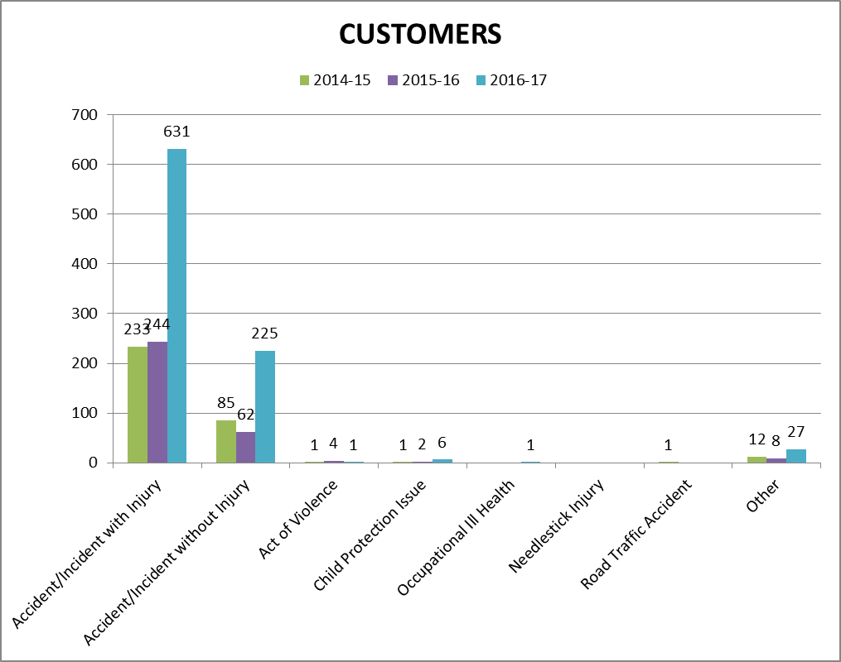

The increase in the number of accidents and incidents in Leisure Facilities is due to the inclusion of Inverness Leisure following the amalgamation of the two companies. When Inverness Leisure data is excluded the number of accidents/incidents is in line with previous years.

Appendix C, Table 3

Accidents and incidents compared to the previous year to users by type of accident/ incident

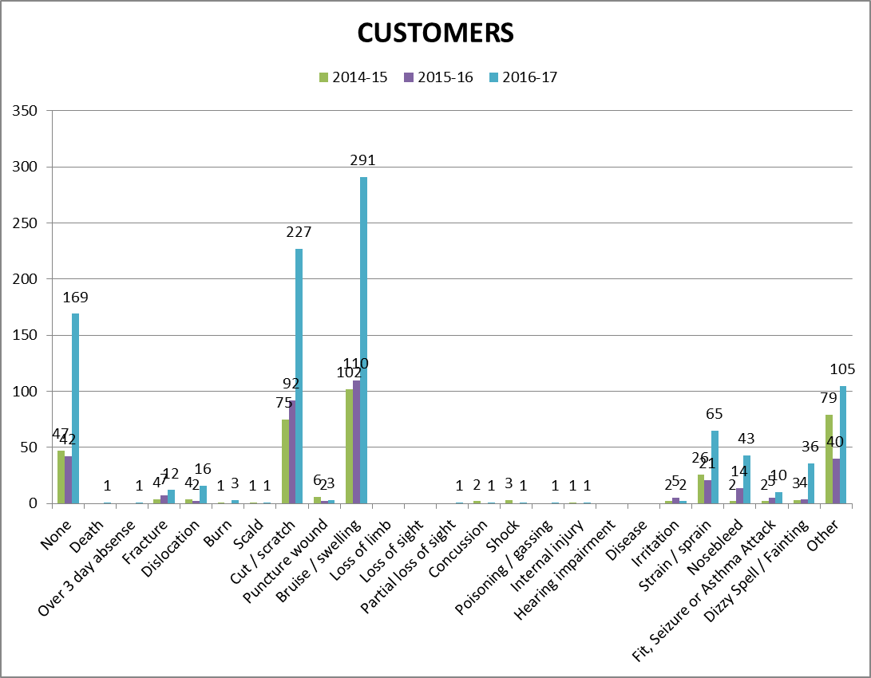

The increase in the number of accidents and incidents in Leisure Facilities is due to the inclusion of Inverness Leisure following the amalgamation of the two companies. When Inverness Leisure data is excluded the number of accidents/incidents is in line with previous years.

Appendix D
PERFORMANCE INDICATORS 2016-17
- Number of Accidents/Incidents to Staff (Employees, Contractors & Volunteers) Against Total Number of FTE Staff

 | FTE Staff | Accidents/Incidents | %
Q1 2015-16 | 496.147 | 5 | 1.01
Q2 2015-16 | 498.120 | 5 | 1.04
Q3 2015-16 | 501.330 | 7 | 1.40
Q4 2015-16 | 511.230 | 11 | 2.16
Q1 2016-17 | 598.130 | 21 | 3.51
Q2 2016-17 | 599.630 | 17 | 2.83
Q3 2016-17 | 602.200 | 8 | 1.33
Q4 2016-17 | 603.950 | 6 | 0.99

- Number of Accidents/Incidents to Users (Customers) Against Total Number of Users
 | Users | Accidents/Incidents | %
Q1 2015-16 | 1,299,041 | 76 | 0.006
Q2 2015-16 | 1,172,747 | 82 | 0.007
Q3 2015-16 | 1,428,031 | 85 | 0.006
Q4 2015-16 | 1,421,410 | 77 | 0.005
Q1 2016-17 | 1,659,898 * | 228 * | 0.013* (0.008 ex ILC)
Q2 2016-17 | 1,435,835 * | 243 * | 0.017* (0.009 ex ILC)
Q3 2016-17 | 1,462,072* | 180 * | 0.012* (0.008 ex ILC)
Q4 2016-17 | 2,119,054* | 222 * | 0.010* (0.007 ex ILC)

Key - * = Including Inverness Leisure’s Accidents and Attendance from 1st April 2016

- Number of Accidents/Incidents to Customers Against Total Number of Users for High Life Highland excluding Inverness Leisure
 | Users | Accidents/Incidents | %
Q1 2016-17 | 1,448,984 | 126 | 0.008
Q2 2016-17 | 1,261,724 | 109 | 0.009
Q3 2016-17 | 1,307,550 | 100 | 0.008
Q4 2016-17 | 1,877,868 | 131 | 0.007

- Number of Accidents/Incidents to Customers Against Total Number of Users for Inverness Leisure only
 | Users | Accidents/Incidents | %
Q1 2016-17 | 210,914 | 102 | 0.048
Q2 2016-17 | 174,110 | 134 | 0.077
Q3 2016-17 | 154,522 | 80 | 0.052
Q4 2016-17 | 241,186 | 91 | 0.038

Breakdown of Accidents or Incidents by Employees, Contractors and Volunteers

 | Accidents |  |  | Incidents
 | Employees | Contractors | Volunteers | Employees | Contractors | Volunteers
Q1 2016-17 | 14 | 0 | 1 | 5 | 1 | 0
Q2 2016-17 | 10 | 1 | 0 | 5 | 1 | 0
Q3 2016-17 | 4 | 0 | 0 | 4 | 0 | 0
Q4 2016-17 | 3 | 0 | 0 | 3 | 0 | 0

