HIGH LIFE HIGHLAND  REPORT TO BOARD OF DIRECTORS  14 December 2016 | AGENDA ITEM 14 REPORT No HLH32/16

HUMAN RESOURCES - Report by Chief Executive

Summary

The purpose of this report is to update Directors on Human Resources activity for July to September 2016 including a quarterly report on absence, disciplinary and grievance issues.

It is recommended that Directors:

- note the content of the quarterly report including the update on the staffing establishment; and
- comment on and approve the revised Harassment Policy and the minor amendments to the Policy on the Secure Handling, Use, Storage and Retention of Disclosure Information.

1 | Business Plan Contribution
1.1 | This report supports the highlighted Business Outcomes from the High Life Highland (HLH) Business Plan:  - To advance sustainable growth and financial sustainability  - Deliver the Service Delivery Contract with THC  - Improving staff satisfaction  - Improving customer satisfaction  - A positive company image  - Services designed around customers and through market opportunities  - Sustain a good health and safety performance  - A trusted partner
2 | Background
2.1 | The quarterly Human Resources (HR) report is a numerical representation of HR activity in the preceding quarter. It gives an update on current staff numbers and any change in numbers from previous reports. There is also an outline of the absence levels within the Company, number of formal disciplinary cases, number of formal grievance complaints, any harassment issues and an employee relations update.
3  3.1  3.1.1  3.1.2  3.1.3 | Human Resources Report: July - September 2016  Staff Establishment Numbers  The report to Directors covering the last quarter gave a total establishment figure of 503.92 FTE (598.13 FTE inclusive of Inverness Leisure).  The change to the establishment during quarter 2 (July to September 2016) has been an overall increase of 1.505 FTE. Two new full time posts were created following the transfer of Janitorial staff at Lochaber High School to HLH which was accompanied by a slight reduction in the overall facility supervisors hours.  The changes over quarter 2 can be summarised as:-
3.1.4 | Leisure Assistants - Badenoch Centre -1.07  Cashier/Receptionist - Badenoch Centre -0.71  Leisure Supervisor - Badenoch Centre 0.43  Caretaker - Invergordon -0.11  Reorganisation - MacPhail Centre 0.36  Library Assistant - Dingwall -0.4  Library Assistant - HMP Inverness 0.142  Facility Supervisors - Lochaber High School -0.164  Leisure Assistant - Lochaber High School 0.027  Janitors - Lochaber High School 2.0  Operations Assistant - Highland Folk Museum 1.0  Total Change over quarter 2 1.505  The staffing establishment at the end of quarter 2 is therefore 505.425 FTE (599.635 FTE inclusive of Inverness Leisure).
3.2  3.2.1  3.2.2  3.2.3  3.2.4  3.3.  3.3.1  3.4  3.4.1 | Absence Levels  The absence figures for quarter 2 (July to September 2016) were as follows:  % Absence Rates Quarter 1 Apr - Jun Quarter 2 Jul - Sep Quarter 3 Oct - Dec Quarter 4 Jan - Mar  2013/14 3.48% (2.22 days/FTE) 3.79% (2.50 days/FTE) 3.48% (2.12 days/FTE) 3.44% (2.13 days/FTE)  2014/15 2.91% (1.80 days/FTE) 2.72% (1.79 days/FTE 2.83% (1.72 days/FTE) 3.40% (2.10 days/FTE)  2015/16 2.48% (1.51 days/FTE) 2.78% (1.83 days/FTE) 3.4% (2.1 days/FTE) 3.82% (2.48 days/FTE)  2016/17 3.23% (2.07 days/FTE) 2.77% (1.83 days/FTE) - -  (2016/17 inclusive of IL) 3.59% (2.30 days/FTE) 3.09% (2.04 days/FTE) - -  In 2016/17, quarter 2 has shown a reduction in the absence rate of 0.5% (0.46% if Inverness Leisure is excluded) from the previous quarter to 3.09% (2.77%).  Of the 3.09% headline figure, 2.41% was due to long term absence (10 consecutive work days or more).  Line Managers, with the support of HR and Occupational Health, continue to manage each absence according to their individual circumstances. One employee was dismissed in the last quarter on the grounds of capability as a result of ill-health.  Discipline  There were four disciplinary issues that arose during quarter 2 2016/17. One case was dropped and no further action was taken, in two cases an informal warning was given and the remaining case led to a final written warning being issued.  Grievance  There were no formal grievance issues raised during quarter 2 2016/17.
3.5  3.5.1 | Harassment  There were no harassment issues raised during quarter 2 in 2016/17.
3.6  3.6.1  3.6.2  3.6.3  3.6.4 | Employee relations  The Company has recognised and engaged with three Trade Unions that have members within the organisation, namely Unison, Unite and GMB. The Company deals with the Trade Unions formally through the Joint Consultation Forum (JCF) which meets quarterly, the last meeting was held on 7 September 2016.  The main discussion areas at this meeting were the proposal to set up donations points in libraries. One trade union (GMB) had an issue with this and this was resolved by confirming the reasons for these and the actions that staff were expected to undertake. The transfer of some or all of CCFM to High Life Highland continued to be a topic of discussion as was communication issues around the Company.  In addition to the JCF, the Trade Unions are represented on the staff Health and Safety Committee.  Management also meet with the TUs regularly to discuss other issues (e.g. restructuring proposals, updated working practices, etc.).
4  4.1  4.2 | Annual Services Equalities Report  High Life Highland recognises and understands its duties and responsibilities under The Equalities Act 2010. The Company recognises its duty not to discriminate against any of the ‘nine characteristics’ (Age, Disability, Gender reassignment, Pregnancy and maternity, Marriage and Civil Partnership, Race, Religion and belief, Sex, and Sexual orientation).  In addition, there are duties on public sector bodies (the “general equality duty”) which also applies to bodies exercising public function to give due regard to the need to:  - Eliminate unlawful discrimination  - Advance equality of opportunity  - Promote good relations
4.3 | High Life Highland implements its duties under the act by considering the following:  - the behaviour of staff who are dealing with customers, clients, service users, club members, associate members or guests or who are taking decisions about how to provide goods, facilities or services to the public or a section of the public  - the building or other place where services are delivered, if this is open to the public or a section of the public  - advertisements and marketing  - written materials, for example, information leaflets provided as part of the service  - websites and internet services  - telephone access and call centres.
4.4 | There were no complaints during 2015/16 related to the implementation of the equalities policy.
5  5.1 | Policies update  The Harassment Policy was reviewed and it was felt that it should be brought into line with other policies and procedures within the Company and consequently this was split into policy and guidelines. The revised policy is attached at Appendix A. The Adult and Child Protection Policy, the Vetting Policy,the Recruitment of Ex-offenders Policy, Equal Opportunities Policy and Payment of Professional Fees were also reviewed with no changes made. A minor alteration was made to the Policy on the Secure Handling, Use, Storage and retention of Disclosure Information. The revised version is attached at Appendix B.
6  6.1  6.2  6.3 | Implications  Resource Implications – there are no new resource implications arising from the recommendations of this report.  Legal Implications – there are no new legal implications arising from the recommendations of this report.  Risk Implications – there are no new risks arising from the recommendations of this report.
Recommendation

It is recommended that Directors:

- note the content of the quarterly report including the update on the staffing establishment; and
- comment on and approve the revised Harassment Policy and the minor amendments to the Policy on the Secure Handling, Use, Storage and Retention of Disclosure Information.

Designation: Chief Executive

Date: 28 November 2016

APPENDIX A

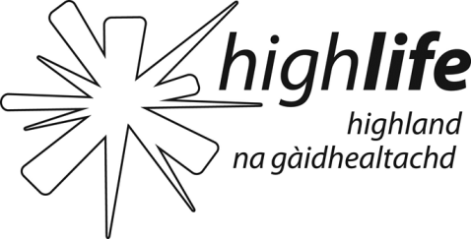 | HARASSMENT AT WORK POLICY  Approved by HLH Board – March 2012  V2 – Updated April 2014  V3 – Updated November 2016 (HLH Board 14/12/16)  Review Date – November 2018

Statement of Policy

1. High Life Highland is committed to encouraging and maintaining good employee relations within a working environment which fosters team working and encourages employees to give of their best. Everyone in the Company and those who have dealings with the Company has a responsibility to maintain good working relationships and not use words or deeds that may harm the wellbeing of others. In addition to the obligations placed upon both employers and employees by the Equality and Human Rights legislation, everyone has the right to be treated with consideration, fairness, dignity and respect. This contributes to a workplace environment in which individuals feel safe and can work effectively competently and confidently.

2. The Company’s policy applies to all staff working within the organisation and to all employees working off the premises. It extends to include non-permanent workers such as secondees, contractors, agency, temporary staff, consultants, volunteers and any other workers. The policy, in addition, covers the behaviour of staff outside working hours which may impact upon work or working relationships.

3. The Company has a “zero tolerance” policy and will investigate any allegations of bullying or harassment, regardless of whether the matter has been raised formally or informally.

APPENDIX B
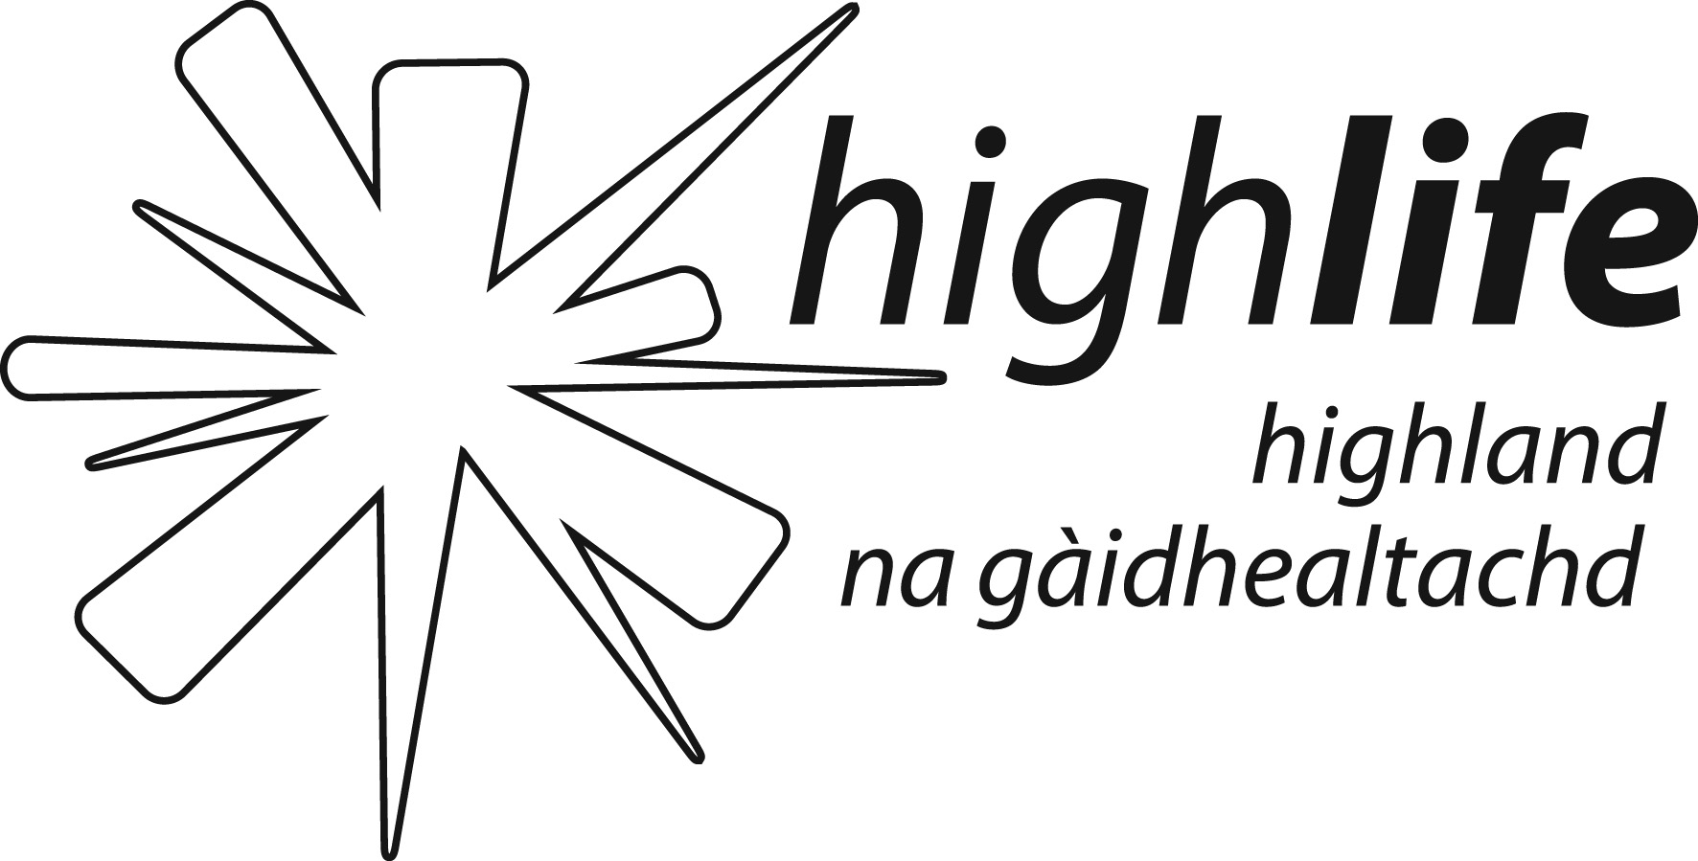 | Policy on the Secure Handling, Use, Storage and Retention of Disclosure Information.  V1 – February 2012 (Approved HLH Board 27/02/14)  V2 – November 2016 (HLH Board 14/12/16)  Review Date – November 2018

In accordance with the Disclosure Scotland Code of Practice for registered persons and other recipients of Disclosure Information we will ensure the following practice.

- Disclosures will only be requested when necessary and relevant to a particular post and the information provided on a disclosure certificate will only be used for recruitment purposes.

- We will ensure that an individual’s consent is given before seeking a disclosure and will seek their consent before using disclosure information for any purpose other than recruitment.

- Disclosure information will only be shared with those authorised to see it in the course of their duties.

- Where additional disclosure information is provided to our designated signatory and not to the disclosure applicant, our designated signatory will not disclose this information to the applicant, but will inform them of the fact that additional information has been provided, should this information affect the recruitment decision.

- Disclosure information will be stored in a locked non-portable container until a certificate is issued or for a maximum of 6 months. Only those authorised to see this information in the course of their duties will have access to this container.

- Disclosure information will be destroyed by shredding.

- No image or photocopy of the disclosure information will be made, however the following details may be retained:
  - Date of issue of disclosure
  - Name of subject
  - Disclosure type
  - Position for which disclosure was requested
  - Unique reference number of disclosure
  - Recruitment decision taken

- If the subject of the Disclosure check is found to be on the ‘Disqualified from Working with (Children/Adults) List’ we will notify the Police that an attempt has been made to acquire work with children/adults.

- We will ensure that all staff with access to disclosure information are aware of this policy and have received relevant training and support.

- We will make a copy of this policy available to any applicant for a post (paid or voluntary) with us that require a disclosure.

