HIGH LIFE HIGHLAND  REPORT TO BOARD OF DIRECTORS  20 June 2013 | AGENDA ITEM 10 REPORT No HLH 15/13

Quarterly Performance Report - Report by Chief Executive

Summary

The purpose of this report is to present performance information for the period March to May 2013.

It is recommended Directors:-

- comment on the report and agree that the overall health check on the company is assessed as green;
- note the performance of the company against its business plan objectives; and
- agree that the operational plans which are contained in the business plan be revised and updated at the October 2013 board meeting.

1. | Business Plan Contribution
1.1 | This report will assist the Board in monitoring performance against all of the business outcomes in the Business Plan and will provide an overview of the performance of the organisation.
2. | Background
2.1 | At the September 2012 meeting Directors agreed that its high level performance monitoring should focus on ten business critical areas.
2.2 | Appendix A contains the summary of performance against the performance indicators. Appendices B and C contain further information on the indicators.
3. | Summary of performance
3.1 | Seven of the ten indicators have been rated as being on target with three not having been rated as they are annual/six-monthly indicators.
3.2 | The monitoring of the operational plans contained in the Business Plan indicates that most of the actions are either complete or green. At the time that the Board developed the Business Plan, it indicated that the operational plans should be reviewed after a year. It is proposed that revised operational plans be considered by the board at its October 2013 meeting.
4. | Implications
4.1 | Resource Implications - there are no new resource implications identified as a result of the production of this report.
4.2 | Legal Implications - there are no new legal implications identified as a result of the production of this report.
4.3 | Risk Implications - there are no new risks identified as a result of the production of this report.

Recommendation

It is recommended Directors:-

- comment on the report and agree that the overall health check on the company is assessed as green;
- note the performance of the company against its business plan objectives; and
- agree that the operational plans which are contained in the business plan be revised and updated at the October 2013 board meeting.

Signature:

Designation: Chief Executive

Date: 6 June 2013
Business Critical Indicators - Summary Appendix A

Business Critical Area/PI | Reporting Frequency | Performance Assessment Method | RAG* Rating November 2012 | RAG Rating February 2013 | RAG Rating May 2013 | Summary of Performance: May 2013
- High level relationship with THC | Annual | Annual meeting, with one of the agenda items to be “assessment of the relationship between HLH and THC”, between:  - the HLH chair, vice chair and the chair of the HLH Finance and Audit Committee; and  - THC’s Leader and Budget Leader | G | G | - | Not assessed – annual PI
- Delivery of the SDC with THC | Twice per year | Agreement of THC’s Culture and Leisure Contracts Scrutiny Sub-Committee that HLH has met the terms of the SDC. | G | G | - | Not assessed – THC’s Culture and Leisure Contracts Scrutiny Sub-Committee assesses the performance of HLH on a six-monthly basis and has not considered the performance of HLH since its meeting of 12 February 2013.
- Delivery of business plan objectives | Quarterly | Reporting all actions which have been RAG rated red with reasons (and remedial action if appropriate). | G | G | G | The overall rating for performance against the business plan has been assessed as being on target. The list of operational plan actions which are red along with explanations/corrective action is in Appendix B. Of the 302 operational plan actions:  1 is recommended for removal  263 are complete or green  33 are amber  5 are red
Business Critical Area/PI | Reporting Frequency | Performance Assessment Method | RAG* Rating Nov 2012 | RAG Rating Feb 2013 | RAG Rating May 2013 | Summary of Performance: May 2013
- Financial monitoring | Quarterly | Financial monitoring reports. RAG rating (Red/Amber/Green) definition:  - Red = Delivery of SDC over budget  - Amber = Delivery of SDC on budget  - Green = Delivery of SDC within budget | G | G | G | As detailed in the finance report, it is confirmed that the Service Delivery Contract has been delivered within budget for the year ended 31 March 2013.
- Health and safety | Annual/  Quarterly | Annual external assessment and report which is agreed by the HLH board.  Quarterly review of RIDDOR reportable accidents/incidents. | G | G | G | There were three RIDDOR reported accidents which have been considered/addressed by the Health and Safety Strategic group.
- Risk management | Annual | Annual risk report agreed by the HLH board. (The risk register is reviewed quarterly by the finance and audit committee) | G | G | G | The Finance and Audit Committee has considered the risk register quarterly.
- Leisure centre customer numbers | Quarterly | Comparison graph or trend analysis to the same period in the preceding year(s). | G | G | G | Customer numbers at High Life sites have increased as can be seen in Appendix C.
Business Critical Area/PI | Reporting Frequency | Performance Assessment Method | RAG* Rating Nov 2012 | RAG Rating Feb 2013 | RAG Rating May 2013 | Summary of Performance: May 2013
- Quality of service provision | Annual | Annual board report on:  Internal assessment of quality:  - customer survey for each of the nine areas of work.  - review of comments and complaints  External assessments of quality e.g.:  - THC’s annual public performance survey.  - Museum Accreditation (takes place every five years)  - The Public Library Quality Improvement Matrix  - HMIe inspection of Community Learning and Development | G | G | - | Not assessed – annual PI
- Staff satisfaction | Annual | Annual staff survey and report to the HLH board which includes a year on year comparison of the overall rating of staff satisfaction. | - | - | G | The first staff survey is complete and is included in the HR report.
Business Critical Area/PI | Reporting Frequency | Performance Assessment Method | RAG* Rating Nov 2012 | RAG Rating Feb 2013 | RAG Rating May 2013 | Summary of Performance: May 2013
- Value for money | Annual | There are three areas of work which can be benchmarked nationally (and year on year) for value for money by calculating the cost per attendance. These are: Leisure Facilities; Libraries; and Museums. | - | - | G Libraries  Others not assessed | There will be a presentation on the CIPFA library stats at the board meeting which give an indication that funding for libraries in Highland is slightly lower than average and performance slightly higher than average.  Because of the difficulties as described below it is proposed that value for money be assessed through customer surveys in future.  The national performance indicators for Museums have ceased and the mechanism for easily making comparisons no longer exists.  THC had previously stopped using the national comparisons for leisure facilities because of the inclusion of property maintenance costs (with THC cannot provide) making comparisons unreliable.

*RAG
Red = No Significant Progress
Amber = Some Slippage
Green = On Target

Operational Plan RAG Rating as at end October 2012 Appendix B

Service Area | Operational Plan Reference | Red Actions | Target Date (from Operational Plan) | Reason and Corrective Action
Corporate | - | None | - | NA
Adult Learning | AL 2.2 | Develop suite of HLH branded promotional material and learning portfolios for adult learning. | Dec 2012 | Planning work complete. Implementation delayed but will be progressed during the current financial year.
Archives | - | None | - | NA
Arts | ART 6.1 | Increase gallery attendances by 5%. | Apr 2013 | Attendances have decreased from 52,031 in 2011/12 to 48,508 in 2012/13 due to reduced opening hours at Inverness Museum and Art Gallery (IMAG) and the Gallery in Thurso being closed due to asbestos/roof repair work. Attendances at Wick Gallery have increased. Because of the reduced opening hours at IMAG, 2012/13 attendances will be used as the new benchmark.
Leisure Facilities | - | None | - | NA
Libraries | LIB 8.2 | Bibliotherapy – reading to cope with life experiences. Collaborate with NHS, ABE, Social Work, Local Charities etc. | Mar 2013 | Staff training in Bibliotherapy is underway. Reading Agency recommended stock list has been ordered. Meeting date with NHS Highland to explore partnership possibilities has been set. Project completion date October 2013.
Service Area | Operational Plan Reference | Red Actions | Target Date (from Operational Plan) | Reason and Corrective Action
Libraries | LIB 8.3 | Promote Audio books in gym – (listening while exercising) | Mar 2013 | Timescale has slipped. Action due to be complete summer 2013.
Museums | - | None | - | NA
Outdoor Learning | - | NA – Operated by THC | -
Sport | - | None | - | NA
Youth Work | YW 7. | Make available a list of youth work grant funding opportunities for Youth Work organisations in each learning community | Mar 2013 | Timescale has slipped. Action due to be complete summer 2013.

Service Areas | Operational Plan Reference | Actions Recommended for Removal by HLH SMT | Target Date (from Operational Plan) | Reason
Archives | ARCH 7.4 | Develop the use of Highland Archive Centre facilities by external organisations. | Mar 2013 | The Archives education and outreach programme has grown to such an extent that the promotion of the meeting room conflicts with the activities staff are running. The meeting room will still be available for external bookings but will be managed in such a way that the core business of the facility will take priority.

Service Areas | Operational Plan Reference | Actions Recommended for Change or Addition by HLH SMT | Target Date | Notes
 |  | None

Appendix C
High Life Facilities – High Life card holder user numbers

(Excluding Culloden Academy Community Complex, Averon Leisure Centre or Aviemore Community Centre as inclusion of these facilities would affect the comparative nature of the indicator. These three facilities will be included after their first full year of operation)

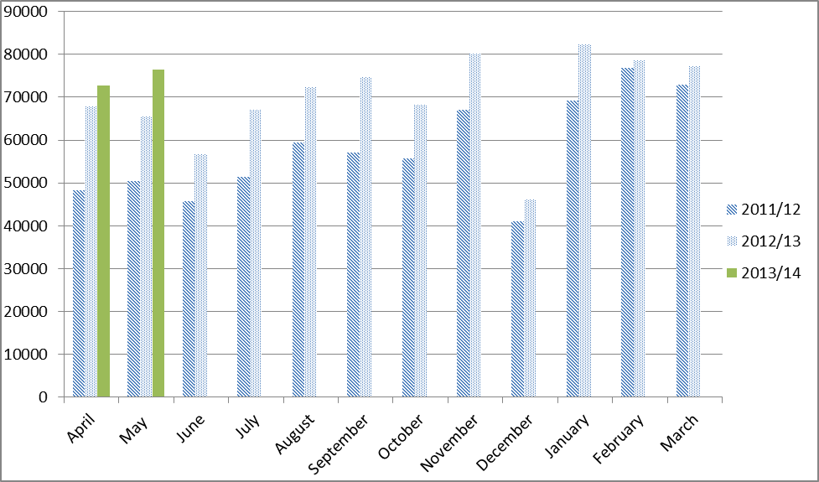

Total user numbers 1st June 2011– 31st May 2012 = 730766
Total user numbers 1st June 2012– 31st May 2013 = 853295
Total Increase/decrease % = +17%

This 17% increase is broken down as follows:
- 2% - Closure of Dingwall swimming pool 2011 / reopening of pool and refurbishment of fitness suite 2012
- 2% - Increase in fitness class provision at Lochaber Leisure Centre since refurbishment last quarter of 2011
- 13% - Overall increase in fitness programmes

