HIGH LIFE HIGHLAND  REPORT TO BOARD OF DIRECTORS  20 June 2013 | AGENDA ITEM 12  REPORT No HLH 17/13

SERVICES’ EQUALITIES POLICY - Report by Chief Executive

Summary

This report recommends a Services’ Equalities Policy for adoption by High Life Highland and outlines a short delivery plan and a reporting mechanism.

It is recommended that Directors:-

- comment on and approve the adoption of the Services’ Equalities Policy in Appendix A; and
- agree the actions detailed in paragraph 3.5 of the report.

 | 1. | Business Plan Contribution
 | 1.1 | This report will help achieve the outcome of the High Life Highland (HLH) Business Plan by improving customer satisfaction and developing a positive company image which promotes inclusion and fairness and meets the needs of all its customers.
 | 2. | Background
 | 2.1 | As an employer and provider of services, HLH has legal obligations under The Equality Act 2010. The Equality Act replaced the range of previous equality legislation with a single harmonised Act. The Act provides protection from discrimination for the following “protected characteristics”:  - Age  - Disability  - Gender reassignment  - Marriage and Civil Partnership  - Pregnancy and maternity  - Race  - Religion and belief  - Sex  - Sexual orientation
 | 2.2  2.3 | In addition, there are duties on public sector bodies (the “general equality duty”) to give due regard to the need to:  - Eliminate unlawful discrimination  - Advance equality of opportunity  - Promote good relations  The general duty also applies to other bodies when exercising public functions which applies to HLH in its relationship with The Highland Council (THC).  In addition there are specific equality duties in Scotland to assist listed public bodies to meet the general duty. HLH is not a listed public body under the Equality Act 2010 (Specific Duties) Regulations Scotland. It is not therefore recommended that these are adopted in their entirety as they include the duty to publish progress reports, gender pay gaps and the like. However it is proposed that High Life Highland adopt the use of equality impact assessments.
 | 2.4 | The Company already has an Equality Policy for the recruitment and treatment of staff. It would assist the public, current funders and the senior management team if the Company also had an Equalities Policy for the delivery of services. This may also assist the Board in undertaking their duties. In time it is the intention to merge these policies as part of the regular policy review process.
 | 3. | A Services’ Equalities Policy
 | 3.1 | A draft Services’ Equalities Policy is included at Appendix A. It will be recommended that the Board comment on and adopt this policy.
 | 3.2 | In order for this to be more than just a statement it will be recommended that the Board receive an annual update on the implementation and actions associated with the policy.
 | 3.3  3.4  3.5 | A traditional approach to implementing new policy is to produce a detailed action plan. There is a danger that a lot of work could go into developing a detailed plan which then gathers dust on a shelf. It is suggested that equalities is an issue of organisational culture which should be mainstream in all activities, requiring to be backed up by strategic direction and leadership, training and monitoring and reporting, rather than overly detailed operational planning.  HLH has a significant advantage in that THC has produced a detailed equalities action plan, designed to engage with, and capture the views of the groups with the characteristics defined by the 2010 Act. It is suggested that by formally including the outputs and outcomes of the THC equalities plan in each review of the implementation of the HLH equalities policy, much duplication of effort can be avoided.  The following actions would follow from the policy, if it is adopted by the HLH Board:  - Designate the Chief Executive as the senior officer responsible for ensuring the implementation of this policy  - Undertake Equality Impact Assessments (EQIAs), and record the results, before initiating or changing policies, plans or services  - Train managers in EQIA  - Review the 9 areas of HLH work using EQIAs and implement the results by June 2014  - Review the accessibility of HLH services, including disabled access to HLH building  - Report annually to the Board on the implementation of the policy to enable the Board to determine whether the Company is fulfilling its obligations under the 2010 act
 | 4. | Implications
 | 4.1  4.2  4.3  4.4 | Resources Implications – there are implications for the resource of staff time to complete equalities assessments but these are recognised as best practice and administration will be kept to a minimum  Legal Implications – there would be legal implications if HLH were not to have appropriate service equality provisions in place  Equalities Implications – As an employer and service provider, HLH is required to comply with the requirements of the Equality Act 2010, in addition, when carrying out public functions, HLH is required to give due regard to the general equality duty.  Risk Implications - There are legal and reputational risks if HLH does not give due regard to the Equality Act 2010.

Recommendation

It is recommended that Directors:-

- comment on and approve the adoption of the Services’ Equalities Policy in Appendix A; and
- agree the actions detailed in paragraph 3.5 of the report.

Signature:

Designation: Chief Executive

Date: 7 June 2013

APPENDIX A
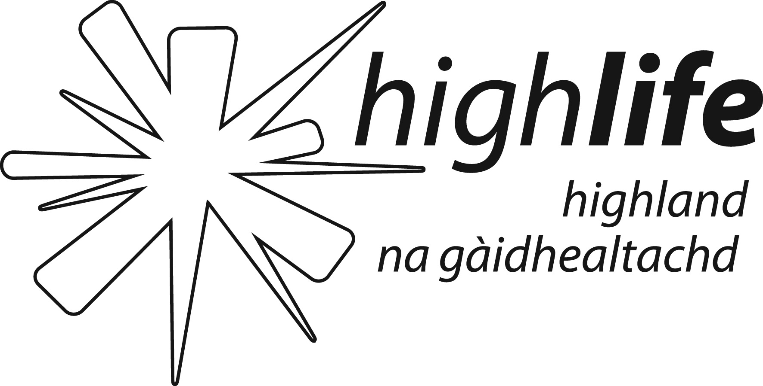 | Services’ Equality Policy  Version 1 – Approved HLH Board ………..

This Policy sets out how High Life Highland will ensure that it meets its responsibilities as a service provider under The Equalities Act 2010. High Life Highland has a separate equal opportunities policy for how it will treat its staff.

High Life Highland recognises and understands its duties and responsibilities under The Equalities Act 2010. The Company recognises its duty not to discriminate against the following characteristics:

- Age
- Disability
- Gender reassignment
- Pregnancy and maternity
- Marriage and Civil Partnership
- Race
- Religion and belief
- Sex
- Sexual orientation

In addition, there are duties on public sector bodies (the “general equality duty”) which also applies to bodies exercising public function to give due regard to the need to:
- Eliminate unlawful discrimination
- Advance equality of opportunity
- Promote good relations

High Life Highland will implement its duties under the act by considering the following:

- the behaviour of staff who are dealing with customers, clients, service users, club members, associate members or guests or who are taking decisions about how to provide goods, facilities or services to the public or a section of the public
- the building or other place where services are delivered, if this is open to the public or a section of the public
- advertisements and marketing
- written materials, for example, information leaflets provided as part of the service
- websites and internet services
- telephone access and call centres.

High Life Highland will take into account the findings, conclusions and action plan of "A Fairer Highland". The Company will also adopt the following good practice:

- Designate a senior officer responsibility for ensuring the implementation of this policy
- Develop a plan to assist the company to take an approach of non-discrimination and which treats people with dignity, respect and fairness and ensure that the implementation of this plan is reported regularly to the Board
- Undertake equality impact assessments before initiating or changing policies, plans or services, and use relevant evidence and take reasonable steps to involve equality groups

