HIGH LIFE HIGHLAND  REPORT TO BOARD OF DIRECTORS  28 March 2013 | AGENDA ITEM 15 REPORT No HLH 9/13

ANNUAL Health and Safety Report - Report by Chief Executive

Summary

An important element of the Governance structure relating to the company’s Health and Safety performance is the Health and Safety Annual Report.

This report informs Directors about the performance of High Life Highland in terms of health and safety management.

It is recommended that Directors note:-

- the low number and low severity of incidents over the period reflecting good practice across the company.

1. | Business Plan Contribution
1.1 | This report contributes to all of the outcomes of the High Life Highland (HLH) Business Plan 2012-15.
2. | Background
2.1 | The terms of the HLH Health and Safety Policy Statement requires annual and exception reporting to the HLH Board on health and safety performance
2.2 | At the meeting on the 6 December 2012 Directors remitted the content of the annual health and safety report to the Health and Safety Strategic Group.
2.3 | Taking on board comments made by Directors at the time, the Health and Safety Group agreed that the Annual Report to the HLH Board should consist of:  - details of all RIDDOR reported accidents and a summary of the follow up internal investigation and actions resulting;  - a graph or table of all accidents and incidents by quarter, and compared to the previous year to staff and contractors by:  - HLH section e.g. libraries, leisure centres  - Nature of accident i.e. accident with injury, accident without injury, act of violence, other  - Type of accident/ incident e.g. fracture, bruise, burn etc.  - A graph or table of all accidents and incidents by quarter, and compared to the previous year to users by:  - HLH section e.g. libraries, leisure centres  - Nature of accident i.e. accident with injury, accident without injury, act of violence, other  - Type of accident/ incident e.g. fracture, bruise, burn etc.  - PIs:  - number of accidents and incidents to staff against numbers of FTE staff  - number of accidents and incidents to users against total number of users
3. | Health and Safety Performance
3.1 | Performance statistics and graphs for the period April to October 2012 are included in Appendix A. Whilst some trend analysis is possible it should be noted that comparisons with previous years will be available from April 2013.
3.2 | Riddor Report Summary  There were two incidents where it was felt necessary to implement the reporting system to the Chair, although the staff actions were exemplary, and HLH procedures immediately executed:  - two young children encountered difficulties in an HLH pool, one immediately after the other. The staff could have had their attention diverted by the first incident and not been immediately aware of the second. This did not happen and both children were assisted to the side of the pool. They remained in the shallow end playing under supervision until their parents arrived; and  - a member of the public had a heart attack whilst using the gym at Aviemore. The Ambulance Service has reported that the quick actions and life saving techniques used by Antonio Vestano, an eighteen year old member of HLH staff on duty, saved the life of the individual concerned.  This last incident is the only one requiring follow up internal investigation, in terms of whether and if so how and where, to acquire defibrillators for HLH leisure centres and possibly other sites. This work is continuing and a verbal report on the subject appears as agenda item 6 of this meeting.
3.3 | Given the size of the HLH operation and the number of visits to HLH facilities (over 3 million a year), there have been a very small number of incidents, reflecting good practice in our facilities. Good progress has been made in terms of reviewing all policies and procedures, and the audit and review groups have ensured a culture of continuous improvement.
4. | Risk Implications
4.1 | There are no additional risks requiring to be added to the risk register from adopting the recommendations in this report

Recommendation

It is recommended that Directors note:-

- the low number and low severity of incidents over the period reflecting good practice across the company.

Signature:

Designation: Chief Executive

Date: 18 March 2013

APPENDIX A

All RIDDOR Notified Accidents/Incidents – Summary Q1 – Q4 (to Feb 2013) 2012-13
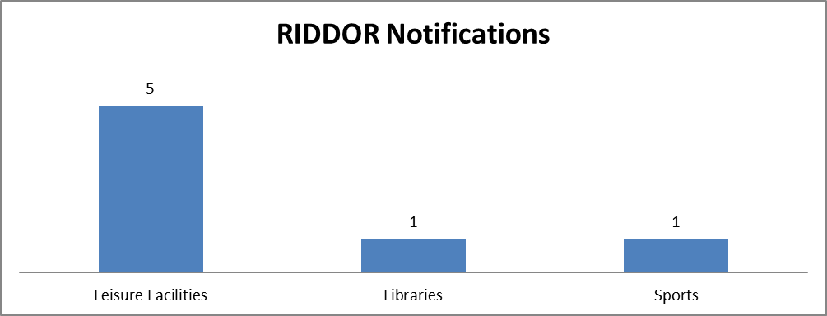
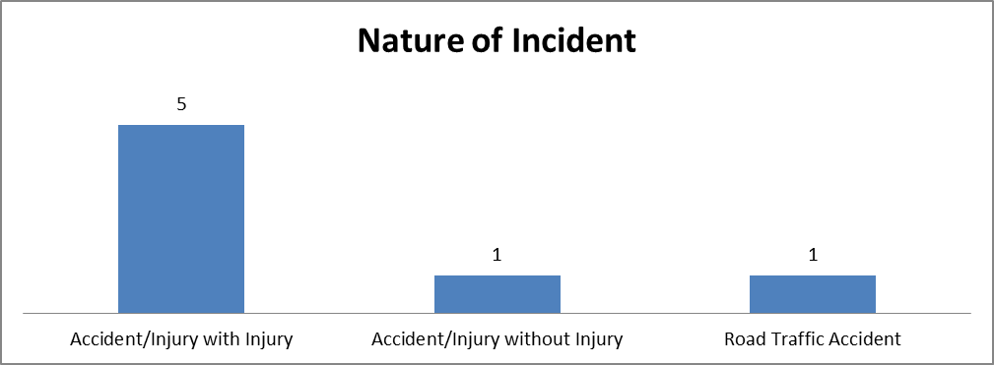
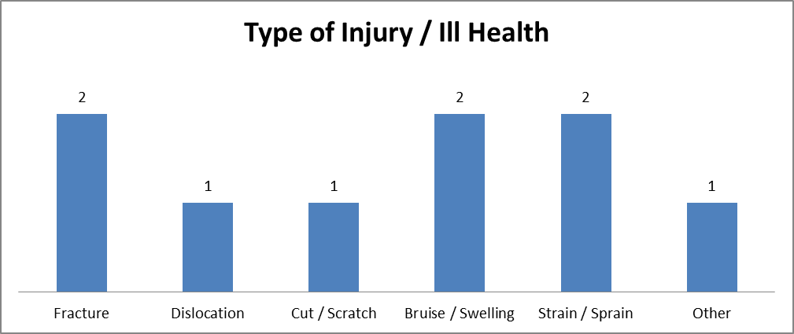

All RIDDOR Notified Accidents/Incidents - Details
Incident No | Accident / Incident Details
29 | A female was doing Frog Jumps in Aqua Aerobics, she started screaming and 3 of the ladies huddled round her. I turned music off and shouted for assistance. Myself and Chris entered the water as the 3 ladies had lifted her out of the water. Myself and Chris guided the spinal board under her. Ambulance was called and we guided the board onto the wall, placed ice pack on the right knee which she had dislocated and wrapped her up in towels  Recommendations: N/A  Leisure Facilities - Tain Royal Academy Community Complex (TRACC) – Date: 08/20/2012
41 | Female member of staff was driving in her own car over the the Dava Moor Road to meet colleagues to travel with them to the CILIPS library conference in Dundee. Her car failed to take a corner and overturned and rolled. The member of staff got out of her car and the driver of another car stopped to help and to call the police and an ambulance.  Recommendations: N/A  Libraries - Inverness Library – Date: 06/12/2012
45 | Individual went over on her ankle on her way to use the toilet  She was wearing brand new trainers at time of incident which may have been a contributory factor. No cause for concern in area.  Leisure Facilities - Craig Maclean Leisure Centre – Date: 04/24/2012
46 | Tripped on an uneven slab. Twisted left ankle and landed on both knees and left hand, arm and shoulder  Recommendations: Uneven slabs were repaired 05.06.12  Sports – Other – Date: 06/01/2012
198 | 59 year old male customer fell off treadmill at 2:10pm, Leisure Attendant adjusted patient into recovery position while supervisor contacted ambulance service. Customer then lost his pulse, at that time the leisure attendant performed CPR and managed to get him back round. Supervisor checked PARQ which showed no pre-existing medical conditions. Ambulance then showed and took responsibility and gave instructions. They DEFIB on site as Anthony went and lost his pulse again. Once he was conscience Leisure Team assisted by putting him on stretcher and carried equipment into ambulance.  Recommendations: Debriefed staff on duty. Will go once incident in training as training aid.  Leisure Facilities – Other – Date: 12/08/2012
253 | Tripped and fell while entering building at doorway. Ambulance called immediately and customer taken to nearby Raigmore Hospital.  Recommendations: No obvious cause of trip - Stewards did not see actual fall  Leisure Facilities - Raigmore Community Centre – Date: 02/07/2013
254 | Incident unprovoked. Male (1) was standing in the foyer; male (2) another club member hit a female club member in the face, then went up to male 1 who landed on his back, bumping the back of his head on the ground; causing slight swelling and bruising/bleeding under the skin. Ice pack placed on site of injury and male 1 taken to A&E to be checked out. Support worker contacted to attend hospital.  Recommendations: To contact manager of Richmond Fellowship who support male 2 - to discuss incident and determine what measures need to be taken to prevent a reoccurrence of any aggressive behaviour from male 2. (male 2 accompanied to club by support worker, Richmond Fellowship who also witnessed the incident and escorted male 2 home)  Leisure Facilities – Other – Date: 02/14/2013

Quarterly Number of Accidents/Incidents to Customers by Service
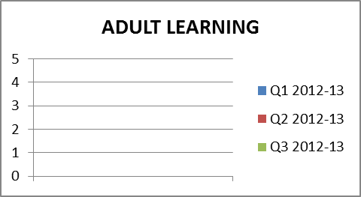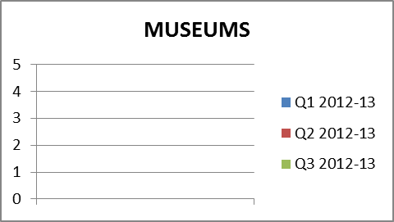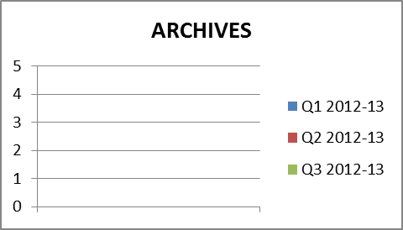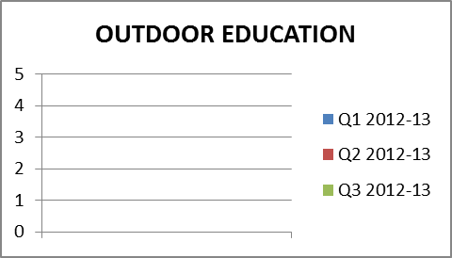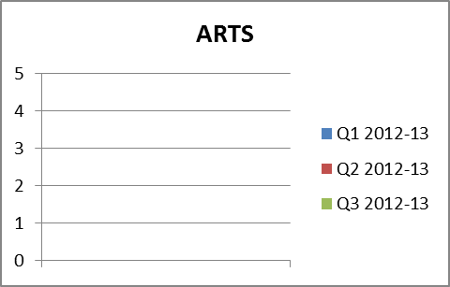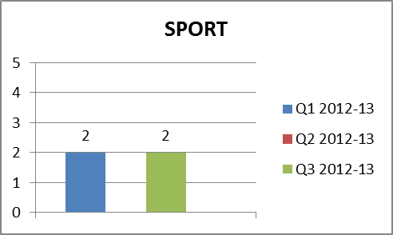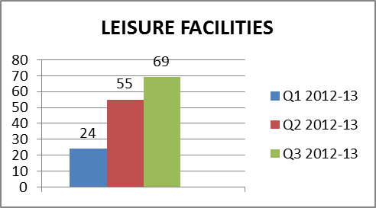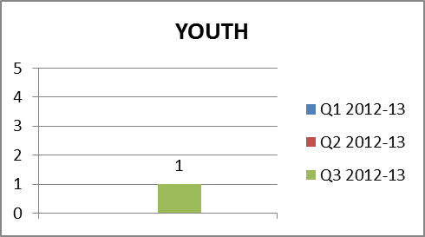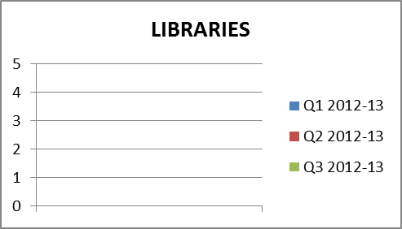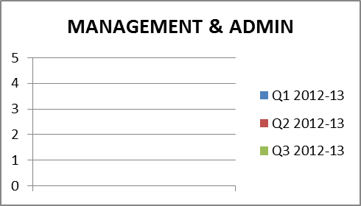
Quarterly Number of Accidents/Incidents to Employees, Contractors & Volunteers by Service
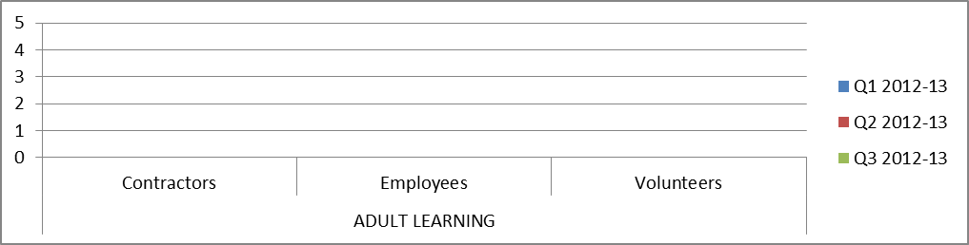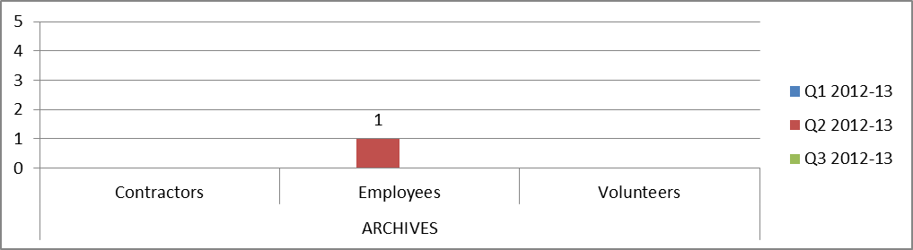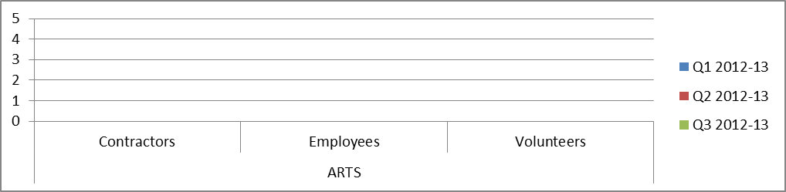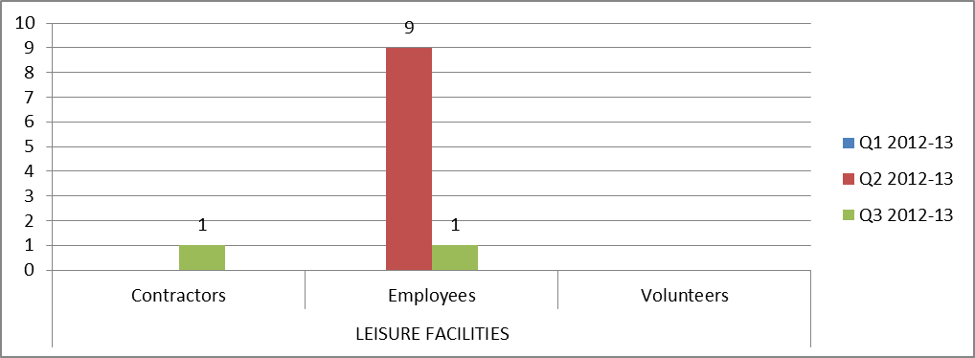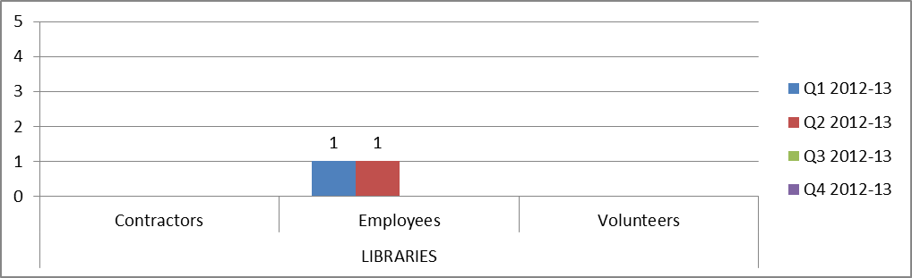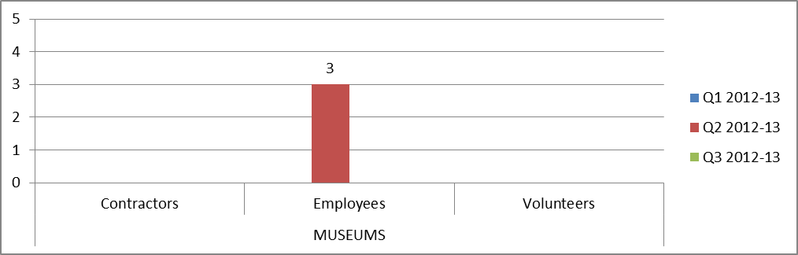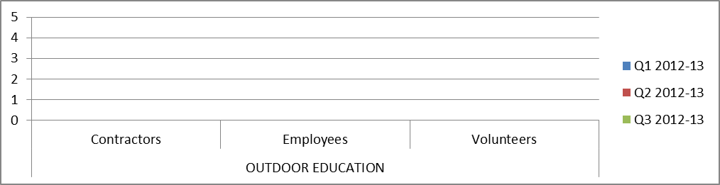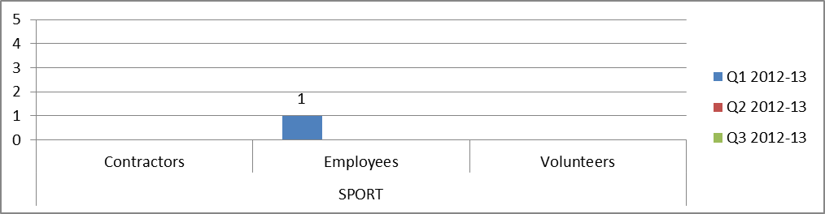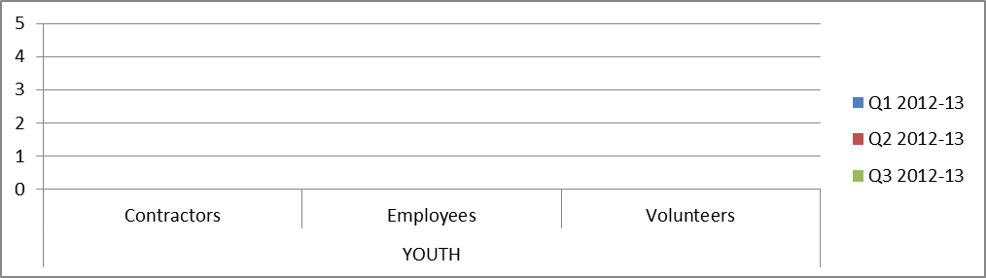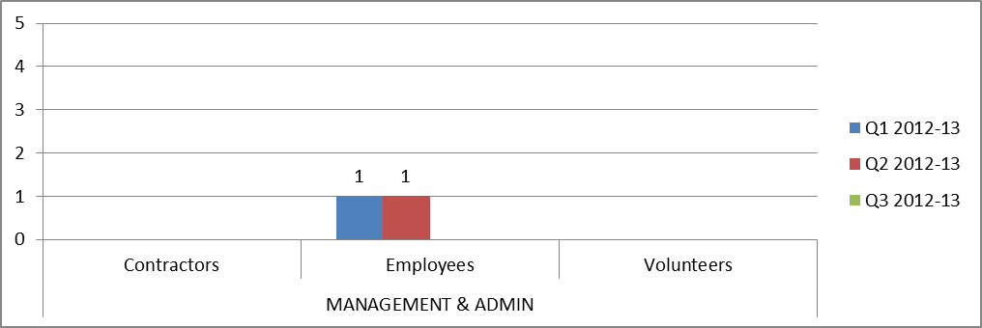

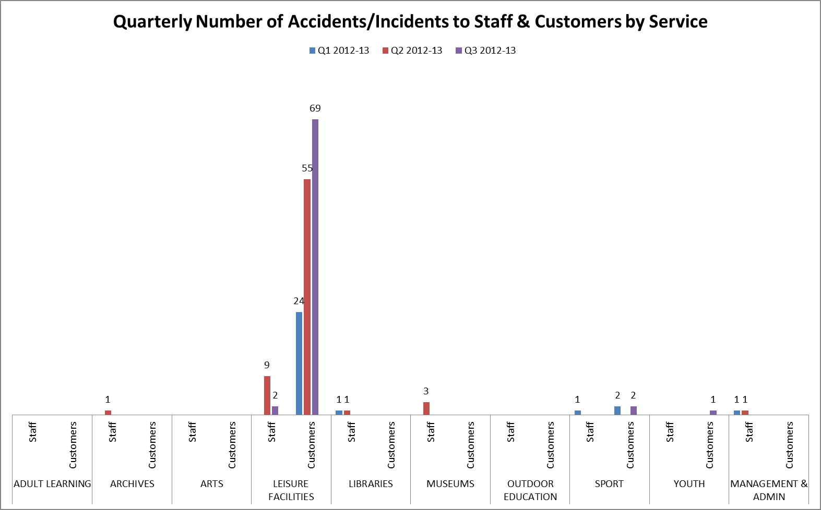
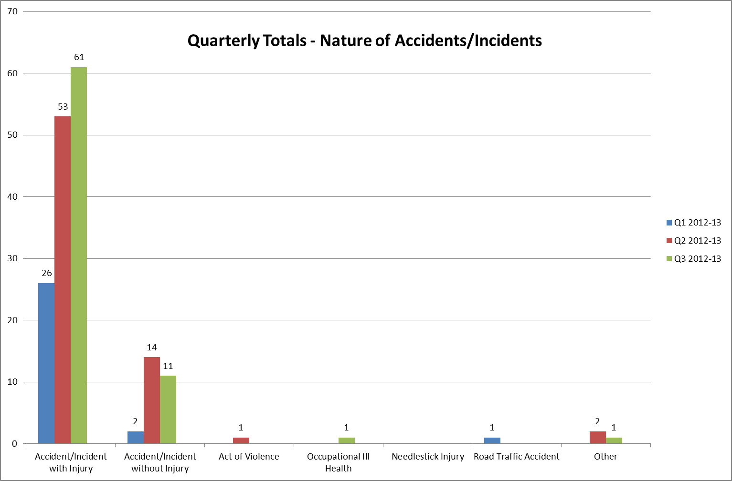

PERFORMANCE INDICATORS
- Number of Accidents/Incidents to Staff (Employees, Contractors & Volunteers) Against Total Number of FTE Staff
 | FTE Staff | Accidents/Incidents | %
Q1 2012-13 | 464.02 | 3 | 0.6
Q2 2012-13 | 466.49 | 15 | 3.2
Q3 2012-13 | 481.44 | 2 | 0.4

- Number of Accidents/Incidents to Users (Customers) Against Total Number of Users
 | Users | Accidents/Incidents | %
Q1 2012-13 | 721,395 | 26 | 0.004
Q2 2012-13 | 729,721 | 55 | 0.008
Q3 2012-13 | 693,560 | 72 | 0.010

