HIGH LIFE HIGHLAND  REPORT TO BOARD OF DIRECTORS  6 December 2012 | AGENDA ITEM 4  REPORT No HLH 31/12

HIGH LIFE HIGHLAND SUCCESSES - Report by Chief Executive

Summary

The purpose of this report is to present Directors with the best submissions from staff teams on the successful work being carried out by High Life Highland throughout the Highlands and across all areas of work.

It is recommended that Directors comment on the items presented and note that the selected items will form part of a long list for the annual Staff and Volunteer Award Scheme.

1. | Background
1.1  1.2  1.3  1.4 | The September 2012 meeting, agreed the alignment of the successes submitted on a quarterly basis with the Staff and Volunteer Award Scheme. A small assessment group comprising the Chief Executive and 2 Directors, Jaci Douglas and Douglas Graham was set up to consider future submissions and select up to 15 as “best of” successes for presentation to each Board meeting.  The 13 successes presented to this meeting in Appendix A are those selected by the assessment group for this quarter. The full list of all 35 submissions received appears at Appendix B.  The criteria used to select the successes presented to this meeting are distilled from the 9 outcomes which form the basis of the HLH Business Plan.  - increased internal collaboration & new partnership working;  - doing what we do, but better;  - contributing toward a growing company; and  - contributing toward a positive company image.  The successes at this meeting will be added to that forming the long list for the annual staff award system.
2. | Business Plan Contribution
2.1 | The successes contributes to achieving the following outcomes of the HLH Business Plan 2012-15:-  - increased staff satisfaction  - increased internal collaboration  - delivery of the SDC with THC  - increased awareness of product and services  - increased customer satisfaction  - a positive company image  - a growing company  - increased financial sustainability
3. | Risk Implications
3.1 | There are no new risks resulting from this report.

Recommendation

It is recommended that Directors comment on the items presented and note that the selected items will form part of a long list for the annual Staff and Volunteer Award Scheme.

Signature:

Designation: Chief Executive

Date: 22 November 2012
APPENDIX A

Area of work (e.g. Arts) | Adult Learning - ESOL Tutor Training and E-training
Location | Inverness
Title of piece of work | Communication Course for Frontline Staff
Description of event  (the purpose / targets) | Description  Language / communication barriers are usually the principal difficulties encountered when delivering services to migrant communities. This short language awareness course explores simple but effective ways of making spoken and written English more understandable to non-native speakers. It is aimed at front-line staff from a variety of public and voluntary service providers. The course is delivered online over a period of 2 weeks. Participants are invited to download weekly tasks and take part in online forum discussions.  Aims and objectives  - To raise awareness of language barriers faced by non-native speakers of English  - To develop strategies for communicating clearly and effectively with non-native speakers of English  - To increase confidence in dealing with people from different language groups  - To raise awareness of own practice  - To raise awareness of strategies for dealing with language barriers  - To provide a forum for the sharing of experience and good practice  Targets  12 participants per course; 2 courses in 2012 = 24 participants
Which staff were / are involved | Developed, coordinated and delivered by Gillian Scott, ESOL Tutor Training Coordinator (p/t)  Email: g.scott@weascotland.org.uk  With some case studies developed by Melanie Danet. Other trainers, Shona Radojkovic and Melanie Danet to deliver 2nd course.  This course is part of the ESOL Tutor Training and e-Training Project which is managed by Mary Rhind, High Life Highland and funded by High Life Highland, the Scottish Government and the European Social Fund, and supported by Highland Council.
What were the results /  numbers involved /  Feedback | Exceeded target numbers: 29 participants in 2012.  12 enrolled on pilot course in August 2012 from various organizations across Highland: NHS, Highland Homeless Trust, Women’s Aid, Job Centre Plus, Highland Council, Lifestyles Fort William and WEA.  17 participants are enrolled on the November course: they come from a range of organizations including Inverness College, Action for Children, Highlife Highland Libraries, Inverness Royal Academy, Lochaber Women’s Aid, and Highlife Highland/Adult learning (Literacies).  Feedback  This was a non-accredited course, but the feedback was excellent.  Here are some feedback comments from the August pilot course participants:  "I felt that as a general introduction the course was absolutely perfect. It certainly met my needs. I certainly enjoyed reading other participants' experiences and viewpoints in the forums."  "Even after Module 1, I started using shorter sentences with NNS's [non-native speakers] and noticed a difference in how successful I was in communicating."  "Very good course, enjoyable and so worthwhile."  "Thank you, I have picked up valuable points."
Attach photos or web links | The course is available on the TESOL Training Scotland website:  Please note: access is restricted and username and password are needed. Please contact Gillian Scott to arrange this if you would like to view it.
Name & email of staff member submitting news item | Mary Rhind  Adult Literacies Coordinator  Mary.rhind@highlifehighland.com

Area of work (e.g. Arts) | Archives
Location | The Highland Archive & Registration Centre
Title of piece of work | Maps and Travellers
Description of event  (the purpose / targets) | This event was organised as part of The Highland Archaeology Festival. Maps and Travellers consisted of a one day symposium involving speakers from UHI, and the world of journalism as well as archive staff, speaking on subjects such as Gaelic mountain names and the Romans in the Moray Firth area.  The event included a behind the scene’s tour of the Archive Centre.
Which staff were / are involved | Paul Brough, Anne Fraser, Colin Waller, Janet Baker, Fiona MacLeod, Peter Mennie, Rachael Shepherd
What were the results /  numbers involved /  Feedback | There was a great demand by members of the public for places at the symposium, and the event was fully booked. Last minute requests for places were unfortunately unsuccessful. Comments on the event were very positive, including “ fascinating and highly informative” . 31 members of the public attended the event.
Attach photos or web links | 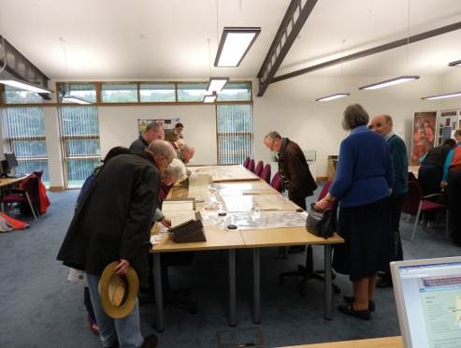  Delegates viewing original documents relating to maps and travellers in the Archive Searchroom
Name & email of staff member submitting news item | Janet Baker  janet.baker@highlifehighland.com

Area of work (e.g. Arts) | Arts
Location | Wick Carnegie Public Library/St Fergus Gallery
Title of piece of work | Family Craft workshops
Description of event  (the purpose / targets) | During the school holidays in October, the St Fergus Gallery ran 4 workshops for children ages 4 to 9 years based upon 2 of their recent exhibitions, ‘Polish Paper Cuts’ and ‘Signs for Sounds’.  The workshops were collaboration between the library and gallery services. The idea came as a result of feedback received from parents of junior library members who enjoyed the craft sessions ran over the Summer holidays, and requested there be something held during the October holidays.  The Library arranged the promotion and booking of the events and the Gallery service delivered the sessions. Both children and their parents got involved and fun time was had by all.
Which staff were / are involved | Jana Emburey – Gallery Attendant  Robbie Macdonald - Library Supervisor, Wick.
What were the results /  numbers involved /  Feedback | Four sessions with a total attendance of 48 children and their parents.
Attach photos or web links | 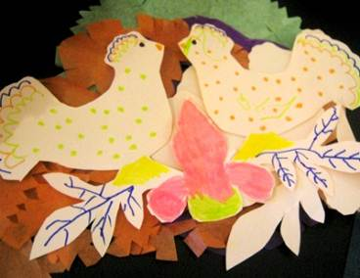  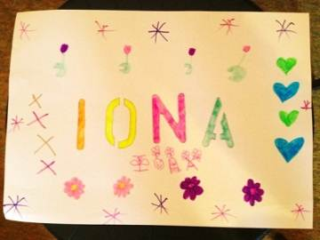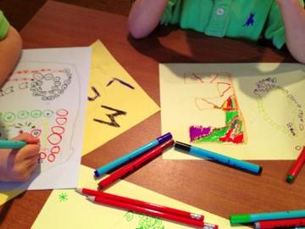
Name & email of staff member submitting news item | Robbie Macdonald – robbiemacdonald@highlifehighland.com
Area of work (e.g. Arts) | Arts/Lifetime Learning
Location | Craigmonie Centre - Drumnadrochit
Title of piece of work | Free Concert from the Scottish Ensemble
Description of event  (the purpose / targets) | As part of their residency at Inverness during October, the Scottish Ensemble contacted HLH about holding short ‘getting to know you’ sessions comprising of a Free short concert and a Q&A session to be held in unusual venues.  Although established as an arts venue, the Craigmonie Centre had never held an afternoon concert of classical music before, and knew that it would be the perfect opportunity to target new audiences for both the kind of music and for the venue, and to make both more accessible to those who perhaps find that finances are a barrier to the arts or for trying new things.  Held at 4pm on Saturday October 27th we chose to hold the concert in the canteen area overlooking the courtyard, in cabaret style to give the event a more informal feel and bring the audience as close to the musicians as we could.  Entry was on a walk up basis – no tickets required. Coffee, tea and biscuits were provided (donations invited for this but not required).  As well as a programme of short popular classics, the members of the Ensemble answered questions from the audience about their instruments, how they got interested in music, their experiences of playing in the ensemble, etc.  Targets: Accessible arts, learning
Which staff were / are involved | Fran Davidson – Centre Co-ordinator
What were the results /  numbers involved /  Feedback | The audience of over 30 that attended the concert ranged in age from pre-school with their parents to seniors in their 90s.  Some who attended had either never been to the Craigmonie Centre before or had never attended a classical concert before.  The audience was a mix of locals / from the Great Glen ILC and those who travelled in from the Inverness /Beauly area. We even had a couple of tourists from Greece who saw the posters and came along.  Comments sent to the Centre after the concert and anecdotal on the day Included:-  ‘We really enjoyed the Scottish Ensemble on Saturday – and it is not often you get a treat like that for free!’ E Telfer  ‘a delightful event’ N MacInnes’  I’ve never been here before and didn’t realise what a nice venue it was, and it was great to be able to see the musicians close up  Thank you for the concert – I’m in my 90s and don’t like to go out in the evening so it was wonderful to be able to enjoy this in the afternoon.  It was the first time I brought my children to a concert of this type – they really enjoyed it and may daughter now wants to try the cello!  In addition – The members of the Scottish Ensemble who appeared here enjoyed their experience and we discussed them making a return appearance here either during their next trip to Inverness in December or in 2013.  As co-ordinator, I will also look to programme more of these short taster concerts in the afternoon to cater for this audience / encourage new audiences.
Attach photos or web links | 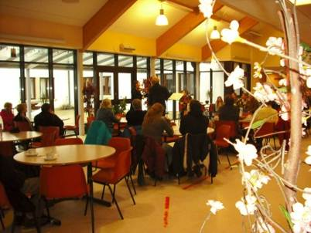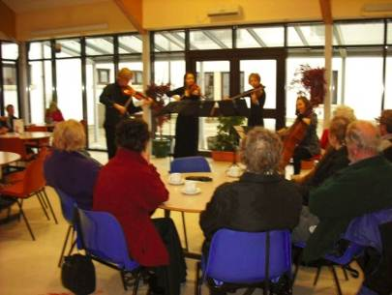
Name & email of staff member submitting news item | Fran Davidson  Fran.davidson@highlifehighland.com

Area of work (e.g. Arts) | Leisure Facilities
Location | Craig MacLean Leisure Centre
Title of piece of work | CMLC Youth Try Tri
Description of event  (the purpose / targets) | With Triathlon being the UK’s number one growing sport, the Craig MacLean Leisure Centre hosted their 2nd Annual Junior Try Tri event on Saturday the 8th of Sept. 130 participants signed up for the competition which was open to children aged from 4 - 12 years, the course consisted of a non-stop swim, cycle and run challenge suitable for all abilities over very achievable distances in a safe environment. Everyone on the day received a medal for their efforts and the winners of each category were rewarded with a trophy and certificate. Our aim now is to continue promoting this all inclusive event to high life members and visitors to the area and form a Try Tri committee with volunteers in the community.
Which staff were / are involved | A special thank you must be made to the CMLC staff, management committee, high school pupils, active schools, parent volunteers and specialist triathlon timer Hendry Trotter for making this day a great success.
What were the results /  numbers involved /  Feedback | Fraser Tulloch: “I have been overwhelmed with positive feedback from parents and children. Combined with original senior Try Tri on the Sunday families from as far as Glasgow, Carnoustie and Stirling can now make a weekend of it with their kids taking part in Saturdays’ Junior event. I derive a great deal of satisfaction seeing the personal achievement sport can bring to children and the highlight for me was seeing youngsters aged 5 crossing the finish line with a big smile on their face”  Tristar 1 boy’s 7-8 years: 3rd Jamie Calder 3.31sec, 2nd Rory Sangster 3.28sec & 1st Calum MacKintosh 3.12sec  Tristar 2 girl’s 7-8 years: 3rd Hanah Henderson 4.07sec, 2nd Caitlyn Hollands 3.54sec & 1st Katie Hay 3.38sec  Tristar 2 boy’s 9-10 years: 3rd Angus Harrold 6.12sec, 2nd Harry Baike 5.20sec & 1st Ewan Mackintosh 5.14sec  Tristar 2 girl’s 9-10 years: 3rd Niamh Peters 6.12sec, 2nd Sophie Maclean 6.08sec & 1st Lauren Phillip 6.07sec  Tristar 3 boy’s 11-12 years: 3rd Angus Sangster 8.01sec, 2nd Ryan MacLean 7.29sec & 1st Ben Baike 7.13sec  Tristar 3 girl’s 11.12 years: 3rd Amelia Mcauly-Brand 8.36sec, 2nd Zoe Hodi 8.21sec & 1st Wizzy Mills 8.15sec
Attach photos or web links
Name & email of staff member submitting news item | Fraser Tulloch  Fraser.tulloch@highlifehighland.com

Area of work (e.g. Arts) | Leisure Facilities and Health and Wellbeing
Location | Black Isle Leisure Centre
Title of piece of work | Eat, Play and Grow well
Description of event  (the purpose / targets) | During the current term (August – October 2012) the Black Isle Leisure Centre, in partnership with NHS Highland, trialed the delivery of a brand new approach to delivering the NHS Highland Child Healthy Weight Community Programme. The programme was run as part of the Saturday Club, which runs from 10am – 12pm every Saturday in term time, in the Black Isle Leisure Centre.  The trial was successful with 100% of regular Saturday Club participants taking part in the Child Healthy Weight Community Programme. Feedback from children and parents/guardians was very positive. Parents/guardians particularly enjoyed attending the family sessions which promoted healthy lifestyles to the whole family.  The programme met with the aims of the Highland Healthy Weight Strategy and Child Healthy Weight 1- 1 Community Programme, specifically in the following areas:-  - To support families to feel confident in making positive, sustainable changes to lifestyle choices around fun physical activity and healthy eating;  - To support family communication around goal setting, reflective learning and decision making;  - To engage in a variety of play and fun physical activities;  - To increase awareness, knowledge, skills and confidence around food choices and meal planning and preparation.  These aims were achieved by High Life Highland staff delivering a series of fun filled sessions, including a supermarket shop, fruit tasting and active sessions.  The staff at the Black Isle Leisure centre were very well supported by Serena Ferguson, NHS Public Health Practitioner, for the delivery of the programme. The NHS also provided all the healthy snacks for the promotion which the children were encouraged to try – and they did - to the amazement of many of the parents!!
Which staff were / are involved | Ian Goode, Facilities Manager  May Duncan, Leisure Supervisor  Gareth Williams, Relief Leisure Attendant  Nicola MacKenzie, Active Schools Co-ordinator  Mattie Kramer Relief Leisure Attendant  Serena Ferguson, NHS Public Health Practitioner  Lynn Johnson, Health and Wellbeing Manager
What were the results /  numbers involved /  Feedback | Participant numbers during the six week programme increased, from 20 on week one to 27 for the final few weeks.  The children thoroughly enjoyed the various activities and the staff were delighted to see that all embraced the concept of healthier snacks, which they were openly reluctant to do at the start of the programme.  The programme ended with a social event for parents, to share the learning that had taken place. The children made smoothies powered by a bicycle, for parents to sample and a discussion led by the Public Health Practitioner on healthy food incorporating the leaning the children had achieved over the 6 week period.  Comments made by parents and guardians since the programme took place have been very encouraging, they were delighted we were providing the opportunity to look at this proactive approach to healthy food and activity.  The Leisure Centre staff found the promotion to be very rewarding and are now looking at how to integrate these activities and messages into our wider Playscheme activities. Feedback form parents and children indicate a strong desire for this.  The success of the Eat, Play and Grow programme has inspired a proposal to the Highland Council preventative spend programme to develop a new service, in seven High Life Highland operated facilities, based on the Black Isle Leisure Centre “Saturday Club” model.  The new service will be possible if funding is approved. The service will be designed to provide a variety of opportunities for children to play and participate in a vast range of fun activities, which promote healthy living including; physical activities; opportunities for social interaction; and activities that boost self-esteem and mental wellbeing.  Health messages within the new service would be delivered subtly and subliminally, building on the success of the delivery of the Child Healthy Weight Community programme activities that have taken place at the Black Isle Leisure Centre.
Attach photos or web links | 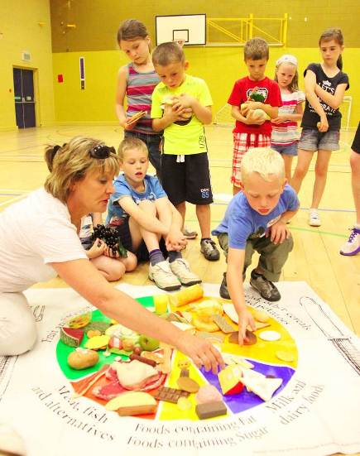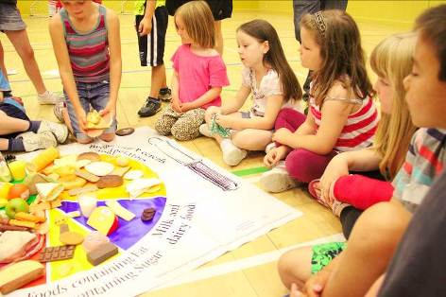  Serena Ferguson NHS Highland and the Healthy Platter  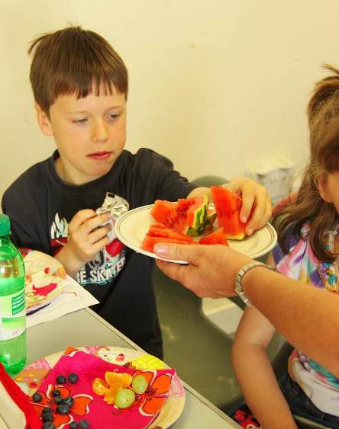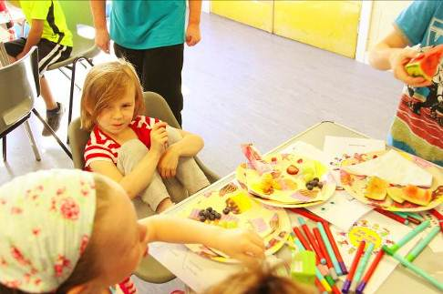  Healthy Snack Time  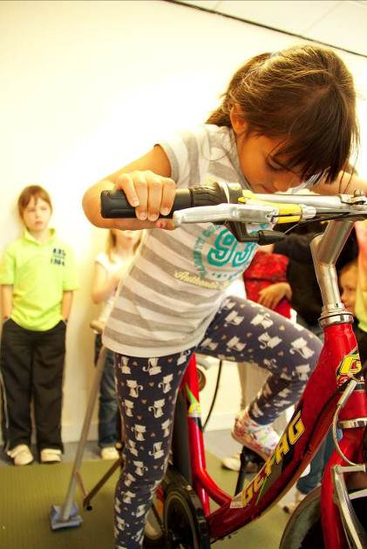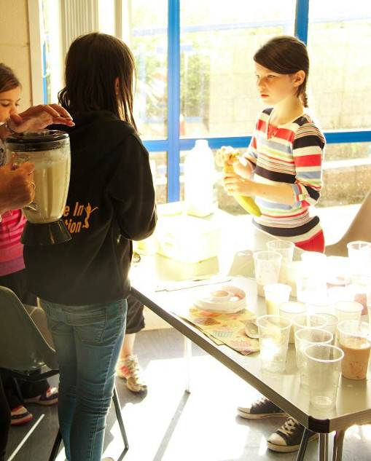  Fruit smoothie making for the parents  Information session  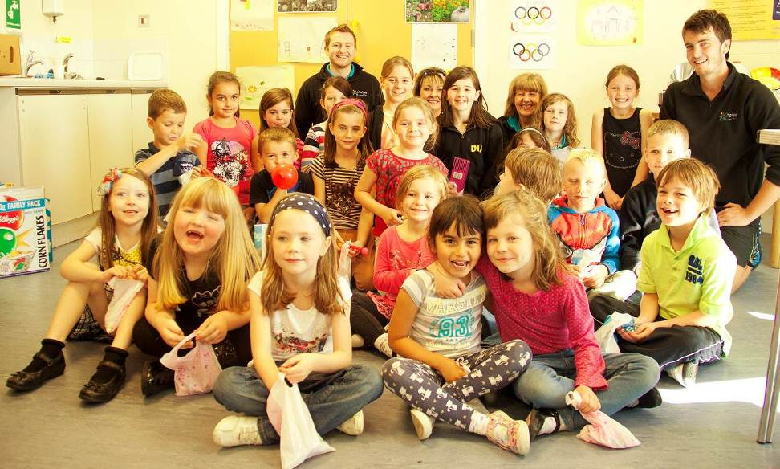  Some of the “Saturday Crew”
Name & email of staff member submitting news item | Ian Goode – Ian.goode@highlifehighland.com

Area of work (e.g. Arts) | Arts and Heritage
Location | Inverness Museum & Art Gallery
Title of piece of work | Engagement Programme
Description of event  (the purpose / targets) | Inverness Museum & Art Gallery are making a strategic shift in their approach to visitor involvement, enhancing the provision and range of opportunities available from simply viewing to hands-on participation with the development of an on-going engagement programme. This has the added benefit of utilising the museum in the periods when it is closed to the public, particularly in the winter months.  The programme is designed to bring local communities together with the museum’s collections and to complement the temporary touring exhibitions in the art galleries. Many of the activities have been developed through collaborative working across HLH services and facilities and is designed to reach into every corner of the community to make the museum an integral part of city life.  Some recent highlights of the programme include:-  - The Monday Schools Programme:  ‘Connect’ - a Curriculum for Excellence linked-in Education Pack that enables teachers to lead a guided tour to the exhibitions, along with activities and worksheets that support meaningful engagement between the collections and relevant curriculum topics.  We are running a CPD day for Teachers with the HLH Creative Learning Leader to launch this programme to local school teachers.  - Behind the Scenes at the Museum Workshops and events  Designed to open up the walls of the museum and invite local people to discover and celebrate their heritage through the objects in our stores where many hidden gems are reserved due to fragility, lack of display space, or because we do not have enough knowledge of the object to display it in meaningful way.  - Curator led ‘Tours of the Stores’  - ‘Heritage Detectives’ with local schools, exploring items in our collections found in their locality  - ‘About Town’ with local schools exploring the archaeological and historic landscape of the City Centre in partnerships with colleagues from Archives, Libraries and Am Baile  - Re-Collecting Home and Illuminating Inverness  Two parallel series of workshops, one with patients and volunteers from the Highland Hospice, the other with local community members from the Merkinch Community Centre, respectively. Both ran as part of the Luminate Creative Ageing Festival, supported by Age Scotland and accompanied the Compass Gallery’s Force and Form of Memory exhibition in the Small Gallery for which we were successful in securing funding from Luminate of £1100. The ‘Re-Collecting Home’ exhibition display panels will travel throughout the Highland Hospice network as part of their 25th Anniversary Celebrations. The ‘Illuminating Inverness’ exhibition display panels will be displayed in Merkinch Community Centre and other locations that the group may choose.  Future development for projects using this model has been funded by a grant of £1000 from the Hugh Fraser Foundation.  - Tertiary and other education  - Facilitating a collections research workshop for all teaching and research staff and postgraduate students from the University of the Highlands and Islands  - Tutoring a museums experience practical module for students from the University of the Highlands and Islands Cultural Studies Degree Programme  - Piloting a Local Area Orientation Course for the 39 Engineer Regiment (Air Support), recently moved to permanent barracks at Kinloss.  - Highland Photographic Archive at Culloden Battlefield  An exhibition of historic images of the battlefield from the Photographic Archive went on display at Culloden Battlefield Visitor Centre in October in collaboration with the National Trust for Scotland there.  - The Big Craft Give-Away  Piloted at IMAG and the Botanic Gardens Edinburgh, The Big Craft Giveaway is a national initiative, funded by Creative Scotland as part of The Year of Creative Scotland, organised by Really Interesting Objects, to bring together leading craft artists with people who do not usually have a chance to be involved with craft. Thousands of craft objects were created by the participants which were then released across the country on Saturday 22 September 2012. Jeweller Dorothy Hogg worked with target groups at IMAG to create medals and jewellery using twisted wire and aluminium discs embossed with emblems inspired by the objects in the museum. Participants at workshops and drop-in sessions each made an object to keep and one to give away. The programme continues next year.  - Winter Art and Craft Workshops  Life Drawing, bookbinding, jewellery and decorations from natural materials are some of the artist-led activities on offer. The craft workshops will tie-in with the launch of the new Craft Gallery
Which staff were / are involved | Cait McCullagh, Cathy Shankland, Lesley Junor, Jeanette Pearson, Amanda Truscott, Jamie Gaukroger.
What were the results /  numbers involved /  Feedback | - Combined figures for events and activities in September October totaled 2009  - Positive feedback from all partners and participants. Facebook and website proving invaluable in increasing communications and capturing feedback  - Developing relationships with national and local organisations, e.g. NTS Culloden; Botanic Gardens, Edinburgh; Highland Hospice, Cairdeas Cottage, UHI, University of the Third Age, Merkinch Community Centre  Further images and information about IMAG’s projects on www.inverness.highland.museum and Facebook
Attach photos or web links | 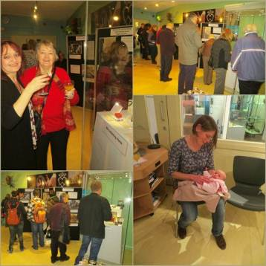  Recollecting Home  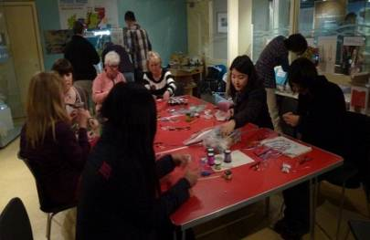  The Big Craft Give Away
Name & email of staff member submitting news item | Cathy.Shankland@highlifehighland.com  Cait.McCullagh@highlifehighland.com
Area of work (e.g. Arts) | Sports/Construction
Location | Highland Wide
Title of piece of work | ‘Building Bridges’
Description of event  (the purpose / targets) | ‘Building Bridges’ is a school transition event with the aim of informing, educating, and encouraging children to work with others, and to perform at their highest potential , whilst also having fun in a sporting environment. It was the first project in the Highlands to be awarded Olympic ‘Inspire’ status.  The project is an example of partnership working, and is a collaboration between Construction Skills, a company who promote the construction industry throughout schools, colleges and community groups in the Highlands and Islands, and Active Schools.  The project uses an Olympic theme throughout the 2 parts of the activity. Primary school children are brought into their cluster Secondary school, where senior pupils, many of them Sports Leaders, are assigned to teams and help them work through the activities. These teams are given names of Olympic countries.  Using the construction of the Olympic Park, and its many buildings and bridges to introduce the morning’s activity, teams are given roles to play such as Project Engineer, Buyer, Quantity Surveyor etc, and they have to construct a bridge, which is hidden from view. These roles are changed regularly so everyone gets to do each job. Each team has a budget of ‘Monopoly’ money to spend, and has to keep accounts, and they have to pay each time they view the bridge, and then relay the information to their team without use of pen and paper. Teams have to work out the exact amount of pieces of differing lengths and shapes, before buying their materials and assembling their bridge from the plastic kits provided. The team which constructs their bridge correctly for the least amount of money collects maximum points, with the others receiving points on a sliding scale. These points are carried on to the second activity, which has a sporting theme. The same teams, again led by their senior pupils, take part in 5 Olympic themed events, such as long jump, relay race and target throwing. Emphasising the Olympic values, the children are encouraged to work to the best of their ability, and the points system adopted means that everybody’s score counts towards their team’s total. Once the athletics events are completed, the points gained are added to those from the construction activity, and gold, silver and bronze medals are awarded accordingly.
Which staff were / are involved | Billy Skinner (Education Adviser) from Construction Skills and Gary Morris (Youth Sporting Coordinator) from High Life Highland.
What were the results /  numbers involved /  Feedback | 29 Primary Schools from Alness, Ullapool, Golspie, Gairloch, Inverness, Lochaber (280 pupils), 7 Secondary schools (40 pupils).  One teacher from Dornoch commented on her evaluation form ‘An excellent, well-structured event with a good balance/variety of activities which encouraged my pupils to work co-operatively throughout and was enjoyed by all’
Attach photos or web links
Name & email of staff member submitting news item | Gary Morris  Gary.morris@highlifehighland.com

Area of work (e.g. Arts) | Sport
Location | Inverness/Highland
Title of piece of work | FIT (Future – Interactive – Training) to Coach
Description of event  (the purpose / targets) | High Life Highland, in partnership with sportscotland, organised and delivered the above event on Sunday 28th October 2012 at Dingwall Academy. The conference programme was full packed with a variety of workshops which attracted coaches, sports leaders, clubs members and professional sports staff.  The day kicked off with Fiona Wernham (Head of Coaching & Volunteering, sportscotland) and Ian Murray setting the scene with information about the national picture with regards to coaching and volunteering and then onto the local landscape.  The informative workshops included ‘Analyse Your Coaching’, ‘Positive Coaching Scotland – Double Goal Coach’, ‘How to Develop Your Club’ and ‘Guide to Mentoring’. Sports Specific workshops from Golf, Hockey, Badminton, Swimming and Rugby. Special guests were Scotland rugby star Chris Paterson & top rugby coach Rob Moffat who gave an insight into their ‘player-coach relationship’ over the years.  As part of the event 2 programmes were launched:  - HLH Coach Education Grant Scheme  - Positive Coaching Scotland workshops in Highland  Also the Highland Coaching Awards 2012 were awarded. Each winner was invited along free of charge and presented with their award by Chris Paterson. Four out of six winners attended.  Each delegate was given a HLH lanyard with a name badge and workshop choice on the reverse, a pack containing: notepaper & pen, Highland sports development contacts sheet, HLH Coach Education Grant application form, Highland Funding Opportunities, Move It To Lose It flyer, map of the building and an evaluation form. Lunch was also included in the cost of £20 for non- High Life Members and £10 for High Life Members.  Delegates travelling from the further parts of Highland were offered to share contact details with others in their area to car share.  The HLH banners, feathers and large display were all used around the venue.
Which staff were / are involved | Elissa Steven was the main organiser along with Jan Stander, sportscotland and with assistance from Darren Reid.  Workshops on the day were delivered by Elissa Steven and Lindsay Campbell (PCS), Jeff Tavendale (Swimming) , Darren Reid, with assistance from Charlie Forbes and Miles Fuller, (How to Develop Your Club) and Gregg Binns (First Aid course).  Assistance on the day from Mags Duncan and Miles Fuller with Willie MacKay organising the Golf session.
What were the results /  numbers involved /  Feedback | The results were fantastic! Over 100 coaches attended and nearly a 50/50 split of males and females.  8 Sports Leaders attended and 5 coaches from the Tain Community Sport Hub, both groups were awarded funded places.  We attracted 3 Orkney Council staff who was attending certain workshops to begin their tutor training. A coach from Moray, paid for by the Sports Development Officer at Moray Council. Plus the Club & Pathway Development Officer from RYA Scotland attended. We had such a spread of coaches; abilities, age and knowledge.  Very positive feedback from the delegates on the evaluation forms as well as additional emails thanking me for the excellent day.  Quote: “Been fantastic! Had a great time, networked and learnt a lot.”
Attach photos or web links | 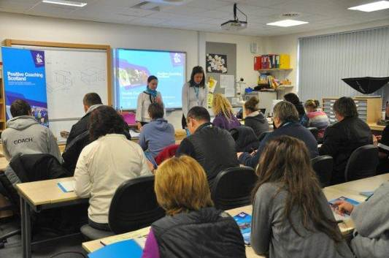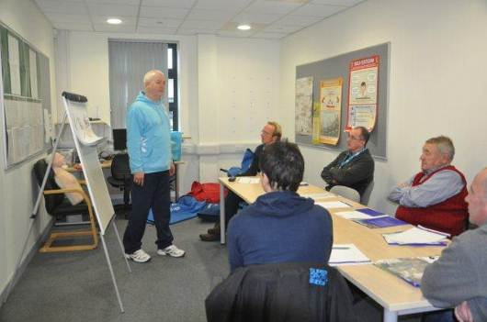  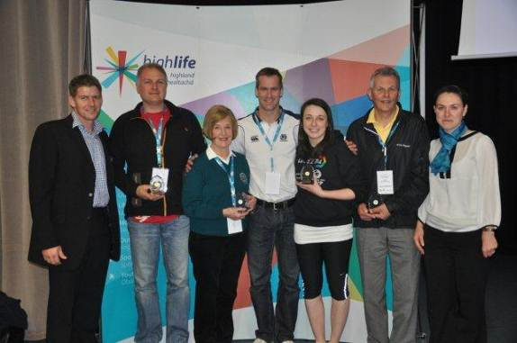
Name & email of staff member submitting news item | Elissa Steven – elissa.steven@highlifehighland.com

Area of work (e.g. Arts) | Sport - Active Schools
Location | Fort William / Grantown / Golspie
Title of piece of work | Highland Junior Mountain Bike Race Series
Description of event  (the purpose / targets) | Working alongside Scottish Cycling and volunteers from local bike clubs, Active Schools Co-ordinators in Fort William, Golspie and Grantown are helping to organise and run a Junior Mountain Bike Race Series. Local bike shops have provided event sponsorship.  There are age categories for riders from 5-17 years old.  Previous bike races organised by Active Schools have inspired children to enter club and national events and one young rider from Kinlochleven is now competing all over the UK and Europe as part of the Olympic Talent Team.
Which staff were / are involved | Active Schools
What were the results /  numbers involved /  Feedback | So far round one attracted over 70 riders from all over the Highlands and round 2 (held in the October holidays) 53, whilst round 3 in Golspie is still to take place.
Attach photos or web links | U6 race start line  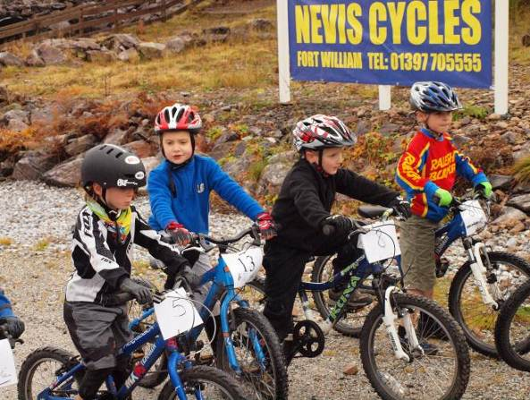
Name & email of staff member submitting news item | Bridget Thomas  Bridget.thomas@highlifehighland.com

Area of work (e.g. Arts) | Sports
Location | Grantown
Title of piece of work | Sports Leadership Awards
Description of event  (the purpose / targets) | Fourteen teenagers from Grantown Grammar have successfully completed their Sports Leaders Level 1 Award delivered in partnership by Active Schools and the Craig Maclean Leisure Centre for the first time. Another new partnership aspect was that log books were funded through the HLH sports leaders award programme. The young people, aged between 13 and 17 spent the week-long course learning to improve their leadership skills and leading others young people in recreational activities. The candidates coached the younger children taking part in the Craig Maclean Leisure Centre’s October holiday activity programme. The sports leaders are now ready to undertake volunteering placements within their communities and progress onto sport specific coaching awards and possible employment. Sports Leaders UK is a national initiative inspiring people and communities through leadership qualifications in sport. Active Schools have already trained 22 young leaders at Grantown Primary school who are delivering playground games during breaks, this has risen by over 100% as last year 10 were involved. Two of these sports leaders have been given subsidised places for the “fit to coach” day being organised by HLH Sports Development Officer. Bringing the cluster totals to 55 level 1’s. 15 level 2’s. 6 women get set go, 51 young/playground leaders.
Which staff were / are involved | Dawn Horsburgh – Active Schools Grantown Cluster  Fraser Tulloch – Leisure Supervisor, Craig Maclean Leisure Centre  Gary Morris - Youth Sporting Co-ordinator - Alness  Donna Reilly - Leisure Manager, Craig Maclean Leisure Centre
What were the results /  numbers involved /  Feedback | In 2012  14 Sports Leaders Level 1 qualified and volunteering  20 P1-7 pupils being coached for a week  22 Playground Leaders  87 P1-3 pupils being buddied  Two articles in the Badenoch and Strathspey herald
Attach photos or web links | 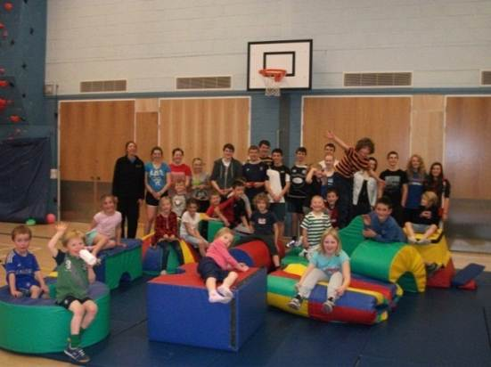
Name & email of staff member submitting news item | Dawn.Horsburgh@highlifehighland.com

Area of work (e.g. Arts) | Sports Development
Location | Aviemore
Title of piece of work | Community Sport Hubs
Description of event  (the purpose / targets) | A major step in the development of our second community sport hub in the Highlands took place from August - October as meetings of the key partners of the Aviemore area was facilitated at the new Community School in Aviemore.  High Life Highland facility, Active-school, Sports Development and Outdoor Education staff were joined with representatives from Cairngorm National Park, Cairngorm Mountain Range, Scottish Orienteering, Snowsport Scotland, Scottish Cycling, Glenmore Lodge, Scottish Disability Sport, sportscotland, Highland Institute of Sport, Badenoch and Strathspey Sports Council, and the local Parents Council to discuss the development of a Community Sport Hub in the Aviemore Area.  The meeting gave those who influence sport and physical activity provision in the area the chance to come together to discuss the opportunities and challenges that exist within the area and ultimately establish the potential there is for developing a Community Sport Hub in the area. All those present were also give a tour of the fantastic new facility.  This meeting along with a subsequent follow up meeting will allow us to take this project forward in partnership with these key bodies and work closely with them to provide fantastic support for the sport and physical activity system contained within the local community.  This strong partnership is now in a position to take the project forward to the community and community clubs in the area. This community engagement evening will take place in January 2013 in the new Community School in Aviemore.
Which staff were / are involved | Mags Duncan – Principle Sports Development Manager  Donna Reilly – Facility Manager  Tina Gibson – Active School Co-coordinator  George Reid – Outdoor Education Officer  Darren Reid - Community Sport Hub Officer
What were the results /  numbers involved /  Feedback | 12 different organisations present, and an informal partnership formed between them. Now in a position to take the project forward to the community engagement stage collectively.
Attach photos or web links
Name & email of staff member submitting news item | Darren Reid  Darren.reid@highlifehighland.com

Area of work (e.g. Arts) | Leisure Facilities and Libraries
Location | Aviemore Community Centre
Title of piece of work | Opening of new Facility
Description of event  (the purpose / targets) | Aviemore Community Centre opened its doors to the public on Monday 13th August 2012. The Centre operating hours reflects the opening hours of a standard High Life Highland leisure facility.  The facility consists of the following -:  Fitness Room: which hosts 16 pieces of interactive cardiovascular equipment, 8 fixed resistance machines, free weights area, 2 power plates and an Arke fitness system.  2 Multi- Purpose Studios: which can be used for aerobic/ dance based classes, spinning, and children’s activities. It can also be used to accommodate large meetings and conferences and is home to many community clubs and groups.  Sports Hall: Out with the school day High Life Highland operate the 2-court games hall from 3pm onwards for a programme of after school activities, group fitness classes, club use and social events.  Meeting room: Is a widely used resource for variety of meetings, regular bookings include community council, sports hub and community clubs, senior arts group, life coaching and MSP surgeries.  Library: Prior to relocating, Aviemore Public Library was open only 18 hours per week. The shared premises now enable customers to access the library any time during the extensive 7 days a week opening hours of the new centre. Leisure staff perform the basic library service of issuing books and advising how to use the people’s network out with the times when the Library Assistant is on duty. Mutual training opportunities and a shared counter and reception area enable all centre staff to offer a warm welcome and a degree of service to all.  Outdoor Pitch: The 3G synthetic pitch is due to open soon, it will be operated by High Life Highland out with school hours. This facility will provide the only all-weather surface in the area and will be most welcomed by residents and many of Badenoch and Strathspey sports clubs  The facility has been very busy since opening, most children’s classes are full. Additional classes and Instructors have been coordinated to cope with demand. Group Fitness classes are proving to be very popular with number of participants increasing daily. The feedback from the community has been very positive and indicated that they are enjoying the services available at the facility and love the buzz in the liveliest library in the Highlands!  In addition to public swimming at Aviemore Highland resort being included in the High Life membership package. Swimming lessons are now available locally and included as part of the package. High Life Highland launched SASA’s Learn to Swim Programme at the Resort on the 23rd October 2012.  Swimming lessons will be taught over 4 terms of 8 weeks blocks by High Life Highland staff on a Tuesday and Thursday from 3.30pm to 5.00pm. All 98 children that attended enrolment successfully gained a place on the scheme; parents were delighted to secure a place and many comments were received commending the efficiency of the enrolment process and the overall quality and level of provision for children activities in the area.
Which staff were / are involved | Emma Thomson, Donna Reilly and HLH Leisure Team  Charlotte MacArthur and the Library Team
What were the results /  numbers involved /  Feedback | High Life Membership sales to date:  Direct Debit Family: 157  Direct Debit Individual: 67  Annual Family: 7  Annual Individual: 3  Budget Cards: 7  Report from 13th August – 31st October 2012  Number of Children’s Activities per week:  5 preschool sessions, 2 teen sessions, 28 primary sessions  Opportunities/ places per week: 430 primary, 16 high school, 60 preschool  Children’s activity usages: 2570  Inductions to the Fitness Room: 357  Fitness Room Usage: 1929  Number of Group Fitness Classes per week: 30  Number of Attendees to Group Fitness Classes: 3420  Total Number of Highlife activity usages: 7919  Library Statistics to date  Customer comments and feedback  Just wanted to say a huge thank you to you and all the staff for yesterday, it was so daunting! But you all made it very simple and everyone was smiling and taking it in their stride. Hope you weren't there all night and that everyone was happy!!  Jennifer x  I was delighted to get both my boys in on a Tues afternoon at 4pm and 4.30pm. Same night, same place, fantastic!  Sharon Avery  What a great facility we had and that the staff were exceptionally helpfully at the changeover for the PTA event.  Mike Donaghy  Fantastic range of classes at Aviemore, “ I love it”  Raine Selkirk  Face book comment after swim lesson enrolment night  - Mike Langran Absolutely fantastic to finally see local swimming lessons available for kids in Aviemore under High Life. Thanks again to everyone who supported the SOS campaign :-)  - Claire Darroch Thanks to you also Mike. We thought this would have never happened.
  Parameter | 2nd Qu 2011 | 2nd Qu 2012 | Difference | % Difference
  Issues | 3,127 | 4,320 | 1,193 | 38.2%
  New Members | 58 | 208 | 150 | 258.6%
  Active Members | 369 | 558 | 189 | 51.2%
  Total Members | 836 | 1044 | 208 | 24.9%
  PN Users | 165 | 185 | 20 | 12.1%
Attach photos or web links | 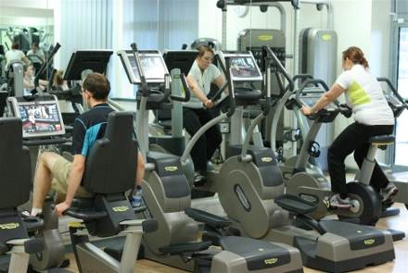 Fitness Room  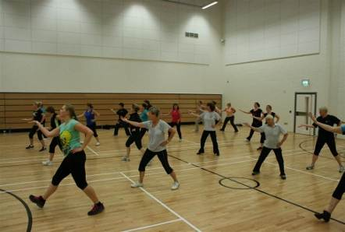  Group Fitness  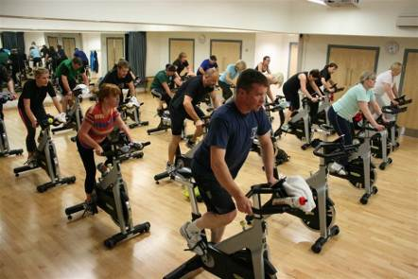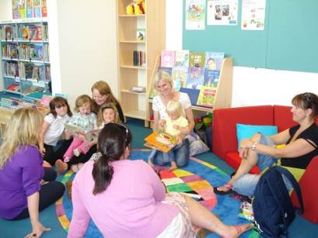  Group Fitness Library – Mums sharing  Stories  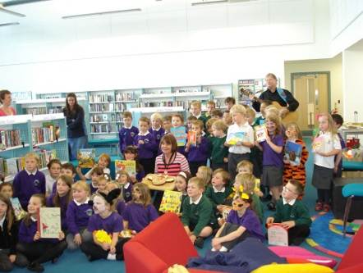 Julia, kids & Gruffalo  cake  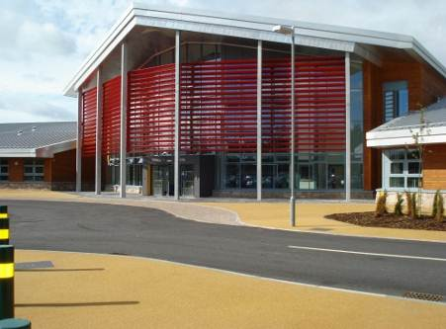  Outside Entrance  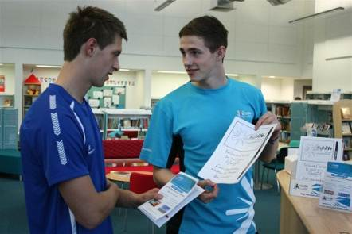  Reception
Name & email of staff member submitting news item | Emma Thomson: Area Facilities Officer  Emma.thomson@highlifehighland.com

APPENDIX B

AREA OF WORK | TITLE
Adult Learning | Communication Course for Frontline Staff
 | International Womens Group
 | Pilot Summer Courses Programme for Adult Learning
Archives | Maps & Travellers
Arts
 | Family Craft Workshops
 | Fiddle Forte
 | Free Concert from the Scottish Ensemble
Leisure Facilities | CMLC Youth Try Tri
 | Eat, Play & Grow Well
Libraries | Monthly Lochcarron Library News
 | Scottish Poet Visit
 | Summer Challenges
 | Chae Strathie visits Fort William Library
 | Julia Donaldson Book Tour
 | New Play@home
 | Visit from P4 Tarradale Primary School
 | Outreach events for pre-school & primary age children
Museums | Engagement Programme
Sport | Building Bridges
 | European 2012 Youth & Sport Forum in Cyprus
 | First Club Golf Training for CSLA Pupils
 | FIT to Coach
 | Golf Successful Pathway
 | Highland Junior Mountain Bike Race Series
 | HLH Young Persons Coach of the Year
 | North District Swimming Team Selections
 | SHARP Shooter Paul McGregor
 | Sports Leadership Awards
 | X Country Morefield
 | Community Sports Hub
 | Inclusive Sports Taster Event
Youth | Helter Skelter Shelter Shed Project
 | Kakatsitsi African Drumming & Dance Workshop
 | Urban Art Project
Joint Leisure Facilities and Library | Aviemore New Facility

