HIGH LIFE HIGHLAND  REPORT TO BOARD OF DIRECTORS  20 June 2013 | AGENDA ITEM 5  REPORT No HLH 12/13

HIGH LIFE HIGHLAND SUCCESSES - Report by Chief Executive

Summary

The purpose of this report is to present Directors with the best submissions from staff teams on the successful work being carried out by High Life Highland throughout the Highlands and across all areas of work.

It is recommended that Directors comment on the items presented and note that the selected items will form part of the long list for the annual Staff and Volunteer Award Scheme for 2013/14.

1. | Business Plan Contribution
1.1 | The successes contributes to achieving the following outcomes of the High Life Highland (HLH) Business Plan 2012-15:-  - increased staff satisfaction  - increased internal collaboration  - delivery of the SDC with THC  - increased awareness of product and services  - increased customer satisfaction  - a positive company image  - a growing company  - increased financial sustainability
2. | Background
2.1  2.2  2.3  2.4 | The September 2012 meeting agreed the alignment of the successes submitted on a quarterly basis with the Staff and Volunteer Award Scheme. A small assessment group comprising the Chief Executive and 2 Directors was set up to consider future submissions and select up to 15 as “best of” successes for presentation to each Board meeting. For the submissions this time, the group consisted of the Chief Executive and Directors Douglas Graham and Jaci Douglas.  The 13 successes presented to this meeting in Appendix A are those selected by the assessment group for this quarter. The full list of all 25 submissions received appears at Appendix B.  The criteria used to select the successes presented to this meeting are distilled from the 9 outcomes which form the basis of the HLH Business Plan:-  - increased internal collaboration & new partnership working;  - doing what we do, but better;  - contributing toward a growing company; and  - contributing toward a positive company image.  The successes at this meeting will be added to that forming the long list for the annual staff award system for 2013/14.
3. | Implications
3.1  3.2  3.3 | Resource Implications – there are no resource implications resulting from the recommendations of this report.  Legal Implications – there are no legal implications resulting from the recommendations of this report.  Risk Implications - there are no new risks resulting from the recommendations of this report.

Recommendation

It is recommended that Directors comment on the items presented and note that the selected items will form part of the long list for the annual Staff and Volunteer Award Scheme for 2013/14.

Signature:

Designation: Chief Executive

Date: 6 June 2013

APPENDIX A

Area of work (e.g. Arts) | Active Schools
Location | Gairloch
Title of piece of work | Sportscotland pilot a national award in Poolewe
Description of event  (the purpose / targets) | Sportscotland are in the process of developing a new qualification: the “Multi-skills in Sport” Award. The course is being designed for coaches, teachers and volunteers who wish to coach children and young people in a variety of sports. Sportscotland offered to run an initial pilot course in Highland and the Gairloch Active School area was selected for the privilege. The pilot was conducted over the week-end of 20th and 21st April and utilised Poolewe Village Hall as a venue.
Which staff were / are involved | John Shearer: Active Schools Co-ordinator  assisted by Mags Duncan, Willie MacKinnon and Elissa Steven
What were the results /  numbers involved /  Feedback | The course designer, Sergio Lara-Bercial of Leeds University, was in attendance as course tutor and led 11 participants through an intensive two day course covering the Fundamental Principles of Multi-skills sport on day one and moving on to the planning, delivery and review of Multi-skills sports sessions on day two, culminating in a practical assessment. All participants, (eight were from the Gairloch area), successfully completed the course. The Gairloch participants included two Leisure Centre staff and six Active Schools volunteers. The unanimous view of the participants was that the course, although intense and at times demanding, was highly relevant to the diverse challenges faced when running sports sessions for young people. The participants included a spread from new volunteers to volunteers with considerable experience of working with children. The consensus was that there was much of value for everyone in the course content. Sergio was very happy with the contribution from the participants and although generally pleased with the course content, he thanked the participants for giving him the in-sight for a few modifications he might make before the course gets rolled-out nationally.  The course costs for this pilot were covered by Sportscotland and High Life Highland.
Attach photos or web links
Name & email of staff member submitting news item | John Shearer, Active Schools Co-ordinator, Gairloch  john.shearer@highlifehighland.com
Area of work (e.g. Arts) | Adult Learning (Literacies)
Location | Abriachan Forest
Title of piece of work | Launch of Literacy Trail
Description of event  (the purpose / targets) | The grand Launch of the Literacy Trail took place at Abriachan Forest on Friday 3rd May. This was part of the LIMA project, (Literacies Inspiring Motivation and Achievement ) which was managed by Apex Highland and funded by High Life Highland, Highland Council Criminal Justice and Forests 4 People, aimed at supporting and developing the basic skills of ex-offenders and recovering substance misusers. The Trail has allowed service users to develop their literacy and numeracy skills while planning and ordering the resources needed for the trail, while also learning other practical employability skills and team work. It has also created a useful asset for the general public at Abriachan Wood.  Each person taking part has compiled a record of work and a portfolio, and is encouraged to reflect on their own progress. All the participants at Abriachan are volunteers and were presented at the event with John Muir Awards for their work at the forest. Nine received Intermediate Awards and three received Basic Awards.  All those attending the launch were invited to test 2 geocache routes which had been organized by the participants through the forest. An exhibition of photos from the whole project was on display.
Which staff were / are involved | Mary Rhind from High Life Highland plus partner organization staff from Highland Council, NHS, HMP Inverness, Northern Constabulary, Abriachan Forest and from the Apex Board of Directors.
What were the results /  numbers involved /  Feedback | 30 people attended in total including the volunteers who had helped to create the trails. 3 people were presented with Basic John Muir Awards and 9 with Intermediate John Muir Awards.
Attach photos or web links | 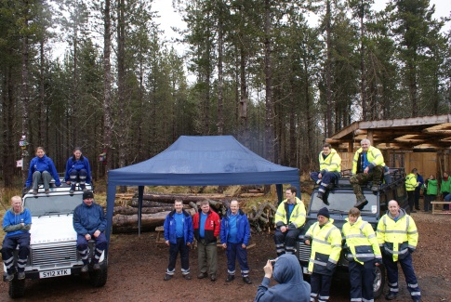  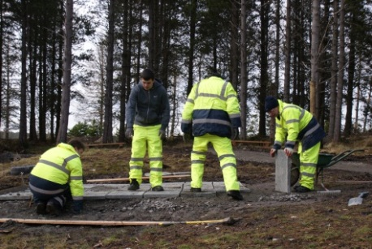  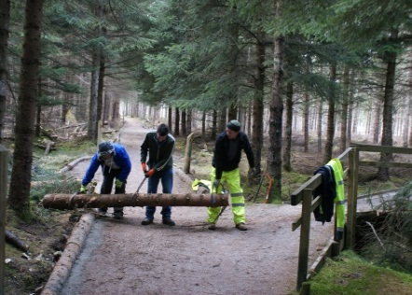
Name & email of staff member submitting news item | Mary Rhind, Adult Literacies Coordinator

Area of work (e.g. Arts) | Archives
Location | The Highland Archive and Registration Centre
Title of piece of work | Culloden, Clans & Ancestors
Description of event  (the purpose / targets) | The evening of 12 April witnessed a colorful and important event taking place at the Highland Archive and Registration Centre.  The 16 April marks the anniversary of the Battle of Culloden. Every year there is a memorial service held at the battlefield which is organised by the Gaelic Society of Inverness. People from many parts of the world attend.  This year the Highland Archive Service was invited to play an important part in the commemoration by hosting an evening reception for people wishing to commemorate the event.  The Highland Archive Service provided an exhibition of archive material relating to the battle of Culloden and its aftermath as well as genealogical sources relating to the clans involved. The evening also witnessed an important historical event in its own right: the inauguration of a new Association of Highland Clans and Societies.  This was a very colorful event with lots of tartan in evidence, which was achieved by a collaboration between Highland Archive Service, Highland Council Registration Service and the Highland Family History Society, with assistance from Inverness Library.
Which staff were / are involved | Fiona Macleod, Colin Waller, Peter Mennie & Karen Rushton
What were the results /  numbers involved /  Feedback | 47 people representing 13 clans attended the evening reception, including Lord Strathspey and Brodie of Brodie, the National Trust and the 1745 Association also being represented.  The Inverness Courier carried a full page feature on the event.  The participants regarded the event as a great success and there were several requests for it to become an annual event as part of the Culloden commemoration weekend.
Attach photos or web links | 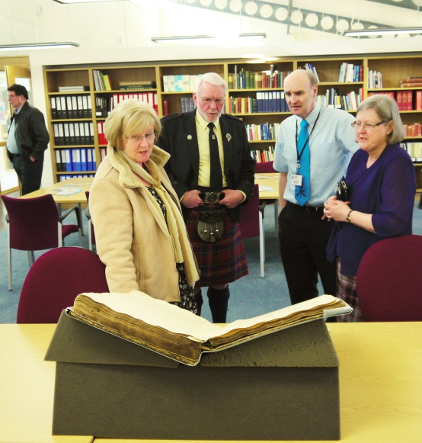
Name & email of staff member submitting news item | Janet Baker  janet.baker@highlifehighland.com

Area of work (e.g. Arts) | Arts / Social / Learning / Supporting small businesses
Location | Craigmonie Centre – Glen Urquhart High School - Drumnadrochit. Great Glen ILC
Title of piece of work | Loch Ness Craft Fair
Description of event  (the purpose / targets) | The First Loch Ness Spring Craft Fair  Saturday April 20th at the Craigmonie Centre.  This was organised by the Centre Co-ordinator on behalf of the Loch Ness Craft Club to showcase Arts and Crafts from both Craft Club members and from crafters and artist from the local area and beyond, to provide a friendly and social community event and to test the venue as a retail fair environment.  It was also to provide club members who had not shown / sold their work publicly before, a friendly & supportive environment to debut their work.  Craft Club members were offered one free table to encourage participation, and the event encouraged small home business to start / grow, targeting women across the whole age spectrum from Young Mums to retirees who were the predominant participants .  We did not charge an Entry fee to encourage as many customers through the door as possible.  Offer a networking opportunity for local crafters and a social event for the community.
Which staff were / are involved | Fran Davidson: Centre Co-ordinator  Craft Club volunteers who were not exhibiting
What were the results /  numbers involved /  Feedback | With an original target of 20 stalls & exhibition spaces we ended up with 36 participants! (and had to turn some away as we didn’t want to be ‘too big’ on our first event) and although the majority were taken by sellers and exhibitors from the Great Glen ILC – we also had applications from as far afield as Perth, Lochinver, etc.  - We confirmed the venue as more than suitable for future similar events, and know that we can increase the number of stall holders by a small margin for our next event . We have been requested to hold more in the future.  - An estimated 500 customers through the door on the day from 11am to 4pm, with a healthy mix of locals and those travelling from out with the ILC specifically to visit the Craft Fair.  - PR in the form of an article in Inverness Courier promoting the fair on Friday April 19th and also a slot on BBC Radio Scotland’s Fred McCauley show. Good coverage in social media (Facebook, local websites, etc.) – posters and flyers throughout the ILC including a letter box drop organized by Craft Club members  - Stall holders reported good customer feedback and sales of their works – including some craft club members who had never shown / sold their work publicly before.  - Customers enjoyed the experience, the range of the arts and crafts available, the demonstrations and the retail environment.  - Both stall holders and customers have asked for another Craft fair in this venue  - Local businesses noted an upsurge of visitors from those who came to the village specifically for the Craft Fair  - The High School parents took over £200 in tea and coffee sales raising much needed school funds.  - Anecdotal feedback from stall holders that all made at least enough through sales to cover their day’s costs, and one stall holders who had never sold / displayed publicly before made over £500.  - The event generated £400 in funds for the Centre and minimal cost apart from co-ordinator time and stationery / office printing costs. Future events could generate much more.  Some Feedback from stall holders as follows:  A successful event in a great venue - generous room well laid out, and supported by a good variety of stall holders: Sue Wilson - Studio in the Glen  On the day I thought the stalls were well organised and any initial problem was quickly resolved. The opening hours were perfect and set up time was okay. The range of products was fine; the stall holders were friendly and informative. Have you considered a regular fair over the summer season? Sandra Hugill  Just to let you know, I really enjoyed the fair. It was a good result for me and the people were super; as was my fellow crafters. I would be most interested if you held one late August over two days. Rosemary MacKenzie  We had a fantastic time at the fair on Saturday, I loved where I was placed, the lighting was brilliant [for jewellery] and I liked the fact there was tea and a place for people to sit and drink their tea, and check over what they bought x . Actually it was one of the best run ones I have been to in a long time x I would defiantly be interested in any more you do, whenever, A HUGE BIG THANK YOU FROM Salka scented candles  I had a very good experience at the craft fair. I received plenty of information prior to the event, was welcomed at the door on arrival and shown to 'my table'. The table was well placed and I had a happy day selling, chatting to fellow crafters and drinking tea. I would certainly attend again. Christine of 'Magpie Glass'  I had many visitors in past my shop after they had already been to your craft fair and all had positive feedback from it, the only comment was that every one of them mentioned they would have liked to have been able to buy home baking to take away, everything else was to their liking so well done and good to see it well attended. Audrey (Courtyard Corner Crafts)  The Fair was well advertised, I saw it in the local paper and signs around the village. Having it on the same day as a Shinty game was really good as people came up from that. Really enjoyed the day and as someone who hasn’t done craft fairs before if they are all as well attended I would love to do more of them. Julie Bell.
Attach photos or web links | Further images and feedback can be found at the following Facebook page: https://www.facebook.com/LochNessCrafts  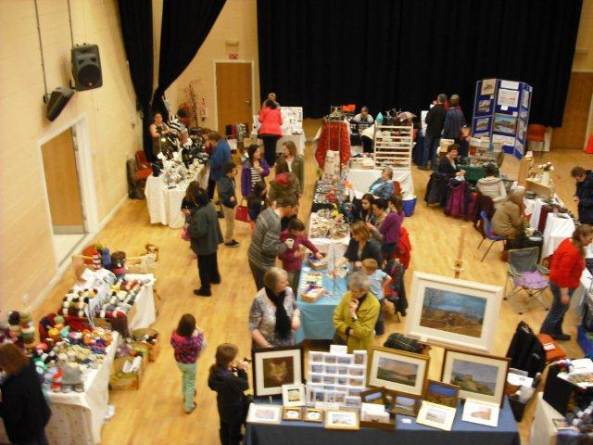  Main Hall Selling Area  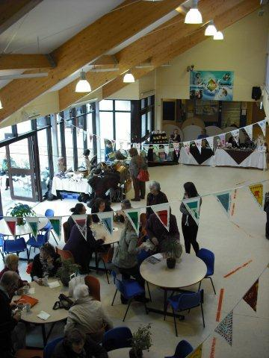  Canteen café area and sales area and a display of community bunting  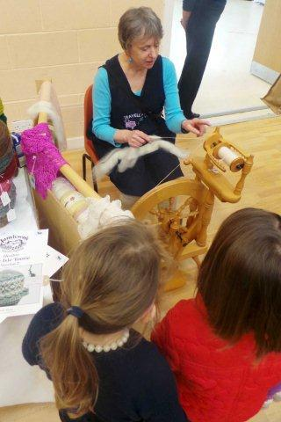  Demonstrating Spinning by one of the craft club members  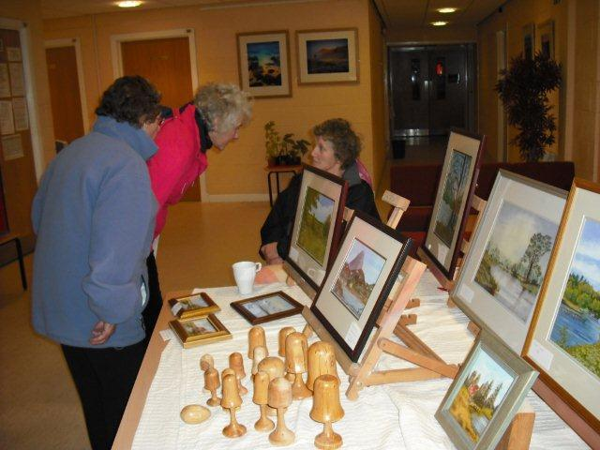  Stall holder in the Café Bar area  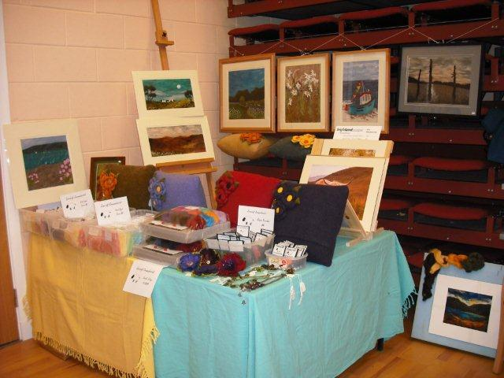  Debut stall of a craft club member  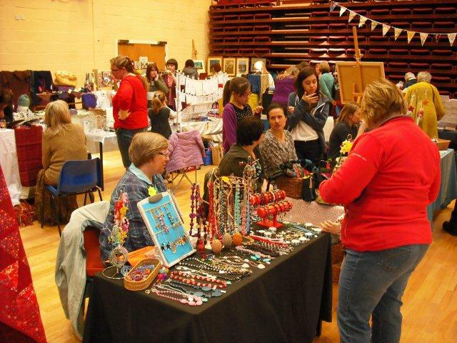  More stall in the main hall and community bunting on show  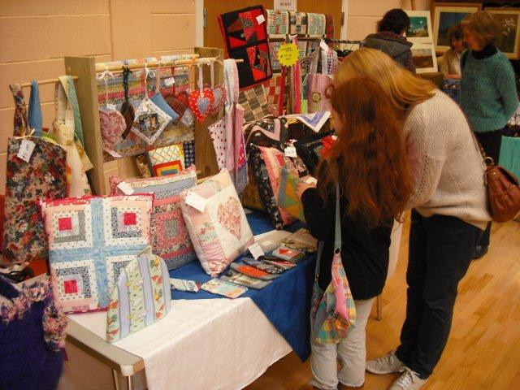  Local Textile crafts by craft club member
Name & email of staff member submitting news item | Fran Davidson: Centre Co-ordinator  Frran.davidson@highlifehighland.com

Area of work (e.g. Arts) | Arts
Location | Inverness Museum and Art Gallery
Title of piece of work | ‘Secret Egypt’ exhibition and exhibition launch
Description of event  (the purpose / targets) | The summer season at IMAG opened with the blockbuster ‘Secret Egypt’ exhibition which has as its spectacular centerpiece the mummy and mummy case of Namenkhetamun from Birmingham Museums collection. There are several interactive displays in the exhibition including brass rubbings, Top Trumps, quizzes and dressing-up facilities which relate to the many precious objects, illustrating themes such as ‘Did Aliens build the pyramids?’ and ‘Were the Egyptians obsessed with Death?’ The exhibition continues until 1st June.  Walk like an Egyptian -  To launch ‘Secret Egypt’ we had a Fun Day on Saturday 30th March to engage families with the exhibition. Themed refreshments were served, the magician Clive Grewcock performed some exotic magic and staff members set up face-painting sessions for children to bring out their inner Cleopatras or Ramesses.  The exhibition has more than achieved our objectives which were to raise user figures and facilitate community engagement particularly with families. User figures are much higher than usual and schools are visiting on a regular basis as many pupils study ancient Egypt as part of the curriculum.
Which staff were / are involved | Cathy Shankland, Lucy Woodley, Dean Melville and Jeanette Pearson organized and installed the exhibition.  Lucy Woodley and Amanda Truscott face-painted at the Fun Day.  The Gallery Attendants are making special efforts to patrol the exhibition and engage with visitors.  Inverness Common Good Fund and The Highland Council contributed to the costs of the exhibition.
What were the results /  numbers involved /  Feedback | So far the exhibition has been very popular with good press coverage and higher than average attendance figures, drawing many visitors to the museum who have not previously visited. 16 schools have visited to date and more are planning to come.
Attach photos or web links | 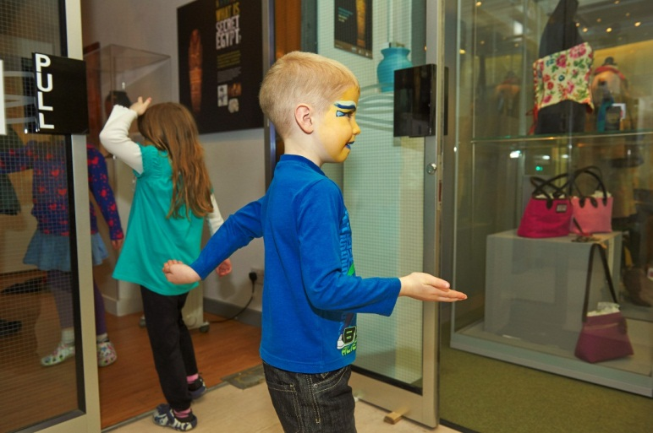  Walk like an Egyptian!  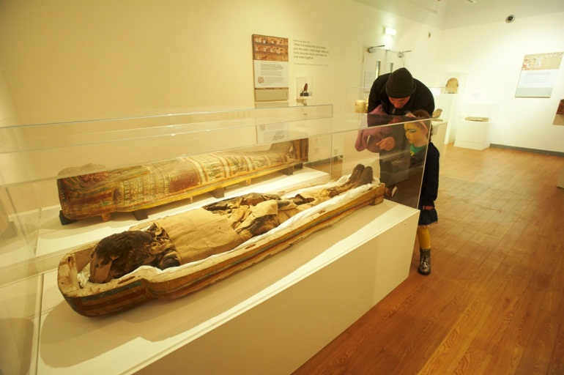
Name & email of staff member submitting news item | Cathy Shankland

Area of work (e.g. Arts) | Health and Wellbeing
Location | Dingwall
Title of piece of work | Still Game
Description of event  (the purpose / targets) | ‘Still Game’ is an innovative new project supported by Comic Relief, aimed at improving the lives of older people in our communities.  Over 55’s in the Ross-shire area were invited to see if they’re ‘still game’ as part of a new initiative being run in partnership by Ross County Football Club, with High Life Highland.  The programme ran for 10 weeks, on Wednesday mornings from 10am – 12.15pm, starting on 27th March 2013. Each session was made up of three parts;  - active Session - for example, light aerobics, outdoor walks or an active stadium tour;  - social time - refreshments provided and the opportunity to get to know the group;  - advice/skills session – this will include specific discussions and talks on a range of subjects.  The programme was delivered between Ross County Football Club and at Dingwall Leisure Centre with some contributions from NHS Highland Public Health staff.  The overall goal of the project, as developed by the SPL Trust, is to provide hope, dignity and a renewed sense of purpose to older people in the communities that surround the SPL Clubs. Through this new way of working we hope to:  - Provide hope and dignity to people neglected in society.  - To help older people re-engage with society using the Football Club as the vehicle to achieve this.  - Increase physical activity levels  - Increase awareness of mental health issues and knowledge of where to get help.  - Participants to lead healthier lifestyles  - To signpost individuals to places within communities that they can best make use of their skills.  - Bringing young and older people together to tackle inter-generational stereotypes
Which staff were / are involved | Ian Goode – Acting Leisure Manager Dingwall Leisure Centre  James Robertson – Relief Supervisor Dingwall Leisure Centre  NHS Public Health Staff  Lynn Johnson – Health and Wellbeing Manager  Laurie Piper – Marketing and Communications Manager
What were the results /  numbers involved /  Feedback | Up to 15 older people per week took part over the 10 week programme.
Attach photos or web links | 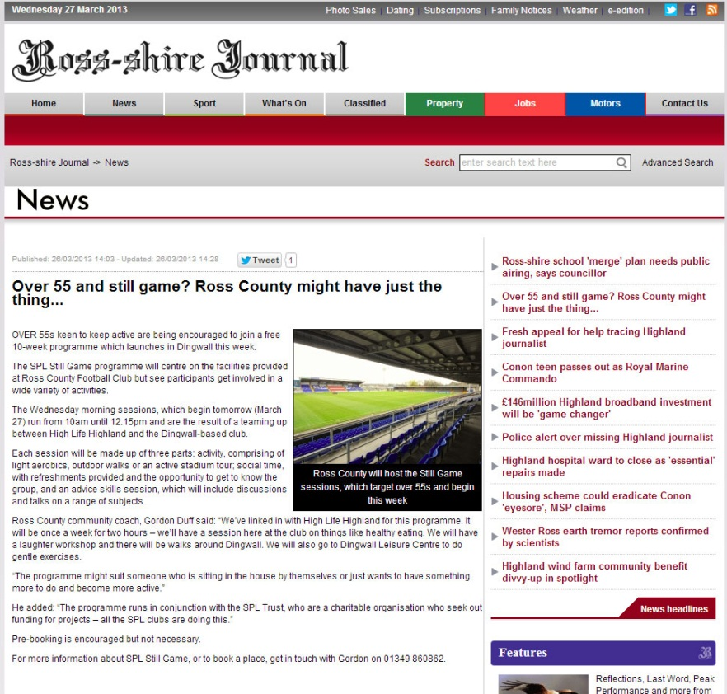  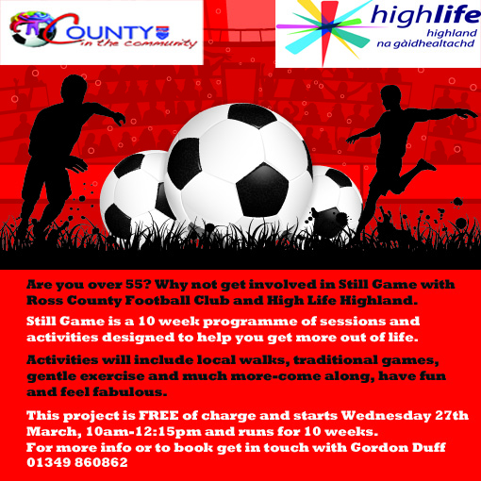
Name & email of staff member submitting news item | Lynn Johnson, Health and Wellbeing Manager  Lynn.johnson@highlifehighland.com

Area of work (e.g. Arts) | Health and Wellbeing
Location | Dingwall
Title of piece of work | Well Now - Health at Every Size
Description of event  (the purpose / targets) | ‘Well Now’ is a brand new course being offered to HLH staff to promote staff health and wellbeing in partnership with NHS Highland.  The course provides an exciting new opportunity to explore with people different approaches to weight management and offers an alternative approach to slimming clubs.  ‘Well Now’ focuses on health gain rather than weight loss and is run over 6-12 sessions and aims to support adults who want to feel better about food, eating and their bodies.  The ‘Well Now’ course aligns with the internationally recognised and respected HAES (Health at Every Size) philosphy – which is an approach to health that does not pursue the goal of a particular body weight, but rather concentrates on what health benefits and improvements can practically be achieved for individuals.  HLH staff in the Dingwall area were offered the opportunity to take part in a pilot programme including a taster session and a full 12 week course.  The ‘Well Now’ course has been well received by the staff involved – we are now looking at options and opportunities to roll the course out wider for more staff members as well as to the wider community.
Which staff were / are involved | Ian Goode – Leisure Manager, Dingwall Leisure Centre  Lynn Johnson – Health and Wellbeing Manager  Laurie Piper – Marketing and Communications Manager
What were the results /  numbers involved /  Feedback | 15 staff members from HLH and NHS Highland took part in this initial pilot.
Attach photos or web links
Name & email of staff member submitting news item | Lynn Johnson, Health and Wellbeing Manager  Lynn.johnson@highlifehighland.com

Area of work (e.g. Arts) | Leisure
Location | Gairloch Leisure Centre
Title of piece of work | Innovative Speakers – Cory Jones and Paul Tattersall – Speakers from the Edge Gairloch Style
Description of event  (the purpose / targets) | Introduce the amazing adventurers we have in our community. Inspire young and old. Bring people into the Leisure Centre who normally never attend. Raise funds for Poolewe Swimming Pool Charity and Primus Climbing Club.
Which staff were / are involved | Mandy E Rush. Margot Bowker. Paul Tattersall
What were the results /  numbers involved /  Feedback | We raised £216 in total. Over 60 people attended the event on a Saturday evening the 9th of March. The bus and interest was amazing and positive. People were enthused and in awe of these gentlemen. Cory crossed the Patagonian Ice in the footsteps of Eric Shipton, with Eric Shiptons son and Paul helped the youngest Brit ever, Ella Kirkpatrick, climb El Cap.
Attach photos or web links | https://www.facebook.com/gairlochleisurecentre?ref=hl#!/media/set/?set=a.440731159341928.1073741825.375460169202361&type=1  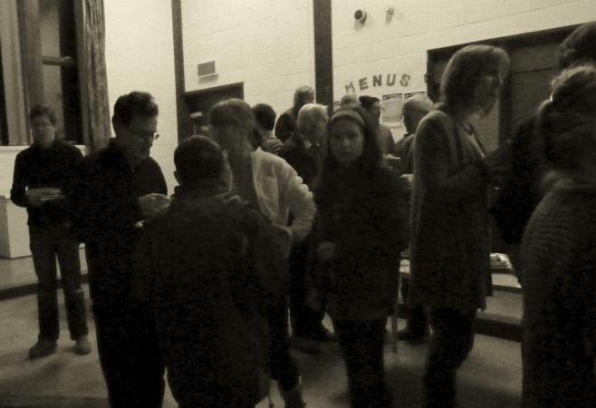  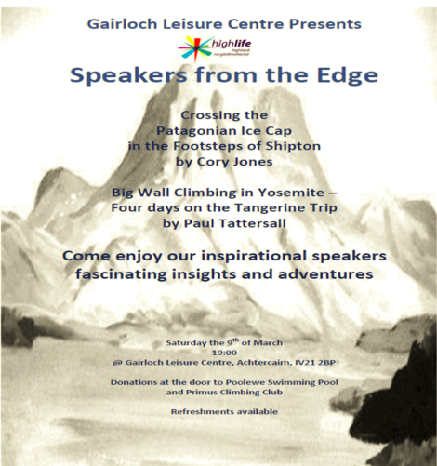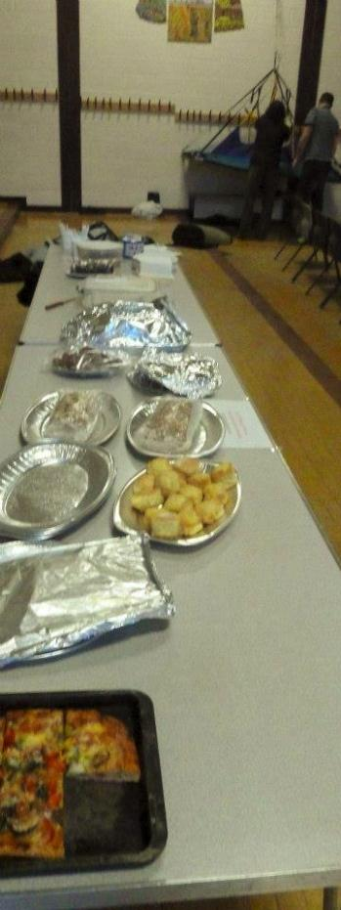  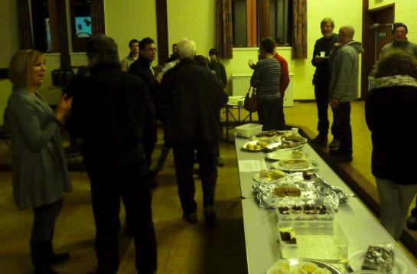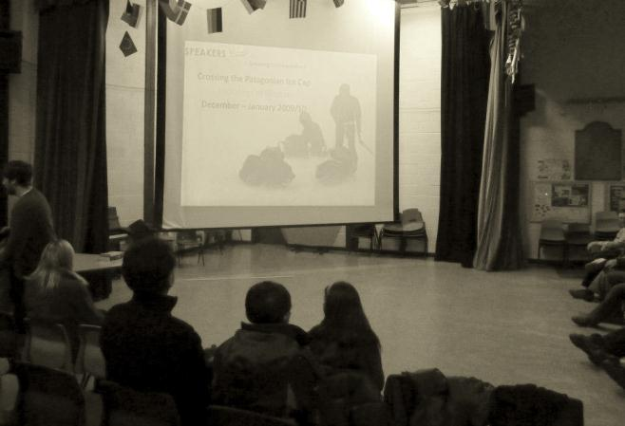  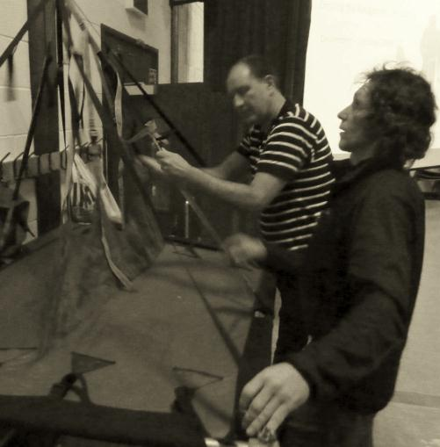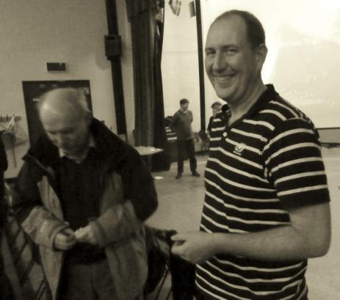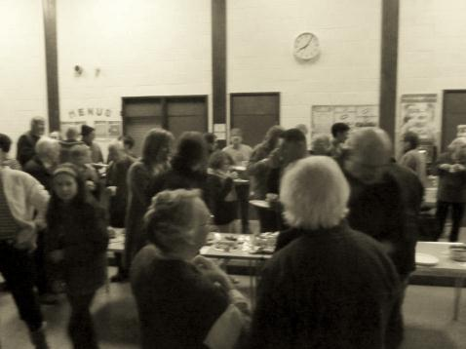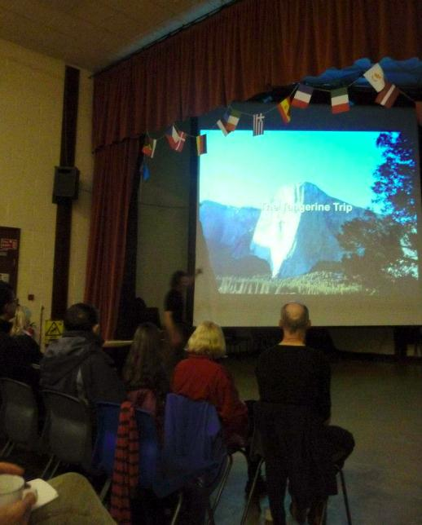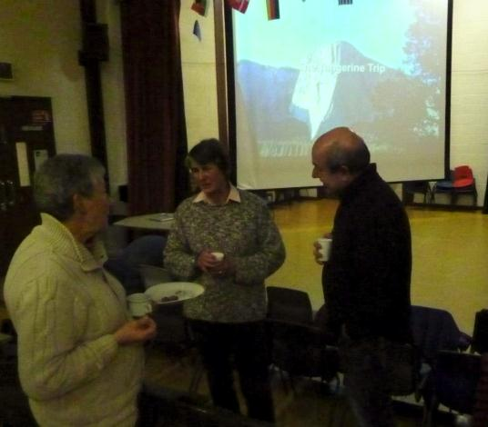
Name & email of staff member submitting news item | mandy.rush@highlifehighland.com  Mandy Elizabeth Rush

Area of work (e.g. Arts) | Libraries
Location | Inverness Royal Academy
Title of piece of work | IRA Library
Description of event  (the purpose / targets) | Led by the school librarian, the aim was to develop a school library partnership with Cameron House, our local Care Home.  A weekly reading group was set up, involving a specially chosen group of S6 pupils. Some initial training was given, to develop storytelling skills and consider appropriate reading materials. Overseen by the librarian, the responsibility was ultimately given to the pupils for running the group, in liaison with the Cameron House Activities Coordinator.
Which staff were / are involved | Network Librarian Susan Appleby
What were the results /  numbers involved /  Feedback | The three teams of S6 pupils, working a Thursday afternoon rota, chose a range of reading materials, from short stories to poems and even including songs - which the residents loved! The S6 pupils are all going on to further education, to study English, medicine or social work, so this experience at the Care Home was invaluable.  Says S6 pupil Ceilidh MacDonald:  "I really enjoyed my time at Cameron House. It was great to be able to give the residents something to look forward to. Doing the reading group gave me the chance to help people in our community, and it made me very happy to see them smiling when I read a poem that they knew from years ago, or when they started singing 'My Love is like a Red Red Rose' after I'd just recited it to them. I would definitely encourage new S6 pupils to take part because they would be helping to put a smile on someone's face - and that is a wonderful feeling"  Cameron House Activities Co-ordinator, Jeannie Sparling, has confirmed that she has been delighted with our pupils’ input, and that the reading group has been of real benefit to her residents. We plan to repeat the reading group with next year’s S6 pupils.
Attach photos or web links | 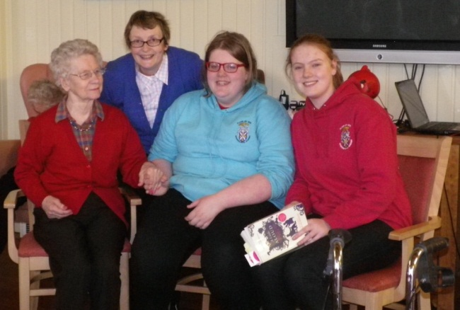  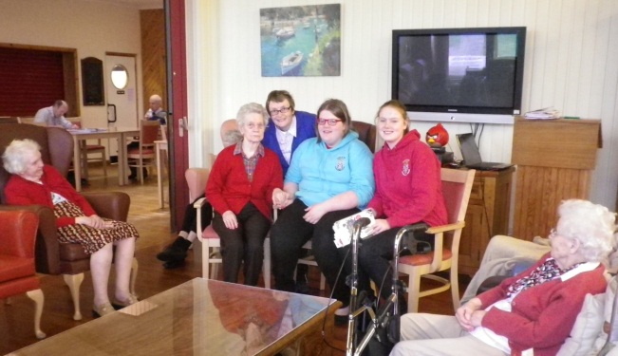
Name & email of staff member submitting news item | Susan Appleby, Network Librarian  Susan.appleby@highlifehighland.com

Area of work (e.g. Arts) | Libraries
Location | Inverness
Title of piece of work | Portfolio Development Day
Description of event  (the purpose / targets) | To help us achieve best practice in libraries all the staff are actively encouraged to keep their CPD up to date and to qualify through the professional association Cilip (Chartered Institute of Library and Information Professionals). All levels need a portfolio, so I asked Michael Martin from Cilip Headquarters in London to come and show us how to get the best out of this. Michael was accompanied by other speakers, including one who is regularly invited to international professional conferences. The development day was aimed at the staff either doing or considering the para-professional Aclip qualification, or working towards any of the professional qualification levels: Chartership, Revalidation or even Fellowship. It was a hands on workshop to look at all aspects of building and developing your portfolio at all levels. Different styles and aims were discussed, and examples made available both on the day and to take away.  The aim was to re-invigorate those staff currently working towards qualifications, and inspire those who were considering qualifying, with the long-term benefits to the service.
Which staff were / are involved | The event was organised in partnership with a NHS Librarian, who was able to offer a free venue. It was offered to all Cilip members within travelling distance of Inverness and of the 26 names received 3 were not HLH staff. Library assistants and Librarians from across the Highlands attended.
What were the results /  numbers involved /  Feedback | On the day we had a couple of people not turn up due to illness, but others had come in hope so our numbers were as planned.  The informal feedback from all levels has been positive, from the person considering Aclip that will now give it a go to a stalled Fellowship person who is starting back up again.  It is seldom that speakers of this caliber travel so far north, and the event provided a rare opportunity for a large number of staff to attend a professional training event, at little cost to the service. It was also a successful partnership with NHS colleagues.
Attach photos or web links | Link to website about Cilip qualifications  http://www.cilip.org.uk/jobs-careers/qualifications/pages/qualifications-.aspx
Name & email of staff member submitting news item | Ruan Peat ruan.peat@highlifehighland.com

Area of work (e.g. Arts) | Community Sport Hubs
Location | Tain
Title of piece of work | Tain Celebration of Sport
Description of event  (the purpose / targets) | Tain Community Sport Hub delivered a successful ‘Celebration of Sport’ in Tain during the Easter Holidays.  The Community Sport Hub partnership came together to provide the public with an action packed afternoon of activity held at Tain Royal Academy Community Complex (TRACC) on the 4th of April.  The afternoon of activity allowed the public to come, try and find out more about the wide range of sports and activities that are available in the local community. 8 local sports clubs along with TRACC staff and Active Schools provide the public the opportunity to try activities such as golf, rugby, tennis, table tennis, swimming, athletics, spinning, bokwa and more all in one afternoon and all at TRACC. The event also had fun activities such as a bouncy castle, smoothie bike, face painting and cage football to keep the whole family entertained.  Following the event a week of Easter activities was offered to the local public at the individual clubs involved in the Community Sport Hub.  The event which was attended by over 100 members of the local community demonstrated well the positive impact the Community Sport Hub project is having in the area and how this strong partnership can deliver quality opportunities to the local community.
Which staff were / are involved | Darren Reid, Kelly Skinner, Julie Cleghorn, Rob Parkes, Elissa Steven
What were the results /  numbers involved /  Feedback | Over 100 members of the local community attended.  Some of the feedback from the participants included: “Fab” , “Awesome” , “fun”, “Active” & “More”
Attach photos or web links | 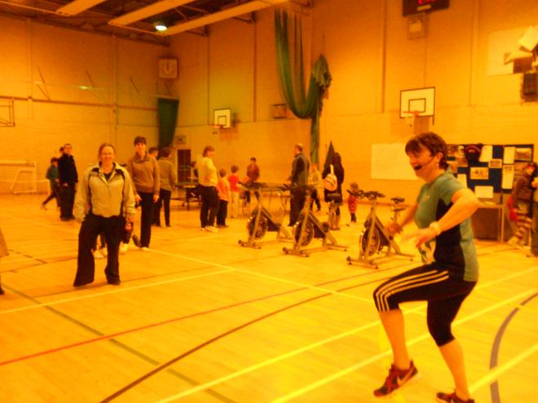
Name & email of staff member submitting news item | Darren Reid darren.reid@highlifehighland.com

Area of work | Youth Work
Location | Inverness Leisure
Title of piece of work | FUSION
Description of event  (the purpose / targets) | BACKGROUND  The FUSION programme is planned as a monthly diversionary weekend activity for young people throughout the winter. This years programme is funded by Cashback for Communities and High Life Highland.  Each event is different, offering young people the opportunity to socialise, try new activities, learn new skills and relate to local youth workers. The generic outcomes fulfill targets set under youth work priorities: Coordination of Activities; Targeting Vulnerable Young People; Working in Partnership.  EVENT  For this FUSION event Youth Development Officers partnered with Inverness Leisure to offer young people from across the area a youth only evening: the whole facility was open, free between 6.30 and 9.30pm on Saturday 10 November 2012.  The event was marketed through regular youth work sessions, schools and the press.  YDO’s ran minibuses from outlying areas to facilitate attendance. Once registered young people were free to move between the leisure pool, the main pool with aquarun, fitness suite, dance studio, indoor sports hall for football, badminton and table tennis, social space and climbing wall. All activities were supervised by Inverness Leisure and High Life Highland staff. Feedback comments were invited on a mural size sheet.
Which staff were / are involved | Nicola Mowatt, Shona McDonald, Lita Leslie, Andy McMahon
What were the results /  numbers involved /  Feedback | Over 150 young people attended from across the Highlands, participating in all activities on offer. Activities offered: Both swimming pools, flumes & aqua run, gym halls (football & badminton), climbing wall & table tennis, dance studio and fitness suite. The session was staffed by both High Life Highland & Inverness Leisure, the session taking part in activities not usually available on a Saturday evening. Feedback comments included, “these events should be held every week”; "awesome"; "fabulous"; "more please" "10000 out of 10".  A follow up event is planned for Saturday 9 March 2013. Enhanced marketing is planned in the hope that if interest is sustained and continues to grow Inverness Leisure can host more regular nights exclusively for young people.
Attach photos or web links | 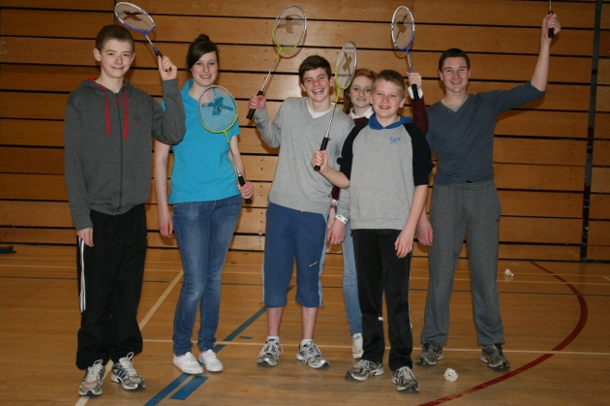
Name & email of staff member submitting news item | Shona McDonald  Shona.mcdonald@highlifehighland.com

Area of work (e.g. Arts) | Youth Work
Location | Greater Fort William
Title of piece of work | Fusion @ Spectrum
Description of event  (the purpose / targets) | Fusion Youth Space in Fort William had regularly been attracting on average 50 Young People to its Friday night activity. We approached the Nevis centre to see if we could make use of the Spectrum Play indoor play area as a new experience for young people. Normally the Indoor is only accessible to children up to the age of 10. This was a pilot event which we would see happening again.  We wanted an activity which would build a positive image of High Life Highland by attracting new young people and improve our Service to existing clients.  Over 80 young people took part in the event and for them it was a chance to remember their childhood running around in the ball pools and sliding down chutes! In addition the event enabled young people to let go of daily stresses and strains and for them to just have fun and expend energy positively and creatively.  Encourage future engagement in decision making processes and give the young people a voice.  Encouraging a greater understanding of youth worker roles and how they can access help and support through us.
Which staff were / are involved | Rachel Carmichael – Assistant Youth Worker, Mary Barker – Youth Development Officer and sessional staff from Lochaber Youth Work Team.
What were the results /  numbers involved /  Feedback | 83 Young People Total  43 Males and 40 Females  Average age was 15.  Fusion @ Spectrum was a massive success encapsulated with one young boys feedback being:  “Please Rachel can we do this once a month, cos we have had an amazing night and I am sweating!”  All that could be heard was roaring laughter, screams of joy and excitement in amongst the music, which spoke volumes for staff in hearing how much fun was being had by all.  Another young girl said:  “This is great, I feel like I am 10 years old again running about and sliding down the chutes, screaming and laughing”  The young people really appreciated their night too with copious amounts of thank you’s to staff for organizing the session.  Throughout the session staff also got to know young people better and spoke with new faces whom had never attended Fusion and since then they have been back each week and are building positive relationships with our numbers of attendance weekly staying above 60.  This night was also a great help in getting young people to think further down the line this year to our yearly summer youth work programme and young people have been involved in discussion and decision making processes regarding this.  As well as more positive relationship foundations being built with youth work staff and our young people, the staff of The Nevis Centre also feedback that they too had had a fun evening and had enjoyed speaking to young people which stands everyone in good stead for future working relationships and networking to create more frequent positive experiences for the young people and a chance to share knowledge and support to one another.
Attach photos or web links | 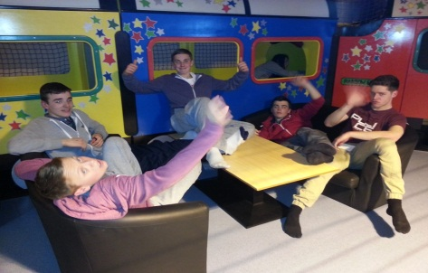  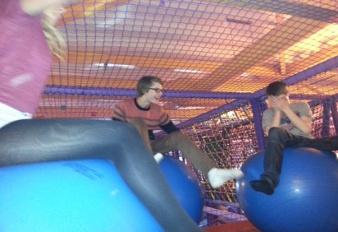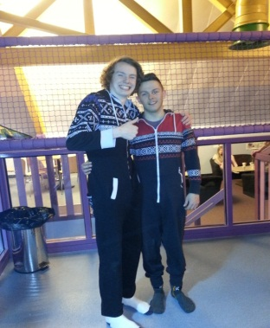
Name & email of staff member submitting news item | Rachel Carmichael.  Rachel.carmichael@highlifehighland.com

Appendix B
Area of Work | Title
Active Schools | Lochaber Wide Primary Football Festival
 | Sportscotland pilot a national award in Poolewe
Adult Learning | Launch of Literacy Trail
Archives | Culloden, Clans & Ancestors
Arts | Loch Ness Craft Fair
 | Secret Egypt
Facilities | Visit from HRH the Duke of Edinburgh to Cameron Youth Centre
Health & Wellbeing | Still Game
 | Well Now – Health at Every Size
Leisure | Innovative Speakers
 | Personal Training
Libraries | Bookbug sessions at Cromarty
 | IRA Library
 | Library visit & tour of new facilities
 | Portfolio Development Day
 | Public Computer Access Service Transformation
 | Rhymetime
 | World Book Day 2013
 | World Book Night at Fortrose
 | Writing Competition
Sport | Indoor Football In-Service
Sport Hub | Tain Celebration of Sport
Youth Work | Fusion
 | Fusion @ Spectrum
 | Ocean Youth Trust Sailing Event

