HIGH LIFE HIGHLAND  REPORT TO BOARD OF DIRECTORS  6 December 2012 | AGENDA ITEM 7 REPORT No HLH 32/12

APPROVAL OF DRAFT ANNUAL REPORT AND ACCOUNTS TO 31 MARCH 2012 - Report by Chief Executive

Summary

The purpose of this report is to present the first annual report and accounts for High Life Highland for Directors agreement.

It is recommended that Directors agree the Annual Report and Audited Accounts, the latter of which is to follow, prior to them being submitted to the High Life Highland Annual General meeting immediately after this meeting.

1. | Background
1.1 | The Company is required to submit annual returns to the Office of the Scottish Charity Regulator (OSCR) and Companies House. In addition it is good practice for companies to use these returns as the core of an annual report.
2. | Business Plan Contribution
2.1 | This report will contribute to all outcomes of the HLH Business Plan 2012-15.
3. | Annual Report and Accounts October 2011 to March 2012
3.1 | The period covered by the first annual report and accounts is the six months from the establishment of High Life Highland (HLH) to the end of its financial year (October 2011 to March 2012). Given this period covers the initial setting up period of the Company, the draft annual report and accounts is primarily the content of the statutory returns, with five case studies of work during that period as illustrations.
3.2 | Directors will be asked to consider the shape, content and style preferred for future reports. The draft Annual Report for September 2011 to March 2012 is attached as Appendix A. The full Annual Report and Audited Accounts for the period ending 31 March 2012 will be forwarded to Directors under separate cover in advance of the meeting.
4. | Risk Implications
4.1 | As the contents of this report relate to historical information, there are no new risks identified by the production of this report.

Recommendation

It is recommended that Directors agree the Annual Report and Audited Accounts, the latter of which is to follow, prior to them being submitted to the High Life Highland Annual General meeting immediately after this meeting.

Signature:

Designation: Chief Executive

Date: 26 November 2012
APPENDIX A

Charity Registration No. SC042593

Company Registration No. SC 407011Scotland

HIGH LIFE HIGHLAND

(A COMPANY LIMITED BY GUARANTEE)

DIRECTORS’ REPORT AND ACCOUNTS

FOR THE SIX MONTHS ENDED 31 MARCH 2012

LEGAL AND ADMINISTRATIVE INFORMATION

Trustees C Ewan
D Graham
L Kirkland
E McArdle
D McLachlan
K Nicol
J Watt
L Young
D Millar
J Douglas
F Parr
K Gowans

Secretary M Morris

Charity Number SC042593

Company Number SC407011

Registered Office 12-13 Ardross Street
Inverness
IV3 5NS

Auditors Ernst & Young
Barony House
Stoneyfield Business Park
Inverness
IV2 7PA

Bankers Clydesdale Bank PLC
23 Longman Road
Inverness
IV1 1RY

CONTENTS

Page

Directors’ Report x

Statement of Directors’ responsibilities x

Independent auditors’ report x

Statement of financial activities x

Balance sheet x

Notes to the accounts x

DIRECTORS’ REPORT FOR THE SIX MONTHS ENDED 31 MARCH 2012

The Trustees present their report and accounts for the six months ended 31 March 2012.

The accounts have been prepared in accordance with the accounting policies set out in note 1 to the accounts and comply with the charity’s Memorandum and Articles of Association, the Company’s Act 2006 and the Statement of Recommended Practice, “Accounting and Reporting by Charities”, issued in March 2005.

Formation of High Life Highland

High Life Highland (HLH) is a charity registered in Scotland and a company, limited by guarantee, wholly owned by The Highland Council (THC), whose purpose is to develop and promote opportunities in culture, learning, sport, leisure, health and well-being. The Company was established on 1 October 2011 to deliver a suite of community learning and leisure services on behalf of The Highland Council.

The company’s ambition is to be recognised and respected as the leading organisation in the area for the development and promotion of opportunities in culture, learning, sport, leisure, health and well-being.

HLH operates across the Highlands of Scotland, currently within the geographical boundary of THC’s administrative area.

The main business of the company is the delivery of a Service Delivery Contract for The Highland Council across nine areas of work:

- Adult Learning
- Archives
- Arts
- Leisure Facilities
- Libraries
- Museums
- Outdoor Education
- Sport
- Youth Work

Structure, governance and management

The charity is a company limited by guarantee, governed by its Memorandum and Articles of Association.

The Trustees, who are also the Directors for the purposes of company law, who served during the period were:

C Ewan
D Graham
L Kirkland
E McArdle
D McLachlan
K Nicol
J Watt
L Young
D Millar
J Douglas
T Prag
P Corbett

The overall management and policy decisions of the company are the responsibility of the Board of Directors who are elected under the terms of the company’s Articles of Association.

The Board consists of eight independent Directors and four Highland Council nominated Directors. The retiral and replacement of the Directors is governed by the Articles of Association.
In addition there are a number of Board committees responsible for various activities of the company, being the Finance and Audit Committee, Nominations Committee and the Funding and Sponsorship Committee.

Objectives and Activities

The company has identified nine business outcomes which form the basis of its work.
These business outcomes shape and inform the Operational Plans for each of the nine services. The outcomes are:
- Safety and environmental compliance
- Delivery of the contract with the Highland Council
- Increased awareness of the company’s products and services
- Increased customer satisfaction
- Increased staff satisfaction
- A positive company image
- A growing company
- Increased financial sustainability
- Increased internal collaboration

In striving to achieve these outcomes, the company has regard to five core values:
- To act legally
- To be non-discriminatory
- To be a good employer
- To have a safe environment for staff and users
- To take steps to reduce our environmental impact
Achievements and Performance

On 1 October 2011 the responsibility for the delivery of culture and leisure services on behalf of Highland Council was entrusted to High Life Highland. The transfer process involved in excess of 1000 employees, and 1,000 volunteers, over 150 buildings and 90 open spaces.

The Directors consider that the transition was effected in an extremely efficient manner, resulting in no disruption to the delivery of the services.

Financial Performance

During the period, the charity has been able to deliver its services within budget by £87,000. As this was the company’s first accounting period, there has been a contribution to reserves of an equivalent amount.

The company’s revenue stream is largely tied to the terms of its Service Delivery Contract with the Highland Council. Under the terms of that contract, there is a direct linkage between the level of service required by the Council and the amount of funding provided to the company to deliver those services.

The Trustees consider that, having due regard to the terms of the Service Delivery Contract, the company has sufficient funds to ensure that variations in funding from other sources can be accommodated within the normal operations of the business.

Future Plans

The company has prepared a business plan covering the period to March 2015 which clearly sets out its objectives and plans for the future.

The overriding financial objective of the company is to ensure that the company achieves financial sustainability in the short, medium and long term. A significant contributor to this objective will therefore be maintaining a positive relationship with The Highland Council and a focus to ensure that sufficient income is generated throughout the company’s activities.

CASE STUDY

ADULT LEARNING - ENGLISH FOR CITIZENSHIP

This work enables migrants from outside of the EU to improve their levels of English while gaining a deeper and broader understating of life in the UK than they would from a regular English class. The Scottish Qualification Assessment which Adult Learning offer as part of this course of study is also recognised by the UK Border Agency and is therefore included by our learners in their applications for settlement and UK citizenship. These qualifications are an important alternative to sitting the Life in the UK test. It is in line with Scottish policy that English language learners below intermediate level have this option. Without this provision people are faced with travelling, often to London, to attend a private college for a week long intensive course at considerable expense.

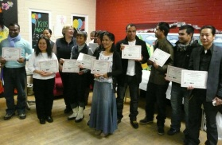

CASE STUDY

LIBRARIES - COMPUTING FOR BEGINNERS

Short computer courses, in collaboration with Adult Basic Education, began in 2010. Those people attending the courses are generally clients of the Adult Basic Education service, or are people aged 50+ who are new to computers.
- Each course consists of 5 one hour sessions
- Courses run with 3 tutors and a maximum of 6 clients
- Course content is tailored to clients’ requirements, but normally covers very basic computer use: internet, email, searching the Library catalogue, and sometimes social networking (depending on client’s interests)

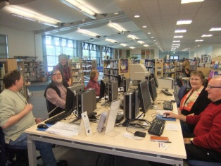

CASE STUDY

HIGH LIFE HIGHLAND LEISURE FACILITIES - MOVE IT TO LOSE IT CAMPAIGN

Move It To Lose It (MITLI) ran in all High Life Highland Leisure Facilities in November 2011 and again in January 2012. The main aim of the campaign was to encourage people to participate in regular exercise, eat healthy and maintain a healthy weight or lose weight in a positive fun supported environment. The campaign also provided High Life Highland a platform to raise the profile of the new company, emphasise the value of High Life membership and showcased the services and facilities available to High Life Members. As a new organisation it also provided the High Life Leisure Team with a shared goal and to focus on the customer driven values of HLH.

- The initial MITLI programme in Nov/Dec saw a 67% increase in usage from the previous year – at a time when facilities are at their quietest;
- The second MITLI programme shows a 35% increase in usage from the previous year – at a time when facilities are at their busiest;
- Total number of participants for November and January Promotion was 2660;
- Total weight lost since Novembers is 510 stone throughout the Highlands; and
- High Life Membership increased by 1.2% which equates to 100 new memberships.

Customer feedback:
What difference has taking part in this challenge had on you?

- Good motivation and degree of accountability knowing you will be getting weighed each week
- Encouraged me to keep coming to exercise and stay off the sofa
- Spent more time in the centre and not in front of the TV
- Got rid of boredom and increased my confidence
- More aware of body measurements
- Improved fitness, weight and inches lost

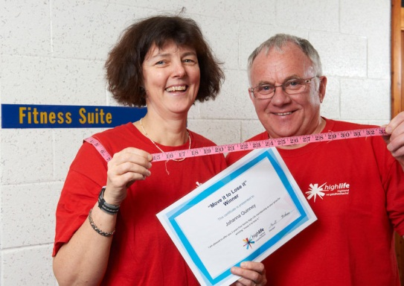

CASE STUDY

YOUTH WORK
TAIN, INVERGORDON, ALNESS (TIA) -YOUTH EMPLOYABILITY PROJECT

TIA is an employability programme for young people to help them become more employable and to improve their self- esteem and confidence as well as their CV. By the end of the course 14 out of 19 young people had been retained and support was offered to those who did not fully engage. All those youngsters that completed the course have gone on to work placements, college placements or activity agreements some of which will lead to full time employment. There has been a significant improvement in their CV’s including a First Aid qualification and some have a welding course, manual handling and forklift training certificates to show for their involvement in the course.

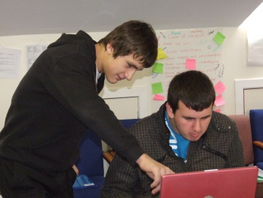

CASE STUDY

SPORT - LOCHABER DANCE PLATFORM
A dance performance event designed to stimulate girls’ physical activity and creativity. The event encourages girls to become active when young and stay involved in activity as they go to high school and become teenagers. High school girls get together in groups, devise dances, choose music and costumes and perform to an audience. High school girls volunteer to run dance classes at the feeder primary schools and teach them a dance to perform. Approx. 200 young people from 5-18 years old take part.

