HIGH LIFE HIGHLAND  REPORT TO BOARD OF DIRECTORS  23 August 2016 | AGENDA ITEM REPORT No HLH /16

Membership Analysis - Report by Chief Executive

Summary

This report provides information on a membership analysis which has been carried out on the leisure and library memberships.

It is recommended Directors comment on and note:-

- that the High Life leisure scheme and library memberships reach 39.5% and 27.67% of the Highland population respectively;
- the confirmation that the leisure and library memberships have a broad appeal, reaching all sections of the Highland population;
- the long-term sustainable growth in participation and income which has been achieved through the High Life leisure scheme;
- the confirmation that the High Life leisure scheme successfully targets middle to low earning individuals and families; and
- the continuing further analysis being carried out through the ScotGrad/HIE Graduate Placement.

1. | Business Plan Contribution
1.1 | This report supports the highlighted Business Outcomes from the High Life Highland (HLH) Business Plan:  - To advance sustainable growth and financial sustainability  - Deliver the Service Delivery Contract with THC  - Improving staff satisfaction  - Improving customer satisfaction  - A positive company image  - Services designed around customers and through market opportunities  - Sustain a good health and safety performance  - A trusted partner
2. | Background
2.1 | All-inclusive High Life membership offers a monthly subscription which provides access to all leisure centre run activities for £29.00 per month for families and £20.00 per month for individuals. The Budget High Life membership provides access to the same arrange of activities for fifty pence per activity for individuals and households on low income benefits. Library membership is free and provides access to lending materials and on-line resources.
2.2 | There are some leisure customers who hold a card and pay for access using the “pay as you go” prices instead of paying a subscription. This facilitates administration such as keeping records of fitness suite inductions, swimming lesson enrolment etc. Pay as you go leisure card holders were not included in this analysis, with the focus for leisure facilities having been on customers who pay a subscription and Budget members. The pay as you go card holders use leisure centres on average, just less than once per month and are therefore unlikely to take up a subscription.
2.3 | There are library and leisure facilities customers who do not hold cards and in the case of libraries, for example, attend activities and events rather than borrow materials or access on-line services and in the case of leisure centres, use the pay as you go prices. This means that the reach of HLH into the highland population is greater than stated in this report.
2.4 | Library membership has been in existence since the inception of libraries and the requirement for membership to be free was first established in the 1850 Public Libraries Act. Membership is an operational requirement for lending materials and more recently accessing on-line services.
2.5 | When the High Life leisure scheme was established in 2002, it was devised to address three seemingly irreconcilable challenges facing local Councils’ leisure facilities – static or falling customer numbers, an increasing gap between income targets and earned income and a concern that those arguably most in need of a healthy lifestyle were being excluded from “their” local facilities because of price. The three aims were to:  - increase attendances through encouraging mass participation and reach mid to low earning individuals and families;  - achieve a level of parity for the unwaged; and  - increase earned income.
2.6 | The scheme’s philosophy is to offer access to leisure centres and swimming pools across Highland at low cost and to include as many products and services within a single monthly payment as possible. This approach is aimed at families, individuals and those in receipt of state benefits; it concentrates on mass family participation, has a focus on social responsibility and aims to be simple, easy to use and excellent value for money making the customer decision to join straightforward. It allows for partnership working with other services such as Social Work Services and more recently NHS Highland.

2.7 | The progress of the High Life scheme in generating additional income and increasing customer numbers has been tracked over the years with it having been recognised by sportscotland and a Scottish Government Ministerial Working Group as being an example of good practice. The table below provides a summary of results since the scheme’s inception.  Increase in participation from 2001 to 2016 – using only the 13 facilities existing from 2001  Total Participation 2001 2016 485,500 930,477 Budget Participation 2001 2016 12,000 37,125 Income 2001 2016 £1.479m £2.848m  Increase in participation = 91.5% Increase in budget participation = 209% Increase in Income = 93%*  A further indication of the success of the scheme is the very low cancellation rate at approximately 3% of overall memberships.
2.8 | Similar models which provide a low cost, all-inclusive price have been introduced by the Western Isles Council, Comhairle nan Eilean Siar, in 2012/13 and Moray Council in 2016 with both experiencing significant gains in attendances and income. Moray Council is yet to formally report on the initial results of its scheme but the Western Isles has reported increases of 33% and 34% attendances and income respectively so far. The Chief Executive has recently presented on the High Life scheme to Orkney Islands Council officials and the Board of the Pickaquoy Centre Trust, which operates a facility broadly equivalent to Inverness Leisure, as part of consideration of an Orkney wide scheme.
3. | Market Analysis – Methodology and Definitions
3.1  3.2 | While it has been straightforward to evaluate the success of the High Life leisure scheme in terms of customer numbers and increased income and to track library customer numbers, the extent to which the membership schemes are successful in providing for mid to low earning families and individuals and the reach of the membership into the Highland population as a whole has not previously been assessed.  The membership analysis was carried out using a system called “Mosaic Profiles” which uses postcode information to compare the memberships with the Highland population. This seeks to provide an assessment of how HLH is reaching various market segments in terms of:  - the number of members in each market segment; and  - the market penetration rate into each segment (whether particular segments are over or under-represented).

3.3 | The market segments are called “Mosaic Profile Groups”. Mosaic Profile Groups give a higher level analysis with more detail being provided through a further breakdown into “Mosaic Profile Types”. This report focuses on the higher level “Groups” analysis.
3.4 | The Mosaic Profile Group definitions are:

Mosaic Profile Group | Definition
Aspiring Homemakers | Younger households settling down in housing priced within their means
City Prosperity | High status city dwellers living in central locations and pursuing careers with high rewards
Country Living | Well-off owners in rural locations enjoying the benefits of country life
Domestic Success | Thriving families who are busy bringing up children and following careers
Family basics | Families with limited resources who have to budget to make ends meet
Modest Traditions | Mature homeowners of value homes enjoying stable lifestyles
Municipal Challenge | Urban renters of social housing facing an array of challenges
Prestige Positions | Established families in large detached homes living upmarket lifestyles
Rental Hubs | Educated young people privately renting in urban neighbourhoods
Rural Reality | Householders living in inexpensive homes in village communities
Senior Security | Elderly people with assets who are enjoying a comfortable retirement
Suburban Stability | Mature suburban owners living settled lives in mid-range housing
Transient Renters | Single people privately renting low cost homes for the short term
Urban Cohesion | Residents of settled urban communities with a strong sense of identity
Vintage Value | Elderly people reliant on support to meet financial or practical needs

3.5 | Separate analyses were carried out for the different HLH membership categories and these are in the appendices as follows:  - All High Life Leisure Members - Appendix A;  - Paid Memberships: Individual and Family High Life Leisure Members – Appendix B;  - High Life Budget Members – Appendix C;  - Library Members – Appendix D;  - Leisure and Library Membership by Highland Council Electoral Ward – Appendix E; and  - Sport and Recreation Trust Association (Sporta) Scotland Leisure Membership – Appendix F.

3.6 | For the analysis of leisure memberships, all leisure centres which offer the High Life scheme including Kyle and Assynt Leisure Centres (the two independently run facilities which offer High Life leisure memberships) have been included. The analysis counted each individual member rather than the number of subscriptions (i.e. each member of a family subscription is counted individually) to allow comparisons with the population.
4. | All High Life Leisure Memberships – See Appendix A
4.1 | The overall result of the analysis of all High Life leisure members (not including pay as you go card holders) is in the table below. The scheme reaches just over 25% of the Highland population with paid for and budget memberships reaching just over 20% and 5% of the population respectively.  Number of Members Percentage Penetration Rate (of the Highland Population) Range of Penetration Rates across the Mosaic Profile Groups  All High Life Members 62,068 25.75% 21.79% to 62.86%  All Paid High Life Subscriptions (Family and Individual Subscriptions) 48,591 20.16% 12.82% to 36.36%  Budget High Life Memberships 13,477 5.59% 2.02% to 37.14%
4.2 | The largest Mosaic Profile Groups within the High Life leisure membership are as follows:  - “Rural Reality - Householders living in inexpensive homes in village communities”;  - “Country Living - Well-off owners in rural locations enjoying the benefits of country life”; and  - “Domestic Success - Thriving families who are busy bringing up children and following careers”.
4.3 | Some key points to note from the analysis are:  - the High Life leisure scheme is reaching all sections of the Highland community;  - looking only at those market segments which are considered to be mid to low earning they account for 63% of the High Life membership;  - High Life membership is attractive to Mosaic Profile Groups which have families;  - the rural-reality group, even though it is the largest group in the Highland population, is slightly under-represented (less than statistically expected). It is difficult to assess why this is, but a factor might be that Mallaig and Bettyhill swimming pools do not offer High Life memberships. (Note, Mallaig has recently asked to be included in the High Life scheme);  - the “Senior Security” and “Vintage Value” groups are under-represented (less than statistically expected). This might be because the concessionary “pay as you go” charges make a High Life membership less attractive to older people.
5. | Individual and Family High Life Leisure Members (Members who Pay Subscriptions) – See Appendix B
5.1 | 20.16% of the Highland population (48,591 members) pay a subscription either as an individual or through a family membership. The largest Mosaic Profile Groups in the individual and family membership are the same as for the overall membership: “Rural Reality”; followed by “Country Living” and Domestic Success”. Some key points to note from the analysis are:  - looking only at those market segments which are considered to be mid to low earning, they account for 61% of the High Life individual and family memberships; and  - the over-represented groups (more than statistically expected) compared with the Highland population are made up of groups which could be considered to be financially better off.
6. | High Life Budget Leisure Memberships – See Appendix C
6.1 | The High Life Budget scheme allows access to leisure centres for fifty pence per activity for people in households on: Income Support, Pension Guarantee Credit, Job Seekers Allowance or Employment Support Allowance, individuals on War Disability Pension, Disability Living Allowance, Personal Independence Payment and Attendance Allowance or Carer’s Allowance.
6.2 | The qualifying benefits listed above seek to target financial disadvantage irrespective of where people live. The Mosaic Profiles analysis uses post codes to assign people into market segments so it is to be expected that there would be some apparent mismatches of category.
6.3 | 5.59% of the Highland population (13,477 members) are High Life Budget members. (Using census figures, the Budget memberships reach 25% of the eligible population.)
6.4 | The largest Mosaic Profile Groups within the High Life Budget membership are as follows:  - “Rural Reality - Householders living in inexpensive homes in village communities”;  - “Municipal Challenge - Urban renters of social housing facing an array of challenges”; and  - “Family Basics – Families with limited resources who have to budget to make ends meet”.
6.5 | The over-represented groups (more than statistically expected) are made up of market segments which could be considered to be financially less well off.
7. | Library Memberships – See Appendix D
7.1 | There are 66,709 library members which is 27.67% of the Highland population.
7.2 | The largest Mosaic Profile Groups within the library membership are as follows:  - “Rural Reality - Householders living in inexpensive homes in village communities”;  - “Country Living - Well-off owners in rural locations enjoying the benefits of country life”; and  - “Domestic Success -Thriving families who are busy bringing up children and following careers”.
7.3 | The market penetration rates for libraries range from 19% to 32.05% if the “City Prosperity” category (which only has 35 people in it in the Highland population in it) is excluded. There are relatively small variations in penetration rates across the different Mosaic Profile Groups, showing that library membership has broad appeal.
7.4 | Part of the reason for libraries being successful in reaching the whole Highland population is the number and location of libraries (including the eight mobile libraries) which gives a good geographic coverage of the Highlands. The range of services which are provided by libraries staff contribute to their appeal across customer groups. Looking only at those market segments which are considered to be mid to low earning they account for 67% of the library membership.
8. | Leisure and Library Membership by Highland Council Electoral Ward – See Appendix E
8.1 | When library customers were surveyed they were asked which other HLH services they used. From this it has been possible to estimate the combined Leisure/Library reach into the Highland population at 51%. While there could be inaccuracies associated with this figure, given that HLH has customers who are not members, it is considered to be a reasonable estimate, possibly an under-estimate. Work to combine customer database information across the Company is complex and is at a very early stage, but it is envisaged that it will be possible in future to provide a more accurate number of the reach of the organisation into the Highland population without the risk of double counting.
8.2 | The breakdown of memberships by Council Electoral Ward provides useful information such as where it might be beneficial to target membership promotions and could be used to help inform decision-making around capital and programme development. Some key points to note from the Ward breakdown are:  - Wards which have higher than average memberships have local facilities within easy travelling distance of most settlements in the Ward (e.g. Badenoch and Strathspey) and conversely Wards with a lower or lower than average membership have longer travel times to High Life facilities (e.g. East Sutherland and Edderton);  - private sector provision is mainly within/adjacent to the Inverness Wards and this does not appear to significantly impact High Life membership;  - the decision to promote the High Life Card in Caithness because of the new facility developments taking place is further strengthened by the knowledge that the three Caithness Wards have a lower than average membership;  - the highest Budget High Life uptake is in the Wards which have higher levels of deprivation; and  - library memberships are spread relatively evenly across the Highland Electoral Wards (14% variation between lowest and highest) with the lowest numbers of memberships being in the four Inverness Wards which do not have library facilities which would be perceived as being “local” to the residents of the Wards.
9. | Sport and Recreation Trust Association (Scotland) Leisure Membership Market Analysis – See Appendix F
9.1 | The Sport and Recreation Training Association (Sporta) Scotland is the membership organisation for cultural and leisure Arm’s Length External Organisations (ALEOs). Its membership postcode data was compared with the Scottish population (the Sporta analysis includes HLH memberships) using the methodology described above. The Sporta membership covers parts of the Scottish population so comparisons will only give an indication of how the High Life leisure membership scheme compares with others and does not provide the ability to compare HLH reach into the Highland population with the reach of other organisations into their populations (the Sporta organisations wished to keep this information confidential).
9.2 | The largest Mosaic Profile Groups within the Sporta leisure membership are as follows:  - “Rural Reality - Householders living in inexpensive homes in village communities”;  - “Domestic Success - Thriving families who are busy bringing up children and following careers” and  - “Municipal Challenge - Urban renters of social housing facing an array of challenges”.
9.3 | Looking only at those market segments which are considered to be mid to low earning they account for 54% of the Sporta membership. This is less than the High Life leisure membership at 63%.

9.4 | Some key points to note from the analysis of Sporta Scotland’s members are:  - Sporta Scotland memberships reach 5.65% of the Scottish population;  - the over-represented groups (more than statistically expected) are different from the High Life membership with “Domestic Success” being the most over-represented group amongst the Sporta Membership;  - The “Family Basics” and “Municipal Challenge” groups are less well represented in the Sporta membership than for HLH;  - the Rural Reality group is less well represented in Highland than in the Sporta membership. It is unclear why this is but it might be because of the relative size of the segment in Highland which has 113,618 people in it, 18% of the Scottish “Rural Reality” market segment; and  - while comparisons between Sporta memberships and the High Life leisure scheme should be treated with caution because of the small sample size in relation to the Scottish population, it seems clear that the High Life scheme is better at reaching mid to low earning individuals and families, and people who are unwaged.
10. | Pricing
10.1 | The pricing of the High Life Card is reviewed every year in the context of setting budgets and it has always been considered that increasing the price of it significantly above inflation could cause people to cancel and therefore impact income and attendances. This thinking is supported by a number of factors including:  - the on-going success of the scheme;  - there are some private sector operators which have reduced their charges over the years and charge less than the High Life individual price;  - customers tend to have one main use which they make of leisure facilities (even though the High Life card allows access to all leisure centre run activities) so the value to the customer is based on their main activity rather than what they could theoretically use;  - offering a concessionary price on the standard pay as you go charges (e.g. for children/senior citizens) is necessary for reasons of social inclusion and at the current charges the individual High Life subscription is roughly equivalent to two uses per week at the concessionary rate for activities such as swimming or use of the fitness suite.
10.2 | There was a previous attempt to carry out a price sensitivity analysis from which it was difficult to draw conclusions, however, the mosaic profile analysis further points to the requirement to keep High Life subscriptions low with 63% of those who pay for a High Life subscription being from groups which are considered to be middle to low income.
11. | Further Detailed Analysis
11.1 | This report provides a summary analysis and as mentioned above, the Mosaic Profile Groups are further broken down into “Types”. This allows for more detailed analysis such as preferred communication channels of target markets. HLH has recently appointed a twelve month Graduate Placement partially funded through ScotGrad/HIE (£16K) with the remaining 30% coming from the HLH Marketing budget. The Graduate Business Development Co-ordinator is in the process of carrying out an in-depth analysis of customer information to support the development of the High Life Card including future marketing and promotional activities.
12. | Implications
12.1 | Resource Implications - there are no additional resource implications arising from this report.
12.2 | Legal Implications - there are no new legal implications arising from this report.
12.3 | Risk Implications - there are no new risk implications arising from this report.

Recommendation

It is recommended Directors comment on and note:-

- that the High Life leisure scheme and library memberships reach 39.5% and 27.67% of the Highland population respectively;
- the confirmation that the leisure and library memberships have a broad appeal, reaching all sections of the Highland population;
- the long-term sustainable growth in participation and income which has been achieved through the High Life leisure scheme;
- the confirmation that the High Life leisure scheme successfully targets middle to low earning individuals and families; and
- the continuing further analysis being carried out through the ScotGrad/HIE Graduate Placement.

Signature:

Designation: Chief Executive

Date: 12 August 2016
Appendix A
All High Life Leisure Memberships

This appendix provides information on all High Life leisure memberships

The table below shows the results of the analysis by Mosaic Profile Group. In it, the number of High Life members are compared with the number of people in the Highland population in each group. The following terms are used in the column headings:

- “Target” is the number of High Life members in each Mosaic Profile Group.
- “Base” is the Highland population in each Mosaic Profile Group.
- “Pen” is a percentage measure of the “target” column (number of High Life members) compared to the “base” column (Highland population).
- “Index” is a percentage measure of the “target %” column (number of High Life members) compared to the “base %” column (Highland population). An index of 100 means the percentage of members is equal to the percentage of that market segment in the Highland population. An index below 100 means the number of members is under represented. An index above 100 means the number of members over represented.

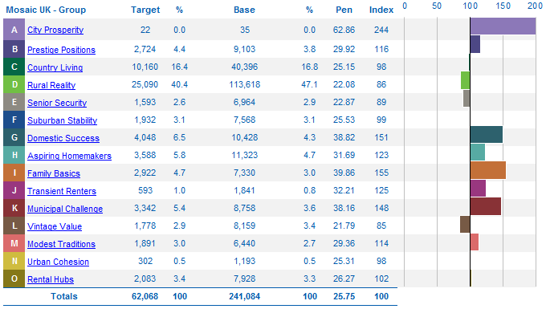

Appendix A (cont)
All High Life Leisure Memberships

The graph below shows the number of members in each Mosaic Profile Group in order of size.

The table below lists the groups considered to be mid to low earning and they account for 63% of the High Life membership.

Rural Reality | Householders living in inexpensive homes in village communities | 25,090
Aspiring Homemakers | Younger households settling down in housing priced within their means | 3,588
Municipal Challenge | Urban renters of social housing facing an array of challenges | 3,342
Family basics | Families with limited resources who have to budget to make ends meet | 2,922
Rental Hubs | Educated young people privately renting in urban neighbourhoods | 2,083
Vintage Value | Elderly people reliant on support to meet financial or practical needs | 1,778
Transient Renters | Single people privately renting low cost homes for the short term | 593
 |  | 39,396

Appendix A (cont)
All High Life Leisure Memberships

The table below re-lists the Mosaic Profile Groups ranked by the “Index” column. Index is a percentage measure of the “target %” column (number of High Life members) compared to the “base %” column (Highland population). An index of 100 means the percentage of members is equal to the percentage of that market segment in the Highland population. An index below 100 means that the number of members is under represented. An index above 100 means that the number of members is over represented.

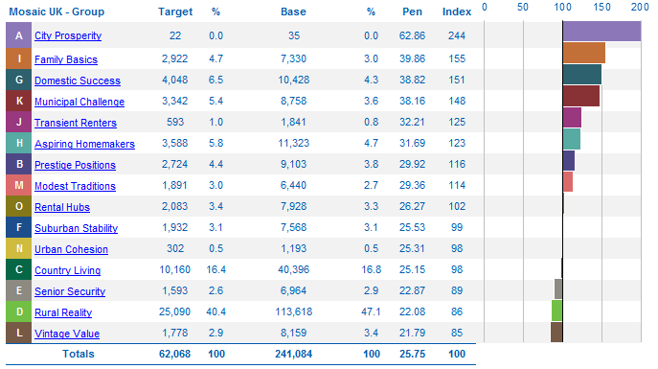

Appendix A (cont)
All High Life Leisure Memberships

Dot Map Showing High Life Member Locations – All High Life Leisure Members

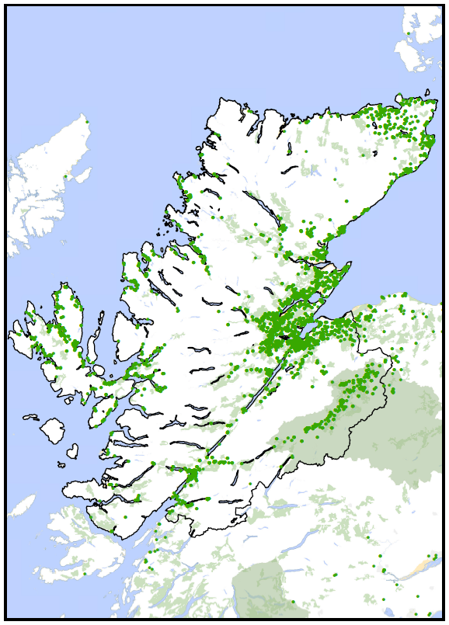

Appendix B
Paid Memberships: Individual and Family High Life Leisure Members

This appendix provides information on memberships for which a subscription is paid by the customer (individual and family memberships).

The table below shows the results of the analysis by Mosaic Profile Group. In it, the number of High Life members are compared with the number of people in the Highland population in each group. The following terms are used in the column headings:
- “Target” is the number of High Life members in each Mosaic Profile Group.
- “Base” is the Highland population in each Mosaic Profile Group.
- “Pen” is a percentage measure of the “target” column (number of High Life members) compared to the “base” column (Highland population).
- “Index” is a percentage measure of the “target %” column (number of High Life members) compared to the “base %” column (Highland population). An index of 100 means the percentage of members is equal to the percentage of that market segment in the Highland population. An index below 100 means the number of members is under represented. An index above 100 means the number of members over represented.

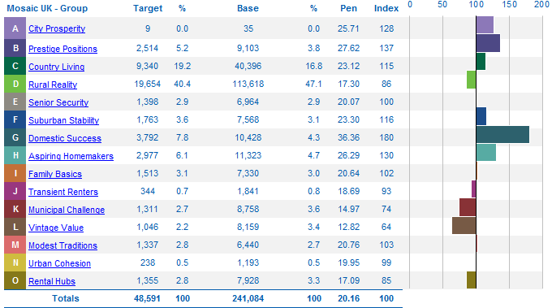

Appendix B (cont)
Paid Memberships: Individual and Family High Life Leisure Members

The graph below shows the number of members in each Mosaic Profile Group in order of size.

The table below lists the groups considered to be mid to low earning and they account for 61% of the individual and family membership.

Rural Reality | Householders living in inexpensive homes in village communities | 19,654
Aspiring Homemakers | Younger households settling down in housing priced within their means | 2,977
Family basics | Families with limited resources who have to budget to make ends meet | 1,513
Rental Hubs | Educated young people privately renting in urban neighbourhoods | 1,355
Modest Traditions | Mature homeowners of value homes enjoying stable lifestyles | 1,337
Municipal Challenge | Urban renters of social housing facing an array of challenges | 1,311
Vintage Value | Elderly people reliant on support to meet financial or practical needs | 1,046
Transient Renters | Single people privately renting low cost homes for the short term | 344
 |  | 29,537

Appendix B (cont)
Paid Memberships: Individual and Family High Life Leisure Members

The table below re-lists the Mosaic Profile Groups ranked by “Index” column.

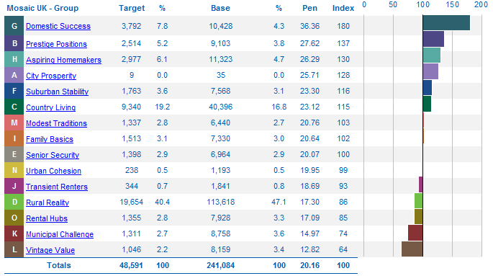

Appendix B (cont)
Paid Memberships: Individual and Family High Life Leisure Members

Dot Map Showing High Life Member Locations – Paid Memberships: Individual and Family High Life Leisure Members
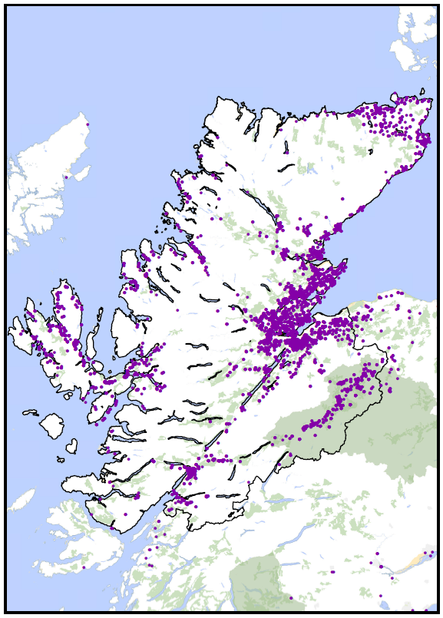

Appendix C
High Life Budget Members

This appendix provides information on budget memberships (Budget membership is for individuals and families on benefits. There is no subscription charge, budget members pay £0.50 per person per activity).

The table below shows the results of the analysis by Mosaic Profile Group. In it, the number of High Life Budget members are compared with the number of people in the Highland population in each group. The following terms are used in the column headings:

- “Target” is the number of High Life members in each Mosaic Profile Group.
- “Base” is the Highland population in each Mosaic Profile Group.
- “Pen” is a percentage measure of the “target” column (number of High Life members) compared to the “base” column (Highland population).
- “Index” is a percentage measure of the “target %” column (number of High Life members) compared to the “base %” column (Highland population). An index of 100 means the percentage of members is equal to the percentage of that market segment in the Highland population. An index below 100 means the number of members is under represented. An index above 100 means the number of members over represented.

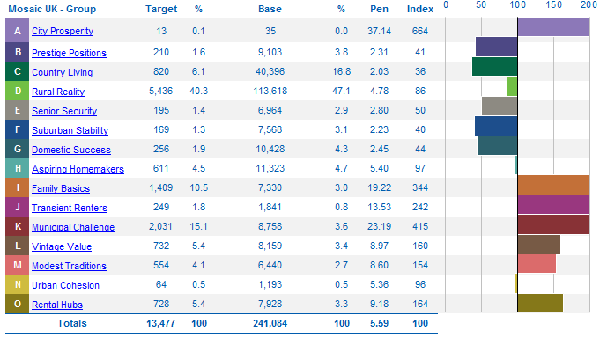

Appendix C (cont)
High Life Budget Members

The graph below shows the number of Budget members in each Mosaic Profile Group in order of size.

The table below re-lists the Budget member Mosaic Profile Groups ranked by “Index” column.

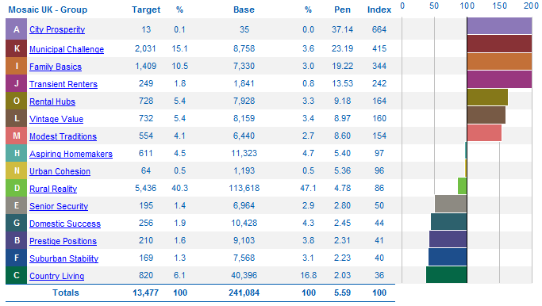

Appendix C (cont)
High Life Budget Members

Dot Map Showing High Life Member Locations – High Life Budget Members

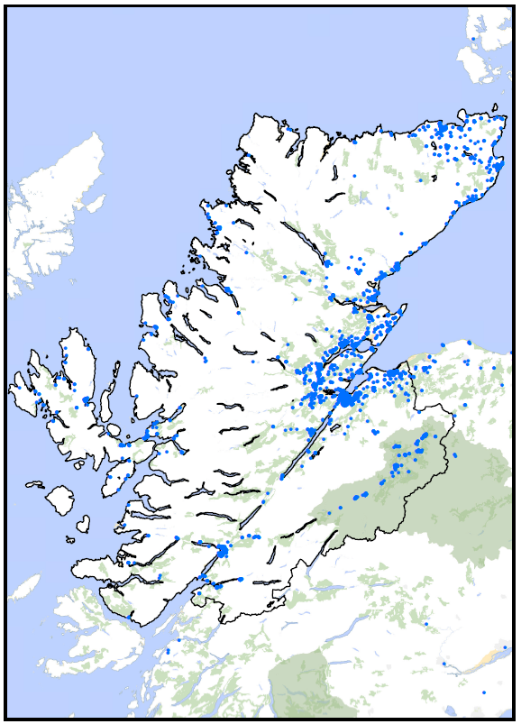

Appendix D
Library Members

This appendix provides information on the library membership.

The table below shows the results of the analysis by Mosaic Profile Group. In it, the number of library members are compared with the number of people in the Highland population in each group. The following terms are used in the column headings:
- “Target” is the number of High Life members in each Mosaic Profile Group.
- “Base” is the Highland population in each Mosaic Profile Group.
- “Pen” is a percentage measure of the “target” column (number of High Life members) compared to the “base” column (Highland population).
- “Index” is a percentage measure of the “target %” column (number of High Life members) compared to the “base %” column (Highland population). An index of 100 means the percentage of members is equal to the percentage of that market segment in the Highland population. An index below 100 means the number of members is under represented. An index above 100 means the number of members over represented.

Appendix D (cont)
Library Members

The graph below shows the number of library members in each Mosaic Profile Group in order of size.

The table below re-lists the library member Mosaic Profile Groups ranked by “Index” column.

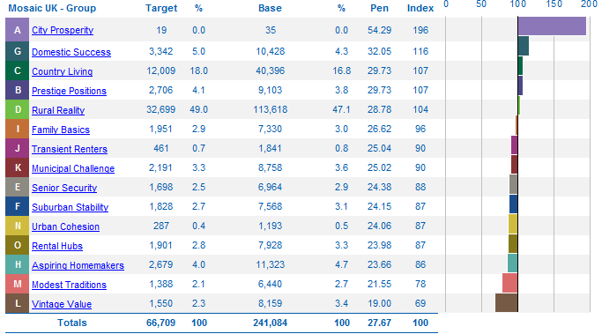

Appendix D (cont)
Library Members

The table below lists the groups considered to be mid to low earning and they account for 67% of the library membership.

Rural Reality | Householders living in inexpensive homes in village communities | 25,090
Aspiring Homemakers | Younger households settling down in housing priced within their means | 3,588
Municipal Challenge | Urban renters of social housing facing an array of challenges | 3,342
Family basics | Families with limited resources who have to budget to make ends meet | 2,922
Rental Hubs | Educated young people privately renting in urban neighbourhoods | 2,083
Vintage Value | Elderly people reliant on support to meet financial or practical needs | 1,778
Transient Renters | Single people privately renting low cost homes for the short term | 593
 |  | 39,396

Appendix D (cont)
Library Members

Dot Map Showing Library Member Locations

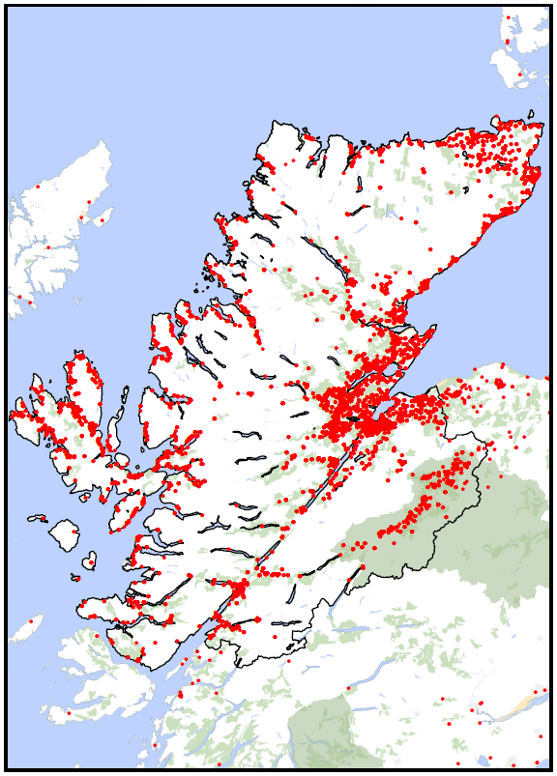

Appendix E
Leisure and Library Membership by Highland Council Electoral Ward

The table below provides a breakdown of library and leisure memberships by Council Electoral Ward.

Highland Electoral Wards | No. Of High Life Subscription Members | % Of High Life Subscription Members | No. Of High Life Budget Members | % Of High Life Budget Members | Total No. Of ALL High Life Members | Total % Of ALL High Life Members | No. Of Highland Library Members | % Of Highland Library Members | Total Population | % Of Population that have a High Life Membership | % Of Population that have a Library Membership
Aird and Loch Ness | 2,002 | 4.10% | 304 | 2.24% | 2,306 | 3.69% | 3,531 | 5.22% | 11,970 | 19.26% | 29.50%
Badenoch and Strathspey | 4,535 | 9.28% | 403 | 2.96% | 4,938 | 7.90% | 4,566 | 6.75% | 15,027 | 32.86% | 30.39%
Black Isle | 2,806 | 5.74% | 312 | 2.29% | 3,118 | 4.99% | 3,558 | 5.26% | 10,840 | 28.76% | 32.82%
Caol and Mallaig | 1,782 | 3.65% | 204 | 1.50% | 1,986 | 3.18% | 2,596 | 3.84% | 9,122 | 21.77% | 28.46%
Cromarty Firth | 3,104 | 6.35% | 1,750 | 12.87% | 4,854 | 7.77% | 3,292 | 4.87% | 12,893 | 37.65% | 25.53%
Culloden and Ardersier | 2,324 | 4.75% | 679 | 4.99% | 3,003 | 4.81% | 3,239 | 4.79% | 11,639 | 25.80% | 27.83%
Dingwall and Seaforth | 3,134 | 6.41% | 658 | 4.84% | 3,792 | 6.07% | 3,394 | 5.02% | 12,127 | 31.27% | 27.99%
East Sutherland and Edderton | 1,213 | 2.48% | 571 | 4.20% | 1,784 | 2.86% | 2,442 | 3.61% | 8,046 | 22.17% | 30.35%
Eilean a'Cheo | 1,834 | 3.75% | 211 | 1.55% | 2,045 | 3.27% | 3,867 | 5.72% | 11,527 | 17.74% | 33.55%
Fort William and Ardnamurchan | 2,242 | 4.59% | 570 | 4.19% | 2,812 | 4.50% | 3,479 | 5.14% | 11,863 | 23.70% | 29.33%
Inverness Central | 2,333 | 4.77% | 1,948 | 14.32% | 4,281 | 6.85% | 2,842 | 4.20% | 14,365 | 29.80% | 19.78%
Inverness Millburn | 1,716 | 3.51% | 394 | 2.90% | 2,110 | 3.38% | 2,063 | 3.05% | 8,707 | 24.23% | 23.69%
Inverness Ness-Side | 2,539 | 5.19% | 567 | 4.17% | 3,106 | 4.97% | 2,612 | 3.86% | 11,513 | 26.98% | 22.69%
Inverness South | 3,649 | 7.46% | 424 | 3.12% | 4,073 | 6.52% | 3,746 | 5.54% | 13,860 | 29.39% | 27.03%
Inverness West | 2,261 | 4.63% | 726 | 5.34% | 2,987 | 4.78% | 1,819 | 2.69% | 8,854 | 33.74% | 20.54%
Landward Caithness | 1,240 | 2.54% | 475 | 3.49% | 1,715 | 2.74% | 2,999 | 4.43% | 11,237 | 15.26% | 26.69%
Nairn | 2,382 | 4.87% | 685  Appendix E (cont)  Leisure and Library Membership by Highland Council Electoral Ward | 5.04% | 3,067 | 4.91% | 3,978 | 5.88% | 12,179 | 25.18% | 32.66%
North, West and Central Sutherland | 514 | 1.05% | 171 | 1.26% | 685 | 1.10% | 1,825 | 2.70% | 6,909 | 9.91% | 26.41%
Tain and Easter Ross | 2,109 | 4.31% | 763 | 5.61% | 2,872 | 4.60% | 2,765 | 4.09% | 9,442 | 30.42% | 29.28%
Thurso | 1,160 | 2.37% | 727 | 5.35% | 1,887 | 3.02% | 2,186 | 3.23% | 8,088 | 23.33% | 27.03%
Wester Ross, Strathpeffer and Lochalsh | 2,458 | 5.03% | 328 | 2.41% | 2,786 | 4.46% | 4,414 | 6.52% | 13,669 | 20.38% | 32.29%
Wick (Highland) | 1,064 | 2.18% | 616 | 4.53% | 1,680 | 2.69% | 1,931 | 2.85% | 7,828 | 21.46% | 24.67%
Proportion outside Highland | 485 | 0.99% | 114 | 0.84% | 599 | 0.96% | 518 | 0.77% | - - | - - | - -
Totals | 48,886 | 100.00% | 13,600 | 100.00% | 62,486 | 100.00% | 67,662 | 100.00% | 241,705 | 25.85% | 27.99%

Appendix E (cont)
Leisure and Library Membership by Highland Council Electoral Ward

The graphs below show the percentage uptake for each Ward of: all High Life subscriptions; High Life paid subscriptions; High Life Budget memberships; and Library Memberships.

Appendix E (cont)
Leisure and Library Membership by Highland Council Electoral Ward

Appendix F
Sport and Recreation Trust Association (Scotland) Leisure Membership

This appendix provides information on Sporta Scotland memberships.

The organisations who participated were:

Aberdeen  (Sport Aberdeen) | Kilmarnock Leisure  (The Galleon Centre)
Angus Council | North Ayrshire (K.A. Leisure)
Borders Sport & Leisure Trust | North Lanarkshire Leisure
East Dunbartonshire Leisure & Culture | Orkney (Pickaquoy Centre)
East Lothian (Enjoy Leisure) | Perth & Kinross (Live Active Leisure)
Edinburgh Leisure | Renfrewshire Leisure
Falkirk Community Trust | Shetland Recreational Trust
Glasgow Life | South Lanarkshire Leisure & Culture
Jedburgh Leisure Facilities Trust | Stirling (Active Stirling)
High Life Highland | West Dunbartonshire Leisure
Inverclyde Leisure | West Lothian Leisure
Inverness Leisure

Appendix F (cont)
Sport and Recreation Trust Association (Scotland) Leisure Membership

The table below shows the results of the analysis by Mosaic Profile Group. In it, the number of Sporta Scotland Leisure members are compared with the number of people in the Scottish population in each group. The following terms are used in the column headings:

- “Target” is the number of High Life members in each Mosaic Profile Group.
- “Base” is the Highland population in each Mosaic Profile Group.
- “Pen” is a percentage measure of the “target” column (number of High Life members) compared to the “base” column (Highland population).
- “Index” is a percentage measure of the “target %” column (number of High Life members) compared to the “base %” column (Highland population). An index of 100 means the percentage of members is equal to the percentage of that market segment in the Highland population. An index below 100 means the number of members is under represented. An index above 100 means the number of members over represented.

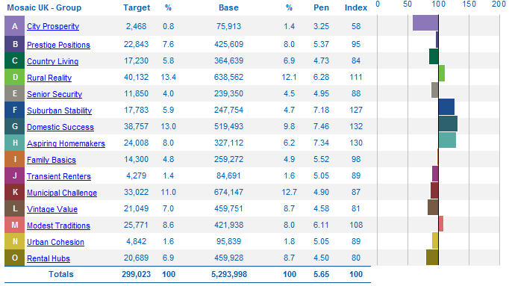

Appendix F (cont)
Sport and Recreation Trust Association (Scotland) Leisure Membership

The graph below shows the number of Sporta Scotland members in each Mosaic Profile Group in order of size.

The table below lists the groups considered to be mid to low earning and they account for 54% of the Sporta Scotland membership.

Rural Reality | Householders living in inexpensive homes in village communities | 40,132
Municipal Challenge | Urban renters of social housing facing an array of challenges | 33,022
Aspiring Homemakers | Younger households settling down in housing priced within their means | 24,008
Vintage Value | Elderly people reliant on support to meet financial or practical needs | 21,049
Rental Hubs | Educated young people privately renting in urban neighbourhoods | 20,689
Family Basics | Families with limited resources who have to budget to make ends meet | 14,300
Urban Cohesion | Residents of settled urban communities with a strong sense of identity | 4,842
Transient Renters | Single people privately renting low cost homes for the short term | 4,279
 |  | 162,321

Appendix F (cont)
Sport and Recreation Trust Association (Scotland) Leisure Membership

The table below re-lists the Mosaic Profile Groups ranked by the “Index” column.

