HIGH LIFE HIGHLAND  REPORT TO BOARD OF DIRECTORS  19 March 2015 | AGENDA ITEM REPORT No HLH /15

Performance Report - Report by Chief Executive

Summary

The purpose of this report is to present performance information for the period October 2014 to February 2015.

It is recommended Directors:-

- comment on the report and agree that the overall health check on the company for the period is assessed as green;
- note the performance of the company against its business plan objectives;
- agree to remit the task of developing new performance indicators based on the work by the Board at its ten year strategy workshop to the Finance and Audit Committee;
- note the positive contribution made by HLH to the Council’s annual survey of performance and attitudes; and
- note that the data protection policy has been reviewed and that no changes were necessary.

1. | Business Plan Contribution
1.1 | This report supports all the Business Outcomes from the High Life Highland (HLH) Business Plan:  1. A positive company image  2. A growing company  3. Delivery of the contract with THC  4. Increased awareness of our products and services  5. Increased customer satisfaction  6. Increased financial sustainability  7. Increased internal collaboration  8. Increased staff satisfaction  9. Safety & environmental compliance
2. | Background
2.1 | At the September 2012 meeting Directors agreed that its high level performance monitoring should focus on ten business critical areas.
3. | Summary of performance
3.1 | Seven of the ten indicators have been rated as being on target with none being rated amber or red. Two of the indicators which are reviewed six-monthly/annually have not been rated and one has not been rated because of a change of reporting process with THC. Appendix A contains the summary of performance against the performance indicators. Appendix B contains further information on performance indicator vii, leisure centre customer numbers. Appendices C and D contain information on THC’s annual survey of performance and attitudes 2014.
4. | Review of KPI/Business Outcome Measures
4.1 | As part of its ten year planning work the Board considered KPI/Business outcome measures. Recommendation three from the workshop was: “The majority of HLH KPIs and Business Outcomes remain relevant and important in measuring the performance and impact of the organisation. Further or replacement KPI/Business Outcome Measures to be considered by the Board for 2015-2018 would include:  - % of Earned Income (outwith the existing THC SDC);  - Customer satisfaction (the opportunity to conduct an annual survey at HLH or business unit level);  - Visitor/User Numbers of HLH services;  - Stakeholder Relations (this would be a qualitative but important measure given the aims and aspirations of the organisation going forward, and based on a stakeholder engagement plan);  - Financial sustainability measure (to be further defined); and  - The opportunity to express Business Outcomes in terms of the difference or contribution HLH will make – health, economy, inclusion – which will be helpful particularly in engaging at a Community Planning Partnership level.”
4.2 | It is recommended that Directors agree to remit the task of developing new performance indicators based on the work by the Board at its ten year strategy workshop to the Finance and Audit Committee.
5. | THC’s annual survey of performance and attitudes
5.1 | THC’s annual survey of performance and attitudes is carried out independently by the UHI Centre for Remote and Rural Studies. It surveys the Citizen’s Panel of 2,752 individuals who have been selected to be representative of the Highland population. In 2014 there were 1,148 responses to the survey.
5.2 | The 2014 survey assessed satisfaction ratings for 46 Council services. As can be seen in Appendix C, the survey placed all of the HLH services which form part of the survey in the top 22. All except one of HLH’s service areas sustained or achieved an increased net satisfaction rate compared with 2013. Directors should note that the services most directly attributable to HLH are libraries, swimming pools and other sports facilities. Of the twenty Council funded museums HLH provides the two regional museums. The table below extracts the information relevant to HLH.
  Rank | Service | 2014 | 2013 | 2012 | 2011 | 2010
   |  | % | % | % | % | %
  1. | Libraries | 84 | 84 | 81 | 89 | 78
  9. | Swimming pools | 71 | 65 | 64 | 62 | 53
  10. | Other sports facilities | 70 | 62 | 69 | 72 | 52
  14. | Museums | 64 | 74 | 64 | 79 | 59
  22. | Community learning/adult education | 51 | 39 | 47 | 41 | 32
5.3 | Appendix D shows rankings where respondents were invited to prioritise the five services from the list of 46 they regarded as being the most important to them. The report gives further information where services are valued by 10% of respondents or more and provides the following analysis for HLH services:  “Libraries are in the top 5 of 20% of the sample (19% in 2013; 16% in 2012; 18% in 2011; 22% in 2010). But whereas libraries are found in the top 5 of 29% of students, 25% of people who are retired, 24% of people unemployed, and 24% of people who are unable to work, it is in the top of 14% of people who are employed.”  “Swimming pools are listed in the top 5 of 16% of the entire sample (15% in 2013; 14% in 2012; 18% in 2011; 22% in 2010) while other sports facilities are listed by 13% (13% in 2013; 11% in 2012 and 2011; 12% in 2010). But when one looks at the categories of respondents it is noticeable that:  - some 30% of those aged 16 to 24 and a same percentage of those aged 25 to 44 list swimming pools as a top 5 service compared with 10% of those aged 45-64 and 4% of those aged 65+;  - some 26% of those aged 16 to 24 and 20% of those aged 25 to 44 list other sports facilities as a top 5 service compared with 7% of those aged 45-64 and 3% of those aged 65+;  - of people with school aged children 24% list swimming pools and 16% list other sports facilities in their top 5 compared with 9% and 6% respectively for those who have no school aged children.”
5.4 | The full report can be seen by following the link in Appendices C and D. It is recommended that Directors note the positive contribution made by HLH to the Council’s annual survey of performance and attitudes.
6. | Data Protection Policy Review
6.1 | The Data Protection policy was reviewed by Heads of Service in December 2014. It is recommended that the Directors note that the data protection policy has been reviewed and that no changes were necessary. A further review is schedule for two years’ time.
7. | Implications
7.1 | Resource Implications - there are no new resource implications arising from the recommendations of this report.
7.2 | Legal Implications - there are no new legal implications arising from the recommendations of this report.
7.3 | Risk Implications - there are no new risk implications arising from the recommendations of this report.

Recommendation

It is recommended Directors:-

- comment on the report and agree that the overall health check on the company for the period is assessed as green;
- note the performance of the company against its business plan objectives;
- agree to remit the task of developing new performance indicators based on the work by the board at its ten year strategy workshop to the Finance and Audit Committee;
- note the positive contribution made by HLH to the Council’s annual survey of performance and attitudes; and
- note that the data protection policy has been reviewed and that no changes were necessary.

Signature:

Designation: Chief Executive

Date: 20 February 2015
Appendix A
Business Critical Indicators

*RAG
Red = No Significant Progress
Amber = Some Slippage
Green = On Target

Business Critical Area/PI | Reporting Frequency | Performance Assessment Method | RAG* Rating December 2013 | RAG* Rating Apr-Jun 2014 | RAG* Rating Jul-Sep 2014 | RAG* Rating Oct-Feb 2015 | Summary of Performance:  Oct 2014 to Feb 2015
- High level relationship with THC | Annual | Annual meeting, with one of the agenda items to be “assessment of the relationship between HLH and THC”, between:  - the HLH chair, vice chair and the chair of the HLH Finance and Audit Committee; and  - THC’s Leader and Budget Leader | - | G | - | G | The HLH Chair has assessed this indicator as being on target. The budget discussions have been robust and have resulted in a fair outcome for HLH. HLH has been invited to join the Community Planning Partnership.
- Delivery of the SDC with THC | Twice per year | Agreement of THC’s Culture and Leisure Contracts Scrutiny Sub-Committee that HLH has met the terms of the SDC. | - | - | - | - | Now reporting to THC’s ECAS committee. The report to the November ECAS committee initiated the system but did not review HLH’s performance. The next scheduled report to the ECAS Committee is May 2015.

Business Critical Area/PI | Reporting Frequency | Performance Assessment Method | RAG* Rating December 2014 | RAG* Rating Apr-Jun 2014 | RAG* Rating Jul-Sep 2014 | RAG* Rating Oct-Feb 2015 | Summary of Performance:  Oct 2014 to Feb 2015
- Delivery of business plan objectives | Quarterly | Reporting all actions which have been RAG rated red with reasons (and remedial action if appropriate). | G | G | G | G | The overall rating for performance against the business plan has been assessed as being on target. Of the 608 operational plan actions:  48 are complete  539 are green  21 are amber  0 are red
- Financial monitoring | Quarterly | Financial monitoring reports. RAG rating (Red/Amber/Green) definition:  - Red = Delivery of SDC over budget  - Amber = Delivery of SDC on budget  - Green = Delivery of SDC within budget | A | A | A | G | It is projected that the SDC will be delivered within budget.
- Health and safety | Annual/  Quarterly | Annual external assessment and report which is agreed by the HLH board.  Quarterly review of RIDDOR reportable accidents/incidents. | G | G  G | G | G | Annual report was considered by the HLH board on 23 April 2014.The H&S Strategic Group continues to meet quarterly and it reviews RIDDOR reports.  The annual external audit has taken place and is being actioned. The next annual report is scheduled for the June 2015 Board meeting.
Business Critical Area/PI | Reporting Frequency | Performance Assessment Method | RAG* Rating December 2014 | RAG* Rating Apr-Jun 2014 | RAG* Rating Jul-Sep 2014 | RAG* Rating Oct-Feb 2015 | Summary of Performance:  Oct 2014 to Feb 2015
- Risk manage-ment | Annual | Annual risk report agreed by the HLH board.  (The risk register is reviewed quarterly by the finance and audit committee) | G | G  G | G | G  G | The Annual Risk Register Update report is scheduled for the March 2015 HLH Board Meeting. The Finance and Audit Committee continues to consider the risk register quarterly.
- Leisure centre customer numbers | Quarterly | Comparison graph or trend analysis to the same period in the preceding year(s). | G | G | G | G | See Appendix B

Business Critical Area/PI | Reporting Frequency | Performance Assessment Method | RAG* Rating December 2014 | RAG* Rating Apr-Jun 2014 | RAG* Rating Jul-Sep 2014 | RAG* Rating Oct-Feb 2015 | Summary of Performance:  Oct 2014 to Feb 2015
- Quality of service provision | Annual | Annual board report on:  Internal assessment of quality:  - customer survey for each of the nine areas of work.  - review of comments and complaints  External assessments of quality e.g.:  - THC’s annual public performance survey.  - Museum Accreditation (takes place every five years)  - The Public Library Quality Improvement Matrix  - HMIe inspection of Community Learning and Development | G | G | - | G | See report above section five above and Appendix C.
- Staff satisfaction | Bi - Annual | Bi - Annual staff survey and report to the HLH board which includes a year on year comparison of the overall rating of staff satisfaction. | - | - | - | - | NA – Bi Annual Indicator. The 2014/15 survey is underway with a submission deadline of 27 February 2015.
Business Critical Area/PI | Reporting Frequency | Performance Assessment Method | RAG* Rating December 2014 | RAG* Rating Apr-Jun 2014 | RAG* Rating Jul-Sep 2014 | RAG* Rating Oct-Feb 2015 | Summary of Performance:  Oct 2014 to Feb 2015
- Value for money | Annual | There are three areas of work which can be benchmarked nationally (and year on year) for value for money by calculating the cost per attendance. These are: Leisure Facilities; Libraries; and Museums. | - | G | - | - | NA – annual indicator.

Appendix B

High Life facilities – High Life card holder user numbers

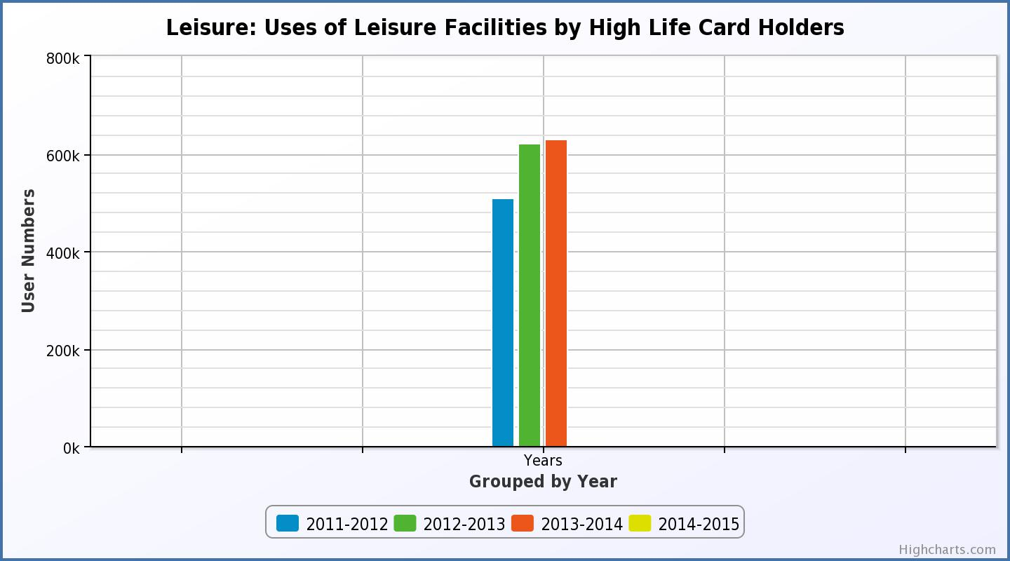

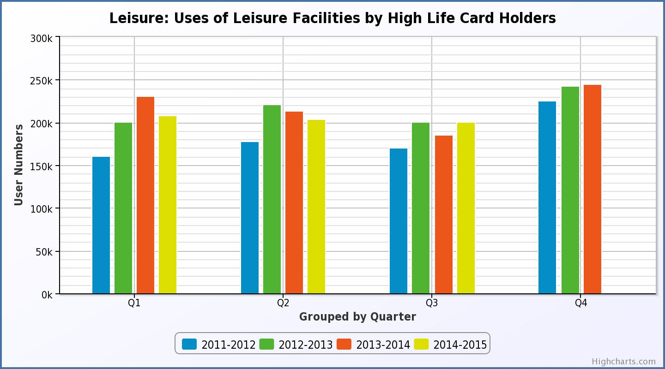

Use of Leisure Facilties by High Life members has been increasing. While the first two quarters this year shows a slight reduction compared with the same quarters in 2013/14, use increased again in quarter three. High Life memberships in January 2015 were higher than they have ever been at 11,259 which was 406 more than they were in January 2014.

Appendix C
Extract from THC’s Annual Survey of Performance and Attitudes 2014
http://www.highland.gov.uk/download/downloads/id/12042/annual_survey_of_performance_and_attitudes_2014 (opens .pdf file)

Views on The Highland Council’s Services: The Net Satisfaction Rate | Respondents Using Service  % | 2014 % | 2013 % | 2012 % | 2011 % | 2010 %
- Libraries | 56 | 84 | 84 | 81 | 89 | 78
- Walking routes e.g. Great Glen Way | 35 | 84 | 84 | 80 | 83 | 77
- Payment of Council Tax | 63 | 81 | 87 | 82 | 82 | 78
- Public Parks and other open spaces | 65 | 80 | 76 | 73 | 82 | 63
- Recycling facilities | 89 | 76 | 75 | 72 | 66 | 61
- Refuse/bin collection | 92 | 75 | 78 | 72 | 73 | 74
- Council Service Points | 41 | 73 | 79 | 74 | 83 | 74
- Registrars for Births, Deaths & Marriages | 25 | 73 | 67 | 73 | 80 | 74
- Swimming pools | 38 | 71 | 65 | 64 | 62 | 53
- Other sports facilities | 30 | 70 | 62 | 69 | 72 | 52
- Countryside ranger service | 21 | 69 | 69 | 67 | 71 | 61
- Primary education | 20 | 68 | 59 | 65 | 64 | 74
- Street lighting | 77 | 67 | 67 | 64 | 69 | 63
- Museums | 35 | 64 | 74 | 64 | 79 | 59
- Burials and cremations | 21 | 63 | 61 | 68 | 68 | 63
- Secondary education | 21 | 61 | 60 | 57 | 63 | 60
- Council Service Centre | 26 | 58 | n/a | n/a | n/a | n/a
- School meals | 19 | 57 | 54 | 45 | 60 | 45
- Pre-school services | 15 | 54 | 58 | 62 | 65 | 63
- School transport | 15 | 54 | 41 | 33 | 45 | 51
- Environmental Health Service | 24 | 52 | 54 | 55 | 53 | 33
- Community learning/adult education | 20 | 51 | 39 | 47 | 41 | 32
- Cycling paths | 27 | 45 | 44 | 50 | 65 | 36
- Street cleaning | 79 | 44 | 47 | 43 | 37 | 30
- Housing information and advice | 17 | 40 | 43 | 30 | 30 | 18
- Services to protect children from harm | 13 | 39 | 42 | 28 | 37 | 24
- Breakfast and after school clubs | 11 | 39 | 40 | 24 | 46 | 28
- Community Occupational Therapy | 15 | 39 | 32 | 30 | 28 | 17
- Trading Standards | 18 | 38 | 46 | 41 | 42 | 38
- Services to protect adults at risk from harm | 13 | 36 | 30 | 28 | 25 | 18
- Advice on Benefits | 12 | 35 | 35 | 30 | 34 | 20
- Dealing with flooding | 45 | 34 | 27 | 18 | 28 | 21
- Economic development / business support | 17 | 30 | 31 | 35 | 27 | 10
- Public conveniences | 62 | 30 | 28 | 19 | 38 | 18
- Planning applications & building warrants | 30 | 23 | 19 | -2 | 2 | -4
- Gaelic Pre-school services | 7 | 20 | 27 | 21 | n/a | n/a
- Residential homes for disabled/elderly people | 17 | 19 | 24 | 21 | 32 | 11
- Services to reduce offending | 11 | 18 | 7 | -13 | -9 | -27
- Gaelic Primary education | 8 | 17 | 14 | 24 | n/a | n/a
- Winter road maintenance | 81 | 17 | 14 | 0 | -9 | -23
- Pavement maintenance | 77 | 15 | 21 | 16 | 8 | 6
- Gaelic community learning/adult education | 9 | 12 | 1 | 15 | n/a | n/a
- Care at home services | 16 | 11 | 33 | 23 | 25 | 23
- Planning for future land use (Local Plan) | 31 | 8 | 14 | 3 | 3 | -9
- Gaelic Secondary education | 7 | 8 | 7 | 14 | n/a | n/a
- Road repairs and pot holes | 86 | -56 | -61 | -59 | -55 | -57

Appendix D
Extract from THC’s Annual Survey of Performance and Attitudes 2014
http://www.highland.gov.uk/download/downloads/id/12042/annual_survey_of_performance_and_attitudes_2014 (opens .pdf file)

Importance of Services to Respondents: Appearance in Respondents’ Top Five Services | 2014  % | 2013  % | 2012  % | 2011  % | 2010 %
- Road repairs and pot holes | 57 | 57 | 61 | 63 | 48
- Refuse/bin collection | 47 | 41 | 48 | 50 | 45
- Winter road maintenance | 43 | 48 | 50 | 54 | 49
- Recycling facilities | 30 | 32 | 32 | 39 | 37
- Public Parks and other open spaces | 21 | 19 | 18 | 17 | 16
- Libraries | 20 | 19 | 16 | 18 | 22
- Primary education | 19 | 19 | 22 | 24 | 27
- Secondary education | 18 | 18 | 18 | 20 | 23
- Pavement maintenance | 16 | 12 | 14 | 15 | 12
- Swimming pools | 16 | 15 | 14 | 16 | 18
- Street cleaning | 15 | 16 | 17 | 16 | 14
- Other sports facilities | 13 | 13 | 11 | 11 | 12
- Public conveniences | 11 | 8 | 11 | 10 | 7
- Council Service Points | 11 | 6 | 7 | 9 | 8
- Cycle paths | 9 | 10 | 9 | 8 | 8
- Street lighting | 9 | 10 | 8 | 9 | 8
- Care at home services | 8 | 9 | 10 | 9 | 11
- Walking routes e.g. Great Glen Way | 8 | 8 | 8 | 8 | 8
- Planning for future land use (Local Plan) | 8 | 7 | 10 | 8 | 9
- Payment of Council Tax | 6 | 8 | 6 | 8 | 7
- Pre-school services | 6 | 8 | 6 | 7 | 7
- Residential homes for disabled/elderly people | 6 | 8 | 7 | 8 | 14
- School meals | 5 | 3 | 6 | 4 | 4
- Services to protect children from harm | 5 | 7 | 6 | 8 | 11
- Dealing with flooding | 5 | 6 | 6 | 4 | 4
- Planning applications and building warrants | 5 | 5 | 6 | 6 | 8
- School transport | 5 | 4 | 6 | 5 | 7
- Museums | 4 | 6 | 4 | 4 | 5
- Environmental Health Service | 4 | 3 | 3 | 3 | 5
- Advice on Benefits | 4 | 3 | 2 | 4 | 3
- Community learning/adult education | 3 | 4 | 3 | 4 | 5
- Services to protect adults at risk of harm | 3 | 3 | 3 | 4 | 5
- Housing information and advice | 3 | 4 | 4 | 5 | 4
- Council Service Centre | 3 | n/a | n/a | n/a | n/a
- Economic development / business support | 2 | 2 | 2 | 3 | 3
- Services to reduce offending | 2 | 2 | 2 | 3 | 5
- Community Occupational Therapy | 2 | 1 | 2 | 2 | 3
- Breakfast and after school clubs | 2 | 2 | 1 | 1 | 3
- Burials and cremations | 2 | 2 | 0.9 | 1 | 2
- Registrars for Births, Deaths and Marriages | 2 | 1 | 1 | 1 | 1
- Trading Standards | 2 | 1 | 1 | 1 | 1
- Countryside ranger service | 1 | 2 | 1 | 2 | 3
- Gaelic primary education | 1 | 1 | 0.7 | n/a | n/a
- Gaelic secondary education | 0.6 | 0.7 | 1 | n/a | n/a
- Gaelic pre-school services | 0.5 | 2 | 0.8 | n/a | n/a
- Gaelic community learning/adult education | 0.5 | 0.7 | 1 | n/a | n/a

