HIGH LIFE HIGHLAND  REPORT TO BOARD OF DIRECTORS  15 June 2017 | AGENDA ITEM 10 REPORT No HLH10/17

Performance Report - Report by Chief Executive

Summary

The purpose of this report is to present performance information for the period January to March 2017.

It is recommended Directors:-

- comment on the report and agree that the overall health check on the Company for the period is assessed as green;
- note that the delivery of the business plan is assessed as green; and
- note that the number of customer visits has grown by an average of 10% per year over the past three years and in 2016/17 were 6,689,578.

1. | Business Plan Contribution
1.1 | This report supports all the Business Outcomes from the High Life Highland (HLH) Business Plan:  - To advance sustainable growth and financial sustainability  - Deliver the Service Delivery Contract with THC  - Improving staff satisfaction  - Improving customer satisfaction  - A positive company image  - Services designed around customers and through market opportunities  - Sustain a good health and safety performance  - A trusted partner
2. | Background
2.1 | At its meeting held on 19 March 2015, the HLH Board agreed to remit the task of developing new performance indicators based on the work by the Board at its ten year strategy workshop to the Finance and Audit Committee. At its meeting held on 26 March 2015, the Finance and Audit Committee set the performance indicators; and agreed that reporting on the delivery of the business outcomes would be by exception (i.e. reporting where managers had RAG rated the actions “red – no significant progress”). At its meeting held on 20 August 2015, the Board requested trend information for numeric performance indicators.

3. | Summary of Performance
3.1 | Appendix A contains a summary of performance against the performance indicators along with trend information for numeric PIs. There are eleven performance indicators scheduled for assessment at the June 2017 Board meeting. Nine have been RAG rated as “green”; one “amber” and one “red”. There is information on the PIs which have been RAG rated amber and red below.
3.2 | The High Life subscription cancellation rate was 3.83% and was RAG rated amber. While it could be argued that this is still a low cancellation rate, a member of staff has been dedicated to administering High Life card subscriptions which includes monitoring and managing cancellations. The task also involves contacting members to provide an analysis of the reasons for cancellations and as a retention mechanism. The number of High Life subscriptions increased during 2016/17 so the number of new subscriptions outweighed the number of cancellations.
3.3 | The staff absence rate for quarter four 2016/17 was RAG rated “red”. Please see the Human Resources report elsewhere on this agenda for further information.
4. | Delivery of Business Outcomes
4.1 | The Business Plan 2015-19 was agreed by the Board at its March 2015 meeting. The Business Plan identified eight business outcomes and the approach which the Company would take to deliver them. Operational plans were then developed for each of the nine HLH areas of work which are RAG rated every quarter.
4.2 | The RAG ratings of the operational plans has identified that delivery of the Business Plan is on target. Four of the nine areas of HLH work RAG rated all of the actions “green – on target” or complete; one area of work RAG rated one action as “amber – some slippage”; two areas of work RAG rated two actions as “amber - some slippage”; and two areas of work RAG rated three as “amber – some slippage”. The Board has agreed that reporting on the delivery of the business outcomes would be by exception (i.e. reporting where managers had RAG rated the actions “red – no significant progress”) and there have been no actions which have been RAG rated “red” in quarter four 2016/17.
5. | Performance Indicator for More Detailed Consideration
5.1 | The HLH Board has asked that one of the performance indicators be considered in greater detail at each board meeting. This report contains further information on customer numbers which was set as a performance indicator for business outcome four - improving customer satisfaction.
5.2 | Customer numbers have been increasing year on year since HLH was established (October 2011) as can be seen in the graph below (the 2016/17 bar shows Inverness Leisure customers separately for comparative purposes). The average customer number increase over the past three years (excl. Inverness Leisure) has been 10% or 0.5M per year.
5.3 | A breakdown of customer numbers by HLH areas of work for 2015/16 and 2016/17 can be seen in Appendix B. Most areas have increased customer numbers and a summary is provided for each below.
5.4 | Adult Learning (Literacy, Numeracy and English for Speakers of Other Languages (ESOL) attendances have been recorded since April 2016. Prior to that, unique participants were reported. This new reporting has a better fit with the overall HLH customer numbers reporting. Annual comparisons of performance will be possible from this financial year onwards.
5.5 | Archives customer visits decreased by 32% in 2016/17. The more significant reduction is in “electronic customer engagements” resulting from a change in the way Facebook records engaged users, and a reduction in the use of the old Am Baile web site which was closed after a period of running in parallel with the new site. The gap in use between the old and new sites is beginning to close. The small reduction in footfall is due to a number of factors including staff vacancies, one of which required a temporary closure of a facility which has since been re-opened. It is anticipated that the greater focus on outreach activity and activities/events in archive centres which is being taken by staff will address this.
5.6 | Arts customer numbers have increased following the re-opening of the art gallery in Thurso in December 2015. Arts customer numbers are 2000 higher than they were before the gallery closed in January 2013 for refurbishment.
5.7 | Leisure customer visits have remained steady between the two years with decreases in customer visits to High Life Leisure facilities (-2%) and visitor attractions (-11%) being offset by increased visits to community centres (7%), town halls (26%) and the Highland Football Academy (48%). The reduction in visits to High Life Leisure facilities is more than accounted for by the closure for refurbishment of Thurso and Craig Maclean Leisure Centres which together account for 44,651 fewer customers (against an overall reduction of 28,589).
5.8 | Libraries customer visits in person and virtual visits have increased by 16% and 37% respectively. The increase in footfall has been driven by a number of factors, including the customer focus through customer service excellence, combining Alness Library and the Averon Leisure Centre, and an increase in the number of events which seek to attract additional customers (with attendances at events increasing from 219K in 2015/16 to 311K last year). There are an increasing number of on-line and electronic resources available such as newspapers, e-books, e-audio books and digital magazines as well as on-line reference and training courses such as the driving theory test, ICT and language learning.
5.9 | Museums customer numbers increased by 5% last year. This was due to an increase in “visits by other means” (33%) which includes contact with museums for research purposes, and access to on-line services. There was a 10% decrease in visits in person compared with the previous year. This is due to 2015/16 having been a particularly good year in which there were two popular exhibitions – Lego and the Great Scottish Tapestry. Both museums’ visitor numbers were second highest since records have been retained, second only to last years “bumper” year.
5.10 | Outdoor activities provision increased in 2016/17 with 894 activity days having been provided compared with 201 in the previous year. It should be noted that this is a count of full days provided, some of which include overnight stays and it is estimated that this is equivalent to in excess of 5,000 visits to a library, leisure centre, etc. This area of work is under development and expected to grow in the coming year.
5.11 | Sports Development grew its participant sessions by 12% in 2016/17. It is worth noting that it has increased the Active Schools programme participation by girls to a higher level than that of boys which is a unique achievement in Scotland and demonstrates the success of staff in reaching this target group.
5.12 | Youth Work attendances had a reduction in customer visits (-5%) in 2016/17. This reflects the fact that staff are increasingly focusing on engaging vulnerable young people through targeted and open access youth work provision. Youth Work has developed a standard approach to a partnership agreement with secondary schools and also refreshed its operational guidance to ensure that work is aligned with the Community Planning Partnership (CPP) commitments to tackling inequality. In 2017/18 Youth Work staff will focus on activity which contributes to closing the attainment gap, reducing health inequality and tackling social isolation.
6. | Implications
6.1 | Resource Implications – there are no additional resource implications arising from this report.
6.2 | Legal Implications - there are no new legal implications arising from this report.
6.3 | Risk Implications – there are no new risk implications arising from this report.

Recommendation

It is recommended Directors:-

- comment on the report and agree that the overall health check on the Company for the period is assessed as green;
- note that the delivery of the business plan is assessed as green; and
- note that the number of customer visits has grown by an average of 10% per year over the past three years and in 2016/17 were 6,689,578.

Designation: Chief Executive

Date: 29 May 2017
Appendix A
HLH Performance Indicators

Business Plan Outcome | Performance Indicator | Reporting Frequency | RAG* Rating Definition  (*Red/Amber/Green) | RAG Rating Q1 16/17 | RAG Rating Q2 16/17 | RAG Rating Q3 16/17 | RAG Rating Q4 16/17 | Summary of Quarter Four Performance
1. To advance sustainable growth and financial sustainability | 1. Financial monitoring. | Quarterly. | An assessment of the year end outturn where:  - Red = delivery of the SDC over budget above 2%.  - Amber = delivery of the SDC between break-even and 2% over budget.  - Green = delivery of SDC within budget. | Green | Green | Green | Green | The variance for the budget up to the end of quarter four was £234,907* so the SDC will be delivered within budget for financial year 2016/17. See the Finance Report elsewhere on this agenda for further information.  * Unaudited figure

Performance Indicator 1 - Financial monitoring, variance to budget per quarter.
See the Finance Report elsewhere on this agenda for further information.
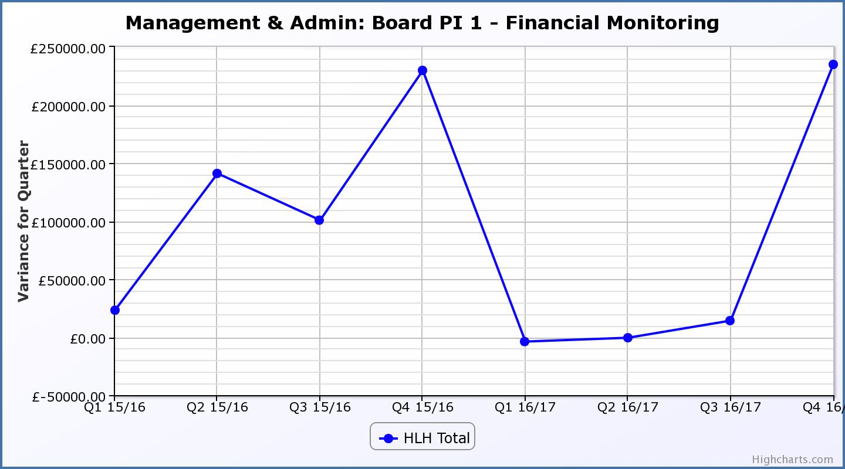
Business Plan Outcome | Performance Indicator | Reporting Frequency | RAG Rating Definition | RAG Rating Q1 16/17 | RAG Rating Q2 16/17 | RAG Rating Q3 16/17 | RAG Rating Q4 16/17 | Summary of Quarter Four Performance
1. To advance sustainable growth and financial sustainability (cont) | 2. Number of High Life subscriptions. | Quarterly. | - Red = more than 5% below target.  - Amber = up to 5% below target.  - Green = on or exceeds target. | Green | Green | Green | Green | The number of subscriptions each month during Q4 exceeded the target of 17,911 (the target has been set at the level required to achieve the High Life income target).

Performance Indicator 2 - Number of High Life Subscriptions
There are two graphs shown below. The first shows High Life card subscriptions excluding Inverness Leisure to allow historic comparison, the second, subscriptions for the whole charity. The increase in Q4 2016/17 is due to the re-opening of Thurso Leisure Centre following refurbishment and extension.

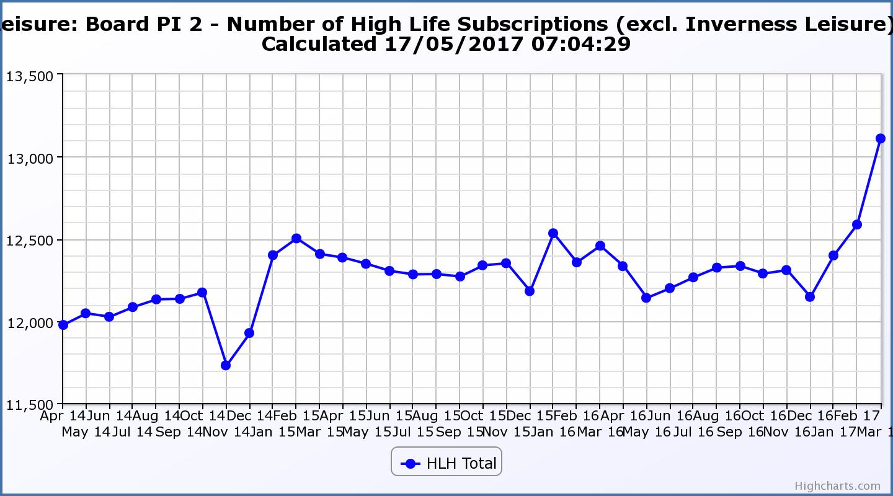
Performance Indicator 2 (contd) - Number of High Life Subscriptions
The graph below shows subscriptions for the whole charity including Inverness Leisure. The increase in April 2016 is due to the amalgamation of HLH and Inverness Leisure.

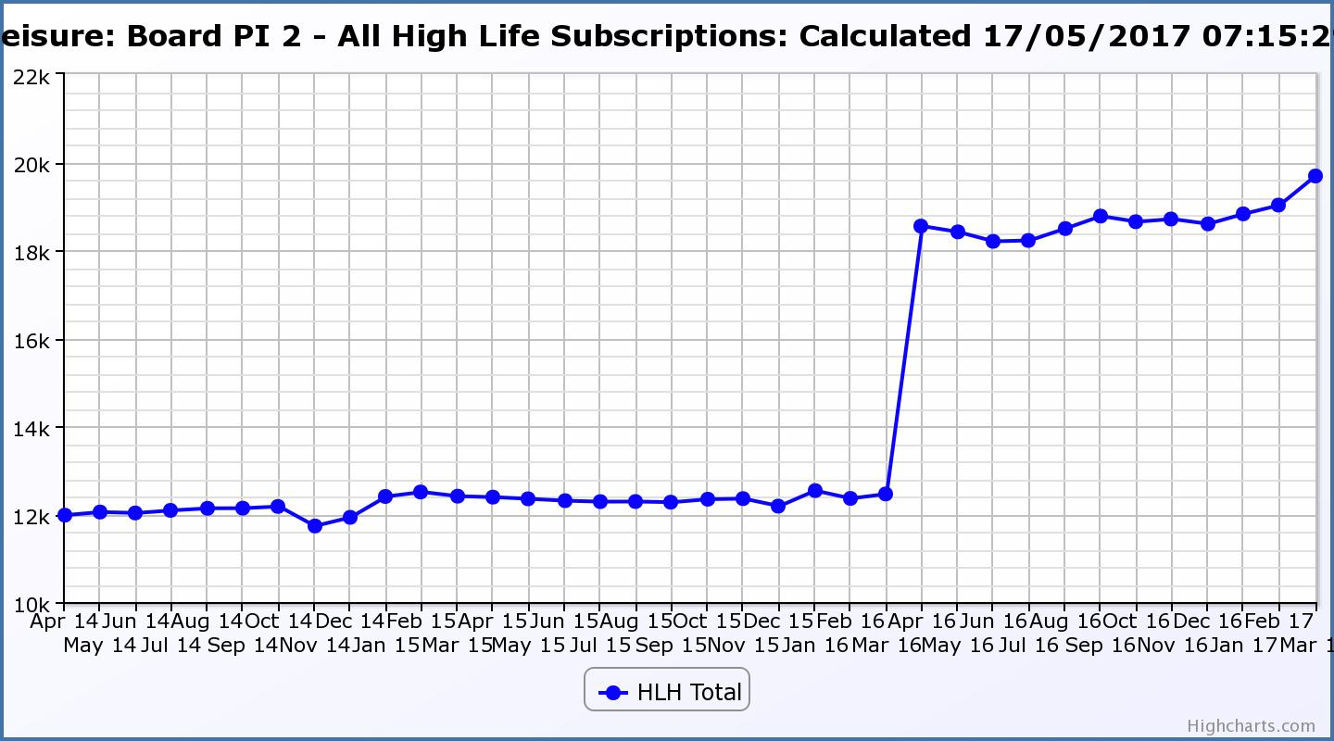

Business Plan Outcome | Performance Indicator | Reporting Frequency | RAG Rating Definition | RAG Rating Q1 16/17 | RAG Rating Q2 16/17 | RAG Rating Q3 16/17 | RAG Rating Q4 16/17 | Summary of Quarter Four Performance
1. To advance sustainable growth and financial sustainability (cont) | 3. High Life cancellation rate. | Quarterly. | - Red = cancellation rate above 6% of High Life memberships.  - Amber = cancellation rate is 3% - 6% of High Life memberships.  - Green = cancellation rate is up to 3% of High Life memberships. | Amber | Green | Green | Amber | The average High Life Direct Debit cancellation rate per month for Q4 was 3.33%.

Performance Indicator 3 - High Life Cancellation Rate
The graph below shows that there has been a slight (approx. 1%) increase in the cancellation rate over time. A member of staff has been dedicated to monitoring and managing cancellations and this includes contacting members to provide and analysis of the reasons for cancellation and as a retention mechanism.
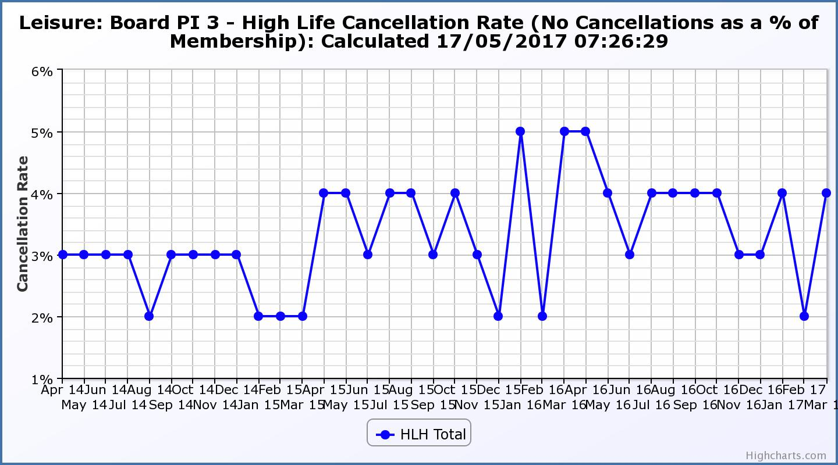

Business Plan Outcome | Performance Indicator | Reporting Frequency | RAG Rating Definition | RAG Rating Q1 16/17 | RAG Rating Q2 16/17 | RAG Rating Q3 16/17 | RAG Rating Q4 16/17 | Summary of Quarter Four Performance
2. Deliver the Service Delivery Contract with THC | 4. Delivery of the Service Delivery Contract (SDC) with the Highland Council (THC). | Six-monthly. | - Red = agreement of THC’s ECAS Committee that HLH has not met the terms of the SDC.  - Amber = agreement of THC’s ECAS Committee that HLH has met the terms of the SDC but has set some improvement targets.  - Green = agreement of THC’s ECAS Committee that HLH has met or exceeded the terms of the SDC. |  | Green |  |  | THC’s Education, Children and Adult Services Committee, at its meeting held on 26 October 2016, agreed that HLH met or exceeded the outcomes expected in the Service Delivery Contract with the Council for the period April to September 2016. The next report to THC’s ECAS Committee will be in August 2017 (later than originally planned because of changes to the Council meetings schedule).

Business Plan Outcome | Performance Indicator | Reporting Frequency | RAG Rating Definition | RAG Rating Q1 16/17 | RAG Rating Q2 16/17 | RAG Rating Q3 16/17 | RAG Rating Q4 16/17 | Summary of Quarter Four Performance
3. Improving staff satisfaction | 5. Staff turnover (resignations as a percentage of posts). | Quarterly. | - Red = more than 2%  - Amber = 1.7 to 2%  - Green = 1.6% or less | Green | Green | Green | Green | The average number of resignations per month as a percentage of posts in Q4 was 0.63%.

Performance Indicator 5 - Staff Turnover (resignations as a percentage of posts)

The graph below shows that resignations as a percentage of the number of posts and resignations have been consistent with previous years and continue to be low (1% equates to 10.6 staff).
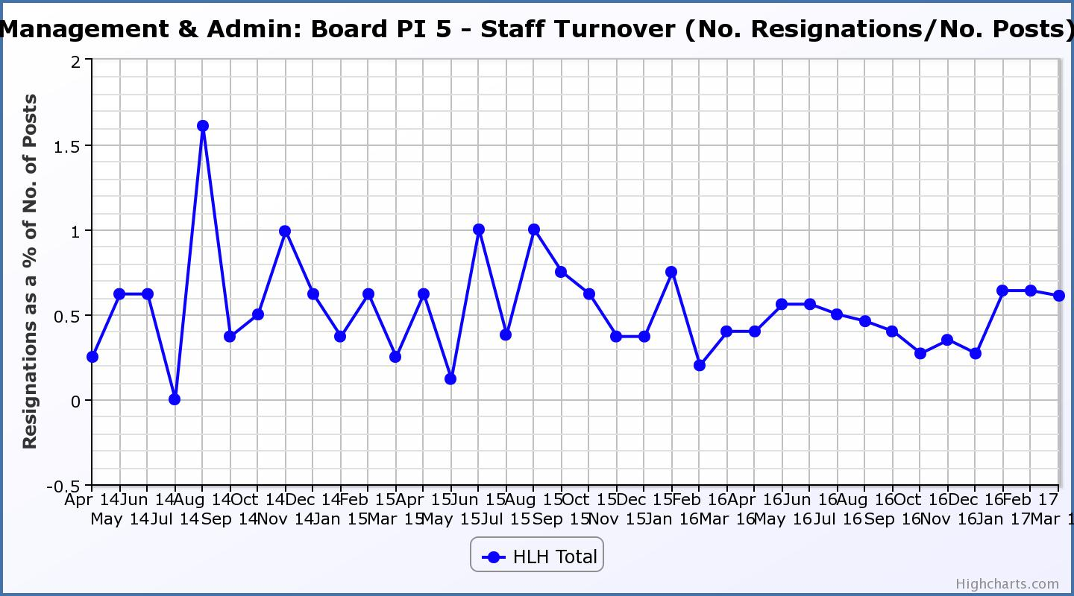
Business Plan Outcome | Performance Indicator | Reporting Frequency | RAG Rating Definition | RAG Rating Q1 16/17 | RAG Rating Q2 16/17 | RAG Rating Q3 16/17 | RAG Rating Q4 16/17 | Summary of Quarter Four Performance
3. Improving staff satisfaction (cont.) | 6. Staff absence rates. | Quarterly. | - Red = absence rate greater than 3.6%.  - Amber = absence rate between 3.4% and 3.6%.  - Green = absence rate 3.3% or less. | Amber | Green | Green | Red | The absence rate for Q4 was 3.83%. Please see the HR report elsewhere on this agenda for further information.

Performance Indicator 6 - Staff Absence Rates
The graph below tracks absence rates which were RAG rated amber for Q1 2016/17, green for Q2 and Q3 and red for Q4 2016/17.
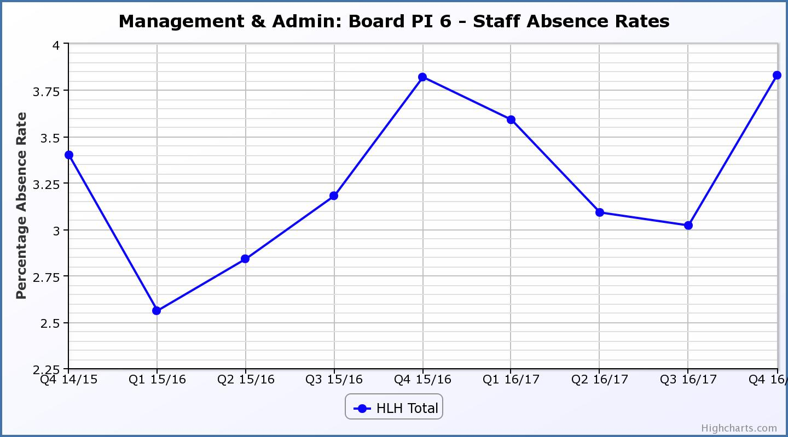
Business Plan Outcome | Performance Indicator | Reporting Frequency | RAG Rating Definition | RAG Rating Q1 16/17 | RAG Rating Q2 16/17 | RAG Rating Q3 16/17 | RAG Rating Q4 16/17 | Summary of Quarter Four Performance
4. Improving customer satisfaction | 7. Customer surveys. | Quarterly. | - Red = no staff surveys have been completed or scheduled.  - Amber = 4 to 8 of the HLH areas of work have completed or scheduled customer surveys.  - Green = all areas of HLH work have completed or scheduled customer surveys. | Green | Green | Green | Green | All areas of work included customer surveys in the operational plans for 2016/17.This PI was considered in more detail at the March 2017 HLH Board meeting.

Business Plan Outcome | Performance Indicator | Reporting Frequency | RAG Rating Definition | RAG Rating Q1 16/17 | RAG Rating Q2 16/17 | RAG Rating Q3 16/17 | RAG Rating Q4 16/17 | Summary of Quarter Four Performance
4. Improving customer satisfaction (cont) | 8. Customer Numbers. | Quarterly. | - Red = customer numbers are more than 5% lower than the corresponding quarter in the previous year.  - Amber = customer numbers are less than the corresponding quarter in the previous year.  - Green = customer numbers are the same as or have increased compared with the corresponding quarter in the previous year. | Green | Green | Green | Green | Customer Numbers (excl. Inverness Leisure) have increased from 1,447,690 in Q4 2015/16 to 1,672,589 in Q4 2016/17.  When Inverness Leisure customer numbers are included the Q4 total was 1,903,063.

Performance Indicator 8 - Customer Numbers
The graph below shows a year on year increase in customer numbers which are holding steady or increasing across all areas of HLH work. The second graph below shows customer numbers including Inverness Leisure.
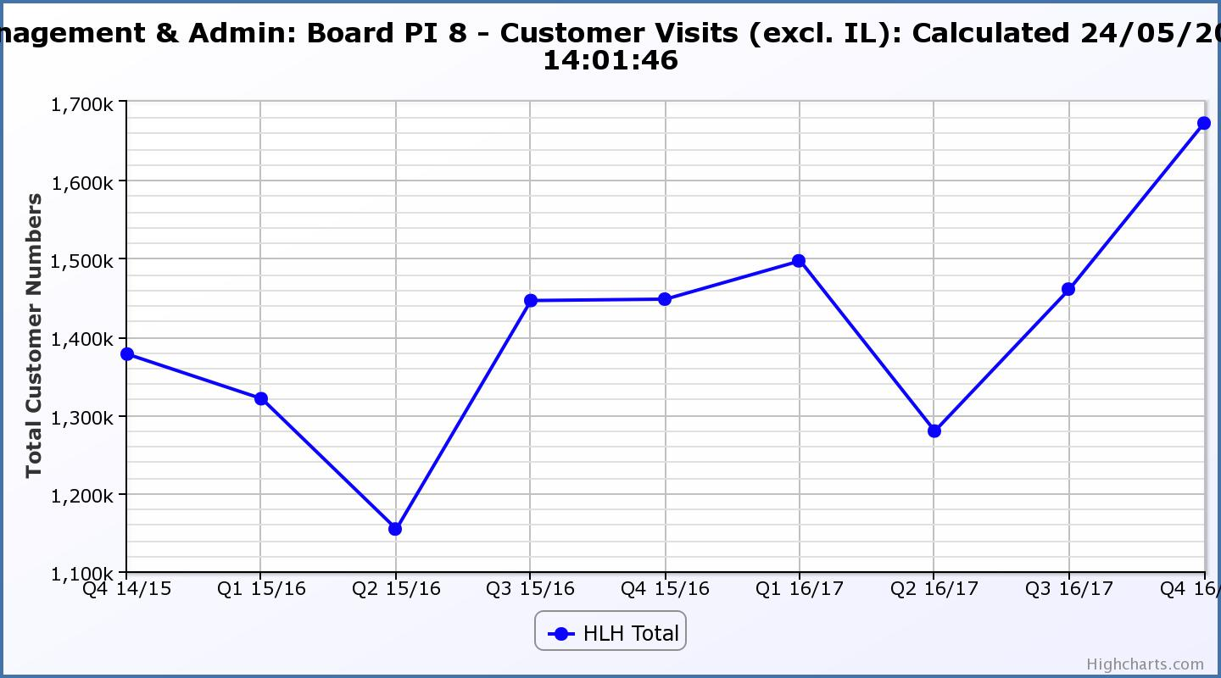
Performance Indicator 8 - Customer Numbers
This graph shows customer numbers including Inverness Leisure.
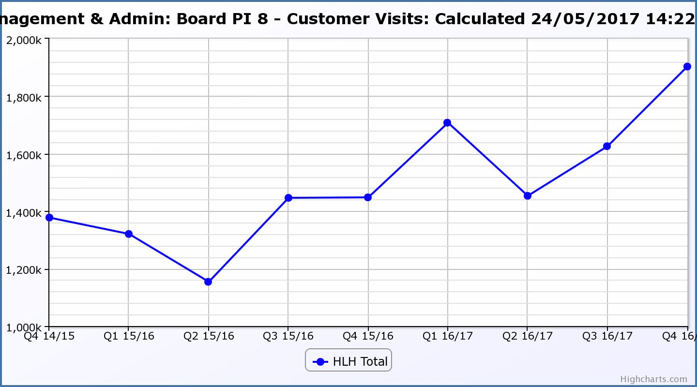
Business Plan Outcome | Performance Indicator | Reporting Frequency | RAG Rating Definition | RAG Rating Q1 16/17 | RAG Rating Q2 16/17 | RAG Rating Q3 16/17 | RAG Rating Q4 16/17 | Summary of Quarter Four Performance
5. A positive company image | 9.Media clippings. | Quarterly | - Red = number of negative press clippings outweigh neutral and positive.  - Amber = number of negative and neutral press clippings outweigh positive.  - Green = number of positive and neutral media clippings outweigh negative. | Green | Green | Green | Green | Positive media clippings for Q4 totalled 57 with there having been 31 which were neutral and 4 which were negative.

Performance Indicator 9 - Media Clippings
The following two graphs show the numbers of positive and neutral media clippings compared with negative. The positive and neutral outweigh the negative.

Business Plan Outcome | Performance Indicator | Reporting Frequency | RAG Rating Definition | RAG Rating Q1 16/17 | RAG Rating Q2 16/17 | RAG Rating Q3 16/17 | RAG Rating Q4 16/17 | Summary of Quarter Four Performance
5. A positive company image (cont.) | 10. Formal complaints. | Quarterly. | - Red = 21 or more complaints per quarter.  - Amber = 11 to 20 complaints per quarter.  - Green = 10 complaints or fewer per quarter. | Green | Green | Green | Green | There were two complaints received during Q4 2016/17.

Performance Indicator 10 - Formal Complaints
The graph below shows the number of complaints which continue to be very low in relation to customer numbers.

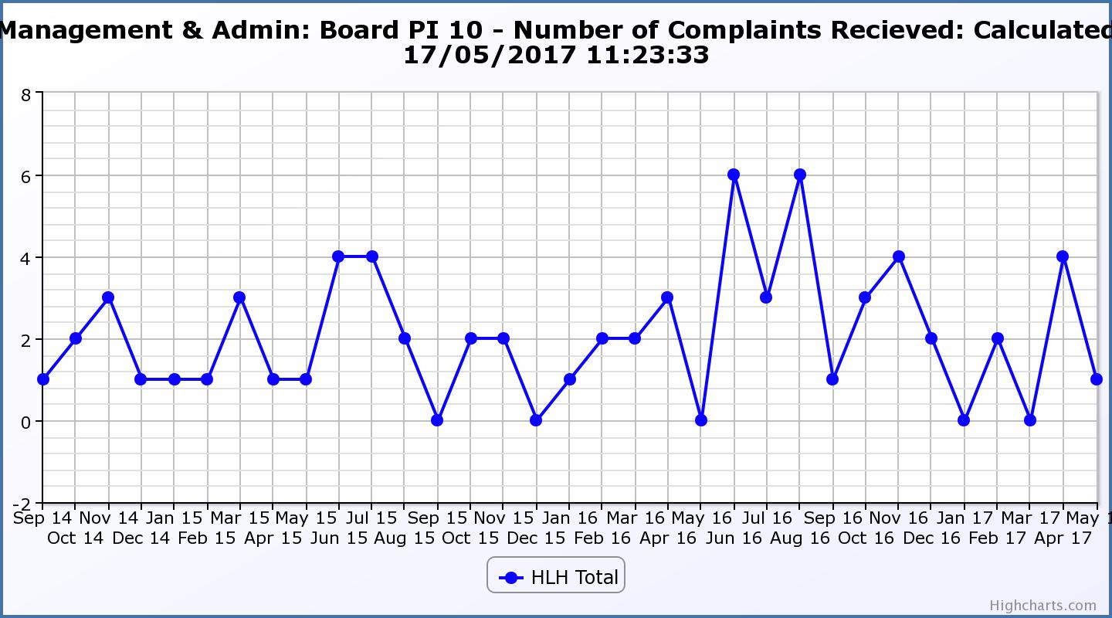
Business Plan Outcome | Performance Indicator | Reporting Frequency | RAG Rating Definition | RAG Rating Q1 16/17 | RAG Rating Q2 16/17 | RAG Rating Q3 16/17 | RAG Rating Q4 16/17 | Summary of Quarter Four Performance
7. Sustain a good health and safety performance | 11. Health and safety audit. | Annual. | - Red = the external audit raises systemic (i.e. applying across multiple sites) H&S issues.  - Amber = the external audit highlights common actions to be addressed across the company.  - Green = the external audit does not raise systemic issues. |  |  |  | Green | See Health and Safety and Environmental Compliance report elsewhere on this agenda.

Business Plan Outcome | Performance Indicator | Reporting Frequency | RAG Rating Definition | RAG Rating Q1 16/17 | RAG Rating Q2 16/17 | RAG Rating Q3 16/17 | RAG Rating Q4 16/17 | Summary of Quarter Four Performance
7. Sustain a good health and safety performance  (cont) | 12. RIDDOR accidents/incidents. | Quarterly. | - Red = number of RIDDOR reports per quarter is above 20.  - Amber = number of RIDDOR reports per quarter is between 10 and 20  - Green = number of RIDDOR reports per quarter is less than 10. | Green | Green | Green | Green | There was one RIDDOR reported accident during Q4 2016/17.  Please see the Annual Health and Safety and Environmental Compliance report elsewhere on this agenda for further information.

Performance Indicator 12 - RIDDOR Accidents
The graph below tracks the number of accidents and incidents reported under the RIDDOR regulations. There was one in Q 3 2016/17. Please see the main report above for information.
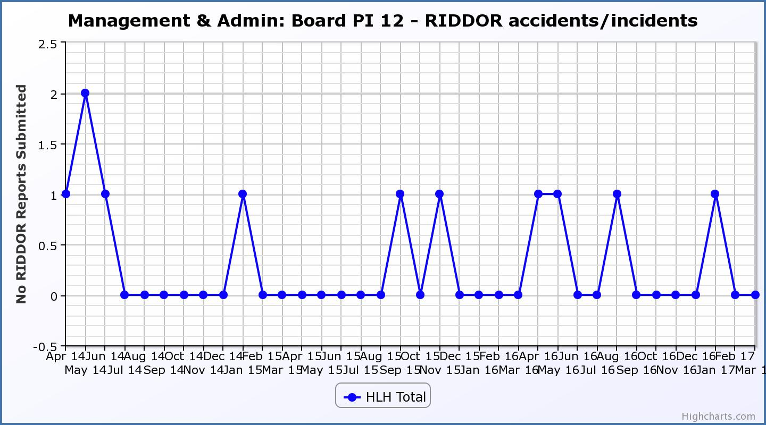
Business Plan Outcome | Performance Indicator | Reporting Frequency | RAG Rating Definition | RAG Rating Q1 16/17 | RAG Rating Q2 16/17 | RAG Rating Q3 16/17 | RAG Rating Q4 16/17 | Summary of Quarter Three Performance
8. A trusted partner | 13. THC’s annual survey of performance and attitudes. | Annual. | - Red = all HLH areas of work represented receive lower net satisfaction ratings than the previous year.  - Amber = two or more areas of HLH work receive lower net satisfaction ratings than the previous year.  - Green = net satisfaction ratings are maintained or improved for three or more areas of HLH work compared with the previous year. |  | Green |  |  | NA. This is an annual indicator.

Appendix B
Table of Customer Visits by Area of Work 2015/16-2016/17

Area of Work |  | Fin Year 2015/16 | Fin Year 2016/17 | Increase/ Decrease | % Change
Adult Learning | Adult Learning Attendances |  | 13,374 | NA | NA
Archives | Electronic Customer Engagements | 361,778 | 243,342 | -118,436 | -33%
Archives | Customer Visits in Person | 4,928 | 4,678 | -250 | -5%
Subtotal Archives |  | 366,706 | 248,020 | -118,686 | -32%
Arts | Caithness Gallery Customer Visits | 5,646 | 9,580 | 3,934 | 70%
Leisure | High Life Leisure Facility Customer Visits (Excl. Inverness Leisure) | 1,184,750 | 1,156,161 | -28,589 | -2%
Leisure | Community Centre Customer Visits | 341,147 | 366,289 | 25,142 | 7%
Leisure | Visitor Attractions Customer Visits | 181,672 | 161,760 | -19,912 | -11%
Leisure | Town Hall Customer Visits | 39,449 | 49,600 | 10,151 | 26%
Leisure | Highland Football Academy Customer Visits | 43,196 | 64,102 | 20,906 | 48%
Leisure | Theatre Customer Visits | 318 | 534 | 216 | 68%
Leisure | Inverness Leisure Customer Visits |  | 780,732 | NA | NA
Subtotal Leisure |  | 1,790,532 | 2,579,178 | 7,914 | 0%
Libraries | Customer Visits | 1,709,471 | 1,989,823 | 280,352 | 16%
Libraries | Virtual Customer Visits | 791,655 | 1,087,937 | 296,282 | 37%
Subtotal Libraries |  | 2,501,126 | 3,077,760 | 576,634 | 23%
Museums | Customer Visits in Person | 120,524 | 108,719 | -11,805 | -10%
Museums | Customer Visits by Other Means | 64,581 | 86,092 | 21,511 | 33%
Subtotal Museums |  | 185,105 | 194,811 | 9,706 | 5%
Outdoor Activities | Customer Activity Days | 201 | 894 | 693 | 345%
Sports Development | Participant Sessions | 432,346 | 484,004 | 51,658 | 12%
Youth Services | Youth Work Attendances | 86,319 | 81,957 | -4,362 | -5%
Total Customer Visits |  | 5,367,981 | 6,689,578
2016/17 Total ex Inverness Leisure |  |  | 5,908,846 | 540,865

* Adult Learning staff previously recorded unique participants rather than attendances so no directly comparable figure is available for 2015/16. Attendances have been recorded since 1 April 2016.

