HIGH LIFE HIGHLAND  REPORT TO BOARD OF DIRECTORS  2 December 2015 | AGENDA ITEM REPORT No HLH /15

Performance Report - Report by Chief Executive

Summary

The purpose of this report is to present performance information for the period July to September 2015.

It is recommended Directors:-

- comment on the report and agree that the overall health check on the company for the period is assessed as green;
- note that delivery of the business plan is assessed as green; and
- note the feedback on the operation of the new Adult and Youth structure.

1. | Business Plan Contribution
1.1 | This report supports the highlighted Business Outcomes from the High Life Highland (HLH) Business Plan:  - To advance sustainable growth and financial sustainability  - Deliver the Service Delivery Contract with THC  - Improving staff satisfaction  - Improving customer satisfaction  - A positive company image  - Services designed around customers and through market opportunities  - Sustain a good health and safety performance  - A trusted partner
2. | Background
2.1 | At its meeting held on 19 March 2015, the HLH Board agreed to remit the task of developing new performance indicators based on the work by the Board at its ten year strategy workshop to the Finance and Audit Committee. At its meeting held on 26 March 2015, the Finance and Audit committee set the performance indicators; and agreed that reporting on the delivery of the business outcomes would be by exception (i.e. reporting where managers had RAG rated the actions “red – no significant progress”). At its meeting held on 20 August 2015 the Board asked for trend information for numeric performance indicators.
3. | Summary of performance
3.1 | Appendix A contains a summary of performance against the performance indicators along with trend information for numeric PIs. There are ten performance indicators scheduled for assessment at the December Board meeting and they have all been assessed as being green.
4. | Delivery of Business Outcomes
4.1 | The Business Plan 2015-19 was agreed by the Board at its March 2015 meeting. The Business Plan identified eight business outcomes and the approach which the company will take to deliver them. Operational plans were then developed for each of the nine HLH areas of work which have the same 22 actions which are RAG rated every quarter. The RAG ratings of the operational plans has identified that delivery of the business plan is on target. Two areas of work identified 4 actions as being “amber - some slippage” and four areas of work RAG rated one action each as being “amber”. The board has agreed that reporting on the delivery of the business outcomes would be by exception (i.e. reporting where managers had RAG rated the actions “red – no significant progress”) and there have been no actions which have been RAG rated “red”.
5. | Review of Adult and Youth Services Staff Structure
5.1 | The HLH Board agreed amendments to the Adult and Youth Services structure at its meeting held on 12 December 2014 and asked that feedback on the operation of the new structure be brought to a future board meeting.
5.2 | The structural amendments were cost neutral and included: the creation of specialist management posts for Adult Learning and Youth Work; increasing the number of Area Youth Work Officers from two to three to improve the line management capacity of front-line staff; and the creation of a specialist achievement awards officer post. The main focus of this update is on youth work because the majority of the changes took place within that area of work.
5.3 | The new structure has been in place for approximately six months (there were also vacancies which arose during that time due to staff leaving the organisation and internal appointments) with the achievement awards officer having been in post for approximately three months. Work to review the service carried out alongside the structural changes reinforced the important place of new technology and new media platforms in the way that young people communicate and learn most effectively. The vacancies mentioned above allowed the opportunity to invest in mobile technology to support learning outcomes and further increase the effectiveness of the service.
5.4 | The Head of Performance and Principal Adult and Youth Services Manager visited all youth work staff on a one to one basis during the summer of 2015 and discussed key areas of work with them including:  - needs assessment (a requirement of the Community Learning and Development legislation and HMIe inspections)  - how they are targeting young people in need/prevention work  - youth participation (area youth forums and their link with the Highland Youth parliament)  - the delivery of achievement awards  - planning; budget management and management of part time sessional staff.  The visits identified that the morale of staff was good with staff reporting that they felt that they were better managed, had clearer direction and support and felt more confident about their jobs than they had in the past.
5.5 | The visits also identified that that there are areas for further development including:  - a more standardised approach to partnerships with schools which focus on young people in need and a standardised format for this has been developed and is being tested with some staff and head teachers before it is adopted Highland wide  - more effective use of technology for recording work on a session by session basis as they are delivered by staff and this is being added to the electronic system for planning and evaluation with a target date of implementing it from April 2016  - training requirements for the “named person” role where Youth Work staff will be the point of contact for young people aged 16 to 18 who have left school and require multi-agency support from August 2016  - the need for developing youth work brands to add to the existing “Fusion” brand which is HLH’s brand for diversionary activity for young people.
5.6 | The areas for further development are underway with staff and the team are planning the changes within the Customer Service Excellence (CSE) framework. This will ensure that there is a structured approach to service improvement. It is anticipated that the team will achieve the CSE standard in approximately 18 months’ time.
5.7 | Performance data indicates that the management changes and renewed focus on targeting young people in need is having a positive impact. The number of learning hours delivered by youth work staff has increased from 97,624 in the first six months of 2014/15 to 144,272 during the same period this year; as previously reported to the Board in a report on achievement awards, the number of awards being delivered is increasing; and the attendances at “Fusion” diversionary activities has increased from 1,126 to 1,819. In Adult Learning the numbers of participants are fewer and there have been front-line staff vacancies which have hand an effect but despite this numbers have remained steady at an average of 500 distinct participants per month.
5.8 | In summary, the Adult and Youth Services structural changes have improved management and direction of staff and there has been benefit from the increased capacity of managers through the creation of the Adult Learning and Youth Work specialist posts.
6. | Implications
6.1 | Resource Implications – There are no additional resource implications arising from this report.
6.2 | Legal Implications - There are no new legal implications arising from this report.
6.3 | Risk Implications – There are no new risk implications arising from this report.

Recommendation

It is recommended Directors:-

- comment on the report and agree that the overall health check on the company for the period is assessed as green;
- note that delivery of the business plan is assessed as green; and
- note the feedback on the operation of the new Adult and Youth structure.

Signature:

Designation: Chief Executive

Date: 20 November 2015

Appendix A
HLH Performance Indicators

Business Plan Outcome | Performance Indicator | Reporting Frequency | RAG* Rating Definition  (*Red/Amber/Green) | RAG Rating Q1 15/16 | RAG Rating Q2 15/16 | RAG Rating Q3 15/16 | RAG Rating Q4 15/16 | Summary of Quarter Two Performance
1. To advance sustainable growth and financial sustainability | 1. Financial monitoring. | Quarterly. | An assessment of the year end outturn where:  - Red = delivery of the SDC over budget above 2%.  - Amber = delivery of the SDC between break-even and 2% over budget.  - Green = delivery of SDC within budget. | Green | Green |  |  | It is projected that the SDC will be delivered at or within budget. See finance report elsewhere on this agenda for further details.

Performance Indicator 1. Financial monitoring.
The graph below shows the variance against the budget for quarters 1 and 2 2015/16 which increased from a positive variance of £23,183 in Q1 to £140,973 in Q2.
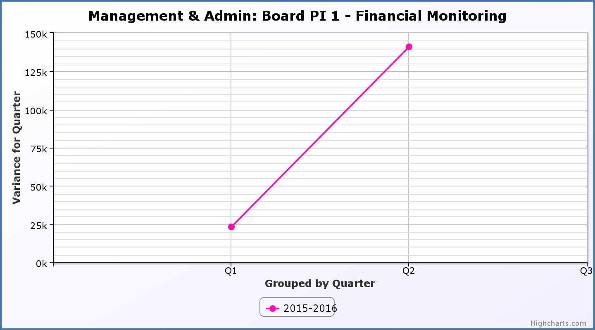
Business Plan Outcome | Performance Indicator | Reporting Frequency | RAG Rating Definition | RAG Rating Q1 15/16 | RAG Rating Q2 15/16 | RAG Rating Q3 15/16 | RAG Rating Q4 15/16 | Summary of Quarter Two Performance
1. To advance sustainable growth and financial sustainability (cont) | 2. Number of High Life subscriptions. | Quarterly | - Red = more than 5% below target.  - Amber = up to 5% below target.  - Green = on or exceeds target. | Green | Green |  |  | The average number of subscriptions per month for Q2 was 12,319.

Performance Indicator 2. Number of High Life Subscriptions.
The trend for High Life subscriptions continues to be positive.

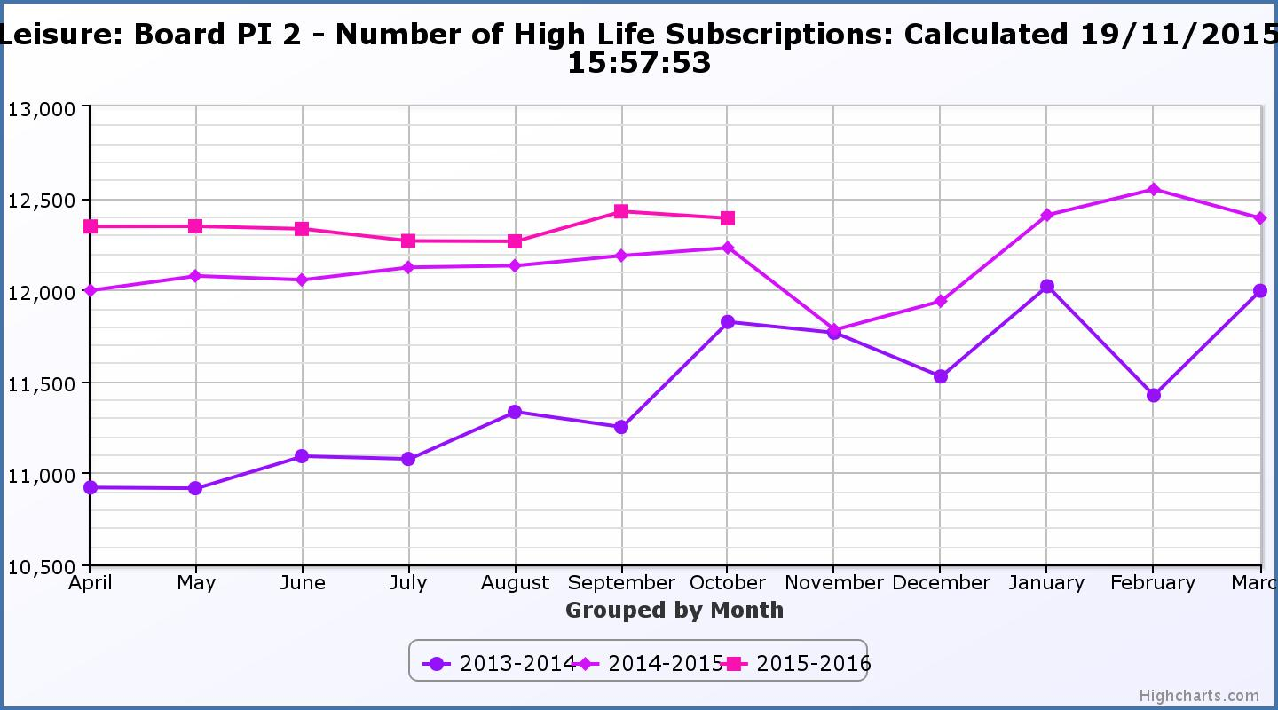

Business Plan Outcome | Performance Indicator | Reporting Frequency | RAG Rating Definition | RAG Rating Q1 15/16 | RAG Rating Q2 15/16 | RAG Rating Q3 15/16 | RAG Rating Q4 15/16 | Summary of Quarter Two Performance
 | 3. High Life cancellation rate. | Quarterly | - Red = cancellation rate above 6% of High Life memberships.  - Amber = cancellation rate is 3% - 6% of High Life memberships.  - Green = cancellation rate is up to 3% of High Life memberships. | Green | Green |  |  | The average High Life Direct Debit cancellation rate per month for Q2 was 2.28%.

Performance Indicator 3. High Life Cancellation Rate.
The graph below shows that the High Life subscriptions have remained constantly low at 2-3% for the current financial year and that this is consistent with the previous financial year.
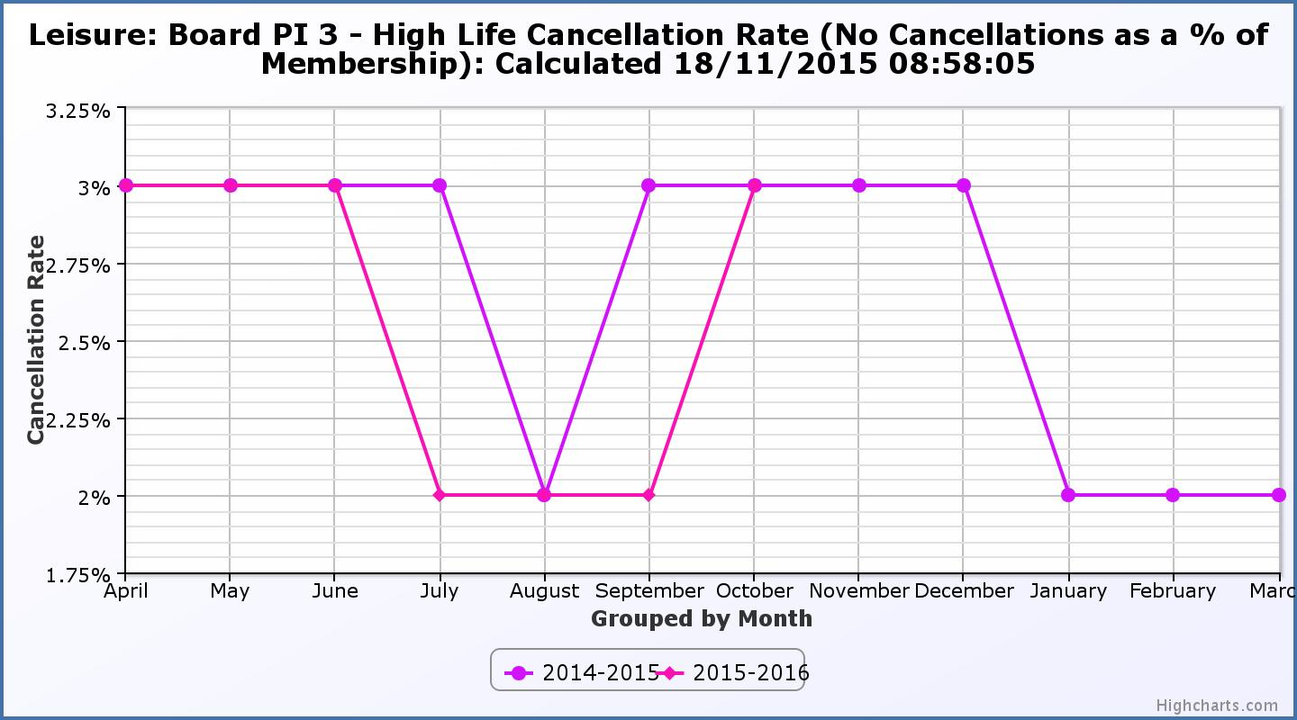
Business Plan Outcome | Performance Indicator | Reporting Frequency | RAG Rating Definition | RAG Rating Q1 15/16 | RAG Rating Q2 15/16 | RAG Rating Q3 15/16 | RAG Rating Q4 15/16 | Summary of Quarter Two Performance
2. Deliver the Service Delivery Contract with THC | 4. Delivery of the Service Delivery Contract (SDC) with the Highland Council (THC). | Six-monthly. | - Red = agreement of THC’s ECAS Committee that HLH has not met the terms of the SDC.  - Amber = agreement of THC’s ECAS Committee that HLH has met the terms of the SDC but has set some improvement targets.  - Green = agreement of THC’s ECAS Committee that HLH has met or exceeded the terms of the SDC. | Green | Green |  |  | THC’s Education, Children and Adult Services Committee at its meeting held on 11 November 2015 agreed that HLH had met or exceeded the requirements of the Service Delivery Contract.

Business Plan Outcome | Performance Indicator | Reporting Frequency | RAG Rating Definition | RAG Rating Q1 15/16 | RAG Rating Q2 15/16 | RAG Rating Q3 15/16 | RAG Rating Q4 15/16 | Summary of Quarter Two Performance
3. Improving staff satisfaction | 5. Staff turnover (resignations as a percentage of posts). | Quarterly. | - Red = more than 2%  - Amber = 1.7 to 2%  - Green = 1.6% or less | Green | Green |  |  | The average number of resignations per month as a percentage of posts in Q2 2015 was 0.71%.

Performance Indicator 5. Staff Turnover (resignations as a percentage of posts).

The graph below shows resignations as a percentage of the number of posts and resignations have continued to be low for the current financial year (1% equates to eight staff).
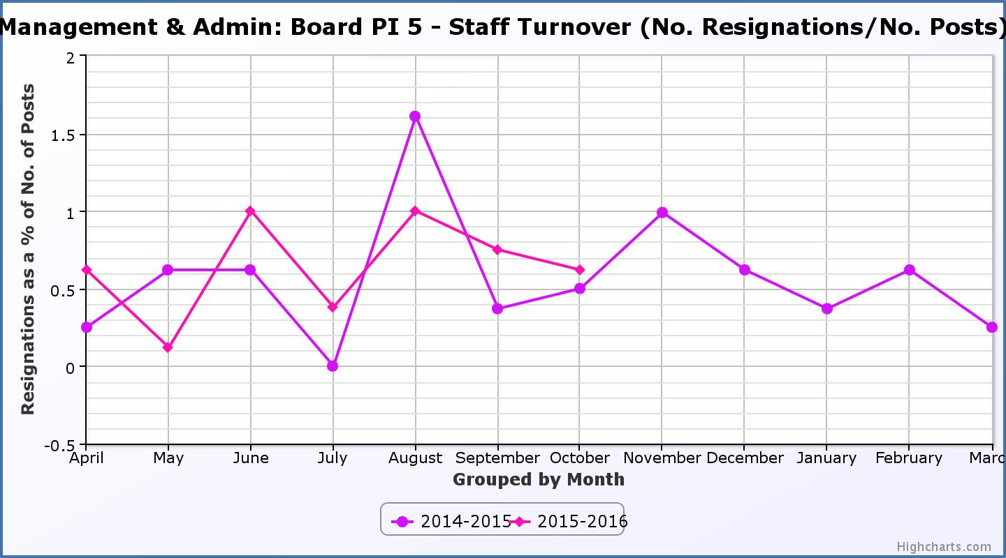
Business Plan Outcome | Performance Indicator | Reporting Frequency | RAG Rating Definition | RAG Rating Q1 15/16 | RAG Rating Q2 15/16 | RAG Rating Q3 15/16 | RAG Rating Q4 15/16 | Summary of Quarter Two Performance
3. Improving staff satisfaction (cont.) | 6. Staff absence rates. | Quarterly. | - Red = absence rate greater than 3.6%.  - Amber = absence rate between 3.4% and 3.6%.  - Green = absence rate 3.3% or less. | Green | Green |  |  | The absence rate for Jul-Sep 2015 was 2.78%.

Performance Indicator 6. Staff Absence Rates.
The graph below tracks absence rates. Absence rates which for the current year have been lower than previous years.
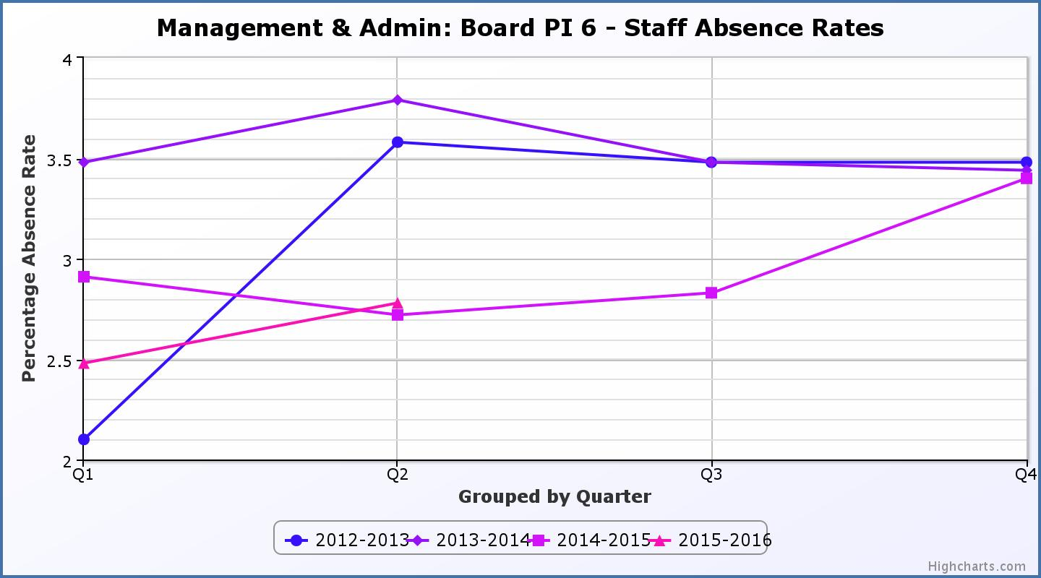
Business Plan Outcome | Performance Indicator | Reporting Frequency | RAG Rating Definition | RAG Rating Q1 15/16 | RAG Rating Q2 15/16 | RAG Rating Q3 15/16 | RAG Rating Q4 15/16 | Summary of Quarter Two Performance
4. Improving customer satisfaction | 7. Customer surveys. | Quarterly. | - Red = no staff surveys have been completed or scheduled.  - Amber = 4 to 8 of the HLH areas of work have completed or scheduled customer surveys.  - Green = all areas of HLH work have completed or scheduled customer surveys. | Green | Green |  |  | All areas of work have included customer surveys in the operational plans for 2015/16.

Business Plan Outcome | Performance Indicator | Reporting Frequency | RAG Rating Definition | RAG Rating Q1 15/16 | RAG Rating Q2 15/16 | RAG Rating Q3 15/16 | RAG Rating Q4 15/16 | Summary of Quarter Two Performance
4. Improving customer satisfaction (cont) | 8. Customer Numbers. | Quarterly. | - Red = customer numbers are more than 5% lower than the corresponding quarter in the previous year.  - Amber = customer numbers are less than the corresponding quarter in the previous year.  - Green = customer numbers are the same as or have increased compared with the corresponding quarter in the previous year. | Green | Green |  |  | Customer Numbers have increased from 999,200 in Q2 2014/15 to 1,164,196 in Q2 2015/16.

Performance Indicator 8. Customer Numbers.
The graph below shows a consistent increase in customer numbers which are holding steady or increasing across all areas of HLH work.
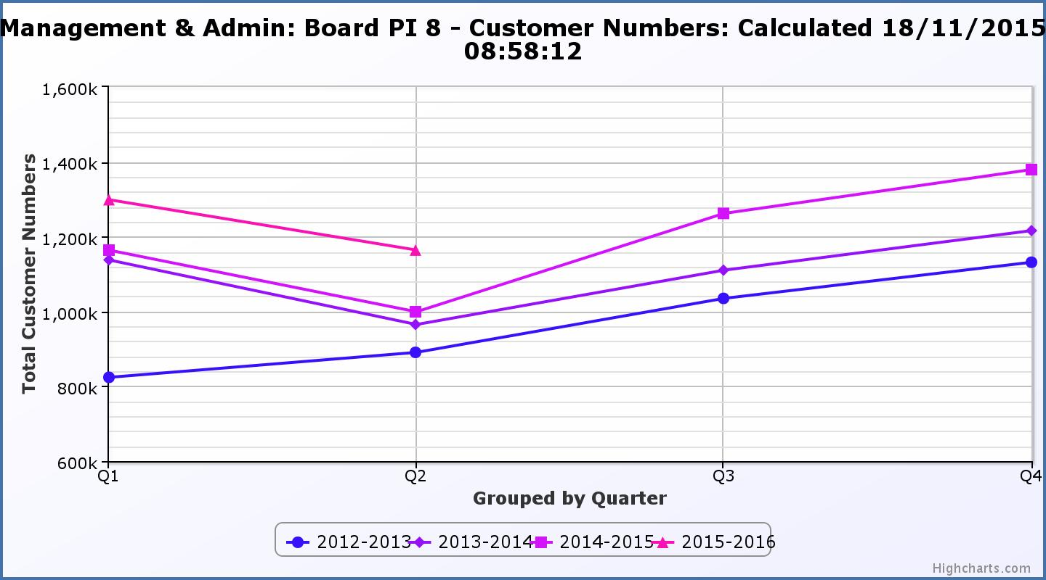
Business Plan Outcome | Performance Indicator | Reporting Frequency | RAG Rating Definition | RAG Rating Q1 15/16 | RAG Rating Q2 15/16 | RAG Rating Q3 15/16 | RAG Rating Q4 15/16 | Summary of Quarter Two Performance
5. A positive company image | 9. Media clippings. | Quarterly | - Red = number of negative press clippings outweigh neutral and positive.  - Amber = number of negative and neutral press clippings outweigh positive.  - Green = number of positive and neutral media clippings outweigh negative. | Green | Green |  |  | Positive media clippings totalled 117 with there being 182 which were neutral and 12 which were negative.

Performance Indicator 9. Media Clippings.
The following two graphs show the numbers of positive and neutral media clippings compared with negative with the trends for this year being good in both cases.

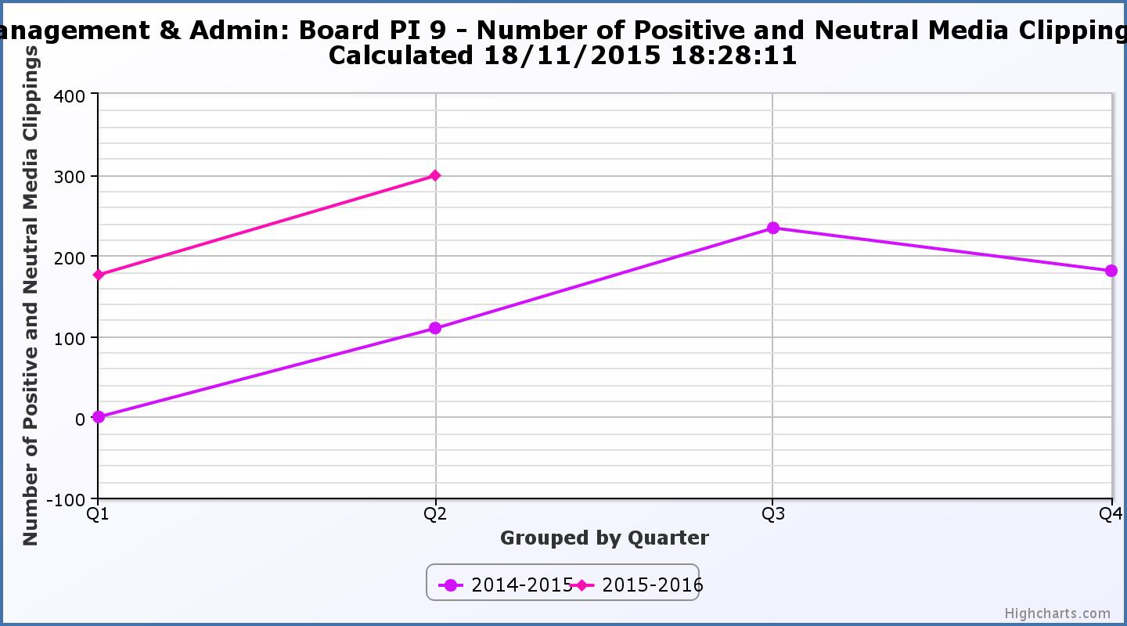

Business Plan Outcome | Performance Indicator | Reporting Frequency | RAG Rating Definition | RAG Rating Q1 15/16 | RAG Rating Q2 15/16 | RAG Rating Q3 15/16 | RAG Rating Q4 15/16 | Summary of Quarter Two Performance
5. A positive company image (cont.) | 10. Formal complaints | Quarterly | - Red = 21 or more complaints per quarter.  - Amber = 11 to 20 complaints per quarter.  - Green = 10 complaints or fewer per quarter. | Green | Green |  |  | There were six complaints received during Q2 2015.

Performance Indicator 10. Formal Complaints.
The graph below shows the number of complaints which continue to be very low in relation to customer numbers. (Note, reporting began Q2 2014/15).
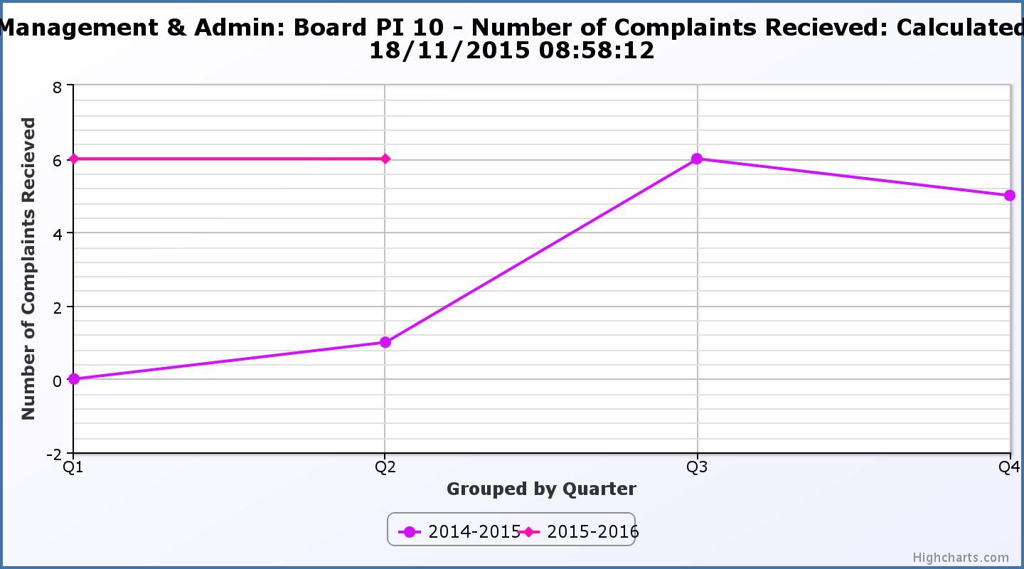
Business Plan Outcome | Performance Indicator | Reporting Frequency | RAG Rating Definition | RAG Rating Q1 15/16 | RAG Rating Q2 15/16 | RAG Rating Q3 15/16 | RAG Rating Q4 15/16 | Summary of Quarter Two Performance
7. Sustain a good health and safety performance | 11. Health and safety audit. | Annual. | - Red = the external audit raises systemic (i.e. applying across multiple sites) H&S issues.  - Amber = the external audit highlights common actions to be addressed across the company.  - Green = the external audit does not raise systemic issues. |  |  |  |  | Not applicable this quarter – Annual indicator.

Business Plan Outcome | Performance Indicator | Reporting Frequency | RAG Rating Definition | RAG Rating Q1 15/16 | RAG Rating Q2 15/16 | RAG Rating Q3 15/16 | RAG Rating Q4 15/16 | Summary of Quarter Two Performance
 | 12. RIDDOR accidents/incidents. | Quarterly. | - Red = number of RIDDOR reports per quarter is above 20.  - Amber = number of RIDDOR reports per quarter is between 10 and 20  - Green = number of RIDDOR reports per quarter is less than 10. | Green | Green |  |  | There were no RIDDOR accidents during Q2 2015.

Performance Indicator 12. RIDDOR Accidents.
The graph below tracks the number of accidents and incidents reported under the RIDDOR regulations. There have been none so far in 2015/16.
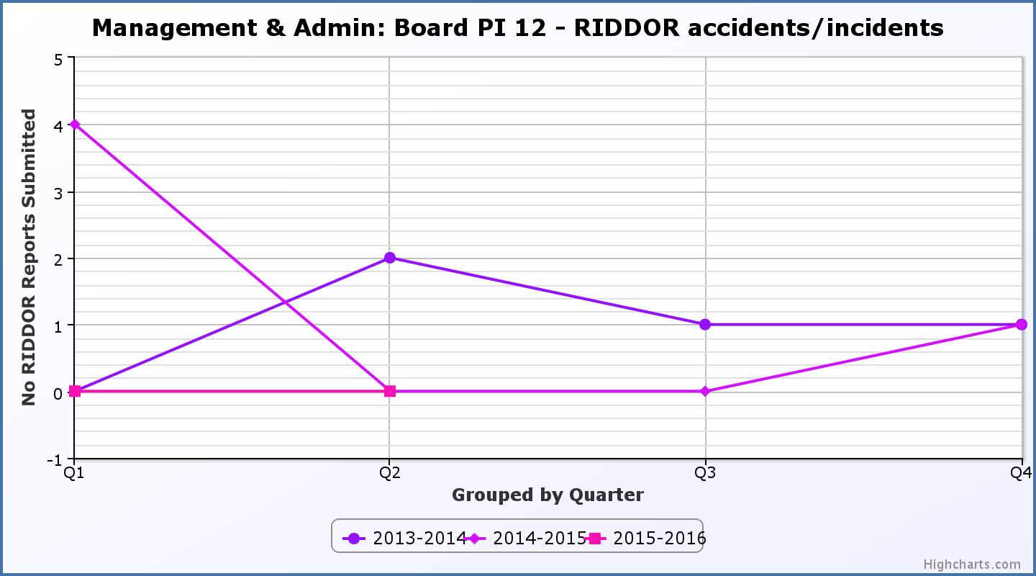
Business Plan Outcome | Performance Indicator | Reporting Frequency | RAG Rating Definition | RAG Rating Q1 15/16 | RAG Rating Q2 15/16 | RAG Rating Q3 15/16 | RAG Rating Q4 15/16 | Summary of Quarter Two Performance
8. A trusted partner | 13. THC’s annual survey of performance and attitudes. | Annual. | - Red = all HLH areas of work represented receive lower net satisfaction ratings than the previous year.  - Amber = two or more areas of HLH work receive lower net satisfaction ratings than the previous year.  - Green = net satisfaction ratings are maintained or improved for three or more areas of HLH work compared with the previous year. |  |  |  |  | Not applicable this quarter – Annual indicator. Reporting anticipated December 2015 following publication of THC report.

