HIGH LIFE HIGHLAND  REPORT TO BOARD OF DIRECTORS  28 October 2014 | AGENDA ITEM REPORT No HLH /14

Quarterly Performance Report - Report by Chief Executive

Summary

The purpose of this report is to present performance information for the period July to September 2014.

It is recommended Directors:-

- comment on the report and agree that the overall health check on the company for the period is assessed as green; and
- note the performance of the company against its business plan objectives.

1. | Business Plan Contribution
1.1 | This report supports all the Business Outcomes from the High Life Highland (HLH) Business Plan:  1. A positive company image  2. A growing company  3. Delivery of the contract with THC  4. Increased awareness of our products and services  5. Increased customer satisfaction  6. Increased financial sustainability  7. Increased internal collaboration  8. Increased staff satisfaction  9. Safety & environmental compliance
2. | Background
2.1 | At the September 2012 meeting Directors agreed that its high level performance monitoring should focus on 10 business critical areas.
3. | Summary of performance
3.1 | Four of the ten indicators have been rated as being on target with one being amber. Five of them have not been rated as they are annual or six-monthly indicators. Appendix A contains the summary of performance against the performance indicators. Appendix B contains further information on performance indicator vii, leisure centre customer numbers.
4. | The Highland Council Governance Arrangements
4.1 | Changes in The Highland Council’s (THC) service and management structure have led to changes in reporting to it. The previously scheduled Culture and Leisure Services Contracts Scrutiny Sub-Committee meetings have not taken place and a report on the delivery of the Service Delivery Contract (SDC) has been requested for the November Education, Children and Adult Services (ECAS) Committee meeting.
4.2 | There have been discussions on the client function within the Council following the retirement of THC’s Learning and Leisure Client Manager. Meantime, similarly to previous arrangements:  - fortnightly meetings between THC’s Head of Adult Services and the HLH Chief Executive have been scheduled,  - there is a standing invitation to THC’s Head of Adult Services to the weekly HLH Heads of Service meetings; and  - HLH will continue to provide reports on the delivery of the SDC which feed into the Quarterly Performance Review meetings which take place between THC’s Chief Executive and Director of Care and Learning.  iv. an update report on the delivery of the SDC by HLH will be presented twice yearly to the ECAS Committee beginning in November 2014. This framework may also offer the opportunity for HLH to discuss its contribution to wider agendas such as prevention, employability or achievement.
5. | Implications
5.1 | Resource Implications - there are no new resource implications arising from the recommendations of this report.
5.2 | Legal Implications - there are no new legal implications arising from the recommendations of this report.
5.3 | Risk Implications - there are no new risk implications arising from the recommendations of this report.

Recommendation

It is recommended Directors:-

- comment on the report and agree that the overall health check on the company for the period is assessed as green; and
- note the performance of the company against its business plan objectives.

Signature:

Designation: Chief Executive

Date: 10 October 2014
Appendix A
Business Critical Indicators

*RAG
Red = No Significant Progress
Amber = Some Slippage
Green = On Target
Business Critical Area/PI | Reporting Frequency | Performance Assessment Method | RAG Rating October 2013 | RAG Rating December 2013 | RAG Rating Apr-Jun 2014 | RAG* Rating Jul-Sep 2014 | Summary of Performance: Apr-Jun 2014
- High level relationship with THC | Annual | Annual meeting, with one of the agenda items to be “assessment of the relationship between HLH and THC”, between:  - the HLH chair, vice chair and the chair of the HLH Finance and Audit Committee; and  - THC’s Leader and Budget Leader | - | - | G | - | Annual indicator. However the June informal bi-monthly meeting with the Council’s leadership continued a cordial as well as productive exchange of information and views.
- Delivery of the SDC with THC | Twice per year | Agreement of THC’s Culture and Leisure Contracts Scrutiny Sub-Committee that HLH has met the terms of the SDC. | G | - | - | - | NA see paragraph 4.1 of the report above on the THC governance arrangements.

Business Critical Area/PI | Reporting Frequency | Performance Assessment Method | RAG Rating October 2013 | RAG* Rating December 2014 | RAG Rating Apr-Jun 2014 | RAG* Rating Jul-Sep 2014 | Summary of Performance: Apr-Jun 2014
- Delivery of business plan objectives | Quarterly | Reporting all actions which have been RAG rated red with reasons (and remedial action if appropriate). | G | G | G | G | The overall rating for performance against the business plan has been assessed as being on target. Of the 608 operational plan actions:  14 are complete  567 are green  27 are amber  0 are red
- Financial monitoring | Quarterly | Financial monitoring reports. RAG rating (Red/Amber/Green) definition:  - Red = Delivery of SDC over budget  - Amber = Delivery of SDC on budget  - Green = Delivery of SDC within budget | G | A | A | A | It is projected that the SDC will be delivered on budget.  Management action is being taken to ensure that this is achieved.
- Health and safety | Annual/  Quarterly | Annual external assessment and report which is agreed by the HLH board.  Quarterly review of RIDDOR reportable accidents/incidents. | G | G | G  G | G | Annual report was considered by the HLH board on 23 April 2014.The H&S Strategic Group continues to meet quarterly and it reviews RIDDOR reports.  The annual external audit has taken place and the audit report is awaited.

Business Critical Area/PI | Reporting Frequency | Performance Assessment Method | RAG Rating October 2013 | RAG* Rating December 2014 | RAG* Rating Apr-Jun 2014 | RAG* Rating Jul-Sep 2014 | Summary of Performance: Apr-Jun 2014
- Risk manage-ment | Annual | Annual risk report agreed by the HLH board.  (The risk register is reviewed quarterly by the finance and audit committee) | G | G | G  G | G | Annual Risk Register Update report was considered by the HLH Board in April 2014.The Finance and Audit Committee continues to consider the risk register quarterly.
- Leisure centre customer numbers | Quarterly | Comparison graph or trend analysis to the same period in the preceding year(s). | G | G | G | G | See Appendix B

Business Critical Area/PI | Reporting Frequency | Performance Assessment Method | RAG Rating October 2013 | RAG* Rating December 2014 | RAG* Rating Apr-Jun 2014 | RAG* Rating Jul-Sep 2014 | Summary of Performance: Apr-Jun 2014
- Quality of service provision | Annual | Annual board report on:  Internal assessment of quality:  - customer survey for each of the nine areas of work.  - review of comments and complaints  External assessments of quality e.g.:  - THC’s annual public performance survey.  - Museum Accreditation (takes place every five years)  - The Public Library Quality Improvement Matrix  - HMIe inspection of Community Learning and Development | G | G | G | - | NA – next assessment due is THC’s annual public performance survey. The survey has been undertaken and the report is awaited.
- Staff satisfaction | Bi - Annual | Bi - Annual staff survey and report to the HLH board which includes a year on year comparison of the overall rating of staff satisfaction. | - | - | - | - | NA – Bi Annual Indicator. Next survey due to be carried out during Q4 2014/15.
Business Critical Area/PI | Reporting Frequency | Performance Assessment Method | RAG Rating October 2013 | RAG* Rating December 2014 | RAG* Rating Apr-Jun 2014 | RAG* Rating Jul-Sep 2014 | Summary of Performance: Apr-Jun 2014
- Value for money | Annual | There are three areas of work which can be benchmarked nationally (and year on year) for value for money by calculating the cost per attendance. These are: Leisure Facilities; Libraries; and Museums. | - | - | G | - | NA – annual indicator.

Appendix B

High Life facilities – High Life card holder user numbers

(Excluding Culloden Academy Community Complex, Averon Leisure Centre or Aviemore Community Centre as inclusion of these more recently acquired facilities would affect the comparative nature of the indicator)

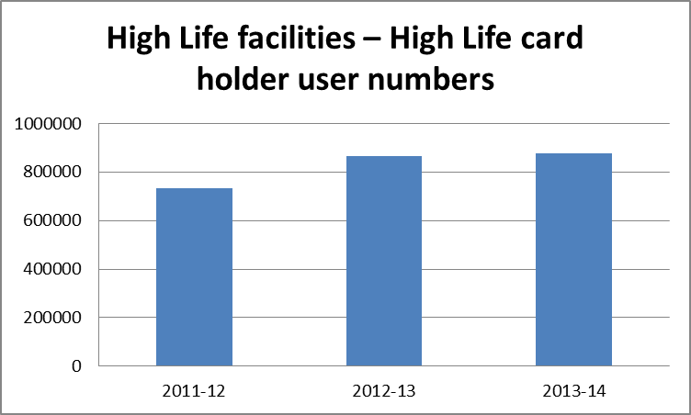

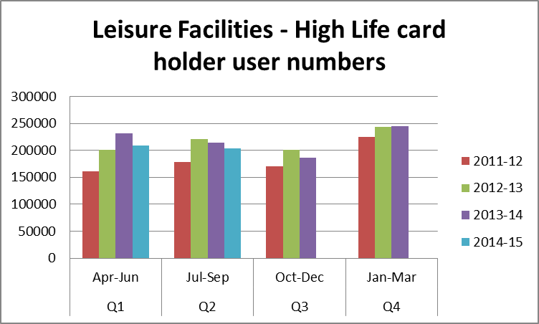

Use of Leisure Faciltiies by High Life members rose from 865,892 in 2012/13 to 875,837 in 2013/14. While the quarter this year shows a drop of 9,940 uses compared with the same quarter in 2013/14, High Life memberships in September 2014 were 11,192, the highest they have ever been and 514 more than they were in the same month last year.

