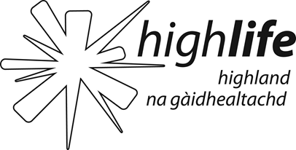 | HIGH LIFE HIGHLAND  JOB DESCRIPTION

JOB TITLE: Sessional Assistant Youth Worker
SALARY: £10.18 per hour
LOCATION: Ardnamurchan
RESPONSIBLE TO: Youth Development Officer and Area Youth Officer
RESPONSIBLE FOR: Supporting services for young people
JOB PURPOSE : Develop good relationships with young people.
Deliver youth work in a variety of informal settings.
Involve young people in decision making with respect to programme planning and development.

KEY DUTIES AND RESPONSIBILITIES INCLUDE:
- Develop positive relationships with young people based on an understanding of the youth workers role.
- Create opportunities, which enable young people to take responsibility, make decisions and explore the outcomes of these decisions.
- Create opportunities for young people to explore issues that are important to them and enable them to make informed choices about their actions and their lives.
- To enable young people to adopt positive relationships with their peers and adults.
- Create opportunities for young people to participate in wider community activities/issues.
- Create opportunities for young people to have fun, have new experiences and gain new skills.
- Facilitate the young people to play a part in programme design and implementation.
- Assist in the planning and delivery of quality learning opportunities and activities.
- Ensure that young people have access to relevant information, advice and support as necessary.
- Carry out risk assessments to ensure safe environment
- To consider equal opportunities in all aspects of work.
- Attend supervision sessions with line manager
- Attend training sessions and staff meetings as appropriate.
- Other appropriate duties as requested by line manager.
Other Duties:

You may be required to perform duties, appropriate to the post, other than those given in the job specification. The particular duties and responsibilities attached to posts may also be varied without changing the general character of the duties or the level of responsibility entailed. Such variations are a common occurrence and would not themselves justify reconsideration of the grading. As a result of such variations it will be necessary to update this job specification from time to time.

Date: 26/11/14
HIGH LIFE HIGHLAND
PERSON SPECIFICATION

JOB TITLE: Sessional Assistant Youth Worker
LOCATION: Ardnamurchan
ESSENTIAL ATTRIBUTES:
To carry out the duties and responsibilities of this post effectively, the following essential requirements have been identified:

- KNOWLEDGE

- Good level of general education
- Knowledge of issues relating to young people
- Equal Opportunities

- EXPERIENCE

- Experience of working with young people
- Experience of planning and delivering quality learning opportunities and activities

- SKILLS

- Ability to relate to young people
- Have skills to pass on to young people e.g. music, crafts, drama, arts, sports, photography

- PERSONAL AND SOCIAL SKILLS

- Good level of communication skills
- Willingness to work flexible hours
- Ability to work as part of a team
- Sense of humour

