|  |  |
| --- | --- |
| HIGH LIFE HIGHLAND  REPORT TO BOARD OF DIRECTORS  19 March 2020 | AGENDA ITEM REPORT No HLH /20 |

## **ORGANISATIONAL RESTRUCTURE UPDATE - Report by Chief Executive**

|  |
| --- |
| **Summary** The purpose of this report is to provide Directors with an update to the organisational restructure initiated following discussions at the December 2019 HLH Board meeting needed to create additional capacity to support the programme of change required to meet the challenge presented by budget cuts and continue to grow HLH as an organisation and secure a sustainable future.  It is recommended Directors note the update and appointment to the Corporate Programme Manager post. |

|  |  |
| --- | --- |
| **1.** | **Business Plan Contribution** |
| 1.1 | This report supports the highlighted Business Outcomes from the High Life Highland (HLH) Business Plan:   1. Sustain a high standard of health and safety, and environmental performance 2. Implement the Service Delivery Contract with THC 3. **Improving customer engagement and satisfaction** 4. **Improving staff engagement and satisfaction** 5. **Enhance the positive charity image** 6. **Be a trusted and effective partner** 7. **Achieve sustainable growth across the organisation** 8. Develop health and wellbeing across Highland communities 9. **Develop and promote the High Life brand** |
| **2.** | **Background** |
| 2.1  2.2  2.3 | The HLH Board at their meeting on 11 December 2019 raised concerns that despite over 40 new services having been absorbed into HLH, the Senior Management structure had not changed since the charity was formed in 2011.  This has been a corporate risk (HLH05) for a significant period of time, specifically captured in the risk register as ‘over-reaching and over-commitment leading to failure of significant projects and pressure on central services.’  At the December Board meeting, the Chief Executive undertook to conduct a review to seek solutions that would create additional capacity to support the programme of change required to meet the challenge presented by budget cuts and continue to grow HLH as an organisation and secure a sustainable future. |
| 2.4 | Although authority to implement a management restructure is delegated to the Chief Executive, a paper (**Appendix A**) was circulated to Directors in early February for consideration and any feedback and ensuring the Board were fully informed of the rationale behind changes and the process for implementation (**Appendix B**). Since the circulation there has been one further change in post title with all Heads of Service being re-designated as Directors (see **Appendix A(1)**). |
|  |  |
| **3** | **Appointments and Review of Changes** |
| 3.1 | Following interviews on 3 March 2020, Simon Swanson was appointed to the new Corporate Programme Manager position and takes up position in March. A full review of progress and testing of effectiveness of all these changes is scheduled for October 2020. |
| **4.** | **Implications** |
| 4.1 | Resource Implications – there are no additional resource implications arising from this report. |
| 4.2 | Legal Implications - there are no new legal implications arising from this report. |
| 4.3 | Equality Implications – there are no new equality implications arising from this report. |
| 4.4 | Risk Implications – there are no new risk implications arising from this report. |

|  |
| --- |
| **Recommendations** It is recommended Directors note the update and the appointment to the Corporate Programme Manager post. |

Designation: Chief Executive

Date: 9 March 2020

**Appendix A**

**BRIEFING NOTE TO HIGH LIFE HIGHLAND BOARD**

**Introduction**

This paper provides an update to the High Life Highland Board with respect to service organisational re-structure. Although authority to implement a management re-structure is delegated to the Chief Executive, the purpose of this paper is ensure that the Board are fully informed of the rationale behind the changes and the process for implementation.

**Background**

The HLH Board on 11 December 2019 raised concerns that despite over 40 new services having been absorbed into the Trust, the Senior Management structure had not changed since the Trust was formed in 2011. This has been a corporate risk (HLH05) for a significant period of time, specifically captured in the risk register as ‘over-reaching and over-commitment leading to failure of significant projects and pressure on central services.’

At the December Board, the CE undertook to conduct a review to seek solutions that would create additional capacity to undertake the work required to continue to grow HLH as an organisation and secure a sustainable future.

A Heads of Service away day was held in early January 2020 where a series of workshops were conducted to address the challenge and create capacity to undertake the initiatives required to deliver efficiencies, grow the business and develop strategies. It was also acknowledged that more recently, increased workload from the Inverness Castle Project has led to a significant resource pressure across services that needed to be addressed with some urgency. In addition to the extant business plan requirements, the key high-level deliverables that were assessed as requiring additional capacity were:

* Castle Project
* Investment – Leisure
* Investment – Marketing & Comms
* Pricing & Charging Review
* Workforce Planning
* New facilities (Strathpeffer / Caithness – with possibly Lochalsh and Nevis to follow)
* Climate challenge
* Catering Strategy

With significant budget challenges both in-year, and for 20/21, a solution that was as close to cost-neutral as possible needed to be found. With this challenge in mind, the option of creating an additional HoS position or Depute CE were considered. However, on analysis, it was clear that the best option was to adjust the responsibilities of our current HoS and create additional capacity elsewhere. This included the establishment of a separate team to deliver the Inverness Castle Project, led on a full-time basis by the current Project Manager.

The new structure at **Appendix A(1)** includes the creation of a Corporate Programme Manager as an additional position. The CPM will be responsible for co-ordination, sequencing, governance, resourcing and reporting of all projects within the HLH change portfolio. This post will be mainly funded by the removal of a post within the Library Service and will be limited to internal applicants. The person and job specification for this post can be found at **Appendix B**.

**Key points to note:**

The 3 new services will be:

Corporate Services – James Martin

Sport and Leisure – Douglas Wilby

Culture and Learning – John West

Inverness Castle – Fiona Hampton will move full-time to lead the Inverness Castle Project Development is at **Appendix C** and will over the coming months establish a team of personnel solely focused on Castle business and fully funded by the Inverness Castle Project; these posts will be part of the HLH establishment. This is an interim arrangement and Fiona will remain as full member of the HLH HoS team.

With respect to the new position of Culture and Learning, due to the material change in this position, and in the interest of a fair and transparent process, the SMT were invited to express notes of interest. No formal notes of interest were received and John West will move to 5 days /week, leading Culture and Learning. The revised Job Specifications for the Heads of Service positions can be found at **Appendix D**.

Although line managed within Corporate Services, the Principal Business Support Manager will continue to report direct to the CE on matters of Board governance, planning and tracking.

The additional costs of creating the CPM post (£69722.78) will be offset by not backfilling a senior post in the Library Service (£48,530), with the remaining cost covered by the 5% recoverable from the Castle Project central costs allocation.

**Process**

The HR and engagement process for the re-structure is outlined at **Appendix E.** TheF&A Committee and the HLH Board will be kept informed of progress at the February and March meetings. Recognised unions will be informed of the changes.

The plan will be to review the changes after a period of 6 months, including evaluation of the new HoS positions to check accuracy and test and adjust as required.

There are significant changes in line management reporting associated with this new structure. As ever, good communication and mutual respect in line with our Role Model Behaviours will help in moving to the new structure, creating capacity and moving forward in 2020 with confidence.

**Appendix A(1)**

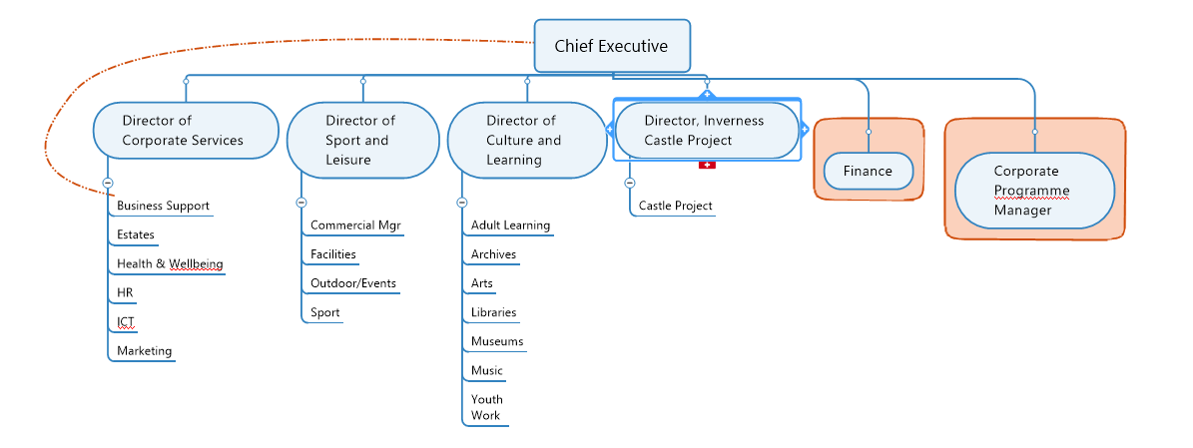

**APPENDIX B**

|  |  |  |  |  |
| --- | --- | --- | --- | --- |
| **Action** | **Day** | **Date** | **Action** | **Lead (s)** |
| 1 | Wed | 08-Jan-20 | HOS meeting to consider required structure to create capacity | CE/HOS |
| 2 | Mon | 14-Jan-20 | CE/HOS to communicate restructure with SMT reports | CE/HOS |
| 3 | Wed | 24-Jan-20 | Expressions of interest invited for full time temporary H of C&L post. | CE |
| 4 | Wed | 29-Jan-20 | HOS meeting to consider timeline/job specs/Board comm/approve PD post | CE/HOS |
| 5 | Wed | 29-Jan-20 | Board communication re changes, attaching timeline and job and person specifications for comment by 7 Feb - **prior to issue to staff/advert** | CE |
| 6 | Friday | 10-Feb-20 | Taking any Board comments into account, finalise paperwork for all staff communication re - JW appt/other changes (including date of implementation)/*highlighting commencement of recruitment process including date of implementation* | CE |
| 7 | Mon | 10-Feb-20 | PM recruitment process commences with issue of all staff email, **including interview date** | HRM |
| 8 | Mon | 10-Feb-20 | Select interview panel - CE/DofSL/HRM | CE |
| 9 | Friday | 21-Feb-20 | Closing Date | HR |
| 10 | Monday | 24-Feb-20 | Update to F&A Committee, include as part of Risk Register and Risk relating to overcommitment? | CE |
| 11 |  | w/c 24 Feb 2020 | Shortleeting - date dependent on interview panel availability | CE/DofSL/HRM |
| 12 | Tuesday | 03-Mar-20 | Interview Date | CE/DofSL/HRM |
| 13 | Friday | 06-Mar-20 | Staff communication re outcome | CE |
| 14 | Thursday | 19-Mar-20 | Update to HLH Board in quarterly HR report. | CE |
| 15 |  | Oct-20 | 6 month progress and testing | CE/HOS |