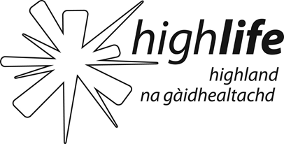 | HLH purpose, key business objectives and corporate values as extracted from the HLH Business Plan 2019-24  Updated March 2019

Purpose: High Life Highland (HLH) is a charity registered in Scotland and a company, Limited by Guarantee, wholly owned by The Highland Council (THC), whose purpose is to develop and promote opportunities in culture, learning, sport, leisure, health and wellbeing. The charity was established on 1 October 2011 to deliver Community Learning and Leisure Services on behalf of THC.

The main business of HLH is the delivery of a Service Delivery Contract (SDC) for THC across the charity’s nine areas of work:

- Adult Learning  - Archives  - Arts  - Leisure Facilities  - Libraries | - Museums  - Music Tuition  - Sport and Outdoor Education  - Youth Work

Key Business Objectives: HLH has nine business outcomes which form the basis of the work of the charity over the period of the Business Plan:

- Sustain a high standard of health and safety, and environmental performance
- Implement the Service Delivery Contract with THC
- Improving customer engagement and satisfaction
- Improving staff engagement and satisfaction
- Enhance the positive company image
- Be a trusted and effective partner
- Achieve sustainable growth across the organisation
- Develop health and wellbeing across Highland communities
- Develop and promote the High Life brand

Corporate Values: The Charity’s ambition is to be recognised and respected as the leading organisation for developing, promoting and inspiring opportunities in culture, learning, sport, leisure, health and wellbeing and, to grow the business in a sustainable and innovative way by enabling and facilitating services that the public value and by being valued as a trusted and effective partner. It has the following core values:

- To act ethically, legally and safely
- To provide quality services, important to individuals and communities
- To balance community, social and financial objectives
- To encourage and enable innovation and entrepreneurship
- To continue to be a good employer and partner
- To reduce our environmental impact

Establishing a positive company ethos, where staff at all levels exhibit positive ‘role model behaviour’ is a vital tool to: (i) ensure the positive consolidation of the company; and (ii) as a focus on the importance of the users of services.

