HIGH LIFE HIGHLAND  REPORT TO BOARD OF DIRECTORS  27 August 2020 | AGENDA ITEM REPORT No HLH /20

Performance Report - Report by Chief Executive

Summary

The purpose of this report is to present performance information for the period April to June 2020.

It is recommended Directors:

- comment on the report and agree that the overall health check on the Charity for that period is assessed as amber because the effect of the lockdown;
- note that the delivery of the business plan is on hold with the focus having become the Recovery Action Plan and that the business plan will be reviewed in the light of the COVID pandemic; and
- note that the mitigating actions are being developed as contained in the recovery report and highlife subscriptions bounceback report elsewhere on this agenda.

1. | Business Plan Contribution
1.1 | This report supports all of the Business Outcomes from the High Life Highland (HLH) Business Plan:  - Sustain a high standard of health and safety, and environmental performance  - Implement the Service Delivery Contract with THC  - Improving customer engagement and satisfaction  - Improving staff engagement and satisfaction  - Enhance the positive charity image  - Be a trusted and effective partner  - Achieve sustainable growth across the organisation  - Develop health and wellbeing across Highland communities  - Develop and promote the High Life brand
2. | Background
2.1 | The implementation of the HLH Business Plan 2019-24 is monitored in two ways:  - through a set of performance indicators set by the Board at its meeting held on 11 December 2018; and  - by RAG rating the delivery of the business outcomes contained in the business plan with these being reported to the Board by exception (i.e. reporting where managers had RAG rated the actions “red – no significant progress”).

3. | Summary of Performance
3.1 | Sixteen performance indicators (PIs) were identified by the HLH Board to assess the overall performance of the charity. At its meeting in December 2019 the HLH Board agreed to develop a simplified/summarised reporting format and Appendix A contains a summary of performance against the PIs for quarter four 2019/20.
3.2 | Appendix B provides a summary of all the PIs along with trend information for numeric ones. Thirteen performance indicators were scheduled for assessment at the August 2020 Board meeting. Eight of them have been RAG rated “green” and five have been RAG rated “red”.
3.3 | PI 9 – media clippings has been RAG rated “green” on target. Articles are normally assessed as being positive, neutral and negative and presented in Appendix B. It has not been possible to collate this information in the same way due to the furlough of staff. External communications and media coverage during the period have been overwhelmingly positive ranging from specific COVID-19 and furlough items to online resources like fitness classes, music tuition and Bookbug, plant donations from Inverness Botanic gardens and HLH staff volunteering. There was only one negative piece of coverage during the quarter.
3.4 | The PIs which have been RAG rated red are as follows:  - PI 4. Customer Engagements.  - PI 12. Financial monitoring.  - PI 13. Number of High Life subscriptions  - PI 14. highlife subscription cancellation rate.  - PI 16. Uptake of HLH card towards the target of 80% of the population.
3.5 | PI 4. Customer Engagements has been RAG rated red. The number of engagements in quarter one 2019/20 was 2,265,078 and in the same quarter this year was 1,182,117 The customer engagements that took place were on-line or by telephone as summarised below.  - Adult learning and youth work continued to provide services to vulnerable young people and adults by telephone and via on-line video calling. Over the quarter adult learning engagements were 559 and youth work 3,524, There are no comparable figures for previous years as engagements have been in person.  - Archives delivered on-line learning sessions and the Gaelic language and culture web site use continued with social media engagements associated with it increasing. On-line archives engagements through activities such as the provision of activities which are normally delivered in buildings being delivered on line increased by 56% from 90,619 to 141,043.  - Over 260 individual participants of Cardiac Rehabilitation, Parkinson’s Exercise and Falls Prevention exercise classes, many of whom were in the shielding category, are regularly contacted by 2 part time qualified instructors using telephone and emails to support them to keep physically active. (Note, this is a count of the individuals with whom contact was maintained rather than the number of contacts).  - The Move More programme, for people affected by cancer, replaced all previous face-to-face activities with telephone and online interactions, using digital platforms to support people to remain physically active, including those shielding. Facebook Live classes are offered twice per week and have been viewed over 12,000 times.  - Leisure facilities staff delivered fitness classes on-line. This was a new service and on-line attendances were 69,730 over the quarter.  - Libraries continued to deliver on-line services including on-line storytelling and other activities as well as its traditional on-line landing services which increased by 61% from 359,337 to 577,030.  - Music tuition transferred all of its activity on-line and only saw a slight drop in customers from 3,666 in February 2020 to 3,550 by the end of the quarter. On-line engagements were 18,974 which was less than the engagements delivered in person in the previous year which were 25,996 but an excellent performance given the complete shift to delivering the whole service remotely.
3.6 | PI 12. Financial monitoring has been RAG rated red. While there is a surplus against budget for the current quarter the financial scenario planning indicates that there could be a loss of the order of £1.5m at the financial year end. There is further information contained in the Finance Report elsewhere on this agenda.
3.7 | PI 13. Number of highlife subscriptions. In March as group activities were stopped in response to the COVID-19 situation and following the closure of facilities customers started to cancel or freeze their subscriptions. As can be seen on the graph in Appendix B the number of subscriptions before lockdown were 21,170 and in June were 8,530. highlife income from April to August was £1,097,855 and the number of active subscriptions is reflective of the generosity and support of the Highland community. There is a highlife development report elsewhere on this agenda which contains a plan for rewarding, retaining and re-engaging customers in the highlife leisure scheme.
3.8 | PI 14. highlife subscription cancellation rate has been RAG rated red for the quarter. It however, changed from red in April and May to amber in June. The cancellation rate is calculated as a percentage of the total number of subscriptions so as the total number reduces and the cancellations level off this change in RAG rating is to be expected.
3.9 | PI 16. Uptake of the HLH card has been RAG rated red for reasons as explained above.

4. | Delivery of Business Outcomes
4.1 | The HLH Business Plan 2019-24 identifies nine business outcomes and the approach which the charity takes to deliver them. The resultant operational plans for each of the nine HLH areas of work are RAG rated every quarter.
4.2 | With most of the regular work of HLH having stopped the Recovery Action Plan has been the focus of the work of the organisation and there is a separate report elsewhere on this agenda which contains an update on the recovery work. The business plan outcomes have, therefore, not been RAG rated.
5. | Performance Indicator for More Detailed Consideration
5.1 | The performance indicators scheduled for more detailed consideration at the August HLH Board meeting are:  - PI 11, partnership work with sportscotland; and  - 15. Partnership work with NHSH and other health related organisations.  Both of these performance indicators have been rated as being green, on target. There is further information on PI 15 in the health and wellbeing update elsewhere on this agenda and PI 11 below.
5.2 | The sports development team continues to work well with sportscotland towards the outcomes of the four-year partnership agreement which started in 2019 and runs to 2023. As part of that HLH has committed to support the Highland & Islands Regional Leadership Group (which is a grouping of Local Authorities and Arms Length External Organisations (ALEO’s) in the Highland and Islands together with sportscotland and from this two key areas of work have emerged:  - In January 2020 £12K of funding (£2K from HLH and £10K from sportscotland was identified to support talented athletes to travel for training and competition out with the Highland area. Invitations to apply were advertised for eight grants of £1500 in March 2020. Highland had 29 applications but due to lockdown restrictions the funding has been suspended. It will continue when competition resumes.  - HLH and sportscotland were keen to find a better way to support Institute of Sport athletes and those on performance pathways and an improved strength and conditioning suite has been funded by sportscotland at Inverness Leisure at a total cost of £75,000 with sportscotland funding £37.5K. The remainder has been funded from the Inverness Leisure reserves which were designated by the former Inverness Leisure Board. There will be public access to the facilities and the new equipment can be used as part of the re-opening/recovery work (this forms part of the phased development of Inverness Leisure).
5.3 | HLH receives approximately two thirds of the funding (£953,872) required for Active Schools Coordinators from sportscotland who gave permission for them to be used during lockdown to support the local emergency response to the management of the coronavirus pandemic. The team were heavily involved in volunteering in a range of settings including supporting humanitarian assistance, delivering activities to childcare hubs and local community support. In addition, three of the team worked through that period and delivered a range of activities through Google Classroom. A highlight was ‘Wake up Shake up’ dance sessions which attracted 780 participants in a single session (average attendance was 500). On-line activities supporting volunteers to deliver virtual physical activity will continue throughout and after recovery.
5.4 | sportscotland has been keen to see Active Schools staff resume normal operations if possible from the new school term in August. Also welcomed by sportscotland has been the delivery of a small summer programme comprising ninety HLH bounceback activity sessions for the last few weeks of the summer school break. These have taken place on open green spaces and attracted over 500 participants.
5.5 | sportscotland supports the development of people through investment into the HLH Leadership programme and also supporting the recognition of coaches and volunteers. The Leadership programme is only one of two supported programmes in Scotland. The programme delivered by HLH is unique in that it has developed an in-house qualification rated at levels four and five SCQF called ‘Choose to Lead’. This is accredited in partnership with UHI and has cut expenditure on leadership training by 50%. The team are developing a ‘Knowledge Bank’ to support future course delivery and opportunities for online delivery. HLH has now issued 16 gold hoodies that indicate that individuals have supported the work of HLH through the delivery of a minimum of 500 hours of volunteering each (total number of hoodies issued last year were 450). HLH supports an annual recognition event for coaches and volunteers aligned to sportscotland’s national awards, with a number of Highland recipients receiving both National and UK wide recognition.
5.6 | sportscotland also invests £100,432 into the delivery of community sport hubs which funds the employment of two community sport hub officers with the programme aimed at bringing together clubs and organisations to develop sport at local level. HLH now supports twelve community sport hubs across the Highland area with the Aviemore hub receiving recognition as the community sport hub of the year in 2016 and recently the Inverness Royal Academy community sport hub received national recognition from sportscotland for playing its part in creating new and improved opportunities for people to participate and get active.
5.7 | HLH is supported by a designated staffing team from sportscotland that provides guidance and support to HLH in the areas of school and community sport, facilities development, people development, Scottish Governing Body of sport partnerships and performance sport.

6. | Implications
6.1 | Resource Implications – there are no additional resource implications arising from this report. Resource implications have been covered in the Finance Report elsewhere on this agenda.
6.2 | Legal Implications - there are no new legal implications arising from this report.
6.3 | Equality Implications – there are no new equality implications arising from this report.
6.4 | Risk Implications – there are no new risk implications arising from this report.

Recommendation

It is recommended Directors:

- comment on the report and agree that the overall health check on the Charity for that period is assessed as amber because the effect of the lockdown;
- note that the delivery of the business plan is on hold with the focus having become the Recovery Action Plan and that the business plan will be to be reviewed in the light of the COVID pandemic; and
- note that the mitigating actions are being developed as contained in the recovery report and highlife subscriptions bounceback report elsewhere on this agenda.

Designation: Chief Executive

Date: 18 August 2020

Appendix A
HLH Performance Indicators year to date 2020/21
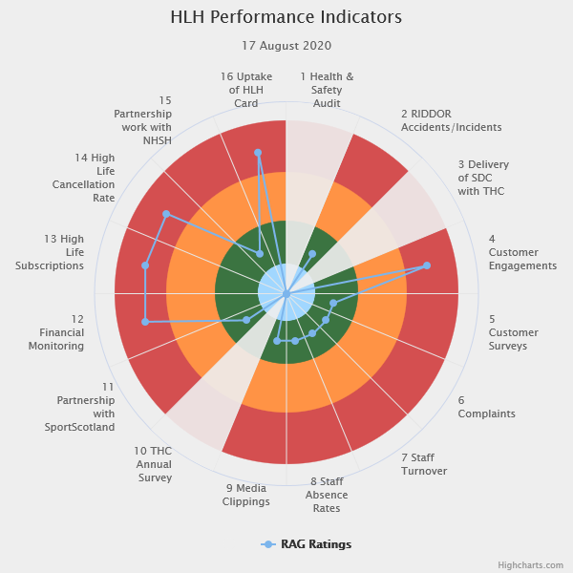 | Sixteen performance indicators (PIs) are used by the High Life Highland Board to assess the overall performance of the charity.  The PIs are RAG rated (allocated a "Red", "Amber" or "Green" status) so that it is easy to see at a glance how the organisation is performing. Most of the PIs are RAG rated every quarter throughout the year with some (such as partnership working with NHSH for example) being considered annually, so greyed out sectors on this radar diagram mean that the PI is to be considered at a future HLH Board meeting.
Appendix B
HLH Performance Indicators

Business Plan Outcome | Performance Indicator | Reporting Frequency | RAG Rating Definition | RAG Rating Q1 20/21 | RAG Rating Q2 20/21 | RAG Rating Q3 20/21 | RAG Rating Q4 20/21 | Summary of Quarter One Performance
1. Sustain a high standard of health and safety and environmental performance | 1. Health and safety audit. | Annual. | - Red = the external audit raises systemic (i.e. applying across multiple sites) H&S issues.  - Amber = the external audit highlights common actions to be addressed across the company.  - Green = the external audit does not raise systemic issues. | N/A. |  |  |  | N/A

Business Plan Outcome | Performance Indicator | Reporting Frequency | RAG Rating Definition | RAG Rating Q1 20/21 | RAG Rating Q2 20/21 | RAG Rating Q3 20/21 | RAG Rating Q4 20/21 | Summary of Quarter One Performance
1. Sustain a high standard of health and safety and environmental performance (cont.) | 2. RIDDOR accidents/incidents. | Quarterly. | - Red = number of RIDDOR reports per quarter is above 20.  - Amber = number of RIDDOR reports per quarter is between 10 and 20  - Green = number of RIDDOR reports per quarter is less than 10. | Green |  |  |  | There were no accidents reported under the RIDDOR regulations during Q1 2020/21.

Performance Indicator 2 - RIDDOR accidents/incidents
The graph below tracks the number of accidents and incidents reported under the Reporting of Injuries, Diseases and Dangerous Occurrences Regulations (RIDDOR). There were no RIDDOR accidents / incident reported in Q1 2020/21.
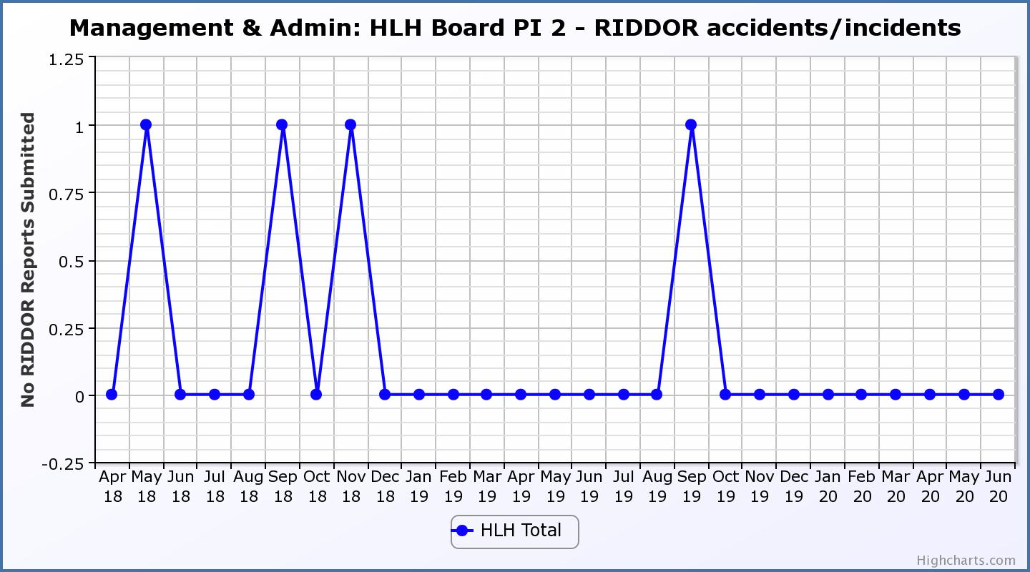

Business Plan Outcome | Performance Indicator | Reporting Frequency | RAG Rating Definition | RAG Rating Q1 20/21 | RAG Rating Q2 20/21 | RAG Rating Q3 20/21 | RAG Rating Q4 20/21 | Summary of Quarter One Performance
2. Implement the Service Delivery Contract with The Highland Council | 3. Delivery of the Service Delivery Contract (SDC) with The Highland Council (THC). | Six-monthly. | - Red = agreement of THC’s CLH Committee that HLH has not met the terms of the SDC.  - Amber = agreement of THC’s CLH Committee that HLH has met the terms of the SDC but has set some improvement targets.  - Green = agreement of THC’s CLH Committee that HLH has met or exceeded the terms of the SDC. | N/A |  |  |  | N/A. Note, a recovery action plan report has been submitted to THC in place of the regular HLH update report.

Business Plan Outcome | Performance Indicator | Reporting Frequency | RAG Rating Definition | RAG Rating Q1 20/21 | RAG Rating Q2 20/21 | RAG Rating Q3 20/21 | RAG Rating Q4 20/21 | Summary of Quarter One Performance
3. Improve customer engagement and satisfaction | 4. Customer engagements. | Quarterly. | - Red = customer numbers are more than 5% lower than the corresponding quarter in the previous year.  - Amber = customer numbers are less than the corresponding quarter in the previous year.  - Green = customer numbers are the same as or have increased compared with the corresponding quarter in the previous year. | Red |  |  |  | Customer engagements decreased from 2,265,078 in Q1 2019/20 to  1,182,117 in Q1 2020/21. The reduction was associated with the lockdown in March 2020. Please see section five of this report for further information on on-line engagements which have increased in comparison to on-line engagements during the same period last year.
Performance Indicator 4 - Customer engagements
Customer numbers decreased due to the COVID-19 situation.
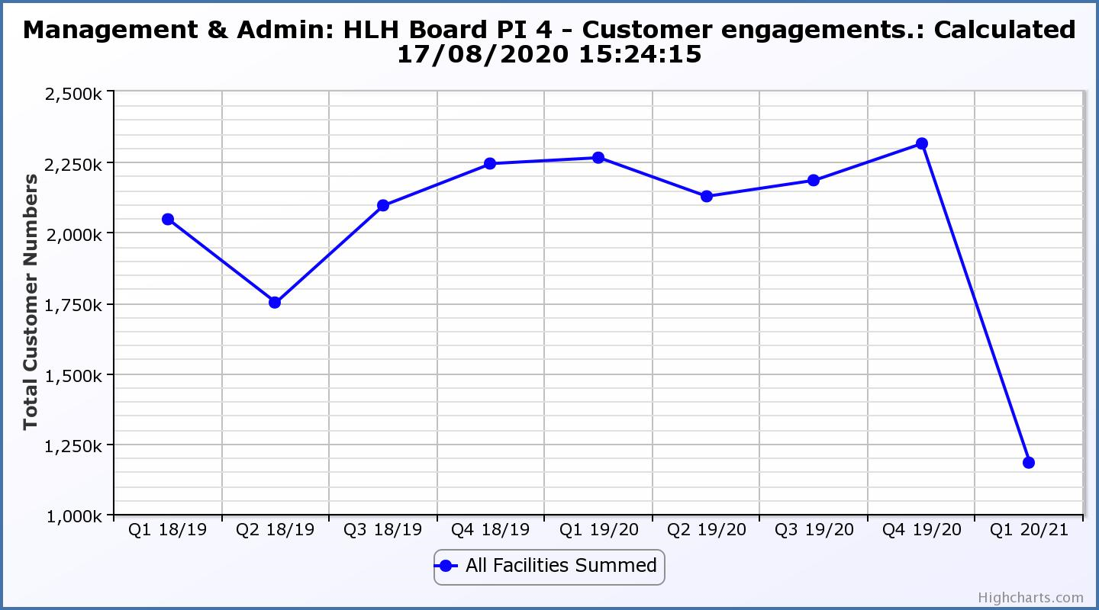

Business Plan Outcome | Performance Indicator | Reporting Frequency | RAG Rating Definition | RAG Rating Q1 20/21 | RAG Rating Q2 20/21 | RAG Rating Q3 20/21 | RAG Rating Q4 20/21 | Summary of Quarter One Performance
3. Improve customer engagement and satisfaction (cont.) | 5. Customer surveys. | Quarterly. | - Red = no surveys have been completed or scheduled.  - Amber = 4 to 8 of the HLH areas of work have completed or scheduled customer surveys.  - Green = all areas of HLH work have completed or scheduled customer surveys. | Green |  |  |  | All areas of work have included customer surveys in their operational plans for 2020/21.  This PI was reported on in further detail at the March 2020 HLH Board meeting.  Since then there has been a COVID customer survey.

Business Plan Outcome | Performance Indicator | Reporting Frequency | RAG Rating Definition | RAG Rating Q1 20/21 | RAG Rating Q2 20/21 | RAG Rating Q3 20/21 | RAG Rating Q4 20/21 | Summary of Quarter One Performance
3. Improve customer engagement and satisfaction (cont.) | 6. Formal complaints. | Quarterly. | - Red = 41 or more complaints per quarter.  - Amber = 31 to 40 complaints per quarter.  - Green = 30 complaints or fewer per quarter. | Green |  |  |  | There were 2 complaints received during Q1 2020/21.

Performance Indicator 6 - Formal Complaints
The graph below shows the number of complaints which continue to be very low in relation to customer numbers.
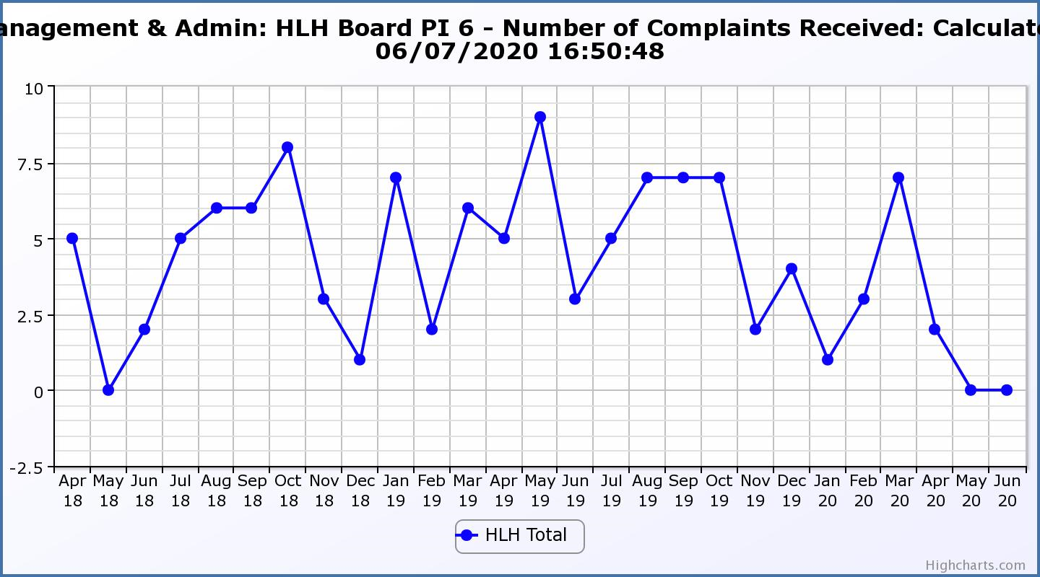
Business Plan Outcome | Performance Indicator | Reporting Frequency | RAG Rating Definition | RAG Rating Q1 20/21 | RAG Rating Q2 20/21 | RAG Rating Q3 20/21 | RAG Rating Q4 20/21 | Summary of Quarter One Performance
4. Improve staff engagement and satisfaction | 7. Staff turnover (resignations as a percentage of posts). | Quarterly. | - Red = more than 2%  - Amber = 1.7 to 2%  - Green = 1.6% or less | Green |  |  |  | The number of resignations per month as a percentage of posts in Q1 was 0.3% in April 0.16% in May and 0.16% in June. Please see HR report elsewhere on this agenda for further information.

Performance Indicator 7 - Staff Turnover (resignations as a percentage of posts)
The graph below shows resignations as a percentage of the number of posts and resignations have been consistent with previous years and continue to be low (1% equates to 10.6 staff)
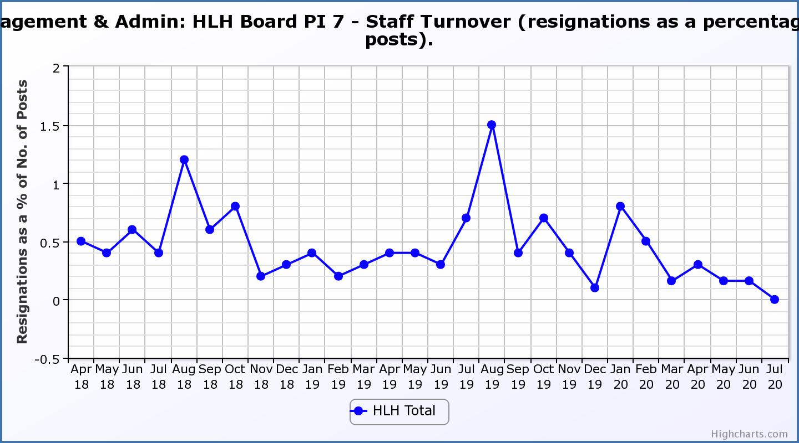
Business Plan Outcome | Performance Indicator | Reporting Frequency | RAG Rating Definition | RAG Rating Q1 20/21 | RAG Rating Q2 20/21 | RAG Rating Q3 20/21 | RAG Rating Q4 20/21 | Summary of Quarter One Performance
4. Improve staff engagement and satisfaction (cont.) | 8. Staff absence rates. | Quarterly. | - Red = absence rate greater than 3.6%.  - Amber = absence rate between 3.4% and 3.6%.  - Green = absence rate 3.3% or less. | Green |  |  |  | The absence rate for Q1 was 0.06%. Please see the HR report elsewhere on this agenda for further information.

Performance Indicator 8 - Staff Absence Rates
The absence rate reduced in quarter one 2020/21 was low, however, staff being furloughed meant that they did not have to report absences as they normally would. Please see the HR report elsewhere on this agenda for further information.
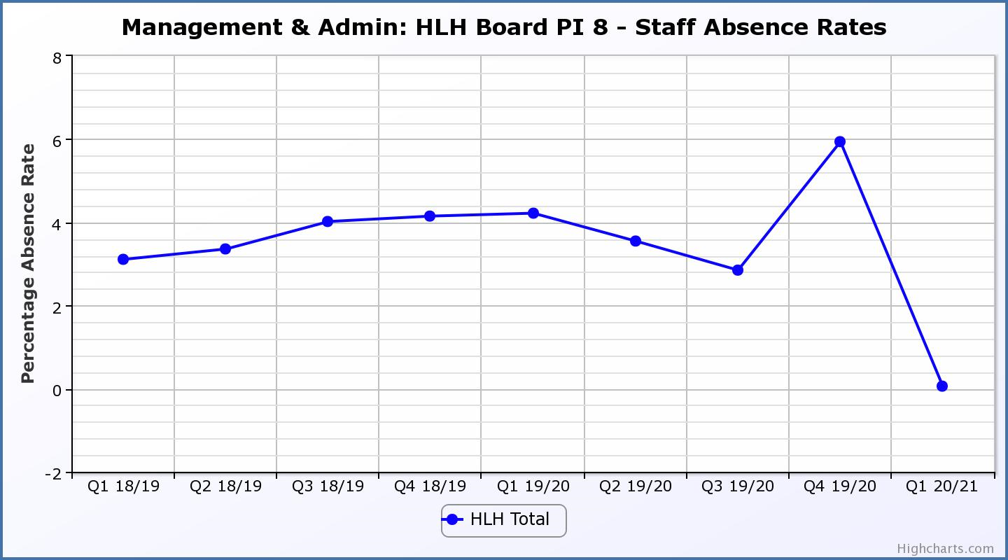

Business Plan Outcome | Performance Indicator | Reporting Frequency | RAG Rating Definition | RAG Rating Q1 20/21 | RAG Rating Q2 20/21 | RAG Rating Q3 20/21 | RAG Rating Q4 20/21 | Summary of Quarter One Performance
5. Enhance the positive company image | 9. Media clippings. | Quarterly | - Red = number of negative press clippings outweigh neutral and positive.  - Amber = number of negative and neutral press clippings outweigh positive.  - Green = number of positive and neutral media clippings outweigh negative. | Green |  |  |  | Media clippings have been assessed differently from normal in Q1. Please see paragraph 3.3 of this report for further information.

Business Plan Outcome | Performance Indicator | Reporting Frequency | RAG Rating Definition | RAG Rating Q1 20/21 | RAG Rating Q2 20/21 | RAG Rating Q3 20/21 | RAG Rating Q4 20/21 | Summary of Quarter One Performance
6. Be a trusted and effective partner | 10. THC’s annual survey of performance and attitudes. | Annual. | - Red = all HLH areas of work represented receive lower net satisfaction ratings than the previous year.  - Amber = two or more areas of HLH work receive lower net satisfaction ratings than the previous year.  - Green = net satisfaction ratings are maintained or improved for three or more areas of HLH work compared with the previous year. | NA |  |  |  | NA – this is an annual PI which was reported to the HLH Board at its 11 December 2019 meeting.

Business Plan Outcome | Performance Indicator | Reporting Frequency | RAG Rating Definition | RAG Rating Q1 20/21 | RAG Rating Q2 20/21 | RAG Rating Q3 20/21 | RAG Rating Q4 20/21 | Summary of Quarter One Performance
6. Be a trusted and effective partner (cont.) | 11. Partnership work with sportscotland | Annual | - Red = cancellation of Partnership Agreement with sportscotland  - Amber = continuation of current level of partnership work with sportscotland  - Green = Growth in partnership working with sportscotland | Green |  |  |  | Please see section 5 of this report for further information.

Business Plan Outcome | Performance Indicator | Reporting Frequency | RAG* Rating Definition  (*Red/Amber/Green) | RAG Rating Q1 20/21 | RAG Rating Q2 20/21 | RAG Rating Q3 20/21 | RAG Rating Q4 20/21 | Summary of Quarter One Performance
7. Achieve sustainable growth across the organisation | 12. Financial monitoring. | Quarterly. | An assessment of the year end outturn where:  - Red = delivery of services over budget above 2%.  - Amber = delivery of services between break-even and 2% over budget.  - Green = delivery of services within budget. | Red |  |  |  | The projected year end variance to budget using the financial scenario planning as reported in the Finance Report elsewhere on this agenda shows a negative variance to budget of £1.5M. The PI has, therefore been RAG rated red despite the positive variance in the quarter.

Performance Indicator 12 - Financial monitoring
See the Finance Report elsewhere on this agenda for further information.
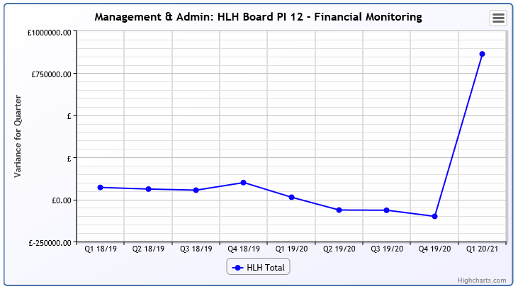
Business Plan Outcome | Performance Indicator | Reporting Frequency | RAG Rating Definition | RAG Rating Q1 20/21 | RAG Rating Q2 20/21 | RAG Rating Q3 20/21 | RAG Rating Q4 20/21 | Summary of Quarter One Performance
7. Achieve sustainable growth across the organisation (cont.) | 13. Number of High Life subscriptions. | Quarterly. | - Red = more than 5% below target.  - Amber = up to 5% below target.  - Green = on or exceeds target. | Red |  |  |  | The number of subscriptions each month during Q1 2020/21 fell short of the target with the average number of subscriptions for the quarter having been 9,187. (The target has been set at the level required to achieve the High Life Subscriptions income target.)

Performance Indicator 13 - Number of High Life Subscriptions
This graph shows the reduction in subscriptions since lockdown with this slowing in recent months. There is information on the reduction in March and into the current financial year in section 3 of this report above.

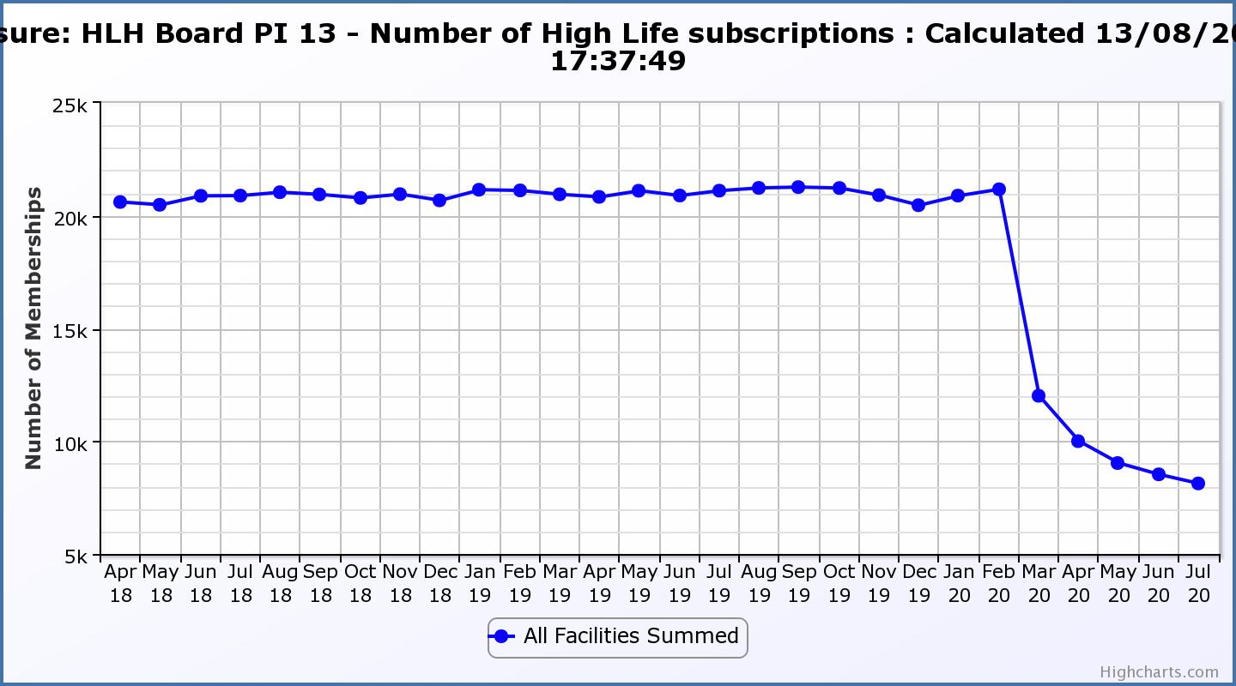
Business Plan Outcome | Performance Indicator | Reporting Frequency | RAG Rating Definition | RAG Rating Q1 20/21 | RAG Rating Q2 20/21 | RAG Rating Q3 20/21 | RAG Rating Q4 20/21 | Summary of Quarter One Performance
7. Achieve sustainable growth across the organisation (cont.) | 14. High Life cancellation rate. | Quarterly. | - Red = cancellation rate above 6% of High Life memberships.  - Amber = cancellation rate is 3% - 6% of High Life memberships.  - Green = cancellation rate is up to 3% of High Life memberships. | Red |  |  |  | The High Life cancellation rates in Q1 were 10% in April 6% in May and 5% in June. Please see section three of this report for further information.

Performance Indicator 14 - High Life Cancellation Rate
Please see section three of this report for further information.
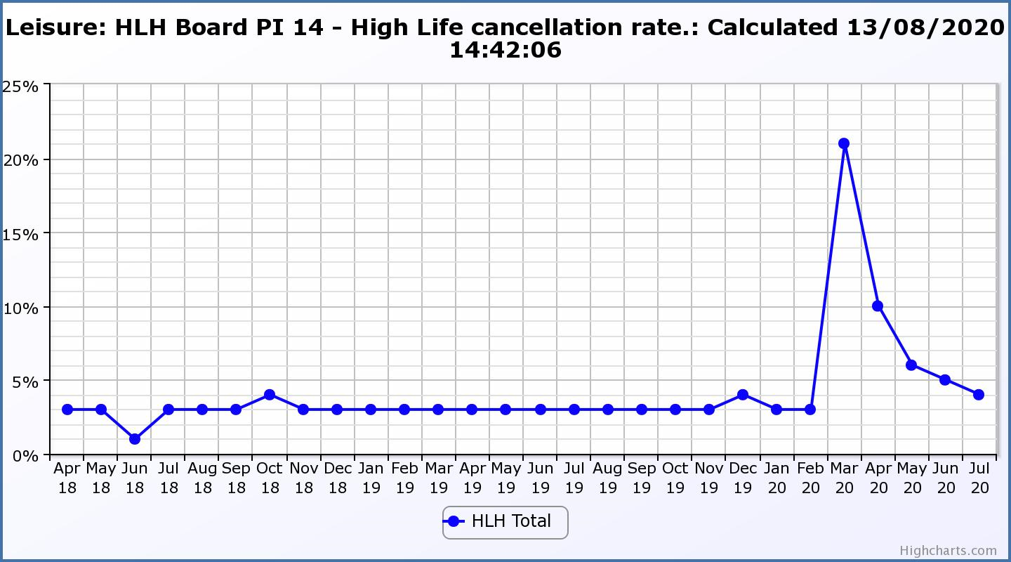
Business Plan Outcome | Performance Indicator | Reporting Frequency | RAG Rating Definition | RAG Rating Q1 20/21 | RAG Rating Q2 20/21 | RAG Rating Q3 20/21 | RAG Rating Q4 20/21 | Summary of Quarter One Performance
8. Develop health and wellbeing across Highland communities | 15. Partnership work with NHSH and other health related organisations. | Annual. | - Red = no partnership work with NHSH etc.  - Amber = Reduction of current level of partnership work with NHSH etc.  - Green = Continuation or growth in partnership working with NHSH etc. | Green | NA | NA | NA | Please see the health and wellbeing update report elsewhere on this agenda.

Business Plan Outcome | Performance Indicator | Reporting Frequency | RAG Rating Definition | RAG Rating Q1 20/21 | RAG Rating Q2 20/21 | RAG Rating Q3 20/21 | RAG Rating Q4 20/21 | Summary of Quarter One Performance
9. Develop and promote the High Life brand | 16. Uptake of HLH card towards the target of 80% of the population. | Annual | - Red = number of card-holders is maintained.  - Amber = number of card-holders is increased by 1-4%.  - Green = number of card-holders is increased by 5% or more. | Red | NA | NA |  | This is an annual indicator, it is, however RAG rated red. Please see section 3 of this report for further information.

