HIGH LIFE HIGHLAND  REPORT TO BOARD OF DIRECTORS  18 June 2020 | AGENDA ITEM  REPORT No HLH/ /20

ANNUAL Health and Safety And EnvironmeNtal Compliance Report

Report by Chief Executive

Summary

An important element of the governance structure relating to the charity’s health and safety and environmental compliance performance is the annual Health and Safety and Environmental Compliance report. This report informs Directors about the performance of High Life Highland in terms of health and safety and environmental compliance for the reporting period 2019-2020.

It is recommended that Directors comment on and note:

- due to HLH facilities closing for COVID-19 reasons, quarter four figures will be further reviewed by the HSECC once all accidents and incidents are closed out for the quarter, after staff return from furlough leave to enable this to be done;
- that there were no notifications for improvement or enforcement actions during the reporting period;
- that there were no environmental incidents requiring SEPA notification during the reporting period;
- the low number and low severity of accidents or incidents over the reporting period, reflecting continuing good practice across the company;
- that the Health and Safety and Environmental Compliance Committee continues to meet quarterly to review Health and Safety performance and on reviewing the accident and incident trend data it concluded that there are no issues arising from this requiring companywide action;
- that the creation of the workstreams for the 5-year Health and Safety Plan will commence post COVID-19 restrictions; and
- that one union safety audit had been completed within the reporting period in line with the Safety Representatives Charter, with the remaining ones deferred due to COVID-19 restrictions.

1. | Business Plan Contribution
1.1 | This report supports the highlighted Business Outcomes from the High Life Highland (HLH) Business Plan:  - Sustain a high standard of health and safety, and environmental performance  - Implement the Service Delivery Contract with THC  - Improving customer engagement and satisfaction  - Improving staff engagement and satisfaction  - Enhance the positive charity image  - Be a trusted and effective partner  - Achieve sustainable growth across the organisation  - Develop health and wellbeing across Highland communities  - Develop and promote the High Life brand
2. | Background
2.1 | The HLH Health and Safety Policy Statement requires annual and exception reporting, to the HLH Board on health and safety performance.
2.2  2.3  2.4  2.5 | At the HLH Board meeting on the 23 April 2014 Directors agreed to delegate to the Health and Safety Strategic Group, now the Health and Safety and Environmental Compliance Committee (HSECC) as of 14 June 2018. The Committee reviewed and agreed the information in this report and accompanying appendices at its meeting held on 19 May 2020.  Of significant note is that due to the ongoing COVID-19 situation, HLH closed all of its facilities as part of the government’s lock down protocol, on 20 March 2020. Whilst we are comfortable with the accuracy of the number of accidents and incidents within this report, within the quarter four reporting period, there are some that still require further clarification and discussion with staff members, to enable the data base to be fully populated with comments and any remedial actions taken relating to any such accidents/incidents. As such, this number may require adjustment when the full review is completed, once staff return from furlough leave to permit this to be done.  Once this review has been completed, then an updated report will be provided to the next meeting of the HSECC for their further review and comment and if necessary, escalation to the HLH Board.  Furthermore, due to the high number of staff on furlough leave, our management teams continue to maintain contact with their staff and teams to maintain the welfare contact and support necessary at this time. Staff are also being assisted through a suite of activities and programmes fed from the health and wellbeing support package plan. The support package content has been generated following consultation and review with the HLH COVID-19 Working Group, extended (Quarterly) Management Team and the Executive Team through the weekly business meeting.
3. | Health and Safety and Environmental Compliance Performance
3.1 | There were no enforcing officer notifications for improvement, or enforcement action during the reporting period. There were no environmental incidents requiring reporting to SEPA during the reporting period.
3.2 | Having analysed the information in Appendices A-D, the Health and Safety and Environmental Compliance Committee identified the following information as being important to report to the HLH Board:  - there were no trends indicating that any company wide actions were required;  - the 3 acts of violence recorded against HLH staff and the 5 recorded against customers were behavioural and all incidents were dealt with appropriately. All have been reviewed and assessed, with no trends;  - one accident was reported under RIDDOR within the reporting period and was dealt with appropriately and reviewed with no trends (details contained in Appendix A);  - the Health and Safety and Environmental Compliance Committee approved a number of themed topics to focus on particular H&S matters to help support accident reduction within the organisation over the reporting period. The topics were:  - Q1 Stress awareness  - Q2 Manual handling awareness and training  - Q3 Slips trips falls/gritting plans  - Q4 Fire safety and general housekeeping.  - the generation of quarterly themes will continue to feature in all future years.
3.3  3.3.1 | Given the size of HLH and the number of physical visits to our facilities, circa 6M, the very small number of accidents/incidents reflects the good practice across all areas of work.  Whilst the figures do indicate a small increase in employee accidents and incidents, these have been thoroughly reviewed. However, whilst any increase is disappointing, there are no trends identifiable requiring any service wide action and staff are consistently reminded of the need to remain vigilant and ensure that staff carry out their duties diligently and safely.
4.  4.1  4.2 | Internal Audit - Health & Safety/Property (RPO and Database)/ Facilities operational Procedures  Within this reporting period, and as part of a three-year programme of internal audits the HLH Finance and Audit Committee agreed to audit the “Health & Safety/Property (RPO and Database)/Facilities operational Procedures”. The audit was completed in May 2019 and the findings presented by the internal auditor to the Finance and Audit Committee at its meeting held on 5 August 2019 with the Directors on the Health and Safety and Environmental Compliance Committee having been invited to attend. At the Finance and Audit Committee meeting the auditor confirmed that the audit was a very positive one and that had the facilities database been fully populated that the audit opinion “Full Assurance” would have been given.  The Internal Audit Report was also reviewed in detail by the Health and Safety and Environmental Compliance Committee at its meeting on 20 August 2019. In summary, the report reflected that strong procedures were in place. All actions have since been completed.
5.  5.1  5.2  5.3  5.4 | Health and Safety Plan 2020-2025  At its meeting held on 14 May 2019 the Health and Safety and Environmental Compliance Committee agreed to develop a Health and Safety Plan for 2020-25 with it reviewing the final draft at its meeting on 19 November prior to it being approved by the HLH Board on 11 December 2019.  The Plan went live on 1 April 2020 and the first phase was to be the creation of individual workstreams to deliver the key themes within the plan. Understandably, the creation of these workstreams has been postponed due to the ongoing COVID-19 restrictions.  One element however, was completed prior to the lock down, with HLH being awarded the bronze Healthy Working Lives Award. Accordingly, the plan will focus on achieving the silver award within the life of the plan.  The workstreams will commence once we can establish the ‘new normal’ operating conditions, to enable staff to concentrate on getting back to business-as-usual. However, there still remains a strong focus on all H&S matters, and especially so as we prepare for the lead up to re-opening our facilities as greater clarity is revealed on the lock down restrictions being relaxed.
6. | Safety Representatives Charter
6.1  6.2 | In line with the Safety Representatives Charter agreed in June 2016, Unison undertook a safety audit at Inverness Leisure Centre within the reporting period. The audit was very well received with only minor advisory comments noted with an overall very positive report being received from the inspector.  Additionally, the planned QLM audits will take place post COVID-19 and are likely to be scheduled for 2021/22 to allow the HLH recovery action plan to commence and permit staff to concentrate on getting back to business.
7. | Staff Health and Wellbeing
7.1 | Directors will also note the report in Appendix E. This report was presented to the HSECC at their May meeting and details the work undertaken by the COVID-19 group specifically relating to the welfare of staff during and post pandemic. The report will be referenced in the recovery presentation to the Board.
8. | Implications
8.1 | Resource Implications – there are no additional resource implications arising from this report.
8.2 | Legal Implications - there are no additional legal implications arising from this report.
8.3 | Equality Implications – there are no additional equality implications arising from this report.
8.4 | Risk Implications – there are no new risks which require to be added to the risk register arising from this report.
Recommendations

It is recommended that Directors comment on and note:

- due to HLH facilities closing for COVID-19 reasons, quarter four figures will be further reviewed by the HSECC once all accidents and incidents are closed out for the quarter, after staff return from furlough leave to enable this to be done;
- that there were no notifications for improvement or enforcement actions during the reporting period;
- that there were no environmental incidents requiring SEPA notification during the reporting period;
- the low number and low severity of accidents or incidents over the reporting period, reflecting continuing good practice across the company;
- that the Health and Safety and Environmental Compliance Committee continues to meet quarterly to review Health and Safety performance and on reviewing the accident and incident trend data it concluded that there are no issues arising from this requiring companywide action;
- that the creation of the workstreams for the 5-year Health and Safety Plan will commence post COVID-19 restrictions; and
- that one union safety audit had been completed within the reporting period in line with the Safety Representatives Charter, with the remaining ones deferred due to COVID-19 restrictions.

Designation: Chief Executive

Date: 4 June 2020
Appendix A

All RIDDOR Notified Accidents/Incidents – Summary

 | 2019-2020
Service Area | Q1 Apr-Jun | Q2 Jul-Sep | Q3 Oct-Dec | Q4 Jan-Mar
Adult Learning
Archives
Arts
Leisure Facilities
Libraries |  | 1
Museums
Music
Outdoor Activities
Sport
Youth Services
Management & Administration
GRAND TOTAL | 0 | 1 | 0 | 0

All RIDDOR Notified Accidents/Incidents – Details Q1 – Q4 2019-2020

INCIDENT 1 - RIDDOR Notified Accidents/Incidents – Q2 2019-2020
Library – Plockton High School Library – 12 September 2019 16:45

DESCRIPTION: The staff member stepped off the carpeted area of the library on to the linoleum of the corridor. The floor was wet, having just been cleaned and there were Wet Floor Signs in position. The staff member slipped on the wet floor, put their right arm out and landed on their wrist. They were helped up by two visiting members of the public and a passing teacher called a first aider who recommended going to hospital.

The staff member was taken to Broadford Hospital by their husband and their wrist was found to be broken. They had a bad reaction to the sedative used when the wrist was being set and they had to spend the night in hospital before being discharged the next day.

Staff member acknowledged that they had seen the sign in advance of stepping from carpeted area.

Actions Taken: Reported to RIDDOR – No further action taken as the staff member had acknowledged that the correct signage was in place and that she had seen it prior to the slip.

Appendix B, Tables 1-8

Accidents and incidents compared to the previous year for staff, volunteers and contractors by HLH section

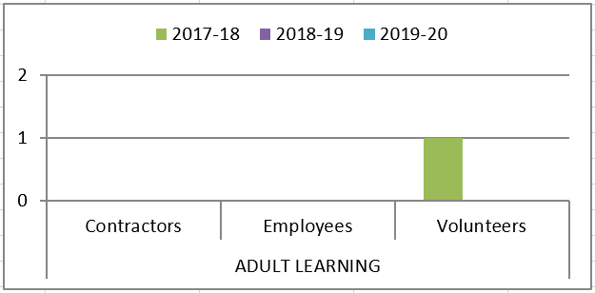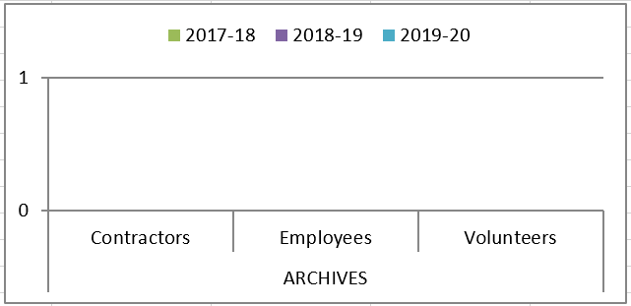

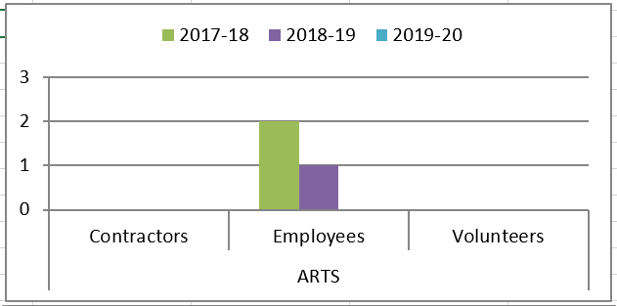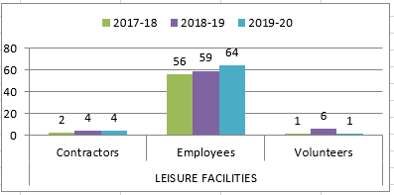

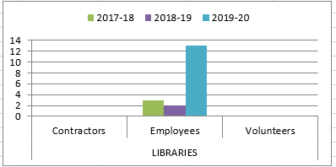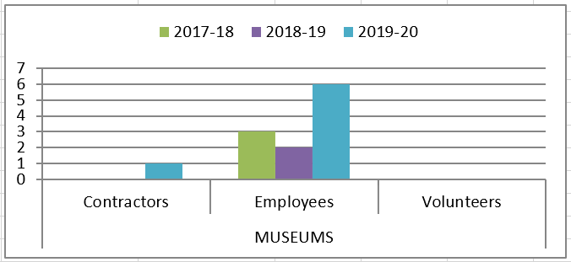

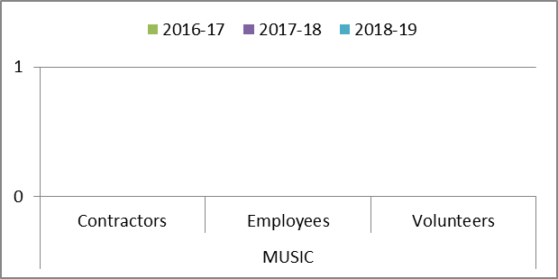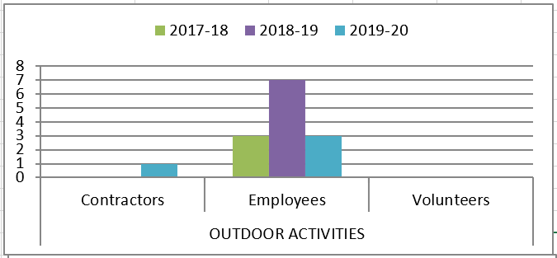

Appendix B, Tables 9-11

Accidents and incidents compared to the previous year for staff, volunteers and contractors by HLH section

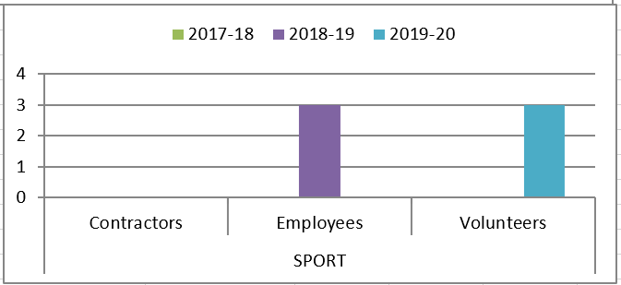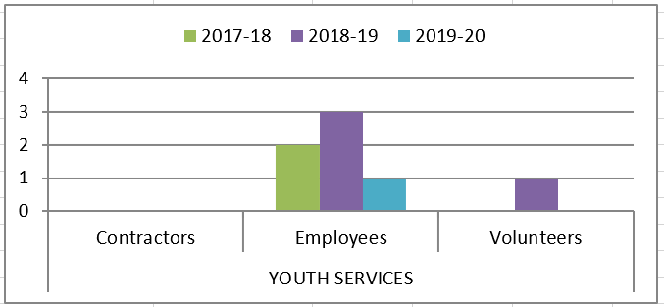

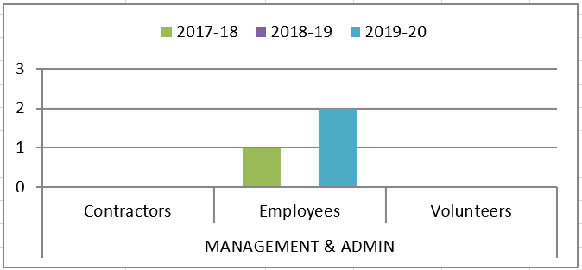

Appendix B, Table 12

Accidents and incidents compared to the previous year for staff by nature of accident

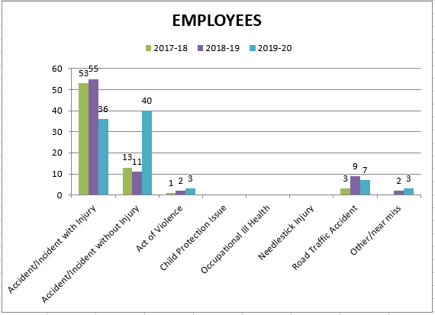

Appendix B, Tables 13-14

Accidents and incidents compared to the previous year for volunteers and contractors by nature of accident

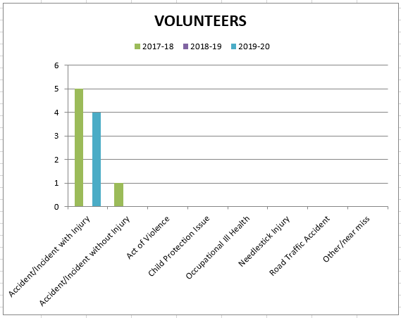

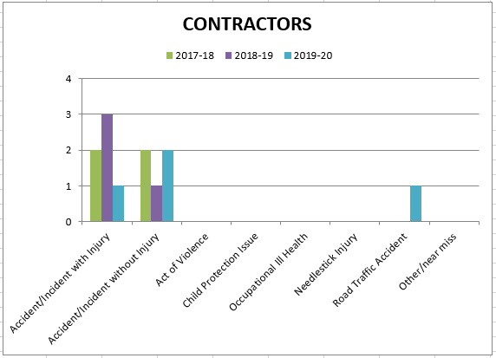

Appendix B, Table 15 – 16

Accidents and incidents compared to the previous year to staff and volunteers by type of accident/ incident

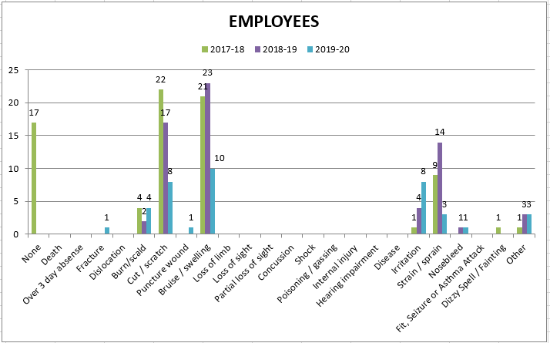

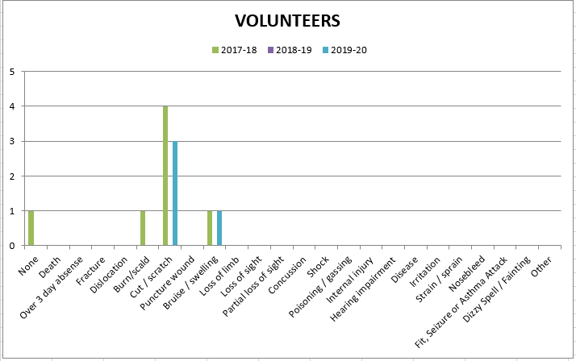
Appendix B, Table 17

Accidents and incidents compared to the previous year to contractors by type of accident/ incident

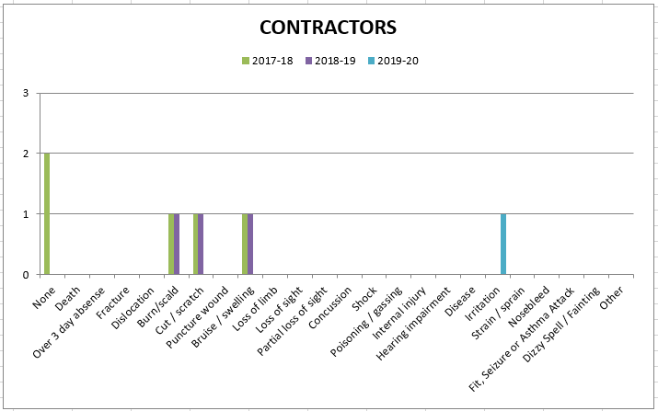

Appendix C, Table 1

Accidents and incidents compared to the previous year for users by HLH section

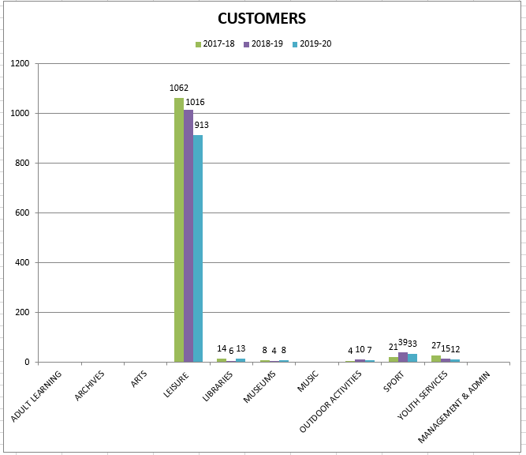

Appendix C, Table 2

Accidents and incidents compared to the previous year for users by nature of accident

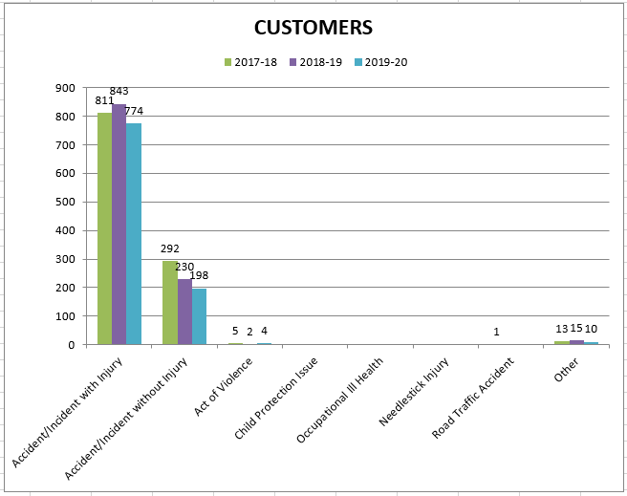

Appendix C, Table 3

Accidents and incidents compared to the previous year to users by type of accident/ incident

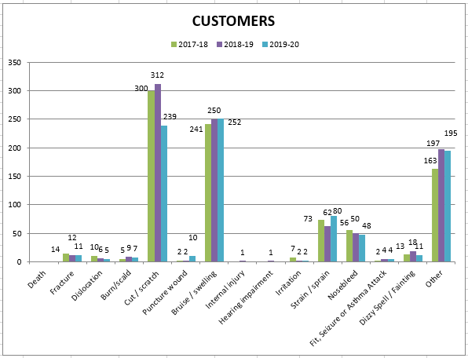

Appendix D

PERFORMANCE INDICATORS 2019-20

Number of Accidents / Incidents involving Staff (Employees, Contractors & Volunteers) Against Total Number of FTE Staff.
Quarter | FTE Staff | Accidents/Incidents | %
Q1 2018-19 | 682.430 | 17 | 2.49
Q2 2018-19 | 687.650 | 17 | 2.47
Q3 2018-19 | 687.910 | 26 | 3.78
Q4 2018-19 | 687.850 | 21 | 3.05
Q1 2019 -2020 | 693.88 | 24 | 3.46
Q2 2019 -2020 | 698.63 | 33 | 4.72
Q3 2019 -2020 | 704.08 | 16 | 2.41
Q4 2019 -2020 | 703.95 | 16 | 2.27

Number of Accidents / Incidents involving customers against total number of customer visits.
Quarter | Customer Visits | Accidents/Incidents | %
Q1 2018-19 | 1,578,586 | 331 | 0.020
Q2 2018-19 | 1,311,066 | 267 | 0.020
Q3 2018-19 | 1,584,194 | 220 | 0.014
Q4 2018-19 | 1,664,408 | 273 | 0.016
Q1 2019 -2020 | 1,581,909 | 273 | 0.017
Q2 2019 -2020 | 1,428,080 | 295 | 0.020
Q3 2019 -2020 | 1,529,209 | 220 | 0.014
Q4 2019 -2020 | 1,156,567 | 198 | 0.017

Breakdown of Accidents or Incidents by Employees, Contractors and Volunteers
 | Accidents/Incidents
Quarter | Employees | Contractors | Volunteers
Q1 2018-19 | 17 | 0 | 0
Q2 2017-18 | 17 | 0 | 0
Q3 2018-19 | 23 | 3 | 0
Q4 2018-19 | 20 | 1 | 0
Q1 2019 -2020 | 24 | 0 | 1
Q2 2019 -2020 | 33 | 0 | 1
Q3 2019 -2020 | 15 | 1 | 1
Q4 2019 -2020 | 17 | 3 | 1

Total number of Incidents that resulted or could have resulted in a fire
Quarter | Incidents
Q1 2018-19 | 0
Q2 2018-19 | 0
Q3 2018-19 | 0
Q4 2018-19 | 1
Q1 2019 -2020 | 1
Q2 2019 -2020 | 0
Q3 2019 -2020 | 1
Q4 2019 -2020 | 0
There were no environmental incidents recorded during 2019-2020
APPENDIX E
HIGH LIFE HIGHLAND  REPORT TO HEALTH, SAFETY AND ENVIRONMENTAL COMPLIANCE COMMITTEE  19 May 2020 | AGENDA ITEM  REPORT No HLH/HS /20

STAFF HEALTH AND WELLBEING UPDATE - Report by Chief Executive

Summary

The purpose of this report is to provide an update on developments in staff health and wellbeing during the COVID-19 outbreak.

It is recommended that Directors note and comment on the report.

1. | Business Plan Contribution
1.1 | This report supports the highlighted Business Outcomes from the High Life Highland (HLH) Business Plan:  1. Sustain a high standard of health and safety, and environmental performance  2. Implement the Service Delivery Contract with THC  3. Improving customer engagement and satisfaction  4. Improving staff engagement and satisfaction  5. Enhance the positive charity image  6. Be a trusted and effective partner  7. Achieve sustainable growth across the organisation  8. Develop health and wellbeing across Highland communities  9. Develop and promote the High Life brand
2. | Background
2.1  2.2 | Prior to the COVID-19 outbreak the focus of staff health and wellbeing centred on the NHS Health Scotland framework called Healthy Working Lives. The Healthy Working Lives framework enables organisations like HLH to develop a planned and integrated approach to improving health, safety and wellbeing at work and ensure health, safety and wellbeing needs in the organisation are being addressed. HLH successfully secured the Healthy Working Lives Bronze Award in December 2019.  Since the COVID-19 outbreak Healthy Working Lives has been put on hold by NHS Health Scotland and staff health and wellbeing in HLH has been refocussed to consider what the organisation can do to support employees in reasonable and practical ways at this time.
3. | Staff Health and Wellbeing During COVID-19: Delivery Plan
3.1  3.2  3.3  3.4 | To outline what HLH can do to reasonably and practically support employees at this time a delivery plan for staff health and wellbeing, during COVID-19, has been written (see Appendix A).  The plan content has been generated following consultation and review with the HLH COVID-19 Working Group, Extended (Quarterly) Management Team and the Executive Team through the weekly business meeting.  The plan relates to staff who have been furloughed as well as those who have not been furloughed and outlines the activities, tasks, milestones, progress indicators and responsible persons for implementation to ensure that HLH Staff Health and Wellbeing is facilitated, supported and enabled during the period whilst the organisation continues to manage its response to and the effects of the COVID-19 outbreak.  The objective and intended outcome of the plan is to facilitate positive health and wellbeing of HLH Staff during the coronavirus outbreak. Three themes are covered in the plan:  1. Information Sharing  2. Engagement and Activities  3. Recovery
4. | Activities/Tasks
4.1 | The activities and tasks within the plan are wide ranging and can be viewed in Appendix A. A sample of some of the activities are listed below:
- Provide content and links to key information for staff from validated, reliable sources on staff health and wellbeing website
- Keep in mind anyone who may be shielded or vulnerable due to a pre-existing health condition, or disability, age, or pregnancy, and be aware of the additional duties as an employer to these specific groups of employees
- Ensure staff are supported and in regular contact with Senior Management Team member or Line Manager
- Provide more focused welfare calls when requested
- Facilitate specific opportunities for employees to take care of their mental and physical health and wellbeing
- Be prepared to adjust resourcing plans accordingly (based on virus spread, heightened infection risk and furlough status)
- Be prepared for staff returning to work and customers returning to buildings
4.2 | Good progress in delivering the plan has been made, with all work plan areas reporting Green in the RAG rating which can be found viewed at Appendix A.
5. | Bringing the plan to life
5.1  5.2  5.3  5.4 | It has become better known and understood that just as we all have physical health we all have mental health too. It’s equally important we take the time to look after both our physical and mental health and wellbeing.  The plan takes account that some employees might feel worried or stressed about coronavirus and how it may be affecting their life and their loved ones. Acknowledging there are things we can all do to look after our mental and physical wellbeing, which can help to cope if with feelings of anxiousness or worry can be helpful for some.  The plan also acknowledges that if staff are struggling with mental health, it’s okay to say that and finding a trusted person to speak to and share those feelings with can help. Employees are encouraged, if they’re worried about someone, or even if not, to reach out to friends, family and colleagues who you might not be seeing, ask them if they’re okay, and have a chat.  A couple of examples of the how the plan is being implemented are outlined below.
6. | Staff Health and Wellbeing Website
6.1  6.2 | Within the staff health and wellbeing website a section called “Your Health and Wellbeing” has been created. This section of the website focusses purely on providing staff with useful information, from reliable and verified sources, to support their mental and physical health and wellbeing. It is regularly up-dated, and employees are encouraged to contribute to the content by sharing helpful information that they have found personally beneficial which may also benefit others.  The content of the “Your Health and Wellbeing” section of the website includes the following topics:  - How do I look after my mental wellbeing?  - Physical activity  - Looking after your sleep  - Building wellbeing and resilience  - Fun activities to do at home with the family  - Working from home tips
7. | HLH Huddles
7.1  7.2  7.3 | Weekly Staff Health and Wellbeing sessions called HLH Huddles are currently being scoped out as a pilot project and small test of change. HLH Huddles are intended to be for all staff (furloughed and not furloughed) to engage in during this time.  The concept is simple – each week there will be different activities/topics for staff to join in with that will support and facilitate their health and wellbeing. Now, at a time when everyone must stay home and be physically distant, staff may find it helpful to engage in informal and fun activities with colleagues as form of support during the coronavirus outbreak.  The Huddles will be facilitated by staff volunteers who have enthusiasm for their topic and a desire to share with colleagues.  The draft programme is shaping up as follows:  - Support to look after your mental health and wellbeing  - Learn with Lorna - keeping perspective: we have come through epidemics before (the 1918 Spanish Flu epidemic)  - Virtual Book Group with Joolz from library service  - Introduction to Music with music instructors
7.4 | At the time of writing this report the ICT challenges are being worked on and an appropriate platform for the sessions to take place on is being explored such as Vscene and Microsoft Teams, to ensure that all staff can access the offering from their personal devices if they do not have a work device to use at home.
8.  8.1  8.2 | Governance  The proposed Governance and ongoing monitoring of the Staff Health and Wellbeing Plan will be once per month through the extended Management Team during the COVID-19 outbreak whilst specific guidance and measures remain in place as determined by both Scottish and UK Governments.  As things move towards a more stable and ‘new normal’ footing the proposed Governance of staff health and wellbeing is twice per year through the Extended (Quarterly) Management Team, the Executive Team and the Staff Health Safety Group, also reporting to the Health Safety and Environmental Compliance Committee twice per year.
9. | Implications
9.1  9.2  9.3  9.4 | Resource Implications – there are no new resource implications associated with this report.  Legal Implications – there are no new legal implications associated with this report.  Equality Implications – there are no new equality issues associated with this report.  Risk Implications – there are no new risk implications associated with this report.

Recommendation

It is recommended that Directors note and comment on the report.

Designation: Chief Executive

Date: 28 April 2020

Staff Health and Wellbeing During COVID-19: Delivery Plan

This plan relates to staff who are furloughed as well as those who are not furloughed, it outlines the activities, tasks, milestones, progress indicators and responsible persons for implementation to ensure that HLH Staff Health and Wellbeing is facilitated, supported and enabled during the period whilst the organisation continues to manage its response to and the effects of the COVID-19 outbreak.

Three themes are covered in this plan: 1. Information Sharing 2. Engagement and Activities 3. Recovery

Objective (impact) | Theme | Activity/Tasks | Milestones | Timescale | Progress Indicators | Lead | Support | Status | Blockers
Positive health and wellbeing of HLH Staff during C-19 outbreak | 1 | Introduce section for regular updates on staff health and wellbeing website | New section created and maintained | 30.03.20 onwards | - Website updated and maintained | AJ | LB  QMT | G | None
 | 1 | Make sure managers are clear on any relevant policies and processes, for example sickness reporting and sick pay, homeworking and death in service policy. | Updates from Scottish and UK Governments, Occ. Health and Unions | 30.03.20 onwards | - Quality (over quantity) of updates given  - Emails and SPOR information given  - Feedback from teams on content | MM | LB  QMT | G | None
 | 1 | Provide content and links to key information for staff from validated, reliable sources on staff health and wellbeing website | Minimum weekly updates | 30.03.20 onwards | - Quality (over quantity) of updates given  - Variety of updates given  - Website viewing figures  - Feedback from teams | LB | AJ  QMT | G | None
 | 1 | Keep in mind anyone who may be shielding or vulnerable due to a pre-existing health condition, or disability, age, or pregnancy, and be aware of the additional duties as an employer to these specific groups of employees. | Updates from Scottish and UK Governments, Occ. Health and Unions | 30.03.20 onwards | - Daily monitoring of information released in general media to the general-public and from partner organisations | LB | MM  QMT | G | None
 | Theme | Activity/Tasks | Milestones | Timescale | Progress Indicators | Lead | Support | Status | Blockers
 | 1 | Ensure Line Managers are supported and provided with relevant and up-to-date resources to maintain regular contact with teams | Aid Memoirs created  Ask/check with Managers re support req | 30.03.20 onwards | - Quality (over quantity) of resources developed  - Feedback from Managers  - Feedback from team(s) | LB | MM  QMT | G | None
 | 1 | Review and redesign information from partner orgs for relevance and sharing with HLH staff on staff health and wellbeing website | Contact with partner orgs for info sharing | 30.03.20 onwards | - Quality (over quantity) of sources reviewed & issued  - No. of views on website of information given | LB | QMT | G | None
 | 2 | Ensure staff are supported and in regular contact with Senior Management Team member or Line Manager | Timescale and process to be agreed w/ op teams | 30.03.20 onwards | - Number of contacts made  - Feedback from Managers  - Feedback from team(s) | All Line Managers | QMT | G | None
 | 2 | More focused “welfare” call followed-up by HR Manger, HWB Manager or Director of Corporate Services when requested | Triggered by Line Managers (inc, temp Line Managers) | 30.03.20 onwards | - Number of requests made  - Number of follow-up calls made  - Feedback from Managers and staff | MM | LB  QMT | G | None
 | 2 | Enable staff participation in health and wellbeing activities e.g. motivational staff challenges | New challenges established | 30.03.20 onwards | - Number of activities  - Type of activities | LB | QMT | G | None
 | 2 | Facilitate specific opportunities for employees to take care of their mental health and wellbeing | Info provided on SPOR and through Line Managers (inc. temp Line Managers) | 30.03.20 onwards until more normal service resumes | - Quality (over quantity) of sources provided  - Use of validated tools and sources only | LB | QMT | G | None
 | Theme | Activity/Tasks | Milestones | Timescale | Progress Indicators | Lead | Support | Status | Blockers
 | 2 | Facilitate specific opportunities for employees to take care of their physical health and wellbeing | Information provided on Single Point of Reference and through Line Managers (inc. temp Line Managers) | 30.03.20 onwards until more normal service resumes | - Quality (over quantity) of sources provided  - Use of validated tools and sources only | LB | QMT | G | None
 | 3 | Business continuity and pressure on remaining staff – if some people are taking on additional responsibilities to bridge gaps, make sure they feel appreciated and this is for a relatively short time | Regularly communicate how much everyone’s contribution is valued  Monitor expectations/workloads/work-life balance | 30.03.20 onwards until more normal service resumes | - Regular phone or Skype catch-ups with team members from Managers  - Statement/update from CEO through SPOR | All Line Managers | QMT | G | None
 | 3 | Be prepared to adjust resourcing plans accordingly (based on virus spread, heightened infection risk and furlough status) | Updates from Scottish and UK Governments | 30.03.20 onwards until more normal service resumes | - Daily monitoring of information released in general media to the general public  - Daily monitoring of information released by partner organisations | LB | QMT | G | None
 | 3 | Be prepared for staff returning to work and customers returning to buildings. Ask staff if they have any concerns about returning | Updates from Scottish and UK Governments | 17.04.20 onwards | - Daily monitoring of information released from both Governments | LB | MM  QMT | G | None

