HIGH LIFE HIGHLAND  REPORT TO BOARD OF DIRECTORS  10 December 2020 | AGENDA ITEM REPORT No HLH /20

Performance Report - Report by Chief Executive

Summary

The purpose of this report is to present performance information for the period July to September 2020.

It is recommended Directors:

- comment on the report and agree that the overall health check on the Charity for that period is assessed as amber because the effect of the lockdown and COVID-19 management arrangements which are required to operate;
- note that the delivery of the business plan has been paused, with the focus having become the Recovery Action Plan and that the business plan is being reviewed in the light of the COVID pandemic; and
- note that the mitigating actions are being developed as contained in the Recovery Action Plan and other reports elsewhere on this agenda.

1. | Business Plan Contribution
1.1 | This report supports all of the Business Outcomes from the High Life Highland (HLH) Business Plan:  - Sustain a high standard of health and safety, and environmental performance  - Implement the Service Delivery Contract with THC  - Improving customer engagement and satisfaction  - Improving staff engagement and satisfaction  - Enhance the positive charity image  - Be a trusted and effective partner  - Achieve sustainable growth across the organisation  - Develop health and wellbeing across Highland communities  - Develop and promote the High Life brand
2. | Background
2.1 | The implementation of the HLH Business Plan 2019-24 is monitored in two ways:  - through a set of performance indicators set by the Board at its meeting held on 11 December 2018; and  - by RAG rating the delivery of the business outcomes contained in the business plan with these being reported to the Board by exception (i.e. reporting where managers had RAG rated the actions “red – no significant progress”).

3. | Summary of Performance
3.1 | Sixteen performance indicators (PIs) were identified by the HLH Board to assess the overall performance of the Charity. At its meeting in December 2019 the HLH Board agreed to develop a simplified/summarised reporting format and Appendix A contains a summary of performance against the PIs for quarter two 2020/21.
3.2 | Appendix B provides a summary of all the PIs along with trend information. Eleven performance indicators were scheduled for assessment at the August 2020 Board meeting. Six of them have been RAG rated “green” and four have been RAG rated “red”.
3.3 | PI 9. Media Clippings has not been RAG rated because media profile has been monitored in other ways since March 2020 and there is further information on this in the Marketing and Communications item elsewhere on this agenda.
3.4 | The PIs which have been RAG rated red are as follows:  - PI 4. Customer Engagements.  - PI 12. Financial monitoring.  - PI 13. Number of highlife subscriptions  - PI 14. highlife subscription cancellation rate.
3.5.1 | PI 4. Customer Engagements has been RAG rated red. The number of engagements in quarter two 2019/20 was 2,127,870 and in the same quarter this year was 1,325,355. As services have returned there has been an increase in customer visits of 15% between quarters 1 and 2. Archives customer engagements increased due to an increase in the use of the Am Baile Gaelic language and culture web site and social media engagements between Q2 2019/20 and Q2 this year.
3.5.2 | Because of the importance of highlife leisure subscriptions to the charity, footfall at the highlife leisure sites is being monitored weekly. This is encouraging with 6,729 visits during the first week of opening, increasing to 16,178 12 weeks after opening. The weekly trend can be seen in the graph below.
3.6 | PI 12. Financial monitoring has been RAG rated red. While there is a surplus against budget for the current quarter the financial scenario planning indicates that there could be a loss of the order of £560K at the financial year end. There is further information contained in the Finance Report elsewhere on this agenda.
3.7.1 | PI 13. Number of highlife subscriptions. This PI has been RAG rated red because of the reduced number of subscriptions during Q2 2020/21 compared with previous years. At the time of writing the number of subscriptions were 11,004 which (as explained below) is ahead of what was anticipated at this stage. The number of subscriptions is being monitored weekly because of the importance of them for financial recovery.
3.7.2 | The graph below shows the reduction in subscriptions income since lockdown and a projection for the remainder of this financial year and next which reflects the budget planning which has been undertaken. As can be seen on the graph the income exceeded the number required to achieve the budget forecast in November. The full effect of the reintroduction of swimming lessons will be seen in the December direct debit run and these are currently on track to exceed the target set for that month. Please note that the forecast for next year relies on restrictions ending in March 2021. Current restrictions incur additional cost, and opening hours (except at Inverness Leisure) have been reduced on average by 38% to offset this. In addition, capacity has significantly reduced because of the need for physical distancing.  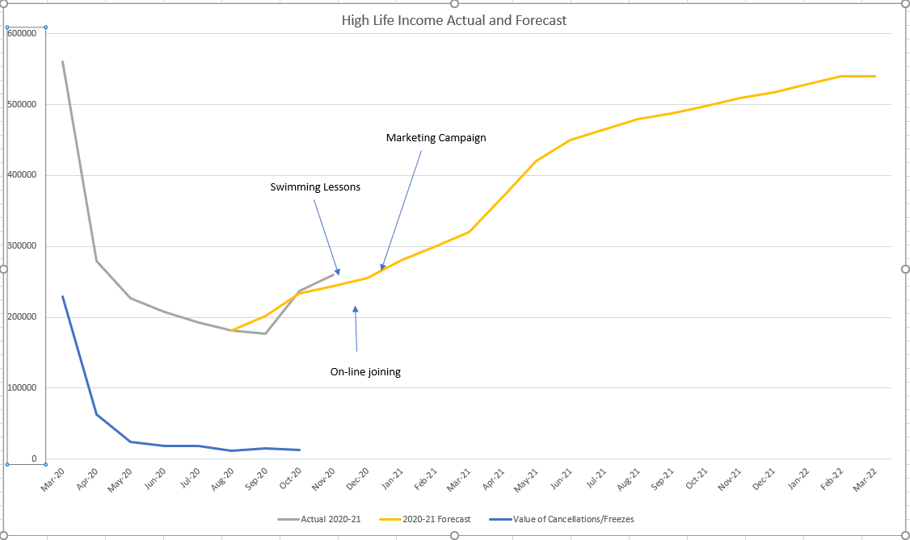
3.8.1 | PI 14. highlife subscription cancellation rate has been RAG rated red for the quarter. While the cancellation rate is fairly close to previous levels there are still customers who are suspending their subscriptions in addition to those who cancel. The reasons people gave for suspending and cancelling their subscriptions have been reviewed for two time periods: one during lockdown; and the other after reopening.
3.8.2 | Between 23 March and 31 August, the time when leisure facilities had to close, the overwhelming reason for people cancelling was for COVID-19 concerns with 80% cancelling for that reason. 8.3 % said affordability and 2.5% saying they had moved away. All other reasons were less than 1.5%.  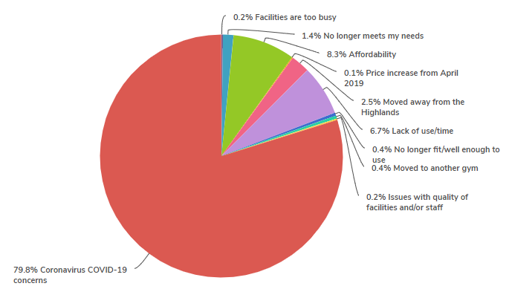
3.8.3 | From 1 September to the first week in November, after facilities had re-opened, 40% of cancellations were because of coronavirus concerns. Despite being allowed to open, during that time there was a resurgence in the virus with the tiered system being introduced and lockdowns in England and Northern Ireland. This almost certainly had an impact on customer confidence. The next most frequently given response was lack of use/time at 23%, then affordability at 9.7% and people having moved away from the highlands at 8%.  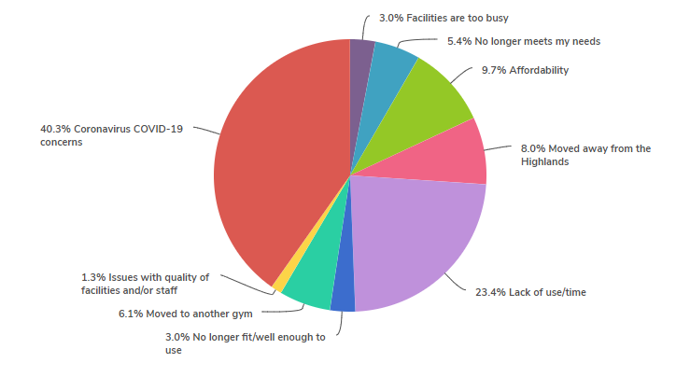
3.8.4 | By way of comparison, prior to lockdown the lack of use/time was the most frequently given response at 40%, then moved away from the highlands at 28% with the rest being split between reasons such as affordability, facilities being too busy and the service no longer meeting people's needs.
3.9.1 | A survey of customers who returned to leisure facilities since 31 August 2020 was issued on 20 November 2020 with 912 responses. The survey was timed to follow the reintroduction of all of the activities which are allowed under the COVID-19 management guidance (the last of which was swimming lessons) in order to ensure that the results were based on HLH having done as much as possible from a programming perspective to encourage customers to return.
3.9.2 | The survey responses indicate that as far as customers are concerned the service in leisure facilities and the new arrangements are meeting customer expectations. The results are summarised below and there is further detail in Appendix C:  - 91.5% rated their customer experience with the new COVID-19 arrangements as good, very good or excellent;  - 94.6% rated cleaning provision as good, very good or excellent;  - 87.6% said that it was easy or very easy to maintain social distancing;  - 59.1 % said that compared with other places they had visited their safety experience was better than others, (with 39.7% saying it was about the same). Reasons people gave for saying that their experience felt less safe was not taking customer temperatures prior to entry, other customers not following one way systems in changing rooms, there being limited circulation space, there being too many swimmers per lane (lane swimming is bookable and numbers are restricted in compliance with government guidance), and a suggestion that people wear face coverings in fitness suites while exercising on resistance equipment;  - 79% said that the changes to opening hours suited them; and  - 89.6% said that the online booking system was good, very good or excellent.
3.9.3 | Customers were also asked what could be done to improve the service and many of the responses were to keep doing what we are doing. There were a high number of responses saying that customers liked that all activities are bookable and that numbers in activities are restricted compared to pre-lockdown. There were some requests that opening hours be extended (operating costs associated with COVID-19 management arrangements are higher than they were before and opening hours have been targeted to the busiest times in order to minimise costs).
3.9.4 | The leisure managers have reviewed the survey and the following changes were made:  - instructors of group activities have re-enforced physical distancing messages;  - signage has been reviewed to clarify one-way systems;  - public address systems have been used to reinforce physical distancing messages;  - the current 12 midnight start time for advance booking is being changed to 10pm; and  - where possible additional classes have been added to programmes to cater for demand.
3.9.5 | The positive survey results have provided an opportunity for a media release which will be issued by the marketing and communications team in the coming week.
3.9.6 | A further two surveys will be issued to customers: one to customers who have cancelled; and the other to those who have frozen their subscriptions. This will help to ascertain whether there is anything which can be done to encourage them to return.
3.10 | In order to build on the Charity’s BounceBack recovery work which aims to maximise customer return and engage new customers there will be a social media, radio and television marketing campaign in December and January. Further information on the campaign will be highlighted in the biannual Marketing and Communications presentation at the Board meeting.

4. | Delivery of Business Outcomes
4.1 | The HLH Business Plan 2019-24 identifies nine business outcomes and the approach which the Charity takes to deliver them. The resultant operational plans for each of the nine HLH areas of work are RAG rated every quarter.
4.2 | With most of the regular work of HLH having stopped the Recovery Action Plan has been the focus of the work of the organisation and there is a separate report elsewhere on this agenda which contains an update on the recovery work. The business plan outcomes have, therefore, not been RAG rated.
5. | Performance Indicators for More Detailed Consideration
5.1 | The performance indicators scheduled for more detailed consideration at the December HLH Board meeting are:  - PI 3. Delivery of the Service Delivery Contract (SDC) with The Highland Council (THC).  - PI 6. Formal complaints.  - PI 9. Media clippings.  - PI 10. THC’s annual survey of performance and attitudes.
5.2 | PI 3. Delivery of the Service Delivery Contract (SDC) with The Highland Council (THC) has been RAG rated as being on target. The Highland Council’s Education Committee considered a six-monthly HLH Progress Report which included a presentation by the HLH Chief Executive at its meeting held on 18 November 2020. At the meeting the committee noted that “... HLH met or exceeded the outcomes expected in the Service Delivery Contract with The Highland Council for the operating period to September 2020". A link to the report and webcast can be seen on THC’s web site:  - https://www.highland.gov.uk/meetings/meeting/4345/education_committee  - https://highland.public-i.tv/core/portal/webcast_interactive/465113
5.3.1 | PI 6. Formal complaints have been assessed (through the RAG rating system) as being on target over the past year. From November 2019 to October 2020 there were only 28 formal complaints which is very low in relation to the number of customer visits. The resolution status of the complaints was as follows:  Upheld 10  Partially upheld 6  Not upheld 12  Total 28
5.3.2 | The complaint breakdown by area of work was as follows:  Libraries 3  Leisure 21  Management & Admin 2  Outdoor activities 1  Sport 1  Total 28
5.3.3 | The complaints were categorised as follows:  Other 25  Pricing 2  Staff 1  Total 28
5.3.4 | Because of the number of complaints that were categorised as “other” they were reviewed to assess whether there were any patterns which required to be addressed across the charity. Five related to a confidential staffing matter, most of the others related to continuing charging during the lockdown (refunds were provided). There were a number of others which were complaints about having to comply with the new COVID-19 management arrangements or facilities not being open during lockdown. Two related to bookings system faults which were fixed. There were a few isolated complaints which included a delay in replying to correspondence, a child being in a health suite area and a glitch in the booking system relating to the “carer goes free” scheme.
5.3.5 | Of the complaints categorised as “pricing” one was about payments during lockdown and the other about pay as you go charges having been applied despite the customer having an active subscription (refunds made in both cases). The one categorised as “staff” related to language being used by other class participants.
5.3.6 | Having reviewed the complaints over the past year it is not considered that there is any pattern indicative of the need for procedural or other changes across the organisation.
5.4 | PI 10 - THC’s annual survey of performance and attitudes has not been RAG rated because the Council paused its annual survey during 2020. It is expected that this will be resumed next year.

6. | Implications
6.1 | Resource Implications – there are no additional resource implications arising from this report. Resource implications have been covered in the Finance Report elsewhere on this agenda.
6.2 | Legal Implications - there are no new legal implications arising from this report.
6.3 | Equality Implications – there are no new equality implications arising from this report.
6.4 | Risk Implications – there are no new risk implications arising from this report.

Recommendation

It is recommended Directors:

- comment on the report and agree that the overall health check on the Charity for that period is assessed as amber because the effect of the lockdown;
- note that the delivery of the business plan has been paused, with the focus having become the Recovery Action Plan and that the business plan is being reviewed in the light of the COVID pandemic; and
- note that the mitigating actions are being developed as contained in the Recovery Action Plan and other reports elsewhere on this agenda.

Designation: Chief Executive

Date: 30 November 2020

Appendix A
HLH Performance Indicators year to date 2020/21
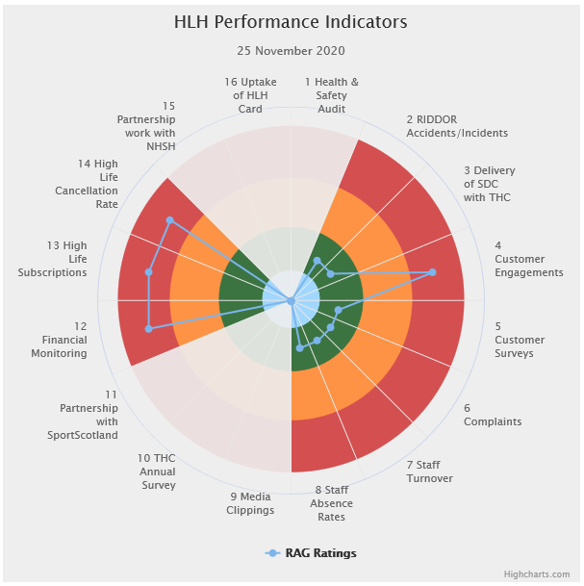 | Sixteen performance indicators (PIs) are used by the High Life Highland Board to assess the overall performance of the charity.  The PIs are RAG rated (allocated a "Red", "Amber" or "Green" status) so that it is easy to see at a glance how the organisation is performing. Most of the PIs are RAG rated every quarter throughout the year with some (such as partnership working with NHSH for example) being considered annually, so greyed out sectors on this radar diagram mean that the PI is to be considered at a future HLH Board meeting.
Appendix B
HLH Performance Indicators

Business Plan Outcome | Performance Indicator | Reporting Frequency | RAG Rating Definition | RAG Rating Q1 20/21 | RAG Rating Q2 20/21 | RAG Rating Q3 20/21 | RAG Rating Q4 20/21 | Summary of Quarter Two Performance
1. Sustain a high standard of health and safety and environmental performance | 1. Health and safety audit. | Annual. | - Red = the external audit raises systemic (i.e. applying across multiple sites) H&S issues.  - Amber = the external audit highlights common actions to be addressed across the company.  - Green = the external audit does not raise systemic issues. | N/A. | N/A |  |  | N/A. This is an annual indicator.

Business Plan Outcome | Performance Indicator | Reporting Frequency | RAG Rating Definition | RAG Rating Q1 20/21 | RAG Rating Q2 20/21 | RAG Rating Q3 20/21 | RAG Rating Q4 20/21 | Summary of Quarter Two Performance
1. Sustain a high standard of health and safety and environmental performance (cont.) | 2. RIDDOR accidents/incidents. | Quarterly. | - Red = number of RIDDOR reports per quarter is above 20.  - Amber = number of RIDDOR reports per quarter is between 10 and 20  - Green = number of RIDDOR reports per quarter is less than 10. | Green | Green |  |  | There was one accident reported under the RIDDOR regulations during Q2 2020/21. This has been reported at the Health and safety and environmental Compliance Committee.

Performance Indicator 2 - RIDDOR accidents/incidents
The graph below tracks the number of accidents and incidents reported under the Reporting of Injuries, Diseases and Dangerous Occurrences Regulations (RIDDOR). There was 1 RIDDOR accidents / incident reported in Q2 2020/21.
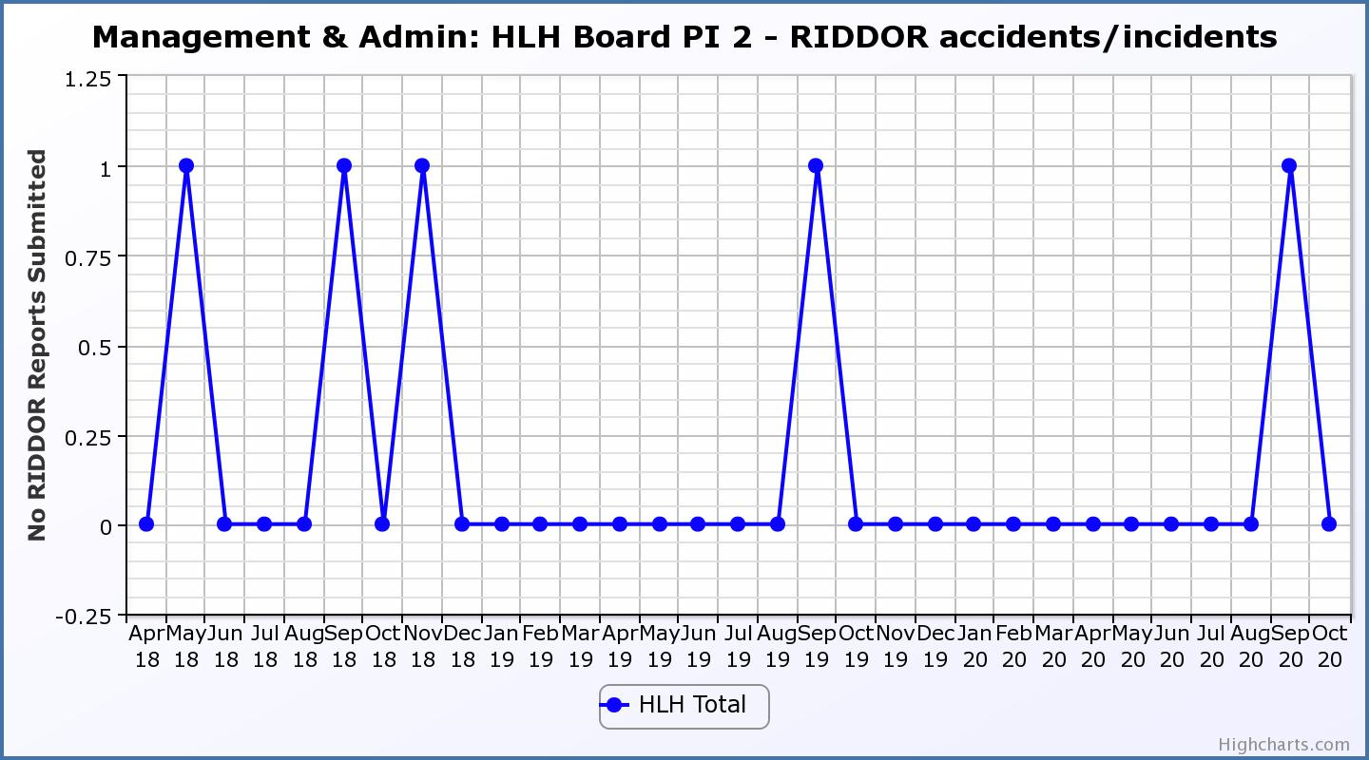

Business Plan Outcome | Performance Indicator | Reporting Frequency | RAG Rating Definition | RAG Rating Q1 20/21 | RAG Rating Q2 20/21 | RAG Rating Q3 20/21 | RAG Rating Q4 20/21 | Summary of Quarter Two Performance
2. Implement the Service Delivery Contract with The Highland Council | 3. Delivery of the Service Delivery Contract (SDC) with The Highland Council (THC). | Six-monthly. | - Red = agreement of THC’s CLH Committee that HLH has not met the terms of the SDC.  - Amber = agreement of THC’s CLH Committee that HLH has met the terms of the SDC but has set some improvement targets.  - Green = agreement of THC’s CLH Committee that HLH has met or exceeded the terms of the SDC. | N/A | Green |  |  | At its meeting held on 18 November 2020, THC's Education committee noted that “... HLH met or exceeded the outcomes expected in the Service Delivery Contract with The Highland Council for the operating period to September 2020"

Business Plan Outcome | Performance Indicator | Reporting Frequency | RAG Rating Definition | RAG Rating Q1 20/21 | RAG Rating Q2 20/21 | RAG Rating Q3 20/21 | RAG Rating Q4 20/21 | Summary of Quarter Two Performance
3. Improve customer engagement and satisfaction | 4. Customer engagements. | Quarterly. | - Red = customer numbers are more than 5% lower than the corresponding quarter in the previous year.  - Amber = customer numbers are less than the corresponding quarter in the previous year.  - Green = customer numbers are the same as or have increased compared with the corresponding quarter in the previous year. | Red | Red |  |  | Customer engagements decreased from 2,127,870 in Q2 2019/20 to  1,325,355 in Q2 2020/21. The reduction was associated with the lockdown and reduced capacity as a result of flowing government COVID management arrangements. Please see section five of this report for further information.
Performance Indicator 4 - Customer engagements
Customer numbers decreased due to the COVID-19 situation and have increased following being allowed to re-open.
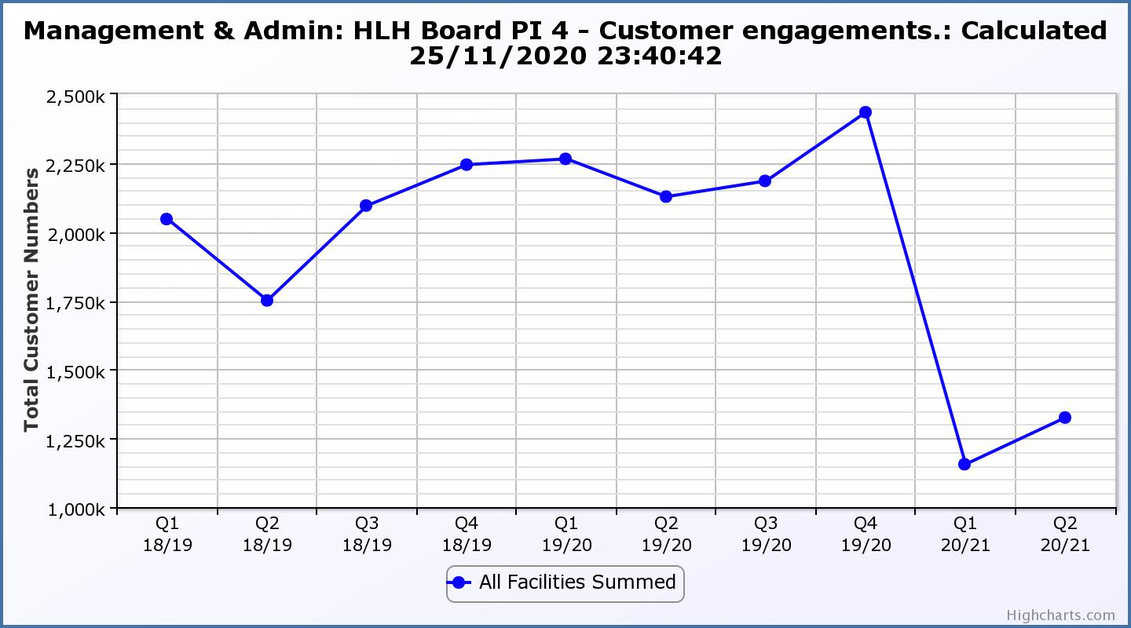

Business Plan Outcome | Performance Indicator | Reporting Frequency | RAG Rating Definition | RAG Rating Q1 20/21 | RAG Rating Q2 20/21 | RAG Rating Q3 20/21 | RAG Rating Q4 20/21 | Summary of Quarter Two Performance
3. Improve customer engagement and satisfaction (cont.) | 5. Customer surveys. | Quarterly. | - Red = no surveys have been completed or scheduled.  - Amber = 4 to 8 of the HLH areas of work have completed or scheduled customer surveys.  - Green = all areas of HLH work have completed or scheduled customer surveys. | Green | Green |  |  | All areas of work have carried out or planned customer surveys for 2020/21.  This PI was last reported on in further detail at the March 2020 HLH Board meeting.  There is information on the current leisure facilities customer survey in section 3.10 of this report and appendix C.

Business Plan Outcome | Performance Indicator | Reporting Frequency | RAG Rating Definition | RAG Rating Q1 20/21 | RAG Rating Q2 20/21 | RAG Rating Q3 20/21 | RAG Rating Q4 20/21 | Summary of Quarter Two Performance
3. Improve customer engagement and satisfaction (cont.) | 6. Formal complaints. | Quarterly. | - Red = 41 or more complaints per quarter.  - Amber = 31 to 40 complaints per quarter.  - Green = 30 complaints or fewer per quarter. | Green | Green |  |  | There were five complaints received during Q2 2020/21.

Performance Indicator 6 - Formal Complaints
The graph below shows the number of complaints which continue to be very low in relation to customer numbers.
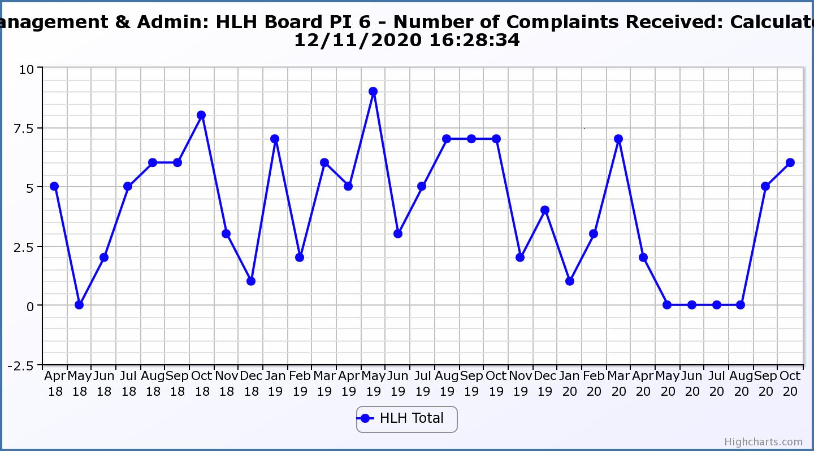
Business Plan Outcome | Performance Indicator | Reporting Frequency | RAG Rating Definition | RAG Rating Q1 20/21 | RAG Rating Q2 20/21 | RAG Rating Q3 20/21 | RAG Rating Q4 20/21 | Summary of Quarter Two Performance
4. Improve staff engagement and satisfaction | 7. Staff turnover (resignations as a percentage of posts). | Quarterly. | - Red = more than 2%  - Amber = 1.7 to 2%  - Green = 1.6% or less | Green | Green |  |  | The number of resignations per month as a percentage of posts in Q2 was 1% in July, 1% in August and 0.8% in September. Please see HR report elsewhere on this agenda for further information.

Performance Indicator 7 - Staff Turnover (resignations as a percentage of posts)
The graph below shows resignations as a percentage of the number of posts and resignations have been consistent with previous years and continue to be low (1% equates to 10.6 staff)

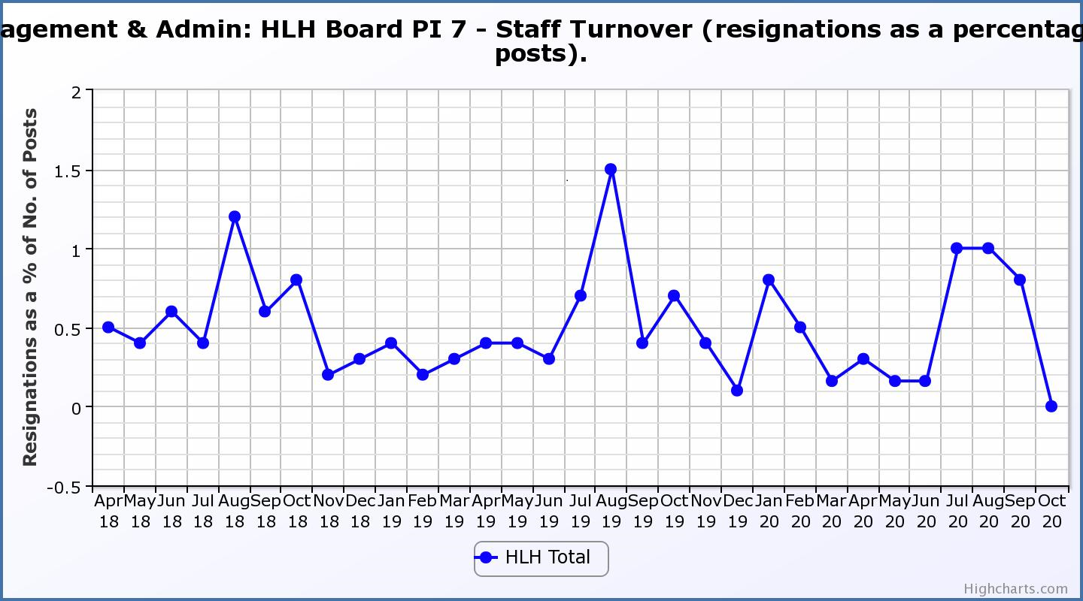

Business Plan Outcome | Performance Indicator | Reporting Frequency | RAG Rating Definition | RAG Rating Q1 20/21 | RAG Rating Q2 20/21 | RAG Rating Q3 20/21 | RAG Rating Q4 20/21 | Summary of Quarter Two Performance
4. Improve staff engagement and satisfaction (cont.) | 8. Staff absence rates. | Quarterly. | - Red = absence rate greater than 3.6%.  - Amber = absence rate between 3.4% and 3.6%.  - Green = absence rate 3.3% or less. | Green | Green |  |  | The absence rate for Q2 was 0.98%. Please see the HR report elsewhere on this agenda for further information.

Performance Indicator 8 - Staff Absence Rates
The absence rate reduced in quarters one and two 2020/21 was low, however, staff being furloughed meant that they did not have to report absences as they normally would. Please see the HR report elsewhere on this agenda for further information.
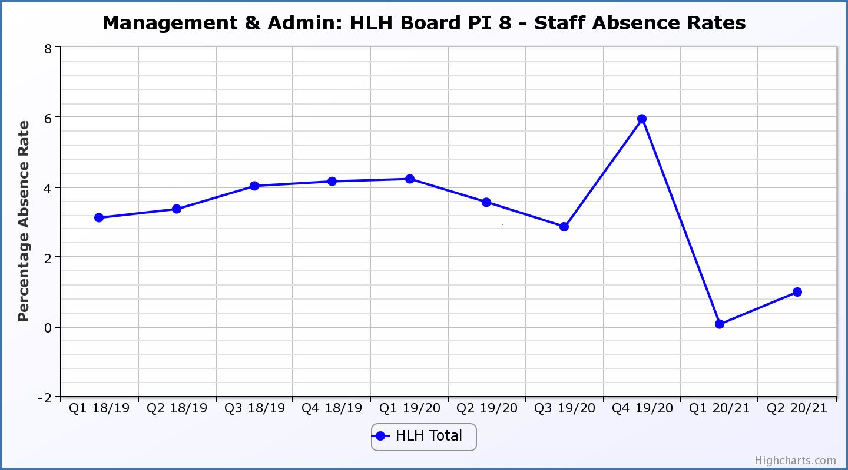

Business Plan Outcome | Performance Indicator | Reporting Frequency | RAG Rating Definition | RAG Rating Q1 20/21 | RAG Rating Q2 20/21 | RAG Rating Q3 20/21 | RAG Rating Q4 20/21 | Summary of Quarter Two Performance
5. Enhance the positive company image | 9. Media clippings. | Quarterly | - Red = number of negative press clippings outweigh neutral and positive.  - Amber = number of negative and neutral press clippings outweigh positive.  - Green = number of positive and neutral media clippings outweigh negative. | Green | NA |  |  | Media Clippings have not been RAG rated because media profile has been monitored in other ways since March 2020. There is further information on this in the Marketing and Communications report elsewhere on this agenda.

Business Plan Outcome | Performance Indicator | Reporting Frequency | RAG Rating Definition | RAG Rating Q1 20/21 | RAG Rating Q2 20/21 | RAG Rating Q3 20/21 | RAG Rating Q4 20/21 | Summary of Quarter Two Performance
6. Be a trusted and effective partner | 10. THC’s annual survey of performance and attitudes. | Annual. | - Red = all HLH areas of work represented receive lower net satisfaction ratings than the previous year.  - Amber = two or more areas of HLH work receive lower net satisfaction ratings than the previous year.  - Green = net satisfaction ratings are maintained or improved for three or more areas of HLH work compared with the previous year. | NA | NA |  |  | This PI has not been RAG rated because the Council paused its annual survey during 2020. It is expected that this will be resumed next year.

Business Plan Outcome | Performance Indicator | Reporting Frequency | RAG Rating Definition | RAG Rating Q1 20/21 | RAG Rating Q2 20/21 | RAG Rating Q3 20/21 | RAG Rating Q4 20/21 | Summary of Quarter Two Performance
6. Be a trusted and effective partner (cont.) | 11. Partnership work with sportscotland | Annual | - Red = cancellation of Partnership Agreement with sportscotland  - Amber = continuation of current level of partnership work with sportscotland  - Green = Growth in partnership working with sportscotland | Green | NA |  |  | This is an annual indicator and was last considered by the HLH Board at its meeting held on 27 August 2020.

Business Plan Outcome | Performance Indicator | Reporting Frequency | RAG* Rating Definition  (*Red/Amber/Green) | RAG Rating Q1 20/21 | RAG Rating Q2 20/21 | RAG Rating Q3 20/21 | RAG Rating Q4 20/21 | Summary of Quarter Two Performance
7. Achieve sustainable growth across the organisation | 12. Financial monitoring. | Quarterly. | An assessment of the year end outturn where:  - Red = delivery of services over budget above 2%.  - Amber = delivery of services between break-even and 2% over budget.  - Green = delivery of services within budget. | Red | Red |  |  | The projected year end variance to budget using the financial scenario planning as reported in the Finance Report elsewhere on this agenda shows a negative variance to budget of £560K. The PI has, therefore been RAG rated red despite the positive variance in the quarter.

Performance Indicator 12 - Financial monitoring
See the Finance Report elsewhere on this agenda for further information.
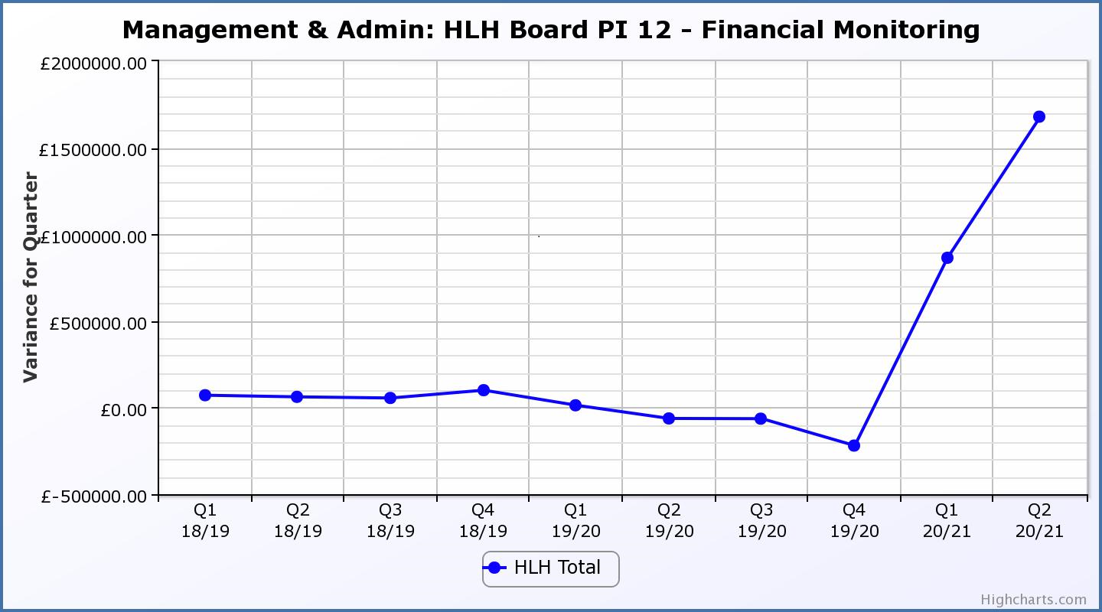
Business Plan Outcome | Performance Indicator | Reporting Frequency | RAG Rating Definition | RAG Rating Q1 20/21 | RAG Rating Q2 20/21 | RAG Rating Q3 20/21 | RAG Rating Q4 20/21 | Summary of Quarter Two Performance
7. Achieve sustainable growth across the organisation (cont.) | 13. Number of High Life subscriptions. | Quarterly. | - Red = more than 5% below target.  - Amber = up to 5% below target.  - Green = on or exceeds target. | Red | Red |  |  | This PI has been RAG rated red because of the reduced number of subscriptions during Q2 2020/21 compared with previous years. The income being generated is, however, above the level required to achieve the target in the recovery planning work.

Performance Indicator 13 - Number of High Life Subscriptions
This graph shows the number of subscriptions with an increase in October as sites re-opened. There is further information in paragraph 3.7 above.

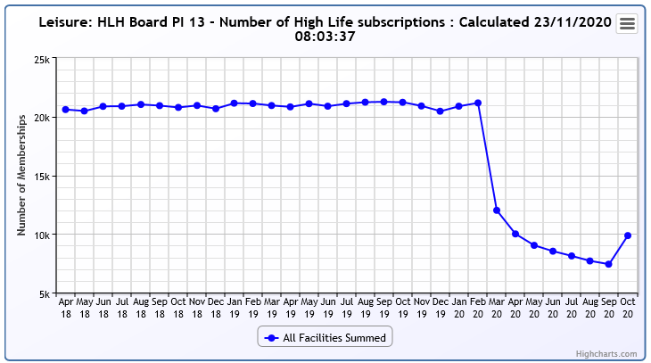
Business Plan Outcome | Performance Indicator | Reporting Frequency | RAG Rating Definition | RAG Rating Q1 20/21 | RAG Rating Q2 20/21 | RAG Rating Q3 20/21 | RAG Rating Q4 20/21 | Summary of Quarter Two Performance
7. Achieve sustainable growth across the organisation (cont.) | 14. High Life cancellation rate. | Quarterly. | - Red = cancellation rate above 6% of High Life memberships.  - Amber = cancellation rate is 3% - 6% of High Life memberships.  - Green = cancellation rate is up to 3% of High Life memberships. | Red | Red |  |  | The combined rate of cancelled and frozen subscriptions was 7% in July, 6% in August and 8% in September. (The October figure was 5%). Please see section three of this report for further information.

Performance Indicator 14 - High Life Cancellation Rate
This graph shows cancelled subscriptions, frozen subscriptions have been included in the information in the table above. Please see section three of this report for further information.
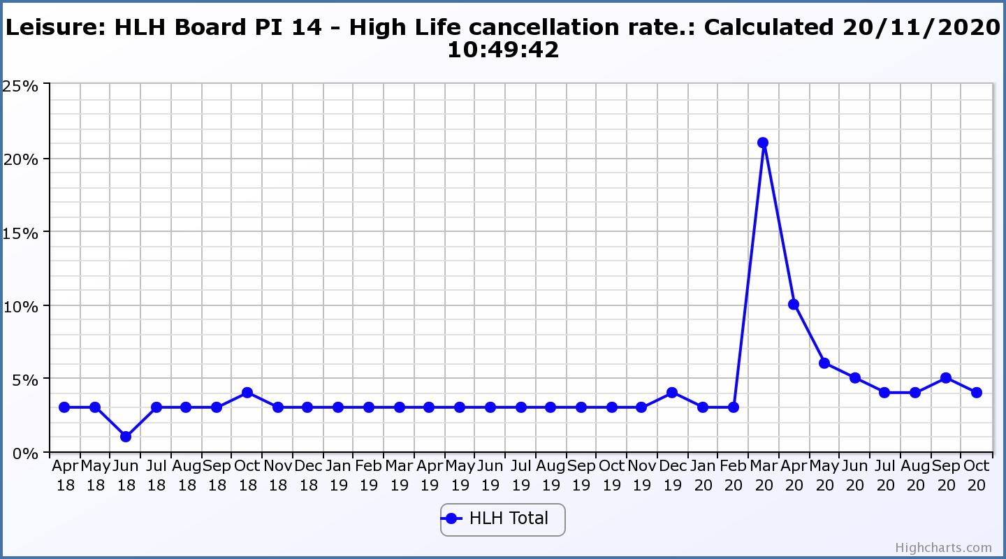

Business Plan Outcome | Performance Indicator | Reporting Frequency | RAG Rating Definition | RAG Rating Q1 20/21 | RAG Rating Q2 20/21 | RAG Rating Q3 20/21 | RAG Rating Q4 20/21 | Summary of Quarter Two Performance
8. Develop health and wellbeing across Highland communities | 15. Partnership work with NHSH and other health related organisations. | Annual. | - Red = no partnership work with NHSH etc.  - Amber = Reduction of current level of partnership work with NHSH etc.  - Green = Continuation or growth in partnership working with NHSH etc. | Green | NA | NA | NA | This is an annual indicator.

Business Plan Outcome | Performance Indicator | Reporting Frequency | RAG Rating Definition | RAG Rating Q1 20/21 | RAG Rating Q2 20/21 | RAG Rating Q3 20/21 | RAG Rating Q4 20/21 | Summary of Quarter Two Performance
9. Develop and promote the High Life brand | 16. Uptake of HLH card towards the target of 80% of the population. | Annual | - Red = number of card-holders is maintained.  - Amber = number of card-holders is increased by 1-4%.  - Green = number of card-holders is increased by 5% or more. | Red | NA | NA | NA | This is an annual indicator.

Appendix C
Highlife facilities custoemr survey results

How would you rate the customer experience with the new COVID compliant measures in place?
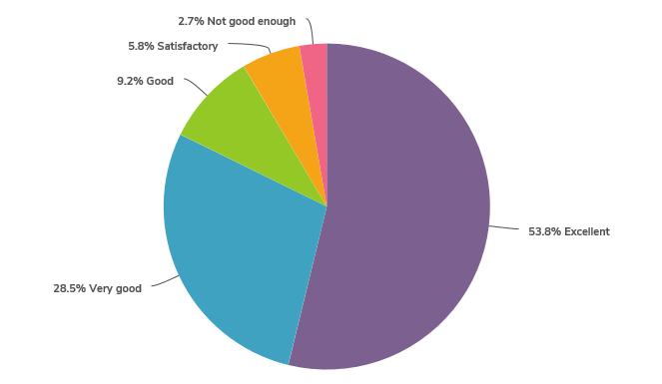

How would you rate the cleaning provision in your local centre?
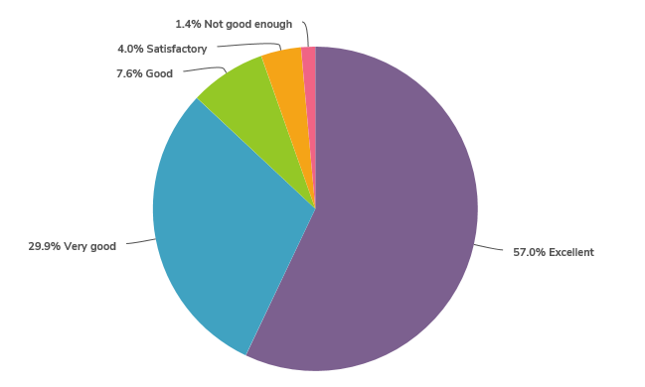

How easy has it been to maintain social distancing on site?
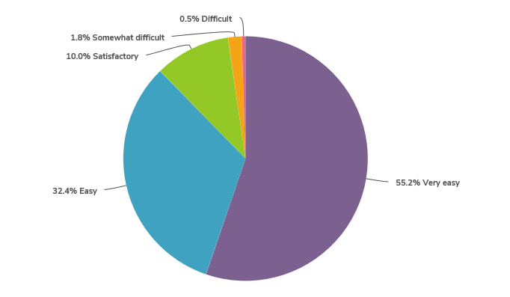

Compared to other places you have visited during the pandemic how safe was your experience?
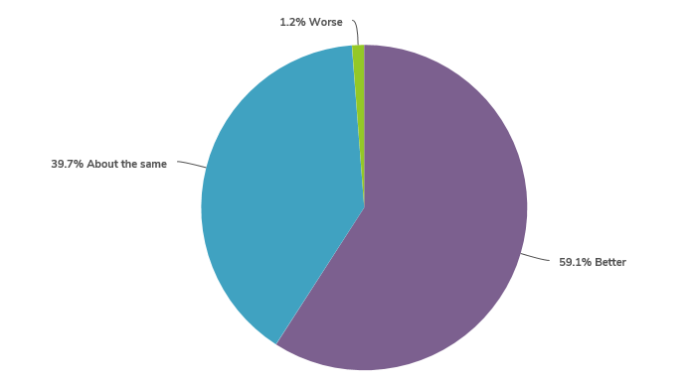

Do changes to opening hours suit you?
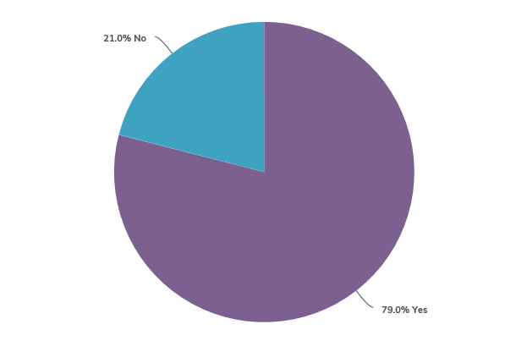

How have you found the online booking system?
