HIGH LIFE HIGHLAND  REPORT TO BOARD OF DIRECTORS  24 March 2021 | AGENDA ITEM REPORT No HLH /21

Performance Report - Report by Chief Executive

Summary

The purpose of this report is to present performance information for the period October to December 2020.

It is recommended Directors:

- comment on the report and agree that the overall health check on the Charity for that period is assessed as amber because the effect of the lockdown and COVID-19 management arrangements which are required to operate; and
- note that the delivery of the business plan has been paused, with the focus having become the Recovery Action Plan and that the business plan is being reviewed in the light of the COVID pandemic.

1. | Business Plan Contribution
1.1 | This report supports all of the Business Outcomes from the High Life Highland (HLH) Business Plan:  - Sustain a high standard of health and safety, and environmental performance  - Implement the Service Delivery Contract with THC  - Improving customer engagement and satisfaction  - Improving staff engagement and satisfaction  - Enhance the positive charity image  - Be a trusted and effective partner  - Achieve sustainable growth across the organisation  - Develop health and wellbeing across Highland communities  - Develop and promote the High Life brand
2. | Background
2.1 | The implementation of the HLH Business Plan 2019-24 is monitored in two ways:  - through a set of performance indicators set by the Board at its meeting held on 11 December 2018; and  - by RAG rating the delivery of the business outcomes contained in the business plan with these being reported to the Board by exception (i.e. reporting where managers had RAG rated the actions “red – no significant progress”).

3. | Summary of Performance
3.1 | Sixteen performance indicators (PIs) were identified by the HLH Board to assess the overall performance of the Charity. At its meeting in December 2019 the HLH Board agreed to develop a simplified/summarised reporting format and Appendix A contains a summary of performance against the PIs for quarter three 2020/21.
3.2 | Appendix B provides a summary of all the PIs along with trend information. Eleven performance indicators were scheduled for assessment at the March 2021 Board meeting. Six of them have been RAG rated “green”; three amber and two “red”.
3.3 | The PIs which have been RAG rated red are as follows:  - PI 4. Customer engagements; and  - PI 13. Number of highlife subscriptions
3.3.1 | PI 4. Customer Engagements has been RAG rated red. The number of engagements in quarter three 2019/20 was 2,184,907 and in the same quarter this year was 834,208.
3.3.2 | Customer visits April to December 2020 were 3,315,914 (they were 6,577,769 during the same period in 2019) with 2,730,810 of these having been on-line engagements mainly through archives and libraries. There will be further detail on customer engagements at the June HLH Board meeting when a summary of the customer engagements for the full financial year will be provided.
3.3.3 | Because of the importance of the leisure subscriptions to the charity, footfall at the highlife leisure sites was monitored weekly prior to the second lockdown with 6,729 visits during the first week of opening, increasing to 16,253 fourteen weeks after opening at the end of November. It is normal for the number of visits to reduce in December and the same pattern was seen in December 2020. The weekly trend can be seen in the graph below. As sites are re-opened footfall will continue to be monitored so that opening hours can be adjusted to meet demand.
3.4.1 | PI 13. Number of highlife subscriptions. This PI has been RAG rated red because of the reduced number of subscriptions during Q3 2020/21 compared with previous years. At the time of writing the number of subscriptions were 7,188 which is lower than they were at their previous low point in September (7,422) but ahead of what was anticipated in the financial scenario planning contained elsewhere on this agenda. The number of subscriptions is being monitored weekly by the Senior Team.
3.4.2 | It is anticipated that leisure facilities will be allowed to re-open at the end of April 2021. At the Finance and Audit Committee Directors asked for further information on highlife subscription promotions, there will be three formal promotions on and following re-opening:  - A promotion for the 7,000 customers who have continued to pay their subscriptions;  - A promotion to the 8,500 customers who have frozen subscriptions to try to re-engage them as early as possible; and  - The previously agreed TV, radio and social media campaign.
3.4.3 | The first two above are linked with the pricing of the highlife card and there is, therefore, further detail on them in the Budget Planning and Approval (21-22) report elsewhere on this agenda. In addition, staff will contact customers directly where annual subscriptions have lapsed as part of their direct contact with customers to ask them whether they want to re-engage subscriptions. Online joining is now fully enabled and is expected to facilitate an expedited recovery of subscriptions upon re-opening.
4. | Delivery of Business Outcomes
4.1 | The HLH Business Plan 2019-24 identifies nine business outcomes and the approach which the Charity takes to deliver them. The resultant operational plans for each of the nine HLH areas of work are RAG rated every quarter.
4.2 | With most of the regular work of HLH having stopped, the Recovery Action Plan has been the focus of the work of the organisation and there is a separate report elsewhere on this agenda which contains an update on the recovery work. The business plan outcomes have, therefore, not been RAG rated.
5. | Performance Indicators for More Detailed Consideration
5.1 | The performance indicators scheduled for more detailed consideration at the March HLH Board meeting are:  - PI 5. Customer surveys; and  - PI 7. Staff turnover - resignations as a percentage of posts (covered in the HR report elsewhere on this agenda).
5.2 | The customer surveys performance indicator has been RAG rated amber because four out of the nine areas of HLH work have completed surveys. The remaining five have paused them for this year. The four surveys which have taken place are as follows:  - Leisure facilities – survey of customers who returned after lockdown. This was reported in detail at the December 2020 HLH Board meeting.  - Libraries – As part of the Customer Service Excellence (CSE) evaluation the assessor talked to a sample of customers about their level of satisfaction with the service. The assessor reported that: “‘All the customers…. commended the staff and were pleased with the service delivery. They took time to explain the excellent service provided during the Covid-19 pandemic as services changed and evolved …. and as restrictions were modified and a greater understanding of the virus was developed’. Examples of services being adapted to changing customer needs included Bookbug sessions delivered through Facebook Live and the Click and Collect book service.  - Museums – carried out a customer survey with very positive results. 99.5% felt comfortable with the COVID-19 management arrangements; and 97.3% saying that they were very likely or likely to recommend visiting the museum to others.  - Youth Work – carried out a customer satisfaction survey which assessed the accessibility, effectiveness and quality of the service. 95.7 % said that the service was easy or very easy to access; 92% agreed or strongly agreed that youth work helps them to be more confident; 85% agreed or strongly agreed that it helps them cope better with life; 92% agreed or strongly agreed that youth work helps them understand the importance of making good decisions.
6. | Implications
6.1 | Resource Implications – there are no additional resource implications arising from this report. Resource implications have been covered in the Finance Report elsewhere on this agenda.
6.2 | Legal Implications - there are no new legal implications arising from this report.
6.3 | Equality Implications – there are no new equality implications arising from this report.
6.4 | Risk Implications – there are no new risk implications arising from this report.

Recommendation

It is recommended Directors:

- comment on the report and agree that the overall health check on the Charity for that period is assessed as amber because the effect of the lockdown and COVID-19 management arrangements which are required to operate; and
- note that the delivery of the business plan has been paused, with the focus having become the Recovery Action Plan and that the business plan is being reviewed in the light of the COVID pandemic.

Designation: Chief Executive

Date: 8 March 2021

Appendix A
HLH Performance Indicators year to date 2020/21
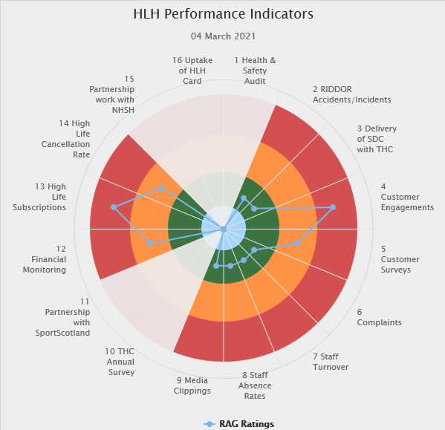 | Sixteen performance indicators (PIs) are used by the High Life Highland Board to assess the overall performance of the charity.  The PIs are RAG rated (allocated a "Red", "Amber" or "Green" status) so that it is easy to see at a glance how the organisation is performing. Most of the PIs are RAG rated every quarter throughout the year with some (such as partnership working with NHSH for example) being considered annually, so greyed out sectors on this radar diagram mean that the PI is to be considered at a future HLH Board meeting.
Appendix B
HLH Performance Indicators

Business Plan Outcome | Performance Indicator | Reporting Frequency | RAG Rating Definition | RAG Rating Q1 20/21 | RAG Rating Q2 20/21 | RAG Rating Q3 20/21 | RAG Rating Q4 20/21 | Summary of Quarter Three Performance
1. Sustain a high standard of health and safety and environmental performance | 1. Health and safety audit. | Annual. | - Red = the external audit raises systemic (i.e. applying across multiple sites) H&S issues.  - Amber = the external audit highlights common actions to be addressed across the company.  - Green = the external audit does not raise systemic issues. | N/A. | N/A | N/A |  | The resumption of annual external Audits will be considered following the easing of restrictions in 2021.

Business Plan Outcome | Performance Indicator | Reporting Frequency | RAG Rating Definition | RAG Rating Q1 20/21 | RAG Rating Q2 20/21 | RAG Rating Q3 20/21 | RAG Rating Q4 20/21 | Summary of Quarter Three Performance
1. Sustain a high standard of health and safety and environmental performance (cont.) | 2. RIDDOR accidents/incidents. | Quarterly. | - Red = number of RIDDOR reports per quarter is above 20.  - Amber = number of RIDDOR reports per quarter is between 10 and 20  - Green = number of RIDDOR reports per quarter is less than 10. | Green | Green | Green |  | There was one accident reported under the RIDDOR regulations during Q3 which was reviewed at the Health and Safety and Environmental Compliance Committee meeting held on 23 February 2021.

Performance Indicator 2 - RIDDOR accidents/incidents
The graph below tracks the number of accidents and incidents reported under the Reporting of Injuries, Diseases and Dangerous Occurrences Regulations (RIDDOR). There was one RIDDOR incident reported in Q3 2020/21.
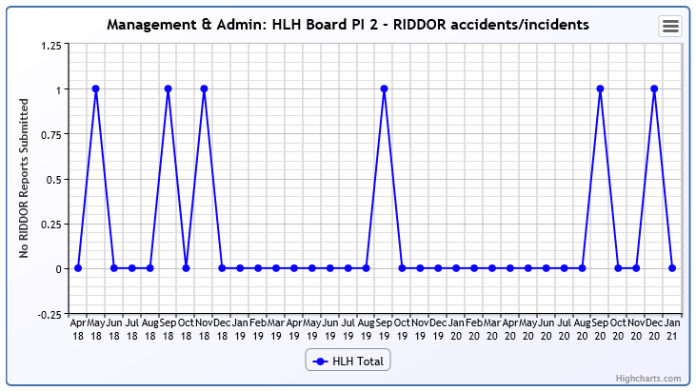

Business Plan Outcome | Performance Indicator | Reporting Frequency | RAG Rating Definition | RAG Rating Q1 20/21 | RAG Rating Q2 20/21 | RAG Rating Q3 20/21 | RAG Rating Q4 20/21 | Summary of Quarter Three Performance
2. Implement the Service Delivery Contract with The Highland Council | 3. Delivery of the Service Delivery Contract (SDC) with The Highland Council (THC). | Six-monthly. | - Red = agreement of THC’s CLH Committee that HLH has not met the terms of the SDC.  - Amber = agreement of THC’s CLH Committee that HLH has met the terms of the SDC but has set some improvement targets.  - Green = agreement of THC’s CLH Committee that HLH has met or exceeded the terms of the SDC. | NA | Green | NA |  | This performance indicator was considered by the HLH Board at its December 2020 meeting.

Business Plan Outcome | Performance Indicator | Reporting Frequency | RAG Rating Definition | RAG Rating Q1 20/21 | RAG Rating Q2 20/21 | RAG Rating Q3 20/21 | RAG Rating Q4 20/21 | Summary of Quarter Three Performance
3. Improve customer engagement and satisfaction | 4. Customer engagements. | Quarterly. | - Red = customer numbers are more than 5% lower than the corresponding quarter in the previous year.  - Amber = customer numbers are less than the corresponding quarter in the previous year.  - Green = customer numbers are the same as or have increased compared with the corresponding quarter in the previous year. | Red | Red | Red |  | Customer engagements decreased from 2,184,907 in Q3 2019/20 to  834,186 in Q3 2020/21. The reduction was associated with the lockdown and reduced capacity as a result of following government COVID management arrangements. Please see section five of this report for further information.
Performance Indicator 4 - Customer engagements
Customer numbers decreased due to the COVID-19 situation.
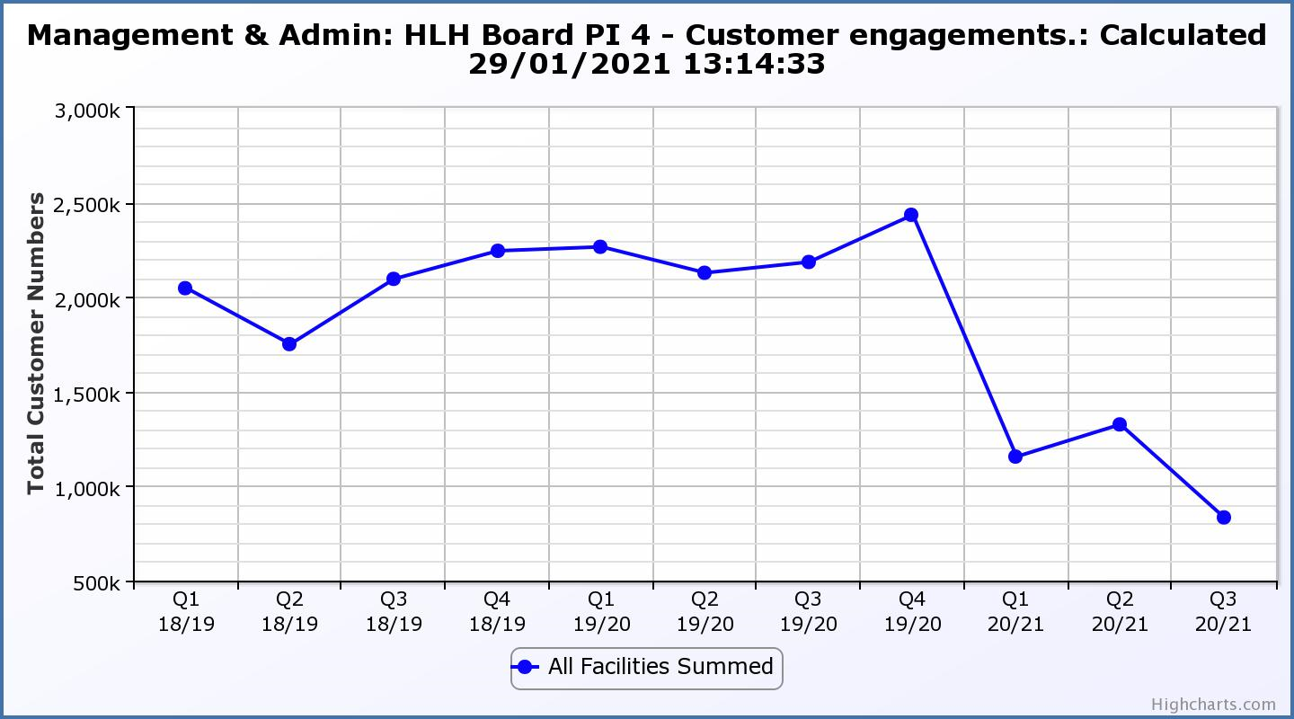

Business Plan Outcome | Performance Indicator | Reporting Frequency | RAG Rating Definition | RAG Rating Q1 20/21 | RAG Rating Q2 20/21 | RAG Rating Q3 20/21 | RAG Rating Q4 20/21 | Summary of Quarter Three Performance
3. Improve customer engagement and satisfaction (cont.) | 5. Customer surveys. | Quarterly. | - Red = up to three surveys have been completed or scheduled.  - Amber = 4 to 8 of the HLH areas of work have completed or scheduled customer surveys.  - Green = all areas of HLH work have completed or scheduled customer surveys. | Green | Green | Amber |  | Four areas of work have completed customer surveys. Please see section four of this report for further information.

Business Plan Outcome | Performance Indicator | Reporting Frequency | RAG Rating Definition | RAG Rating Q1 20/21 | RAG Rating Q2 20/21 | RAG Rating Q3 20/21 | RAG Rating Q4 20/21 | Summary of Quarter Three Performance
3. Improve customer engagement and satisfaction (cont.) | 6. Formal complaints. | Quarterly. | - Red = 41 or more complaints per quarter.  - Amber = 31 to 40 complaints per quarter.  - Green = 30 complaints or fewer per quarter. | Green | Green | Green |  | There were sixteen complaints received during Q3 2020/21.

Performance Indicator 6 - Formal Complaints
The graph below shows the number of complaints which continue to be very low in relation to customer numbers.
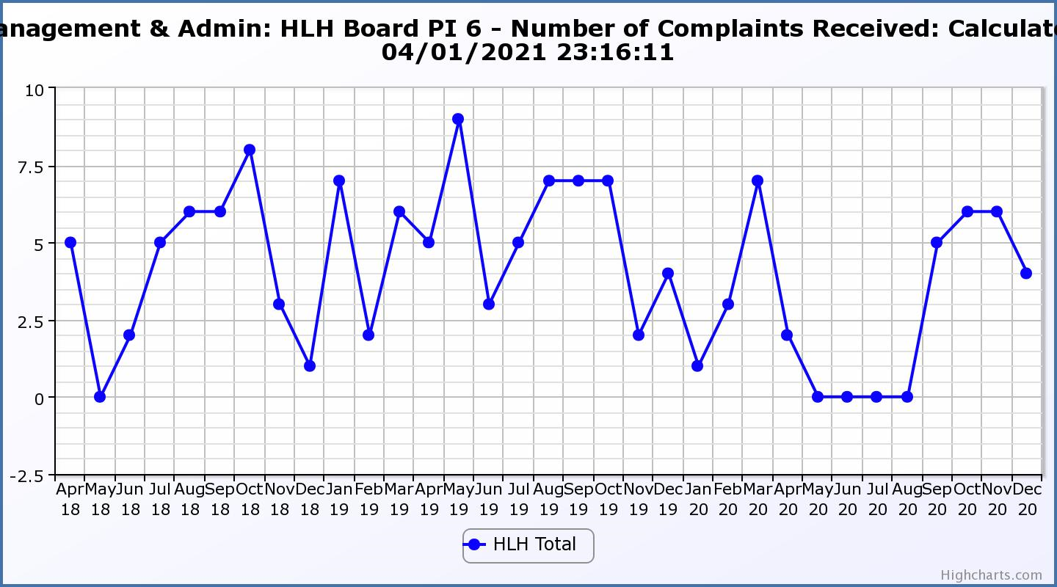
Business Plan Outcome | Performance Indicator | Reporting Frequency | RAG Rating Definition | RAG Rating Q1 20/21 | RAG Rating Q2 20/21 | RAG Rating Q3 20/21 | RAG Rating Q4 20/21 | Summary of Quarter Three Performance
4. Improve staff engagement and satisfaction | 7. Staff turnover (resignations as a percentage of posts). | Quarterly. | - Red = more than 2%  - Amber = 1.7 to 2%  - Green = 1.6% or less | Green | Green | Green |  | The number of resignations per month as a percentage of posts in Q3 was 1% in October, 0.3% in November and 0.15% in December. Please see HR report elsewhere on this agenda for further information.

Performance Indicator 7 - Staff Turnover (resignations as a percentage of posts)
The graph below shows resignations as a percentage of the number of posts and resignations have been consistent with previous years and continue to be low (1% equates to 10.6 staff)

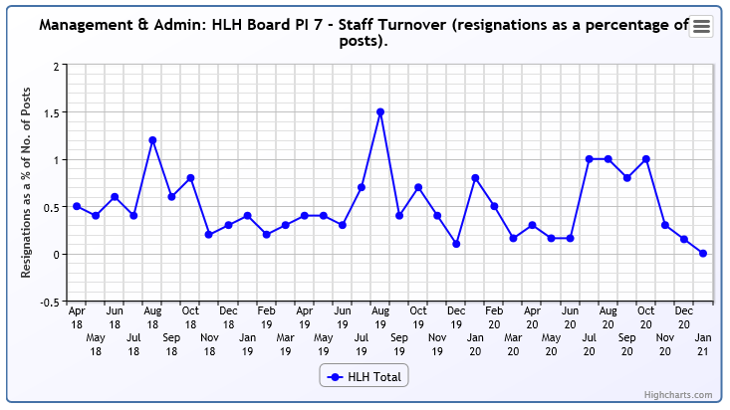

Business Plan Outcome | Performance Indicator | Reporting Frequency | RAG Rating Definition | RAG Rating Q1 20/21 | RAG Rating Q2 20/21 | RAG Rating Q3 20/21 | RAG Rating Q4 20/21 | Summary of Quarter Three Performance
4. Improve staff engagement and satisfaction (cont.) | 8. Staff absence rates. | Quarterly. | - Red = absence rate greater than 3.6%.  - Amber = absence rate between 3.4% and 3.6%.  - Green = absence rate 3.3% or less. | Green | Green | Green |  | The absence rate for Q3 was 2.64%. Please see the HR report elsewhere on this agenda for further information.

Performance Indicator 8 - Staff Absence Rates
The absence rate reduced in quarters one and two 2020/21 was low, however, staff being furloughed meant that they did not have to report absences as they normally would. Absence rates increased but were RAG rated as “green” during quarter three.
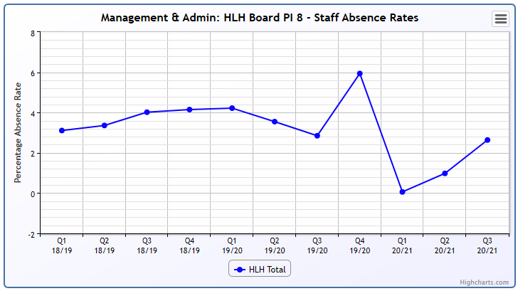

Business Plan Outcome | Performance Indicator | Reporting Frequency | RAG Rating Definition | RAG Rating Q1 20/21 | RAG Rating Q2 20/21 | RAG Rating Q3 20/21 | RAG Rating Q4 20/21 | Summary of Quarter Three Performance
5. Enhance the positive company image | 9. Media clippings. | Quarterly | - Red = number of negative press clippings outweigh neutral and positive.  - Amber = number of negative and neutral press clippings outweigh positive.  - Green = number of positive and neutral media clippings outweigh negative. | Green | NA | Green |  | During quarter three there were 29 media articles all of which were positive although one was in response to some negative unfounded rumours on social media regarding support for NHS Highland.

Business Plan Outcome | Performance Indicator | Reporting Frequency | RAG Rating Definition | RAG Rating Q1 20/21 | RAG Rating Q2 20/21 | RAG Rating Q3 20/21 | RAG Rating Q4 20/21 | Summary of Quarter Three Performance
6. Be a trusted and effective partner | 10. THC’s annual survey of performance and attitudes. | Annual. | - Red = all HLH areas of work represented receive lower net satisfaction ratings than the previous year.  - Amber = two or more areas of HLH work receive lower net satisfaction ratings than the previous year.  - Green = net satisfaction ratings are maintained or improved for three or more areas of HLH work compared with the previous year. | N/A | N/A | N/A | NA | This PI has not been RAG rated because the Council paused its annual survey during 2020. It is expected that this will be resumed next year.

Business Plan Outcome | Performance Indicator | Reporting Frequency | RAG Rating Definition | RAG Rating Q1 20/21 | RAG Rating Q2 20/21 | RAG Rating Q3 20/21 | RAG Rating Q4 20/21 | Summary of Quarter Three Performance
6. Be a trusted and effective partner (cont.) | 11. Partnership work with sportscotland | Annual | - Red = cancellation of Partnership Agreement with sportscotland  - Amber = continuation of current level of partnership work with sportscotland  - Green = Growth in partnership working with sportscotland | Green | NA | NA | NA | This is an annual indicator and was last considered by the HLH Board at its meeting held on 27 August 2020.

Business Plan Outcome | Performance Indicator | Reporting Frequency | RAG* Rating Definition  (*Red/Amber/Green) | RAG Rating Q1 20/21 | RAG Rating Q2 20/21 | RAG Rating Q3 20/21 | RAG Rating Q4 20/21 | Summary of Quarter Three Performance
7. Achieve sustainable growth across the organisation | 12. Financial monitoring. | Quarterly. | An assessment of the year end outturn where:  - Red = delivery of services over budget above 2%.  - Amber = delivery of services between break-even and 2% over budget.  - Green = delivery of services within budget. | Red | Red | Amber |  | The Finance Report elsewhere on this agenda forecasts a positive variance to budget in financial year 2020/21. This PI has been RAG rated amber because of the projected deficit in 2021/22. Budget discussions took place in early 2021 with relevant member and officer groups resulting in THC, at its meeting on 4th March 2021, approving a commitment to underwrite any HLH deficit in 2021/22.

Performance Indicator 12 - Financial monitoring
See the Finance Report elsewhere on this agenda for further information.
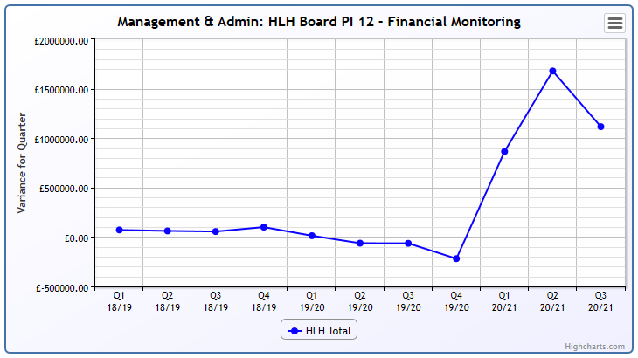
Business Plan Outcome | Performance Indicator | Reporting Frequency | RAG Rating Definition | RAG Rating Q1 20/21 | RAG Rating Q2 20/21 | RAG Rating Q3 20/21 | RAG Rating Q4 20/21 | Summary of Quarter Three Performance
7. Achieve sustainable growth across the organisation (cont.) | 13. Number of High Life subscriptions. | Quarterly. | - Red = more than 5% below target.  - Amber = up to 5% below target.  - Green = on or exceeds target. | Red | Red | Red |  | This PI has been RAG rated red because of the reduced number of subscriptions during Q3 2020/21 compared with previous years. The income being generated is, however, above the level required to achieve the target in the financial modelling.

Performance Indicator 13 - Number of High Life Subscriptions
This graph shows the number of subscriptions with an increase in October as sites re-opened. There is further information in section 3 above. The current lockdown has meant that as at March 2021, subscriptions had reduced to the September level of just over 7,000.
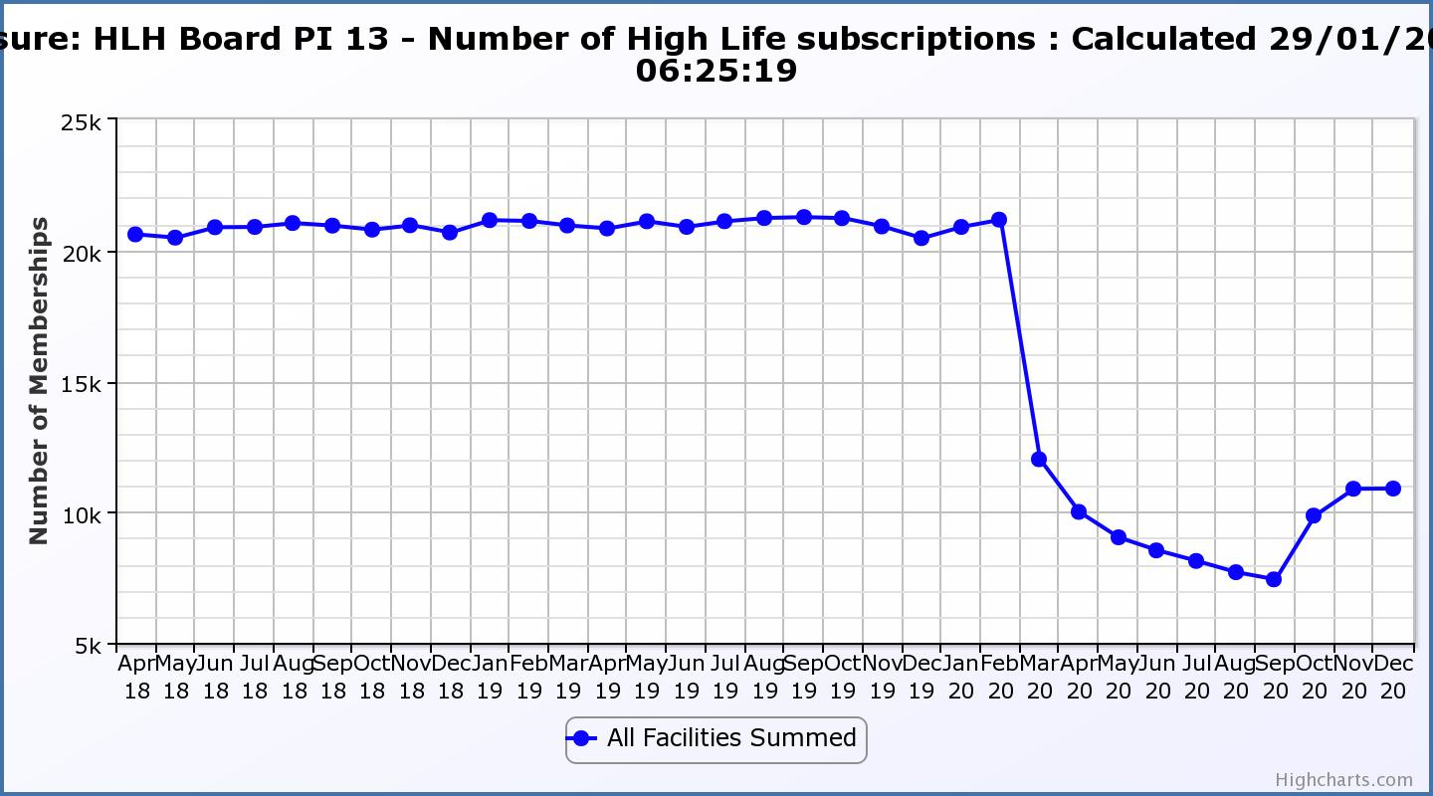
Business Plan Outcome | Performance Indicator | Reporting Frequency | RAG Rating Definition | RAG Rating Q1 20/21 | RAG Rating Q2 20/21 | RAG Rating Q3 20/21 | RAG Rating Q4 20/21 | Summary of Quarter Three Performance
7. Achieve sustainable growth across the organisation (cont.) | 14. High Life cancellation rate. | Quarterly. | - Red = cancellation rate above 6% of High Life memberships.  - Amber = cancellation rate is 3% - 6% of High Life memberships.  - Green = cancellation rate is up to 3% of High Life memberships. | Red | Red | Amber |  | The number of cancelled subscriptions was 4% each month during the quarter Please see section three of this report for further information.

Performance Indicator 14 - High Life Cancellation Rate
This graph shows cancelled subscriptions. In addition, there are currently 8,500 frozen subscriptions. Please see section 3 of this report for further information.
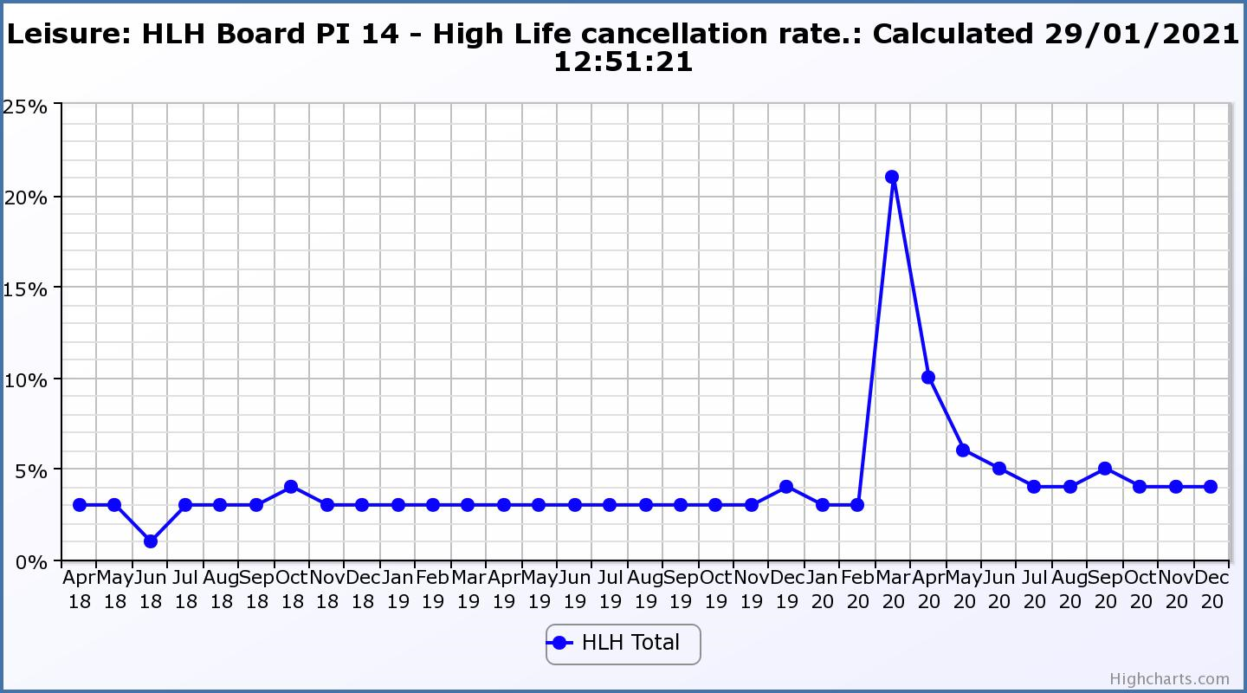

Business Plan Outcome | Performance Indicator | Reporting Frequency | RAG Rating Definition | RAG Rating Q1 20/21 | RAG Rating Q2 20/21 | RAG Rating Q3 20/21 | RAG Rating Q4 20/21 | Summary of Quarter Three Performance
8. Develop health and wellbeing across Highland communities | 15. Partnership work with NHSH and other health related organisations. | Annual. | - Red = no partnership work with NHSH etc.  - Amber = Reduction of current level of partnership work with NHSH etc.  - Green = Continuation or growth in partnership working with NHSH etc. | Green | N/A | N/A | N/A | This is an annual indicator.

Business Plan Outcome | Performance Indicator | Reporting Frequency | RAG Rating Definition | RAG Rating Q1 20/21 | RAG Rating Q2 20/21 | RAG Rating Q3 20/21 | RAG Rating Q4 20/21 | Summary of Quarter Three Performance
9. Develop and promote the High Life brand | 16. Uptake of HLH card towards the target of 80% of the population. | Annual | - Red = number of card-holders is maintained.  - Amber = number of card-holders is increased by 1-4%.  - Green = number of card-holders is increased by 5% or more. | Red | N/A | N/A | N/A | This is an annual indicator.

