HIGH LIFE HIGHLAND  REPORT TO BOARD OF DIRECTORS  23 JUNE 2021 | AGENDA ITEM REPORT No HLH /21

ANNUAL Health and Safety And EnvironmeNtal Compliance Report - Report by Chief Executive

Summary

An important element of the governance structure relating to the company’s Health and Safety and Environmental Compliance performance is the annual Health and Safety and Environmental Compliance Report.

This report informs Directors about the performance of High Life Highland in terms of health and safety and environmental compliance for the reporting period 2020-21.

It is recommended that Directors comment on and note:

- that there were no notifications for improvement or enforcement actions during the reporting period;
- that there were no environmental incidents requiring SEPA notification during the reporting period;
- the low number and low severity of accidents or incidents over the reporting period, reflecting continuing good practice across the charity and the operational restrictions through the year;
- that the Health and Safety and Environmental Compliance Committee continues to meet quarterly with officers and the charity’s external Health and Safety advisers to review Health and Safety performance, and on reviewing the accident and incident trend data it concluded that there are no issues arising from this requiring charity-wide action;
- that the external safety audit was not completed within the reporting period as a result of the pandemic;
- that there were no union safety audits completed within the reporting period as a result of the pandemic; and
- the creation of a COVID-19 Incident Reporting & Monitoring system along with COVID-19 staff and management guidance to support the HLH team over 2020-21.

1. | Business Plan Contribution
1.1 | This report supports the highlighted Business Outcomes from the High Life Highland (HLH) Business Plan:  - Sustain a high standard of health and safety, and environmental performance  - Implement the Service Delivery Contract with THC  - Improving customer engagement and satisfaction  - Improving staff engagement and satisfaction  - Enhance the positive charity image  - Be a trusted and effective partner  - Achieve sustainable growth across the organisation  - Develop health and wellbeing across Highland communities  - Develop and promote the High Life brand
2. | Background
2.1 | The HLH Health and Safety Policy Statement requires annual and exception reporting, to the HLH Board on health and safety performance.
2.2 | At the HLH Board meeting on the 23 April 2014 Directors agreed to delegate to the Health and Safety Strategic Group, now the Health and Safety and Environmental Compliance Committee (as of 14 June 2018), the decision on the final layout of the tables in the appendices to this report. The Committee reviewed and agreed the information in this report and accompanying appendices at its meeting held on 18 May 2021.
3. | Health and Safety and Environmental Compliance Performance
3.1 | There were no enforcing officer notifications for improvement, or enforcement action during the reporting period. There were no environmental incidents requiring reporting to SEPA during the reporting period.
3.2 | Having analysed the information in the appendices, the Health and Safety and Environmental Compliance Committee identified the following information as being important to report to the HLH Board:  - there are no trends indicating that any charity-wide actions are required;  - there were no accidents reported which were an “Act of Violence”;  - there were two accidents reported under RIDDOR within the reporting period, all RIDDOR incidents have been dealt with appropriately. Both incidents have been reviewed and assessed, with no trends identified (details contained in Appendix A);  - the introduction of the HLH online reporting system in April 2017 and associated staff training has continued to be developed to help improve the analysis of accidents and incidents within the reporting period;  - due to seven unrelated fire incidents in HLH facilities over 2017/18, close monitoring of all incidents that could have resulted in a fire within the reporting period was carried out with one incident recorded over 2020/21.  - the Health and Safety and Environmental Compliance Committee approved a number of themed H&S matters on which to focus and would help support accident reduction within the organisation, however with the pandemic covering all of 2020/21 the priority was changed to focus on COVID-19 topics. Presuming a return to a “business as usual” approach, it is envisaged that the generation of quarterly themes will be resumed in the 2021/22 reporting period.
3.3 | Even with COVID-19 and the restrictions in place, given the size of HLH and the number of physical visits to our facilities the very small number of accidents/incidents reflects the good practice across all areas of work.
4. | Annual External Audit
4.1 | The annual external safety audit carried by QLM the HLH external safety adviser was initially deferred early in 2020, however as the extent of the pandemic unfolded and with restrictions in place for both travel and access to operational properties the decision to cancel the 2020/21 audit programme was taken.
4.2  4.3  4.4 | Prior to reopening after the first lockdown the Estates team completed a pre-opening site visit to each HLH property to support the RPO and Management planning process to cover Risk Assessments, Alterations to Safe Systems of Work, Emergency Action Plans, Normal Operating Procedures and customer journeys to include one way systems and maximum occupancy.  When facilities were allowed to reopen under restrictions after the first lockdown the Estates team undertook a number of monitoring visits to all operational HLH locations to ensure compliance with COVID guidance in place at that time, each site monitoring visit works on a templated format to cover the key principles relating to that service, items like customers journeys, operational systems and a sample review of updated documentation was completed at each location.  It is expected at this time to have the annual safety audit carried out by the HLH external safety adviser later in 2021. At its meeting on 10 August 2021, the Health and Safety and Environmental Compliance Committee will be asked to take a decision as to whether it is safe to proceed with the audit programme for a planned audit within Q3 2021/22.
5. | Safety Representatives Charter
5.1 | In line with the Safety Representatives Charter agreed in June 2016 Unison had planned to undertake three safety audits within the reporting period. However, as the extent of the pandemic unfolded and with the restriction in place to access operational properties the decision to cancel the 2020/21 program of audits was taken.
6. | COVID-19 Incident Reporting & Monitoring system
6.1  6.2 | The Health and Safety and Environmental Compliance Committee Members and HLH Board Directors have been updated on an ongoing basis throughout the year on both the support and systems in place to assist HLH staff whilst dealing with the pandemic and the HLH recovery.  Itemised below are some of the management systems, communication tools and compliance monitoring implemented over the last year to support our staff and aid recovery.  - COVID-19 working group - initial group setup at start of the pandemic;  - RAP Group (Recovery Action Plan);  - C-19 Group – to deal with any COVID-19 incidents;  - COVID-19 Officer;  - SPOR (Single Point of Reference on staff website);  - Direct communication after First Minister announcements;  - Health and Wellbeing guidance and information on SPOR;  - Staff surveys and employee consultation;  - Mental health workshop;  - Mental health representatives;  - Monthly communications on employee health & wellbeing;  - Employee activities (social interaction) – Huddles & Big Team Challenges;  - Management direct contact with individuals and teams (including all staff whilst on furlough);  - Templated documents – RA, NOP, First Aid, etc;  - COVID-19 Guidance;  - PPE Store – central store for COVID-19 PPE stock;  - Pre-opening Site Visits;  - COVID-19 monitoring compliance (site visits when open); and  - COVID-19 Incident Reporting & Monitoring system.
6.3 | The above, non-exhaustive list outlines the key areas where HLH have supported staff in complying with the everchanging situation throughout the year.
6.4 | Lessons: Lessons identified through the pandemic have been captured within the HLH recovery programme documentation and will be reported on within the Recovery Update report elsewhere on the agenda.
7. | Implications
7.1 | Resource Implications – there are no additional resource implications arising from this report.
7.2 | Legal Implications - there are no additional legal implications arising from this report.
7.3 | Equality Implications – there are no additional equality implications arising from this report.
7.4 | Risk Implications – there are no new risks which require to be added to the risk register arising from this report.

Recommendations

It is recommended that Directors comment on and note:

- that there were no notifications for improvement or enforcement actions during the reporting period;
- that there were no environmental incidents requiring SEPA notification during the reporting period;
- the low number and low severity of accidents or incidents over the reporting period, reflecting continuing good practice across the charity and the operational restrictions through the year;
- that the Health and Safety and Environmental Compliance Committee continues to meet quarterly with officers and the charity’s external Health and Safety advisers to review Health and Safety performance, and on reviewing the accident and incident trend data it concluded that there are no issues arising from this requiring charity-wide action;
- that the external safety audit was not completed within the reporting period as a result of the pandemic;
- that there were no union safety audits completed within the reporting period as a result of the pandemic; and
- the creation of a COVID-19 Incident Reporting & Monitoring system along with COVID-19 staff and management guidance to support the HLH team over 2020-21.

Designation: Chief Executive

Date: 20 May 2021
Appendix A

All RIDDOR Notified Accidents/Incidents – Summary

 | 2020-21
Service Area | Q1 Apr-Jun | Q2 Jul-Sep | Q3 Oct-Dec | Q4 Jan-Mar
Adult Learning
Archives
Arts
Leisure Facilities |  | 1 | 1
Libraries
Museums
Music
Outdoor Activities
Sport
Youth Services
Management & Administration
GRAND TOTAL | 0 | 1 | 1 | 0

All RIDDOR Notified Accidents/Incidents – Details Q1 – Q4 2020-21

INCIDENT 1 - RIDDOR Notified Accidents/Incidents – Q2 2020-2021
Leisure – Inverness Leisure – 17 September 2020 18:00

DESCRIPTION: IP left sports hall 2 using the climbing wall fire exit and slipped on the grass outside landing on her wrist and resulting in 2 fractures.

Actions Taken: Area well lit, dry and clean with no trip hazards or defects. CCTV checked and IP had left using the incorrect exit route and crossed the grass, so it was found to be a result of human error/environment
INCIDENT 2 - RIDDOR Notified Accidents/Incidents – Q3 2020-2021
Leisure – Charleston Academy Community Complex – 06 December 2020 13:00

DESCRIPTION: It is alleged that a group of children were playing football on the open space grass area next to the School / High Life Highland (HLH) synthetic pitch. This was not an activity that HLH were running nor is the open space within our grounds / estate, this was just a group of kids that had got together to play football on open grass land.

During play, the ball was kicked over the fence that surrounds the synthetic pitch, at the time of this incident the area was not in use by HLH or The Highland Council (school) with all the gates locked and no staff on site.

One of the group decided that he would climb the fence to recover the ball, even though there is clear signage on the fence stating, "Do not climb this fence at any time".

As he was climbing the fence, he pulled back one of the top panels to try and gain access into the synthetic pitch, it is alleged that one of the upper panels on the fence was loose at one end, the child has stated he pushed the upper panel back to give himself room to squeeze through and jump over, at which point he slipped, caught his arm on the fence bars causing a severe laceration on his forearm and got trapped between the top and middle panels.

We were only advised of the incident by the child’s parents after the child had been at hospital.

Actions Taken: We contacted THC to appoint a contractor to attend site and repair the damaged caused by this child’s attempt to access the synthetic pitch.

Appendix B, Tables 1-9

Accidents and incidents compared to the previous year for staff, volunteers and contractors by HLH section
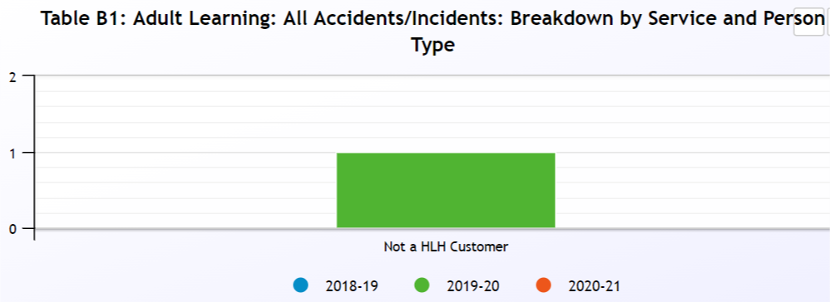
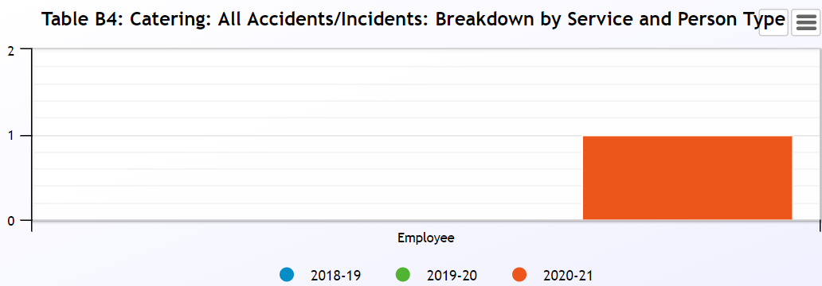
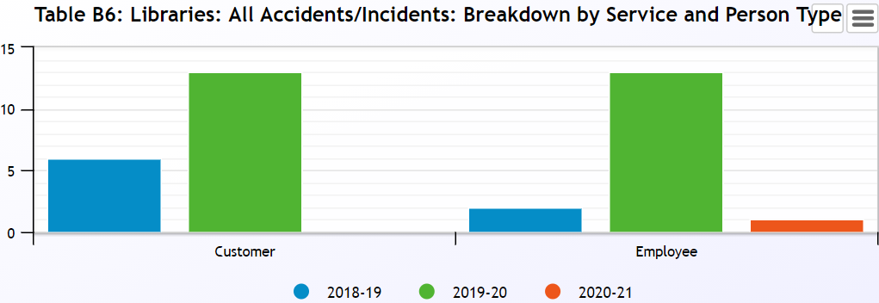
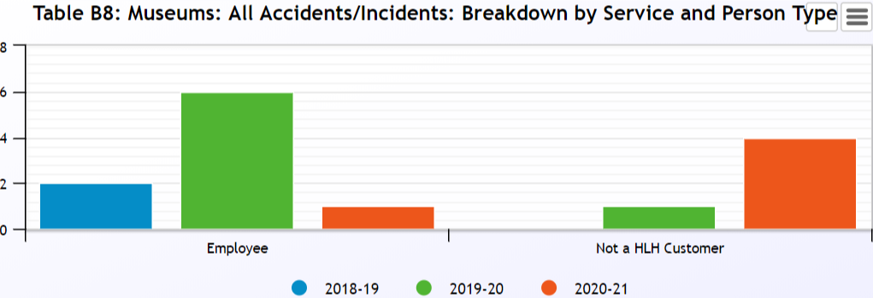
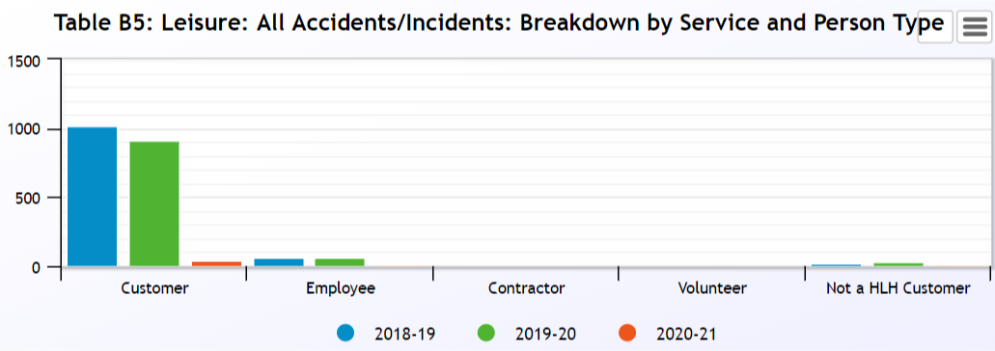
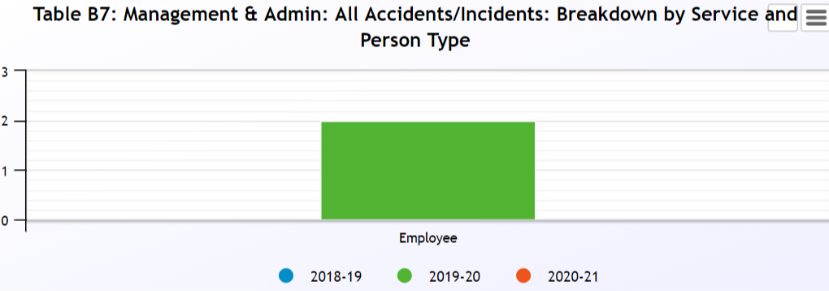
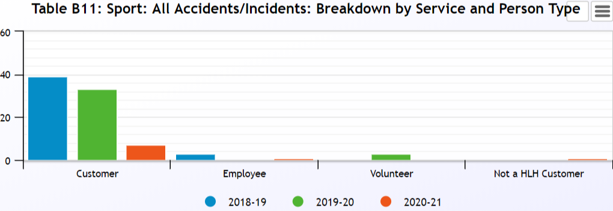
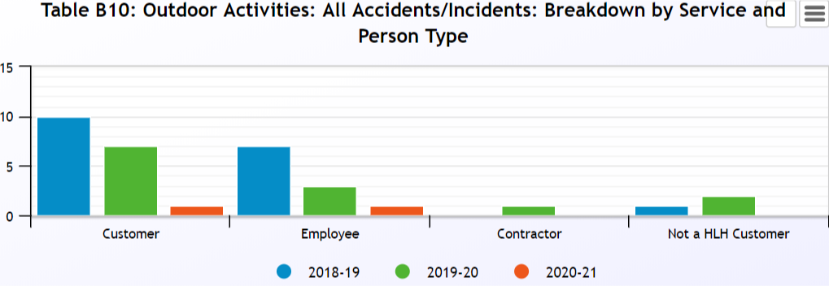
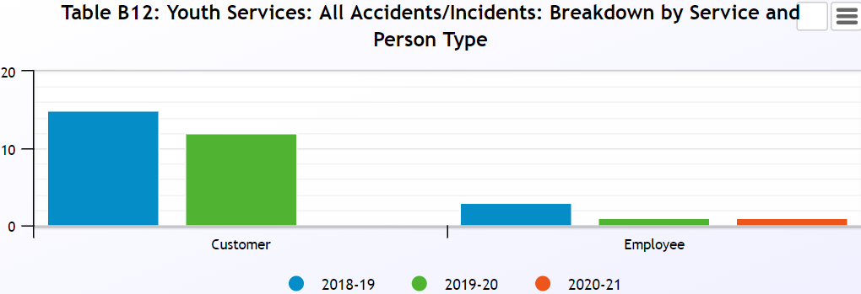

Please note that there were no incidents reported for Archives, Arts, or Music Tuition.

Appendix B, Table 10

Accidents and incidents compared to the previous year for staff by nature of accident

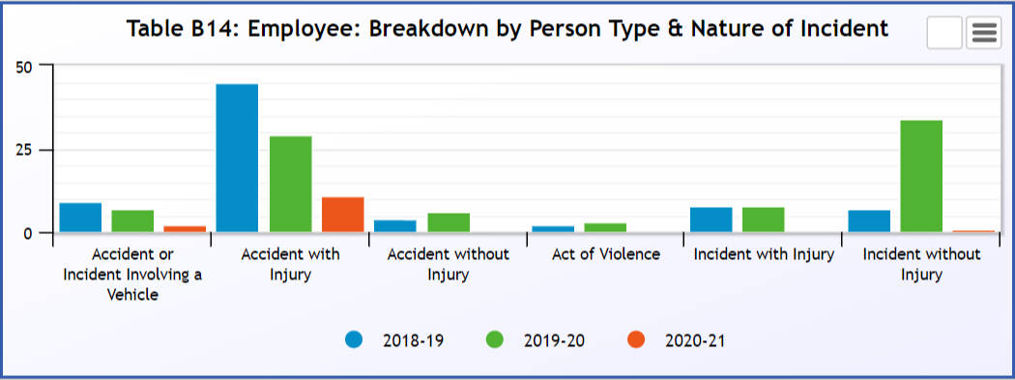

Appendix B, Tables 11-12

Accidents and incidents compared to the previous year for volunteers and contractors by nature of accident

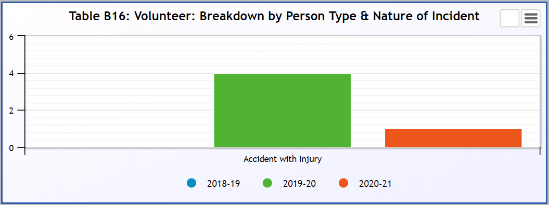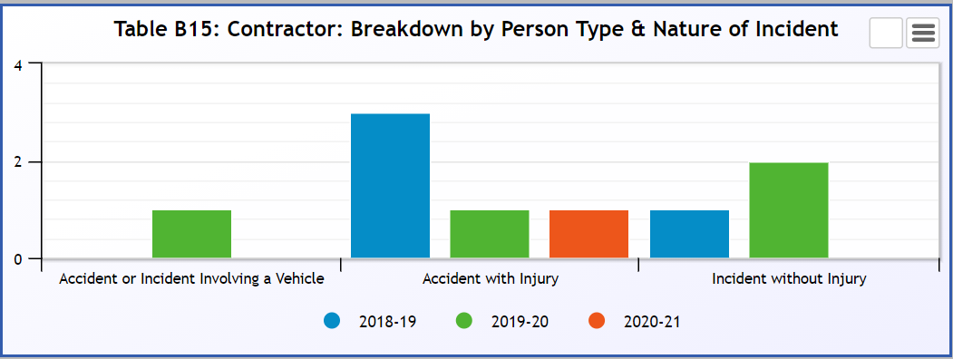

Appendix B, Table 13-14

Accidents and incidents compared to the previous year to staff and volunteers by type of accident/ incident

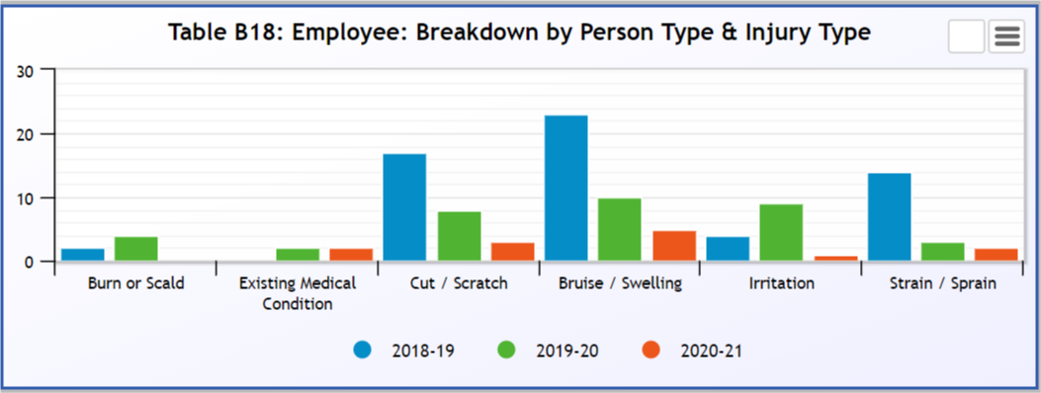
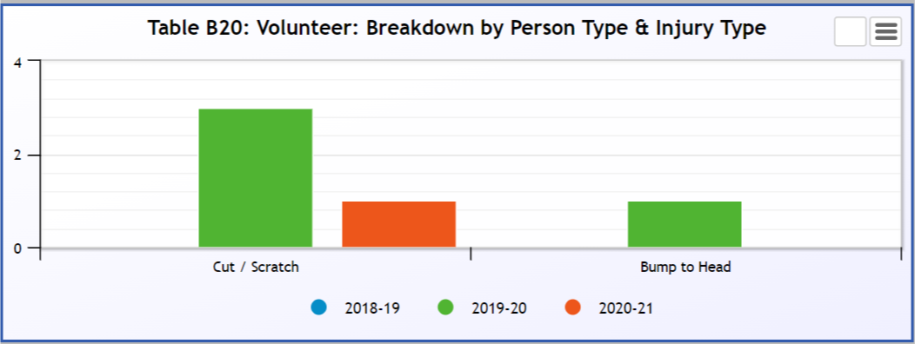

Appendix B, Table 15

Accidents and incidents compared to the previous year to contractors by type of accident/ incident

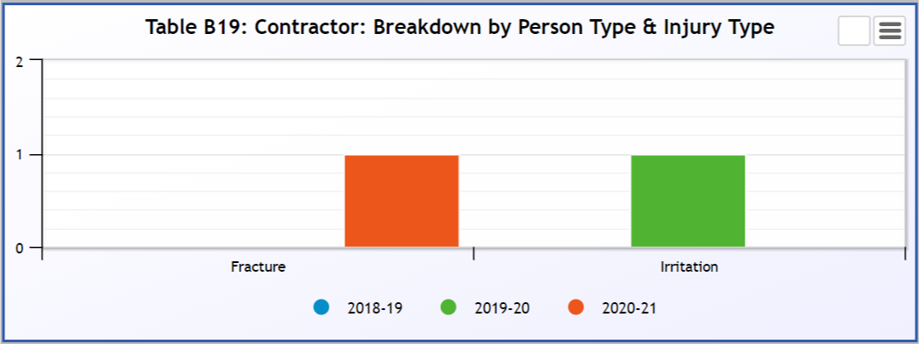

Appendix C, Table 1

Accidents and incidents compared to the previous year for users by HLH section
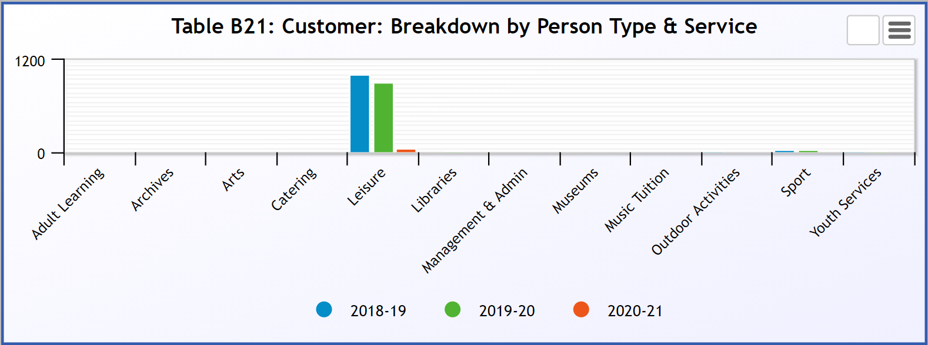

Appendix C, Table 2

Accidents and incidents compared to the previous year for users by nature of accident
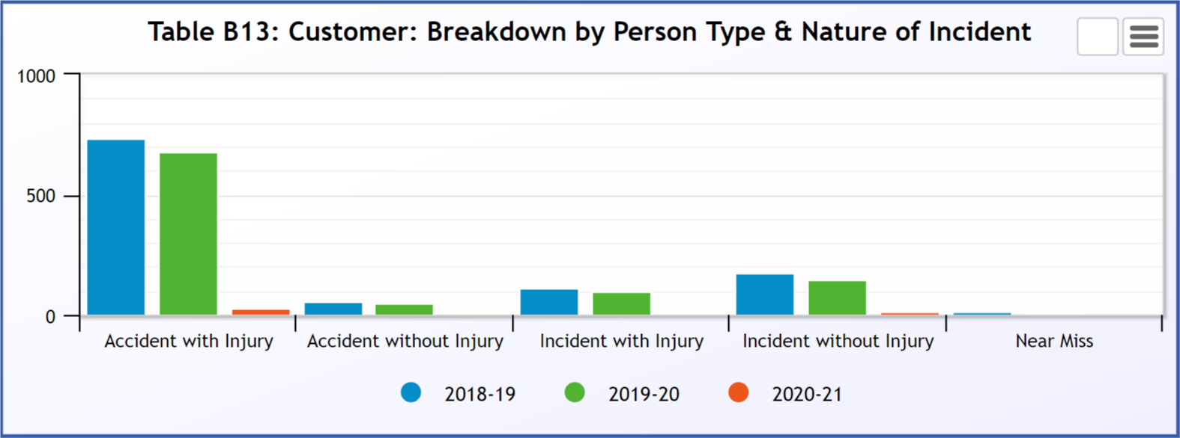

Appendix C, Table 3

Accidents and incidents compared to the previous year to users by type of accident/ incident
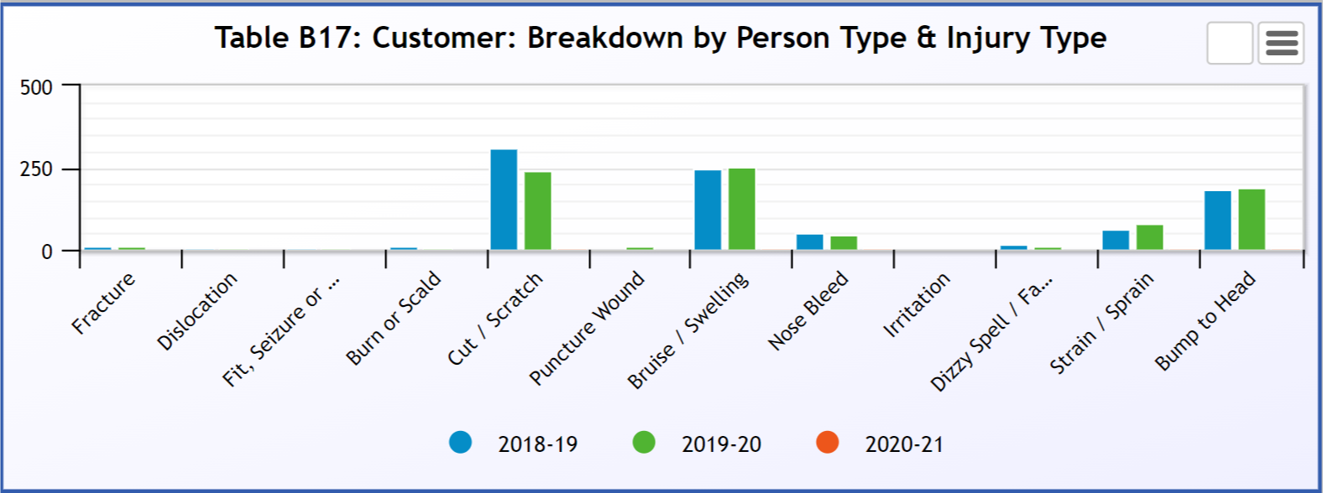

Appendix D

PERFORMANCE INDICATORS 2020-21

Number of Accidents / Incidents involving Staff (Employees, Contractors & Volunteers) Against Total Number of FTE Staff.
 | FTE Staff | Accidents/Incidents | %
Q1 2019-20 | 682.43 | 25 | 3.66
Q2 2019-20 | 687.65 | 34 | 4.94
Q3 2019-20 | 687.91 | 18 | 2.62
Q4 2019-20 | 687.85 | 21 | 3.05
Q1 2020-21 | 703.95 | 0 | 0
Q2 2020-21 | 723.48 | 9 | 1.24
Q3 2020-21 | 739.55 | 5 | 0.68
Q4 2020-21 | 751.39 | 2 | 0.27

Number of Accidents / Incidents involving customers against total number of customer visits.
 | Customer Visits | Accidents/Incidents | %
Q1 2019-20 | 1,578,586 | 274 | 0.017
Q2 2019-20 | 1,311,066 | 296 | 0.023
Q3 2019-20 | 1,584,194 | 220 | 0.014
Q4 2019-20 | 1,529,716 | 199 | 0.013
Q1 2020-21 | 31,115 | 0 | 0
Q2 2020-21 | 164,732 | 9 | 0.005
Q3 2020-21 | 269,813 | 45 | 0.017
Q4 2020-21 | 7,783 | 0 | 0

Breakdown of Accidents or Incidents by Employees, Contractors and Volunteers
 | Accidents |  |  | Incidents
 | Employees | Contractors | Volunteers | Employees | Contractors | Volunteers
Q1 2019-20 | 9 | 0 | 1 | 15 | 0 | 0
Q2 2019-20 | 17 | 0 | 1 | 16 | 0 | 0
Q3 2019-20 | 10 | 0 | 1 | 6 | 1 | 0
Q4 2019-20 | 9 | 2 | 1 | 8 | 1 | 0
Q1 2020-21 | 0 | 0 | 0 | 0 | 0 | 0
Q2 2020-21 | 7 | 1 | 1 | 0 | 0 | 0
Q3 2020-21 | 4 | 0 | 0 | 1 | 0 | 0
Q4 2020-21 | 2 | 0 | 0 | 0 | 0 | 0

Total number of Incidents that resulted or could have resulted in a fire
 | Incidents
Q1 2019-20 | 1
Q2 2019-20 | 0
Q3 2019-20 | 1
Q4 2019-20 | 0
Q1 2020-21 | 0
Q2 2020-21 | 0
Q3 2020-21 | 1
Q4 2020-21 | 0

There were no environmental incidents recorded during 2020-21

