|  |  |
| --- | --- |
| HIGH LIFE HIGHLAND  REPORT TO BOARD OF DIRECTORS  23 JUNE 2021 | AGENDA ITEM REPORT No HLH /21 |

## **Performance Report - Report by Chief Executive**

|  |
| --- |
| **Summary** The purpose of this report is to present performance information for the period January to March 2021.  It is recommended Directors:   1. comment on the report and agree that the overall health check on the Charity for that period is assessed as amber because the effect of the lockdown and COVID-19 management arrangements which are required to operate; and 2. note that the delivery of the business plan has been paused, with the focus having shifted to delivery of the Recovery Action Plan and that the business plan is being reviewed in the light of the COVID-19 pandemic. |

|  |  |
| --- | --- |
| **1.** | **Business Plan Contribution** |
| 1.1 | This report supports all of the Business Outcomes from the High Life Highland (HLH) Business Plan:   1. **Sustain a high standard of health and safety, and environmental performance** 2. **Implement the Service Delivery Contract with THC** 3. **Improving customer engagement and satisfaction** 4. **Improving staff engagement and satisfaction** 5. **Enhance the positive charity image** 6. **Be a trusted and effective partner** 7. **Achieve sustainable growth across the organisation** 8. **Develop health and wellbeing across Highland communities** 9. **Develop and promote the High Life brand** |
| **2.** | **Background** |
| 2.1 | The implementation of the HLH Business Plan 2019-24 is monitored in two ways:   1. through a set of performance indicators set by the Board at its meeting held on 11 December 2018; and 2. by RAG (Red’ Amber, Green) rating the delivery of the business outcomes contained in the business plan with these being reported to the Board by exception (i.e. reporting where managers had RAG rated the actions “red – no significant progress”). |

|  |  |
| --- | --- |
| **3.** | **Summary of Performance** |
| 3.1 | 16 performance indicators (PIs) were identified by the HLH Board to assess the overall performance of the Charity. At its meeting in December 2019 the HLH Board agreed to develop a summarised reporting format and **Appendix A** contains a summary of performance against the PIs for Q3 2020/21. |
| 3.2 | **Appendix B** provides a list of all the PIs along with trend information. 12 PIs were scheduled for assessment at the June 2021 Board meeting. Seven of them have been RAG rated “green”; one amber and four “red”. |
| 3.3 | The PIs which have been RAG rated red are as follows:   * PI 4. Customer engagements; * PI 13. Number of *high****life*** subscriptions; * PI 14.  *high****life*** subscriptions cancellation rate; and * PI 16. Uptake of the HLH card. |
| 3.4 | **PI 4. Customer engagements** – There were 4.8M customer engagements during 2020/21 compared with 9M in the previous year. Most of the engagements in 2020/21 were on-line virtual engagements delivered through: archives on-line services; digital lending in libraries and the blended service delivery which was adopted by the Music Tuition team. The table below provides a comparison by each area of HLH work between 2019/20 and 2020/21. In most areas of work there was a reduction in customer numbers The main exception was in archives which saw significant increases in engagements, especially in its Am Baile and “Learn with Lorna” digital offers.   |  |  |  | | --- | --- | --- | |  | **2019/20** | **2020/21** | | **Adult Learning** | 16,062 | 3,896 | | **Archives** | 1,303,574 | 1,957,901 | | **Arts** | 4,525 | 175 | | **Leisure** | 2,995,034 | 468,555 | | **Libraries** | 3,745,093 | 2,196,053 | | **Museums** | 264,246 | 95,501 | | **Music Tuition** | 99,738 | 40,687 | | **Outdoor Activities** | 17,858 | 217 | | **Sport** | 494,451 | 29,955 | | **Youth Work** | 71,757 | 24,935 | | **Total** | **9,012,338** | **4,817,875** | |  |  |  | |
| 3.5 | **PI 13. Number of***high****life* subscriptions** – Maintenance of subscriptions has been a priority throughout the pandemic. During the pre-pandemic year, the number of subscriptions remained stable at an average of 21,263 per month. The number of subscriptions reduced to 7,000 after the first and again after the second lockdowns. Throughout the year the average number of subscriptions per month was 9,008 with the total at the time of writing this report recovering, to 10,387. |
| 3.6 | At its meeting held on 24 March 2021 the HLH Board set the charges for 2021 including a 12-month price freeze for members who had continued to pay during lockdown and a six-month price freeze campaign which ran from when leisure centres re-opened on 26 April to the end of May. Options are being considered, informed by a survey of customers to ascertain the best approach to encourage them to return. |
| 3.7 | The actions which have been taken to increase subscriptions this year are as follows:   * 15 Mar - outdoor group exercise classes reintroduced. * 12 Apr - social media campaign. * 26 Apr - sites reopened under level 3 restrictions; price freeze campaign; join now Facebook video. * 03 May - Sky TV and radio campaign. * 17 May - level 2 restrictions and group exercise classes reintroduced. |
| 3.8 | There is relatively little service delivery change allowed even when level zero restrictions come into effect, with the anticipated timescale for this being late June. At that time, it is anticipated that physical distancing will not be required during group exercise classes and for indoor contact sports (Note, group exercise distancing requires a change in the current Scottish Government rules which **sport**scotland has indicated is under way. The current rules allow no physical distancing for contact sport but still requires varying distances from two to five metres for other activities). Future actions being planned to increase subscriptions are as follows:   * new cycle spinning studio in Inverness Leisure; * new fitness equipment in Inverness Leisure fitness suite (expanded into former café area); * additional after school sports activities for children; * additional group exercise classes; * additional swimming lessons programmed at the new Alness Leisure Centre; * the summer activity programme includes activities which are free and discounted to *high****life*** customers; * on-line group exercise classes will be maintained; * a range of outdoor fitness classes will continue throughout the summer; * classes for vulnerable groups have restarted such as Otago and cardiac rehab. |
| 3.9 | There is no timescale for the end of level zero restrictions and at this stage it looks like requirements for additional cleaning, cleaning of fitness suites between sessions and bookings will have to remain in place during level zero restrictions as mitigation against the spread of the virus. This will continue to have an impact on costs and income. |
| 3.10 | **PI 14. High Life cancellation rate** – the *high****life*** subscriptions cancellation rate, as might be expected, peaked shortly after the two lockdowns and remained at around 4% after the first lockdown. In April 2021 it was 2%, slightly lower than the standard rate of 3%. |
| 3.11 | **PI 16. Uptake of HLH card towards the target of 80% of the population** – this indicator was chosen as a measure of the reach of HLH into the highland population. It is reported once per year and counts the leisure and library memberships together (counting people who have both only once). Pre-lockdown it was 40% and in Q4 this year it was 19%. |
| **4.** | **Delivery of Business Outcomes** |
| 4.1 | The HLH Business Plan 2019-24 identifies 9 business outcomes and the approach which HLH takes to deliver them. The resultant operational plans for each of the 9 HLH areas of work are RAG rated every quarter. |
| 4.2 | With most of the regular work of HLH having stopped, the Recovery Action Plan has been the focus of the work of the organisation and there is a separate report elsewhere on this agenda which contains an update on the recovery work. The business plan outcomes have, therefore, not been RAG rated. |
| **5.** | **Performance Indicators for More Detailed Consideration** |
| 5.1 | Each quarter more detail is provided on one or more of the 16 performance indicators and with this report being at the end of a financial year the following performance indicators were scheduled. |
| 5.2 | **PI 1. Health and safety audit**, and **PI 2. RIDDOR accidents/incidents** – both are detailed in the Annual Health and Safety and Environmental Compliance Report elsewhere on this agenda. |
| 5.3 | **PI 3. Delivery of the Service Delivery Contract (SDC) with the Highland Council (THC)** – at its meeting held on 20 May the Highland Council’s Education Committee considered the High Life Highland Update Report which can be seen on THC’s web site [here](https://www.highland.gov.uk/download/meetings/id/78210/item_14_high_life_highland_update_report). The report covered the digital and on-line services which were delivered by HLH during the pandemic; general updates including HLH’s recovery work; and the opening plan from 26 April 2021. The report was well received. |
| 5.4 | In addition to the regular reporting on the service delivery contract, HLH’s services made positive contributions to THC’s statutory reporting. At its meeting held on 25 March 2021, THC considered a report “Annual Report of Statutory Performance Indicators and Best Value 2019/20”. The information reported for the HLH services which are included was as follows: |
|  | |
| 5.5 | **PI 4. Customer Engagements** - Customer engagements have been reported in section three above because of their RAG rating. |
| 5.6 | **PI 9. Media clippings** - There is a detailed update on marketing and communications in the Marketing and Communications update elsewhere on this agenda. |
| 5.7 | **PI 13. Number of High Life subscriptions; PI 14. High Life cancellation rate**; and **PI 16. Uptake of HLH card towards the target of 80% of the population** – have all been included in section three of this report because of their RAG ratings. |
| **6.** | **Implications** |
| 6.1 | Resource implications – there are no additional resource implications arising from this report. Resource implications have been covered in the Finance Report elsewhere on this agenda. |
| 6.2 | Legal implications - there are no new legal implications arising from this report. |
| 6.3 | Equality implications – there are no new equality implications arising from this report. |
| 6.4 | Risk implications – there are no new risk implications arising from this report. |
|  |  |

|  |
| --- |
| **Recommendation** It is recommended Directors:   1. comment on the report and agree that the overall health check on the Charity for that period is assessed as amber because the effect of the lockdown and COVID-19 management arrangements which are required to operate; and 2. note that the delivery of the business plan has been paused, with the focus having shifted to delivery of the Recovery Action Plan and that the business plan is being reviewed in the light of the COVID pandemic. |

Designation: Chief Executive

Date: 9 June 2021

**Appendix A**

**HLH Performance Indicators year to date 2020/21**

|  |  |
| --- | --- |
|  | Sixteen performance indicators (PIs) are used by the High Life Highland Board to assess the overall performance of the charity.  The PIs are RAG rated (allocated a "Red", "Amber" or "Green" status) so that it is easy to see at a glance how the organisation is performing. Most of the PIs are RAG rated every quarter throughout the year with some (such as partnership working with NHSH for example) being considered annually, so greyed out sectors on this radar diagram mean that the PI is to be considered at a future HLH Board meeting. |

**Appendix B**

**HLH Performance Indicators**

|  |  |  |  |  |  |  |  |  |
| --- | --- | --- | --- | --- | --- | --- | --- | --- |
| **Business Plan Outcome** | **Performance Indicator** | **Reporting Frequency** | **RAG Rating Definition** | **RAG Rating Q1 20/21** | **RAG Rating Q2 20/21** | **RAG Rating Q3 20/21** | **RAG Rating Q4 20/21** | **Summary of Quarter Four Performance** |
| **1. Sustain a high standard of health and safety and environmental performance** | 1. Health and safety audit. | Annual. | 1. Red = the external audit raises systemic (i.e. applying across multiple sites) H&S issues. 2. Amber = the external audit highlights common actions to be addressed across the company. 3. Green = the external audit does not raise systemic issues. | N/A. | N/A | N/A | NA | As detailed in the Health and safety and Environmental Compliance report elsewhere on this agenda, the Committee has agreed that it will consider the timing of the external audit at its meeting scheduled for 10 August 2021. |

|  |  |  |  |  |  |  |  |  |
| --- | --- | --- | --- | --- | --- | --- | --- | --- |
| **Business Plan Outcome** | **Performance Indicator** | **Reporting Frequency** | **RAG Rating Definition** | **RAG Rating Q1 20/21** | **RAG Rating Q2 20/21** | **RAG Rating Q3 20/21** | **RAG Rating Q4 20/21** | **Summary of Quarter Four Performance** |
| **1. Sustain a high standard of health and safety and environmental performance (cont.)** | 2. RIDDOR accidents/incidents. | Quarterly. | 1. Red = number of RIDDOR reports per quarter is above 20. 2. Amber = number of RIDDOR reports per quarter is between 10 and 20 3. Green = number of RIDDOR reports per quarter is less than 10. | Green | Green | Green | Green | There were no accidents reported under the RIDDOR regulations during Q4. |

**Performance Indicator 2 - RIDDOR accidents/incidents**

The graph below tracks the number of accidents and incidents reported under the Reporting of Injuries, Diseases and Dangerous Occurrences Regulations (RIDDOR). There were no RIDDOR incidents reported in Q4 2020/21.

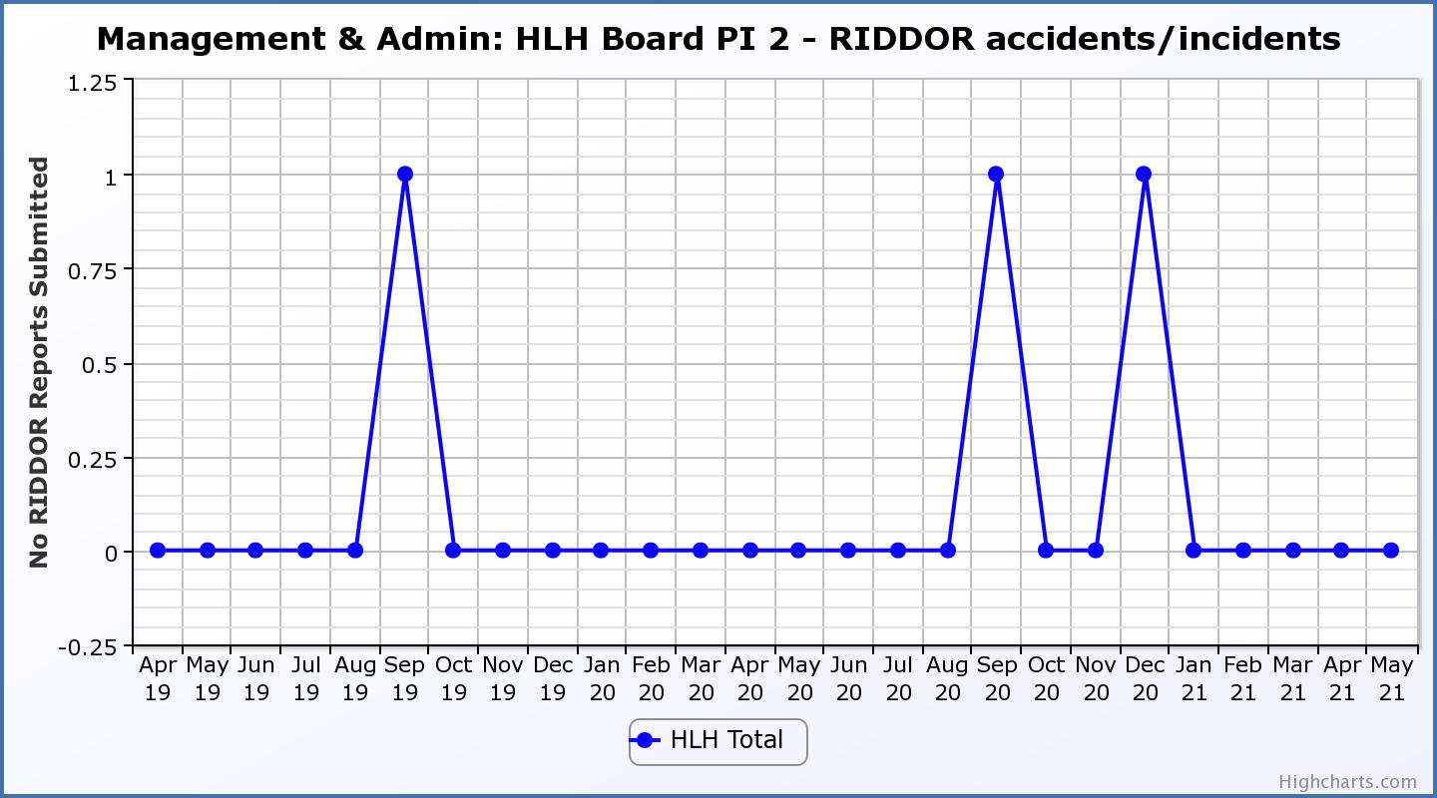

|  |  |  |  |  |  |  |  |  |
| --- | --- | --- | --- | --- | --- | --- | --- | --- |
| **Business Plan Outcome** | **Performance Indicator** | **Reporting Frequency** | **RAG Rating Definition** | **RAG Rating Q1 20/21** | **RAG Rating Q2 20/21** | **RAG Rating Q3 20/21** | **RAG Rating Q4 20/21** | **Summary of Quarter Four Performance** |
| **2. Implement the Service Delivery Contract with The Highland Council** | 3. Delivery of the Service Delivery Contract (SDC) with The Highland Council (THC). | Six-monthly. | 1. Red = agreement of THC’s CLH Committee that HLH has not met the terms of the SDC. 2. Amber = agreement of THC’s CLH Committee that HLH has met the terms of the SDC but has set some improvement targets. 3. Green = agreement of THC’s CLH Committee that HLH has met or exceeded the terms of the SDC. | NA | Green | NA | Green | THC’s Education Committee considered the HLH update report at its May 2021 meeting. Please see section five of this report for further detail. |

|  |  |  |  |  |  |  |  |  |
| --- | --- | --- | --- | --- | --- | --- | --- | --- |
| **Business Plan Outcome** | **Performance Indicator** | **Reporting Frequency** | **RAG Rating Definition** | **RAG Rating Q1 20/21** | **RAG Rating Q2 20/21** | **RAG Rating Q3 20/21** | **RAG Rating Q4 20/21** | **Summary of Quarter Four Performance** |
| **3. Improve customer engagement and satisfaction** | 4. Customer engagements. | Quarterly. | 1. Red = customer numbers are more than 5% lower than the corresponding quarter in the previous year. 2. Amber = customer numbers are less than the corresponding quarter in the previous year. 3. Green = customer numbers are the same as or have increased compared with the corresponding quarter in the previous year. | Red | Red | Red | Red | Customer engagements decreased from 2,434,270 in Q4 2019/20 to  885,096 in Q4 2020/21. The reduction was associated with the lockdown and reduced capacity as a result of following government COVID management arrangements. Please see section three of this report for further information. |

**Performance Indicator 4 - Customer engagements**

Customer numbers decreased due to the COVID-19 situation.

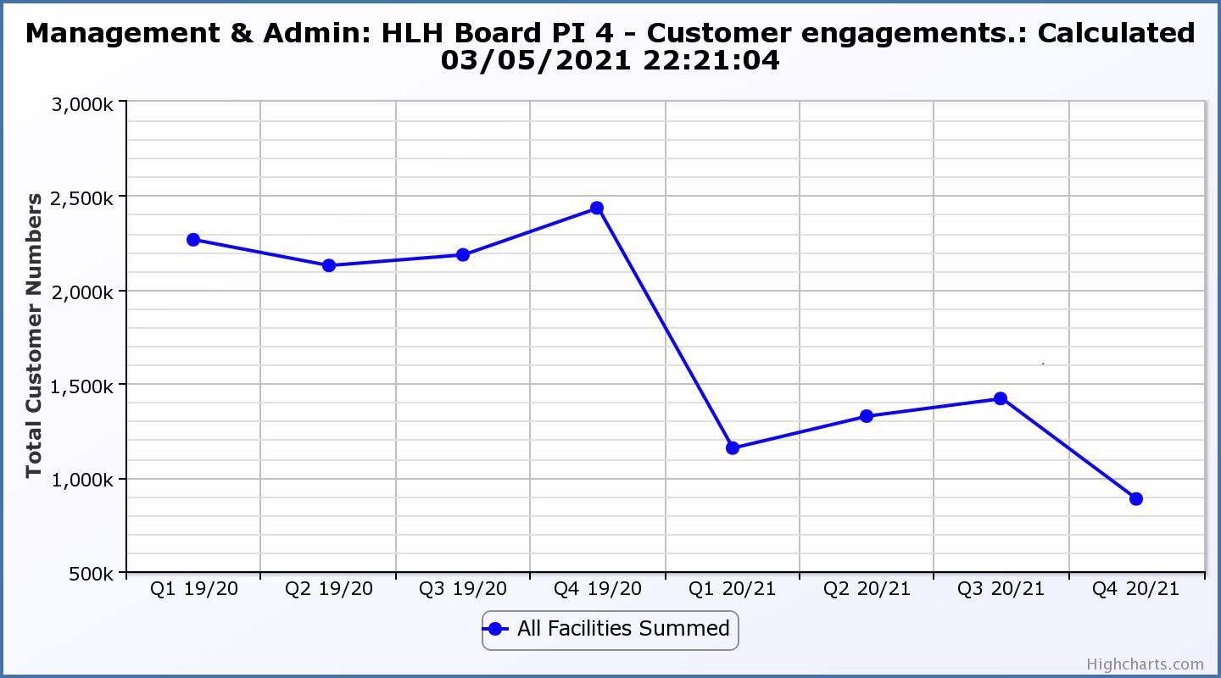

|  |  |  |  |  |  |  |  |  |
| --- | --- | --- | --- | --- | --- | --- | --- | --- |
| **Business Plan Outcome** | **Performance Indicator** | **Reporting Frequency** | **RAG Rating Definition** | **RAG Rating Q1 20/21** | **RAG Rating Q2 20/21** | **RAG Rating Q3 20/21** | **RAG Rating Q4 20/21** | **Summary of Quarter Four Performance** |
| **3. Improve customer engagement and satisfaction (cont.)** | 5. Customer surveys. | Quarterly. | 1. Red = up to three surveys have been completed or scheduled. 2. Amber = 4 to 8 of the HLH areas of work have completed or scheduled customer surveys. 3. Green = all areas of HLH work have completed or scheduled customer surveys. | Green | Green | Amber | Green | One area pf work, Archives has completed a customer survey this financial year with all others having scheduled surveys to take place with Adult Learning and Youth work having scheduled surveys of customers who have not yet returned during the current quarter. |

|  |  |  |  |  |  |  |  |  |
| --- | --- | --- | --- | --- | --- | --- | --- | --- |
| **Business Plan Outcome** | **Performance Indicator** | **Reporting Frequency** | **RAG Rating Definition** | **RAG Rating Q1 20/21** | **RAG Rating Q2 20/21** | **RAG Rating Q3 20/21** | **RAG Rating Q4 20/21** | **Summary of Quarter Four Performance** |
| **3. Improve customer engagement and satisfaction (cont.)** | 6. Formal complaints. | Quarterly. | 1. Red = 41 or more complaints per quarter. 2. Amber = 31 to 40 complaints per quarter. 3. Green = 30 complaints or fewer per quarter. | Green | Green | Green | Green | There were eight complaints received during Q4 2020/21. |

**Performance Indicator 6 - Formal Complaints**

The graph below shows the number of complaints which continue to be very low in relation to customer numbers.

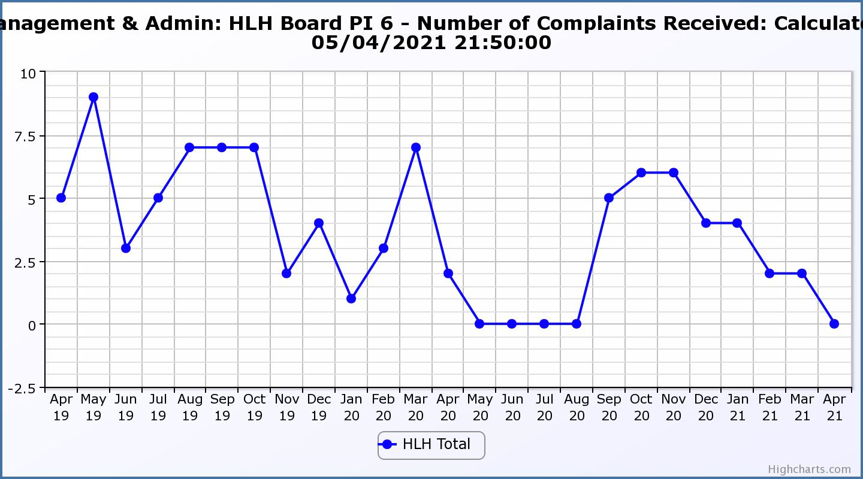

|  |  |  |  |  |  |  |  |  |
| --- | --- | --- | --- | --- | --- | --- | --- | --- |
| **Business Plan Outcome** | **Performance Indicator** | **Reporting Frequency** | **RAG Rating Definition** | **RAG Rating Q1 20/21** | **RAG Rating Q2 20/21** | **RAG Rating Q3 20/21** | **RAG Rating Q4 20/21** | **Summary of Quarter Four Performance** |
| **4. Improve staff engagement and satisfaction** | 7. Staff turnover (resignations as a percentage of posts). | Quarterly. | 1. Red = more than 2% 2. Amber = 1.7 to 2% 3. Green = 1.6% or less | Green | Green | Green | Green | The number of resignations per month as a percentage of posts in Q4 was 0.24% in January, 0.16% in February and 0.47% in March. Please see HR report elsewhere on this agenda for further information. |

**Performance Indicator 7 - Staff Turnover (resignations as a percentage of posts)**

The graph below shows resignations as a percentage of the number of posts and resignations have been consistent with previous years and continue to be low (1% equates to 10.6 staff)

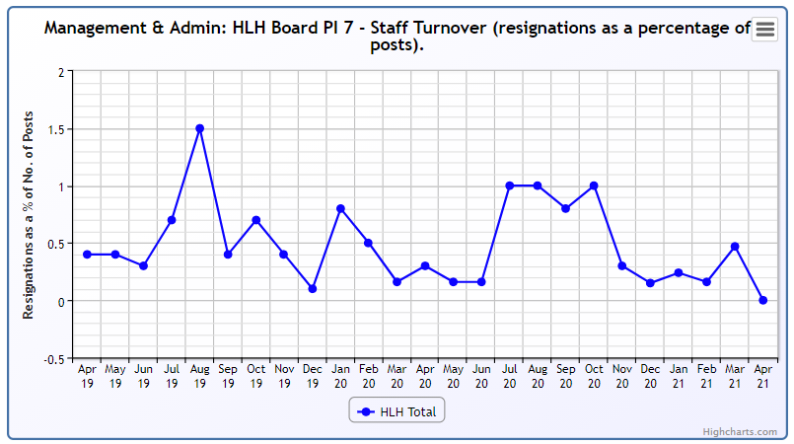

|  |  |  |  |  |  |  |  |  |
| --- | --- | --- | --- | --- | --- | --- | --- | --- |
| **Business Plan Outcome** | **Performance Indicator** | **Reporting Frequency** | **RAG Rating Definition** | **RAG Rating Q1 20/21** | **RAG Rating Q2 20/21** | **RAG Rating Q3 20/21** | **RAG Rating Q4 20/21** | **Summary of Quarter Four Performance** |
| **4. Improve staff engagement and satisfaction (cont.)** | 8. Staff absence rates. | Quarterly. | 1. Red = absence rate greater than 3.6%. 2. Amber = absence rate between 3.4% and 3.6%. 3. Green = absence rate 3.3% or less. | Green | Green | Green | Green | The absence rate for Q4 was 1.24%. Please see the HR report elsewhere on this agenda for further information. |

**Performance Indicator 8 - Staff Absence Rates**

Many HLH staff were on furlough leave during quarter four 2020/21 and the absence rate was low. 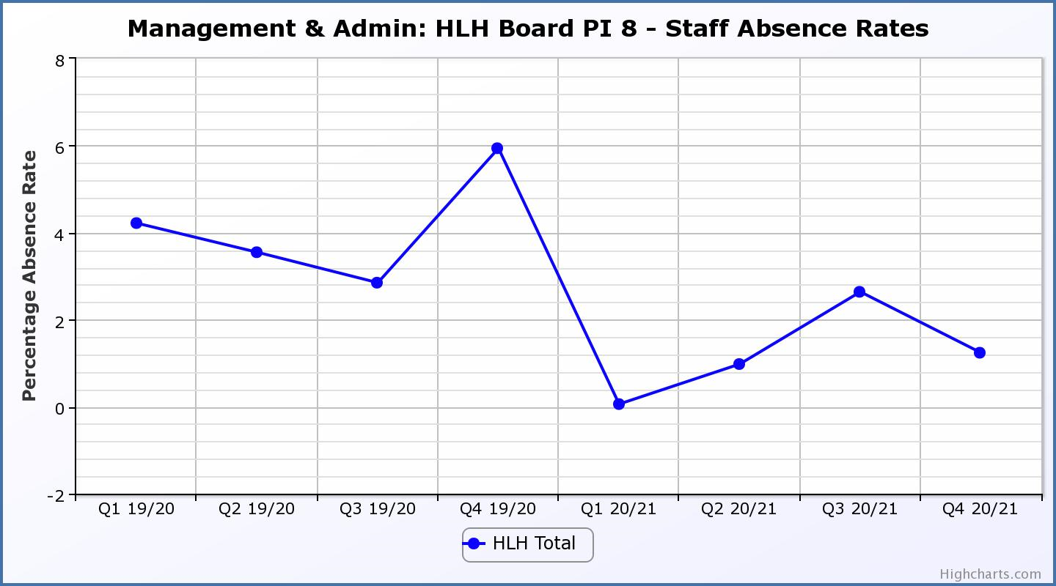

|  |  |  |  |  |  |  |  |  |
| --- | --- | --- | --- | --- | --- | --- | --- | --- |
| **Business Plan Outcome** | **Performance Indicator** | **Reporting Frequency** | **RAG Rating Definition** | **RAG Rating Q1 20/21** | **RAG Rating Q2 20/21** | **RAG Rating Q3 20/21** | **RAG Rating Q4 20/21** | **Summary of Quarter Four Performance** |
| **5. Enhance the positive company image** | 9. Media clippings. | Quarterly | 1. Red = number of negative press clippings outweigh neutral and positive. 2. Amber = number of negative and neutral press clippings outweigh positive. 3. Green = number of positive and neutral media clippings outweigh negative. | Green | NA | Green | Green | During Quarter four there were 19 media articles 18 of which were positive; 0 negative; and 1 neutral. |

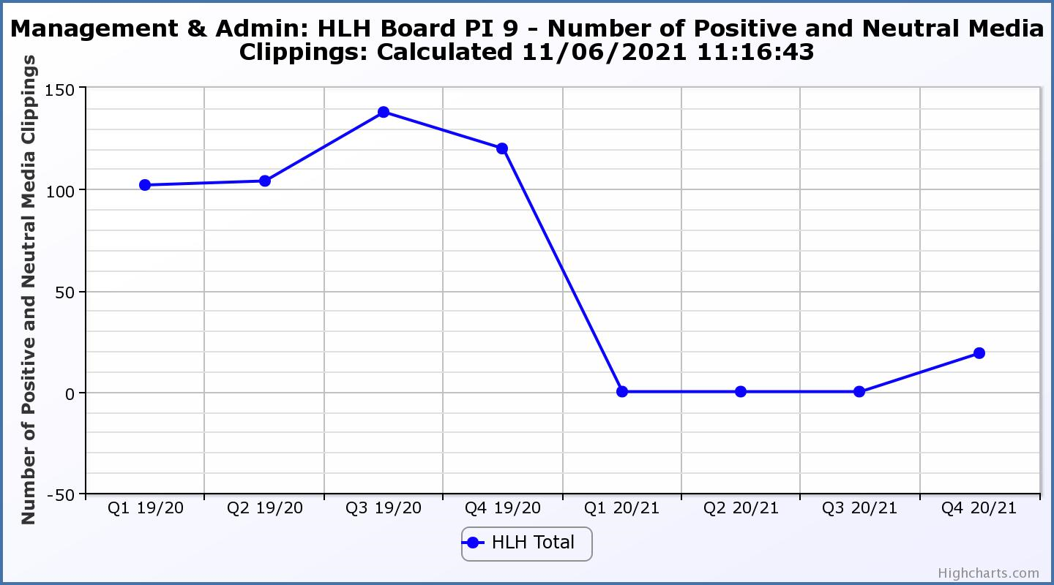 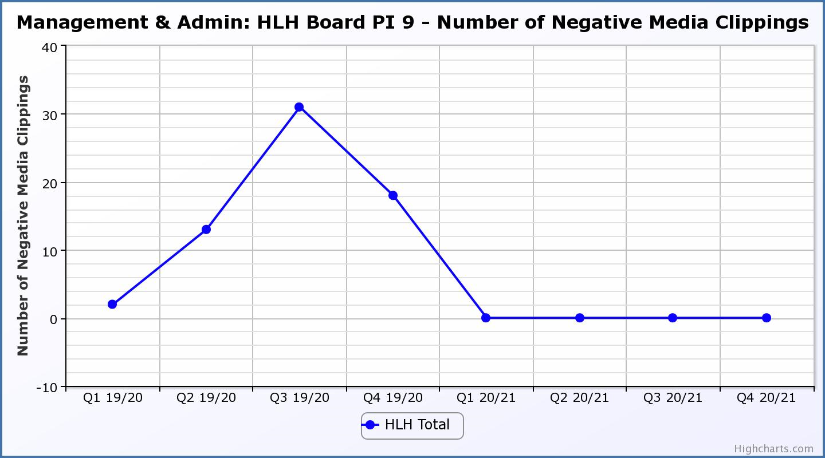

|  |  |  |  |  |  |  |  |  |
| --- | --- | --- | --- | --- | --- | --- | --- | --- |
| **Business Plan Outcome** | **Performance Indicator** | **Reporting Frequency** | **RAG Rating Definition** | **RAG Rating Q1 20/21** | **RAG Rating Q2 20/21** | **RAG Rating Q3 20/21** | **RAG Rating Q4 20/21** | **Summary of Quarter Four Performance** |
| **6. Be a trusted and effective partner** | 10. THC’s annual survey of performance and attitudes. | Annual. | 1. Red = all HLH areas of work represented receive lower net satisfaction ratings than the previous year. 2. Amber = two or more areas of HLH work receive lower net satisfaction ratings than the previous year. 3. Green = net satisfaction ratings are maintained or improved for three or more areas of HLH work compared with the previous year. | N/A | N/A | N/A | NA | This PI has not been RAG rated because the Council paused its annual survey during 2020/21. It is expected that this will be resumed this financial year. |

|  |  |  |  |  |  |  |  |  |
| --- | --- | --- | --- | --- | --- | --- | --- | --- |
| **Business Plan Outcome** | **Performance Indicator** | **Reporting Frequency** | **RAG Rating Definition** | **RAG Rating Q1 20/21** | **RAG Rating Q2 20/21** | **RAG Rating Q3 20/21** | **RAG Rating Q4 20/21** | **Summary of Quarter Four Performance** |
| **6. Be a trusted and effective partner (cont.)** | 11. Partnership work with sportscotland | Annual | 1. Red = cancellation of Partnership Agreement with sportscotland 2. Amber = continuation of current level of partnership work with sportscotland 3. Green = Growth in partnership working with sportscotland | Green | NA | NA | NA | This is an annual indicator and was last considered by the HLH Board at its meeting held on 27 August 2020. |

|  |  |  |  |  |  |  |  |  |
| --- | --- | --- | --- | --- | --- | --- | --- | --- |
| **Business Plan Outcome** | **Performance Indicator** | **Reporting Frequency** | **RAG* Rating Definition**  **(*Red/Amber/Green)** | **RAG Rating Q1 20/21** | **RAG Rating Q2 20/21** | **RAG Rating Q3 20/21** | **RAG Rating Q4 20/21** | **Summary of Quarter Four Performance** |
| **7. Achieve sustainable growth across the organisation** | 12. Financial monitoring. | Quarterly. | An assessment of the year end outturn where:   1. Red = delivery of services over budget above 2%. 2. Amber = delivery of services between break-even and 2% over budget. 3. Green = delivery of services within budget. | Red | Red | Amber | Amber | Please see the Finance Report elsewhere on this agenda for further information. This PI has been RAG rated amber because of the projected deficit in 2021/22. THC, at its meeting on 4 March 2021, approved a commitment to underwrite any HLH deficit in 2021/22. |

|  |  |  |  |  |  |  |  |  |
| --- | --- | --- | --- | --- | --- | --- | --- | --- |
| **Business Plan Outcome** | **Performance Indicator** | **Reporting Frequency** | **RAG Rating Definition** | **RAG Rating Q1 20/21** | **RAG Rating Q2 20/21** | **RAG Rating Q3 20/21** | **RAG Rating Q4 20/21** | **Summary of Quarter Four Performance** |
| **7. Achieve sustainable growth across the organisation (cont.)** | 13. Number of High Life subscriptions. | Quarterly. | 1. Red = more than 5% below target. 2. Amber = up to 5% below target. 3. Green = on or exceeds target. | Red | Red | Red | Red | This PI has been RAG rated red because of the reduced number of subscriptions during Q4 2020/21 compared with previous years. The income being generated is, however, above the level required to achieve the target in the financial modelling. |

**Performance Indicator 13 - Number of High Life Subscriptions**

At the time of writing, 31 May, subscriptions were 10,387 which is close to the level they reached between the two lockdowns. 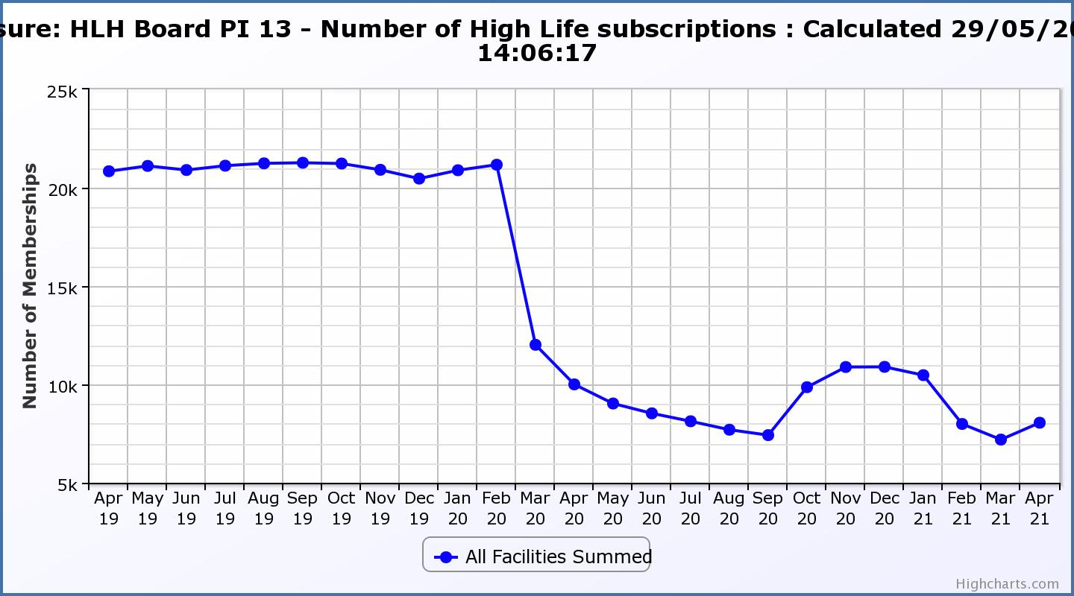

|  |  |  |  |  |  |  |  |  |
| --- | --- | --- | --- | --- | --- | --- | --- | --- |
| **Business Plan Outcome** | **Performance Indicator** | **Reporting Frequency** | **RAG Rating Definition** | **RAG Rating Q1 20/21** | **RAG Rating Q2 20/21** | **RAG Rating Q3 20/21** | **RAG Rating Q4 20/21** | **Summary of Quarter Four Performance** |
| **7. Achieve sustainable growth across the organisation (cont.)** | 14. High Life cancellation rate. | Quarterly. | 1. Red = cancellation rate above 6% of High Life memberships. 2. Amber = cancellation rate is 3% - 6% of High Life memberships. 3. Green = cancellation rate is up to 3% of High Life memberships. | Red | Red | Amber | Red | The number of cancelled subscriptions were 4% in January and February and 8% in March. The increased cancellations were due to the lockdown. Please see section three of this report for further information. |

**Performance Indicator 14 - High Life Cancellation Rate**

This graph shows cancelled subscriptions. Please see section 3 of this report for further information.

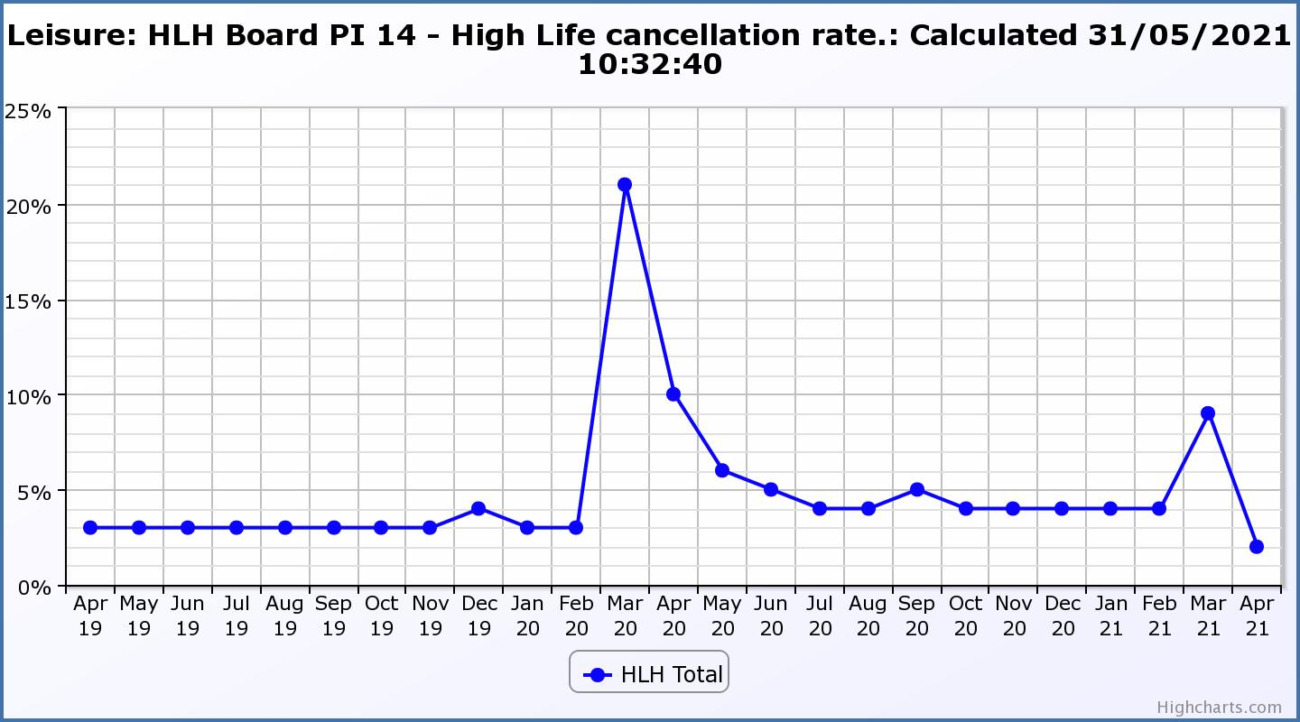

|  |  |  |  |  |  |  |  |  |
| --- | --- | --- | --- | --- | --- | --- | --- | --- |
| **Business Plan Outcome** | **Performance Indicator** | **Reporting Frequency** | **RAG Rating Definition** | **RAG Rating Q1 20/21** | **RAG Rating Q2 20/21** | **RAG Rating Q3 20/21** | **RAG Rating Q4 20/21** | **Summary of Quarter Four Performance** |
| **8. Develop health and wellbeing across Highland communities** | 15. Partnership work with NHSH and other health related organisations. | Annual. | 1. Red = no partnership work with NHSH etc. 2. Amber = Reduction of current level of partnership work with NHSH etc. 3. Green = Continuation or growth in partnership working with NHSH etc. | Green | N/A | N/A | N/A | This is an annual indicator. |

|  |  |  |  |  |  |  |  |  |
| --- | --- | --- | --- | --- | --- | --- | --- | --- |
| **Business Plan Outcome** | **Performance Indicator** | **Reporting Frequency** | **RAG Rating Definition** | **RAG Rating Q1 20/21** | **RAG Rating Q2 20/21** | **RAG Rating Q3 20/21** | **RAG Rating Q4 20/21** | **Summary of Quarter Four Performance** |
| **9. Develop and promote the High Life brand** | 16. Uptake of HLH card towards the target of 80% of the population. | Annual | 1. Red = number of card holders is maintained. 2. Amber = number of card holders is increased by 1-4%. 3. Green = number of card holders is increased by 5% or more. | NA | NA | NA | Red | The percentage of people who live in the THC area with a leisure or library card or both in 2019/20 as a percentage of the population was 40%. In 2020/21 it was 19%. |