|  |  |
| --- | --- |
| HIGH LIFE HIGHLAND  REPORT TO BOARD OF DIRECTORS  1 September 2021 | AGENDA ITEM REPORT No HLH /21 |

## **Performance Report - Report by Chief Executive**

|  |
| --- |
| **Summary** The purpose of this report is to present performance information for the period April to June 2021.  It is recommended that Directors comment on the report and agree that the overall health check on the charity for that period is assessed as “green”, on target, reflecting early indications of customer recovery following COVID-19 restrictions and additional financial support having been agreed by The Highland Council for financial year 2021/22. |

|  |  |
| --- | --- |
| **1.** | **Business Plan Contribution** |
| 1.1 | This report supports all of the Business Outcomes from the High Life Highland (HLH) Business Plan:   1. **Sustain a high standard of health and safety, and environmental performance** 2. **Implement the Service Delivery Contract with THC** 3. **Improving customer engagement and satisfaction** 4. **Improving staff engagement and satisfaction** 5. **Enhance the positive charity image** 6. **Be a trusted and effective partner** 7. **Achieve sustainable growth across the organisation** 8. **Develop health and wellbeing across Highland communities** 9. **Develop and promote the High Life brand** |
| **2.** | **Background** |
| 2.1 | The implementation of the HLH Business Plan 2019-24 is monitored in two ways:   1. through a set of performance indicators set by the Board at its meeting held on 11 December 2018; and 2. by RAG (Red’ Amber, Green) rating the delivery of the business outcomes contained in the business plan with these being reported to the Board by exception (i.e. reporting where managers had RAG rated the actions “red – no significant progress”). Note: this has been temporarily replaced by the work on the Recovery Action Plan. |

|  |  |
| --- | --- |
| **3.** | **Summary of Performance** |
| 3.1 | 16 performance indicators (PIs) were identified by the HLH Board to assess the overall performance of the charity. At its meeting in December 2019 the HLH Board agreed to develop a summarised reporting format and **Appendix A** contains a summary of performance against the PIs for Q1 2021/22. |
| 3.2 | **Appendix B** provides a list of all the PIs along with trend information. Thirteen PIs were scheduled for assessment at the September 2021 HLH Board meeting and they have been RAG rated “green”. |
| 3.3 | During the recent quarterly board reports the following have been regularly RAG rated as red or amber:   * PI 4. customer engagements; * PI 12. financial monitoring; and * PI 13. ***high****life* subscriptions.   This time round they have been RAG rated “green” (on target), this is due to the following:   * customer engagements are showing an increase compared with the same quarter last year indicating the beginnings of a customer recovery from the pandemic; * financial monitoring shows that the organisation is on target to deliver its budget within the amount of additional support that has been agreed by THC; and * ***high****life* subscriptions are ahead of where they need to be to achieve the income required to meet financial projections as above. |
| 3.4 | Having said that, these performance indicators are being closely monitored because they are critical to the success of the charity. A further marketing campaign is being developed to promote ***high****life* subscriptions to support the recovery to pre-pandemic levels. |
| 3.5 | When the HLH Board met in June 2021 there was no timescale for the end of level zero restrictions. The country moved beyond level zero on 9 August 2021. Early indications are that customers have been keen to return and all services are preparing for increases in customer numbers during the first 2 weeks of the new school term, commencing 17 August 2021. |
| 3.6 | During the restrictions, pre-booking in leisure centres was required for all activities. This has now been removed for gyms/fitness suites, public swimming sessions, etc. However, the ability to book lane swimming has been retained in the short-term at some sites because there has been a higher demand for this activity during the pandemic. This will be reviewed at each site over the coming weeks to allow an assessment of customer demand. |
| 3.7 | There are still some additional COVID-19 requirements across all sites compared with previous operations and while they might present a small degree of inconvenience, they also provide a level of customer re-assurance:   * Ventilation regulations - while there are greater capacities in buildings now than while the protection levels were in force there are still capacity limits. Arrangements are in place to ensure that ventilation is adequate, including keeping some rooms in buildings closed where there is limited ventilation and sampling carbon dioxide levels which is the recognised way of monitoring ventilation. * Cleaning - enhanced cleaning of touch points is still a Scottish Government requirement. * Contact tracing and self-isolation – there is still a requirement to maintain contact tracing information. * Wearing of face coverings - is required by legislation while customers and staff are in common areas in buildings. * Movement in common areas (non-activity spaces) - while there is no longer a requirement for physical distancing customers are asked to respect each other and keep left while passing in corridors and more restricted areas and there are floor markings to encourage this. * Physical distancing - signage at entrances has been updated with a message asking customers to keep a safe distance from people in other households. Staff are still being asked to maintain two metre distancing to minimise the risk of having to close buildings due to contact tracing. |
| 3.8 | The above means that there are still restrictions in numbers and increased costs. Additionally, customer confidence is still an unknown and there have been isolated instances of customer feedback indicating concern over the easing of restrictions. To maintain costs within budget, reduced opening hours at leisure centres based on busiest times, pre-pandemic have been retained to achieve a balance between generating income and minimising costs. This is being carefully monitored and hours increased as customer demand increases. |
| **4.** | **Performance Indicators for More Detailed Consideration** |
| 4.1 | Each quarter more detailed information is provided on one or more of the sixteen performance indicators and the following performance indicators were scheduled for consideration at the September 2021 HLH Board meeting:   * PI 3. Delivery of the Service Delivery Contract with The Highland Council. * PI 11. Partnership work with **sport**scotland * PI 15. Partnership work with NHS and other health related organisations. |
| 4.2 | **Delivery of the Service Delivery Contract with The Highland Council** – THC’s Education Committee considers an HLH update report twice per year. The most recent update report was considered at its meeting held on 20 May 2021. The report (which can be seen on THC’s [web site](https://www.highland.gov.uk/download/meetings/id/78210/item_14_high_life_highland_update_report)) and presentation by the HLH Chief Executive were well received with the following having been noted:   1. the services that were delivered by High Life Highland during lockdown through the increased use of technology, including over 4 million online customer engagements in 2020/21; 2. the general updates, including those on High Life Highland’s recovery work; and 3. the opening plan for High Life Highland services from 26 April 2021 as set out in **Appendix A** of the report. |
| 4.3 | Reporting to THC includes a focus on one aspect of HLH work at each meeting and the focus at the May meeting was on online and virtual services. During the discussion HLH was particularly commended for its delivery of music tuition services (HLH was the only organisation to continue to deliver the schools music tuition service during the first lockdown) and the overall approach that HLH took during the lockdowns and restrictions was well received. |
| 4.4 | The Education Committee expressed its appreciation for the exceptional hard work of HLH’s employees during the pandemic. |
| 4.5 | **Partnership work with sportscotland** – one of the performance indicators that the charity has used for a number of years is its relationship with **sport**scotland. HLH receives approximately two thirds of the funding (£953,872) from **sport**scotland towards the Active Schools programme which allows for the employment of a team of Active Schools Coordinators providing services and opportunities for young people across Highland to be active. |
| 4.6 | The HLH sports development team continues to work well with **sport**scotland towards the outcomes of the 4-year partnership agreement which started in 2019 and runs to 2023. HLH has committed to support the Highland and Islands Regional Leadership Group (which is a grouping of Local Authorities and Arms-Length External Organisations (ALEO’s) in the Highland and Islands) together with **sport**scotland, 2 key areas of work have emerged as a result of this initiative:   * In April 2021, £12K of funding (£2K from HLH and £10K from **sport**scotland) was identified to support talented athletes to travel for training and competition outwith the Highland area. Invitations to apply were advertised in June 2021 for athletes to apply for the 2021-2022 year. Funding was awarded to 14 athletes in July 2021. The Council has asked for follow-up information on this at its November Education Committee meeting. * HLH and **sport**scotland are keen to work together to improve support to Highland based Institute of Sport athletes and those on sports performance pathways. In the past year this has seen an improved strength and conditioning suite funded by **sport**scotland at Inverness Leisure at a total cost of £75,000 with **sport**scotland funding £37.5K with the remainder funded by High Life Highland. There will also be public access to the facilities and the new suite is a core part of the recovery to pre-pandemic membership levels. (This forms part of the phased development of Inverness Leisure). |
| 4.7 | **sport**scotland supports the development of people through investment into the HLH Leadership programme and by supporting the training and recognition of coaches and volunteers. The Leadership programme is one of only two supported programmes in Scotland. The programme delivered by HLH is unique in that it has developed an in-house qualification rated at levels four and five SCQF called ‘Choose to Lead’. This is accredited in partnership with UHI and is assessed by **sport**scotland as a ‘sector leading’ initiative. |
| 4.8 | **sport**scotland also invests £100,726 into the delivery of community sport hubs. This funds the employment of 2 community sport hub officers with the programme aimed at bringing together clubs and organisations to develop sport at local level. HLH now supports 12 community sport hubs across the Highland area. |
| 4.9 | HLH was able to expand its School’s Out summer activity programme through the **sport**scotland ‘Get into Summer’ initiative which invested £53,136 in the Highland Council area. The programme focused on rural locations where there was limited access to activities and areas of higher deprivation. |
| 4.10 | HLH is supported by a designated staff team from **sport**scotland that provides guidance and support to HLH in the areas of school and community sport, facilities development, people development, Scottish Governing Body of sport partnerships and performance sport. **sport**scotland has also referred to HLH as an exemplar for its work across the Active Schools programme and Community Sports Hub work. |
| 4.11 | **Partnership work with NHS and other health related organisations** – this performance indicator has been assessed as being “green”, on target and there is further information in the Health and Wellbeing Update report elsewhere on this agenda. |
| **5.** | **Implications** |
| 5.1 | Resource implications – there are no additional resource implications arising from this report. Resource implications have been covered in the Finance Report elsewhere on this agenda. |
| 5.2 | Legal implications - there are no new legal implications arising from this report. |
| 5.3 | Equality implications – there are no new equality implications arising from this report. |
| 5.4 | Risk implications – there are no new risk implications arising from this report. |
|  |  |

|  |
| --- |
| **Recommendation** It is recommended that Directors comment on the report and agree that the overall health check on the charity for that period is assessed as “green”, on target, reflecting early indications of customer recovery following COVID-19 restrictions and additional financial support having been agreed by The Highland Council for financial year 2021/22. |

Designation: Chief Executive

Date: 16 August 2021

**Appendix A**

**HLH Performance Indicators year to date 2021/22**

|  |  |
| --- | --- |
|  | Sixteen performance indicators (PIs) are used by the High Life Highland Board to assess the overall performance of the charity.  The PIs are RAG rated (allocated a "Red", "Amber" or "Green" status) so that it is easy to see at a glance how the organisation is performing. Most of the PIs are RAG rated every quarter throughout the year, with some (such as partnership working with NHSH for example) being considered annually so greyed out sectors on this radar diagram mean that the PI is to be considered at a future HLH Board meeting. |

**Appendix B**

**HLH Performance Indicators**

|  |  |  |  |  |  |  |  |  |
| --- | --- | --- | --- | --- | --- | --- | --- | --- |
| **Business Plan Outcome** | **Performance Indicator** | **Reporting Frequency** | **RAG Rating Definition** | **RAG Rating Q1 21/22** | **RAG Rating Q2 21/22** | **RAG Rating Q3 21/22** | **RAG Rating Q4 21/22** | **Summary of Quarter One Performance** |
| **1. Sustain a high standard of health and safety and environmental performance** | 1. Health and safety audit. | Annual. | 1. Red = the external audit raises systemic (i.e. applying across multiple sites) H&S issues. 2. Amber = the external audit highlights common actions to be addressed across the company. 3. Green = the external audit does not raise systemic issues. | NA | NA | NA |  | This is an annual indicator and the Health and safety and Environmental Compliance Committee, at its meeting held on 10 August 2021, agreed that the annual external audit will take place 15-19 November 2021. |

|  |  |  |  |  |  |  |  |  |
| --- | --- | --- | --- | --- | --- | --- | --- | --- |
| **Business Plan Outcome** | **Performance Indicator** | **Reporting Frequency** | **RAG Rating Definition** | **RAG Rating Q1 21/22** | **RAG Rating Q2 21/22** | **RAG Rating Q3 21/22** | **RAG Rating Q4 21/22** | **Summary of Quarter One Performance** |
| **1. Sustain a high standard of health and safety and environmental performance (cont.)** | 2. RIDDOR accidents/incidents. | Quarterly. | 1. Red = number of RIDDOR reports per quarter is above 20. 2. Amber = number of RIDDOR reports per quarter is between 10 and 20 3. Green = number of RIDDOR reports per quarter is less than 10. | Green |  |  |  | There were no accidents reported under the RIDDOR regulations during Q1. |

**Performance Indicator 2 - RIDDOR accidents/incidents**

The graph below tracks the number of accidents and incidents reported under the Reporting of Injuries, Diseases and Dangerous Occurrences Regulations (RIDDOR). There were no RIDDOR incidents reported in Q1 2021/22.

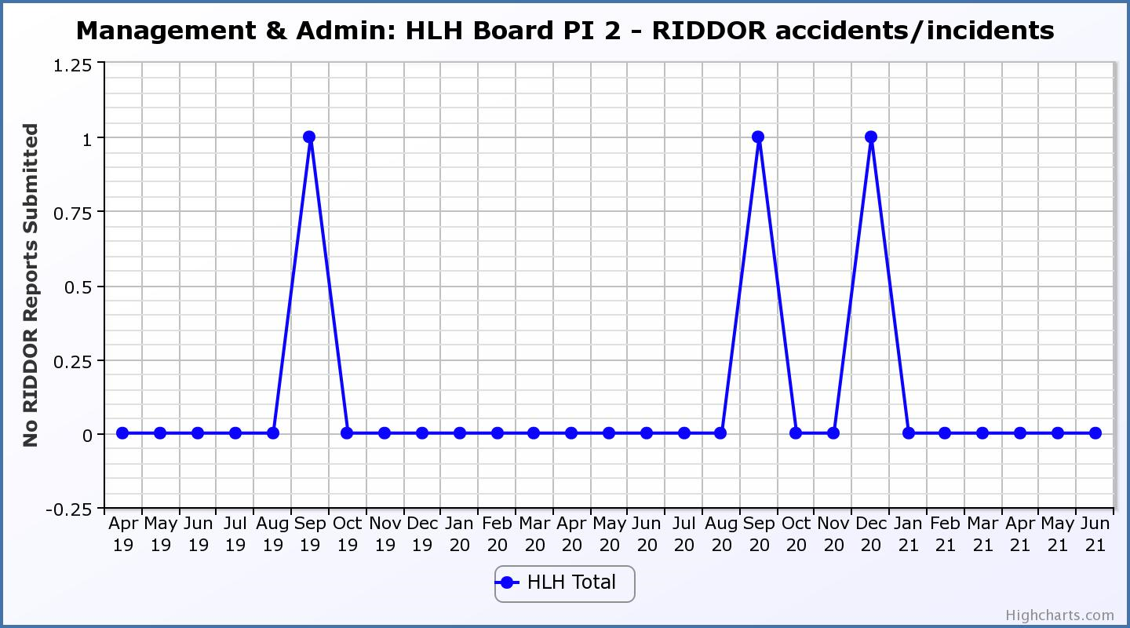

|  |  |  |  |  |  |  |  |  |
| --- | --- | --- | --- | --- | --- | --- | --- | --- |
| **Business Plan Outcome** | **Performance Indicator** | **Reporting Frequency** | **RAG Rating Definition** | **RAG Rating Q1 21/22** | **RAG Rating Q2 21/22** | **RAG Rating Q3 21/22** | **RAG Rating Q4 21/22** | **Summary of Quarter Four Performance** |
| **2. Implement the Service Delivery Contract with The Highland Council** | 3. Delivery of the Service Delivery Contract (SDC) with The Highland Council (THC). | Six-monthly. | 1. Red = agreement of THC’s CLH Committee that HLH has not met the terms of the SDC. 2. Amber = agreement of THC’s CLH Committee that HLH has met the terms of the SDC but has set some improvement targets. 3. Green = agreement of THC’s CLH Committee that HLH has met or exceeded the terms of the SDC. | Green | NA |  | NA | THC’s Education Committee considered the HLH update report at its May 2021 meeting. Please see section five of this report for further detail. |

|  |  |  |  |  |  |  |  |  |
| --- | --- | --- | --- | --- | --- | --- | --- | --- |
| **Business Plan Outcome** | **Performance Indicator** | **Reporting Frequency** | **RAG Rating Definition** | **RAG Rating Q1 21/22** | **RAG Rating Q2 21/22** | **RAG Rating Q3 21/22** | **RAG Rating Q4 21/22** | **Summary of Quarter One Performance** |
| **3. Improve customer engagement and satisfaction** | 4. Customer engagements. | Quarterly. | 1. Red = customer numbers are more than 5% lower than the corresponding quarter in the previous year. 2. Amber = customer numbers are less than the corresponding quarter in the previous year. 3. Green = customer numbers are the same as or have increased compared with the corresponding quarter in the previous year. | Green |  |  |  | Customer engagements increased from 1,155,793 in Q1 2020/21 to  1,243,781 in Q1 2021/22. While this is significantly lower than previous years due to the pandemic is has been RAG rated green as a reflection of recovery from the pandemic. |

**Performance Indicator 4 - Customer engagements**

Customer numbers are showing in increase compared with quarter one 2020/21.

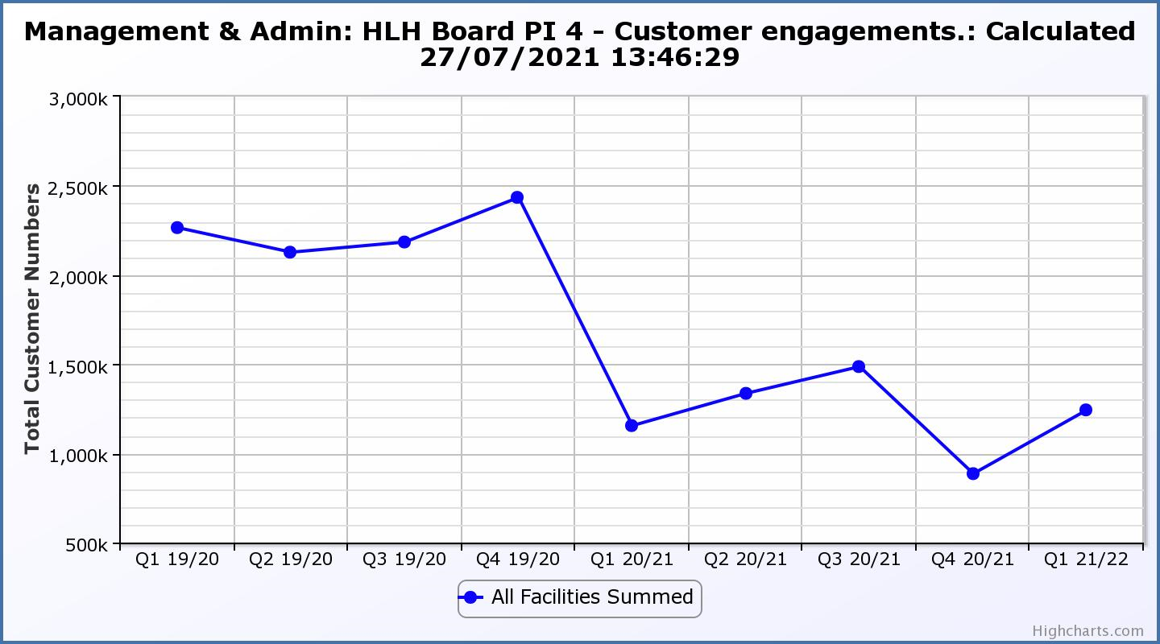

|  |  |  |  |  |  |  |  |  |
| --- | --- | --- | --- | --- | --- | --- | --- | --- |
| **Business Plan Outcome** | **Performance Indicator** | **Reporting Frequency** | **RAG Rating Definition** | **RAG Rating Q1 21/22** | **RAG Rating Q2 21/22** | **RAG Rating Q3 21/22** | **RAG Rating Q4 21/22** | **Summary of Quarter One Performance** |
| **3. Improve customer engagement and satisfaction (cont.)** | 5. Customer surveys. | Quarterly. | 1. Red = up to three surveys have been completed or scheduled. 2. Amber = 4 to 8 of the HLH areas of work have completed or scheduled customer surveys. 3. Green = all areas of HLH work have completed or scheduled customer surveys. | Green |  |  |  | One area of work, Archives has completed a customer survey this financial year with all others having scheduled surveys to take place with Adult Learning and Youth work having scheduled surveys of customers who have not yet returned during the current quarter. |

|  |  |  |  |  |  |  |  |  |
| --- | --- | --- | --- | --- | --- | --- | --- | --- |
| **Business Plan Outcome** | **Performance Indicator** | **Reporting Frequency** | **RAG Rating Definition** | **RAG Rating Q1 21/22** | **RAG Rating Q2 21/22** | **RAG Rating Q3 21/22** | **RAG Rating Q4 21/22** | **Summary of Quarter One Performance** |
| **3. Improve customer engagement and satisfaction (cont.)** | 6. Formal complaints. | Quarterly. | 1. Red = 41 or more complaints per quarter. 2. Amber = 31 to 40 complaints per quarter. 3. Green = 30 complaints or fewer per quarter. | Green |  |  |  | There were thirteen complaints received during Q1 2021/22. |

**Performance Indicator 6 - Formal Complaints**

The graph below shows the number of complaints which continue to be very low in relation to customer numbers.

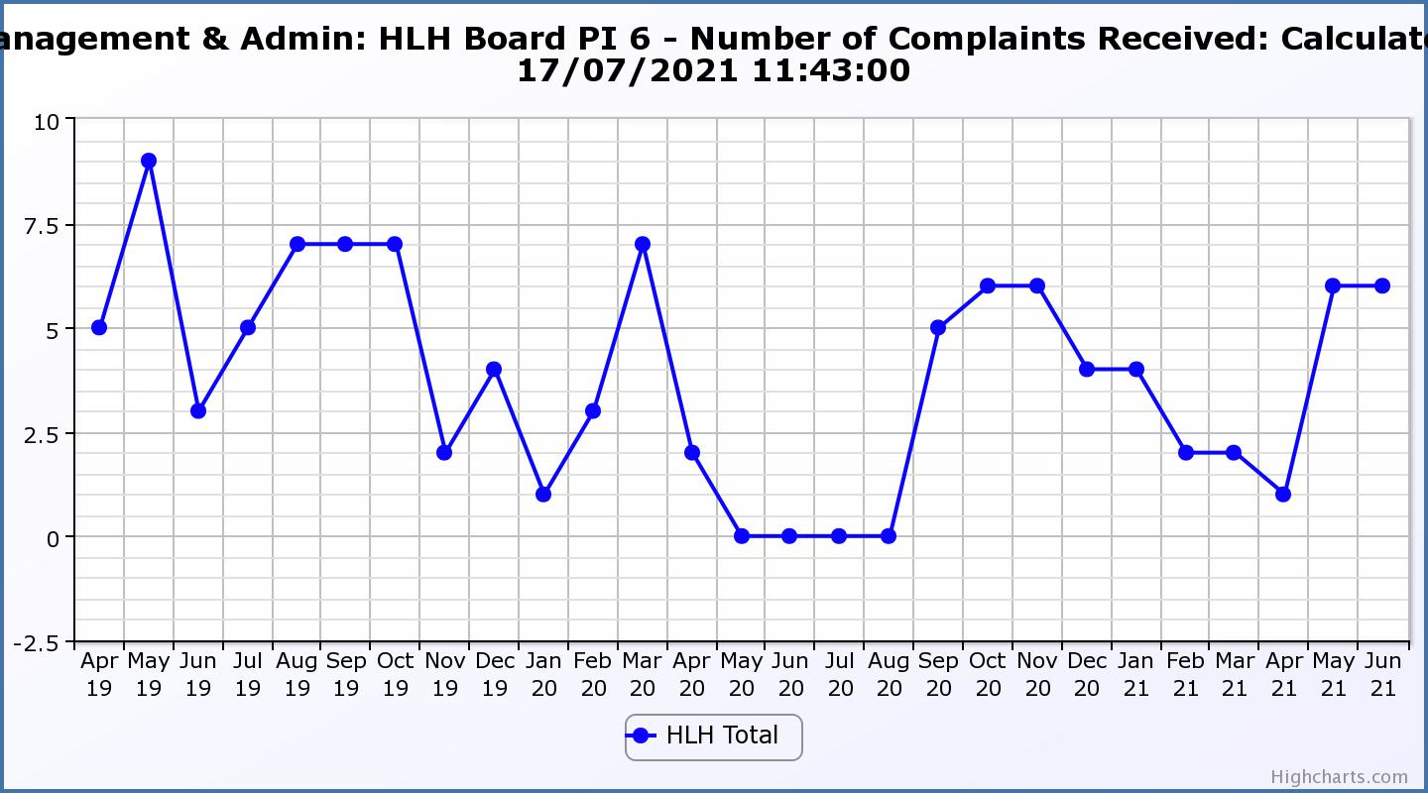

|  |  |  |  |  |  |  |  |  |
| --- | --- | --- | --- | --- | --- | --- | --- | --- |
| **Business Plan Outcome** | **Performance Indicator** | **Reporting Frequency** | **RAG Rating Definition** | **RAG Rating Q1 21/22** | **RAG Rating Q2 21/22** | **RAG Rating Q3 21/22** | **RAG Rating Q4 21/22** | **Summary of Quarter One Performance** |
| **4. Improve staff engagement and satisfaction** | 7. Staff turnover (resignations as a percentage of posts). | Quarterly. | 1. Red = more than 2% 2. Amber = 1.7 to 2% 3. Green = 1.6% or less | Green |  |  |  | The number of resignations per month as a percentage of posts in Q1 was 0.7% in April, 0.8% in May and 0.7% in June. Please see HR report elsewhere on this agenda for further information. |

**Performance Indicator 7 - Staff Turnover (resignations as a percentage of posts)**

The graph below shows resignations as a percentage of the number of posts and resignations have been consistent with previous years and continue to be low (1% equates to 10.6 staff).

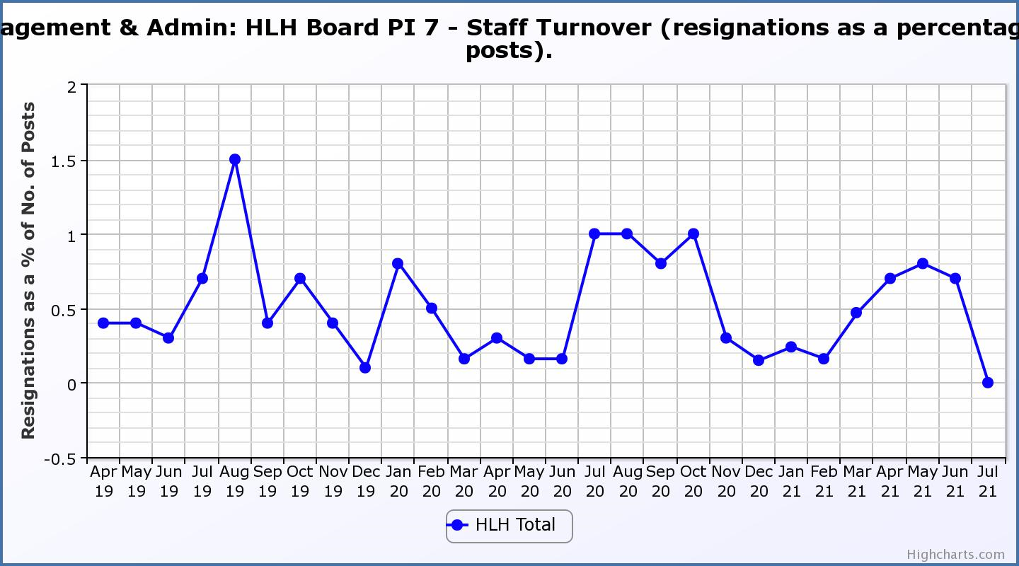

|  |  |  |  |  |  |  |  |  |
| --- | --- | --- | --- | --- | --- | --- | --- | --- |
| **Business Plan Outcome** | **Performance Indicator** | **Reporting Frequency** | **RAG Rating Definition** | **RAG Rating Q1 21/22** | **RAG Rating Q2 21/22** | **RAG Rating Q3 21/22** | **RAG Rating Q4 21/22** | **Summary of Quarter One Performance** |
| **4. Improve staff engagement and satisfaction (cont.)** | 8. Staff absence rates. | Quarterly. | 1. Red = absence rate greater than 3.6%. 2. Amber = absence rate between 3.4% and 3.6%. 3. Green = absence rate 3.3% or less. | Green |  |  |  | The absence rate for Q1 was 2.59%. Please see the HR report elsewhere on this agenda for further information. |

**Performance Indicator 8 - Staff Absence Rates**

Staff absence rates have been lower during furlough/lockdowns with Q3 2020/21 and Q1 2021/22 being broadly comparable. 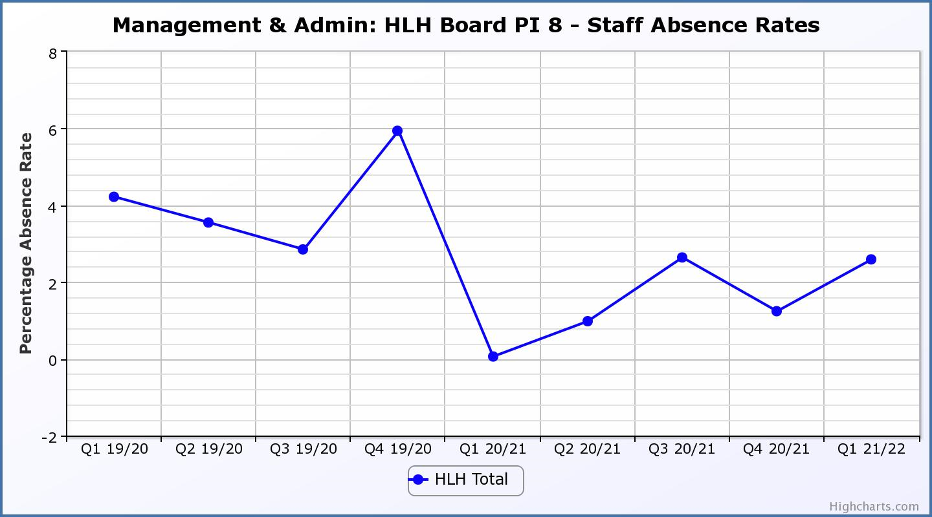

|  |  |  |  |  |  |  |  |  |
| --- | --- | --- | --- | --- | --- | --- | --- | --- |
| **Business Plan Outcome** | **Performance Indicator** | **Reporting Frequency** | **RAG Rating Definition** | **RAG Rating Q1 21/22** | **RAG Rating Q2 21/22** | **RAG Rating Q3 21/22** | **RAG Rating Q4 21/22** | **Summary of Quarter One Performance** |
| **5. Enhance the positive company image** | 9. Media clippings. | Quarterly | 1. Red = number of negative press clippings outweigh neutral and positive. 2. Amber = number of negative and neutral press clippings outweigh positive. 3. Green = number of positive and neutral media clippings outweigh negative. | Green |  |  |  | During Quarter One there were 58 media articles: 33 of which were positive; 3 negative; and 22 neutral. |

**Performance Indicator 9 - Media Clippings**

The following two graphs show the numbers of positive and neutral media clippings compared with negative. The positive and neutral outweigh the negative. (Note, recording stopped during the lockdowns)

|  |  |
| --- | --- |
|  |  |

|  |  |  |  |  |  |  |  |  |
| --- | --- | --- | --- | --- | --- | --- | --- | --- |
| **Business Plan Outcome** | **Performance Indicator** | **Reporting Frequency** | **RAG Rating Definition** | **RAG Rating Q1 21/22** | **RAG Rating Q2 21/22** | **RAG Rating Q3 21/22** | **RAG Rating Q4 21/22** | **Summary of Quarter One Performance** |
| **6. Be a trusted and effective partner** | 10. THC’s annual survey of performance and attitudes. | Annual. | 1. Red = all HLH areas of work represented receive lower net satisfaction ratings than the previous year. 2. Amber = two or more areas of HLH work receive lower net satisfaction ratings than the previous year. 3. Green = net satisfaction ratings are maintained or improved for three or more areas of HLH work compared with the previous year. | N/A | N/A |  | NA | NA, this in an annual indicator. Expected reporting is in Q3. |

|  |  |  |  |  |  |  |  |  |
| --- | --- | --- | --- | --- | --- | --- | --- | --- |
| **Business Plan Outcome** | **Performance Indicator** | **Reporting Frequency** | **RAG Rating Definition** | **RAG Rating Q1 21/22** | **RAG Rating Q2 21/22** | **RAG Rating Q3 21/22** | **RAG Rating Q4 21/22** | **Summary of Quarter One Performance** |
| **6. Be a trusted and effective partner (cont.)** | 11. Partnership work with sportscotland | Annual | 1. Red = cancellation of Partnership Agreement with sportscotland 2. Amber = continuation of current level of partnership work with sportscotland 3. Green = Growth in partnership working with sportscotland | Green | NA | NA | NA | This indicator has been jointly considered between HLH and sportscotland and is assessed as being on target, please see section five of this report for further information. |

|  |  |  |  |  |  |  |  |  |
| --- | --- | --- | --- | --- | --- | --- | --- | --- |
| **Business Plan Outcome** | **Performance Indicator** | **Reporting Frequency** | **RAG* Rating Definition**  **(*Red/Amber/Green)** | **RAG Rating Q1 21/22** | **RAG Rating Q2 21/22** | **RAG Rating Q3 21/22** | **RAG Rating Q4 21/22** | **Summary of Quarter One Performance** |
| **7. Achieve sustainable growth across the organisation** | 12. Financial monitoring. | Quarterly. | An assessment of the year end outturn where:   1. Red = delivery of services over budget above 2%. 2. Amber = delivery of services between break-even and 2% over budget. 3. Green = delivery of services within budget. | Green |  |  |  | This PI has been RAG rated green because it is within the £3.4M under-write agreed by THC, at its meeting on 4 March 2021. Please see the Finance Report elsewhere on this agenda for further information. |

**Performance Indicator 12 - Financial monitoring**

See the Finance Report elsewhere on this agenda for further information.

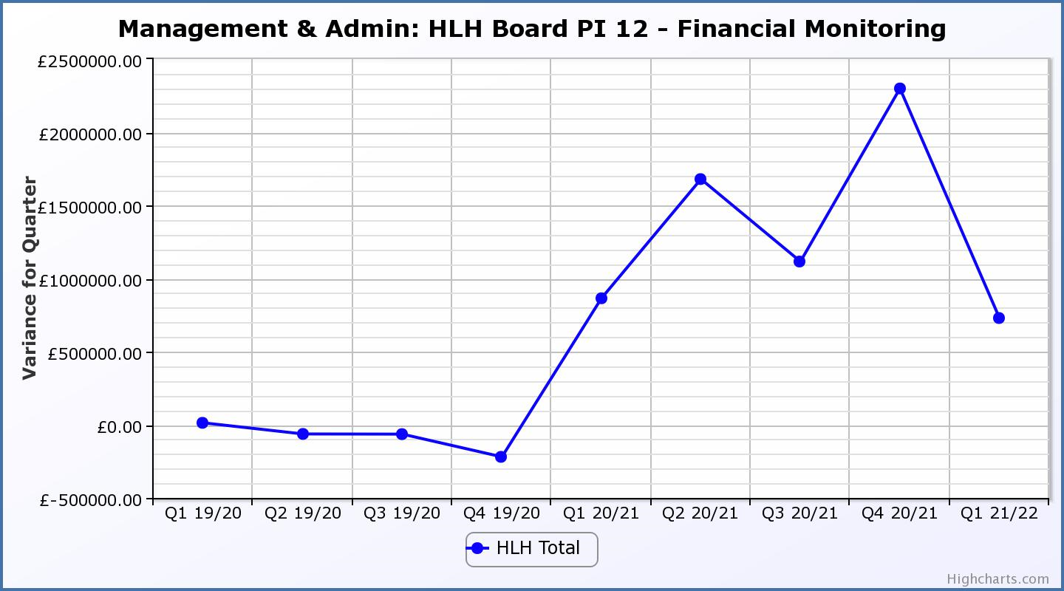

|  |  |  |  |  |  |  |  |  |
| --- | --- | --- | --- | --- | --- | --- | --- | --- |
| **Business Plan Outcome** | **Performance Indicator** | **Reporting Frequency** | **RAG Rating Definition** | **RAG Rating Q1 21/22** | **RAG Rating Q2 21/22** | **RAG Rating Q3 21/22** | **RAG Rating Q4 21/22** | **Summary of Quarter One Performance** |
| **7. Achieve sustainable growth across the organisation (cont.)** | 13. Number of High Life subscriptions. | Quarterly. | 1. Red = more than 5% below target. 2. Amber = up to 5% below target. 3. Green = on or exceeds target. | Green |  |  |  | This PI has been RAG rated green because the number of subscriptions is, above the level required to achieve the target in the financial modelling. As of 9 August 2021 subscriptions were 11,535. |

**Performance Indicator 13 - Number of High Life Subscriptions**

Subscriptions continue to increase slightly ahead of budget projections and as of 9 August 2021 were 11,135 which is slightly more than half of the March 2020 figure and exceeds the December 2020 figure. 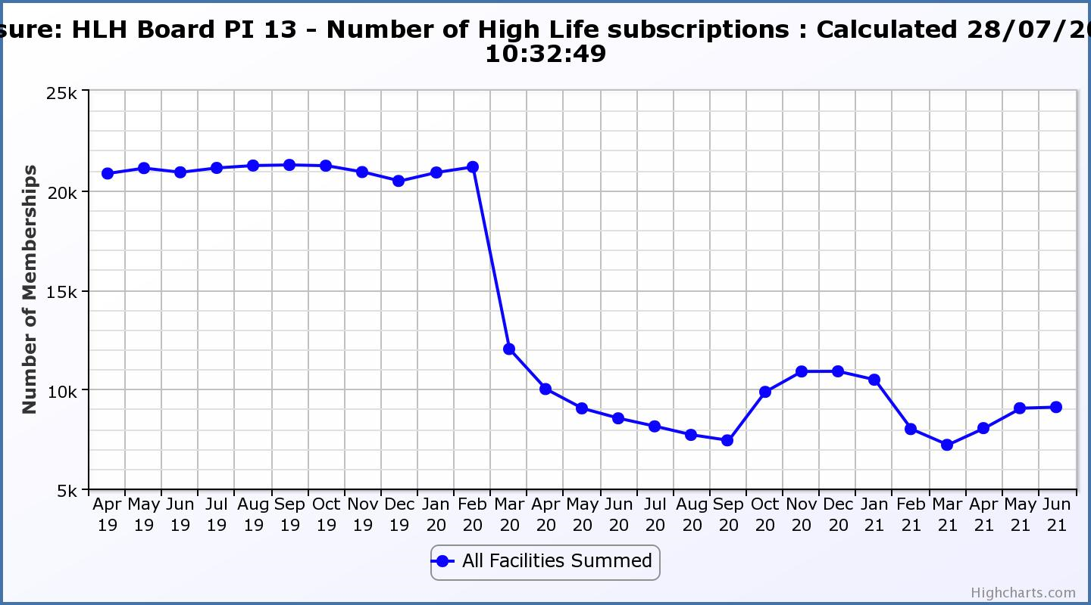

|  |  |  |  |  |  |  |  |  |
| --- | --- | --- | --- | --- | --- | --- | --- | --- |
| **Business Plan Outcome** | **Performance Indicator** | **Reporting Frequency** | **RAG Rating Definition** | **RAG Rating Q1 21/22** | **RAG Rating Q2 21/22** | **RAG Rating Q3 21/22** | **RAG Rating Q4 21/22** | **Summary of Quarter Four Performance** |
| **7. Achieve sustainable growth across the organisation (cont.)** | 14. High Life cancellation rate. | Quarterly. | 1. Red = cancellation rate above 6% of High Life memberships. 2. Amber = cancellation rate is 3% - 6% of High Life memberships. 3. Green = cancellation rate is up to 3% of High Life memberships. | Green |  |  |  | The number of cancelled subscriptions were 2% in April and May and 3% in June. |

**Performance Indicator 14 - High Life Cancellation Rate**

The cancellation rate has returned to historic levels.

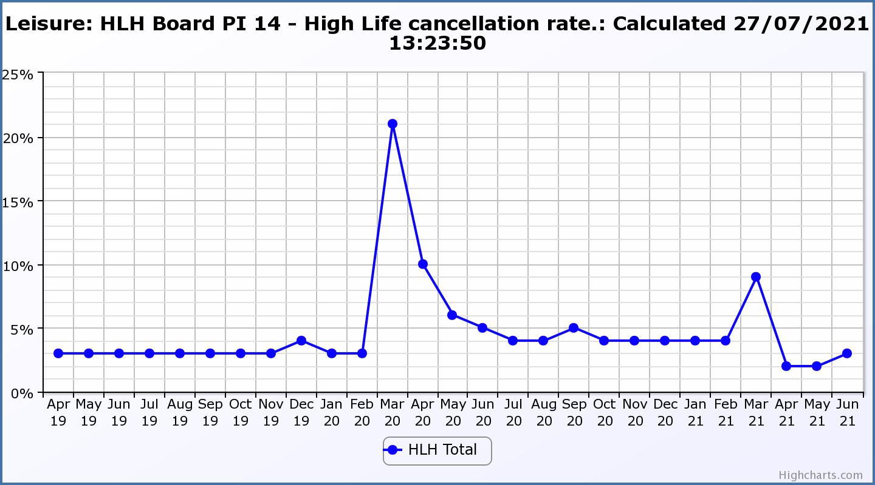

|  |  |  |  |  |  |  |  |  |
| --- | --- | --- | --- | --- | --- | --- | --- | --- |
| **Business Plan Outcome** | **Performance Indicator** | **Reporting Frequency** | **RAG Rating Definition** | **RAG Rating Q1 21/22** | **RAG Rating Q2 21/22** | **RAG Rating Q3 21/22** | **RAG Rating Q4 21/22** | **Summary of Quarter Four Performance** |
| **8. Develop health and wellbeing across Highland communities** | 15. Partnership work with NHSH and other health related organisations. | Annual. | 1. Red = no partnership work with NHSH etc. 2. Amber = Reduction of current level of partnership work with NHSH etc. 3. Green = Continuation or growth in partnership working with NHSH etc. | Green | N/A | N/A | NA | As can be seen in the health and wellbeing update report elsewhere on this agenda the partnership is continuing to progress positively. |

|  |  |  |  |  |  |  |  |  |
| --- | --- | --- | --- | --- | --- | --- | --- | --- |
| **Business Plan Outcome** | **Performance Indicator** | **Reporting Frequency** | **RAG Rating Definition** | **RAG Rating Q1 21/22** | **RAG Rating Q2 21/22** | **RAG Rating Q3 21/22** | **RAG Rating Q4 21/22** | **Summary of Quarter Four Performance** |
| **9. Develop and promote the High Life brand** | 16. Uptake of HLH card towards the target of 80% of the population. | Annual | 1. Red = number of card holders is maintained. 2. Amber = number of card holders is increased by 1-4%. 3. Green = number of card holders is increased by 5% or more. | N/A | NA | NA |  | NA, this is an annual indicator. |

**Appendix C**

**Capital projects submitted to THC for consideration August 2021**

