HIGH LIFE HIGHLAND  REPORT TO BOARD OF DIRECTORS  13 DECEMBER 2021 | AGENDA ITEM REPORT No HLH /21

Performance Report - Report by Chief Executive

Summary

The purpose of this report is to present performance information for the period July to September 2021.

It is recommended that Directors comment on the report and agree that the overall health check on the charity for that period is assessed as “green”, on target, reflecting indications of customer recovery following COVID-19 restrictions and additional financial support having been agreed by The Highland Council for financial year 2021/22.

1. | Business Plan Contribution
1.1 | This report supports all of the Business Outcomes from the High Life Highland (HLH) Business Plan:  - Sustain a high standard of health and safety, and environmental performance  - Implement the Service Delivery Contract with THC  - Improving customer engagement and satisfaction  - Improving staff engagement and satisfaction  - Enhance the positive charity image  - Be a trusted and effective partner  - Achieve sustainable growth across the organisation  - Develop health and wellbeing across Highland communities  - Develop and promote the High Life brand
2. | Background
2.1 | The implementation of the HLH Business Plan 2019-24 is monitored in two ways:  - through a set of performance indicators set by the Board at its meeting held on 11 December 2018; and  - by RAG (Red’ Amber, Green) rating the delivery of the business outcomes contained in the business plan with these being reported to the Board by exception (i.e. reporting where managers had RAG rated the actions “red – no significant progress”). Note: this has been temporarily replaced by the work on the Recovery Action Plan.

3. | Summary of Performance
3.1 | Sixteen performance indicators (PIs) were identified by the HLH Board to assess the overall performance of the charity. At its meeting in December 2019 the HLH Board agreed to develop a summarised reporting format and Appendix A contains a summary of performance against the PIs for Q1 2021/22.
3.2 | Appendix B provides a list of all the PIs along with trend information. Eleven PIs were scheduled for assessment at the December 2021 HLH Board meeting and they have been RAG rated “green”.
3.3 | In the quarter one report it was noted that recent quarterly board reports the following have been regularly RAG rated as red or amber:  - PI 4. customer engagements;  - PI 12. financial monitoring; and  - PI 13. highlife subscriptions.
3.4 | They were RAG rated “green” (on target) and they continued to be so during quarter two because:  - customer engagements continue to increase compared with the same quarter last year indicating the beginnings of a customer recovery trend from the pandemic;  - financial monitoring continues to show that the organisation is on target to deliver its budget within the amount of additional support that has been agreed by THC with the budget position improving; and  - highlife subscriptions continue to be ahead of where they need to be to achieve the income required to meet financial projections as above.
3.5 | These performance indicators are being closely monitored because they are critical to the success of the charity.
4. | Performance Indicators for More Detailed Consideration
4.1 | Each quarter more detailed information is provided on one or more of the sixteen performance indicators and the following performance indicators were scheduled for consideration at the September 2021 HLH Board meeting:  - PI 3. Delivery of the Service Delivery Contract with The Highland Council.  - PI 10. THC’s annual survey of performance and attitudes.
4.2 | Delivery of the Service Delivery Contract with The Highland Council – THC’s Education Committee considers an HLH update report twice per year. The most recent update report was considered at its meeting held on 17 November 2021. The report (which can be seen on THC’s web site) and presentation by High Life Highland’s and sportscotland’s Chief Executives were well received with the following having been noted:  - the information on the performance of High Life Highland (HLH) during the operating period 1 April to 30 September 2021;  - the general updates provided in section two of the report;  - that in the light of the above and the restrictions which were imposed by the coronavirus pandemic, HLH was on target to meet the revised outcomes expected in the Service Delivery Contract with The Highland Council for the operating period to September 2021;  - the positive partnership working between HLH and sportscotland; and  - the new approach to sports facilities investment being taken by sportscotland and its willingness to support the Highland Council’s strategic priorities for sports facility development as the Council develops its capital programme.
4.3 | PI 10. THC’s annual survey of performance and attitudes – The Council has not carried out its annual survey of its citizen’s panel this year and it is anticipated that the next time that it will do this will be in 2022.
5. | Implications
5.1 | Resource implications – there are no additional resource implications arising from this report. Resource implications have been covered in the Finance Report elsewhere on this agenda.
5.2 | Legal implications - there are no new legal implications arising from this report.
5.3 | Equality implications – there are no new equality implications arising from this report.
5.4 | Risk implications – there are no new risk implications arising from this report.

Recommendation

It is recommended that Directors comment on the report and agree that the overall health check on the charity for that period is assessed as “green”, on target, reflecting indications of customer recovery following COVID-19 restrictions and additional financial support having been agreed by The Highland Council for financial year 2021/22.

Designation: Chief Executive

Date: 25 November 2021
Appendix A
HLH Performance Indicators year to date 2021/22
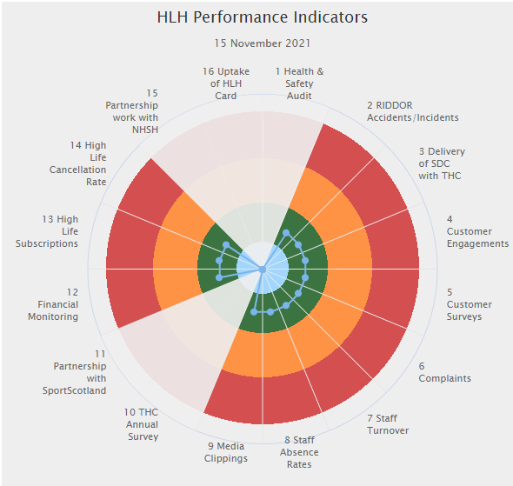 | Sixteen performance indicators (PIs) are used by the High Life Highland Board to assess the overall performance of the charity.  The PIs are RAG rated (allocated a "Red", "Amber" or "Green" status) so that it is easy to see at a glance how the organisation is performing. Most of the PIs are RAG rated every quarter throughout the year, with some (such as partnership working with NHSH for example) being considered annually so greyed out sectors on this radar diagram mean that the PI is to be considered at a future HLH Board meeting.
Appendix B
HLH Performance Indicators

Business Plan Outcome | Performance Indicator | Reporting Frequency | RAG Rating Definition | RAG Rating Q1 21/22 | RAG Rating Q2 21/22 | RAG Rating Q3 21/22 | RAG Rating Q4 21/22 | Summary of Quarter Two Performance
1. Sustain a high standard of health and safety and environmental performance | 1. Health and safety audit. | Annual. | - Red = the external audit raises systemic (i.e. applying across multiple sites) H&S issues.  - Amber = the external audit highlights common actions to be addressed across the company.  - Green = the external audit does not raise systemic issues. | NA | NA | NA |  | This is an annual indicator. The annual audit took place 15-19 November 2021 and the results of it will be considered by the Health and Safety and Environmental Compliance Committee prior to reporting to the HLH Board in the annual Health and Safety Report.

Business Plan Outcome | Performance Indicator | Reporting Frequency | RAG Rating Definition | RAG Rating Q1 21/22 | RAG Rating Q2 21/22 | RAG Rating Q3 21/22 | RAG Rating Q4 21/22 | Summary of Quarter Two Performance
1. Sustain a high standard of health and safety and environmental performance (cont.) | 2. RIDDOR accidents/incidents. | Quarterly. | - Red = number of RIDDOR reports per quarter is above 20.  - Amber = number of RIDDOR reports per quarter is between 10 and 20  - Green = number of RIDDOR reports per quarter is less than 10. | Green | Green |  |  | There was one accident reported under the RIDDOR regulations during Q2 which was considered by the Health and Safety and Environmental Compliance Committee at its meeting held on 15 November 2021.

Performance Indicator 2 - RIDDOR accidents/incidents
The graph below tracks the number of accidents and incidents reported under the Reporting of Injuries, Diseases and Dangerous Occurrences Regulations (RIDDOR). There was one RIDDOR incident reported in Q2 2021/22.
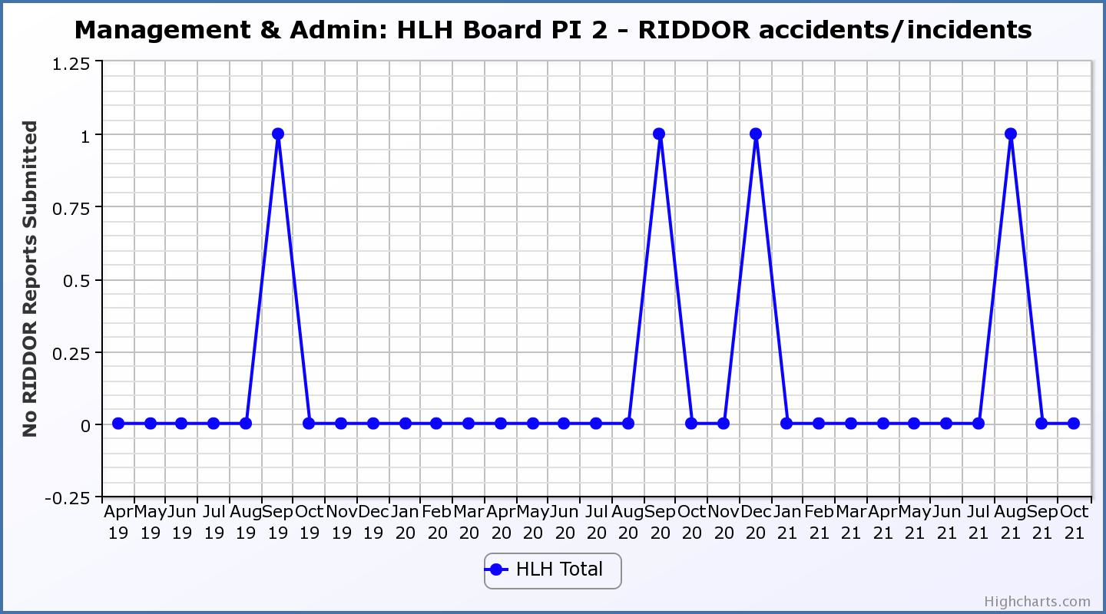

Business Plan Outcome | Performance Indicator | Reporting Frequency | RAG Rating Definition | RAG Rating Q1 21/22 | RAG Rating Q2 21/22 | RAG Rating Q3 21/22 | RAG Rating Q4 21/22 | Summary of Quarter Two Performance
2. Implement the Service Delivery Contract with The Highland Council | 3. Delivery of the Service Delivery Contract (SDC) with The Highland Council (THC). | Six-monthly. | - Red = agreement of THC’s CLH Committee that HLH has not met the terms of the SDC.  - Amber = agreement of THC’s CLH Committee that HLH has met the terms of the SDC but has set some improvement targets.  - Green = agreement of THC’s CLH Committee that HLH has met or exceeded the terms of the SDC. | Green | Green | NA | NA | THC’s Education Committee considered the HLH update report at its November 2021 meeting. Please see section 4.2 of this report for further detail.

Business Plan Outcome | Performance Indicator | Reporting Frequency | RAG Rating Definition | RAG Rating Q1 21/22 | RAG Rating Q2 21/22 | RAG Rating Q3 21/22 | RAG Rating Q4 21/22 | Summary of Quarter Two Performance
3. Improve customer engagement and satisfaction | 4. Customer engagements. | Quarterly. | - Red = customer numbers are more than 5% lower than the corresponding quarter in the previous year.  - Amber = customer numbers are less than the corresponding quarter in the previous year.  - Green = customer numbers are the same as or have increased compared with the corresponding quarter in the previous year. | Green | Green |  |  | Customer engagements increased from 1,336,464 in Q2 2020/21 to  1,634,928 in Q2 2021/22. While this is significantly lower than previous years due to the pandemic is has been RAG rated green as a reflection of recovery from the pandemic.
Performance Indicator 4 - Customer engagements
Customer numbers are showing in increase compared with quarter two 2020/21.
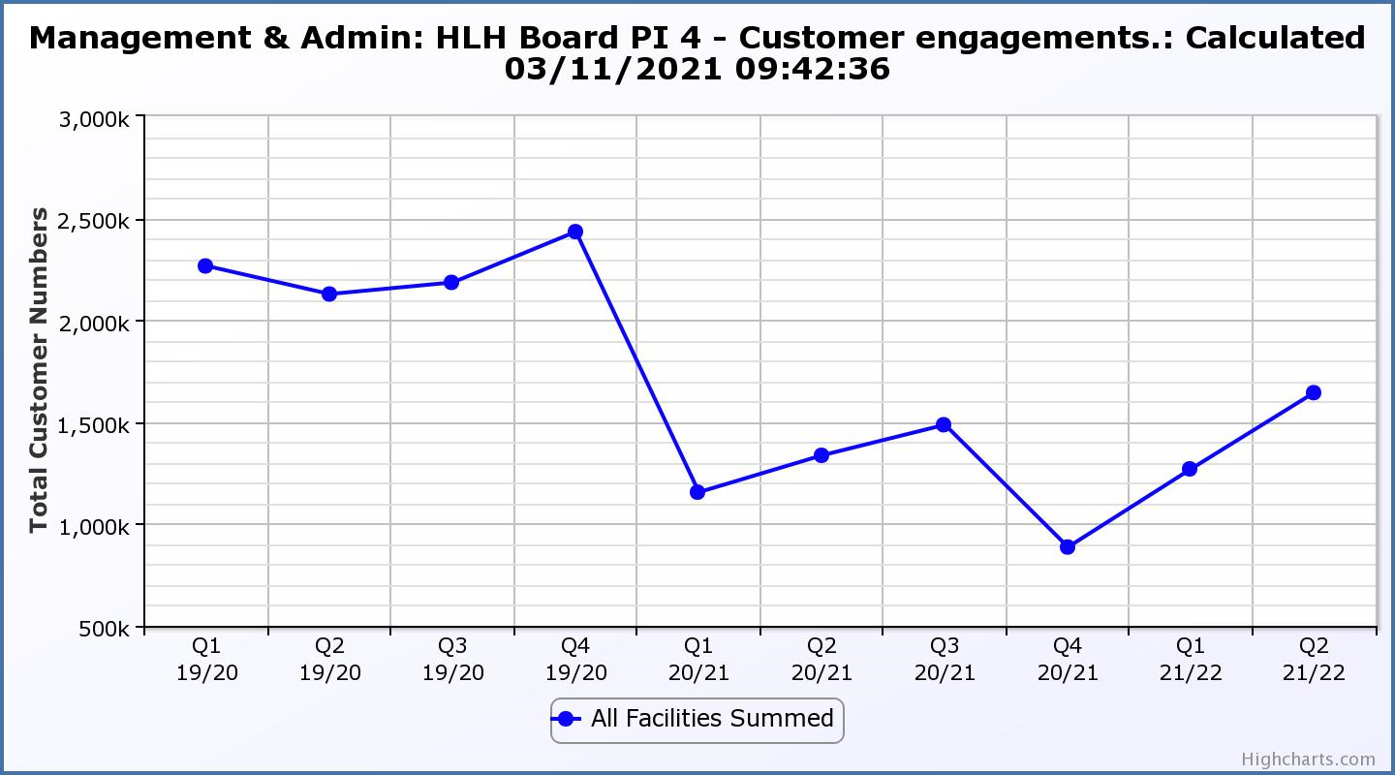

Business Plan Outcome | Performance Indicator | Reporting Frequency | RAG Rating Definition | RAG Rating Q1 21/22 | RAG Rating Q2 21/22 | RAG Rating Q3 21/22 | RAG Rating Q4 21/22 | Summary of Quarter Two Performance
3. Improve customer engagement and satisfaction (cont.) | 5. Customer surveys. | Quarterly. | - Red = up to three surveys have been completed or scheduled.  - Amber = 4 to 8 of the HLH areas of work have completed or scheduled customer surveys.  - Green = all areas of HLH work have completed or scheduled customer surveys. | Green | Green |  |  | One area of work, Archives has completed a customer survey this financial year with all others having scheduled surveys to take place with Adult Learning and Youth work having scheduled surveys of customers who have not yet returned.

Business Plan Outcome | Performance Indicator | Reporting Frequency | RAG Rating Definition | RAG Rating Q1 21/22 | RAG Rating Q2 21/22 | RAG Rating Q3 21/22 | RAG Rating Q4 21/22 | Summary of Quarter Two Performance
3. Improve customer engagement and satisfaction (cont.) | 6. Formal complaints. | Quarterly. | - Red = 41 or more complaints per quarter.  - Amber = 31 to 40 complaints per quarter.  - Green = 30 complaints or fewer per quarter. | Green | Green |  |  | There were fifteen complaints received during Q2 2021/22.

Performance Indicator 6 - Formal Complaints
The graph below shows the number of complaints which continue to be very low in relation to customer numbers.
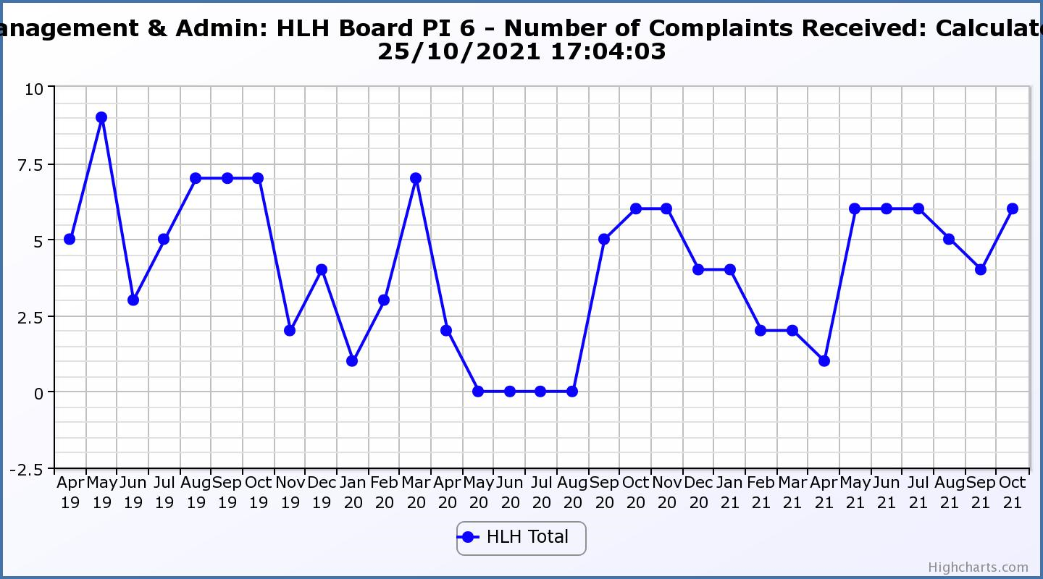
Business Plan Outcome | Performance Indicator | Reporting Frequency | RAG Rating Definition | RAG Rating Q1 21/22 | RAG Rating Q2 21/22 | RAG Rating Q3 21/22 | RAG Rating Q4 21/22 | Summary of Quarter Two Performance
4. Improve staff engagement and satisfaction | 7. Staff turnover (resignations as a percentage of posts). | Quarterly. | - Red = more than 2%  - Amber = 1.7 to 2%  - Green = 1.6% or less | Green | Green |  |  | The number of resignations per month as a percentage of posts in Q2 was 0.8% in July, 1% in August and 1.6% in September. Please see HR report elsewhere on this agenda for further information.

Performance Indicator 7 - Staff Turnover (resignations as a percentage of posts)
The graph below shows resignations as a percentage of the number of posts which have been consistent with previous years (1% equates to 10.6 staff).

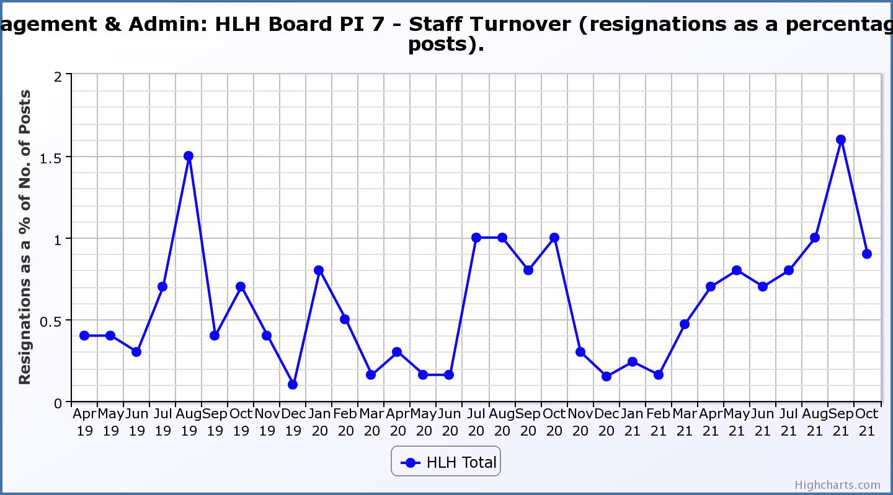

Business Plan Outcome | Performance Indicator | Reporting Frequency | RAG Rating Definition | RAG Rating Q1 21/22 | RAG Rating Q2 21/22 | RAG Rating Q3 21/22 | RAG Rating Q4 21/22 | Summary of Quarter Two Performance
4. Improve staff engagement and satisfaction (cont.) | 8. Staff absence rates. | Quarterly. | - Red = absence rate greater than 3.6%.  - Amber = absence rate between 3.4% and 3.6%.  - Green = absence rate 3.3% or less. | Green | Green |  |  | The absence rate for Q2 was 3.2%. Please see the HR report elsewhere on this agenda for further information.

Performance Indicator 8 - Staff Absence Rates
Staff absence rates have increased slightly following the lockdowns. 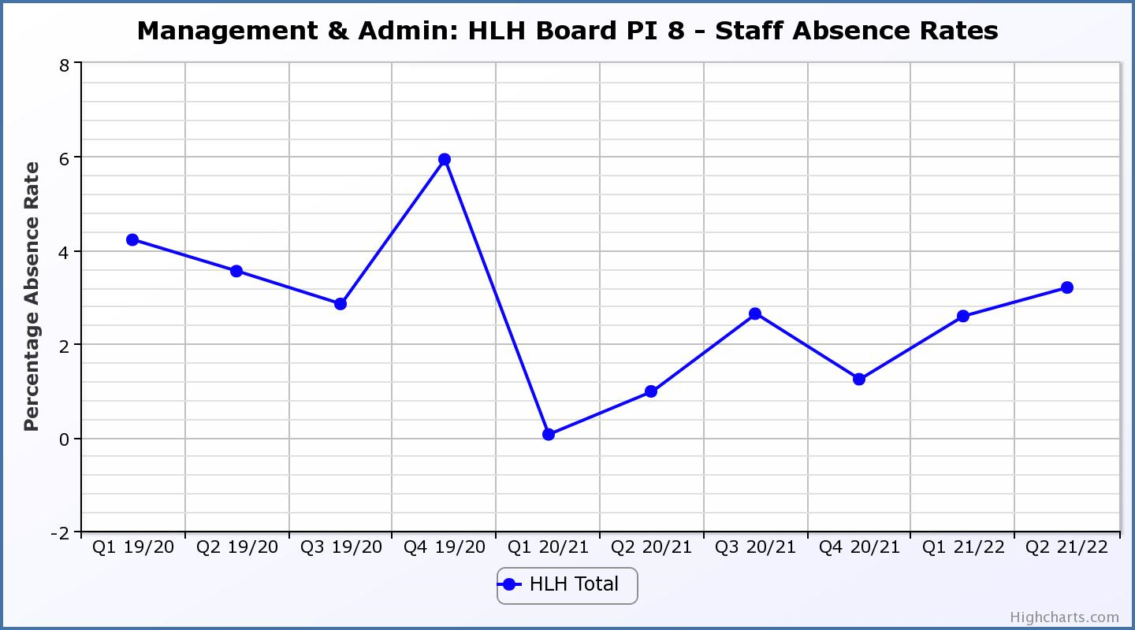

Business Plan Outcome | Performance Indicator | Reporting Frequency | RAG Rating Definition | RAG Rating Q1 21/22 | RAG Rating Q2 21/22 | RAG Rating Q3 21/22 | RAG Rating Q4 21/22 | Summary of Quarter Two Performance
5. Enhance the positive company image | 9. Media clippings. | Quarterly | - Red = number of negative press clippings outweigh neutral and positive.  - Amber = number of negative and neutral press clippings outweigh positive.  - Green = number of positive and neutral media clippings outweigh negative. | Green | Green |  |  | At its September 2021 meeting the HLH Board asked that consideration be given to updating the RAG ratings for this performance indicator based on being likely to always be RAG rated “green” based on past experience. A new graph has been developed below which shows media sentiment. RAG ratings will be developed after some experience of using the new system has been gained.

Performance Indicator 9 - Media Clippings
The following graph is in a new format and shows a greater range of information (different types of media/releases) with recording having commenced in September 2021.
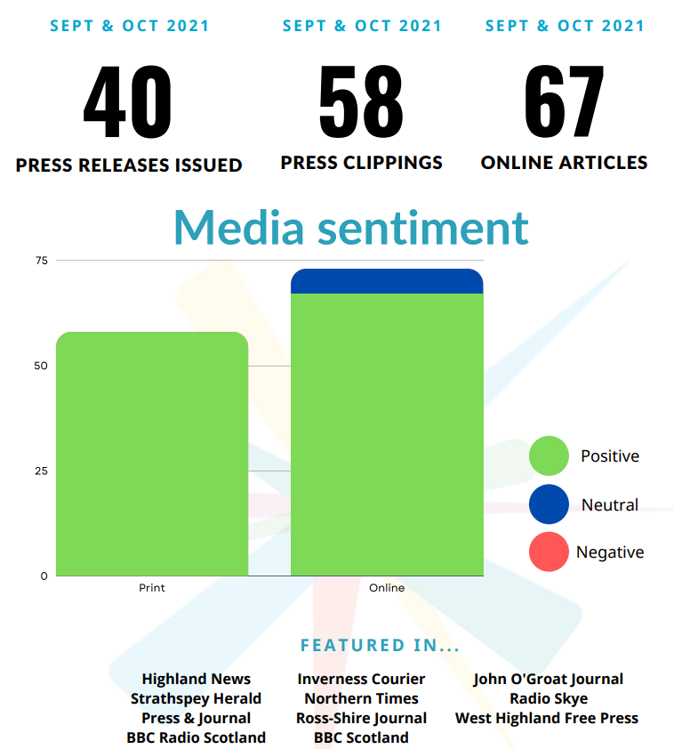
Business Plan Outcome | Performance Indicator | Reporting Frequency | RAG Rating Definition | RAG Rating Q1 21/22 | RAG Rating Q2 21/22 | RAG Rating Q3 21/22 | RAG Rating Q4 21/22 | Summary of Quarter Two Performance
6. Be a trusted and effective partner | 10. THC’s annual survey of performance and attitudes. | Annual. | - Red = all HLH areas of work represented receive lower net satisfaction ratings than the previous year.  - Amber = two or more areas of HLH work receive lower net satisfaction ratings than the previous year.  - Green = net satisfaction ratings are maintained or improved for three or more areas of HLH work compared with the previous year. | N/A | N/A | NA | NA | The Council has not carried out its annual survey of its citizen’s panel this year and it is anticipated that the next time that it will do this will be in 2022.

Business Plan Outcome | Performance Indicator | Reporting Frequency | RAG Rating Definition | RAG Rating Q1 21/22 | RAG Rating Q2 21/22 | RAG Rating Q3 21/22 | RAG Rating Q4 21/22 | Summary of Quarter Two Performance
6. Be a trusted and effective partner (cont.) | 11. Partnership work with sportscotland | Annual | - Red = cancellation of Partnership Agreement with sportscotland  - Amber = continuation of current level of partnership work with sportscotland  - Green = Growth in partnership working with sportscotland | Green | NA | NA | NA | NA – this is an annual indicator which was last considered by the HLH Board at its September 2021 meeting.

Business Plan Outcome | Performance Indicator | Reporting Frequency | RAG* Rating Definition  (*Red/Amber/Green) | RAG Rating Q1 21/22 | RAG Rating Q2 21/22 | RAG Rating Q3 21/22 | RAG Rating Q4 21/22 | Summary of Quarter Two Performance
7. Achieve sustainable growth across the organisation | 12. Financial monitoring. | Quarterly. | An assessment of the year end outturn where:  - Red = delivery of services over budget above 2%.  - Amber = delivery of services between break-even and 2% over budget.  - Green = delivery of services within budget. | Green | Green |  |  | This PI has been RAG rated green because it is within the £3.4M under-write agreed by THC, at its meeting on 4 March 2021. Please see the Finance Report elsewhere on this agenda for further information.

Performance Indicator 12 - Financial monitoring
See the Finance Report elsewhere on this agenda for further information.
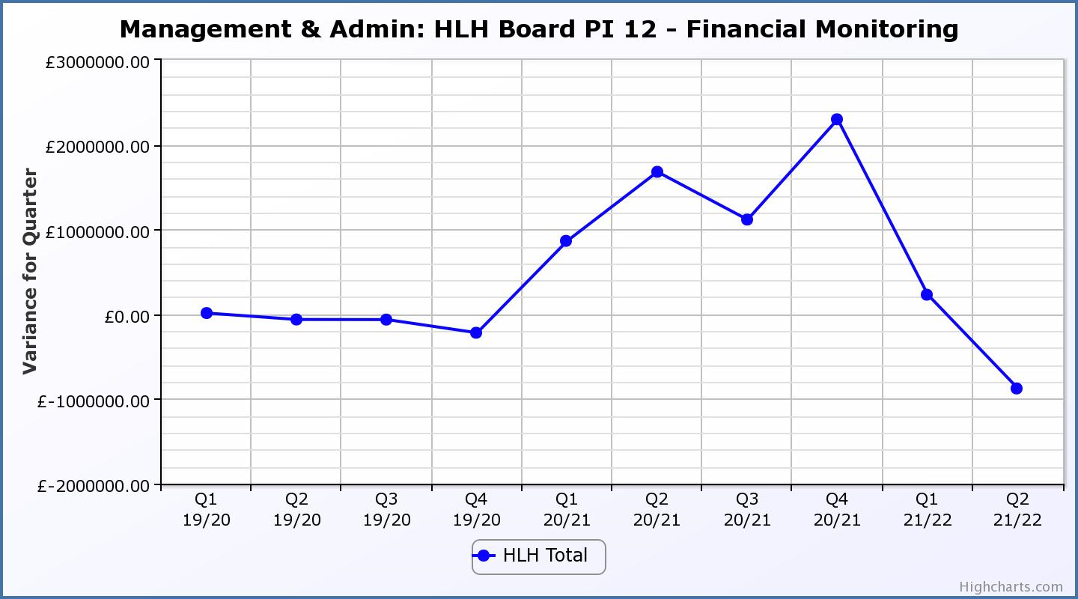

Business Plan Outcome | Performance Indicator | Reporting Frequency | RAG Rating Definition | RAG Rating Q1 21/22 | RAG Rating Q2 21/22 | RAG Rating Q3 21/22 | RAG Rating Q4 21/22 | Summary of Quarter Two Performance
7. Achieve sustainable growth across the organisation (cont.) | 13. Number of High Life subscriptions. | Quarterly. | - Red = more than 5% below target.  - Amber = up to 5% below target.  - Green = on or exceeds target. | Green | Green |  |  | This PI has been RAG rated green because the number of subscriptions is, above the level required to achieve the target in the financial modelling. As of 10 November, subscriptions were 15,353. The Finance and Audit Committee considered subscriptions in more detail at its meeting held on 15 November 2021.

Performance Indicator 13 - Number of High Life Subscriptions
Subscriptions continue to increase slightly ahead of budget projections and as of 10 November 2021 were 15,353 which exceeds the number required to meet the budgeted figure. 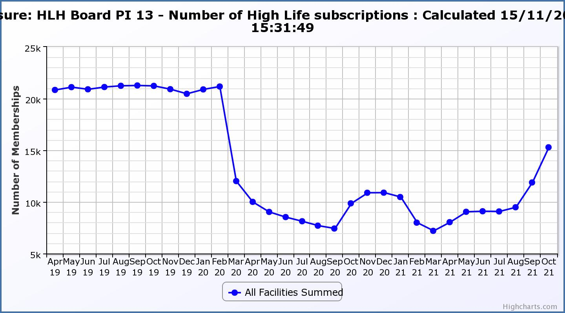
Business Plan Outcome | Performance Indicator | Reporting Frequency | RAG Rating Definition | RAG Rating Q1 21/22 | RAG Rating Q2 21/22 | RAG Rating Q3 21/22 | RAG Rating Q4 21/22 | Summary of Quarter Two Performance
7. Achieve sustainable growth across the organisation (cont.) | 14. High Life cancellation rate. | Quarterly. | - Red = cancellation rate above 6% of High Life memberships.  - Amber = cancellation rate is 3% - 6% of High Life memberships.  - Green = cancellation rate is up to 3% of High Life memberships. | Green | Green |  |  | The number of cancelled subscriptions were 3% in July and August and September.

Performance Indicator 14 - High Life Cancellation Rate
The cancellation rate has returned to historic levels. The increase seen in October relates to the reactivation of frozen subscriptions.
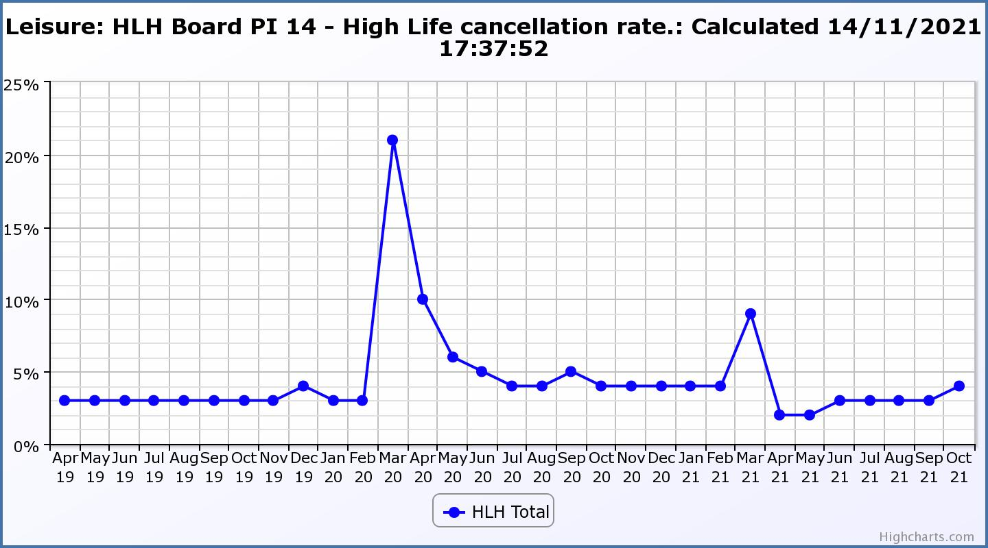

Business Plan Outcome | Performance Indicator | Reporting Frequency | RAG Rating Definition | RAG Rating Q1 21/22 | RAG Rating Q2 21/22 | RAG Rating Q3 21/22 | RAG Rating Q4 21/22 | Summary of Quarter Two Performance
8. Develop health and wellbeing across Highland communities | 15. Partnership work with NHSH and other health related organisations. | Annual. | - Red = no partnership work with NHSH etc.  - Amber = Reduction of current level of partnership work with NHSH etc.  - Green = Continuation or growth in partnership working with NHSH etc. | Green | N/A | N/A | NA | NA, this is an annual indicator last considered by the HLH Board at its meeting held in September 2021.

Business Plan Outcome | Performance Indicator | Reporting Frequency | RAG Rating Definition | RAG Rating Q1 21/22 | RAG Rating Q2 21/22 | RAG Rating Q3 21/22 | RAG Rating Q4 21/22 | Summary of Quarter Two Performance
9. Develop and promote the High Life brand | 16. Uptake of HLH card towards the target of 80% of the population. | Annual | - Red = number of card holders is maintained.  - Amber = number of card holders is increased by 1-4%.  - Green = number of card holders is increased by 5% or more. | N/A | NA | NA |  | NA, this is an annual indicator.

