High Life Highland

Health and Wellbeing Plan
Plana Slàinte agus Sunnd

2022 - 2027

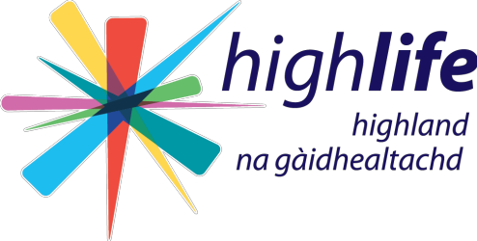

HIGH LIFE HIGHLAND - HEALTH & WELLBEING PLAN

Contents
1. Executive Summary 3
2. Introduction 4
2.1 High Life Highland 4
3. Background Information 5
3.1 What is health? 5
3.2 HLH and NHS Highland 6
3.2 Structure and financials 6
3.4 Scope 7
4. Situation Analysis 7
4.1 Demographics 7
4.2 Health Data 7
4.3 HLH Business Plan and Priority Growth Areas 8
4.4 Service Improvement Plans 9
4.5 Public Health Priorities for Scotland 9
4.6 Highland Community Planning Partnership 9
5. Health and Wellbeing Priorities for HLH 10
5.1 Healthy places and communities 10
5.2 Early Years 11
5.3 Mental Wellbeing 11
5.4 Harmful Substances 11
5.5 Poverty and Inequality 12
5.6 Healthy weight and physical activity 12
6. Monitoring and Evaluation 13
Appendix A – HLH Service Contributions to the Public Health Priorities (at a glance) 14
Appendix B – Action Plan 15

1. Executive Summary

The potential for High Life Highland (HLH) to support people in Highland to improve and/or sustain their health and wellbeing is immense and it is recognised that identifying the key priorities will enable HLH to focus resource and effort will enable the best possible impact.

HLH is a charity registered in Scotland and a Company, Limited by Guarantee, wholly owned by The Highland Council (THC), that makes the Highlands a better place to live, work and visit by working in partnership to develop and promote opportunities in culture, learning, sport, leisure, health and wellbeing.

HLH has identified 11 business outcomes to help achieve its aims including one specific outcome for health and wellbeing:

- Deliver targeted programmes which support and enhance the physical and mental health and wellbeing of the population and which contribute to the prevention agenda

This plan will outline how HLH will achieve business outcome 11.

The actions outlined in this health and wellbeing plan seek to embed health improvement and health promotion as fundamental parts of service delivery, through all HLH services, with a focus on supporting the reduction of health inequalities in Highland through the framework set by the public health priorities for Scotland.

The Head of Health and Wellbeing is the lead officer for the delivery and implementation of this plan and will support all services in their endeavours to deliver on HLH’s Business Outcome 11 within with their operational plans and everyday practice.

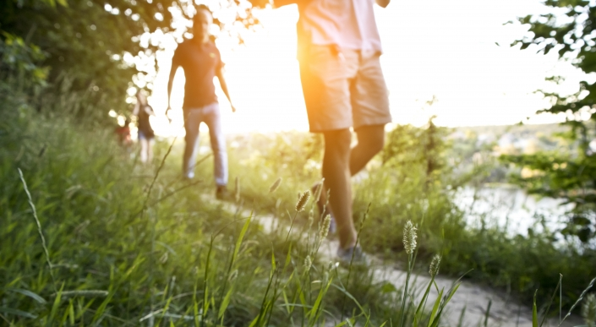

2. Introduction

2.1 High Life Highland

High Life Highland (HLH) is a Charity registered in Scotland and a Company Limited by Guarantee, wholly owned by The Highland Council (THC). The Company was established in 2011 to deliver a suite of Community Learning and Leisure Services on behalf of THC. In delivering these services, HLH fulfils its main business purpose of ensuring the Council meets its Public Service Obligations (PSOs) as laid out in the Service Delivery Contract (SDC) between the two parties. HLH delivers the PSOs of THC in respect of the multiple service areas, including:

- Adult Learning;
- Arts;
- Archives;
- Catering and Commercial;
- Countryside Rangers;
- Leisure Facilities;
- Libraries;
- Museums;
- Music Development;
- Outdoor Activities;
- Sport; and
- Youth Work.

To help HLH deliver those parts of its business that are not charitable by nature, it has a Trading Company (a Community Interest Company), the profits from which are gift aided to the Charitable Company to assist with its purposes.

HLH’s ambitions are:

- To be recognised and respected as the leading organisation for developing, promoting and inspiring opportunities in culture, learning, sport, leisure, health and wellbeing.
- To grow the business in a sustainable and innovative way by enabling and facilitating services that the public value and by being valued as a trusted and effective partner.

HLH has a Business Plan for the period 2022 - 2027 and has identified 11 business outcomes to help achieve its aims, this Health and Wellbeing Strategic Plan will assist HLH to deliver Business Outcome 11 (highlighted in italics below).

- Seek to continuously improve standards of health and safety
- Commit to the Scottish Government’s zero carbon targets and maintain the highest standards in environmental compliance
- Use research and market analysis to develop and improve service to meet customer needs
- Increase employee satisfaction, engagement and development to improve staff recruitment and retention
- Improve the financial sustainability of the organisation
- Value and strengthen the relationship with The Highland Council
- Develop and deliver the HLH Corporate Programme and seek to attract capital investment
- Use research and market analysis to develop and deliver proactive marketing and promotion of HLH and its services
- Initiate and implement and ICT digital transformation strategy across the charity
- Develop and strengthen relationships with customers, key stakeholders and partners
- Deliver targeted programmes which support and enhance the physical and mental health and wellbeing of the population and which contribute to the prevention agenda

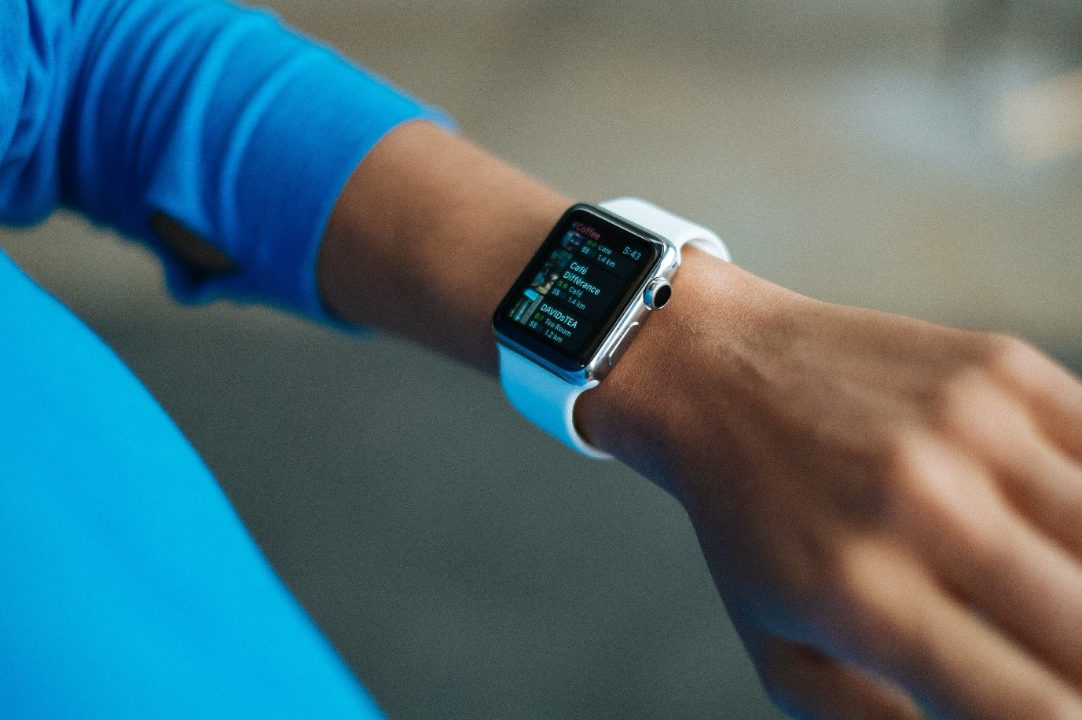

3. Background Information

3.1 What is health?

The World Health Organisation definition of health is given below:

“A state of complete physical, mental and social well-being and not merely the absence of disease or infirmity”

It is now better understood that health and wellbeing cannot be created or sustained by the NHS alone and there is a current growing movement to reset how people think about wellbeing and health – HLH is well placed to be part of a whole systems approach to enabling good health and wellbeing in communities.

3.2 HLH and NHS Highland

HLH works closely with NHS Highland (NHSH) through the Health Improvement team within the Public Health Directorate and other parts of the health care system to enable and encourage healthy lifestyle choices for individuals and communities through delivering a wide range of interventions, opportunities, projects and programmes which contribute to the Health Board’s objectives and priorities around people, quality and care.

NHSH’s mission: to provide quality of care to every person every day
NHSH’s vision: to deliver better health, better care and better value

It is recognised that whilst contributions can be made by HLH through some of the routine work across services such as libraries, leisure and adult learning, there is also vast potential in HLH to do much more to support health improvement and health promotion work of NHSH in reducing inequalities.

This Health and Wellbeing Plan is intended to give a helpful focus and prioritise actions which will be undertaken by HLH to facilitate and enable interventions, initiatives and service developments to support positive physical, mental and emotional health; improve access to HLH and other services; create or advance environments for health and provide opportunities for education and information sharing to promote good health.

3.2 Structure and financials

The Health and Wellbeing Team structure in HLH is detailed below.

Head of Health and Wellbeing (1 FTE)

Activities Development Officer (1 FTE)

Project Assistant (0.5 FTE fixed term to Aug 2023)

The Head of Health and Wellbeing is a strategic post in HLH, part of the Senior Management Team and reports to the Director of Sport and Leisure. HLH and NHSH jointly fund and manage the Head of Health and Wellbeing post and the post is very much part of the Health Improvement Team within the Public Health Directorate.

The Head of Health and Wellbeing is responsible for providing leadership, co-ordination, advice and support to the strategic partnership between HLH and NHSH.

The Head of Health and Wellbeing is also responsible for identifying opportunities for HLH to develop and implement a range of projects and programmes, delivered by HLH, that support improving the health of the population and reducing inequalities, through all HLH services.

HLH has been successful in securing funding for the delivery of several health and wellbeing initiatives and has also been commissioned by NHSH to deliver specific projects and programmes of work such as the implementation of programmes which support people with a range of health conditions including: type 2 diabetes; cardiovascular disease and people at risk of falling. Whilst it is recognised that opportunities to secure external funding are potentially reducing, HLH continues to seek external funding where possible.

3.4 Scope

The health and wellbeing plan covers the period 2022 - 2027.

4. Situation Analysis

4.1 Demographics

The Highlands comprise one third of the Scottish landmass and include 14 inhabited islands. The area has outstanding natural heritage, supported by the coverage of statutory designations to protect the quality of the environment.

The population structure of Highland has more younger people, more older people and fewer people of working age than the national average. Since 1996 the population has increased by 12.5%, at a higher rate than for Scotland as a whole and was estimated to be 235,180 in mid-2017. Population projections for Highland show that if current trends continue the population is expected to rise to 237,988 by 2041.

People aged 75+ increased by 55.3% in the 20 years to 2016. Between 2014 and 2024, the 16 to 24 age group is projected to see the largest percentage decrease (-8.9%) and the 75 and over age group is projected to see the largest percentage increase (+40.5%). In terms of size, however, 45 to 64 is projected to remain the largest age group.

[Source: National Records of Scotland, The Highland Council and The Scottish Public Health Observatory]

4.2 Health Data

Data is at the heart of HLH’s efforts to support health and wellbeing in Highland communities and priorities for action have been identified based on need and the best available evidence which includes the data given below but it’s also important that there is room and opportunity to flex and respond to the needs identified by communities through ongoing community engagement.
- In the NHSH area the rate of people living with long-term illness and limiting long term illness is higher than the rest of Scotland
- The leading causes of deaths in NHSH in 2016 were: cancers; cardiovascular diseases and mental health and substance use disorders;
- Each year, around 1,000 new people in NHSH are diagnosed as having type 2 diabetes. Just over 15,000 people in the NHSH area have the condition at present.
- In NHSH there are around 1600 new cancer registrations and 900 deaths per year from cancer, 25% of all deaths. The commonest cancers are skin, breast, bowel, and lung. Currently, there are 8000 people and their families in NHS Highland who are living with cancer;
- The number of people in Highland aged over 75 is projected to increase by over 40% up to 2024;
- Falls are a significant public health concern. About one in three people over the age of 65 will experience a fall each year, increasing to one in two for those over 80 years of age;
- The percentage of people prescribed medication for anxiety, depression or psychosis in 2014/15 was 15%
- The rate of coronary heart disease in Highland is higher than the Scottish average;

[Sources: Scottish Health Survey, NHSH DPH Report, Macmillan/NHS Highland, Scottish Public Health Observatory, NHS Highland,]

4.3 HLH Business Plan and Priority Growth Areas

It is a requirement for all services within HLH to contribute to achieving the business plan objectives. The HLH Business Plan (2022 - 2027) includes an outcome for health and wellbeing:

“Deliver targeted programmes which support and enhance the physical and mental health and wellbeing of the population”

The HLH Senior Management Team has examined the opportunities for the work of the charity to grow and to develop new business. One of the key areas for business growth which have been prioritised by the HLH Board is:

“The Prevention Agenda”

Work on the Prevention Agenda will have a specific project plan, with progress being reported through HLH’s Programme Board. HLH Board has agreed that the Trading Company shall review progress the growth areas, with periodic updates to the main charity Board. This plan will therefore focus on the Business Plan Outcome for health and wellbeing.

A brief overview of the Prevention Agenda growth projects which are likely to evolve and develop in line with the corporate programme development are listed below:
- More corporate membership arrangements which support Highland employer’s workforce wellbeing
- Contribute to NHSH Transformation Programme through assisting the Community Led Support project
- Develop a social prescribing offering with Primary Care (this has proved challenging in the past but following the pandemic there is some optimism for a successful pilot)
- Support the recovery from Covid-19, for example, through developing initiative(s) including for people affected by Long Covid and the wider impacts of Covid-19

4.4 Service Improvement Plans

As part of each HLH service operational plan actions, all services are required to develop and deliver a health improvement plan based on this Health and Wellbeing Strategy. Services will be supported by the Health and Wellbeing Team in the development of their improvement plans.

4.5 Public Health Priorities for Scotland

In 2018 the Scottish Government and COSLA jointly published public health priorities for Scotland, aimed at focussing action across the public sector and voluntary sector and in communities. The Scottish Government outlines that priorities are the first milestone in a wider reform of public health.

The priorities reflect a consensus for co-ordinated action on:

- healthy places and communities
- early years
- mental wellbeing
- harmful substances
- poverty and inequality
- healthy weight and physical activity.

In discussion with NHSH it has been agreed to align HLH’s Business Plan outcome for health and wellbeing with the public health priorities for Scotland. The table in Appendix A highlights which of the public health priorities each HLH service will support.

4.6 Highland Community Planning Partnership

The Highland Community Planning Partnership (CPP) brings together public agencies, third sector organisations and other key community groups to work collaboratively with the people of Highland to deliver better outcomes.

The CPP works through a series of geographical local Community Partnerships and regional thematic delivery groups on: poverty reduction; infrastructure; mental health and wellbeing; community safety and resilience; community learning, development and engagement. Ultimately these deliver the Highland Outcome Improvement Plan (HOIP).

The HOIP outlines the CPP’s aspirations for Highland and the specific actions being implemented to deliver them. The HOIP also informs local action plans through the Community Partnerships.

HLH contributes to the CPP framework in various ways including providing support through active participation and action through Senior Management representation on each of the local Community Partnerships as well as the thematic delivery groups. The Head of Health and Wellbeing is an active member of the Mental Health Delivery Group and Inverness Community Partnership and HLH are active members of the Highland Community Learning, Development and Engagement Delivery Group at strategic and operational level.

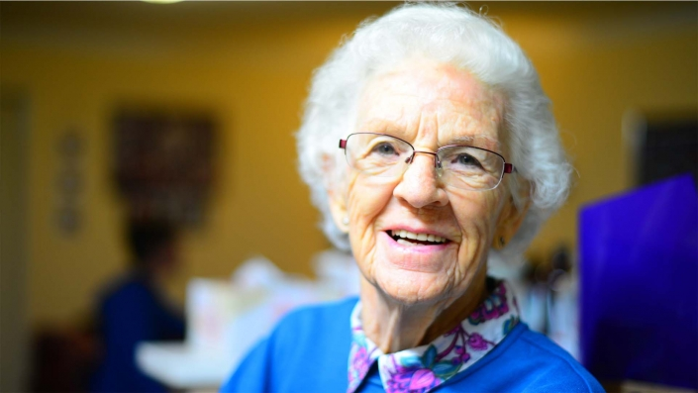

5. Health and Wellbeing Priorities for HLH

5.1 Healthy places and communities

The evidence, that place has an important role to play in the health and wellbeing of communities and in reducing health inequalities, is strong. HLH is uniquely placed to offer safe spaces that nurture and promote health and wellbeing for local people. These places and spaces help to build resilience and include libraries (including mobile libraries for the more remote/rural communities), museums, outdoor facilities, leisure centres, learning centres and community centres.

With venues and facilities located across rural and urban locations, HLH provides essential access and safe spaces for communities. Many facilities are also located in some of areas of deprivation identified in Highland and offer affordable, welcoming services in safe environments.

Priority actions include:
- Delivering activities in libraries and other cultural venues including those which target older people and people with health conditions
- Continuing to support the Highland Green Health Partnership through representation at partnership meetings and taking forward priority actions identified where possible
- Working with 3rd sector partners to facilitate, enable and attract voluntary groups such as walking groups to utilise HLH facilities and encourage engagement in HLH activities

5.2 Early Years

Whilst providing services and facilities for all life stages, there is recognition of the need to offer specific programmes and opportunities for early years. HLH offers some early year’s provision encompassing Book Bug activities in libraries, family friendly exhibitions and parent and toddler swim sessions.

HLH also works closely with education and social work services, providing supported activity for care experienced young people and outdoor trips and holiday activities for local schools.

Priority actions for Early Years include:
- Continuing to grow and develop Book Bug sessions in libraries
- Developing the provision of holiday activity programmes such as ‘Schools Out’ in summer
- Delivering the Youth Music Initiative Programme through KODALY music education including targeting the most vulnerable as part of inclusive delivery practices

5.3 Mental Wellbeing

Enabling and supporting mental wellbeing is embedded in the work of HLH, for both our local communities, and for our workforce. HLH is committed to supporting the good mental health of employees through the work on workforce wellbeing which is based on the Healthy Working Lives framework and is reported through the HLH Health, Safety and Environmental Compliance Committee.

Mental wellbeing has perhaps never been so high-profile, with the impact of Covid-19 and the changes it brought on everyday living taking their toll for many, mental wellbeing has long been brought sharply into focus. All services in HLH have positively responded to the need for wide and varied support for people from birth to older adults, particularly addressing issues of social isolation and loneliness.

HLH works closely with NHSH to deliver wellbeing pathways and support, as well as being a key-partners in the Community Planning Partnership’s (CPP) Mental Health Delivery Group.

Priority actions for Mental Wellbeing include:
- Continuing to be a proactive partner in the CPP Mental Health Delivery Group
- Delivering wellbeing initiatives for young people through the Youth and Sport Services
- Delivering and growing the HLH “You Time” programme in libraries and leisure centres with a focus on targeting older adults to enable reduced social isolation and loneliness

5.4 Harmful Substances

Highland Alcohol and Drugs Partnership (HADP) is a multi-agency strategic partnership which leads on preventing and reducing drug and alcohol related harm in Highland. As local partners, HLH is well placed to work with HADP and NHSH partners to support their important work on preventing and reducing drug and alcohol related harm.

Prior to the Covid-19 pandemic smoking cessation clinics took place in some HLH operated facilities and the Youth Service and Active Schools teams facilitated the participation of young people in the annual Highland Rock Challenge/Nothern Stars event which aims to inspire, engage and motivate young people to make healthy and positive lifestyle choices.

HADP’s ‘People First - Language Matters’ Partner Pledge is an initiative to help reduce the stigma experienced by people; who have drug and alcohol problem(s), people in recovery and family members affected by problem drug and alcohol use – HLH is well placed to use of People First language whether this is person to person, through literature; leaflets or when talking to the media or members of the public and to address and raise awareness in a way which will help to reduce stigma.

Priority actions for Harmful Substances include:
- Updating internal policies and arranging training to reflect the ‘People First - Language Matters’ approach
- Resuming support to Northern Stars event through Youth and Sport Service
- Enabling delivery of smoking cessation clinics in HLH facilities

5.5 Poverty and Inequality

At the heart of HLH’s purpose is offering inclusive and accessible opportunities to take part in culture and leisure activities. HLH recognises that there are various challenges for individuals to access or participate in activities and seek to address these by offering low or no cost access to facilities and services.

HLH also has an important role to play in the Covid-19 recovery, where inequalities have reportedly increased, and will be able to use our connections to signpost and link to existing pathways and opportunities.

Priority actions for Poverty and Inequality include:
- Providing training opportunities for the workforce in topics related to poverty and inequality
- Developing an approach to augmenting trauma informed practice across the workforce
- Promoting and preserve the Budget offering for highlife membership

5.6 Healthy weight and physical activity

Healthy weight and physical activity is the sixth of Scotland’s public health priorities and is potentially the priority where HLH can support in the broadest sense.

Through close partnership working with NHSH including dietetic, physiotherapy, clinical specialities and health promotion teams, HLH offers a range of safe and high-quality activities across our venues and communities including holistic programmes around healthy lifestyles and wellbeing.

HLH recognises the important role our services can play in providing rounded advice, support and opportunities for people to be physically active across all ages and abilities. Underpinning this is a firm focus on fun and enjoyment, encouraging people to start and keep participating in activities to support their health and wellbeing.

Priority actions for Healthy Weight and Physical Activity include:
- Developing the Active Health programme targeting people with a range of health conditions including:
  - cancer;
  - chronic pain;
  - Parkinson’s disease;
  - type 2 diabetes;
  - cardiovascular disease;
  - people a at risk of falling;
  - Neurological conditions.
- Delivering commissioned services for NHSH such as:
  - Live It healthy weight programme
  - Digital Inclusion programme for people with Type 2 Diabetes
  - Physiotherapy in leisure centres
- Supporting the development and implementation of the Active Highland Strategy and Disability Sport Strategy

6. Monitoring and Evaluation

To monitor progress in implementing the health and wellbeing plan HLH Directors will receive a bi-annual update where the areas of work listed in the action plan at Appendix B will be RAG rated. The action plan will be refreshed annually (aligned with timescale when service operational plans are refreshed).

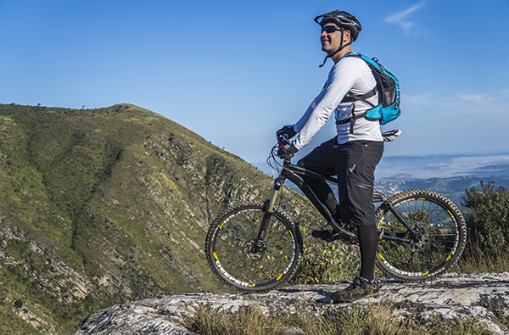

Appendix A – HLH Service Contributions to the Public Health Priorities (at a glance)
KEY – Green box indicates the service is contributing to the corresponding public health priority

 | healthy places and communities | early years | mental wellbeing | harmful substances | poverty and inequality | healthy weight and physical activity
Adult learning

Archives

Arts

Catering & Commercial
Countryside Rangers
Leisure facilities
Libraries

Musems

Music development
Outdoor Activities
Sport

Youth

Appendix B – Action Plan
Scotland’s Public Health Priorities | Action | Date | RAG
Healthy places and community | - Deliver new and improved activities in HLH facilities including targeting older people and people with health conditions (inc. museums Health, Wealth and Happiness project and in libraries)  - Provide trusted health and wellbeing information, in digital and other media through the library and other services  - Continue to support the Highland Green Health Partnership through representation at partnership meetings and taking forward priority actions identified where possible  - Work with 3rd sector partners to facilitate, enable and attract voluntary groups such as walking groups to utilise HLH facilities and encourage engagement in HLH activities  - Deliver Prescribe Culture activities through museums and countryside rangers  - Deliver a range of programmes and activities through HLH Adult Learning and Youth Work teams  - Provide safe and inclusive spaces for people to meet in HLH café’s and catering services, maximising outdoor spaces for catering where possible (e.g. outdoor spaces at Café Aqua, Botanics and Highland Folk Museum) | Mar 23  Mar 23  Mar 23  Mar 23  Mar 23  Mar 23  Mar 23 | G  G  G  G  G  G  G
Early Years | - Provide facilitated reading and storytelling for personal growth and therapeutic support in libraries including Book Bug sessions  - Develop provision of holiday activity programmes such as ‘Schools Out’ in summer  - Augment parent and toddler swim sessions to be programmed in all facilities  - Deliver the Youth Music Initiative Programme through KODALY music education including targeting the most vulnerable as part of inclusive delivery practices  - Provide family learning and literacy opportunities through Adult Learning and Youth Work team in targeted communities to improve educational outcomes  - Facilitate visits for childcare and school groups to cultural facilities including Highland Folk Museum outdoor classroom and at Inverness Museum and Art Gallery | Mar 23  Mar 23  Mar 23  Mar 23  Mar 23  Mar 23 | G  G  G  G  G  G
Mental Wellbeing | - Continue to be a proactive partner in the CPP Mental Health Delivery Group to support the implementation of its action plan  - Deliver wellbeing initiatives for young people through the Youth and Sport Services  - Deliver and grow the HLH “You Time” programme in libraries and leisure centres with a focus on targeting older adults to enable reduced social isolation and loneliness  - Enable access to music instrumental tuition (which facilitates good mental wellbeing and personal development for participants)  - Provide short walks into nature and other wellbeing focussed walks/activities through countryside rangers  - Deliver targeted projects – using nature to improve mental health outcomes  - Help reduce social isolation and loneliness in vulnerable adults through Adult Learning team by providing accessible group work, digital skills and removing barriers to digital connectivity  - Deliver Learn with Lorna sessions through the archive service which support participants social connectedness and help to reduce loneliness  - Offer high quality volunteering opportunities through the archive and museums services  - Deliver initiatives through museums, art galleries and archives that support mental wellbeing through engagement with cultural opportunities.  - Support and assist people affected by dementia and their carers via a range of activities and programmes, including archives providing care homes with reminiscence resource packs and museums developing and delivering the House of and Shinty Memories projects | Mar 23  Mar 23  Mar 23  Mar 23  Mar 23  Mar 23  Mar 23  Mar 23  Mar 23  Mar 23  Mar 23 | G  G  G  G  G  G  G  G  G  G  G  G
Harmful Substances | - Update internal policies and arrange training to reflect the ‘People First - Language Matters’ approach  - Resume support to Northern Stars event through Youth and Sport Service  - Enable delivery of smoking cessation clinics in HLH facilities  - Work closely with a range of referring partners to ensure that learning is available through the Adult Learning Service which is accessible for those living with the impact of harmful substances  - Programme learning opportunities for young people to enable them to make informed choices about substance us and work closely with Highland Drug and Alcohol Partnership on joint initiatives through Youth Services. | Mar 23  Mar 23  Mar 23  Mar 23  Mar 23 | G  G  G  G  G
Poverty and Inequality | - Provide training opportunities for the workforce in topics related to poverty and inequality  - Develop an approach to augmenting trauma informed practice across the workforce  - Promote and preserve the Budget offering for highlife membership  - Facilitate social interaction and empathic help and support – both face-to-face and digital through libraries  - Offer free to access and targeted programmes (towards communities which have locality plans as part of the work of Community Planning partners) to reduce inequalities through Adult Learning Service  - Provide free accessible youth work provision across the region and focus the work at those at risk of poorer outcomes. | Mar 23  Mar 23  Mar 23  Mar 23  Mar 23  Mar 23 | G  G  G  G  G  G
Healthy Weight and Physical Activity | - Develop the Active Health programme targeting people with a range of health conditions including:  - cancer; chronic pain; Parkinson’s disease; type 2 diabetes; cardiovascular disease; people a at risk of falling; neurological conditions.  - Deliver commissioned services for NHSH such as:  - Live It healthy weight programme  - Digital Inclusion programme for people with Type 2 Diabetes  - Physiotherapy in leisure centres  - Support the development and implementation of the Active Highland Strategy and Disability Sport Strategy  - Embed physical activity and nutrition into existing Youth and Adult Learning programmes and activities wherever relevant, inc. healthy snacks at youth club settings, after school food provision to reduce food insecurity, health walks, bushcraft and outdoor activities (with HLH Rangers and Outdoor Activities colleagues).  - Collaborate with UHI on research studies relating to healthy weight and/or physical activity  - Implement Scotland’s Healthy Living Award in all HLH cafés and sustain existing awards in Highland Folk Museum and Inverness Museum and Art Gallery  - Maximise opportunities to provide healthy freshly made food for consumption in all HLH catering outlets | Mar 23  Mar 23  Mar 23  Mar 23  Mar 23  Mar 23  Mar 23 | G  G  G  G  G  G  G

