HIGH LIFE HIGHLAND  REPORT TO BOARD OF DIRECTORS  31 MARCH 2022 | AGENDA ITEM REPORT No HLH /22

Performance Report - Report by Chief Executive

Summary

The purpose of this report is to present performance information for the period October to December 2021.

It is recommended that Directors:

- comment on the report and agree that the overall health check on the charity for that period is assessed as “green”, on target, reflecting indications of customer recovery following COVID-19 restrictions and additional financial support having been agreed by The Highland Council for the current and next financial years; and
- approve the performance indicators in Appendix C which have been developed in line with the new business plan.

1. | Business Plan Contribution
1.1 | This report supports all of the Business Outcomes from the High Life Highland (HLH) Business Plan 2019-2024:  - Sustain a high standard of health and safety, and environmental performance  - Implement the Service Delivery Contract with THC  - Improving customer engagement and satisfaction  - Improving staff engagement and satisfaction  - Enhance the positive charity image  - Be a trusted and effective partner  - Achieve sustainable growth across the organisation  - Develop health and wellbeing across Highland communities  - Develop and promote the High Life brand
2. | Background
2.1 | The implementation of the HLH Business Plan 2019-24 is monitored in two ways:  - through a set of performance indicators set by the Board at its meeting held on 11 December 2018; and  - by RAG (Red, Amber, Green) rating the delivery of the business outcomes contained in the business plan with these being reported to the Board by exception (i.e. reporting where managers had RAG rated the actions “red – no significant progress”). Note: this was temporarily replaced by the work on the Recovery Action Plan and will be re-started later this year based on the new business plan which commences in April.

3. | Summary of Performance
3.1 | Sixteen performance indicators (PIs) were identified by the HLH Board to assess the overall performance of the charity. At its meeting in December 2019 the HLH Board agreed to develop a summarised reporting format and Appendix A contains a summary of performance against the PIs for Q3 2021/22.
3.2 | Appendix B provides a list of all the PIs along with trend information. Eleven PIs were scheduled for assessment at the March 2022 HLH Board meeting. 9 have been RAG rated green; 1 red; and 1 amber.
3.3 | The red indicator is PI 8. staff absence rate; and PI 13. highlife cancellation rate has been RAG rated amber.
3.4 | PI 8. staff absence rate - the indicator which was RAG rated as red is staff absences. There is further information on this in the HR report elsewhere on this agenda which also describes the measures in place to manage absences.
3.5 | PI 13. highlife cancellation rate – despite the amber RAG rating for cancellations, subscriptions are on target to meet the budget projections for this year and are currently at 73% of the pre-pandemic level. The amber RAG rating is due to a higher cancellation rate, which increased after the frozen subscriptions were reactivated following customer communications in October 2021. The cancellation rate reached 6% in November and December and returned to its historic rate of 3% in January and February.
3.6 | During the pandemic customers were given the option to freeze their subscriptions. All 6,031 subscriptions were re-activated in September 2021 and the 998 customers who had asked for their subscriptions to continue to be frozen were surveyed. 169 surveys were completed, a return rate of 17%. 46% said that they had continued to freeze their subscription for covid reasons citing personal circumstance and choice including shielding others, not feeling ready to be in contact with others and the new variant. Customers were offered the opportunity of a site visit to see the covid management measures and one took up this offer.
3.7 | Amongst the remaining 54%, reasons for having frozen subscriptions were:  - Change in financial circumstances (people who selected this option were informed of the budget scheme (50 pence access))  - Having to book activities where this was not required before (changes in restrictions have since allowed bookings to be removed)
3.8 | There were also responses which related to individual sites:  - Programming - 17 customers highlighted concerns around programming (classes, opening hours) which have all been actioned with revised opening hours and classes put in place. Sites where this applied included Aviemore, Black Isle, Dingwall, Invergordon, Inverness Royal Academy Sports Centre, Lochaber, Lochbroom, Nairn, Thurso and Inverness Leisure.  - Cleaning - 1 customer highlighted concerns over fellow customers not cleaning down equipment after use which has been actioned with regular checks and education of customers. Site where this applied was Aviemore  - Ventilation - 8 customers highlighted concerns around ventilation. Ventilation at all sites complies with Government guidance, systems were adjusted to prevent air recirculating and there is carbon dioxide monitoring in place.  Overall, the survey responses gave an indication that programming and opening hours were being balanced well with demand.
3.9 | When asked what HLH could do to encourage customers to return many of the responses related to removal of restrictions such as maximum numbers, the requirement to book and being allowed to use saunas which have all been addressed as the restrictions eased. There were some requests to reinstate the agreement between the Council and MacDonald Aviemore Highland Resort and it is understood that discussions between the two organisations have re-started.
3.10 | The current number of frozen subscriptions is 1,170. Given that all restrictions are likely to be removed through April 2022 the plan is to contact all frozen customers in April. A different approach to these customers is planned this time round because, despite the communication at the time of the last mass un-freeze, there are still customers requesting that subscriptions be re-frozen and asking for refunds. Instead, customers will be contacted by telephone and encouraged to re-activate their subscriptions and it is considered that this pro-active and positive customer focused approach will have less of a risk of customer dissatisfaction.
4. | Performance Indicators for More Detailed Consideration
4.1 | Each quarter more detailed information is provided on one or more of the sixteen performance indicators and the following performance indicators are scheduled for inclusion in this report:  - PI 5 – Customer surveys  - PI 6 - Complaints  - PI 7 - Staff turnover
4.2 | Customer Surveys – All of HLH’s services carry out customer surveys which relate to their areas of work and there are some standard questions which are asked to obtain an overall view of customer opinion for the organisation. Customers are asked to rate their overall experience of HLH and of staff as excellent; good; poor or unsatisfactory and the percentages rating both as good or excellent are given in the table below for the current year to date and past two years:  Year 2020 2021 2022 to date  No of Responses 569 2,240 1,132  Overall experience 96.5% 97% 97.2%  Staff helpfulness 98% 98.1% 98.5%
4.3 | Customers are also asked to say whether they would recommend HLH (yes/no) and the results are as follows:  Year 2020 2021 2022 to date  Recommend HLH (yes) 96.3% 95.2% 95.1%
4.4 | These results indicate that there is a positive view of HLH amongst its customers.
4.5 | Consideration is being given to developing a new approach to surveying customers to help the ongoing development of the organisation and monitor progress on the implementation of the business plan, providing a numeric track which allows comparison over time. Results would be able to be broken down by service and facility and reported overall to the HLH Board as one of the new performance indicators.
4.6 | Complaints – Complaints are monitored at monthly Performance Board meetings where complaints and responses are reviewed. Complaints relate to individual issues and there has been no requirement to undertake any actions across the organisation because of complaints. They are low in number given the c9m (pre-pandemic c5m in 2020/21) customer engagements. The following table shows that numbers of complaints remain comparable year on year and the numbers which were upheld, partially upheld and not upheld.  2018/19 2019/20 2020/21 21/22 YTD  Complaints Received 51 60 31 49  Complaints Upheld 21 17 12 11  Partially Upheld 15 14 11 21  Not upheld 15 29 8 16
4.7 | Staff Turnover – staff turnover (number of resignations as a percentage of the number of posts) was selected as an indicator of staff morale and satisfaction. Turnover continues to be low at an average of 0.64% per month. (1% is approximately 10 staff). The highest recorded rate was during this financial year when it was 1.6% and was at a time when there was a buoyant jobs market being reported in the media. There is further information on staff turnover in the HR report elsewhere in this agenda.
5. | New Performance Indicators
5.1 | The Business Plan 2022-2027 was approved by the HLH Board at its December 2021 meeting. The performance indicators have been reviewed in line with the revised business plan outcomes and are contained in Appendix C. It is recommended that the Board consider and approve the new performance indicators.
6. | Implications
6.1 | Resource implications – there are no additional resource implications arising from this report. Resource implications have been covered in the Finance Report elsewhere on this agenda.
6.2 | Legal implications - there are no new legal implications arising from this report.
6.3 | Equality implications – there are no new equality implications arising from this report.
6.4 | Risk implications – there are no new risk implications arising from this report.

Recommendation

It is recommended that Directors:

- comment on the report and agree that the overall health check on the charity for that period is assessed as “green”, on target, reflecting indications of customer recovery following COVID-19 restrictions and additional financial support having been agreed by The Highland Council for the current and next financial years; and
- approve the performance indicators in Appendix C which have been developed in line with the new business plan.

Designation: Chief Executive

Date: 31 March 2022

Author: Douglas Wilby, Director of Sport and Leisure

Appendix A
HLH Performance Indicators year to date 2021/22
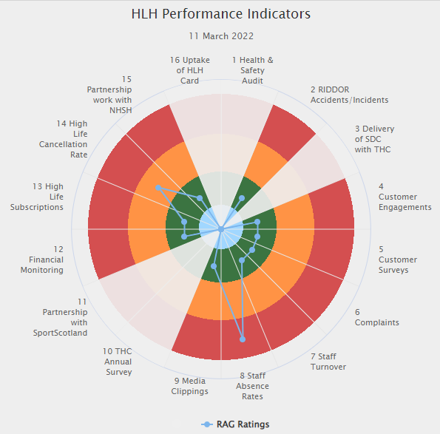 | Sixteen performance indicators (PIs) are used by the High Life Highland Board to assess the overall performance of the charity.  The PIs are RAG rated (allocated a "Red", "Amber" or "Green" status) so that it is easy to see at a glance how the organisation is performing. Most of the PIs are RAG rated every quarter throughout the year, with some (such as partnership working with NHSH for example) being considered annually so greyed out sectors on this radar diagram mean that the PI is to be considered at a future HLH Board meeting.
Appendix B
HLH Performance Indicators

Business Plan Outcome | Performance Indicator | Reporting Frequency | RAG Rating Definition | RAG Rating Q1 21/22 | RAG Rating Q2 21/22 | RAG Rating Q3 21/22 | RAG Rating Q4 21/22 | Summary of Quarter Three Performance
1. Sustain a high standard of health and safety and environmental performance | 1. Health and safety audit. | Annual. | - Red = the external audit raises systemic (i.e. applying across multiple sites) H&S issues.  - Amber = the external audit highlights common actions to be addressed across the company.  - Green = the external audit does not raise systemic issues. | NA | NA | Green | NA | An Audit of five HLH facilities took place in November 2021 resulting in positive compliance results. Ongoing actions will be reported to Health and Safety and Environmental Compliance Committee (HSECC) in May/Aug 2022.

Business Plan Outcome | Performance Indicator | Reporting Frequency | RAG Rating Definition | RAG Rating Q1 21/22 | RAG Rating Q2 21/22 | RAG Rating Q3 21/22 | RAG Rating Q4 21/22 | Summary of Quarter Three Performance
1. Sustain a high standard of health and safety and environmental performance (cont.) | 2. RIDDOR accidents/incidents. | Quarterly. | - Red = number of RIDDOR reports per quarter is above 20.  - Amber = number of RIDDOR reports per quarter is between 10 and 20  - Green = number of RIDDOR reports per quarter is less than 10. | Green | Green | Green |  | There were three accidents reported under the RIDDOR regulations during Q3 which were considered by HSECC at its meeting held on 21 February 2022.

Performance Indicator 2 - RIDDOR accidents/incidents
The graph below tracks the number of accidents and incidents reported under the Reporting of Injuries, Diseases and Dangerous Occurrences Regulations (RIDDOR). There were three RIDDOR incident reported in Q3 2021/22.
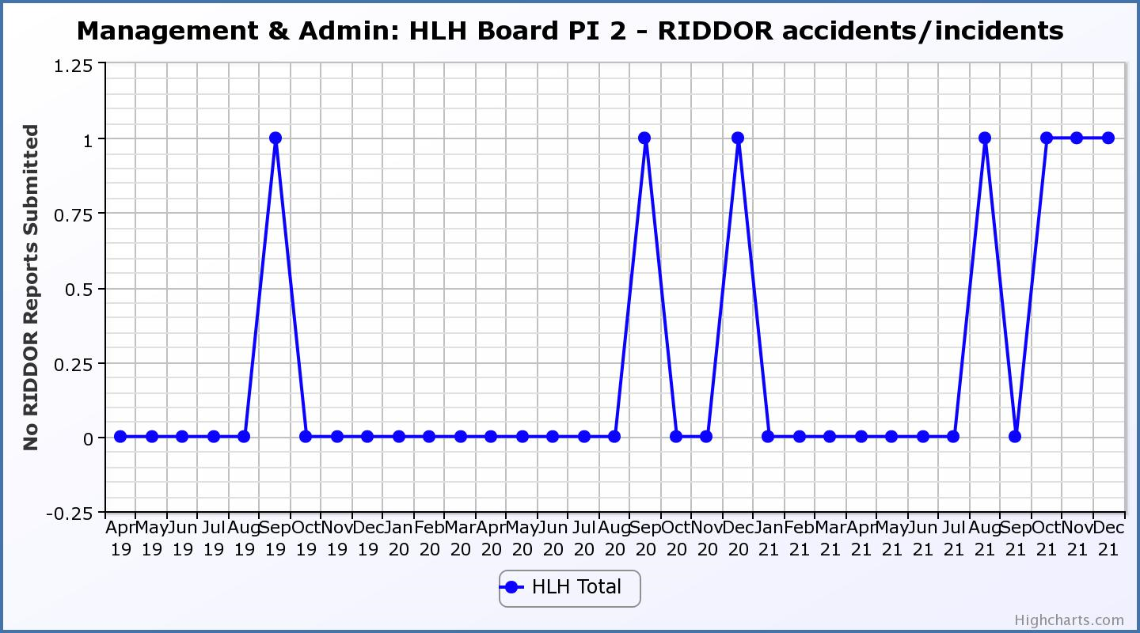

Business Plan Outcome | Performance Indicator | Reporting Frequency | RAG Rating Definition | RAG Rating Q1 21/22 | RAG Rating Q2 21/22 | RAG Rating Q3 21/22 | RAG Rating Q4 21/22 | Summary of Quarter Three Performance
2. Implement the Service Delivery Contract with The Highland Council | 3. Delivery of the Service Delivery Contract (SDC) with The Highland Council (THC). | Six-monthly. | - Red = agreement of THC’s CLH Committee that HLH has not met the terms of the SDC.  - Amber = agreement of THC’s CLH Committee that HLH has met the terms of the SDC but has set some improvement targets.  - Green = agreement of THC’s CLH Committee that HLH has met or exceeded the terms of the SDC. | Green | Green | NA | NA | THC’s Education Committee considered the HLH update report at its November 2021 meeting. The next scheduled reporting would normally be May 2022 however it is anticipated that this will be delayed because of the local government election.

Business Plan Outcome | Performance Indicator | Reporting Frequency | RAG Rating Definition | RAG Rating Q1 21/22 | RAG Rating Q2 21/22 | RAG Rating Q3 21/22 | RAG Rating Q4 21/22 | Summary of Quarter Three Performance
3. Improve customer engagement and satisfaction | 4. Customer engagements. | Quarterly. | - Red = customer numbers are more than 5% lower than the corresponding quarter in the previous year.  - Amber = customer numbers are less than the corresponding quarter in the previous year.  - Green = customer numbers are the same as or have increased compared with the corresponding quarter in the previous year. | Green | Green | Green |  | Customer engagements increased from 1,489,300 in Q3 2020/21 to  1,621,908 in Q3 2021/22. While this is lower than previous years due to the pandemic is has been RAG rated green as a reflection of recovery from the pandemic.
Performance Indicator 4 - Customer engagements
Customer numbers are showing in increase compared with quarter three 2020/21.
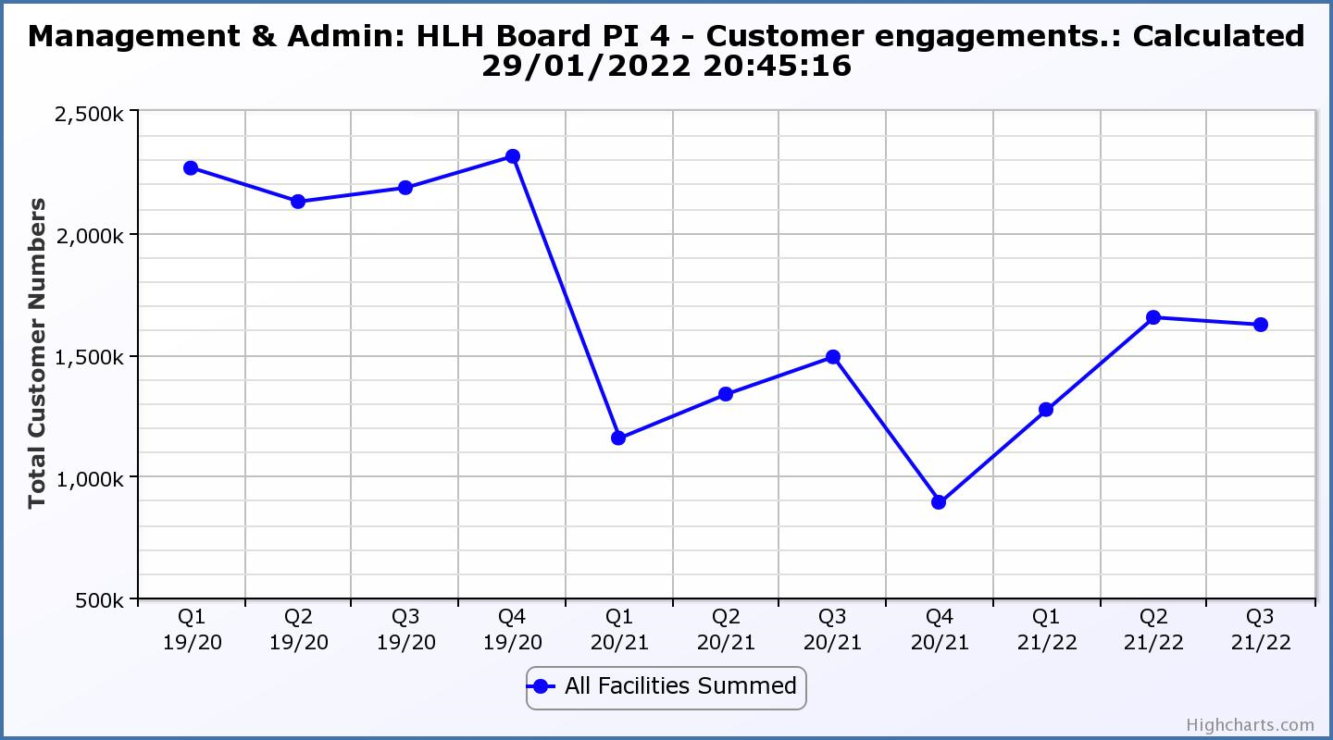

Business Plan Outcome | Performance Indicator | Reporting Frequency | RAG Rating Definition | RAG Rating Q1 21/22 | RAG Rating Q2 21/22 | RAG Rating Q3 21/22 | RAG Rating Q4 21/22 | Summary of Quarter Three Performance
3. Improve customer engagement and satisfaction (cont.) | 5. Customer surveys. | Quarterly. | - Red = up to three surveys have been completed or scheduled.  - Amber = 4 to 8 of the HLH areas of work have completed or scheduled customer surveys.  - Green = all areas of HLH work have completed or scheduled customer surveys. | Green | Green | Green |  | Please see section 4 of this report for further detail.

Business Plan Outcome | Performance Indicator | Reporting Frequency | RAG Rating Definition | RAG Rating Q1 21/22 | RAG Rating Q2 21/22 | RAG Rating Q3 21/22 | RAG Rating Q4 21/22 | Summary of Quarter Three Performance
3. Improve customer engagement and satisfaction (cont.) | 6. Formal complaints. | Quarterly. | - Red = 41 or more complaints per quarter.  - Amber = 31 to 40 complaints per quarter.  - Green = 30 complaints or fewer per quarter. | Green | Green | Green |  | There were twenty-one complaints received during Q3 2021/22. Please see section 4 of this report for further detail.

Performance Indicator 6 - Formal Complaints
The graph below shows the number of complaints which continue to be very low in relation to customer numbers.
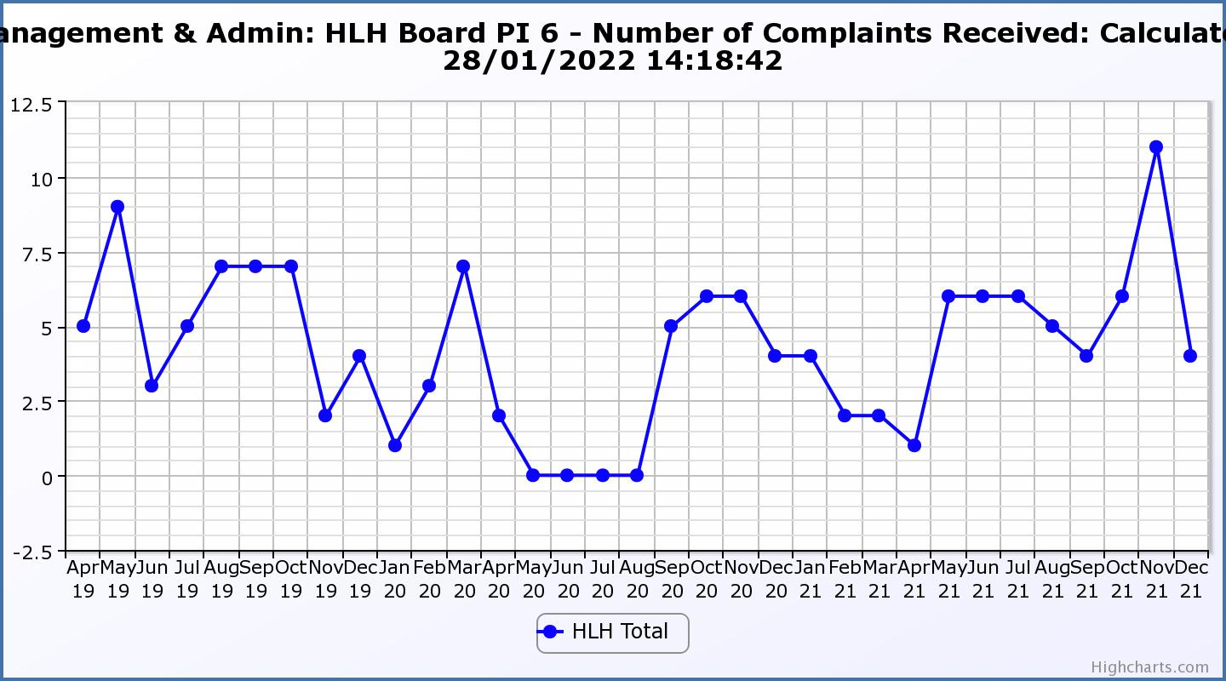
Business Plan Outcome | Performance Indicator | Reporting Frequency | RAG Rating Definition | RAG Rating Q1 21/22 | RAG Rating Q2 21/22 | RAG Rating Q3 21/22 | RAG Rating Q4 21/22 | Summary of Quarter Three Performance
4. Improve staff engagement and satisfaction | 7. Staff turnover (resignations as a percentage of posts). | Quarterly. | - Red = more than 2%  - Amber = 1.7 to 2%  - Green = 1.6% or less | Green | Green | Green |  | The number of resignations per month as a percentage of posts in Q3 was 0.9% in October, 0.78% in November and 0.78% in December. Please see section four and the HR report elsewhere on this agenda for further information.

Performance Indicator 7 - Staff Turnover (resignations as a percentage of posts)
The graph below shows resignations as a percentage of the number of posts which have been consistent with previous years (1% equates to 10.6 staff).

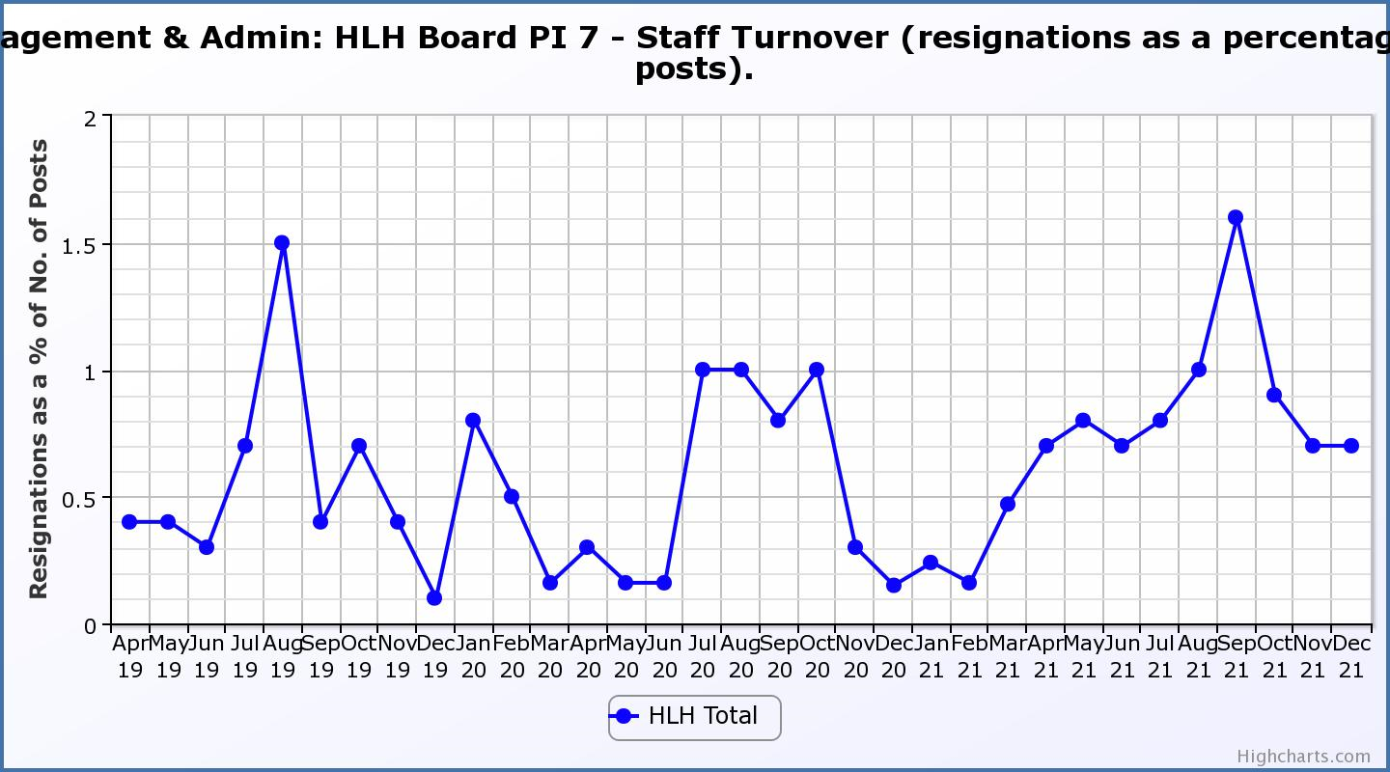

Business Plan Outcome | Performance Indicator | Reporting Frequency | RAG Rating Definition | RAG Rating Q1 21/22 | RAG Rating Q2 21/22 | RAG Rating Q3 21/22 | RAG Rating Q4 21/22 | Summary of Quarter Three Performance
4. Improve staff engagement and satisfaction (cont.) | 8. Staff absence rates. | Quarterly. | - Red = absence rate greater than 3.6%.  - Amber = absence rate between 3.4% and 3.6%.  - Green = absence rate 3.3% or less. | Green | Green | Red |  | The absence rate for Q3 was 4.09%. Please see section three of this report and the HR report elsewhere on this agenda for further information.

Performance Indicator 8 - Staff Absence Rates
Staff absence rates have increased throughout the year and during quarter three the red RAG rating is largely attributable to covid related absences. 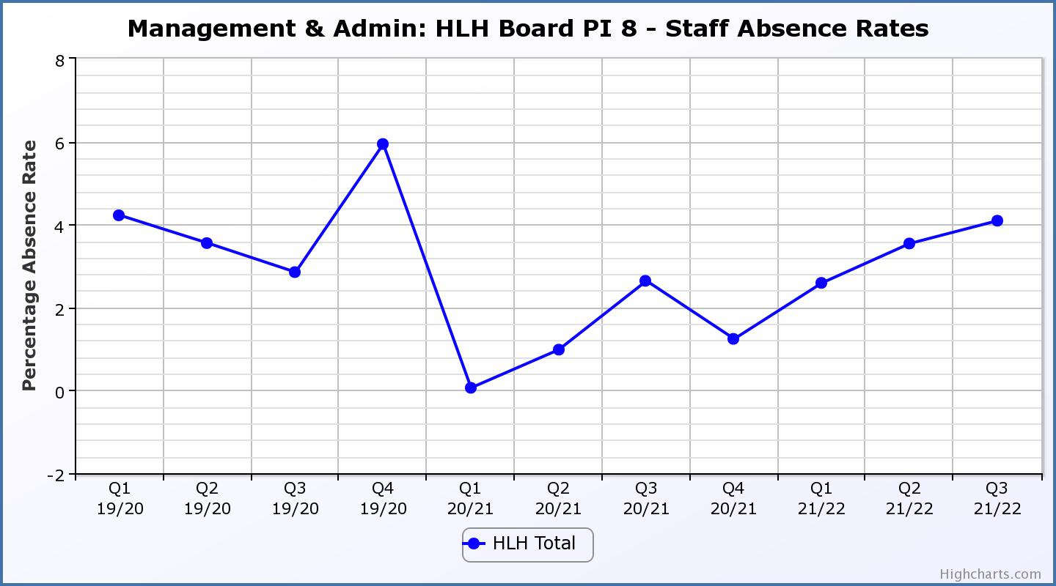

Business Plan Outcome | Performance Indicator | Reporting Frequency | RAG Rating Definition | RAG Rating Q1 21/22 | RAG Rating Q2 21/22 | RAG Rating Q3 21/22 | RAG Rating Q4 21/22 | Summary of Quarter Two Performance
5. Enhance the positive company image | 9. Media clippings. | Quarterly | - Red = number of negative press clippings outweigh neutral and positive.  - Amber = number of negative and neutral press clippings outweigh positive.  - Green = number of positive and neutral media clippings outweigh negative. | Green | Green | Green |  | At its September 2021 meeting the HLH Board asked that consideration be given to updating the RAG ratings for this performance indicator based on being likely to always be RAG rated “green” based on experience. A new graph has been developed below which shows media sentiment. RAG ratings will be developed after some experience of using the new system has been gained.

Performance Indicator 9 - Media Clippings
The following graph is in a new format and shows a greater range of information (different types of media/releases) with recording having commenced in September 2021.
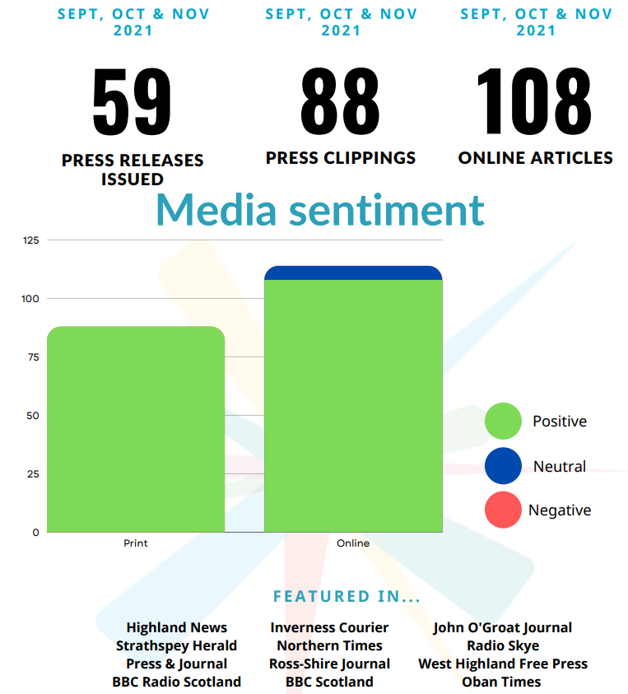
Business Plan Outcome | Performance Indicator | Reporting Frequency | RAG Rating Definition | RAG Rating Q1 21/22 | RAG Rating Q2 21/22 | RAG Rating Q3 21/22 | RAG Rating Q4 21/22 | Summary of Quarter Two Performance
6. Be a trusted and effective partner | 10. THC’s annual survey of performance and attitudes. | Annual. | - Red = all HLH areas of work represented receive lower net satisfaction ratings than the previous year.  - Amber = two or more areas of HLH work receive lower net satisfaction ratings than the previous year.  - Green = net satisfaction ratings are maintained or improved for three or more areas of HLH work compared with the previous year. | N/A | N/A | NA | NA | The Council has not carried out its annual survey of its citizen’s panel this year and it is anticipated that the next time that it will do this will be in 2022.

Business Plan Outcome | Performance Indicator | Reporting Frequency | RAG Rating Definition | RAG Rating Q1 21/22 | RAG Rating Q2 21/22 | RAG Rating Q3 21/22 | RAG Rating Q4 21/22 | Summary of Quarter Two Performance
6. Be a trusted and effective partner (cont.) | 11. Partnership work with sportscotland | Annual | - Red = cancellation of Partnership Agreement with sportscotland  - Amber = continuation of current level of partnership work with sportscotland  - Green = Growth in partnership working with sportscotland | Green | NA | NA | NA | NA – this is an annual indicator which was last considered by the HLH Board at its September 2021 meeting.

Business Plan Outcome | Performance Indicator | Reporting Frequency | RAG* Rating Definition  (*Red/Amber/Green) | RAG Rating Q1 21/22 | RAG Rating Q2 21/22 | RAG Rating Q3 21/22 | RAG Rating Q4 21/22 | Summary of Quarter Two Performance
7. Achieve sustainable growth across the organisation | 12. Financial monitoring. | Quarterly. | An assessment of the year end outturn where:  - Red = delivery of services over budget above 2%.  - Amber = delivery of services between break-even and 2% over budget.  - Green = delivery of services within budget. | Green | Green | Green |  | This PI has been RAG rated green because it is within the under-write agreed by THC. Please see the Finance Report elsewhere on this agenda for further information.

Performance Indicator 12 - Financial monitoring
See the Finance Report elsewhere on this agenda for further information.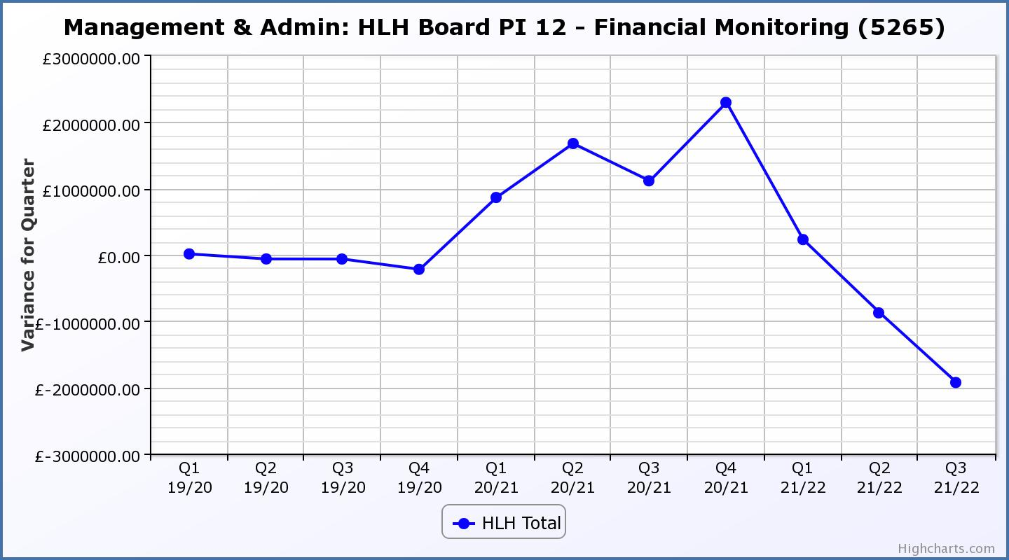

Business Plan Outcome | Performance Indicator | Reporting Frequency | RAG Rating Definition | RAG Rating Q1 21/22 | RAG Rating Q2 21/22 | RAG Rating Q3 21/22 | RAG Rating Q4 21/22 | Summary of Quarter Two Performance
7. Achieve sustainable growth across the organisation (cont.) | 13. Number of High Life subscriptions. | Quarterly. | - Red = more than 5% below target.  - Amber = up to 5% below target.  - Green = on or exceeds target. | Green | Green | Green |  | This PI has been RAG rated green because the number of subscriptions is, above the level required to achieve the target in the financial modelling. As of February, subscriptions were 15,861.

Performance Indicator 13 - Number of High Life Subscriptions
Subscriptions continue to increase slightly ahead of budget projections. The increase in October was when subscriptions were un-frozen and as can be seen on the graph below this led to an increase in cancellations. Please see section three of this report for further information. 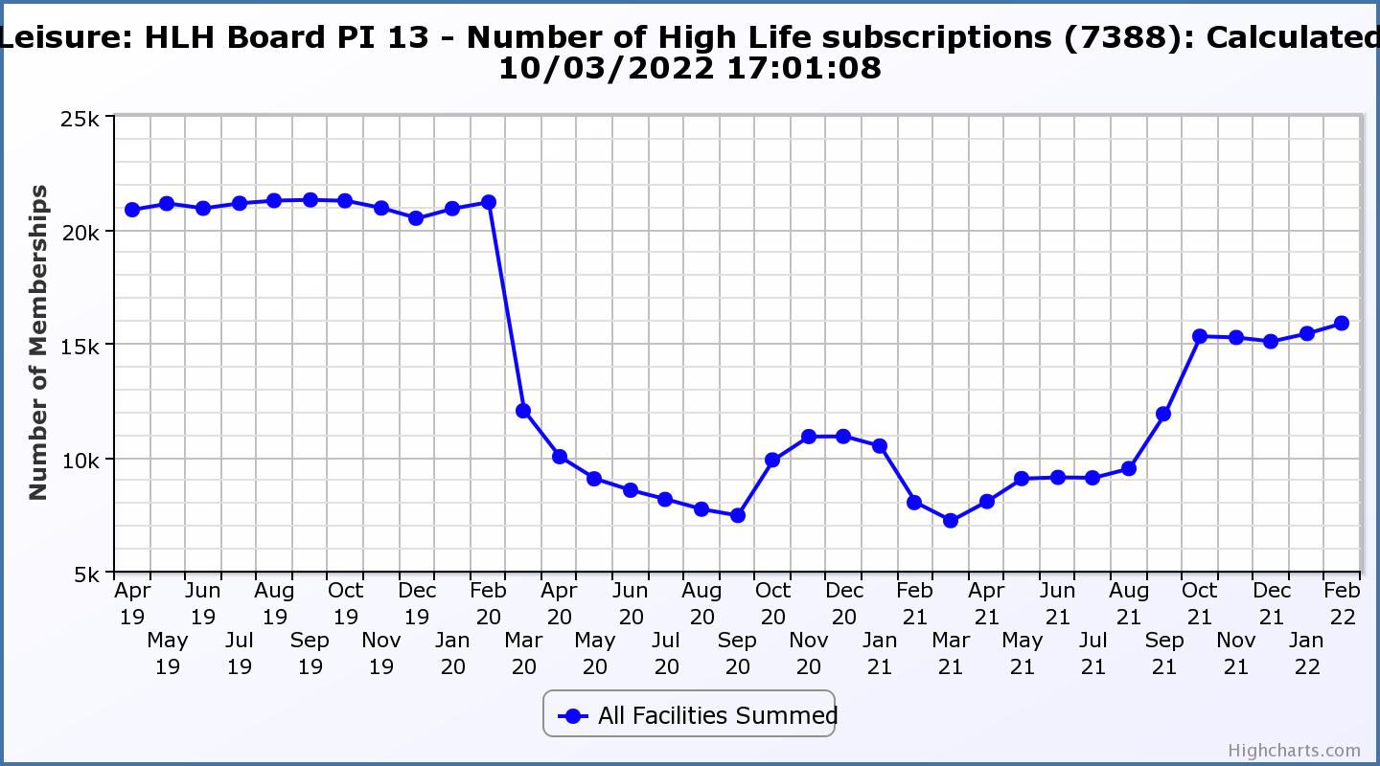
Business Plan Outcome | Performance Indicator | Reporting Frequency | RAG Rating Definition | RAG Rating Q1 21/22 | RAG Rating Q2 21/22 | RAG Rating Q3 21/22 | RAG Rating Q4 21/22 | Summary of Quarter Two Performance
7. Achieve sustainable growth across the organisation (cont.) | 14. High Life cancellation rate. | Quarterly. | - Red = cancellation rate above 6% of High Life memberships.  - Amber = cancellation rate is 3% - 6% of High Life memberships.  - Green = cancellation rate is up to 3% of High Life memberships. | Green | Green | Amber |  | The number of cancelled subscriptions were 4% in October, 6% in November and 6% in December. Please see section three of this report for further information.

Performance Indicator 14 - High Life Cancellation Rate
Following the increase in the cancellation rate associated with the unfreezing of cancellations in October, it returned to historic levels in January 2022. Please see section three of this report for further information
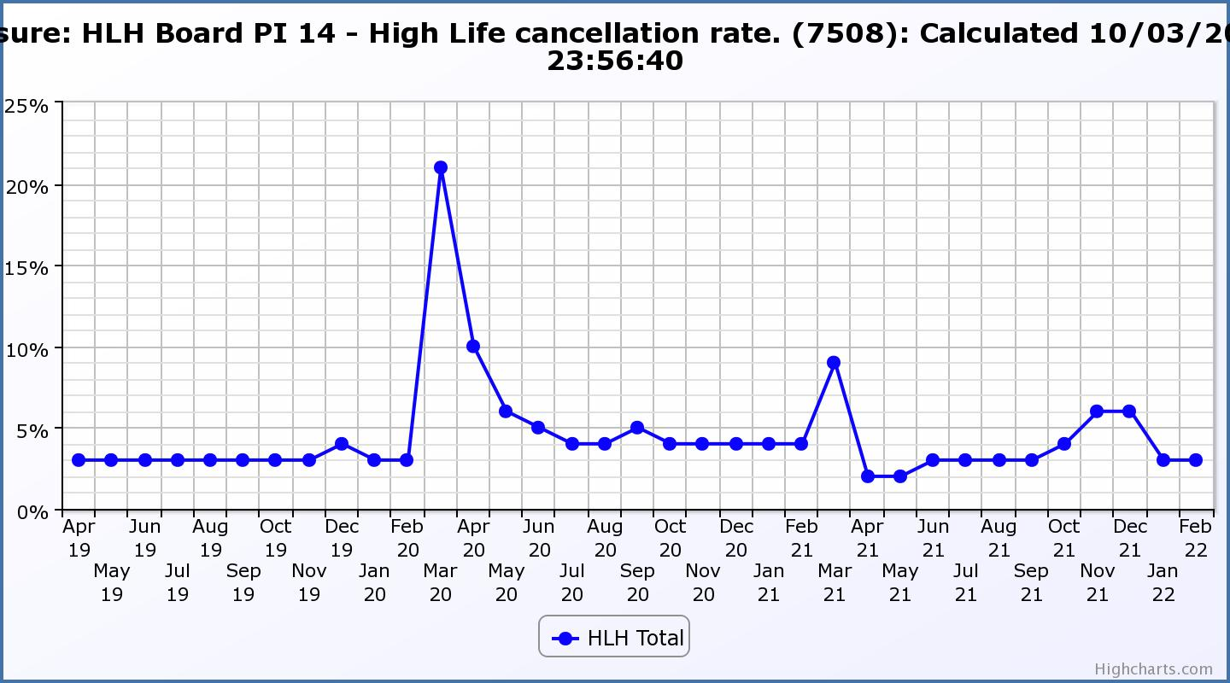

Business Plan Outcome | Performance Indicator | Reporting Frequency | RAG Rating Definition | RAG Rating Q1 21/22 | RAG Rating Q2 21/22 | RAG Rating Q3 21/22 | RAG Rating Q4 21/22 | Summary of Quarter Two Performance
8. Develop health and wellbeing across Highland communities | 15. Partnership work with NHSH and other health related organisations. | Annual. | - Red = no partnership work with NHSH etc.  - Amber = Reduction of current level of partnership work with NHSH etc.  - Green = Continuation or growth in partnership working with NHSH etc. | Green | N/A | N/A | NA | NA, this is an annual indicator last considered by the HLH Board at its meeting held in September 2021.

Business Plan Outcome | Performance Indicator | Reporting Frequency | RAG Rating Definition | RAG Rating Q1 21/22 | RAG Rating Q2 21/22 | RAG Rating Q3 21/22 | RAG Rating Q4 21/22 | Summary of Quarter Two Performance
9. Develop and promote the High Life brand | 16. Uptake of HLH card towards the target of 80% of the population. | Annual | - Red = number of card holders is maintained.  - Amber = number of card holders is increased by 1-4%.  - Green = number of card holders is increased by 5% or more. | N/A | NA | NA |  | NA, this is an annual indicator.

Appendix C
Proposed New Performance Indicators

The HLH Board uses performance indicators to make an assesment of the overall health of the charity and has chosen indicators which:

- relate to the business outcomes identified in its Business Plan
- provide an indication of areas where management action might be required at as early as possible a stage as is possible in order to keep the organisation aligned to its business plan.
The indicators themselves can only be indicators of performance and do not, on their own, give the full detail on each of the business outcomes, there are wider workstreams and plans associated with each such as operational plans for each of the 12 areas of HLH work and strategies such as the Health and Safety Strategy and associated annual reporting which give more detailed reporting at both operational and HLH Board level.

To be useful the performance indicators have to be:

- high enough level to allow an overall assesment of performance and
- lead to the right kinds of organisational behaviour and action when they are rag rated as amber or red.
The performance indicators below are proposed for consideration by the HLH Board for monitoring the new 2022/23 to 2026/27 Business Plan.

Business Plan Outcome | Performance Indicator | Reporting Frequency | RAG Rating Definition
1. Seek to continuously improve standards of health and safety. | External health and safety audit. | Annual. | - Green = the external audit does not raise systemic issues.  - Amber = the external audit highlights common actions to be addressed across the company.  - Red = the external audit raises systemic (i.e. applying across multiple sites) H&S issues.
 | RIDDOR accidents/incidents. | Quarterly. | - Green = number of RIDDOR reports per quarter is less than 10.  - Amber = number of RIDDOR reports per quarter is between 10 and 20  - Red = number of RIDDOR reports per quarter is above 20.
2. Commit to the Scottish Government’s zero carbon targets and maintain the highest standards in environmental compliance. | The HLH Environmental strategy will be developed during 2022/23. Performance indicators will be identified through the development of these plans and will be aligned with THC’s carbon reduction strategy given the contractual (particularly property) arrangements that there are in place between THC and HLH.  Travel (a target to reduce by 50% following the pandemic has previously been set) | -  Quarterly | - Green = 400,000 miles p.a. or less  - Amber = up to 5% greater than target  - Red = more than 5% of target.
3. Use research and market analysis to develop and improve services to meet customer needs. | Customer engagements. | Quarterly. | - Green = customer numbers are the same as or have increased compared with the corresponding quarter in the previous year  - Amber = customer numbers are less than the corresponding quarter in the previous year.  - Red = customer numbers are more than 5% lower than the corresponding quarter in the previous year.
 | Charity-wide customer satisfaction survey | Annually | - Green = Services delivered by HLH is above average  - Amber = Services delivered by HLH is average  - Red = Services delivered by HLH is below average.
4. Increase employee satisfaction, engagement and development to improve staff recruitment and retention. | Staff turnover (resignations as a percentage of posts). | Quarterly. | - Green = 1.6% or less.  - Amber = 1.7 to 2%  - Red = more than 2%
 | Staff attendance rates (figure based on Office for National Statistics for 2020 of absence rate). | Quarterly. | - Green = attendance rate 98% or higher.  - Amber = attendance rate between 97% and 98%.  - Red = attendance rate less than 97%.
5. Improve the financial sustainability of the company | Financial monitoring. | Quarterly. | An assessment of the year end outturn where:  - Green = delivery of services within budget.  - Red = delivery of services over budget above 2%.  - Amber = delivery of services between break-even and 2% over budget.
 | Reserves | Annual | - Green = meets 3% reserves policy  - Amber = achieves 2% reserves  - Red = fails to achieve 2% reserves policy.
 | Number of highlife subscriptions (target is the required number to meet the budget). | Quarterly. | - Green = exceeds target.  - Amber = meets target.  - Red = more than 5% below target.
6. Value and strengthen the relationship with THC. | Delivery of the Service Delivery Contract (SDC) with The Highland Council (THC). | Six-monthly. | - Green = agreement of THC’s Education Committee that HLH has met or exceeded the terms of the SDC.  - Amber = agreement of THC’s Education Committee that HLH has met the terms of the SDC but has set some improvement targets.  - Red = agreement of THC’s Education Committee that HLH has not met the terms of the SDC.
 | THC’s annual survey of performance and attitudes. | Annual. | - Green = net satisfaction ratings are maintained or improved for three or more areas of HLH work compared with the previous year  - Amber = two or more areas of HLH work receive lower net satisfaction ratings than the previous year.  - Red = all HLH areas of work represented receive lower net satisfaction ratings than the previous year.
7. Develop and deliver the HLH Corporate Programme and seek to attract capital investment. | The HLH corporate programme covers investment; business process improvement; capital and asset management plans and plans will be developed as this area of work is developed. Should additional performance indicators be identified through the development of these plans they will be added in future.
8. Use research and market analysis to develop and deliver proactive marketing and promotion of HLH and its services. | Media coverage from proactively issued media releases | Six-monthly | - Green = Positive coverage 95%+  - Amber = Positive coverage 90% - 95%  - Red = Positive coverage 90%-
 | On-line engagement through social media channels. |  | - Green = 5% increase compared with the same period last year.  - Amber = no increase to 4.9% lower compared with the same period last year.  - Red = more than 5% lower or less compared with the same period last year.
9. Initiate and implement an ICT digital transformation strategy across the charity | The HLH digital transformation strategy will be developed during 2022/23. Should performance indicators be identified through the development of these plans they will be added in future.
10. Develop and strengthen relationships with customers, key stakeholders and partners | New approach to customer survey as per Business Outcome 3 above. | - | -
 | Partnership work with sportscotland and other sports related organisations, NHS Highland and other health related organisations (including Memoranda of Understanding) etc. | Annual | - Green = Growth in partnership working  - Amber = continuation of current level of partnership work  - Red = cancellation of Partnership Agreements
11. Deliver targeted programmes which support and enhance the physical and mental health and wellbeing of the population and which contribute to the prevention agenda. | An assessment of the RAG rating of the Health and Wellbeing Strategy action plan. |  | - Green = 80% or more of the actions are RAG rated green  - Amber = 60% to 79% of actions are green.  - Red = 59% or less are rated green.

