HIGH LIFE HIGHLAND  REPORT TO BOARD OF DIRECTORS  22 june 2022 | AGENDA ITEM REPORT No HLH /22

Performance Report - Report by Chief Executive

Summary

The purpose of this report is to present performance information for the period January to March 2022.

It is recommended that Directors:

- comment on the report and agree that the overall health check on the charity for that period is assessed as “green”, on target, reflecting indications of customer recovery following COVID-19 restrictions and additional financial support having been agreed by The Highland Council.

1. | Business Plan Contribution
1.1 | This report supports all the Business Outcomes from the High Life Highland (HLH) Business Plan 2022-27  - Seek to continuously improve standards of health and safety.  - Commit to the Scottish Government’s zero carbon targets and maintain the highest standards in environmental compliance.  - Use research and market analysis to develop and improve services to meet customer needs.  - Increase employee satisfaction, engagement and development to improve staff recruitment and retention.  - Improve the financial sustainability of the company.  - Value and strengthen the relationship with THC.  - Develop and deliver the HLH Corporate Programme and seek to attract capital investment.  - Use research and market analysis to develop and deliver proactive marketing and promotion of HLH and its services.  - Initiate and implement an ICT digital transformation strategy across the charity.  - Develop and strengthen relationships with customers, key stakeholders and partners.  - Deliver targeted programmes which support and enhance the physical and mental health and wellbeing of the population and which contribute to the prevention agenda.
2. | Background
2.1 | The implementation of the HLH Business Plan 2022-27 is monitored in two ways:  - through a set of performance indicators set by the Board at its meeting held on 31 March 2022; and  - by RAG (Red, Amber, Green) rating the delivery of the business outcomes contained in the business plan with these being reported to the Board by exception (i.e. reporting where managers had RAG rated the actions “red – no significant progress”). Note: this will be re-started at the September HLH Board meeting based on the new business plan which commenced in April.
3. | Summary of Performance
3.1 | Nineteen performance indicators (PIs) were identified by the HLH Board to assess the overall performance of the charity at its meeting held on 31 March 2022. Appendix A contains a summary of performance against the PIs for Q4 2021/22. Appendix B provides a list of all the PIs along with trend information. Eleven PIs were scheduled for assessment at the March 2022 HLH Board meeting. 8 have been RAG rated green; 1 red; and 1 amber.
3.2 | The indicator which has been RAG rated as red is PI 8. staff attendance rate. The indicator which has been RAG rated as amber is PI 11 highlife subscriptions.
3.3 | PI 8. staff attendance rate – there is further information on this in the HR report elsewhere on this agenda.
3.4 | PI 11. highlife subscriptions – the number of subscriptions grew by 400 per month in January and February. It has, however, been RAG rated as amber because this slowed to 150 in March and while April is outside of the reporting quarter, stalled during April 2022.
3.5 | There was an increased number of cancellations following the communication with customers on the price increase. The value of the increased number of cancellations following the price increase was £50k (full year effect). The value of the price increase during 2022/23 is projected to be £300k representing a net whole year projected value of £250k.
3.6 | The cancellations appear to have stabilised and the number of subscriptions started to increase again during the last week in May and are currently at 76% of pre-pandemic levels. As part of our reaction to flatlining in April, a “bring a buddy” promotion was launched on 31 May and an ‘every member counts’ campaign started on 1 June. There will also be a High Life Highland presence at the European Pipe Band Championship on Saturday 25 June 2022, where there will be a team of staff promoting highlife subscriptions. A £10 for 10 days promotion is also in development and will be launched in October to address the risk of losing pay-as-you-go income over the summer months.
3.7 | The gym equipment replacement programme as previously reported will continue to support the recovery. HLH offers corporate subscriptions whereby businesses which sign up receive a 10% discount for their staff, this is also a priority area for sales. There are currently 20 corporate subscription agreements in place with 987 subscriptions associated with them. These are being refreshed following the pandemic with businesses being encouraged and supported to promote the scheme amongst their staff. Our new Sales Manager has hit the ground running and 12 new corporate subscription opportunities are currently being followed up.
4. | Performance Indicators for More Detailed Consideration
4.1 | Each quarter more detailed information is provided on one or more of the 19 performance indicators and the following performance indicators are scheduled for inclusion in this report:  - PI 5 - Customer engagements  - PI 6 - Delivery of the Service Delivery Contract (SDC) with The Highland Council (THC)
4.2 | The following performance indicators are scheduled for more detailed consideration through the annual health and safety report elsewhere on this agenda:  - PI 1. External health and safety audit  - PI 2. RIDDOR accidents/incidents.
4.3 | PI 4, Customer Engagements – total engagements, comprising in-person and on-line engagements increased between last year and 2020/21. Last year they were 70% of the pre-pandemic year. The table below shows the breakdown by each of the 11 areas of HLH work.
In-Person Customer Visits and On-Line Engagements
 | 2019/20 | 2020/21 | 2021/22 | % of 2019/20  position
Adult Learning | 16,088 | 3,905 | 9,374 | 58%
Archives | 1,303,574 | 1,957,901 | 1,742,751 | 134%
Arts | 4,525 | 175 | 1,498 | 33%
Leisure | 2,995,583 | 468,555 | 1,377,339 | 46%
Libraries | 3,744,523 | 2,251,855 | 2,574,221 | 69%
Museums | 264,246 | 95,501 | 260,752 | 99%
Music Tuition | 99,736 | 40,687 | 84,245 | 84%
Outdoor Activities | 2,814 | 217 | 1,082 | 38%
Countryside Rangers | 15,044 |  | 5,122 | 34%
Sport | 374,522 | 29,955 | 106,651 | 28%
Youth Services | 71,694 | 24,923 | 54,848 | 77%
Total | 8,892,349 | 4,873,674 | 6,217,883 | 70%

4.4 | The total number of customer visits shows the importance of having re-started services early and continuing to deliver and develop on-line services that were implemented at the start of the pandemic during the first lockdown. The lockdowns and restrictions in 2021/22 meant that the recovery of in-person visits was slower than overall visits as can be seen in the table below.
In-Person Customer Visits
 | 2019/20 | 2020/21 | 2021/22 | % of 2019/20 position
Adult Learning | 16,088 | 3,905 | 9,374 | 58%
Archives | 10,253 | 139 | 2,793 | 27%
Arts | 4,525 | 175 | 1,498 | 33%
Countryside Rangers | 15,044 | 0 | 5,122 | 34%
Leisure | 2,995,583 | 351,453 | 1,393,198 | 46%
Libraries | 2,203,734 | 55,567 | 392,232 | 18%
Museums | 154,873 | 18,549 | 68,229 | 44%
Music Tuition | 127,722 | 47,787 | 111,970 | 88%
Outdoor Activities | 2,814 | 217 | 1,082 | 38%
Sport | 374,522 | 29,955 | 106,651 | 28%
Youth Services | 71,694 | 24,923 | 54,867 | 76%
Total | 5,976,852 | 532,670 | 2,147,016 | 36%

4.5 | When comparing 2021/22 with the pre-pandemic year it is important to note that there were still lockdowns and restrictions in capacity throughout the whole year. Now that restrictions have ended, the picture is an improving one with the April 2022 figures having been the highest for many services since the lockdown in March 2020.
4.6 | Of particular importance is the footfall in the highlife leisure centres due to its relation to income. Footfall at these sites during April 2022 was 64% of previous levels (over the preceding year it was 46%). The indications are that club lets, pay as you go income and customers using their highlife subscriptions will all continue to rise.
4.7 | The cost of living crisis and the legacy impact of covid (customer mindset even though the protective measure is vaccination) are real issues for HLH and recovery continues to be monitored closely because of its importance to the charity and individuals/communities which it serves.
4.8 | PI 6, Delivery of the Service Delivery Contract (SDC) with The Highland Council (THC) – Reporting to the Highland Council’s Education Committee is normally in May for the preceding financial year and then again in December for the first six months of the year. The local government election has meant that the first Education Committee which HLH is able to report to is on 1 September 2022 and it is expected that it will, therefore, be possible to report on this indicator at the December HLH Board meeting.
5. | Implications
5.1 | Resource implications – there are no additional resource implications arising from this report. Resource implications have been covered in the Finance Report elsewhere on this agenda.
5.2 | Equality implications – there are no new equality implications arising from this report.
5.3 | Legal implications – there are no new legal implications arising from this report.
5.4 | Risk implications – there are no new risk implications arising from this report.

Recommendation

It is recommended that Directors:

- comment on the report and agree that the overall health check on the charity for that period is assessed as “green”, on target, reflecting indications of customer recovery following COVID-19 restrictions and additional financial support having been agreed by The Highland Council.

Designation: Chief Executive

Date: 8 June 2022

Author: Douglas Wilby, Director of Sport and Leisure

Appendix A
HLH Performance Indicators summary Q4 2021/22
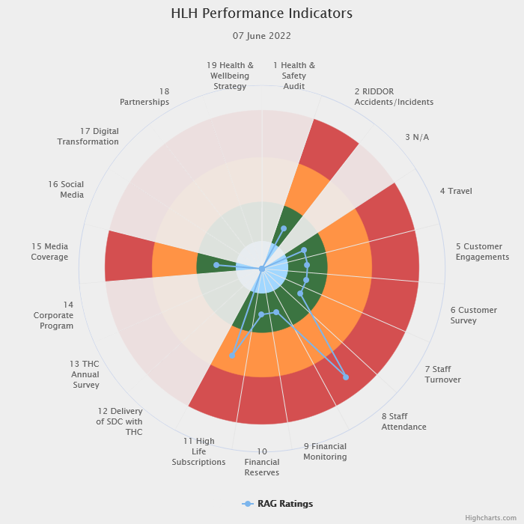 | Nineteen performance indicators (PIs) are used by the High Life Highland Board to assess the overall performance of the charity.  The PIs are RAG rated (allocated a "Red", "Amber" or "Green" status) so that it is easy to see at a glance how the organisation is performing. Most of the PIs are RAG rated every quarter throughout the year, with some (such as partnership working with NHSH for example) being considered annually so greyed out sectors on this radar diagram mean that the PI is to be considered at a future HLH Board meeting.

Appendix B
HLH Performance Indicators – Detail Q4 2021/22

Business Plan Outcome | Performance Indicator | Reporting Frequency | RAG Rating Definition | RAG Rating Q1 21/22 | RAG Rating Q2 21/22 | RAG Rating Q3 21/22 | RAG Rating Q4 21/22 | Summary of Quarter Four Performance
1. Seek to continuously improve standards of health and safety. | 1. External health and safety audit. | Annual. | - Green = the external audit does not raise systemic issues.  - Amber = the external audit highlights common actions to be addressed across the company.  - Red = the external audit raises systemic (i.e. applying across multiple sites) H&S issues. | N/A | N/A | Green | N/A | An Audit of five HLH facilities took place in November 2021 resulting in positive compliance results. Ongoing actions have been reported to the Health and Safety and Environmental Compliance Committee at its May 2022 meeting and an update is scheduled at its August meeting.

Business Plan Outcome | Performance Indicator | Reporting Frequency | RAG Rating Definition | RAG Rating Q1 21/22 | RAG Rating Q2 21/22 | RAG Rating Q3 21/22 | RAG Rating Q4 21/22 | Summary of Quarter Four Performance
1. Seek to continuously improve standards of health and safety. | 2. RIDDOR accidents/incidents. | Quarterly. | - Red = number of RIDDOR reports per quarter is above 20.  - Amber = number of RIDDOR reports per quarter is between 10 and 20  - Green = number of RIDDOR reports per quarter is less than 10. | Green | Green | Green | Green | There were two accidents reported under the RIDDOR regulations during Q4. These were both considered by the Health and Safety and Environmental Compliance Committee at its May 2022 meeting.

Performance Indicator 2 - RIDDOR accidents/incidents
The graph below tracks the number of accidents and incidents reported under the Reporting of Injuries, Diseases and Dangerous Occurrences Regulations (RIDDOR). There were two RIDDOR incident reported in Q4 2021/22.
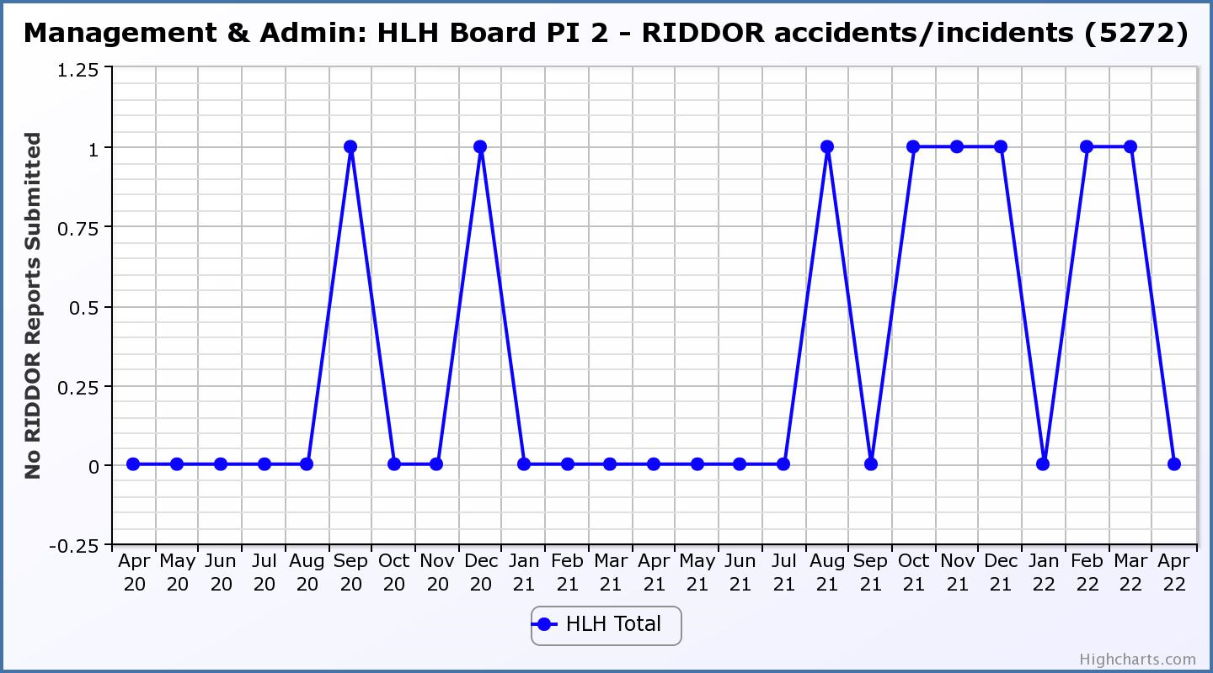

Business Plan Outcome | Performance Indicator | Reporting Frequency | RAG Rating Definition | RAG Rating Q1 21/22 | RAG Rating Q2 21/22 | RAG Rating Q3 21/22 | RAG Rating Q4 21/22 | Summary of Quarter Four Performance
2. Commit to the Scottish Government’s zero carbon targets and maintain the highest standards in environmental compliance. | 3. The HLH Environmental strategy will be developed during 2022/23. | . |  | N/A | N/A | N/A | N/A | NA - Performance indicators will be identified through the development of these plans and will be aligned with THC’s carbon reduction strategy given the contractual (particularly property) arrangements that there are in place between THC and HLH.

Business Plan Outcome | Performance Indicator | Reporting Frequency | RAG Rating Definition | RAG Rating Q1 21/22 | RAG Rating Q2 21/22 | RAG Rating Q3 21/22 | RAG Rating Q4 21/22 | Summary of Quarter Four Performance
2. Commit to the Scottish Government’s zero carbon targets and maintain the highest standards in environmental compliance. | 4. Travel (a target to reduce by 50% following the pandemic has previously been set) | Quarterly. | - Green = 400,000 miles p.a. or less  - Amber = up to 5% greater than target  - Red = more than 5% of target. | N/A | N/A | N/A | Green | There was a total of 380,495 miles driven by HLH staff in the year 2021/22.

Performance Indicator 4 – Travel Miles
The graph below shows the travel miles for the previous two years and will be used as a basis for monitoring travel during the current year. The total Miles were under the target of 400,000 in the year 2021/22.
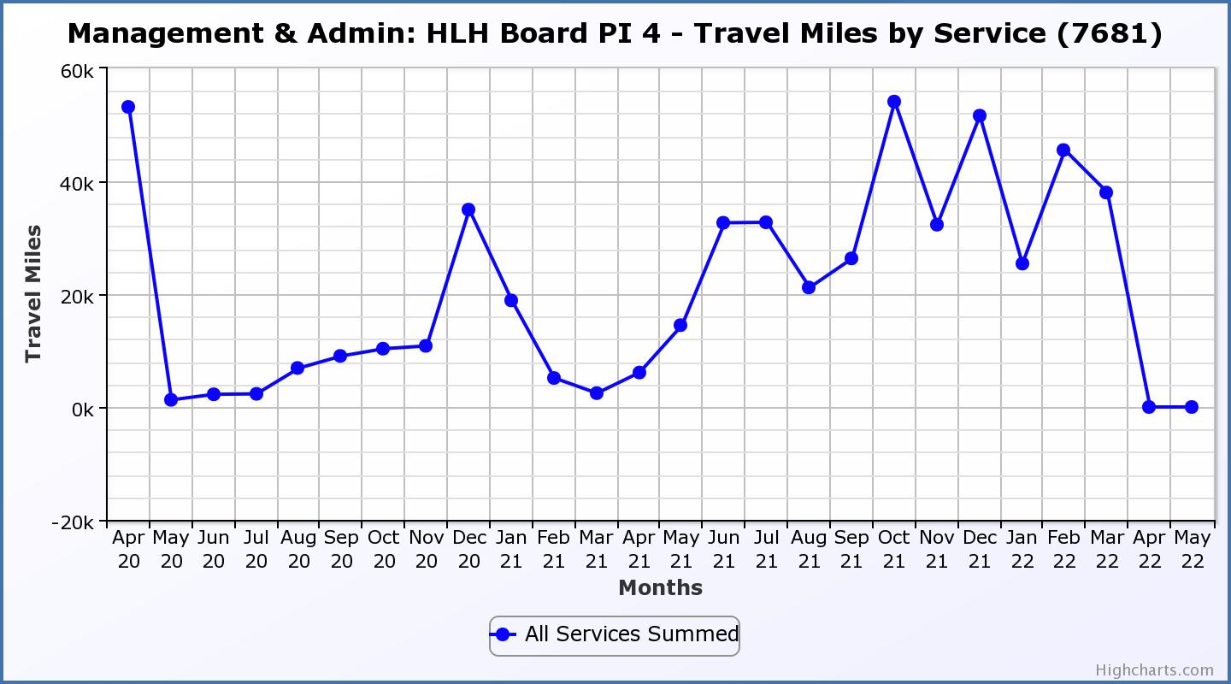

Business Plan Outcome | Performance Indicator | Reporting Frequency | RAG Rating Definition | RAG Rating Q1 21/22 | RAG Rating Q2 21/22 | RAG Rating Q3 21/22 | RAG Rating Q4 21/22 | Summary of Quarter Four Performance
3. Use research and market analysis to develop and improve services to meet customer needs. | 5. Customer engagements. | Quarterly. | - Green = customer numbers are the same as or have increased compared with the corresponding quarter in the previous year  - Amber = customer numbers are less than the corresponding quarter in the previous year.  - Red = customer numbers are more than 5% lower than the corresponding quarter in the previous year. | Green | Green | Green | Green | Customer engagements increased from 891,787 in Q4 2020/21 to  1,653,500 in Q4 2021/22. While this is lower than previous years due to the pandemic is has been RAG rated green as a reflection of recovery from the pandemic.
Performance Indicator 5 - Customer engagements
The lockdowns/restrictions have been listed so that the graph below can be seen in the context of the operating environment over the past two years. It would have been normal to see a slight decrease in Q3 2021/22 because of the holiday periods which fall within that quarter, followed by an increase in Q4. The increase in on-line customer engagements, capacity restrictions and concerns over the Omicron variant have made comparisons less relevant. There is further information on customer visits/engagements in section four of this report above.
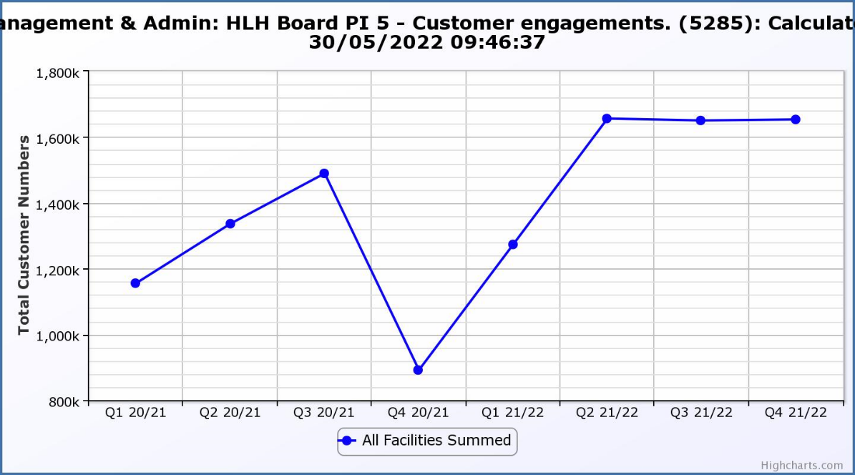 | Q1 20/21 23 March 2020 – First lockdown announced;  Q2 and Q3 20/21 31 August 2020 – HLH facilities re-open with significant restrictions;  Q4 20/21 5 January 2021 – Second Lockdown;  Q1 21/22 26 April 2021 – Level 3 restrictions (HLH still largely closed); 17 May 2021 – Level 2 restrictions (significant restrictions - individual activity only with distancing etc.);  Q2 to Q 4 21/22 19 July 2021 – Level 0 restrictions (HLH facilities open with restrictions remaining – occupancies and activities restricted);  Q1 22/23 (not shown on graph as it is the current quarter). During April 2021 – all restrictions removed (including self - isolation and RIDDOR reporting for workplace transmission of COVID)

Business Plan Outcome | Performance Indicator | Reporting Frequency | RAG Rating Definition | RAG Rating Q1 21/22 | RAG Rating Q2 21/22 | RAG Rating Q3 21/22 | RAG Rating Q4 21/22 | Summary of Quarter Four Performance
3. Use research and market analysis to develop and improve services to meet customer needs. | 6. Charity-wide customer satisfaction survey | Annually. | - Green = Services delivered by HLH is above average  - Amber = Services delivered by HLH is average  - Red = Services delivered by HLH is below average. | Green | Green | Green | Green | This performance indicator was reported in more detail at the March 2022 HLH Board meeting.

Business Plan Outcome | Performance Indicator | Reporting Frequency | RAG Rating Definition | RAG Rating Q1 21/22 | RAG Rating Q2 21/22 | RAG Rating Q3 21/22 | RAG Rating Q4 21/22 | Summary of Quarter Four Performance
4. Increase employee satisfaction, engagement and development to improve staff recruitment and retention. | 7. Staff turnover (resignations as a percentage of posts). | Quarterly. | - Green = 1.6% or less.  - Amber = 1.7 to 2%  - Red = more than 2% | Green | Green | Green | Green | The number of resignations per month as a percentage of posts in Q4 was 0.9% in January, 0.5% in February and 0.9% in March. Please see section four and the HR report elsewhere on this agenda for further information.

Performance Indicator 7 - Staff Turnover (resignations as a percentage of posts)
The graph below shows resignations as a percentage of the number of posts which have been consistent with previous years (1% equates to 10.6 staff).

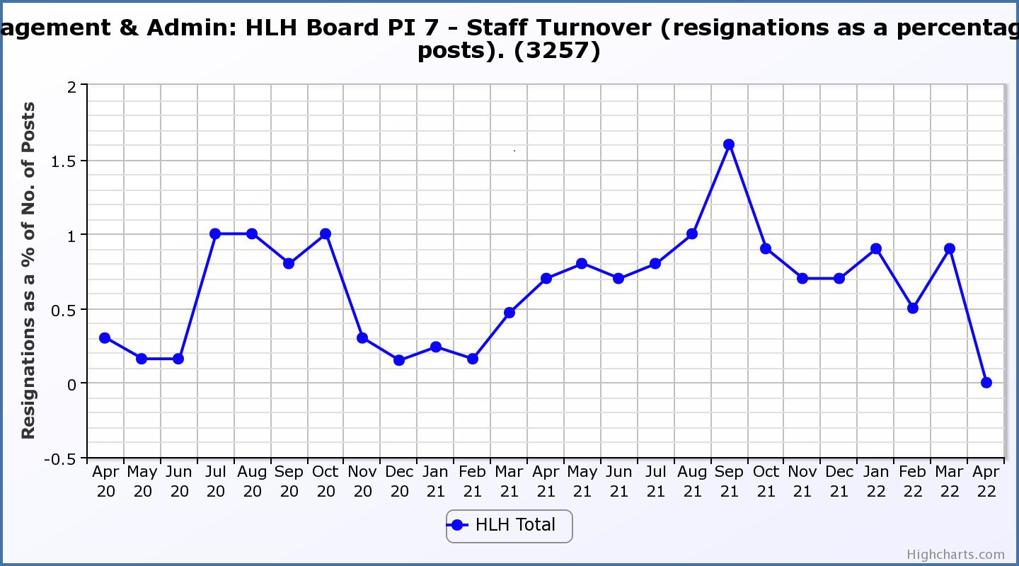

Business Plan Outcome | Performance Indicator | Reporting Frequency | RAG Rating Definition | RAG Rating Q1 21/22 | RAG Rating Q2 21/22 | RAG Rating Q3 21/22 | RAG Rating Q4 21/22 | Summary of Quarter Four Performance
4. Increase employee satisfaction, engagement and development to improve staff recruitment and retention. | 8. Staff attendance rates (RAG ratings based on Office for National Statistics for 2020 of absence rate). | Quarterly. | - Green = attendance rate 98% or higher.  - Amber = attendance rate between 97% and 98%.  - Red = attendance rate less than 97%. | Green | Green | Red | Red | The attendance rate for Q4 was 95.87%. Please see the HR report elsewhere on this agenda for further information.

Performance Indicator 8 - Staff Attendance Rate
Staff attendance rates have decreased throughout the year and during quarter four the red RAG rating is largely attributable to covid related absences which has since lessened. Please see the HR report elsewhere on this agenda for further information. 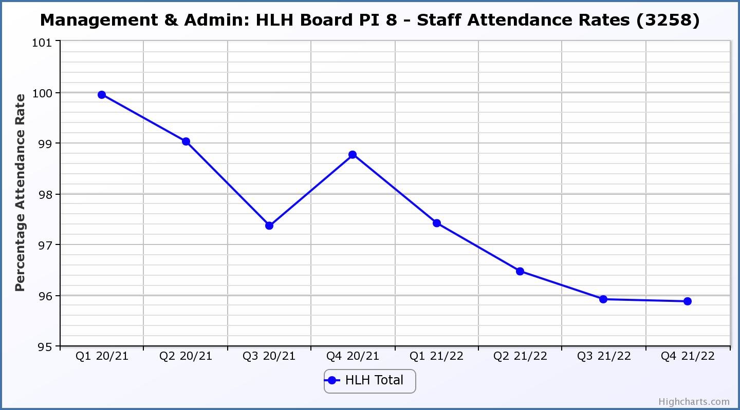

Business Plan Outcome | Performance Indicator | Reporting Frequency | RAG Rating Definition | RAG Rating Q1 21/22 | RAG Rating Q2 21/22 | RAG Rating Q3 21/22 | RAG Rating Q4 21/22 | Summary of Quarter Four Performance
5. Improve the financial sustainability of the company | 9. Financial monitoring. | Quarterly. | An assessment of the year end outturn where:  - Green = delivery of services within budget.  - Red = delivery of services over budget above 2%.  - Amber = delivery of services between break-even and 2% over budget. | Green | Green | Green | Green | While there is a negative variance to budget HLH’s performance has been within the additional support agreed by THC and this indicator has been RAG rated as being on target.

Performance Indicator 9 - Financial Monitoring
See the Finance Report elsewhere on this agenda for further information.

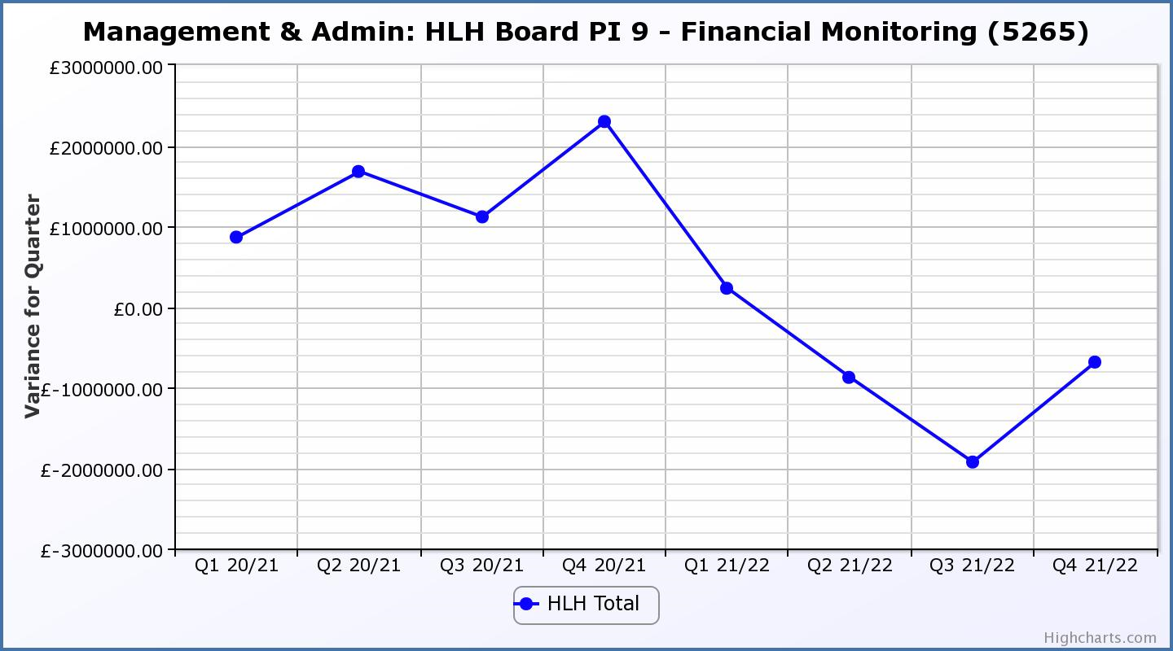

Business Plan Outcome | Performance Indicator | Reporting Frequency | RAG Rating Definition | RAG Rating Q1 21/22 | RAG Rating Q2 21/22 | RAG Rating Q3 21/22 | RAG Rating Q4 21/22 | Summary of Quarter Four Performance
5. Improve the financial sustainability of the company | 10. Reserves | Annual. | - Green = meets 3% reserves policy  - Amber = achieves 2% reserves  - Red = fails to achieve 2% reserves policy. | N/A | N/A | N/A | Green | Reserves at the year end exceeded the 3% reserves policy however they were required to operate during the current financial year and the use of reserves has been included in the 2022/23 budget. It is anticipated that reserves will be 2% (RAG rated amber) by the end of 2022/23.

Performance Indicator 10 - Financial Reserves
HLH has been able to build up reserves to protect services and jobs during 2021/22 based on Government and customer support. This, along with Council support has been required to continue to operate in 2022/23 and it is anticipated that reserves will be at a similar level to what they were pre-pandemic by the end of 2022/23.
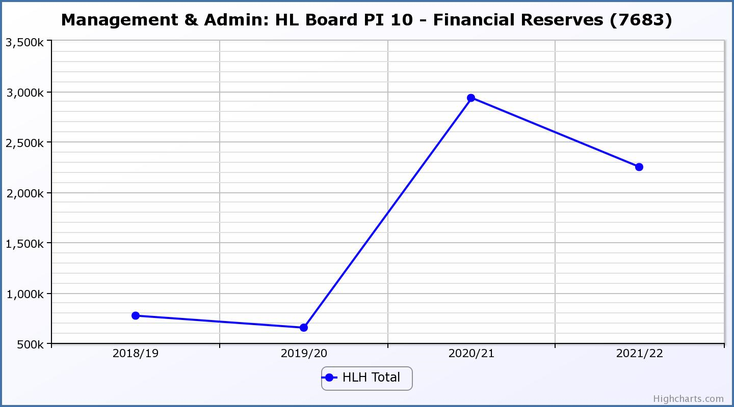

Business Plan Outcome | Performance Indicator | Reporting Frequency | RAG Rating Definition | RAG Rating Q1 21/22 | RAG Rating Q2 21/22 | RAG Rating Q3 21/22 | RAG Rating Q4 21/22 | Summary of Quarter Four Performance
5. Improve the financial sustainability of the company | 11. Number of highlife subscriptions (target is the required number to meet the budget). | Quarterly. | - Green= exceeds target.  - Amber = meets target.  - Red = more than 5% below target. | Green | Green | Green | Amber | This PI has been RAG rated amber. While recovery of subscriptions was good in January and February, this slowed in March and stalled in April. Subscriptions increased again during the last week in April and there is work underway, as can be seen in section three of this report (above) to continue with the recovery of subscriptions.

Performance Indicator 11 - Number of High Life Subscriptions
Subscriptions continued to increase throughout the previous quarter, but the growth has stalled in April. There is further information on this in section three of this report above.
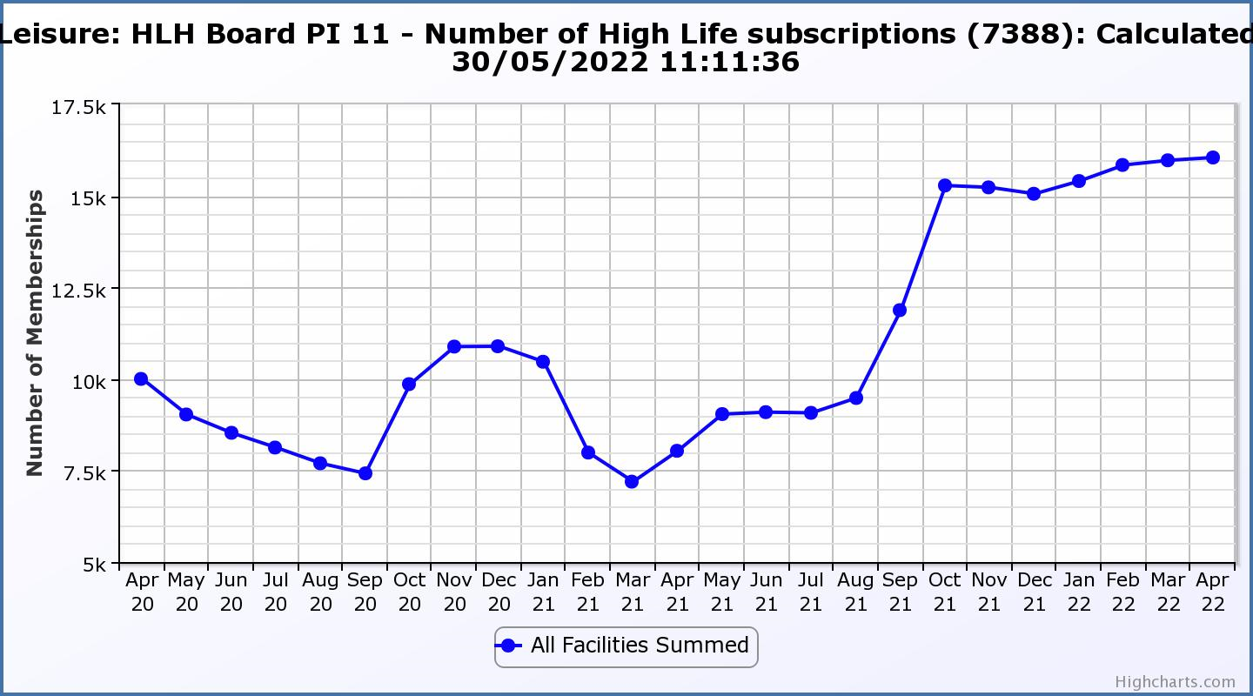

Business Plan Outcome | Performance Indicator | Reporting Frequency | RAG Rating Definition | RAG Rating Q1 21/22 | RAG Rating Q2 21/22 | RAG Rating Q3 21/22 | RAG Rating Q4 21/22 | Summary of Quarter Four Performance
6. Value and strengthen the relationship with THC. | 12. Delivery of the Service Delivery Contract (SDC) with The Highland Council (THC). | Six-monthly. | - Green = agreement of THC’s Education Committee that HLH has met or exceeded the terms of the SDC.  - Amber = agreement of THC’s Education Committee that HLH has met the terms of the SDC but has set some improvement targets.  - Red = agreement of THC’s Education Committee that HLH has not met the terms of the SDC. | N/A | Green | N/A | N/A | The normal reporting frequency has been adjusted to take account of the Council elections in May and it is expected that the next HLH update report to the Council’s Education Committee will be in September 2022.

Business Plan Outcome | Performance Indicator | Reporting Frequency | RAG Rating Definition | RAG Rating Q1 21/22 | RAG Rating Q2 21/22 | RAG Rating Q3 21/22 | RAG Rating Q4 21/22 | Summary of Quarter Four Performance
6. Value and strengthen the relationship with THC. | 13. THC’s annual survey of performance and attitudes. | Annual. | - Green = net satisfaction ratings are maintained or improved for three or more areas of HLH work compared with the previous year  - Amber = two or more areas of HLH work receive lower net satisfaction ratings than the previous year.  Red = all HLH areas of work represented receive lower net satisfaction ratings than the previous year. | N/A | N/A | N/A | N/A | The Council has not carried out its annual survey of its citizen’s panel this year and it is anticipated that the next time that it will do this will be in the summer of 2022.

Business Plan Outcome | Performance Indicator | Reporting Frequency | RAG* Rating Definition  (*Red/Amber/Green) | RAG Rating Q1 21/22 | RAG Rating Q2 21/22 | RAG Rating Q3 21/22 | RAG Rating Q4 21/22 | Summary of Quarter Four Performance
7. Develop and deliver the HLH Corporate Programme and seek to attract capital investment. | 14. The HLH corporate programme covers investment; business process improvement; capital and asset management plans and plans will be developed as this area of work is developed. |  | Should additional performance indicators be identified through the development of these plans they will be added in future. | N/A | N/A | N/A | N/A | NA

Business Plan Outcome | Performance Indicator | Reporting Frequency | RAG Rating Definition | RAG Rating Q1 21/22 | RAG Rating Q2 21/22 | RAG Rating Q3 21/22 | RAG Rating Q4 21/22 | Summary of Quarter Four Performance
8. Use research and market analysis to develop and deliver proactive marketing and promotion of HLH and its services. | 15. Media coverage from proactively issued media releases | Six-monthly. | - Green = Positive coverage 95%+  - Amber = Positive coverage 90% - 95%  - Red = Positive coverage 90%- | N/A (old PI) | N/A (old PI) | N/A (old PI) | Green | There were 147 media articles issued during quarter four and 142 of them were positive.

Performance Indicator 15 - Media coverage from proactively issued media releases
This is a new indicator which assesses the percentage of media releases that are positively reported. Reporting started in Q4 last financial year and historic comparison will be possible over time.

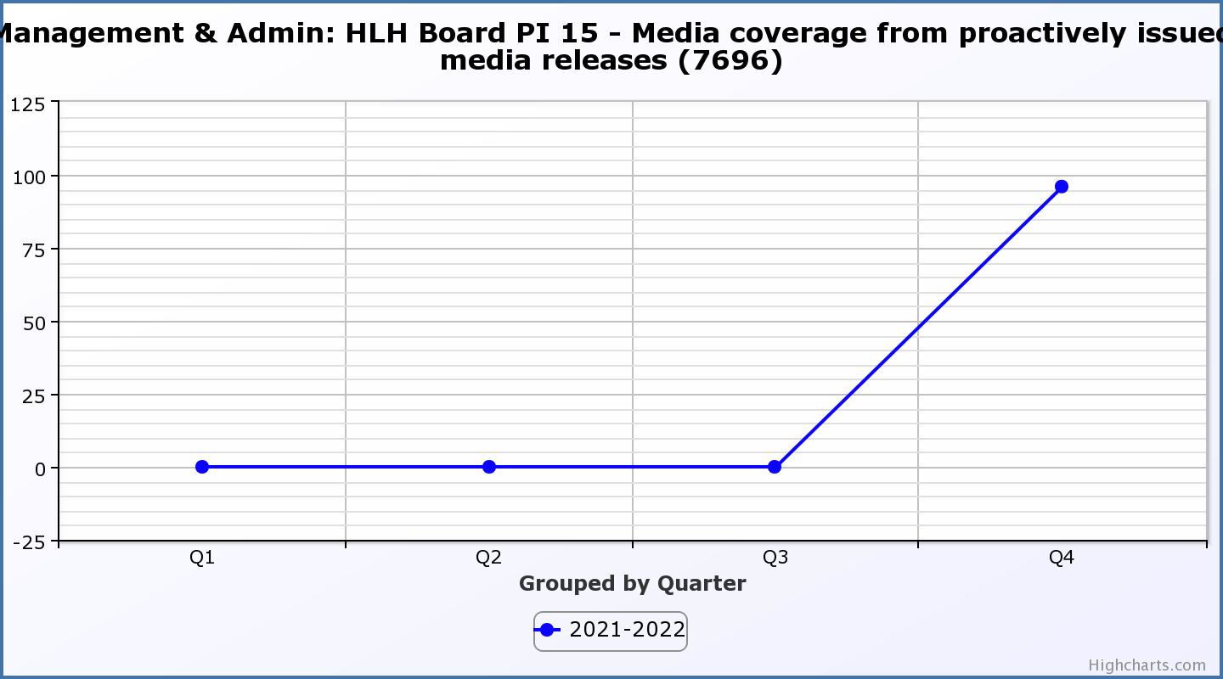

Business Plan Outcome | Performance Indicator | Reporting Frequency | RAG Rating Definition | RAG Rating Q1 21/22 | RAG Rating Q2 21/22 | RAG Rating Q3 21/22 | RAG Rating Q4 21/22 | Summary of Quarter Four Performance
8. Use research and market analysis to develop and deliver proactive marketing and promotion of HLH and its services. | 16. On-line engagement through social media channels. |  | - Green = 5% increase compared with the same period last year.  - Amber = no increase to 4.9% lower compared with the same period last year.  - Red = more than 5% lower or less compared with the same period last year. | N/A (New PI) | N/A (New PI) | N/A (New PI) | N/A (New PI) | The peak for quarter 3 (71,091) arose from the Winter Festival events programme generating a lot of online engagement with our pages. This was due to people using online channels to find out more about the events, together with our use of video clips to promote the events (pre and post event) and HLH’s role in delivering the events. Q4 figure was 26,292.

Performance Indicator 16 - On-line engagement through social media channels.
This is a new marketing indicator which counts the on-line engagement through social media channels. Year on year comparison will be possible over time. (recording engagements started Q2 2021-22).

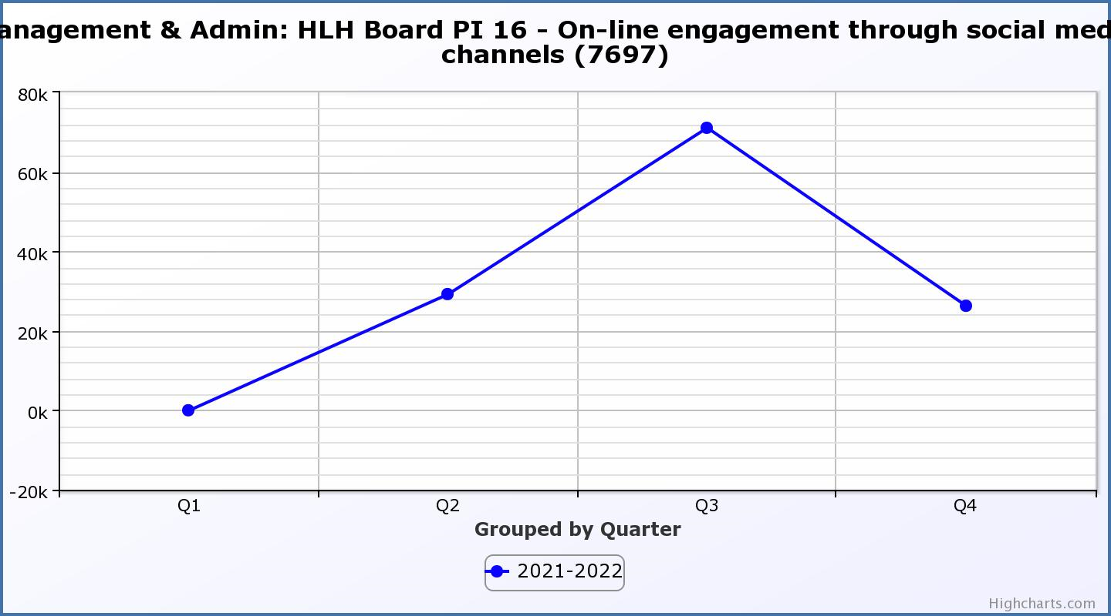

Business Plan Outcome | Performance Indicator | Reporting Frequency | RAG Rating Definition | RAG Rating Q1 21/22 | RAG Rating Q2 21/22 | RAG Rating Q3 21/22 | RAG Rating Q4 21/22 | Summary of Quarter Four Performance
9. Initiate and implement an ICT digital transformation strategy across the charity | 17. The HLH digital transformation strategy will be developed during 2022/23. |  | Should performance indicators be identified through the development of these plans they will be added in future. | N/A | N/A | N/A | N/A | NA

Business Plan Outcome | Performance Indicator | Reporting Frequency | RAG Rating Definition | RAG Rating Q1 21/22 | RAG Rating Q2 21/22 | RAG Rating Q3 21/22 | RAG Rating Q4 21/22 | Summary of Quarter Four Performance
10. Develop and strengthen relationships with customers, key stakeholders and partners | New approach to customer survey as per Business Outcome 3 above.  Same as PI 6 - Charity-wide customer satisfaction survey |  | - | N/A | N/A | N/A | N/A | Please see PI 6 - Charity-wide customer satisfaction survey, above.

Business Plan Outcome | Performance Indicator | Reporting Frequency | RAG Rating Definition | RAG Rating Q1 21/22 | RAG Rating Q2 21/22 | RAG Rating Q3 21/22 | RAG Rating Q4 21/22 | Summary of Quarter Four Performance
10. Develop and strengthen relationships with customers, key stakeholders and partners | 18. Partnership work with sportscotland and other sports related organisations, NHS Highland and other health related organisations (including Memoranda of Understanding) etc. | Annual | - Green = Growth in partnership working  - Amber = continuation of current level of partnership work  - Red = cancellation of Partnership Agreements | - | - | - | N/A | N/A - PI scheduled for assessment at the end of 2022/23

Business Plan Outcome | Performance Indicator | Reporting Frequency | RAG Rating Definition | RAG Rating Q1 21/22 | RAG Rating Q2 21/22 | RAG Rating Q3 21/22 | RAG Rating Q4 21/22 | Summary of Quarter Four Performance
11. Deliver targeted programmes which support and enhance the physical and mental health and wellbeing of the population and which contribute to the prevention agenda. | 19. An assessment of the RAG rating of the Health and Wellbeing Strategy action plan. |  | - Green = 80% or more of the actions are RAG rated green  - Amber = 60% to 79% of actions are green.  - Red = 59% or less are rated green. |  |  |  | N/A | N/A - PI scheduled for assessment at the two HLH Board meetings per year where there is a formal Health and Wellbeing update.

