HIGH LIFE HIGHLAND  REPORT TO BOARD OF DIRECTORS  22 June 2022 | AGENDA ITEM REPORT No HLH /22

ANNUAL Health and Safety And EnvironmeNtal Compliance Report - Report by Chief Executive

Summary

An important element of the governance structure relating to the Charity’s Health and Safety and Environmental Compliance performance is the annual Health and Safety and Environmental Compliance Report.

This report informs Directors about the performance of High Life Highland in terms of health and safety and environmental compliance for the reporting period 2021-22.

It is recommended that Director comment on and note:

- there were no notifications for improvement or enforcement actions during the reporting period;
- there were no environmental incidents requiring SEPA notification during the reporting period;
- the low number and low severity of accidents or incidents over the reporting period, reflecting continuing good practice across the charity and the operational restrictions through the year;
- the Health and Safety and Environmental Compliance Committee (HSECC) continues to meet quarterly with Officers and the Charity’s external Health and Safety advisers to review Health and Safety performance, and on reviewing the accident and incident trend data it concluded that there are no issues arising from this requiring charity-wide action;
- the external safety audit was completed by QLM during November 2021 with an action plan created for risk reduction, no company-wide issues were identified;
- there were 4 safety audits completed by the Union within the reporting period; and
- COVID-19 Incident Reporting & Monitoring systems along with COVID-19 staff and management guidance to support the HLH team have continued to be monitored by the HSECC members.

1. | Business Plan Contribution
1.1 | This report supports the highlighted Business Outcomes from the High Life Highland (HLH) Business Plan:  - Seek to continuously improve standards of health and safety.  - Commit to the Scottish Government’s zero carbon targets and maintain the highest standards in environmental compliance.  - Use research and market analysis to develop and improve services to meet customer needs.  - Increase employee satisfaction, engagement and development to improve staff recruitment and retention.  - Improve the financial sustainability of the company.  - Value and strengthen the relationship with THC.  - Develop and deliver the HLH Corporate Programme and seek to attract capital investment.  - Use research and market analysis to develop and deliver proactive marketing and promotion of HLH and its services.  - Initiate and implement an ICT digital transformation strategy across the charity.  - Develop and strengthen relationships with customers, key stakeholders and partners.  - Deliver targeted programmes which support and enhance the physical and mental health and wellbeing of the population and which contribute to the prevention agenda.
2. | Background
2.1 | The HLH Health and Safety Policy Statement requires annual and exception reporting, to the HLH Board on health and safety performance.
2.2 | The HSECC reviewed and agreed this report and accompanying appendices at its meeting held on 16 May 2022.
3. | Health and Safety and Environmental Compliance Performance
3.1 | There were no enforcing officer notifications for improvement, or enforcement action during the reporting period. There were no environmental incidents requiring reporting to SEPA during the reporting period.
3.2 | Having analysed the information in the appendices, the HSECC identified the following information as being important to report to the HLH Board:  - there are no trends indicating that any charity-wide actions are required;  - there were 7 accidents / incidents reported which were recorded as an “Act of Violence”, 5 were customer to customer and 2 were against HLH staff;  - there were 5 accidents reported under RIDDOR within the reporting period, all RIDDOR incidents have been dealt with appropriately. All incidents have been reviewed and assessed, with no trends identified (summary by service contained in Appendix A);  - the HLH online reporting system continued to be developed to help improve the analysis of accidents and incidents within the reporting period (details contained in Appendix B);  - due to 7 unrelated fire incidents in HLH facilities over 2017/18, close monitoring of all incidents, that could have resulted in a fire within the reporting period was carried out with three incidents recorded over 2021/22 (details contained in Appendix C).
3.3 | Even with COVID-19 and the restrictions in place, given the size of HLH and the number of physical visits to our facilities, Board Members should be re-assured that the very small number of accidents/incidents reflects the good practices across all areas of charity.
4. | Annual External Audit
4.1 | The annual external safety audit for 2021/22 examined the sites listed below, the audit was completed in November 2021, with the report issues to sites in early January 2022.
4.2  4.3  4.4  4.5 | Facilities Audited:  In addition to the properties / services agreed by the Committee, time was utilised on the afternoon of 18 November 2021 for a short audit of the EVOLVE system operated by HLH.  There were no charity-wide issues identified during the audits and the action within the reports continue to be monitored by the Health and Safety and Environmental Compliance Committee.  The completion of all action plans has been set for the end of June 2022. By September 2022 the Health & Safety and Property Officer will have reviewed each plan on site, with individual RPOs providing evidence of completion to ensure that actual compliance has been achieved so that the QLM Audit for 2021/22 can be closed. This will then be reported to the Health and Safety and Environmental Compliance Committee at its November meeting
  Location | Service | Date | Time
  Alness Leisure Centre (New) | Leisure | 16/11/2021 | 0900-1700
  Bellfield Park (New) | Leisure | 17/11/2021 | 0900-1200
  Inverness Museum and Art Gallery | Museum | 17/11/2021 | 1300-1700
  Canal Park | Leisure | 18/11/2021 | 0900-1230
  Highland Archive and Registration Centre | Archive | 19/11/2021 | 0900-1300
5. | Safety Representatives Charter
5.1 | In accordance with the Safety Representatives Charter agreed in June 2016, Unison has undertaken four safety audits in 2021/22 at the sites listed below. A number of positive comments were received from the Unison auditors on HLH operations. Staff and local managers viewed the process as being very positive:  i. Canal Park;  ii. Highland Folk Museum;  iii. Ben Nevis Visitor Centre;  iv. Lochaber Leisure Centre.
6. | COVID-19 Incident Reporting & Monitoring system
6.1  6.2  6.3  6.4 | Throughout the year the HSECC members have been updated on COVID-19 incidents and the guidance put in place to assist HLH staff whilst dealing with the pandemic and the HLH recovery.  The Highland Council EHO’s along with the HSE have completed a number of site visits along with audits completed over the phone across HLH sites and services (primarily Leisure and Libraries) within the reporting period to look at the HLH COVID-19 arrangements in place. All audits have been completed with no remedial action identified by the auditors.  The Scottish Government announced that reporting and testing for COVID-19 will stop from 30 April 2022. The HSE also announced from early April 2022 that risk assessments for COVID-19 are no longer required and have also removed COVID-19 as a RIDDOR reportable incident.  With the changes in place from the end of April 2022, the HLH reporting system for COVID-19 has been closed and the last planned report will be issued to the HSECC members at its August 2022 meeting (subject to any changes in guidance). The HLH reporting systems and guidance will be archived but will remain available should they be required at a later date.
7. | Implications
7.1 | Resource Implications – there are no additional resource implications arising from this report.
7.2 | Legal Implications - there are no additional legal implications arising from this report.
7.3 | Equality Implications – there are no additional equality implications arising from this report.
7.4 | Risk Implications – there are no new risks which require to be added to the risk register arising from this report.
Recommendations

It is recommended that Committee Members comment on and note:

- there were no notifications for improvement or enforcement actions during the reporting period;
- there were no environmental incidents requiring SEPA notification during the reporting period;
- the low number and low severity of accidents or incidents over the reporting period, reflecting continuing good practice across the charity and the operational restrictions through the year;
- the Health and Safety and Environmental Compliance Committee (HSECC) continues to meet quarterly with officers and the Charity’s external Health and Safety advisers to review Health and Safety performance, and on reviewing the accident and incident trend data it concluded that there are no issues arising from this requiring charity-wide action;
- the external safety audit was completed by QLM during November 2021 with an action plan created for risk reduction, no company-wide issues were identified;
- there were 4 union safety audits completed within the reporting period; and
- COVID-19 Incident Reporting & Monitoring systems along with COVID-19 staff and management guidance to support the HLH team have continued to be monitored by the HSECC members.

Designation: Chief Executive

Date: 17 May 2022

Author: Craig Steedman, Principal Estates and Health and Safety Manager
Appendix A

All RIDDOR Notified Incidents compared to the previous years by Service and Person Type - Summary 2021-2022

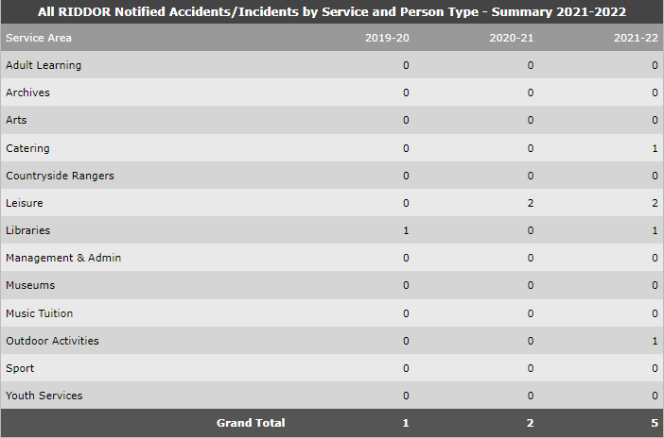

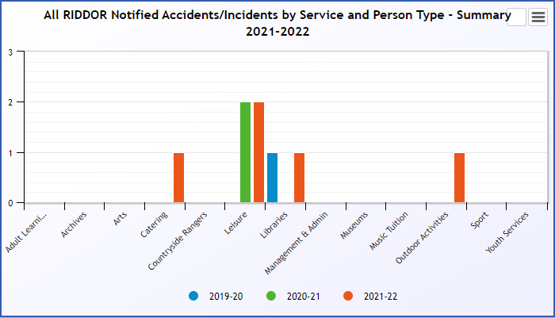

Appendix B, Tables 1-13

Accidents and incidents compared to the previous year for customers, staff, volunteers and contractors by HLH section

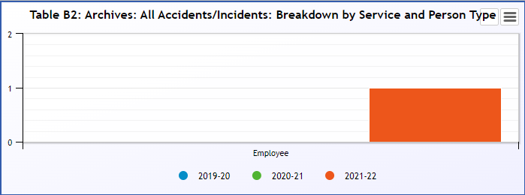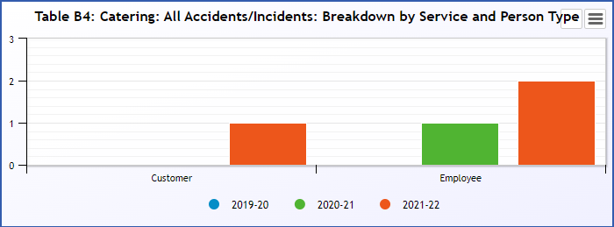
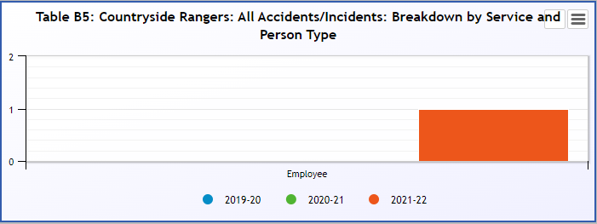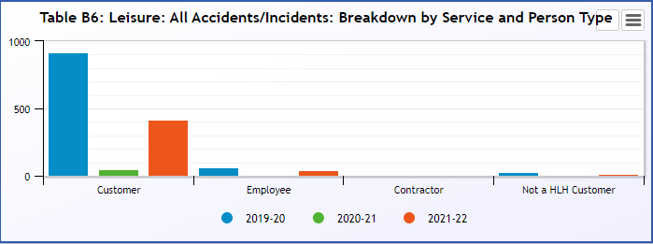
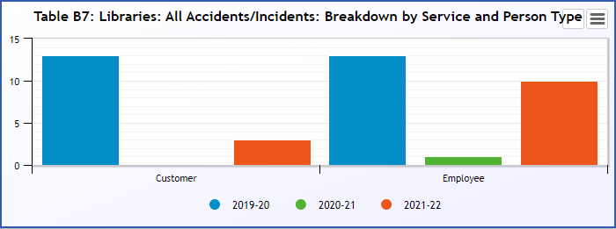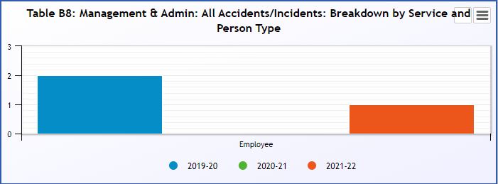
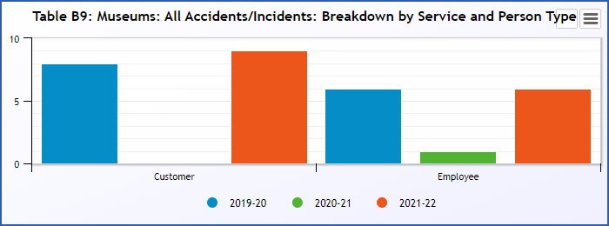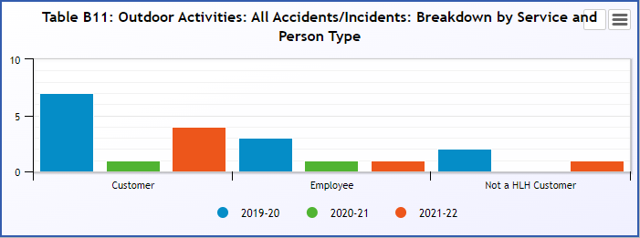
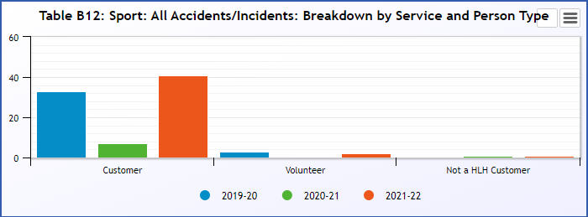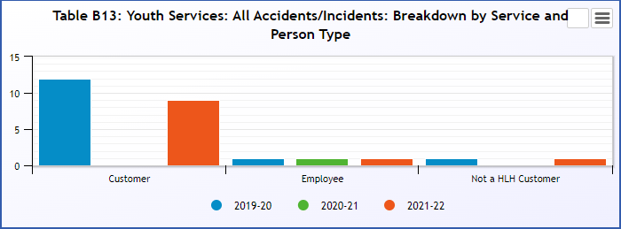

Please note that there were no incidents reported for Adult Learning, Arts and Music Tuition.

Appendix B, Table 14

Accidents and Incidents compared to the previous year for Customers by Type of Incident
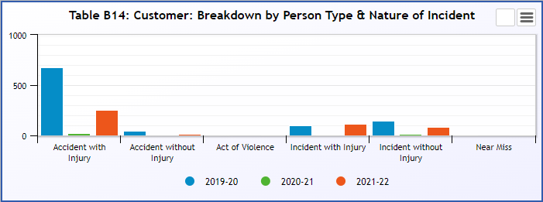
Appendix B, Table 15

Accidents and Incidents compared to the previous year to Employee by Type of Incident
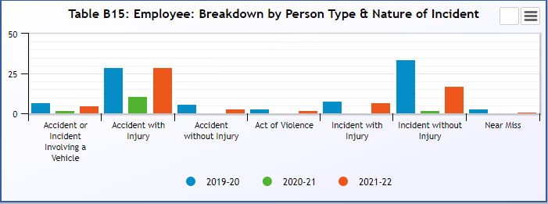

Appendix B, Tables 16

Accidents and Incidents compared to the previous year for Contractors by Type of Incident 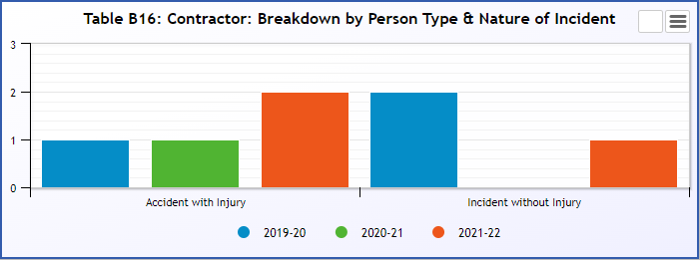
Appendix B, Table 17

Accidents and Incidents compared to the previous year to Volunteers by Type of Incident
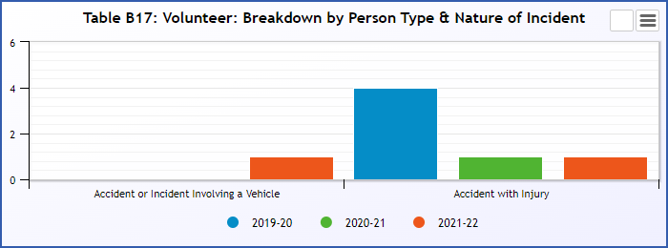
Appendix B, Table 18

Accidents and Incidents compared to the previous year to Customers by Type of Injury
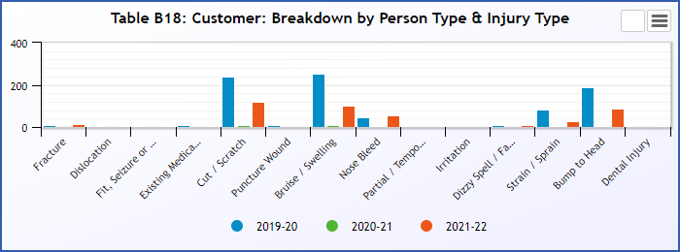

Appendix B, Table 19

Accidents and Incidents compared to the previous year to Employees by Type of Injury
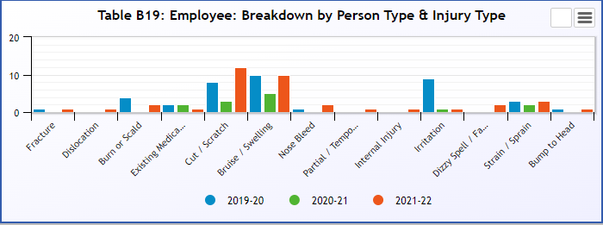

Appendix B, Table 20

Accidents and Incidents compared to the previous year to Contractors by Type of Injury
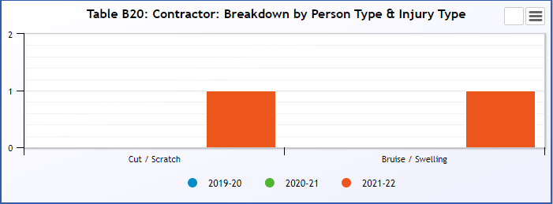

Appendix B, Table 21

Accidents and Incidents compared to previous year to Volunteers by Type of Injury
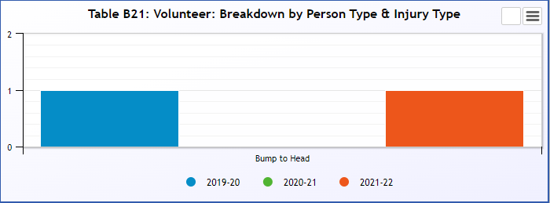

Appendix B, Table 22

Accidents and Incidents compared to the previous year to Customers by Service

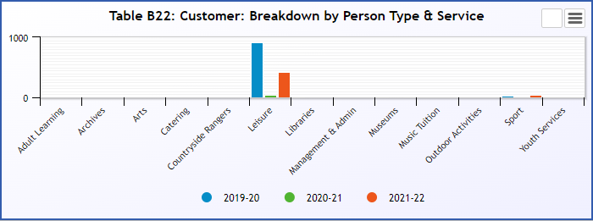

Appendix B, Table 23

Accidents and Incidents compared to the previous year to Employees by Service
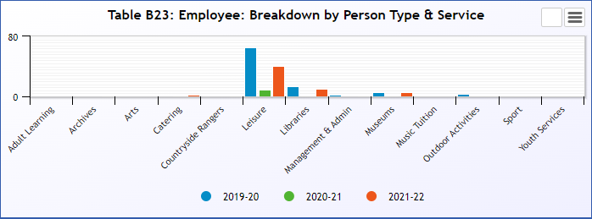

Appendix B, Table 24

Accidents and Incidents compared to the previous year to Contractors by Service
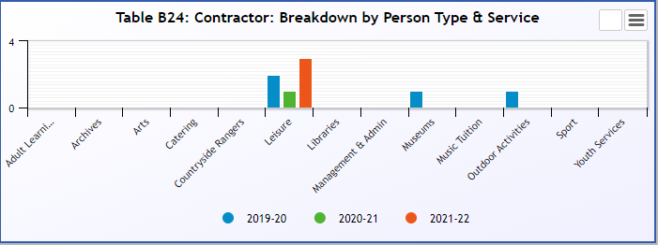

Appendix B, Table 25

Accidents and Incidents compared to the previous year to Volunteers by Service
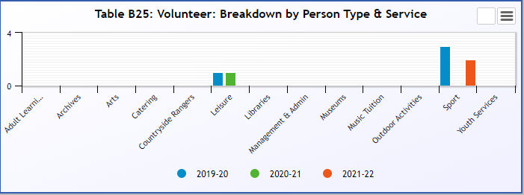

Appendix C

All Fire Related Accidents/Incidents by Service and Person Type - Summary 2021-2022

