HIGH LIFE HIGHLAND  REPORT TO BOARD OF DIRECTORS  31 August 2022 | AGENDA ITEM  REPORT No HLH /10 /22

Performance Report - Report by Chief Executive

Summary

The purpose of this report is to present performance information for the period April to June 2022.

It is recommended that Directors:

- comment on the report and agree that the overall health check on the charity for that period is RAG rated as “amber” because of the financial position caused by customer return having slowed;
- note that the national picture has been taken into account in coming to this assessment;
- note that discussions are underway with Council Officers on HLH’s financial position and the mitigating actions being taken, with the possibility of increased financial challenges in FY 23/24 and beyond having been flagged at this early stage; and
- agree that HLH continues with discussions at officer level with the potential for support of the HLH Chair and the Chair of the Finance and Audit Committee as appropriate.

1. | Business Plan Contribution
1.1 | This report supports all the Business Outcomes from the High Life Highland (HLH) Business Plan 2022-27  - Seek to continuously improve standards of health and safety.  - Commit to the Scottish Government’s zero carbon targets and maintain the highest standards in environmental compliance.  - Use research and market analysis to develop and improve services to meet customer needs.  - Increase employee satisfaction, engagement and development to improve staff recruitment and retention.  - Improve the financial sustainability of the company.  - Value and strengthen the relationship with THC.  - Develop and deliver the HLH Corporate Programme and seek to attract capital investment.  - Use research and market analysis to develop and deliver proactive marketing and promotion of HLH and its services.  - Initiate and implement an ICT digital transformation strategy across the charity.  - Develop and strengthen relationships with customers, key stakeholders and partners.  - Deliver targeted programmes which support and enhance the physical and mental health and wellbeing of the population and which contribute to the prevention agenda.
2. | Background
2.1 | The implementation of the HLH Business Plan 2022-27 is monitored in two ways:  - through a set of performance indicators set by the Board at its meeting held on 31 March 2022; and  - by RAG (Red, Amber, Green) rating the delivery of the business outcomes contained in the business plan with these being reported to the Board by exception (i.e. reporting where managers had RAG rated the actions “red – no significant progress”).
3. | Summary of Performance
3.1 | Nineteen performance indicators (PIs) were identified by the HLH Board to assess the overall performance of the charity at its meeting held on 31 March 2022. Appendix A contains a summary of performance against the PIs for Q1 2022/23. Appendix B provides a list of all the PIs along with trend information. 10 PIs were scheduled for assessment at the August 2022 HLH Board meeting. Of the 10 performance indicators scheduled for assessment, 6 have been RAG rated green; and 4 red. Appendix C contains the RAG ratings of the business plan outcomes for each area of work for Q1 2022/23.
3.2 | The 4 indicators which have been RAG rated as red are PI 4. Travel, PI 8. staff attendance rate, PI 9. financial monitoring and PI 11 highlife subscriptions.
3.3 | PI 4. travel - This indicator was scheduled for more detailed consideration at this HLH Board meeting and has also been RAG rated as “red”. Work travel miles in personal vehicles claimed through the payroll pre-pandemic were 800,000 per annum and a maximum threshold of 400,000 miles per annum was set in advance of the strategic work yet to be undertaken in partnership with the Council on carbon reduction. It was anticipated that the travel reduction would be achieved largely through managers, staff and teams meeting on-line and through services such as music instructors delivering some of their services on-line as well as in person. It has been successful in that there has been a significant reduction in travel, however, if travel continues at the same level this will be around 530,464 miles by the end of the year, exceeding the target by over 100,000 miles. This PI is reported by each of the areas of HLH work at the monthly Performance Board meetings and managers have been asked to review travel with staff (taking account of the need to have some meetings face to face, including site visits) in an attempt to bring travel back within the 400,000 miles p.a. ceiling by the end of the year.
3.4 | The following table shows a breakdown of travel miles for the year to date by area of work.  Apr-22 May-22 Jun-22 Jul-22 YTD  Adult Learning 2,860 158 2,883 1,552 7,453  Archives 720 - 530 - 1,250  Arts - - - - -  Leisure 6,365 8,622 5,230 5,993 26,210  Libraries 1,612 1,273 1,025 2,645 6,555  Mgt & Admin 204 60 - 107 371  Museums 1,887 2,122 1,487 1,521 7,017  Music Tuition 39,434 11,633 27,821 30,762 109,650  Outdoor Activities 346 - - 229 575  Sport 1,911 2,756 5,445 3,818 13,930  Youth Work 1,633 432 812 994 3,871
3.5 | As can be seen on the table, the service most reliant on travel is Music Tuition. This is by necessity because Music Instructors have to travel between schools. A combination of efficient timetabling/travel routes, and more recently, blended in-person/on-line delivery have been used to reduce this. It is considered that travel is at a practical minimum for Music Instructors and the Council’s fleet management team has been asked for an annual cost for an electric vehicle so that an assessment of the viability of this alternative option can be considered.
3.6 | As has been the subject of discussion at the last board meeting, the Performance Board has considered other travel and is currently setting up processes for monitoring travel in official fleet vehicles (e.g. countryside rangers and library vehicles) and is assessing the viability of monitoring green travel. It is expected that it will be possible to report travel miles for the official fleet from the next HLH board meeting.
3.7 | PI 8. staff attendance rate - the staff attendance rate during Q1 was at its lowest level in three years and there is further information on this in the HR report elsewhere on this agenda.
3.8 | PI 9. Financial monitoring - customer income recovery has slowed and is not recovering quickly enough to meet income targets. There is further information in the Finance Report elsewhere on this agenda and the information below on highlife subscriptions is also relevant.
3.9 | PI 11. highlife subscriptions - the red RAG rating of this indicator is due to the number of subscriptions being insufficient to meet budgeted income targets. With a recent survey of Culture and Leisure UK Scotland members (as referenced in the Herald newspaper) finding that recovery Scotland wide appears to be plateauing between 70% and 80% (with HLH at 78%), even though there is a considerable focus on recovering customer income it is prudent to assume that customer income will not recover to budgeted levels by the end of the year. Therefore, other mitigating actions, including discussion with THC are underway.
3.10 | The following graph shows income and a re-profiled income target (to take account of expected growth not materialising) compared with budget and was the subject of discussion at the 8 August 2022 Finance and Audit Committee meeting.
3.11 | The blue line shows the original budget target. It was based on being able to recover subscriptions to their historic level by the end of this financial year. When the budget was set, restrictions were coming to an end and were finally removed in April. In January and February there was a good level of growth, while there were still some restrictions, and in January and February subscriptions grew by 2.3% and 2.9% respectively. At the time the budget was set the indications were that 2% growth month on month was a reasonable assumption.
3.12 | Prior to the start of the current financial year, it looked like subscriptions were almost on track to start the year where they needed to be. Subscription growth stalled in March when it grew by less than 1% and at the start of the financial year subscriptions were behind the level required to meet the budgeted income target.
3.13 | The orange line above shows the actual income to date and the re-profiled income target for the rest of the financial year based on a 1.5% increase month on month. This is proving to be challenging, so far the average growth year to date has been 1%. If the growth continues at 1% income would be £85K lower than projected.
3.14 | Cancellations are around the same as their historic levels, slightly lower in April at 2% of subscriptions, increasing in May to 4%. In and June and July they were 3% and 4%. The reasons which people gave for cancelling subscriptions is tracked over time and the graph below shows this for the four main reasons plus the price increase reason:  - lack of use - green line*  - affordability – red line  - moved away from the highlands – blue line  - lack of time – orange line*  - price increase – yellow line  Graph: Reasons for cancelling (reason as a % of responses per month)  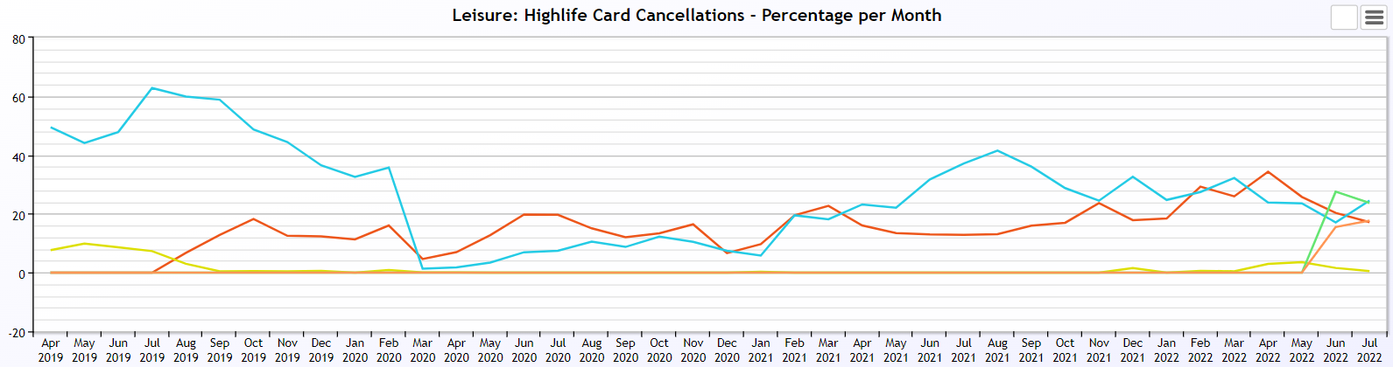  * “Lack of use/time used to be a single response and were separated from June 2022 into lack of use and lack of time.
3.15 | The yellow price increase line has been included because the price was increased at the HLH Board meeting in March and it shows that it was not a significant reason for cancelling. However, the price increase and the requirement to write to customers is likely to have been a trigger for them cancelling for other reasons.
3.16 | Lack of use is the most significant reason for cancelling and this ties in with a count which is kept of the number of subscriptions which have been used in the past month. Pre-pandemic around half of subscriptions were used in the previous month and this remained fairly steady throughout the year. Post pandemic this figure has reduced to 37%. This again, ties in with the national picture which is one of reduced footfall and a reduced footfall relative to subscriptions. Staff have started to phone customers who have cancelled because of lack of use and the feedback is as follows:  - Lack of time / too busy.  - Exercising outdoors / walking / cycling.  - Will return during the winter months.
3.17 | Affordability, as a reason for cancelling started to increase in November 2021 around the same time as the publicity around the cost of living crisis. In June it was the second highest reason for cancelling. People who cancel are offered information on eligibility criteria for the budget highlife scheme.
3.18 | Moved away from the Highlands has always been one of the most frequently cited as a reason for cancelling and this has continued.
3.19 | Promotions and campaigns – as discussed at previous board and trading company meetings there has been a series of promotions aimed at recovering subscriptions:  - “Every membership counts” was developed as a competitive incentive for staff to proactively gain new subscriptions. It ran from the 1 June for 4 weeks and generated 332 memberships. It is anticipated that this will become an annual campaign to remind staff of the importance of selling subscriptions.  - “Bring a buddy” was a customer campaign where 64,779 vouchers were issued with 496 redeemed. So far 203 customers were contacted and 30 have signed up to a membership.  - HLH had a sales presence at the European Pipe Band Championship and Inverness Highland Games. Both events were very busy with many people entering the fitness challenges and there were a small number of new member sign ups on the day.  - UHI freshers week commences on 29 August. 8 events across the Highlands are planned promoting memberships to new and current students at a 30% discount on an individual subscription.  - There will be a 10 days for £10 promotion in October. The plan for this is to engage all HLH teams selling the product in addition to the Leisure Team.  - Move it to lose it is a get into shape/weight loss campaign that will be run over 4 weeks. It will launch in September, will be free to all inclusive members and £35.00 to non- members and comprise weekly weigh ins, access to group exercise classes, 10 minute body blast work outs, last chance workouts and move it to lose it t-shirts and weigh in logbook.  - Corporate subscriptions, where employers sign up to the highlife scheme which is then promoted to its staff has been in place for a number of years. At the start of this year there were 21 companies who had signed up to it with 984 associated subscriptions. This area has been a particular focus for the new High Life Development Manager post who is currently engaging with a further 25 companies.  - As part of the recovery of subscriptions there have been investment in refurbishments and gym equipment refreshes and these have been reported at previous HLH Board and trading company meetings. Fitness equipment replacements at Dingwall and Culloden Leisure Centres are in the final stages of planning and will be in place in Quarter 2.  - The High Life Development Manager is engaging with High Life Highland’s other services to assist with selling subscriptions.
3.20 | The overall RAG rating for the organisation is considered to be “amber” because recovery post pandemic has slowed to a point where there will be an impact in the current financial year and in all likelihood in 2022/23 as well. While there are mitigating actions in place - reduced expenditure and the work being carried out on promotions and marketing described above, a recent Community Leisure UK (Scotland) survey has shown that slow customer return is an issue across Scotland with the other CLUK member organisations reporting that leisure subscriptions having stalled between 70% and 80% of pre-pandemic levels.
3.21 | Given this wider context it is prudent to plan for a longer recovery period than might have been hoped for previously, so in addition to the mitigating actions described above discussions are underway with Council Officers on:  - the likelihood of having to call on some or all of the £1m which it has allocated to support HLH in 2022/23  - the possible requirement for continued additional Council support / significant changes to the Service Delivery Contract in 2023/24 and beyond.
3.22 | While these discussions are taking place at officer level it may be that the HLH Chair and Chair of the Finance and Audit Committee become involved prior to matters being considered by the HLH Board and reaching agreement with THC.
4. | Performance Indicators for More Detailed Consideration
4.1 | Each quarter more detailed information is provided on one or more of the 19 performance indicators and the following performance indicators are scheduled for inclusion in this report:  - PI 4 - Travel  - PI 10 - Reserves  - PI 13 - THC’s annual survey of performance and attitudes
4.2 | PI 4 Travel - this has been covered in section 3.3 above.
4.3 | PI 10 Reserves - Reserves at the year end exceeded the 3% reserves policy however they are required to operate during the current financial year and the use of reserves has been included in the 2022/23 budget. It is anticipated that reserves will be 2% (RAG rated amber) by the end of 2022/23.
4.4 | PI 13 - THC’s annual survey of performance and attitudes. The annual survey carried out by the Council of its citizens panel is normally available for the August HLH Board. The panel has been recruited and THC expects to be able to undertake the survey in the Autumn of this year so it should be possible to report the results of it at the December HLH Board meeting.
5. | Business Plan - Business Outcomes
5.1 | The Business Plan 2022 to 2027 was agreed by the Board at its December 2021 meeting. The Business Plan identified 11 business outcomes and 31 associated actions along with the approach which the charity would take to deliver them. Operational plans were then developed for each of the nine HLH areas of work which are RAG rated every quarter.
5.2 | The RAG rating of the operational plans has identified that delivery of the Business Plan is on target.  No. RAG Rated Green No. RAG Rated Amber No. RAG Rated Red No. not RAG Rated  Adult Learning 19 0 0 12  Archives 19 0 0 12  Arts 19 0 0 12  Countryside Rangers 19 0 0 12  Leisure 19 1 0 11  Libraries 19 0 0 12  Museums 19 0 0 12  Music Tuition 19 0 0 12  Outdoor Activities 19 0 0 12  Sport 19 0 0 12  Youth Services 19 0 0 12
5.3 | The action which was RAG rated as Amber in Leisure was “Develop business cases to secure support for capital investment to support HLH business growth priorities and the five year financial investment model”. Business cases were developed for THC’s capital programme, However, there were insufficient resources in the capital programme for them to be included. Work is continuing with sportscotland and the Highland Council to try to progress this with a new THC capital programme currently under review.
5.5 | The actions which have not been RAG rated relate to business outcomes where plans are yet to be developed such as the development of the digital transformation strategy.
6. | Implications
6.1 | Resource implications - resource implications have been considered in section there of this report.
6.2 | Equality implications - there are no new equality implications arising from this report.
6.3 | Legal implications - there are no new legal implications arising from this report.
6.4 | Risk implications - there are no new risk implications arising from this report.

Recommendation

It is recommended that Directors:

- comment on the report and agree that the overall health check on the charity for that period is RAG rates as “amber” because of the financial position caused by customer return having slowed;
- note that the national picture has been take account of in making this assessment;
- note that discussions are underway with Council Officers on HLH’s financial position and the mitigating actions being taken, with the possibility of the need for additional Council support in 2023/24 having been flagged at this early stage; and
- agree that HLH continues with discussions at officer level with the support of the HLH Chair and the Chair of the Finance and Audit Committee as appropriate.

Designation: Chief Executive

Date: 22 August 2022

Author: Douglas Wilby, Director of Sport and Leisure

Appendix A
HLH Performance Indicators - Summary Q1 2022/23
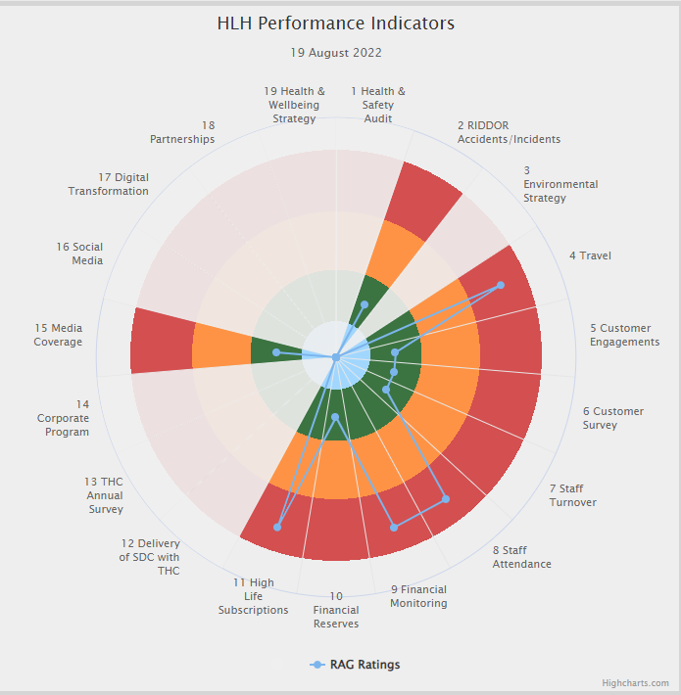 | Nineteen performance indicators (PIs) are used by the High Life Highland Board to assess the overall performance of the charity.  The PIs are RAG rated (allocated a "Red", "Amber" or "Green" status) so that it is easy to see at a glance how the organisation is performing. Most of the PIs are RAG rated every quarter throughout the year, with some (such as partnership working with NHSH for example) being considered annually so greyed out sectors on this radar diagram mean that the PI is to be considered at a future HLH Board meeting.

Appendix B
HLH Performance Indicators - Detail Q1 2022/23

Business Plan Outcome | Performance Indicator | Reporting Frequency | RAG Rating Definition | RAG Rating Q1 22/23 | RAG Rating Q2 22/23 | RAG Rating Q3 22/23 | RAG Rating Q4 22/23 | Summary of Quarter One Performance
1. Seek to continuously improve standards of health and safety. | 1. External health and safety audit. | Annual. | - Green = the external audit does not raise systemic issues.  - Amber = the external audit highlights common actions to be addressed across the company.  - Red = the external audit raises systemic (i.e. applying across multiple sites) H&S issues. | N/A |  |  |  | An Audit of five HLH facilities took place in November 2021 resulting in positive compliance results. Ongoing actions have been reported to the Health and Safety and Environmental Compliance Committee at its May and August meetings.

Business Plan Outcome | Performance Indicator | Reporting Frequency | RAG Rating Definition | RAG Rating Q1 22/23 | RAG Rating Q2 22/23 | RAG Rating Q3 22/23 | RAG Rating Q4 22/23 | Summary of Quarter One Performance
1. Seek to continuously improve standards of health and safety. | 2. RIDDOR accidents/incidents. | Quarterly. | - Red = number of RIDDOR reports per quarter is above 20.  - Amber = number of RIDDOR reports per quarter is between 10 and 20  - Green = number of RIDDOR reports per quarter is less than 10. | Green |  |  |  | There were no accidents reported under the RIDDOR regulations during Q1.

Performance Indicator 2 - RIDDOR accidents/incidents
The graph below tracks the number of accidents and incidents reported under the Reporting of Injuries, Diseases and Dangerous Occurrences Regulations (RIDDOR). There were no RIDDOR incidents reported in Q1 2022/23.
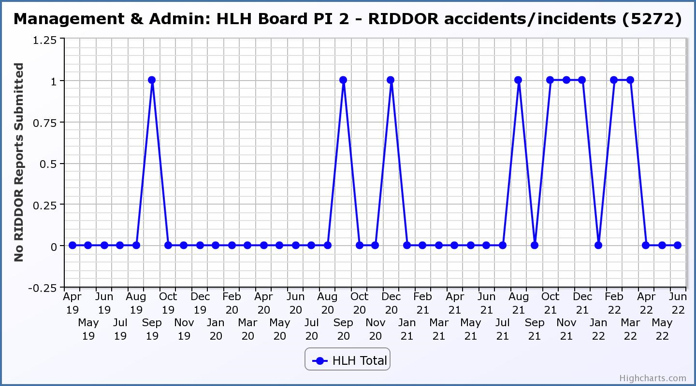

Business Plan Outcome | Performance Indicator | Reporting Frequency | RAG Rating Definition | RAG Rating Q1 22/23 | RAG Rating Q2 22/23 | RAG Rating Q3 22/23 | RAG Rating Q4 22/23 | Summary of Quarter One Performance
2. Commit to the Scottish Government’s zero carbon targets and maintain the highest standards in environmental compliance. | 3. The HLH Environmental strategy will be developed during 2022/23. | . |  | N/A |  |  |  | N/A - Performance indicators will be identified through the development of these plans and will be aligned with THC’s carbon reduction strategy given the contractual (particularly property) arrangements that there are in place between THC and HLH.

Business Plan Outcome | Performance Indicator | Reporting Frequency | RAG Rating Definition | RAG Rating Q1 22/23 | RAG Rating Q2 22/23 | RAG Rating Q3 22/23 | RAG Rating Q4 22/23 | Summary of Quarter One Performance
2. Commit to the Scottish Government’s zero carbon targets and maintain the highest standards in environmental compliance. | 4. Travel (a target to reduce by 50% following the pandemic has been set) | Quarterly. | - Green = 400,000 miles p.a. or less  - Amber = up to 5% greater than target  - Red = more than 5% of target. | Red |  |  |  | There were 129,261 miles driven by HLH staff in Q1 2022/23. Please see section three of this report for further information.

Performance Indicator 4 – Travel Miles
The graph below shows the travel miles for the previous two years and will be used as a basis for monitoring travel during the current year. The total Miles for Q1 22/23 were 129,261.
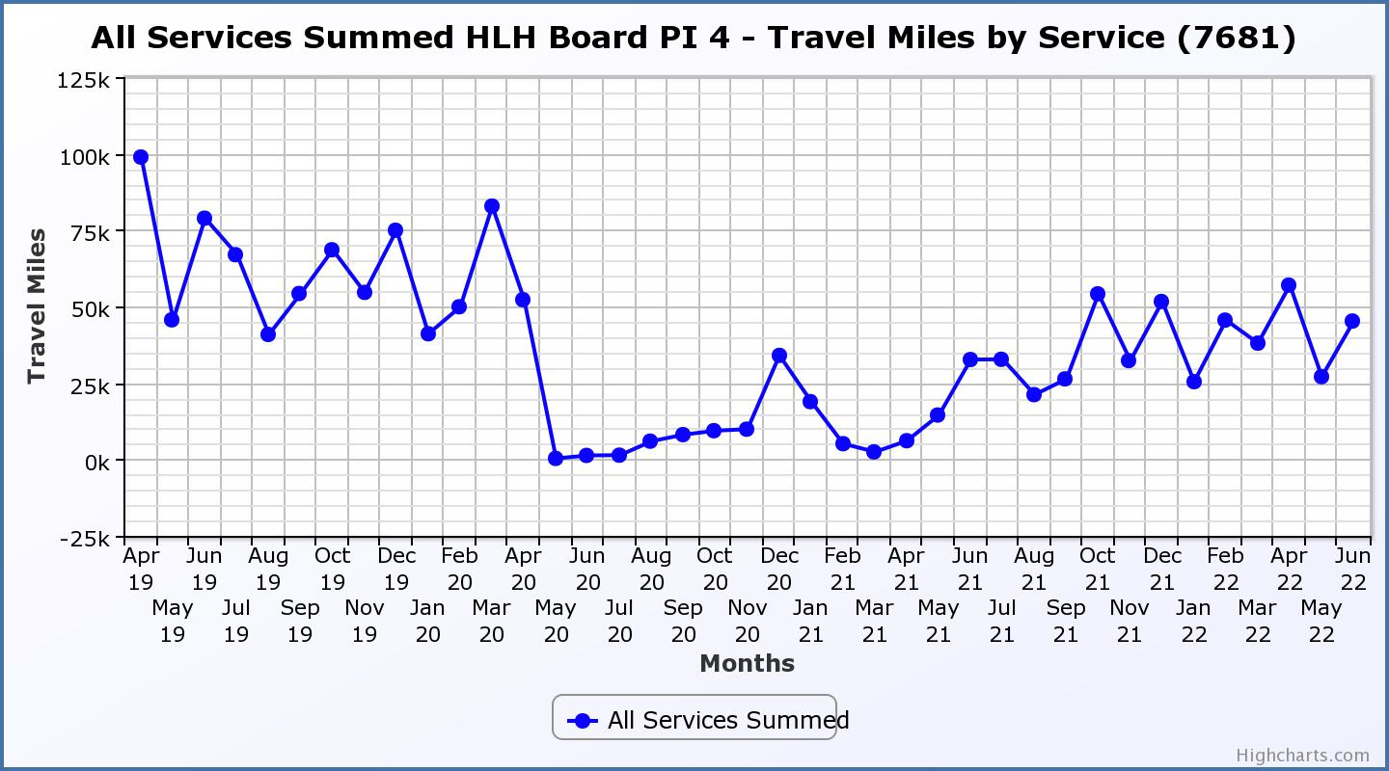

Business Plan Outcome | Performance Indicator | Reporting Frequency | RAG Rating Definition | RAG Rating Q1 22/23 | RAG Rating Q2 22/23 | RAG Rating Q3 22/23 | RAG Rating Q4 22/23 | Summary of Quarter One Performance
3. Use research and market analysis to develop and improve services to meet customer needs. | 5. Customer engagements. | Quarterly. | - Green = customer numbers are the same as or have increased compared with the corresponding quarter in the previous year  - Amber = customer numbers are less than the corresponding quarter in the previous year.  - Red = customer numbers are more than 5% lower than the corresponding quarter in the previous year. | Green |  |  |  | Customer engagements increased from 1,273,267 in Q1 2021/22 to  1,898,956 in Q1 2022/23. While this is lower than previous years it has been RAG rated green as a reflection of recovery from the pandemic.
Performance Indicator 5 - Customer engagements
Customer numbers are showing in increase compared with quarter one 2021/22.

Business Plan Outcome | Performance Indicator | Reporting Frequency | RAG Rating Definition | RAG Rating Q1 22/23 | RAG Rating Q2 22/23 | RAG Rating Q3 22/23 | RAG Rating Q4 22/23 | Summary of Quarter One Performance
3. Use research and market analysis to develop and improve services to meet customer needs. | 6. Charity-wide customer satisfaction survey | Annually. | - Green = Services delivered by HLH is above average  - Amber = Services delivered by HLH is average  - Red = Services delivered by HLH is below average. | Green |  |  |  | This performance indicator was reported in more detail at the March 2022 HLH Board meeting.

Business Plan Outcome | Performance Indicator | Reporting Frequency | RAG Rating Definition | RAG Rating Q1 22/23 | RAG Rating Q2 22/23 | RAG Rating Q3 22/23 | RAG Rating Q4 22/23 | Summary of Quarter One Performance
4. Increase employee satisfaction, engagement and development to improve staff recruitment and retention. | 7. Staff turnover (resignations as a percentage of posts). | Quarterly. | - Green = 1.6% or less.  - Amber = 1.7 to 2%  - Red = more than 2% | Green |  |  |  | The number of resignations per month as a percentage of posts in Q1 was 0.7% in April, 0.5% in May and 0.8% in June.

Performance Indicator 7 - Staff Turnover (resignations as a percentage of posts)
The graph below shows resignations as a percentage of the number of posts which have been consistent with previous years (1% equates to 10.6 staff).

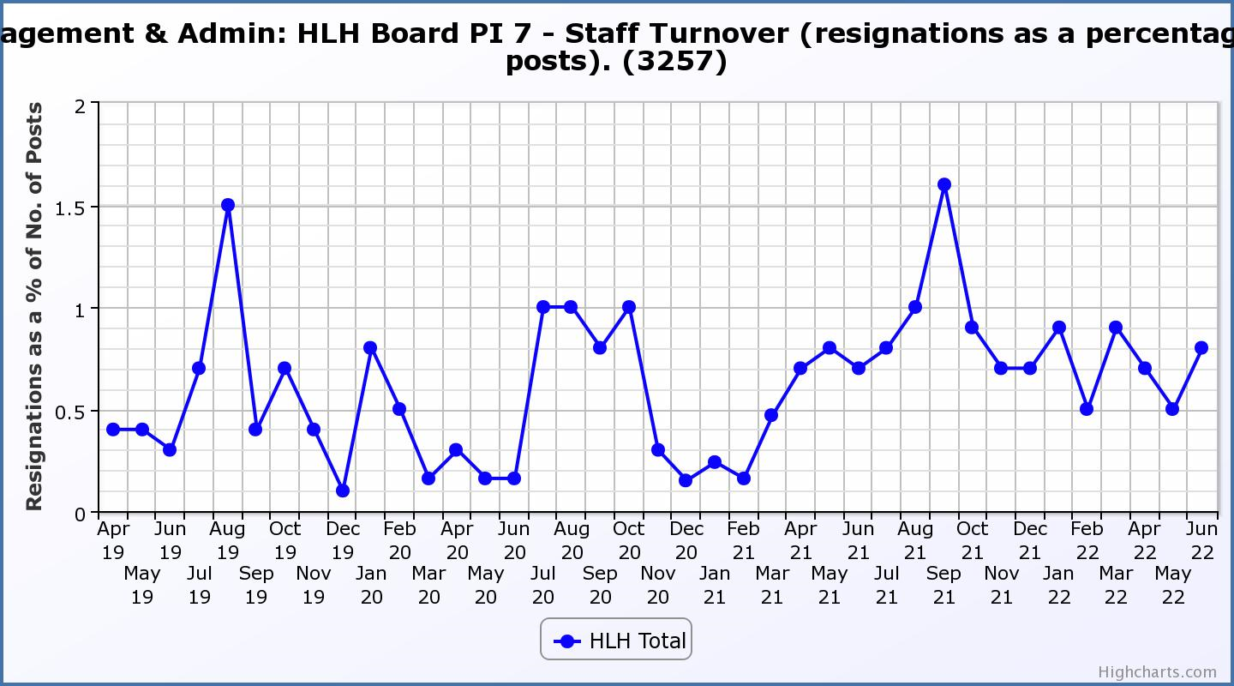

Business Plan Outcome | Performance Indicator | Reporting Frequency | RAG Rating Definition | RAG Rating Q1 22/23 | RAG Rating Q2 22/23 | RAG Rating Q3 22/23 | RAG Rating Q4 22/23 | Summary of Quarter One Performance
4. Increase employee satisfaction, engagement and development to improve staff recruitment and retention. | 8. Staff attendance rates (RAG ratings based on Office for National Statistics for 2020 of absence rate). | Quarterly. | - Green = attendance rate 98% or higher.  - Amber = attendance rate between 97% and 98%.  - Red = attendance rate less than 97%. | Red |  |  |  | The attendance rate for Q1 was 94.17%. Please see the HR report elsewhere on this agenda for further information.

Performance Indicator 8 - Staff Attendance Rate
Staff attendance rates for Q1 were the lowest they have been in three years. Please see the HR report elsewhere on this agenda for further information. 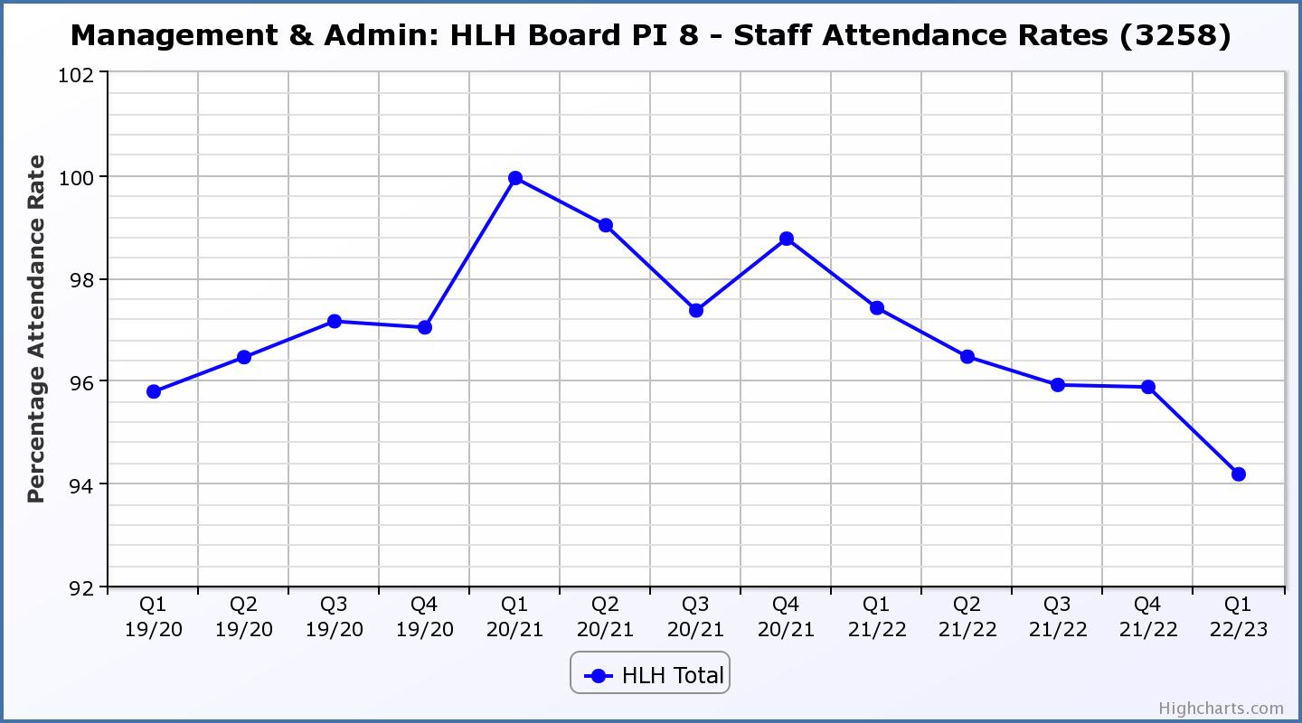

Business Plan Outcome | Performance Indicator | Reporting Frequency | RAG Rating Definition | RAG Rating Q1 22/23 | RAG Rating Q2 22/23 | RAG Rating Q3 22/23 | RAG Rating Q4 22/23 | Summary of Quarter One Performance
5. Improve the financial sustainability of the company | 9. Financial monitoring. | Quarterly. | An assessment of the year end outturn where:  - Green = delivery of services within budget.  - Amber = delivery of services between break-even and 2% over budget.  - Red = delivery of services over budget above 2%. | Red |  |  |  | There is further information in section three of this report and the Finance Report elsewhere on this agenda.

Performance Indicator 9 - Financial Monitoring
See the Finance Report elsewhere on this agenda for further information.

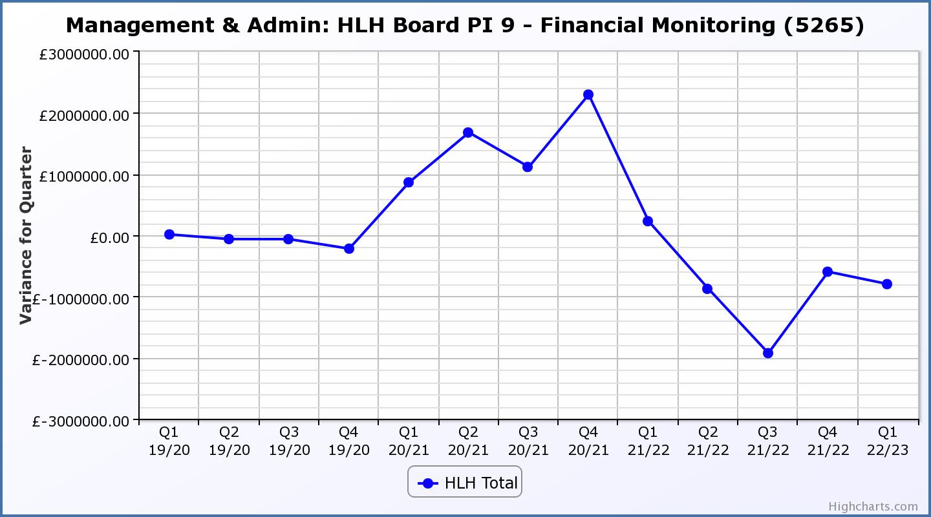

Business Plan Outcome | Performance Indicator | Reporting Frequency | RAG Rating Definition | RAG Rating Q1 22/23 | RAG Rating Q2 22/23 | RAG Rating Q3 22/23 | RAG Rating Q4 22/23 | Summary of Quarter One Performance
5. Improve the financial sustainability of the company | 10. Reserves | Annual. | - Green = meets 3% reserves policy  - Amber = achieves 2% reserves  - Red = fails to achieve 2% reserves policy. | Green | N/A | N/A | N/A | Reserves at the year end exceeded the 3% reserves policy however some reserves are required to operate during the current financial year. It is anticipated that reserves will be 2% (RAG rated amber) by the end of 2022/23.

Performance Indicator 10 - Financial Reserves
HLH has been able to build up reserves to protect services and jobs during 2021/22 based on Government and customer support. Reserves at the year end exceeded the 3% reserves policy however some reserves are required to operate during the current financial year. It is anticipated that reserves will be 2% (RAG rated amber) by the end of 2022/23.
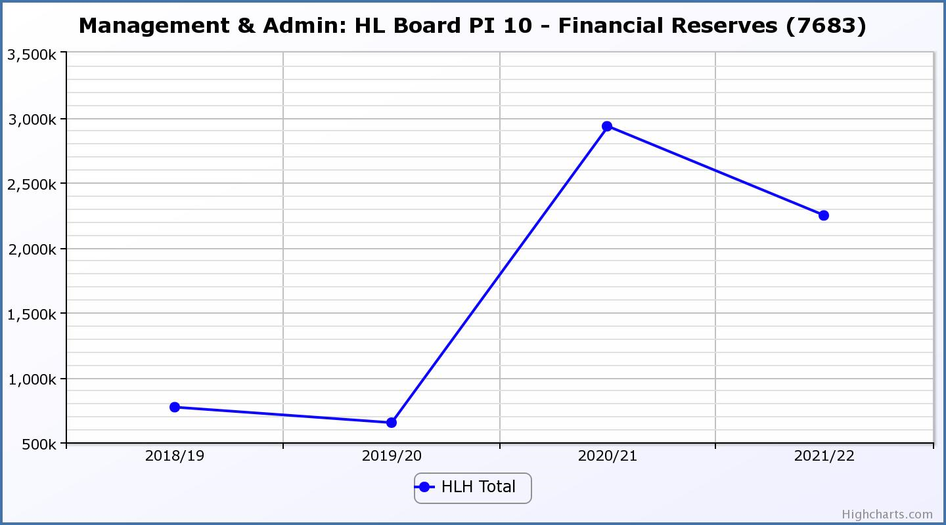

Business Plan Outcome | Performance Indicator | Reporting Frequency | RAG Rating Definition | RAG Rating Q1 22/23 | RAG Rating Q2 22/23 | RAG Rating Q3 22/23 | RAG Rating Q4 22/23 | Summary of Quarter One Performance
5. Improve the financial sustainability of the company | 11. Number of highlife subscriptions (target is the required number to meet the budget). | Quarterly. | - Green= exceeds budgeted income target.  - Amber = risk of budget target not being met.  - Red = budgeted income target unlikely to be met. | Red |  |  |  | This PI has been RAG rated red because subscriptions have been insufficient to meet the income targets set in the budget during quarter one and are not likely to be met by the year end.

Performance Indicator 11 - Number of High Life Subscriptions
Subscriptions continued to increase throughout the previous quarter, but the growth rate reduced in March and April. The growth in subscriptions is no longer sufficient to meet budget targets and there is further information on this in section three of this report.
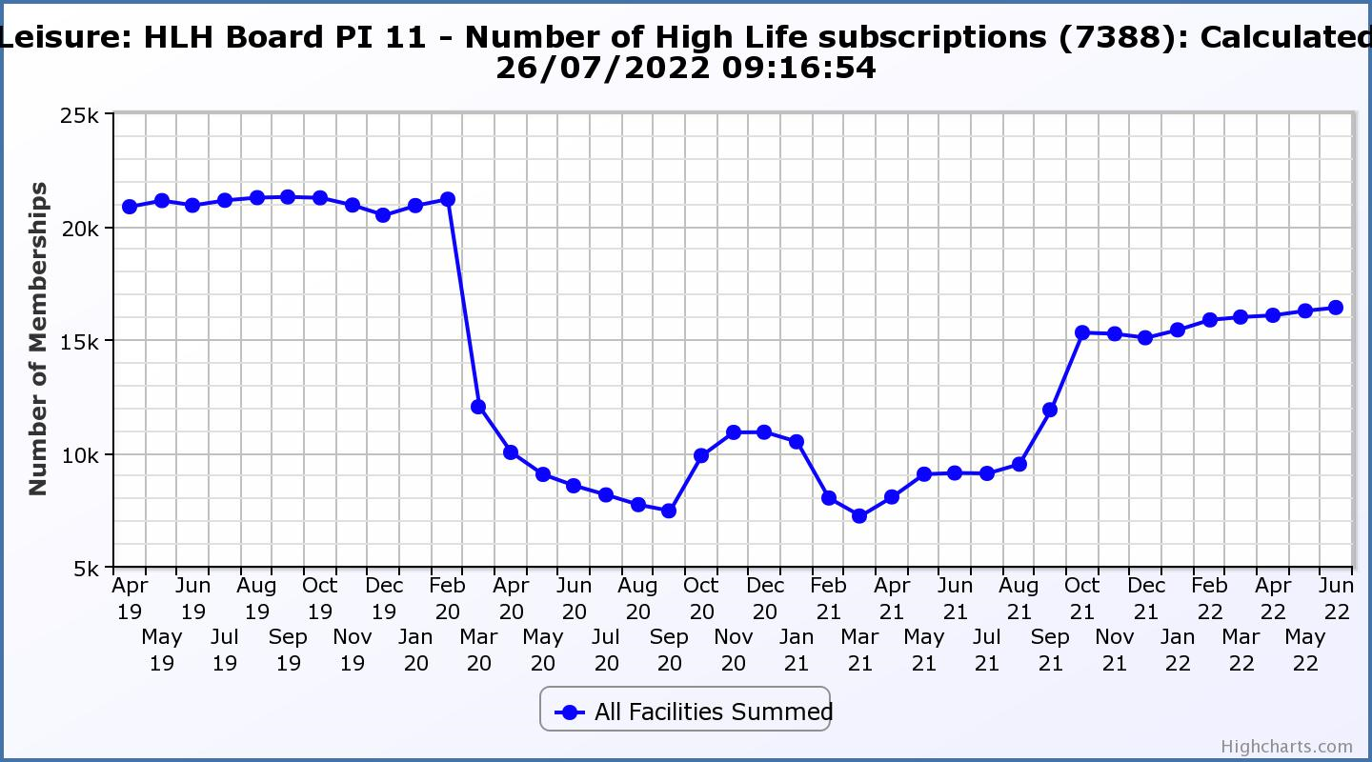

Business Plan Outcome | Performance Indicator | Reporting Frequency | RAG Rating Definition | RAG Rating Q1 22/23 | RAG Rating Q2 22/23 | RAG Rating Q3 22/23 | RAG Rating Q4 22/23 | Summary of Quarter One Performance
6. Value and strengthen the relationship with THC. | 12. Delivery of the Service Delivery Contract (SDC) with The Highland Council (THC). | Six-monthly. | - Green = agreement of THC’s Education Committee that HLH has met or exceeded the terms of the SDC.  - Amber = agreement of THC’s Education Committee that HLH has met the terms of the SDC but has set some improvement targets.  - Red = agreement of THC’s Education Committee that HLH has not met the terms of the SDC. | N/A | N/A | N/A | N/A | THC has requested that HLH report to the Council’s Education Committee be delayed from September to November 2022.

Business Plan Outcome | Performance Indicator | Reporting Frequency | RAG Rating Definition | RAG Rating Q1 22/23 | RAG Rating Q2 22/23 | RAG Rating Q3 22/23 | RAG Rating Q4 22/23 | Summary of Quarter One Performance
6. Value and strengthen the relationship with THC. | 13. THC’s annual survey of performance and attitudes. | Annual. | - Green = net satisfaction ratings are maintained or improved for three or more areas of HLH work compared with the previous year  - Amber = two or more areas of HLH work receive lower net satisfaction ratings than the previous year.  Red = all HLH areas of work represented receive lower net satisfaction ratings than the previous year. | N/A | N/A | N/A | N/A | The annual survey carried out by the Council of its citizens panel is normally available for the August HLH Board. The panel has been recruited and THC expects to be able to undertake the survey in the Autumn of this year so it should be possible to report the results of it at the December HLH Board meeting.

Business Plan Outcome | Performance Indicator | Reporting Frequency | RAG* Rating Definition  (*Red/Amber/Green) | RAG Rating Q1 22/23 | RAG Rating Q2 22/23 | RAG Rating Q3 22/23 | RAG Rating Q4 22/23 | Summary of Quarter One Performance
7. Develop and deliver the HLH Corporate Programme and seek to attract capital investment. | 14. The HLH corporate programme covers investment; business process improvement; capital and asset management plans and plans will be developed as this area of work is developed. |  | Should additional performance indicators be identified through the development of these plans they will be added in future. | N/A | N/A | N/A | N/A | N/A

Business Plan Outcome | Performance Indicator | Reporting Frequency | RAG Rating Definition | RAG Rating Q1 22/23 | RAG Rating Q2 22/23 | RAG Rating Q3 22/23 | RAG Rating Q4 22/23 | Summary of Quarter One Performance
8. Use research and market analysis to develop and deliver proactive marketing and promotion of HLH and its services. | 15. Media coverage from proactively issued media releases | Six-monthly. | - Green = Positive coverage 95%+  - Amber = Positive coverage 90% - 95%  - Red = Positive coverage 90%- | Green |  |  |  | There were 147 media articles issued during quarter one and only 1 of them was negative - giving overall positive coverage of 97%.

Performance Indicator 15 - Media coverage from proactively issued media releases
This is a new indicator which assesses the percentage of media releases that are positively reported. Reporting started in Q4 last financial year and historic comparison will be possible over time.

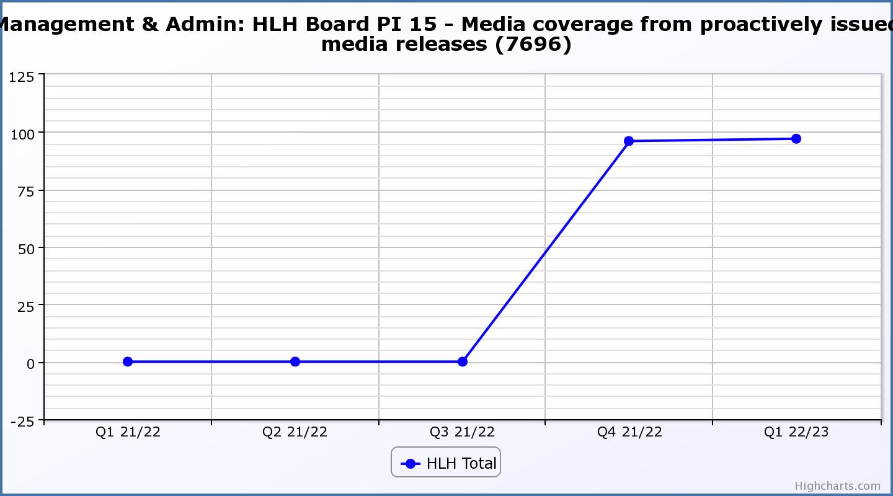

Business Plan Outcome | Performance Indicator | Reporting Frequency | RAG Rating Definition | RAG Rating Q1 22/23 | RAG Rating Q2 22/23 | RAG Rating Q3 22/23 | RAG Rating Q4 22/23 | Summary of Quarter One Performance
8. Use research and market analysis to develop and deliver proactive marketing and promotion of HLH and its services. | 16. On-line engagement through social media channels. |  | - Green = 5% increase compared with the same period last year.  - Amber = no increase to 4.9% lower compared with the same period last year.  - Red = more than 5% lower or less compared with the same period last year. | N/A |  |  |  | Year on year comparison will be possible from the next quarter.

Performance Indicator 16 - On-line engagement through social media channels.
This is a new marketing indicator which counts the on-line engagement through social media channels. Year on year comparison will be possible over time, recording engagements started Q2 2021-22. The peak for quarter 3 (71,091) arose from the Winter Festival events programme generating online engagements HLH social media pages.

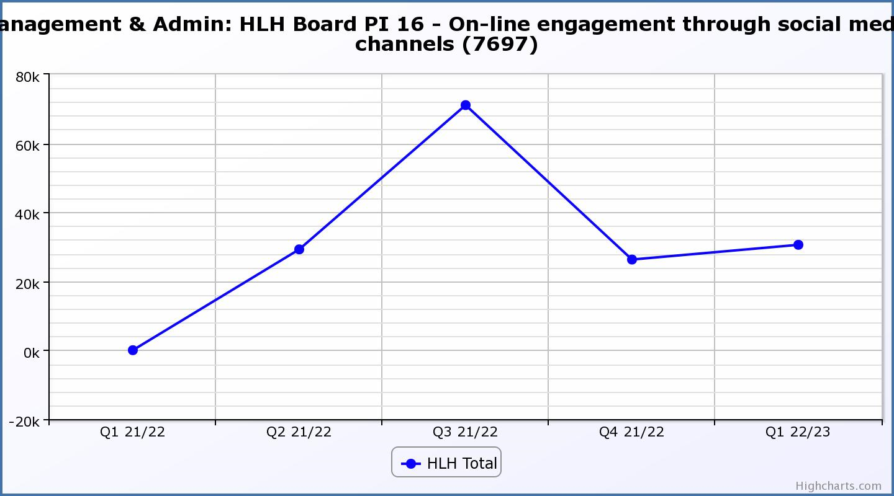

Business Plan Outcome | Performance Indicator | Reporting Frequency | RAG Rating Definition | RAG Rating Q1 22/23 | RAG Rating Q2 22/23 | RAG Rating Q3 22/23 | RAG Rating Q4 22/23 | Summary of Quarter One Performance
9. Initiate and implement an ICT digital transformation strategy across the charity | 17. The HLH digital transformation strategy will be developed during 2022/23. |  | Should performance indicators be identified through the development of these plans they will be added in future. | N/A | N/A | N/A | N/A | N/A

Business Plan Outcome | Performance Indicator | Reporting Frequency | RAG Rating Definition | RAG Rating Q1 22/23 | RAG Rating Q2 22/23 | RAG Rating Q3 22/23 | RAG Rating Q4 22/23 | Summary of Quarter One Performance
10. Develop and strengthen relationships with customers, key stakeholders and partners | New approach to customer survey as per Business Outcome 3 above.  Same as PI 6 - Charity-wide customer satisfaction survey | Quarterly | - | N/A | N/A | N/A | N/A | N/A

Business Plan Outcome | Performance Indicator | Reporting Frequency | RAG Rating Definition | RAG Rating Q1 22/23 | RAG Rating Q2 22/23 | RAG Rating Q3 22/23 | RAG Rating Q4 22/23 | Summary of Quarter One Performance
10. Develop and strengthen relationships with customers, key stakeholders and partners | 18. Partnership work with sportscotland and other sports related organisations, NHS Highland and other health related organisations (including Memoranda of Understanding) etc. | Annual | - Green = Growth in partnership working  - Amber = continuation of current level of partnership work  - Red = cancellation of Partnership Agreements | N/A | N/A | N/A | N/A | N/A - PI scheduled for assessment at the end of 2022/23

Business Plan Outcome | Performance Indicator | Reporting Frequency | RAG Rating Definition | RAG Rating Q1 22/23 | RAG Rating Q2 22/23 | RAG Rating Q3 22/23 | RAG Rating Q4 22/23 | Summary of Quarter One Performance
11. Deliver targeted programmes which support and enhance the physical and mental health and wellbeing of the population and which contribute to the prevention agenda. | 19. An assessment of the RAG rating of the Health and Wellbeing Strategy action plan. |  | - Green = 80% or more of the actions are RAG rated green  - Amber = 60% to 79% of actions are green.  - Red = 59% or less are rated green. | N/A | N/A | N/A | N/A | Please see the health and wellbeing update elsewhere on this agenda.

Appendix C
HLH Operational Plan Q1 2022/23

Code | Outcome | Action | Adult  Learning | Archives | Arts | Countryside  Rangers | Leisure | Libraries | Museums | Music  Tuition | Outdoor  Activities | Sport | Youth  Work
1.1 | Seek to continuously improve standards of health and safety | Review and deliver the health and safety strategy
1.2 | Seek to continuously improve standards of health and safety | Identify and implement appropriate safety and recovery actions in response to UK, SG and NGB policy and guidance on COVID-19.
1.3 | Seek to continuously improve standards of health and safety | Identify the environmental aspects of the Charity’s operations and develop mechanisms to monitor and improve environmental performance measures across the organisation.
2.1 | Commit to the Scottish Government’s zero carbon targets and maintain the highest standards in environmental compliance | Set a joint target with THC to achieve zero carbon emissions targets.
2.2 | Commit to the Scottish Government’s zero carbon targets and maintain the highest standards in environmental compliance | Create and deliver an environmental strategy and policy.
3.1 | Use research and market analysis to develop and improve service to meet customer needs | Use reliable and accurate methods to measure customer satisfaction on a regular basis.
3.2 | Use research and market analysis to develop and improve service to meet customer needs | Make positive, measurable changes to services, including improved customer journeys, as a result of analysing customer experience
3.3 | Use research and market analysis to develop and improve service to meet customer needs | Identify hard to reach and disadvantaged groups and individuals and develop services in support of equalities, diversity and social inclusion.
4.1 | Increase employee satisfaction, engagement and development to improve staff recruitment and retention | Create and deliver a People Strategy, with staff welfare at its core, that reflects current needs and anticipated business growth and diversification.
5.1 | Improve the financial sustainability of the organisation | Identify, develop and implement opportunities to increase revenue from all services
5.2 | Improve the financial sustainability of the organisation | Identify, develop and implement efficiencies to reduce costs in all areas of the organisation.
6.1 | Value and strengthen the relationship with THC | Deliver the agreed SDC in partnership with and to the satisfaction of THC.
6.2 | Value and strengthen the relationship with THC | Work on a continuous basis to establish and strengthen positive working relationships with Members and staff within THC
6.3 | Value and strengthen the relationship with THC | Work collaboratively with Council officers during the annual budget planning process
7.1 | Develop and deliver the HLH Corporate Programme and seek to attract capital investment | Identify, develop, prioritise and implement service investments; physical, procedural and operational
7.2 | Develop and deliver the HLH Corporate Programme and seek to attract capital investment | Create a five year recovery and investment model utilising customer income, THC funding and any available external funding
7.3 | Develop and deliver the HLH Corporate Programme and seek to attract capital investment | Develop business cases to secure support for capital investment to support HLH business growth priorities and the five year financial investment model
7.4 | Develop and deliver the HLH Corporate Programme and seek to attract capital investment | Review and update the strategic asset management plan
8.1 | Use research and market analysis to develop and deliver proactive marketing and promotion of HLH and its services | Create an updated Marketing, PR and Communications strategy in consultation with all services
8.2 | Use research and market analysis to develop and deliver proactive marketing and promotion of HLH and its services | Use performance management information and market intelligence across the charity’s operations to inform marketing and promotions activity.
8.3 | Use research and market analysis to develop and deliver proactive marketing and promotion of HLH and its services | Build on public confidence in accessing HLH services in the post pandemic recovery phase.
8.4 | Use research and market analysis to develop and deliver proactive marketing and promotion of HLH and its services | Develop and deliver a service by service strategic customer engagement plan and promotional plan based on the marketing strategy.
8.5 | Use research and market analysis to develop and deliver proactive marketing and promotion of HLH and its services | Identify marketing opportunities and improvements to support the objectives of the business plan.
8.6 | Use research and market analysis to develop and deliver proactive marketing and promotion of HLH and its services | Increase awareness of the charity’s values and breadth and reach of services.
9.1 | Initiate and implement and ICT digital transformation strategy across the charity | Create an ICT and digital transformation strategy in consultation with all services and THC ICT service to consider the future needs of the charity.
9.2 | Initiate and implement and ICT digital transformation strategy across the charity | Identify opportunities to maximise customer and staff satisfaction through the innovative use of digital technologies.
9.3 | Initiate and implement and ICT digital transformation strategy across the charity | Invest in new technologies and data analysis methodologies to properly inform strategic direction, business performance and operational management decisions.
10.1 | Develop and strengthen relationships with customers, key stakeholders and partners | Look for opportunities for new business developments and partnerships, including, but not exclusively: NHS Highland Sportscotland Creative Scotland HIE UHI SLIC Museums Galleries Scotland
10.2 | Develop and strengthen relationships with customers, key stakeholders and partners | Work with appropriate sector partners to maximise opportunities for collaboration
11.1 | Deliver targeted programmes which support and enhance the physical and mental health and wellbeing of the population and which contribute to the prevention agenda | Revise and implement the health and wellbeing strategy across all HLH service to reflect the new operating environment through and out of the Covid-19 pandemic.
11.2 | Deliver targeted programmes which support and enhance the physical and mental health and wellbeing of the population and which contribute to the prevention agenda | Develop and deliver a service by service health improvement plan based on the health and wellbeing strategy.

