HIGH LIFE HIGHLAND  REPORT TO BOARD OF DIRECTORS  14 December 2022 | AGENDA ITEM  REPORT No HLH /11 /22

Performance Report - Report by Chief Executive

Summary

The purpose of this report is to present performance information for the period July to September 2022.

It is recommended that Directors:

- comment on the report and agree that the overall health check on the charity for that period is RAG rated as “amber” because of the financial position;
- note that there is work underway with the Highland Council to reach a sustainable position from 2022/23 onwards with final decisions by the Council expected when it sets its budget in March 2023.

1. | Business Plan Contribution
1.1 | This report supports all the Business Outcomes from the High Life Highland (HLH) Business Plan 2022-27  - Seek to continuously improve standards of health and safety.  - Commit to the Scottish Government’s zero carbon targets and maintain the highest standards in environmental compliance.  - Use research and market analysis to develop and improve services to meet customer needs.  - Increase employee satisfaction, engagement and development to improve staff recruitment and retention.  - Improve the financial sustainability of the company.  - Value and strengthen the relationship with THC.  - Develop and deliver the HLH Corporate Programme and seek to attract capital investment.  - Use research and market analysis to develop and deliver proactive marketing and promotion of HLH and its services.  - Initiate and implement an ICT digital transformation strategy across the charity.  - Develop and strengthen relationships with customers, key stakeholders and partners.  - Deliver targeted programmes which support and enhance the physical and mental health and wellbeing of the population and which contribute to the prevention agenda.
2. | Background
2.1 | The implementation of the HLH Business Plan 2022-27 is monitored through a set of performance indicators set by the Board at its meeting held on 31 March 2022.
3. | Summary of Performance
3.1 | Nineteen performance indicators (PIs) were identified by the HLH Board to assess the overall performance of the charity at its meeting held on 31 March 2022. Appendix A contains a summary of performance against the PIs for Q2 2022/23. Appendix B provides a list of all the PIs along with trend information. 11 PIs are scheduled for assessment at the December 2022 HLH Board meeting. Of those, 5 have been RAG rated green; 1 amber and 5 red.
3.2 | The 5 indicators which have been RAG rated as red are: PI 4 Travel; PI 8 staff attendance rate; PI 9 financial monitoring; PI 10 Financial Reserves; and PI 11 highlife subscriptions. The amber RAG rating was for staff turnover. Staff attendance and turnover are covered in the HR report elsewhere on this agenda.
3.3 | PI 4 Travel - A ceiling of 400,000 miles p.a. or less was set for this PI, half of the pre-pandemic travel miles. Travel miles in Q1 2019/20 were 223,358 and in Q1 2022/23 were 162,036, a 27% reduction. Q2 2019/20 miles were 129,261 and in 2022/23 were 117,738, a 9% reduction. The year-to-date reduction is 21%. Both quarters fall short of target and travel miles continue to be monitored at Performance Board meetings and staff are being asked to minimise travel.
3.4 | PI 9 Financial Monitoring - Financial monitoring and reserves have been considered at the special HLH Board meeting held on 17 October 2022 and in the Finance report elsewhere on this agenda. The Council has provided HLH with a letter of comfort and meetings have commenced at officer and councillor level on addressing the situation which is being experienced by organisations similar to HLH across the country, caused by the pandemic and the economic environment.
3.5 | PI 11 highlife subscriptions - Growth in subscriptions income during the first two quarters has been insufficient to meet income targets but increased in October. During the financial year to September income increased by 2.2% (for the whole period). In October alone the growth was 3.8%. It is too early to say whether this is a trend and an element of the October growth could be seasonal, as customers return post pandemic (although there has never be an seasonal increase in subscriptions in the past). Growth in the first three weeks of November was 1.6%.
3.6 | To address the slow growth in subscriptions there have been more campaigns than ever before including the following this financial year: 10 days for £10; Move it to Lose it; autumn marketing campaign; Bring a Buddy; Every Membership Counts; UHI freshers’ week; Black Friday; HIE all staff event; Care and Learning Alliance staff day; Strathdearn Community Development Company health and wellbeing event; highland games and European Pipe Band Championships promotions.
3.7 | Having gained some experience in promotions the most successful ones have been the corporate subscriptions with businesses and public sector organisations such as the Council and NHS Highland. The successful campaigns have been those which have included personal telephone follow-up. A team approach is required for this to be successful with the leisure, marketing and ICT teams working together and a review of the resourcing of those teams to allow a focus on subscriptions growth is underway.
4. | Performance Indicators for More Detailed Consideration
4.1 | Each quarter more detailed information is provided on one or more of the performance indicators and the following performance indicators are scheduled for inclusion in this report:  - PI 12 - Delivery of the SDC with the Highland Council  - PI 13 - THC’s annual survey of performance and attitudes
4.2 | PI 12 - Delivery of the SDC with the Highland Council. The HLH progress report was considered by the Council’s Education Committee at its 23 November 2022 meeting and the committee noted that HLH continues to deliver Public Service Obligations on behalf of the Council as set out in the Service Delivery Contract. The report can be viewed on the Council’s web site at:  https://www.highland.gov.uk/meetings/meeting/4708/education_committee
4.3 | PI 13 - THC’s annual survey of performance and attitudes. The annual survey carried out by the Council of its citizens panel is normally available for the August HLH Board. The panel has been recruited and THC expects to be able to undertake the survey in the winter of this year so it should be possible to report the results of it at the March HLH Board meeting.
6. | Implications
6.1 | Resource implications – while this report discusses resources and financial implications, there are no resource implications arising from agreeing the recommendations in this report.
6.2 | Equality implications - there are no new equality implications arising from this report.
6.3 | Legal implications - there are no new legal implications arising from this report.
6.4 | Risk implications - there are no new risk implications arising from this report.

Recommendation

It is recommended that Directors:

- comment on the report and agree that the overall health check on the charity for that period is RAG rated as “amber” because of the financial position.
- note that there is work underway with the Council to reach a sustainable position from 2022/23 onwards with final decisions by the Council expected when it sets its budget in March 2023.

Designation: Chief Executive

Date: 28 November 2022

Author: Douglas Wilby, Director of Sport and Leisure

Appendix A
HLH Performance Indicators - Summary Q2 2022/23  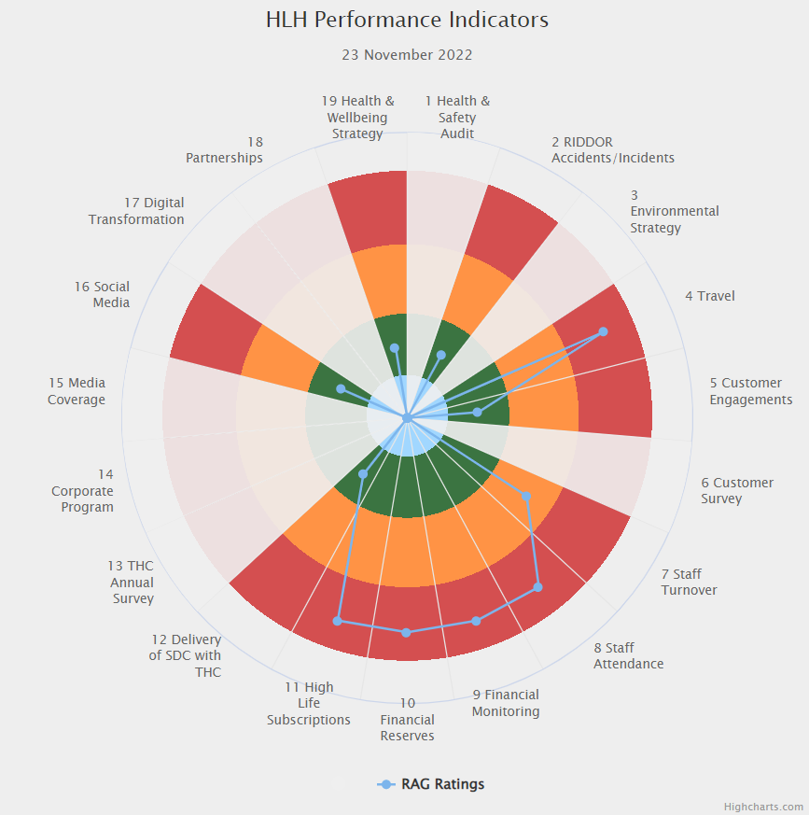 | Nineteen performance indicators (PIs) are used by the High Life Highland Board to assess the overall performance of the charity.  The PIs are RAG rated (allocated a "Red", "Amber" or "Green" status) so that it is easy to see at a glance how the organisation is performing. Most of the PIs are RAG rated every quarter throughout the year, with some (such as partnership working with NHSH for example) being considered annually so greyed out sectors on this radar diagram mean that the PI is to be considered at a future HLH Board meeting.

Appendix B
HLH Performance Indicators - Detail Q2 2022/23

Business Plan Outcome | Performance Indicator | Reporting Frequency | RAG Rating Definition | RAG Rating Q1 22/23 | RAG Rating Q2 22/23 | RAG Rating Q3 22/23 | RAG Rating Q4 22/23 | Summary of Quarter Two Performance
1. Seek to continuously improve standards of health and safety. | 1. External health and safety audit. | Annual. | - Green = the external audit does not raise systemic issues.  - Amber = the external audit highlights common actions to be addressed across the company.  - Red = the external audit raises systemic (i.e. applying across multiple sites) H&S issues. | N/A | N/A |  |  | An audit of six HLH locations took place in October 2022. A verbal update was given to the Health and Safety and Environmental Compliance Committee at its November meeting. A further written update will be provided at its February 2023 meeting.

Business Plan Outcome | Performance Indicator | Reporting Frequency | RAG Rating Definition | RAG Rating Q1 22/23 | RAG Rating Q2 22/23 | RAG Rating Q3 22/23 | RAG Rating Q4 22/23 | Summary of Quarter Two Performance
1. Seek to continuously improve standards of health and safety. | 2. RIDDOR accidents/incidents. | Quarterly. | - Red = number of RIDDOR reports per quarter is above 20.  - Amber = number of RIDDOR reports per quarter is between 10 and 20  - Green = number of RIDDOR reports per quarter is less than 10. | Green | Green |  |  | There was one accident reported under the RIDDOR regulations during Q2. This was considered by the Health and Safety and Environmental Compliance Committee at its November meeting.

Performance Indicator 2 - RIDDOR accidents/incidents
The graph below tracks the number of accidents and incidents reported under the Reporting of Injuries, Diseases and Dangerous Occurrences Regulations (RIDDOR). There was one RIDDOR incident reported in Q2 2022/23.
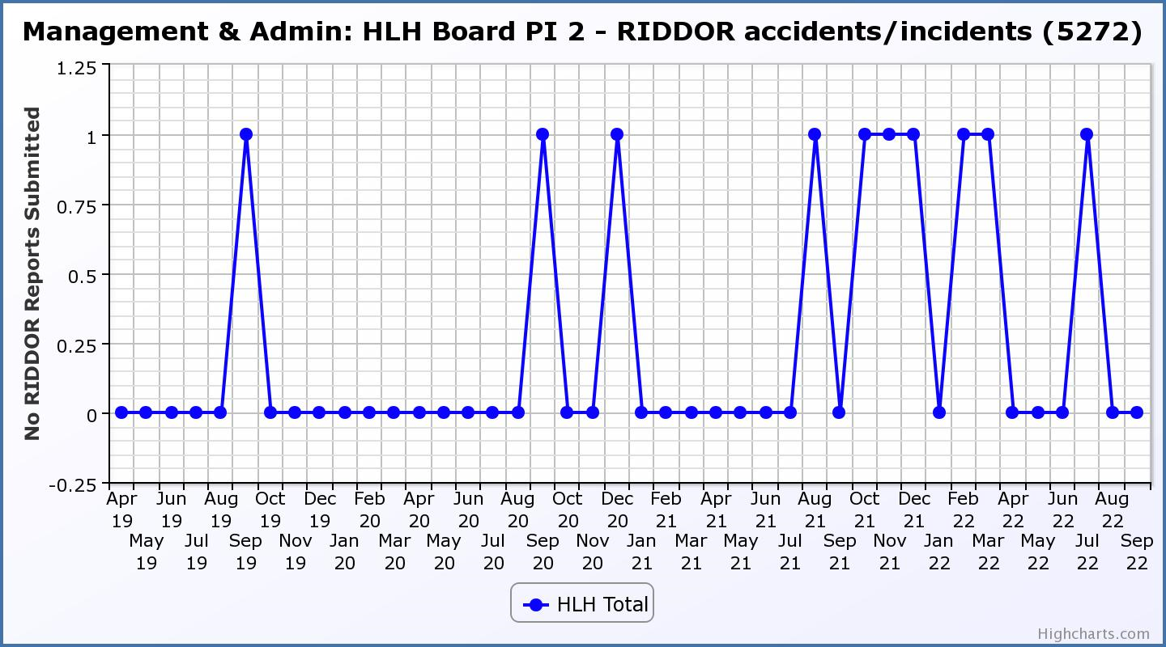

Business Plan Outcome | Performance Indicator | Reporting Frequency | RAG Rating Definition | RAG Rating Q1 22/23 | RAG Rating Q2 22/23 | RAG Rating Q3 22/23 | RAG Rating Q4 22/23 | Summary of Quarter Two Performance
2. Commit to the Scottish Government’s zero carbon targets and maintain the highest standards in environmental compliance. | 3. The HLH Environmental strategy will be developed during 2022/23. | . |  | N/A | N/A |  |  | N/A - Performance indicators will be identified through the development of these plans and will be aligned with THC’s carbon reduction strategy given the contractual (particularly property) arrangements that there are in place between THC and HLH.

Business Plan Outcome | Performance Indicator | Reporting Frequency | RAG Rating Definition | RAG Rating Q1 22/23 | RAG Rating Q2 22/23 | RAG Rating Q3 22/23 | RAG Rating Q4 22/23 | Summary of Quarter Two Performance
2. Commit to the Scottish Government’s zero carbon targets and maintain the highest standards in environmental compliance. | 4. Travel (a target to reduce by 50% following the pandemic has been set) | Quarterly. | - Green = 400,000 miles p.a. or less  - Amber = up to 5% greater than target  - Red = more than 5% of target. | Red | Red |  |  | Please see section 3 of this report for further information.  A ceiling of 400,000 miles p.a. or less was set for this PI, half of the pre-pandemic travel miles. Travel miles in Q1 2019/20 were 223,358 and in Q1 2022/23 were 162,036, a 27% reduction. Q2 2019/20 miles were 129,261 and in 2022/23 were 117,738, a 9% reduction. The year-to-date reduction was 21%.

Performance Indicator 4 – Travel Miles
The graph below shows the travel miles for the previous two years and will be used as a basis for monitoring travel during the current year. The total Miles for Q2 22/23 were 117,738.
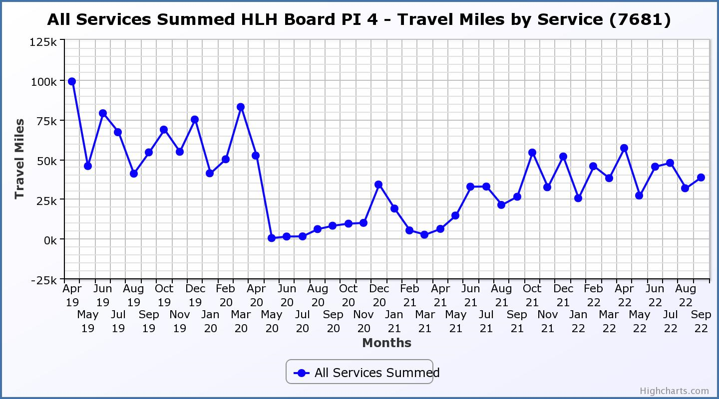

Business Plan Outcome | Performance Indicator | Reporting Frequency | RAG Rating Definition | RAG Rating Q1 22/23 | RAG Rating Q2 22/23 | RAG Rating Q3 22/23 | RAG Rating Q4 22/23 | Summary of Quarter Two Performance
3. Use research and market analysis to develop and improve services to meet customer needs. | 5. Customer engagements. | Quarterly. | - Green = customer numbers are the same as or have increased compared with the corresponding quarter in the previous year  - Amber = customer numbers are less than the corresponding quarter in the previous year.  - Red = customer numbers are more than 5% lower than the corresponding quarter in the previous year. | Green | Green |  |  | Customer engagements increased from 1,656,067 in Q2 2021/22 to  2,053,562 in Q2 2022/23.  Comparing the pre-pandemic year to September with the current FY to September customer numbers are 92% of pre-pandemic. Comparing Q2 pre-pandemic with Q2 this year customer numbers are 97% of pre-pandemic numbers.
Performance Indicator 5 - Customer engagements
Customer numbers are showing an increase compared with quarter two 2021/22 and are close to pre-pandemic numbers.

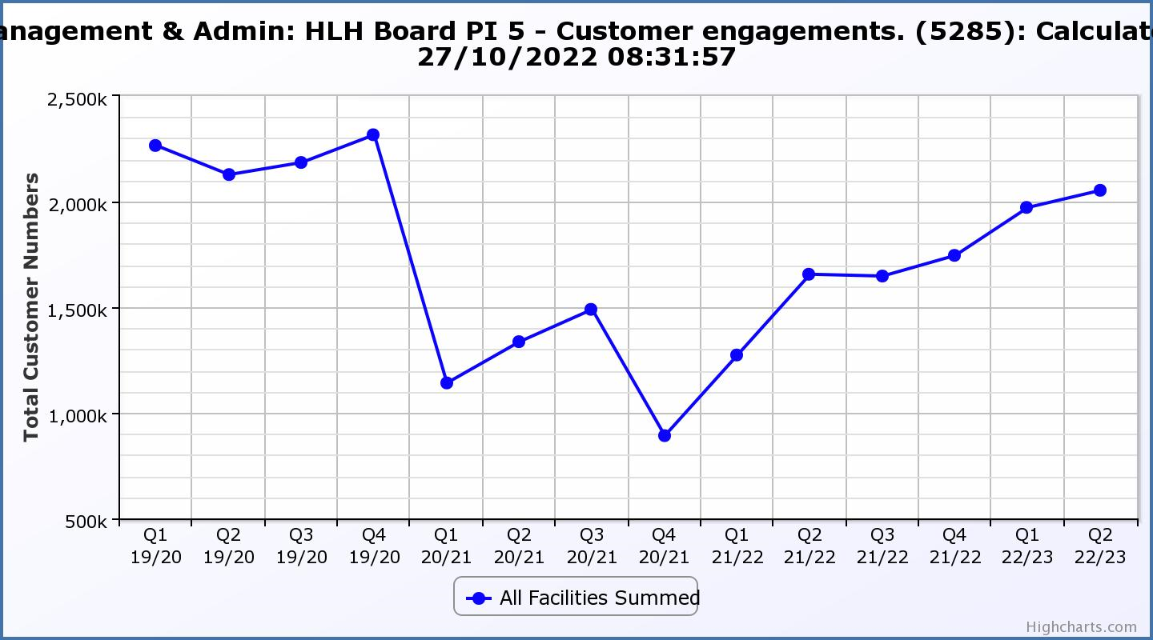

Business Plan Outcome | Performance Indicator | Reporting Frequency | RAG Rating Definition | RAG Rating Q1 22/23 | RAG Rating Q2 22/23 | RAG Rating Q3 22/23 | RAG Rating Q4 22/23 | Summary of Quarter Two Performance
3. Use research and market analysis to develop and improve services to meet customer needs. | 6. Charity-wide customer satisfaction survey | Annually. | - Green = Services delivered by HLH is above average  - Amber = Services delivered by HLH is average  - Red = Services delivered by HLH is below average. | Green | N/A |  |  | This performance indicator was reported in more detail at the March 2022 HLH Board meeting.

Business Plan Outcome | Performance Indicator | Reporting Frequency | RAG Rating Definition | RAG Rating Q1 22/23 | RAG Rating Q2 22/23 | RAG Rating Q3 22/23 | RAG Rating Q4 22/23 | Summary of Quarter Two Performance
4. Increase employee satisfaction, engagement and development to improve staff recruitment and retention. | 7. Staff turnover (resignations as a percentage of posts). | Quarterly. | - Green = 1.6% or less.  - Amber = 1.7 to 2%  - Red = more than 2% | Green | Amber |  |  | The number of resignations per month as a percentage of posts in Q2 was 1.5% in July, 1.7% in August and 2% in September. Please see the HR report elsewhere on this agenda for further information.

Performance Indicator 7 - Staff Turnover (resignations as a percentage of posts)
The graph below shows resignations as a percentage of the number of posts which have been higher in July, August and September than was the case in previous years (1% equates to 10.6 staff).

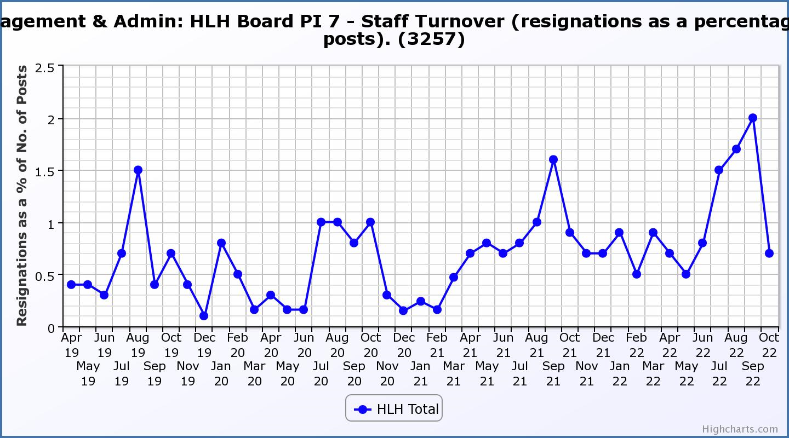

Business Plan Outcome | Performance Indicator | Reporting Frequency | RAG Rating Definition | RAG Rating Q1 22/23 | RAG Rating Q2 22/23 | RAG Rating Q3 22/23 | RAG Rating Q4 22/23 | Summary of Quarter Two Performance
4. Increase employee satisfaction, engagement and development to improve staff recruitment and retention. | 8. Staff attendance rates (RAG ratings based on Office for National Statistics for 2020 of absence rate). | Quarterly. | - Green = attendance rate 98% or higher.  - Amber = attendance rate between 97% and 98%.  - Red = attendance rate less than 97%. | Red | Red |  |  | The attendance rate for Q2 was 94.85%. Please see the HR report elsewhere on this agenda for further information.

Performance Indicator 8 - Staff Attendance Rate
Staff attendance rates for Q2 were 94.85%. Please see the HR report elsewhere on this agenda for further information. 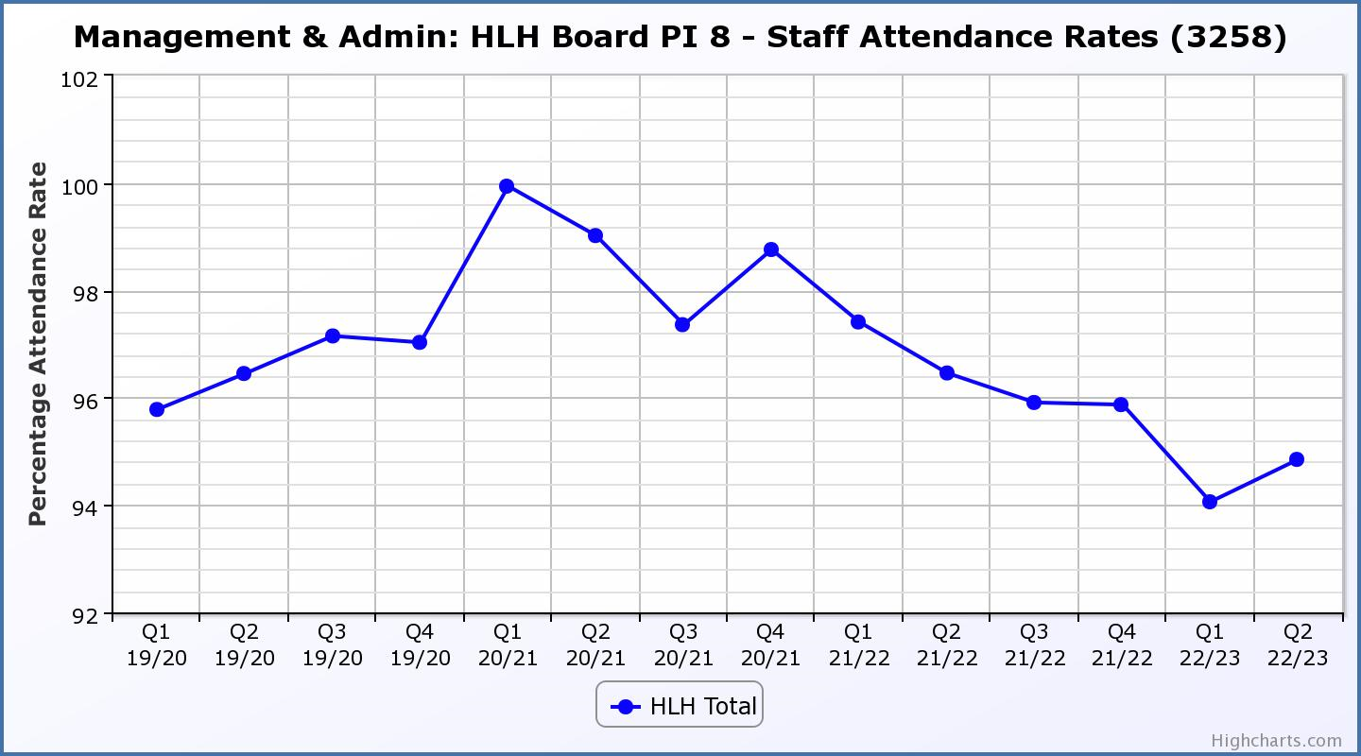

Business Plan Outcome | Performance Indicator | Reporting Frequency | RAG Rating Definition | RAG Rating Q1 22/23 | RAG Rating Q2 22/23 | RAG Rating Q3 22/23 | RAG Rating Q4 22/23 | Summary of Quarter Two Performance
5. Improve the financial sustainability of the company | 9. Financial monitoring. | Quarterly. | An assessment of the year end outturn where:  - Green = delivery of services within budget.  - Amber = delivery of services between break-even and 2% over budget.  - Red = delivery of services over budget above 2%. | Red | Red |  |  | There is further information in the Finance Report elsewhere on this agenda.

Performance Indicator 9 - Financial Monitoring
See the Finance Report elsewhere on this agenda for further information.

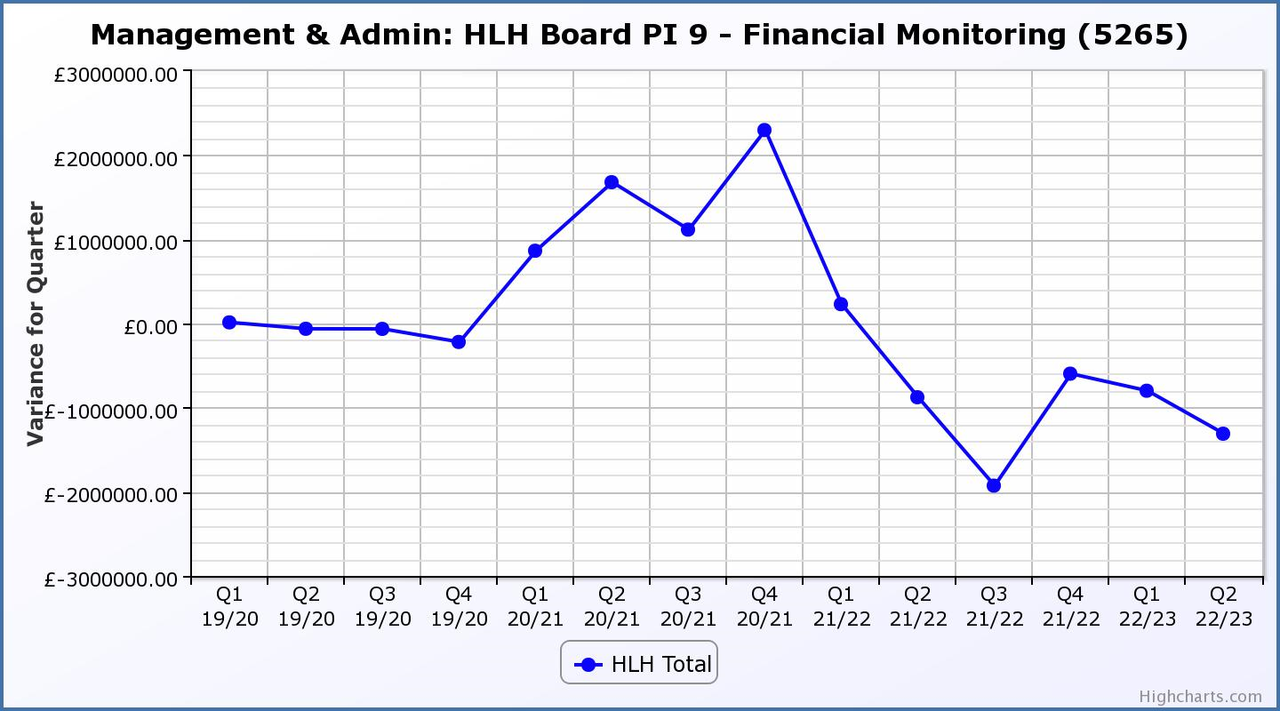

Business Plan Outcome | Performance Indicator | Reporting Frequency | RAG Rating Definition | RAG Rating Q1 22/23 | RAG Rating Q2 22/23 | RAG Rating Q3 22/23 | RAG Rating Q4 22/23 | Summary of Quarter Two Performance
5. Improve the financial sustainability of the company | 10. Reserves | Annual. | - Green = meets 3% reserves policy  - Amber = achieves 2% reserves  - Red = fails to achieve 2% reserves policy. | Green | Red | N/A | N/A | Zero reserves are forecast by the year end. The Council has provided the HLH Board with a letter of comfort and work is underway with the Council to jointly address the financial situation. Please see the Finance Report elsewhere on this agenda and section 3 of this report for further information.

Performance Indicator 10 - Financial Reserves
HLH has been able to build up reserves to protect services and jobs during 2021/22 based on Government and customer support. Reserves at the year end exceeded the 3% reserves policy however some reserves are required to operate during the current financial year. It is anticipated that reserves will be zero (RAG rated red) by the end of 2022/23.
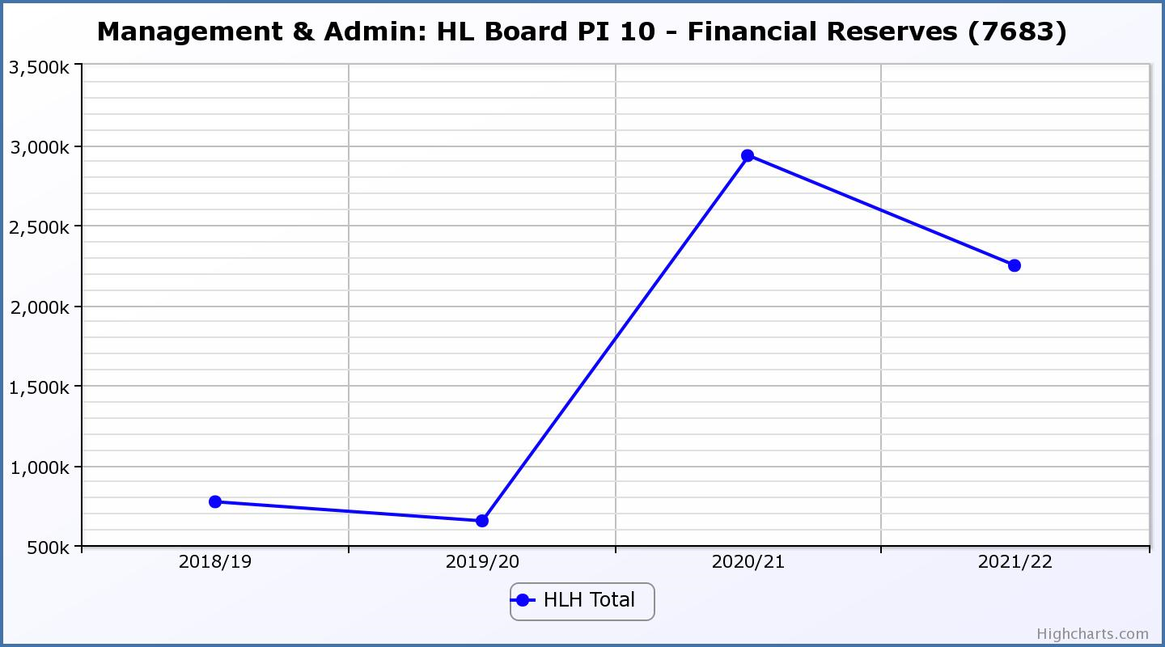

Business Plan Outcome | Performance Indicator | Reporting Frequency | RAG Rating Definition | RAG Rating Q1 22/23 | RAG Rating Q2 22/23 | RAG Rating Q3 22/23 | RAG Rating Q4 22/23 | Summary of Quarter Two Performance
5. Improve the financial sustainability of the company | 11. Number of highlife subscriptions (target is the required number to meet the budget). | Quarterly. | - Green= exceeds budgeted income target.  - Amber = risk of budget target not being met.  - Red = budgeted income target unlikely to be met. | Red | Red |  |  | This PI has been RAG rated red because subscriptions have been insufficient to meet the income targets set in the budget during quarter two and are not likely to be met by the year end. While subscriptions increased on October it is too early to assess whether this is a trend. Please see section 3 of this report for further information.

Performance Indicator 11 - Number of High Life Subscriptions
Subscriptions continued to increase throughout the previous quarter. The growth in subscriptions is no longer sufficient to meet budget targets and there is further information on this in section three of this report.
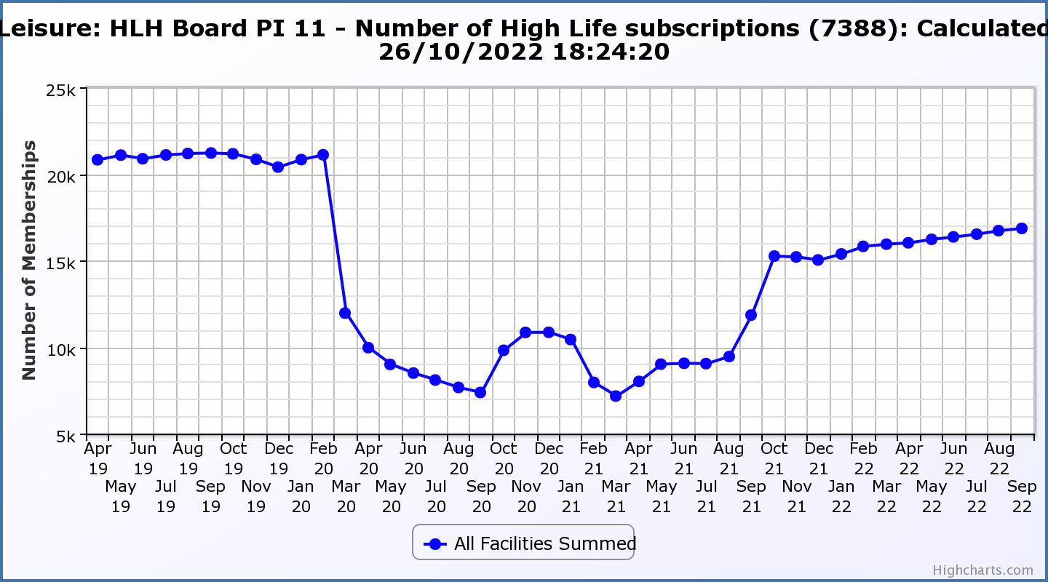

Business Plan Outcome | Performance Indicator | Reporting Frequency | RAG Rating Definition | RAG Rating Q1 22/23 | RAG Rating Q2 22/23 | RAG Rating Q3 22/23 | RAG Rating Q4 22/23 | Summary of Quarter Two Performance
6. Value and strengthen the relationship with THC. | 12. Delivery of the Service Delivery Contract (SDC) with The Highland Council (THC). | Six-monthly. | - Green = agreement of THC’s Education Committee that HLH has met or exceeded the terms of the SDC.  - Amber = agreement of THC’s Education Committee that HLH has met the terms of the SDC but has set some improvement targets.  - Red = agreement of THC’s Education Committee that HLH has not met the terms of the SDC. | N/A | Green | N/A |  | The HLH progress report was considered by the Council’s Education Committee at its meeting held on 23 November 2022. Please see section 4 of this report for further information.

Business Plan Outcome | Performance Indicator | Reporting Frequency | RAG Rating Definition | RAG Rating Q1 22/23 | RAG Rating Q2 22/23 | RAG Rating Q3 22/23 | RAG Rating Q4 22/23 | Summary of Quarter Two Performance
6. Value and strengthen the relationship with THC. | 13. THC’s annual survey of performance and attitudes. | Annual. | - Green = net satisfaction ratings are maintained or improved for three or more areas of HLH work compared with the previous year  - Amber = two or more areas of HLH work receive lower net satisfaction ratings than the previous year.  Red = all HLH areas of work represented receive lower net satisfaction ratings than the previous year. | N/A | N/A | N/A |  | The annual survey carried out by the Council of its citizens panel is normally available for the August HLH Board. The panel has been recruited and THC expects to be able to undertake the survey in the Winter of this year. It should be possible to report the results at the March HLH Board meeting.

Business Plan Outcome | Performance Indicator | Reporting Frequency | RAG* Rating Definition  (*Red/Amber/Green) | RAG Rating Q1 22/23 | RAG Rating Q2 22/23 | RAG Rating Q3 22/23 | RAG Rating Q4 22/23 | Summary of Quarter Two Performance
7. Develop and deliver the HLH Corporate Programme and seek to attract capital investment. | 14. The HLH corporate programme covers investment; business process improvement; capital and asset management plans and plans will be developed as this area of work is developed. |  | Should additional performance indicators be identified through the development of these plans they will be added in future. | N/A | N/A | N/A | N/A | N/A

Business Plan Outcome | Performance Indicator | Reporting Frequency | RAG Rating Definition | RAG Rating Q1 22/23 | RAG Rating Q2 22/23 | RAG Rating Q3 22/23 | RAG Rating Q4 22/23 | Summary of Quarter Two Performance
8. Use research and market analysis to develop and deliver proactive marketing and promotion of HLH and its services. | 15. Media coverage from proactively issued media releases | Six-monthly. | - Green = Positive coverage 95%+  - Amber = Positive coverage 90% - 95%  - Red = Positive coverage 90%- | Green | N/A |  |  | The media officer post has not been filled and this indicator has not been RAG rated.

Business Plan Outcome | Performance Indicator | Reporting Frequency | RAG Rating Definition | RAG Rating Q1 22/23 | RAG Rating Q2 22/23 | RAG Rating Q3 22/23 | RAG Rating Q4 22/23 | Summary of Quarter Two Performance
8. Use research and market analysis to develop and deliver proactive marketing and promotion of HLH and its services. | 16. On-line engagement through social media channels. |  | - Green = 5% increase compared with the same period last year.  - Amber = no increase to 4.9% lower compared with the same period last year.  - Red = more than 5% lower or less compared with the same period last year. | N/A | Green |  |  | Social media engagements have risen from 29,247 in Q2 21/22 to 44,066 in Q2 22/23. There is a Marketing PR and Communications update elsewhere on this agenda.

Performance Indicator 16 - On-line engagement through social media channels.
This is a new marketing indicator which counts the on-line engagement through social media channels. Engagements have risen from 29,247 in Q2 21/22 to 44,066 in Q2 22/23.

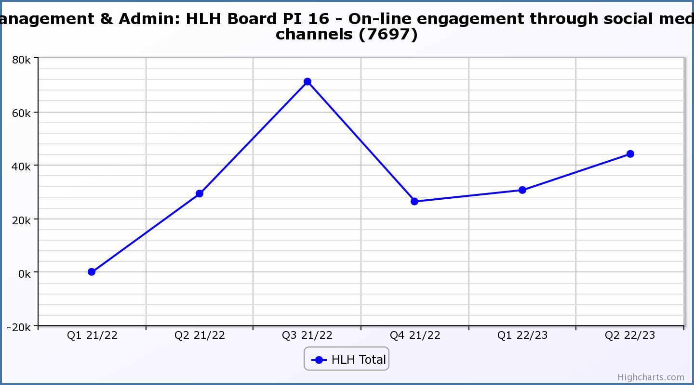

Business Plan Outcome | Performance Indicator | Reporting Frequency | RAG Rating Definition | RAG Rating Q1 22/23 | RAG Rating Q2 22/23 | RAG Rating Q3 22/23 | RAG Rating Q4 22/23 | Summary of Quarter Two Performance
9. Initiate and implement an ICT digital transformation strategy across the charity | 17. The HLH digital transformation strategy will be developed during 2022/23. |  | Should performance indicators be identified through the development of these plans they will be added in future. | N/A | N/A | N/A | N/A | N/A

Business Plan Outcome | Performance Indicator | Reporting Frequency | RAG Rating Definition | RAG Rating Q1 22/23 | RAG Rating Q2 22/23 | RAG Rating Q3 22/23 | RAG Rating Q4 22/23 | Summary of Quarter Two Performance
10. Develop and strengthen relationships with customers, key stakeholders and partners | New approach to customer survey as per Business Outcome 3 above.  Same as PI 6 - Charity-wide customer satisfaction survey | Quarterly | - | N/A | N/A | N/A | N/A | N/A

Business Plan Outcome | Performance Indicator | Reporting Frequency | RAG Rating Definition | RAG Rating Q1 22/23 | RAG Rating Q2 22/23 | RAG Rating Q3 22/23 | RAG Rating Q4 22/23 | Summary of Quarter Two Performance
10. Develop and strengthen relationships with customers, key stakeholders and partners | 18. Partnership work with sportscotland and other sports related organisations, NHS Highland and other health related organisations (including Memoranda of Understanding) etc. | Annual | - Green = Growth in partnership working  - Amber = continuation of current level of partnership work  - Red = cancellation of Partnership Agreements | N/A | N/A | N/A | N/A | N/A - PI scheduled for assessment at the end of 2022/23

Business Plan Outcome | Performance Indicator | Reporting Frequency | RAG Rating Definition | RAG Rating Q1 22/23 | RAG Rating Q2 22/23 | RAG Rating Q3 22/23 | RAG Rating Q4 22/23 | Summary of Quarter Two Performance
11. Deliver targeted programmes which support and enhance the physical and mental health and wellbeing of the population and which contribute to the prevention agenda. | 19. An assessment of the RAG rating of the Health and Wellbeing Strategy action plan. |  | - Green = 80% or more of the actions are RAG rated green  - Amber = 60% to 79% of actions are green.  - Red = 59% or less are rated green. | N/A | N/A | N/A | N/A

