|  |  |
| --- | --- |
| HIGH LIFE HIGHLAND  REPORT TO BOARD OF DIRECTORS  14 MARCH 2023 | AGENDA ITEM 10  REPORT No HLH / 4 /23 |

## **Performance Report - Report by Chief Executive**

|  |
| --- |
| **Recommendation** The purpose of this report is to present performance information for the period October to December 2022.  It is recommended that Directors:   1. comment on the report and agree that the overall health check on the charity for that period is RAG rated as “amber” because of the financial position; 2. note that there HLH should be able to set a balanced budget for 2023/24 following the Council setting its budget on 2 March which should help to bring the overall RAG rating back to green, on target in future years; and 3. note that further work will be required with the Council on the Service Delivery Contract to address the amber RAG rating in the longer term. |

|  |  |
| --- | --- |
| **1.** | **Business Plan Contribution** |
| 1.1 | This report supports all the Business Outcomes from the High Life Highland (HLH) Business Plan 2022-27   1. **Seek to continuously improve standards of health and safety.** 2. **Commit to the Scottish Government’s zero carbon targets and maintain the highest standards in environmental compliance.** 3. **Use research and market analysis to develop and improve services to meet customer needs.** 4. **Increase employee satisfaction, engagement and development to improve staff recruitment and retention.** 5. **Improve the financial sustainability of the company.** 6. **Value and strengthen the relationship with THC.** 7. **Develop and deliver the HLH Corporate Programme and seek to attract capital investment.** 8. **Use research and market analysis to develop and deliver proactive marketing and promotion of HLH and its services.** 9. **Initiate and implement an ICT digital transformation strategy across the charity.** 10. **Develop and strengthen relationships with customers, key stakeholders and partners.** 11. **Deliver targeted programmes which support and enhance the physical and mental health and wellbeing of the population and which contribute to the prevention agenda.** |
| **2.** | **Background** |
| 2.1 | The implementation of the HLH Business Plan 2022-27 is monitored through a set of performance indicators set by the Board at its meeting held on 31 March 2022. |
| **3.** | **Summary of Performance** |
| 3.1 | Nineteen performance indicators (PIs) were identified by the HLH Board to assess the overall performance of the charity at its meeting held on 31 March 2022. **Appendix A** contains a summary of performance against the PIs for Q3 2022/23. **Appendix B** provides a list of all the PIs along with trend information. 13 PIs are scheduled for assessment at the March 2023 HLH Board meeting. Of those, 5 have been RAG rated green; 1 amber and 5 red. |
| 3.2 | The 5 indicators which have been RAG rated as red are: PI 4 Travel; PI 8 staff attendance rate; PI 9 financial monitoring; PI 10 Financial Reserves; and PI 11 *high****life***subscriptions. The amber RAG rating was for PI 16 On-line engagement through social media channels. Staff attendance is covered in the HR report elsewhere on this agenda. |
| 3.3 | PI 4 **Travel** - A ceiling of 400,000 miles p.a. or less was set for this PI, half of the pre-pandemic travel miles. This has been a challenging target to achieve, however, progress has been made and travel miles for the first three quarters of this year have been 56% of pre-pandemic travel. Travel miles continue to be monitored at the management team’s Performance Board meetings and staff are being asked to minimise travel. As has been a topic of discussion at previous HLH Board meetings, work has been undertaken on Enterprise Car hire travel miles and the intention is to include them in the overall PI in future. (The current PI only includes travel claims using personal cars (grey fleet)). |
| 3.4 | PI 8 **Staff Attendance Rate** – This PI is covered in the HR report elsewhere on this agenda. |
| 3.5 | PI 9 **Financial Monitoring** - Financial monitoring and reserves are reported in the Finance report elsewhere on this agenda. The Council has provided HLH with a letter of comfort for 2022/23 and meetings have taken place at officer and councillor level to address the situation which is being experienced by organisations similar to HLH across the country, caused by the pandemic, inflation and the wider economic environment. The Council is scheduled to set its budget on 2 March 2023 and as a result of that HLH should be able to set a balanced budget in 2023/24. Additional work with the Council will be required on the review of the Service Delivery Contract to address the longer term situation. |
| 3.6 | PI 10 **Financial Reserves** – This PI is covered elsewhere on this agenda. |
| 3.7 | PI 11 *high****life* subscriptions** – Subscription targets for 2022/23 were set while there were still covid restrictions in place and they have not met the level needed to meet income targets. For the first half of the year growth was around 1% per month. This increased to 2% in October and remained static during November and December (slight increase those two months). Subscriptions grew by 4% in January and 1% so far in February. The growth seen this year was better than pre-pandemic year performance where growth was levelling out. Subject to a board decision on the price increase elsewhere on this agenda, the current level of subscriptions could achieve pre-pandemic levels of income in 2023/24. The growth in subscriptions has been achieved through the marketing and promotions described at previous board meetings. |
| 3.8 | The attrition rate appears to have stabilised to a similar level to that seen pre-pandemic. It was 2% in April and alternated between 3% and 4% throughout the first half of the year and was 2% every month in Q3. Some of the membership campaigns have been focused on member retention with the twelve days of Christmas and move it to lose it having been recent examples. The four main reasons for cancelling continue to be lack of use (28.9%); moved away from the Highlands (19.6%); affordability (13.2%) and Lack of time (12.1%). |
| 3.9 | PI 16 **On-line engagement through social media channels** – While at the highest level this year, this PI has been RAG rated as amber based on a comparison with the same quarter last year. Similarly to last year Q3 had the most social media engagements due to: the number of events which took place: Bootanics; Fireworks; and Hogmanay. There are two reasons for there being fewer engagements in Q3 this year: 2021/22 was the first year of the events and they received an exceptional amount of interest and feedback on social media; and 2021/22 had two more events than 2022/23. |
| **4.** | **Performance Indicators for More Detailed Consideration** |
| 4.1 | Each quarter more detailed information is provided on one or more of the performance indicators and the following performance indicators are scheduled for inclusion at the March meeting:  13. THC’s annual survey of performance and attitudes.  18. Partnership work  19. Health and Wellbeing Strategy. |
| 4.2 | PI 13 - **THC’s annual survey of performance and attitudes.** The annual survey carried out by the Council of its citizens panel is normally available for the August HLH Board meeting. THC expected to be able to undertake the survey in the winter of this year. There is no date for publication of the report from the Council as yet. |
| 4.3 | PI 18 - **Partnership work**. This PI was considered by the HLH management team at the January performance board meeting. **Appendix C** contains a summary of the main partnerships for each of the HLH areas of work which was provided by the Heads of Service. Having considered the partnerships this PI, including partnerships relating to health and wellbeing work referenced below, is considered to be on track. |
| 4.4 | PI 19 - **Health and Wellbeing Strategy**. There is further information in the health and wellbeing report elsewhere on this agenda. |
| **5.** | **Implications** |
| 5.1 | Resource implications – while this report discusses resources and financial implications, there are no resource implications arising from agreeing the recommendations in this report. |
| 5.2 | Equality implications - there are no new equality implications arising from this report. |
| 5.3 | Legal implications - there are no new legal implications arising from this report. |
| 5.4 | Risk implications - there are no new risk implications arising from this report. |
|  |  |
| **Recommendation** It is recommended that Directors:   1. comment on the report and agree that the overall health check on the charity for that period is RAG rated as “amber” because of the financial position; 2. note that there HLH should be able to set a balanced budget for 2023/24 following the Council setting its budget on 2 March which should help to bring the overall RAG rating back to green, on target, in future years; and 3. note that further work will be required with the Council on the Service Delivery Contract to address the amber RAG rating in the longer term. | |

Designation: Chief Executive

Date: 27 February 2023

Author: Douglas Wilby, Director of Sport and Leisure

**Appendix A**

|  |  |
| --- | --- |
| **HLH Performance Indicators - Summary Q3 2022/23** | Nineteen performance indicators (PIs) are used by the High Life Highland Board to assess the overall performance of the charity.  The PIs are RAG rated (allocated a "Red", "Amber" or "Green" status) so that it is easy to see at a glance how the organisation is performing. Most of the PIs are RAG rated every quarter throughout the year, with some (such as partnership working with NHSH for example) being considered annually so greyed out sectors on this radar diagram mean that the PI is to be considered at a future HLH Board meeting. |

**Appendix B**

**HLH Performance Indicators - Detail Q3 2022/23**

|  |  |  |  |  |  |  |  |  |
| --- | --- | --- | --- | --- | --- | --- | --- | --- |
| **Business Plan Outcome** | **Performance Indicator** | **Reporting Frequency** | **RAG Rating Definition** | **RAG Rating Q1 22/23** | **RAG Rating Q2 22/23** | **RAG Rating Q3 22/23** | **RAG Rating Q4 22/23** | **Summary of Quarter Three Performance** |
| **1. Seek to continuously improve standards of health and safety.** | 1. External health and safety audit. | Annual. | 1. Green = the external audit does not raise systemic issues. 2. Amber = the external audit highlights common actions to be addressed across the company. 3. Red = the external audit raises systemic (i.e. applying across multiple sites) H&S issues. | N/A | N/A | N/A |  | An audit of six HLH locations took place in October 2022. An update was provided to the Health and Safety and Environmental Compliance Committee at its February 2023 meeting. The annual health and safety report is scheduled for the June HLH Board meeting. |

|  |  |  |  |  |  |  |  |  |
| --- | --- | --- | --- | --- | --- | --- | --- | --- |
| **Business Plan Outcome** | **Performance Indicator** | **Reporting Frequency** | **RAG Rating Definition** | **RAG Rating Q1 22/23** | **RAG Rating Q2 22/23** | **RAG Rating Q3 22/23** | **RAG Rating Q4 22/23** | **Summary of Quarter Three Performance** |
| **1. Seek to continuously improve standards of health and safety.** | 2. RIDDOR accidents/incidents. | Quarterly. | 1. Red = number of RIDDOR reports per quarter is above 20. 2. Amber = number of RIDDOR reports per quarter is between 10 and 20 3. Green = number of RIDDOR reports per quarter is less than 10. | Green | Green | Green |  | There was one accident reported under the RIDDOR regulations during Q3. This was considered by the Health and Safety and Environmental Compliance Committee at its February 2023 meeting. |

**Performance Indicator 2 - RIDDOR accidents/incidents**

The graph below tracks the number of accidents and incidents reported under the Reporting of Injuries, Diseases and Dangerous Occurrences Regulations (RIDDOR). There was one RIDDOR incident reported in Q3 2022/23.

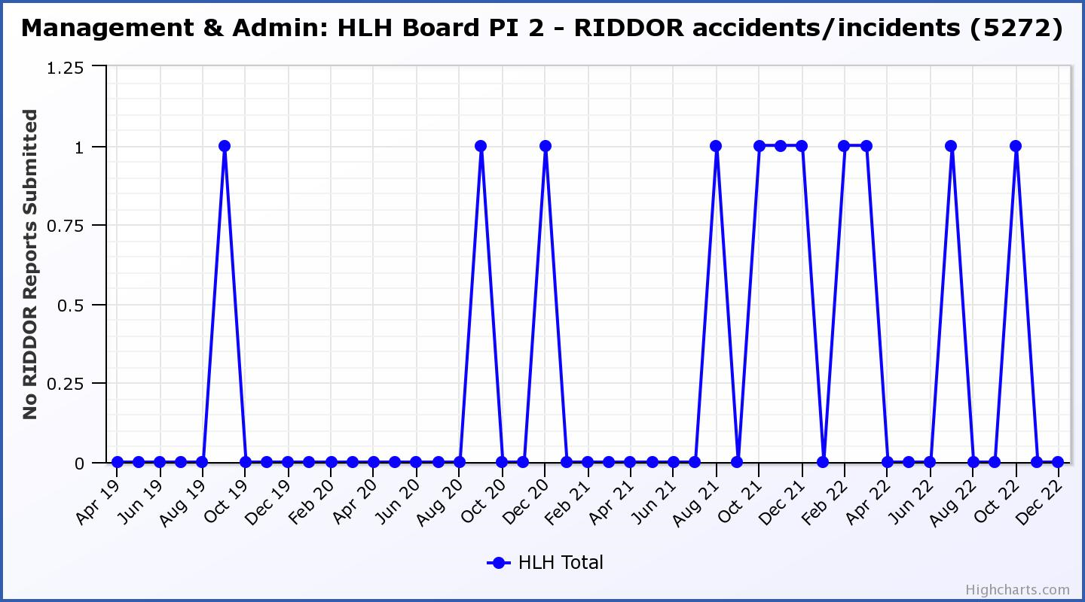

|  |  |  |  |  |  |  |  |  |
| --- | --- | --- | --- | --- | --- | --- | --- | --- |
| **Business Plan Outcome** | **Performance Indicator** | **Reporting Frequency** | **RAG Rating Definition** | **RAG Rating Q1 22/23** | **RAG Rating Q2 22/23** | **RAG Rating Q3 22/23** | **RAG Rating Q4 22/23** | **Summary of Quarter Three Performance** |
| **2. Commit to the Scottish Government’s zero carbon targets and maintain the highest standards in environmental compliance.** | 3. The HLH Environmental strategy will be developed in partnership with the Council as it develops its plans. | . |  | N/A | N/A | N/A |  | N/A - Performance indicators will be identified through the development of these plans and will be aligned with THC’s carbon reduction strategy given the contractual (particularly property) arrangements that there are in place between THC and HLH. |

|  |  |  |  |  |  |  |  |  |
| --- | --- | --- | --- | --- | --- | --- | --- | --- |
| **Business Plan Outcome** | **Performance Indicator** | **Reporting Frequency** | **RAG Rating Definition** | **RAG Rating Q1 22/23** | **RAG Rating Q2 22/23** | **RAG Rating Q3 22/23** | **RAG Rating Q4 22/23** | **Summary of Quarter Three Performance** |
| **2. Commit to the Scottish Government’s zero carbon targets and maintain the highest standards in environmental compliance.** | 4. Travel (a target to reduce by 50% following the pandemic has been set) | Quarterly. | 1. Green = 400,000 miles p.a. or less 2. Amber = up to 5% greater than target 3. Red = more than 5% of target. | Red | Red | Red |  | A ceiling of 400,000 miles p.a. or less was set for this PI, half of the pre-pandemic travel miles. This has been a challenging target to achieve, however, progress has been made and travel for the first three quarters of this year have been 56% of pre-pandemic travel. |

**Performance Indicator 4 – Travel Miles**

The graph below shows the travel miles for the previous two years and will be used as a basis for monitoring travel during the current year. The total Miles for Q3 22/23 were 115,586 and as can be seen on the graph, there has been a downwards trend throughout 2022/23.

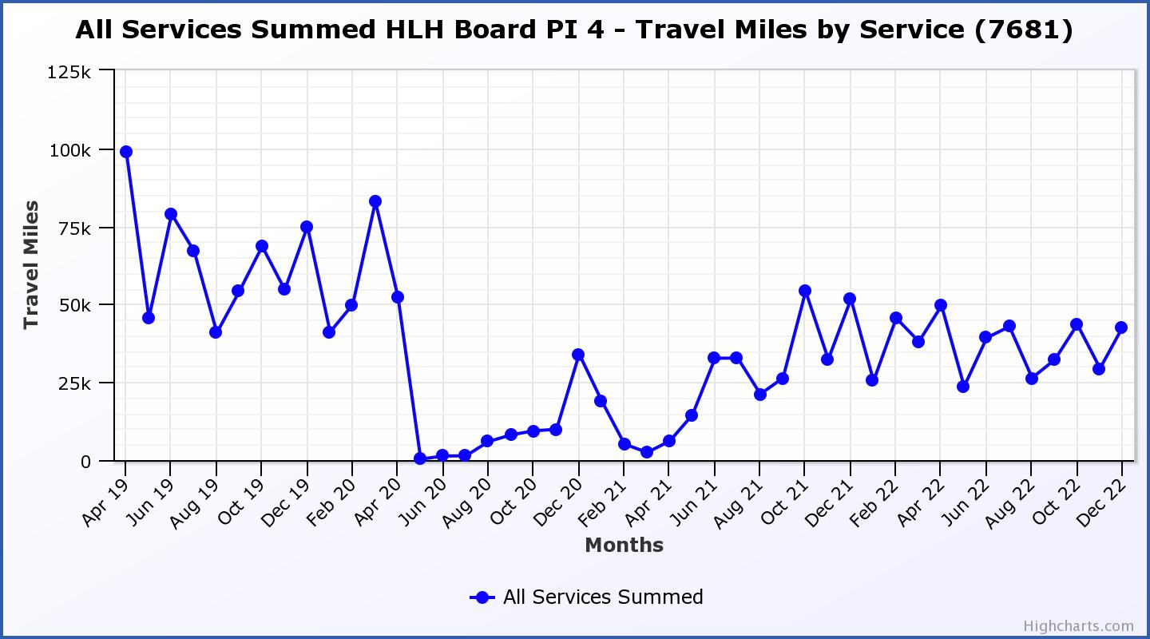

|  |  |  |  |  |  |  |  |  |
| --- | --- | --- | --- | --- | --- | --- | --- | --- |
| **Business Plan Outcome** | **Performance Indicator** | **Reporting Frequency** | **RAG Rating Definition** | **RAG Rating Q1 22/23** | **RAG Rating Q2 22/23** | **RAG Rating Q3 22/23** | **RAG Rating Q4 22/23** | **Summary of Quarter Three Performance** |
| **3. Use research and market analysis to develop and improve services to meet customer needs.** | 5. Customer engagements. | Quarterly. | 1. Green = customer numbers are the same as or have increased compared with the corresponding quarter in the previous year 2. Amber = customer numbers are less than the corresponding quarter in the previous year. 3. Red = customer numbers are more than 5% lower than the corresponding quarter in the previous year. | Green | Green | Green |  | Customer engagements increased from 1,652,537 in Q3 2021/22 to  2,057,579 in Q3 2022/23.  Customer numbers have recovered to pre-pandemic levels with there having been 58,880 more customer engagements in Q3 this year compared with the same quarter in 2019/20.  This PI will be reported in more detail at the June HLH Board meeting once the financial year is complete. |

**Performance Indicator 5 - Customer engagements**

Customer numbers are showing an increase compared with quarter three 2021/22 and are close to pre-pandemic numbers.

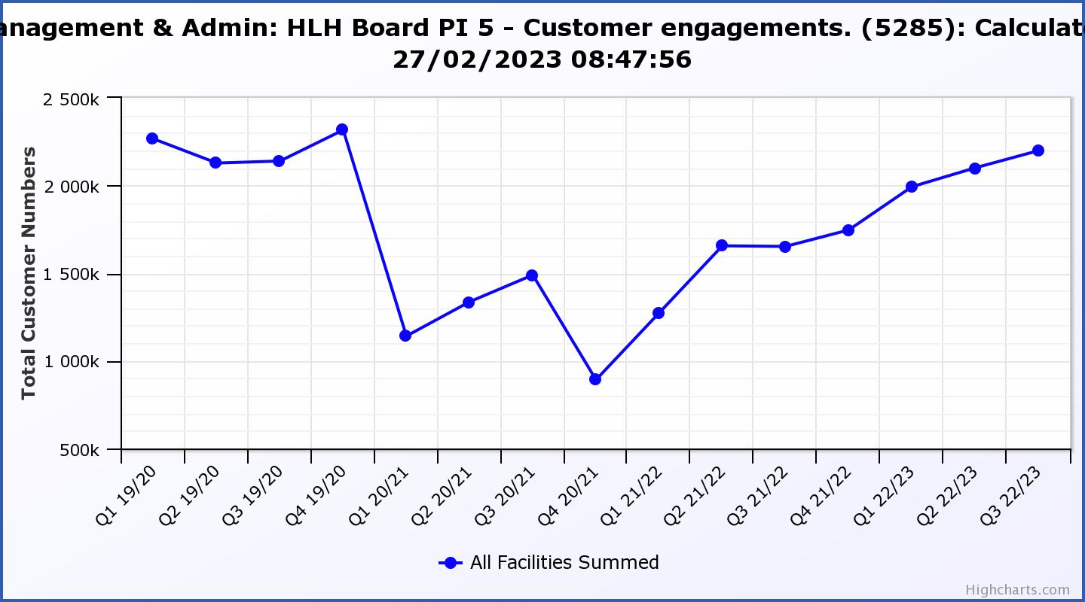

|  |  |  |  |  |  |  |  |  |
| --- | --- | --- | --- | --- | --- | --- | --- | --- |
| **Business Plan Outcome** | **Performance Indicator** | **Reporting Frequency** | **RAG Rating Definition** | **RAG Rating Q1 22/23** | **RAG Rating Q2 22/23** | **RAG Rating Q3 22/23** | **RAG Rating Q4 22/23** | **Summary of Quarter Three Performance** |
| **3. Use research and market analysis to develop and improve services to meet customer needs.** | 6. Charity-wide customer satisfaction survey | Annually. | 1. Green = Services delivered by HLH is above average 2. Amber = Services delivered by HLH is average 3. Red = Services delivered by HLH is below average. | Green | N/A | N/A |  | This performance indicator was reported in more detail at the June 2022 HLH Board meeting. |

|  |  |  |  |  |  |  |  |  |
| --- | --- | --- | --- | --- | --- | --- | --- | --- |
| **Business Plan Outcome** | **Performance Indicator** | **Reporting Frequency** | **RAG Rating Definition** | **RAG Rating Q1 22/23** | **RAG Rating Q2 22/23** | **RAG Rating Q3 22/23** | **RAG Rating Q4 22/23** | **Summary of Quarter Three Performance** |
| **4. Increase employee satisfaction, engagement and development to improve staff recruitment and retention.** | 7. Staff turnover (resignations as a percentage of posts). | Quarterly. | 1. Green = 1.6% or less. 2. Amber = 1.7 to 2% 3. Red = more than 2% | Green | Amber | Green |  | The number of resignations per month as a percentage of posts in Q3 was 0.7% in October, 0.7% in November and 0.4% in December. Please see the HR report elsewhere on this agenda for further information. |

**Performance Indicator 7 - Staff Turnover (resignations as a percentage of posts)**

The graph below shows resignations as a percentage of the number of posts on October, November and December have reduced to a similar level to previous years (1% equates to 10.6 staff).

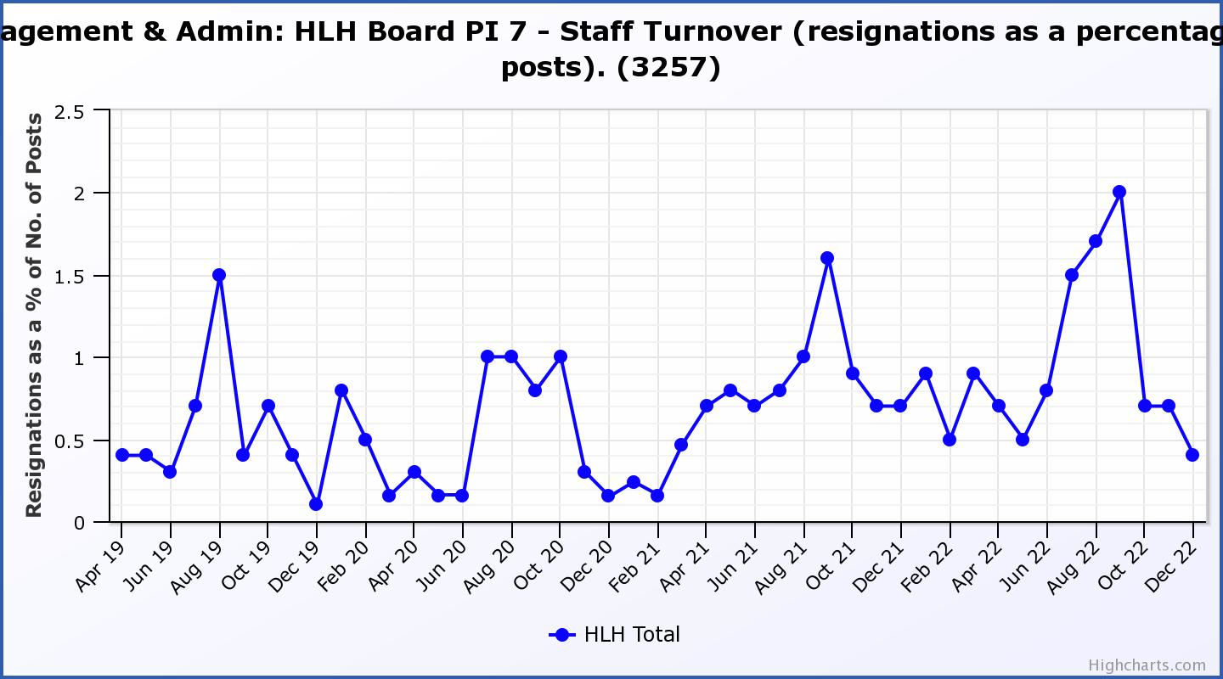

|  |  |  |  |  |  |  |  |  |
| --- | --- | --- | --- | --- | --- | --- | --- | --- |
| **Business Plan Outcome** | **Performance Indicator** | **Reporting Frequency** | **RAG Rating Definition** | **RAG Rating Q1 22/23** | **RAG Rating Q2 22/23** | **RAG Rating Q3 22/23** | **RAG Rating Q4 22/23** | **Summary of Quarter Three Performance** |
| **4. Increase employee satisfaction, engagement and development to improve staff recruitment and retention.** | 8. Staff attendance rates (RAG ratings based on Office for National Statistics for 2020 of absence rate). | Quarterly. | 1. Green = attendance rate 98% or higher. 2. Amber = attendance rate between 97% and 98%. 3. Red = attendance rate less than 97%. | Red | Red | Red |  | The attendance rate for Q3 was 95.27%. Please see the HR report elsewhere on this agenda for further information. |

**Performance Indicator 8 - Staff Attendance Rate**

Staff attendance rates for Q3 were 95.27%. Please see the HR report elsewhere on this agenda for further information. 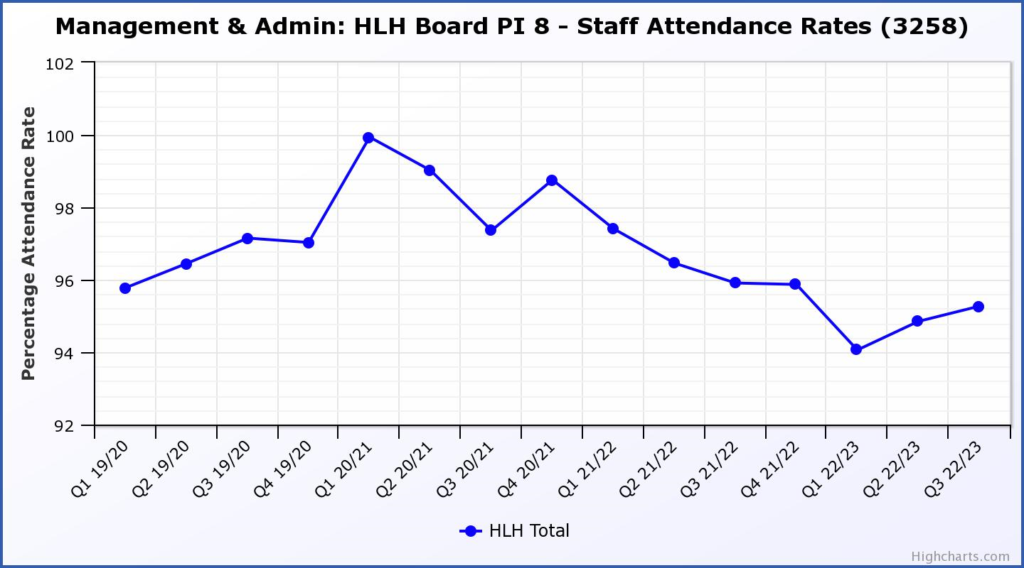

|  |  |  |  |  |  |  |  |  |
| --- | --- | --- | --- | --- | --- | --- | --- | --- |
| **Business Plan Outcome** | **Performance Indicator** | **Reporting Frequency** | **RAG Rating Definition** | **RAG Rating Q1 22/23** | **RAG Rating Q2 22/23** | **RAG Rating Q3 22/23** | **RAG Rating Q4 22/23** | **Summary of Quarter Three Performance** |
| **5. Improve the financial sustainability of the company** | 9. Financial monitoring. | Quarterly. | An assessment of the year end outturn where:   1. Green = delivery of services within budget. 2. Amber = delivery of services between break-even and 2% over budget. 3. Red = delivery of services over budget above 2%. | Red | Red | Red |  | There is further information in the Finance Report elsewhere on this agenda. |

**Performance Indicator 9 - Financial Monitoring**

See the Finance Report elsewhere on this agenda for further information.

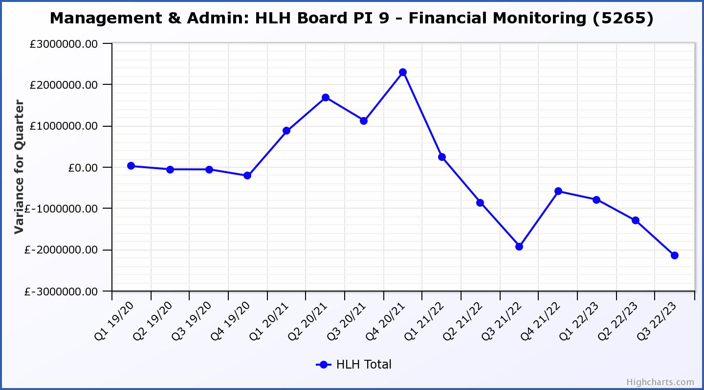

|  |  |  |  |  |  |  |  |  |
| --- | --- | --- | --- | --- | --- | --- | --- | --- |
| **Business Plan Outcome** | **Performance Indicator** | **Reporting Frequency** | **RAG Rating Definition** | **RAG Rating Q1 22/23** | **RAG Rating Q2 22/23** | **RAG Rating Q3 22/23** | **RAG Rating Q4 22/23** | **Summary of Quarter Three Performance** |
| **5. Improve the financial sustainability of the company** | 10. Reserves | Annual. | 1. Green = meets 3% reserves policy 2. Amber = achieves 2% reserves 3. Red = fails to achieve 2% reserves policy. | Green | Red | Red |  | While it is forecast that there will be reserves at the year end, this PI has been RAG rated as red because of the need to earmark funding for pay modelling and the planned use of reserves to balance the budget in 2023/24. |

**Performance Indicator 10 - Financial Reserves**

HLH has been able to build up reserves to protect services and jobs during 2021/22 based on Government and customer support. Reserves at the year end exceeded the 3% reserves policy however some reserves are required to operate during the current financial year. It is anticipated that reserves will be less than 2% (RAG rated red) by the end of 2022/23.

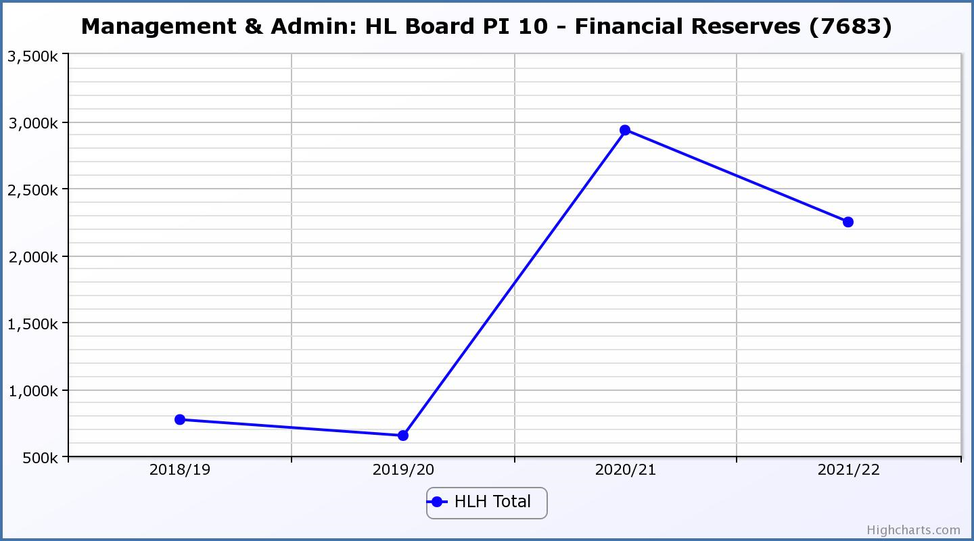

|  |  |  |  |  |  |  |  |  |
| --- | --- | --- | --- | --- | --- | --- | --- | --- |
| **Business Plan Outcome** | **Performance Indicator** | **Reporting Frequency** | **RAG Rating Definition** | **RAG Rating Q1 22/23** | **RAG Rating Q2 22/23** | **RAG Rating Q3 22/23** | **RAG Rating Q4 22/23** | **Summary of Quarter Three Performance** |
| **5. Improve the financial sustainability of the company** | 11. Number of *high****life*** subscriptions (target is the required number to meet the budget). | Quarterly. | 1. Green= exceeds budgeted income target. 2. Amber = risk of budget target not being met. 3. Red = budgeted income target unlikely to be met. | Red | Red | Red |  | This PI has been RAG rated red because subscriptions have been insufficient to meet the income targets set in the budget during quarter three. Subscriptions increased to 17,711 in January and at the time of writing in February were 18,110. A price increase for 2022/23 could bring income to pre-pandemic levels. Please see section 3 of this report for further information. |

**Performance Indicator 11 - Number of High Life Subscriptions**

Subscriptions continued to increase throughout the previous quarter. The growth in subscriptions, while better than it has ever been was insufficient to meet income targets and was particularly good in January and February. There is further information in section three of this report.

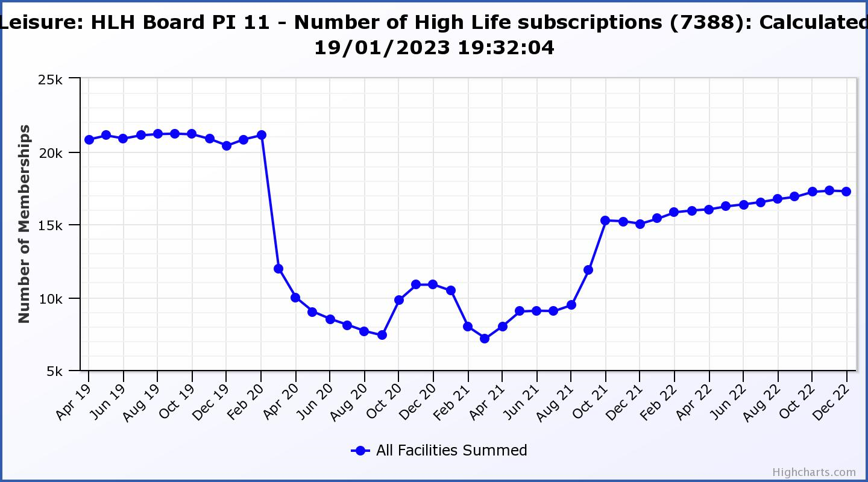

|  |  |  |  |  |  |  |  |  |
| --- | --- | --- | --- | --- | --- | --- | --- | --- |
| **Business Plan Outcome** | **Performance Indicator** | **Reporting Frequency** | **RAG Rating Definition** | **RAG Rating Q1 22/23** | **RAG Rating Q2 22/23** | **RAG Rating Q3 22/23** | **RAG Rating Q4 22/23** | **Summary of Quarter Three Performance** |
| **6. Value and strengthen the relationship with THC.** | 12. Delivery of the Service Delivery Contract (SDC) with The Highland Council (THC). | Six-monthly. | 1. Green = agreement of THC’s Education Committee that HLH has met or exceeded the terms of the SDC. 2. Amber = agreement of THC’s Education Committee that HLH has met the terms of the SDC but has set some improvement targets. 3. Red = agreement of THC’s Education Committee that HLH has not met the terms of the SDC. | N/A | Green | N/A |  | The HLH progress report was considered by the Council’s Education Committee at its meeting held on 23 November 2022. |

|  |  |  |  |  |  |  |  |  |
| --- | --- | --- | --- | --- | --- | --- | --- | --- |
| **Business Plan Outcome** | **Performance Indicator** | **Reporting Frequency** | **RAG Rating Definition** | **RAG Rating Q1 22/23** | **RAG Rating Q2 22/23** | **RAG Rating Q3 22/23** | **RAG Rating Q4 22/23** | **Summary of Quarter Three Performance** |
| **6. Value and strengthen the relationship with THC.** | 13. THC’s annual survey of performance and attitudes. | Annual. | 1. Green = net satisfaction ratings are maintained or improved for three or more areas of HLH work compared with the previous year 2. Amber = two or more areas of HLH work receive lower net satisfaction ratings than the previous year.   Red = all HLH areas of work represented receive lower net satisfaction ratings than the previous year. | N/A | N/A | N/A |  | The annual survey carried out by the Council of its citizens panel is normally available for the August HLH Board. THC expects to be able to undertake the survey in the Winter of this year. A publication date for the report is not available. |

|  |  |  |  |  |  |  |  |  |
| --- | --- | --- | --- | --- | --- | --- | --- | --- |
| **Business Plan Outcome** | **Performance Indicator** | **Reporting Frequency** | **RAG* Rating Definition**  **(*Red/Amber/Green)** | **RAG Rating Q1 22/23** | **RAG Rating Q2 22/23** | **RAG Rating Q3 22/23** | **RAG Rating Q4 22/23** | **Summary of Quarter Three Performance** |
| **7. Develop and deliver the HLH Corporate Programme and seek to attract capital investment.** | 14. The HLH corporate programme covers investment; business process improvement; capital and asset management plans and plans will be developed as this area of work is developed. |  | Should additional performance indicators be identified through the development of these plans they will be added in future. | N/A | N/A | N/A | N/A | N/A |

|  |  |  |  |  |  |  |  |  |
| --- | --- | --- | --- | --- | --- | --- | --- | --- |
| **Business Plan Outcome** | **Performance Indicator** | **Reporting Frequency** | **RAG Rating Definition** | **RAG Rating Q1 22/23** | **RAG Rating Q2 22/23** | **RAG Rating Q3 22/23** | **RAG Rating Q4 22/23** | **Summary of Quarter Three Performance** |
| **8. Use research and market analysis to develop and deliver proactive marketing and promotion of HLH and its services.** | 15. Media coverage from proactively issued media releases | Six-monthly. | 1. Green = Positive coverage 95%+ 2. Amber = Positive coverage 90% - 95% 3. Red = Positive coverage 90%- | Green | N/A | N/A |  | The media officer post has not been filled and this indicator has not been RAG rated. |

|  |  |  |  |  |  |  |  |  |
| --- | --- | --- | --- | --- | --- | --- | --- | --- |
| **Business Plan Outcome** | **Performance Indicator** | **Reporting Frequency** | **RAG Rating Definition** | **RAG Rating Q1 22/23** | **RAG Rating Q2 22/23** | **RAG Rating Q3 22/23** | **RAG Rating Q4 22/23** | **Summary of Quarter Three Performance** |
| **8. Use research and market analysis to develop and deliver proactive marketing and promotion of HLH and its services.** | 16. On-line engagement through social media channels. |  | 1. Green = 5% increase compared with the same period last year. 2. Amber = no increase to 4.9% lower compared with the same period last year. 3. Red = more than 5% lower or less compared with the same period last year. | N/A | Green | Amber |  | Social media engagements were 71,019 in Q3 21/22 to 63,639 in Q3 22/23. Please see section three of this report for further information. |

**Performance Indicator 16 - On-line engagement through social media channels.**

This is a new marketing indicator which counts the on-line engagement through social media channels. The trend this year is an improving one.

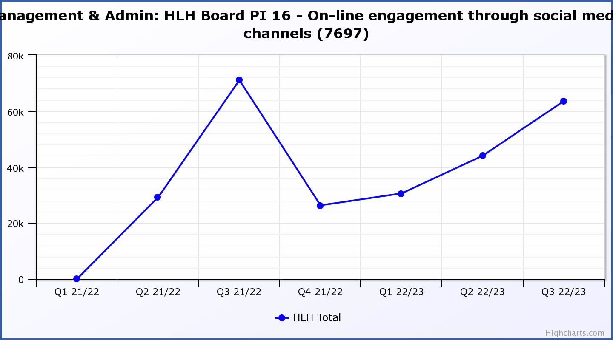

|  |  |  |  |  |  |  |  |  |
| --- | --- | --- | --- | --- | --- | --- | --- | --- |
| **Business Plan Outcome** | **Performance Indicator** | **Reporting Frequency** | **RAG Rating Definition** | **RAG Rating Q1 22/23** | **RAG Rating Q2 22/23** | **RAG Rating Q3 22/23** | **RAG Rating Q4 22/23** | **Summary of Quarter Three Performance** |
| **9. Initiate and implement an ICT digital transformation strategy across the charity** | 17. The HLH digital transformation strategy is yet to be developed. |  | Should performance indicators be identified through the development of these plans they will be added in future. | N/A | N/A | N/A | N/A | N/A |

|  |  |  |  |  |  |  |  |  |
| --- | --- | --- | --- | --- | --- | --- | --- | --- |
| **Business Plan Outcome** | **Performance Indicator** | **Reporting Frequency** | **RAG Rating Definition** | **RAG Rating Q1 22/23** | **RAG Rating Q2 22/23** | **RAG Rating Q3 22/23** | **RAG Rating Q4 22/23** | **Summary of Quarter Three Performance** |
| **10. Develop and strengthen relationships with customers, key stakeholders and partners** | New approach to customer survey as per Business Outcome 3 above.  Same as PI 6 - Charity-wide customer satisfaction survey | Quarterly | - | N/A | N/A | N/A | N/A | N/A |

|  |  |  |  |  |  |  |  |  |
| --- | --- | --- | --- | --- | --- | --- | --- | --- |
| **Business Plan Outcome** | **Performance Indicator** | **Reporting Frequency** | **RAG Rating Definition** | **RAG Rating Q1 22/23** | **RAG Rating Q2 22/23** | **RAG Rating Q3 22/23** | **RAG Rating Q4 22/23** | **Summary of Quarter Three Performance** |
| **10. Develop and strengthen relationships with customers, key stakeholders and partners** | 18. Partnership work with **sport**scotland and other sports related organisations, NHS Highland and other health related organisations (including Memoranda of Understanding) etc. | Annual | 1. Green = Growth in partnership working 2. Amber = continuation of current level of partnership work 3. Red = cancellation of Partnership Agreements | N/A | N/A | Green | N/A | Please see information on partnerships in **Appendix C** of this report. |

|  |  |  |  |  |  |  |  |  |
| --- | --- | --- | --- | --- | --- | --- | --- | --- |
| **Business Plan Outcome** | **Performance Indicator** | **Reporting Frequency** | **RAG Rating Definition** | **RAG Rating Q1 22/23** | **RAG Rating Q2 22/23** | **RAG Rating Q3 22/23** | **RAG Rating Q4 22/23** | **Summary of Quarter Three Performance** |
| **11. Deliver targeted programmes which support and enhance the physical and mental health and wellbeing of the population and which contribute to the prevention agenda.** | 19. An assessment of the RAG rating of the Health and Wellbeing Strategy action plan. |  | 1. Green = 80% or more of the actions are RAG rated green 2. Amber = 60% to 79% of actions are green. 3. Red = 59% or less are rated green. | N/A | N/A | Green | N/A | Please see the Health and Wellbeing report elsewhere on this agenda. |

**Appendix C**

**Summary of partnership work by each of the HLH areas of work**

There are a number of partnerships that High Life Highland is involved in to deliver services and make life better for the people of the Highlands. HLH’s role varies from being the lead organisation, the main supporting partner or working as one of a number of partners in a group. Some partnerships exist because of funding arrangements, with the most significant ones being with **sport**scotland; NHS Highland; and the Council (for funding for projects which are in addition to the services specified in the Service Delivery Contract). There is further information on the partnership with NHS Highland in the Health and Wellbeing Report elsewhere on this agenda.

This appendix describes the range of partnerships which HLH is involved in by each of the HLH areas of work.

**Adult Learning** – The adult learning team continues to deliver much of its work in partnership with other organisations, focusing on the literacy and numeracy aspects of support which people require, including English for speakers of other languages (ESOL) provision. The following represent the more formal and pan Highland partnerships. LEAD Scotland (Learning organisation focus on people with disabilities); Workers Education Association (WEA); UHI; Highland Third Sector Interface (HTSI); THC (for refugee resettlement projects); Education Scotland (policy and development); Northern Alliance Regional collaborative; Learn North Community Learning and Development; Highland Adult Learning and Development Group, (HLH co-chair with third sector representative).

**Archives –** In Caithness**,** the Archives service is a formal subcontractor of Restore Digital, the information management company contracted by the Nuclear Decommissioning Authority to run Nucleus in Wick, the national archive of the British civil nuclear industry and the archive for the County. HLH is currently contracted to deliver all of Nucleus' customer facing service, both in Nucleus and out and about in community settings. The current contract, value £132k pa, comes to an end this year and Restore has submitted a retender application, again with HLH as its subcontractor. A decision is expected in April 2023.

Linked to the Memorandum of Understanding with UHI, Archives collaborates with several sections of UHI on a wide range of activities. Some collaborations are short-life projects, including Prescribe Culture and the People's Archive in Rural Scotland.

Am Baile is currently working closely with the Inverness Caledonian Thistle Community Trust to consolidate and grow the Inverness Football Memories project and related activities.

All four archive centres also work in informal partnerships with a wide variety of third sector and community groups. These include Eden Court Theatre, Dounreay Heritage Group, HMP Inverness, local care homes, Sabhal Mòr Ostaig, West Highland Museum and many more.

**Arts -** In a partnership with Creative Scotland the Visual Arts Unit manage the Visual Artist and Craft Makers Awards (VACMA) scheme in the Highland, Moray and Western Isles area. VACMA offers small grants to visual artists and craft makers for their creative development at all stages of their career. Each year, approximately thirty artists and makers receive support from the scheme.

The Visual Arts Unit also has a longstanding partnership with the National Galleries of Scotland (NGS). This has resulted in a number of NGS curated exhibitions of the highest quality being shown at Inverness Museum and Art Gallery (IMAG), the most recent being an exhibition by Alison Watt.

Related to the Memorandum of Understanding with UHI the Unit provides an annual placement for a final year Fine Art undergraduate. It also collaborates with UHI from time to time on short-life projects and is currently participating in the Prescribe Culture initiative.

**Catering** – The catering team has been working on a food resilience project with the Council and other partners through The Hot Lunch at Hilton project. It is funded by the Highland Council, through its Cost-of-Living Support Grant Scheme. The other organisations involved are; Hilton Family Support, Hilton Church, Citizen’s Advice and Community Police. HLH provides free hot lunches 3 days per week until Easter serving around 150-200 meals per week.

**Countryside Rangers** – The countryside ranger team is involved in a range of project and standing partnerships as follows:

The Green Health Partnership: operates under the branding "Think Health Think Nature" and is one of four area-wide partnerships developed and funded by NatureScot. It aims to encourage more use of the outdoors to tackle physical inactivity, mental health issues and health inequalities. The partnership is made of representatives from High Life Highland (HLH), NHS Highland; NatureScot; The Highland Council; The Cairngorms National Park Authority (CNPA); The University of the Highland and Islands (UHI), The Highland Environment Forum; The Highland Third Sector Interface (HTSI); Paths for All; Forest and Land Scotland and practitioners in the environment, health and social care sectors.

Highland Adapts: is a Highland Council partnership initiative to work with statutory agencies such as NHS Highland, Forestry & Land Scotland and SEPA as well as representatives from communities, businesses, land managers and public sector to facilitate transformational action towards a prosperous, climate ready Highland to look at how the Highlands adapt to climate change.

Highland Environment Forum & Highland biodiversity action plan 2021 - 2026: The Edinburgh Declaration (2021) sets out the aspirations and commitments of the members of the international community, the Scottish Government, its partners, and the wider sub-national community working in biodiversity in delivering for nature over the coming decade. Highland Council met in December 2022 with NatureScot to underline the commitment to tackle the climate and ecological emergency and mark the official signing of the Edinburgh Declaration. The Highland Nature: Biodiversity action plan 2021 - 2026 is the call to action. This plan was created through surveys and meetings with Highland Environment Forum members and the wider public, and through the commitments undertaken by partners. This work is overseen and coordinated by the Highland Environment Forum’s Biodiversity Working Group.

There is a range of current partner funded projects where HLH Ranger service is the lead delivery partner:

* HTSI - Mental Health in communities fund- Healthy Minds delivery in Badenoch and Strathspey (lead Saranne Bish)- targeted work with clients who have diagnosed mental illness. Both direct NHS and self-referrals. Partners: NHS; HTSI; CNPA; Forest and Land Scotland.
* MGC - Year of Stories fund - Weaving Tales: Capturing the spirit of the Lochaber region in a heritage sewing project lead by one of the countryside rangers. Creation of a story quilt, now on permanent display at Fort William Library. Project was completed in February 2023
* Connecting Carers direct funding - targeted green health walks for those with caring responsibilities Status
* THC/NatureScot Nature Restoration Fund Project Grant: Highland Wildflower Meadow Mosaic HLH Ranger service to undertake the creation of 30-40 wildflower meadow sites across Highland Council Area– just awarded

**Leisure** – some of the facilities operated by the leisure team are in partnership with community groups who own/manage local facilities and this is done in partnership with them. The partnerships include: Tongue and Farr Sports Association; Ullaspool Board; Poolewe Board; Puffin Pool Board; Highland Rugby Club; Leanaig Advisory Forum; Strathpeffer Pavilion Community Trust; Macphail Centre Board. In addition there are wider partnerships such as with UHI for training with students for the National Pool Lifeguard Qualification and as sports and group exercise instructors.

**Libraries** – There are a rangeof projects ranging from local to area wide partnerships including:

Work with UHI to support opportunities for PHD collaborations - libraries have just commenced working with a PHD student who will be researching how young people and other age groups interact with nature and the environment through the reading of a selection of environmental literature. To support the research the student will be setting up and delivering book groups both in-person and online with the focus being on eco-literature. It is hoped that the project will attract customers that would otherwise not be engaging with libraries, or at least are not current book group attendees. The project and research will take place over a three year period and will be continuously evaluated throughout this period. The legacy from the initiative will include a book group model that facilitates the group to be community-led (with support from libraries) after the project ends.

‘Meet The Books’ workshops continue at Inverness Library, in collaboration with UHI. This is a series of interactive workshops that introduce students and the wider community to High Life Highland’s special collections, including the Fraser-Mackintosh Library. These monthly workshops have an average of 12 attendees at each event, there are plans to develop the model to include an online platform, potentially reaching a wider audience. ‘Meet The Books’ sessions for families were also trialled last year, with great success. The session was fully subscribed with 30 families attending and 80 families on the waiting list. HLH are currently working with UHI to find a sustainable model that will enable regular family sessions to take place.

Work with the Scottish Libraries and Information Council (SLIC) to participate in expansion of the “one card” initiative with other Scottish Library services. This is a national initiative that forms part of the National Libraries Strategy. The initiative allows anyone living in Scotland that is in receipt of a library membership to use it anywhere throughout the country, offering the customer improved convenience and ease of access. The initiative is currently limited to North of Scotland library authorities and so far there has been a very limited uptake. It is expected that demand for the service will increase with a focus on a national marketing campaign and expansion of the initiative to all authorities across Scotland.

Work with NHS Highland to host Community-led Support Hubs - In collaboration with NHS Highland, a Community-led Support Hub has been set up at Nairn Library. The Hub connects people to the broad range of services in communities which benefit and enable health and wellbeing. Anyone that requires advice can drop in or individuals can be referred through their local health practitioners. The hub has been in operation since last Summer. Attendee numbers vary greatly from month to month, ranging from 5- 32 attendees per session. Feedback from those who use it has been very positive, one customer was able to be directly referred to the hub by library staff. The mum had come into the library to look for resources to support her autistic son and by dropping into the hub later in the day she was able to get further support from a health adviser.

**Museums -** Along with four other Highland Museums, Inverness Museum and Art Gallery (IMAG) is participating in a year-long collaboration with Smartify, the sector leading digital platform for museums. This opportunity became available through collaboration with Museums & Heritage Highland and XPO North Digital (support organisation for creative and heritage groups).

Through a formal partnership with Historic Environment Scotland (HES) the Highland Folk Museum (HFM) hosts an HES Trainee Fellowship. This is a full time, craft worker member of staff based at HFM for a period of one year. The Fellow is an HES employee but managed and trained on a day-to-day basis by HFM staff.

HFM also works in informal partnerships with variety of community groups, including providing an outdoor classroom facility for Newtonmore Primary School and providing resources and activities for the Badenoch Shinty Memories group.

IMAG is part of the Prescribe Culture formal partnership, which is related to the Memorandum of understanding with UHI.

IMAG also has several longstanding and productive collaborative working partnerships with a number of third sector and community groups, including Alzheimer’s Scotland, local Brownie groups, Connecting Carers, WASPS and many more.

**Music Tuition** – has traditionally had good partnerships with the National Youth Orchestras of Scotland and these are being redeveloped after the pandemic with a focus on developing an outreach partnership. There is work underway with the Royal Conservatoire of Scotland (Highland Young Musicians groups) and rebuilding relationships with all the other national professional orchestras following Covid dip and staff changes in many of these organisations.

**Outdoor Activities** – the work the team does with schools has reduced because of financial constraints on schools but both the Council and UHI have a need for MiDAS (Minibus driver training) delivery and the Outdoor Activities Officer is filling that gap.

**Sports Development** – The main partnership in sport is a partnership agreement between the Council and **sport**scotland. High Life Highland delivers the Council’s responsibilities in the agreement. There are three main elements to it:

* Active Schools programme - two thirds of the funding (£953,872) which allows for the deployment of an Active Schools Coordinator in each associated school group providing free access to activities and opportunities for young people across Highland to be active.
* Support for talented athletes to travel for training and competition out with the Highland area (£12K funding)
* Community Sport Hubs sportscotland (£100,726) which funds the employment of two community sport hub officers with the programme aimed at bringing together clubs, community and other organisations to improve access to sport and physical activity opportunities for all ages at local level. HLH supports 12 community sport hubs across the Highland area.

A new four-year partnership agreement from financial year 2023/24 is being developed with an emphasis on Equality, Diversity and Inclusion. The partnership is strong, relationships are good. There are also formal partnership arrangements with Scottish Rugby Union and Scottish Disability Sports formal partnerships with focused National Governing Bodies for Sport. Both these partnerships are positive though need to be developed.

There are emerging partnerships with the Highland Council (Home to Highland Care Experienced Education Team) supporting care experienced young people and the Highland Alcohol and Drugs Partnership Planet Youth initiative. These partnerships are in their infancy but are developing well.

**Youth Work –** the HLH youth service works closely in many partnerships increasingly those where additional funding and projects are involved. The following are the more formal ones: Ecologia Trust; THC - My Future My Success; THC Highland Coastal Communities fund; Young Scot; Youth Scotland; Youth Link Scotland; DofE; Local Authority Youth Work Managers Scotland; Highland Science Skills Academy. The adult learning partnerships are also relevant to this area of work.