HIGH LIFE HIGHLAND  REPORT TO BOARD OF DIRECTORS  13 JUNE 2023 | AGENDA ITEM 10  REPORT No HLH / /23

Quarter Four Performance Report - Report by Chief Executive

Recommendation

The purpose of this report is to present performance information for the period January to March 2023.

It is recommended that Directors:

- comment on the report and agree that the overall health check on the charity for that period is RAG rated as “amber”;
- note that the actions taken to address the budget situation with the Council for financial year 2022/23 could help to address the amber RAG rating during the current financial year, however, inflation and in particular, staff pay inflation will continue to have an impact;
- note that customer numbers have recovered to pre-pandemic levels;
- agree that the executive team review the staff attendance RAG rating definition for future reports;
- approve the travel RAG rating to include all travel in section 3 of this report; and
- agree that the executive team review the need for the strategies/plans where performance indicators have not been developed given the changed focus which has been required given the post-pandemic operating period.

1. | Business Plan Contribution
1.1 | This report supports all the Business Outcomes from the High Life Highland (HLH) Business Plan 2022-27  - Seek to continuously improve standards of health and safety.  - Commit to the Scottish Government’s zero carbon targets and maintain the highest standards in environmental compliance.  - Use research and market analysis to develop and improve services to meet customer needs.  - Increase employee satisfaction, engagement and development to improve staff recruitment and retention.  - Improve the financial sustainability of the company.  - Value and strengthen the relationship with THC.  - Develop and deliver the HLH Corporate Programme and seek to attract capital investment.  - Use research and market analysis to develop and deliver proactive marketing and promotion of HLH and its services.  - Initiate and implement an ICT digital transformation strategy across the charity.  - Develop and strengthen relationships with customers, key stakeholders and partners.  - Deliver targeted programmes which support and enhance the physical and mental health and wellbeing of the population and which contribute to the prevention agenda.
2. | Background
2.1 | The implementation of the HLH Business Plan 2022-27 is monitored through a set of performance indicators set by the Board at its meeting held on 31 March 2022. Nineteen performance indicators (PIs) were identified by the HLH Board to assess the overall performance of the charity at its meeting held on 31 March 2022.
3. | Summary of Performance
3.1 | Appendix A contains a summary of performance against the PIs for Q4 2022/23. Appendix B provides a list of all the PIs along with trend information. 11 PIs are scheduled for assessment at the June 2023 HLH Board meeting. Of those, 6 have been RAG rated green; zero amber; and 5 red.
3.2 | The 5 indicators which have been RAG rated as red are: PI 4 Travel; PI 8 staff attendance rate; PI 9 Financial Monitoring; PI 10 Financial Reserves; and PI 11 High Life subscriptions.
3.3 | PI 4 Travel – A ceiling of 400,000 (grey fleet) travel miles (approx. half of pre-pandemic) was set for the organisation. Travel miles in 2022/23 were 449,773. All services have successfully reduced grey fleet travel. However, this was RAG rated as red being above the target.
3.4 | The organisation also uses Enterprise Car Hire and this is now being recorded, as is the official fleet (mobile libraries and countryside ranger vehicles). The official fleet mileage is closely linked with service delivery but should also be monitored to achieve a balance between seeking to minimise environmental impact and service delivery. With the grey fleet travel mileage having been set without experience of post-pandemic travel and having almost halved, and taking account of enterprise car and fleet miles, it is proposed that all travel be combined into a single indicator at Board level and the following RAG ratings being used in future:  - Green = no more than 10% above the same period last year  - Amber = 10.1 to 20% compared with the same period last year  - Red = more than 20.1% compared with the same period last year
3.5 | PI 8 Staff Attendance Rate – This PI is covered in the HR report elsewhere on this agenda.
3.6 | PI 9 Financial Monitoring and PI 10 Financial Reserves – These PIs are covered in the finance report elsewhere on this agenda.
3.7 | PI 11 High Life Subscriptions – Subscriptions were RAG rated as red because they were insufficient to meet the budgeted income target for financial year 2022/23.
3.8 | If April subscriptions were to have been RAG rated they would be green, on target, because they were sufficient to meet the budgeted income target. The price increase in April (which was agreed as part of the budget setting process) has delivered against what the HLH Board set out to achieve. The graph below shows subscriptions income which has exceeded pre-pandemic levels. Having done this with fewer subscriptions than pre-pandemic there is a level of confidence that there is capacity for subscriptions income to continue to grow.  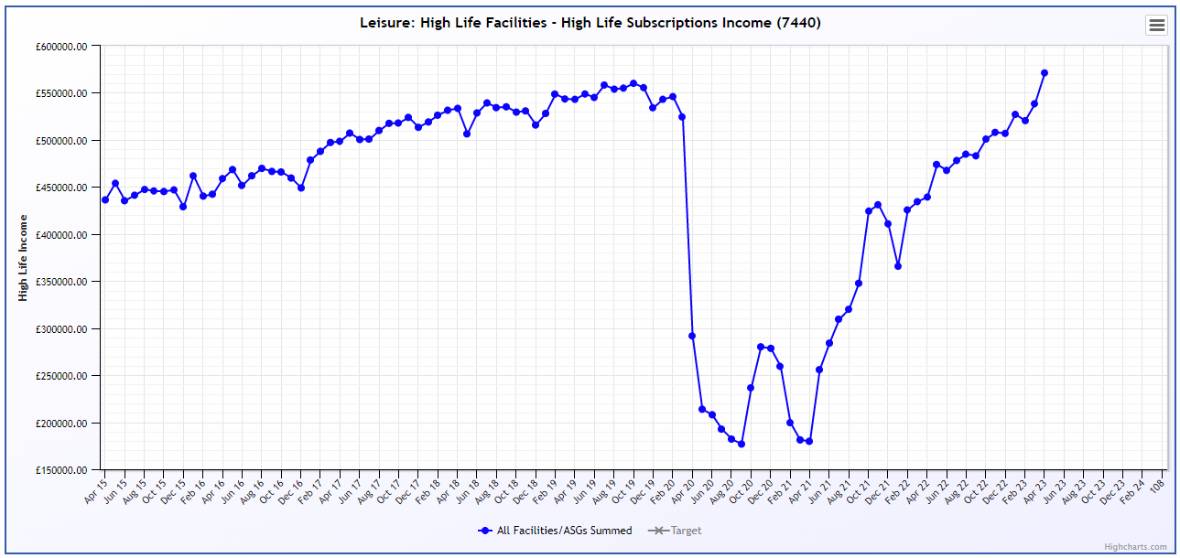
3.9 | In April, cancellations were higher than the normal background level at 5% (background level is 3-4% each month). Fewer than 1% of respondents normally cite the price increase as a reason for cancelling and this increased to 8% in March (which is when customers were written to) and was 5% in April. The tables below list the top six reasons for cancelling provided by customers in the exit survey in March and April (note that the price increase was not in the top six reasons in April). While the price increase accounts for more of the cancellations than normal, they were lower than the estimated number which has allowed the April budget target to be achieved.  March Main Reasons for Cancelling % Respondents April Main Reasons for Cancelling % Respondents  1. Lack of use 29% - Lack of use 29%  2. Lack of time 12% - Climbing Wall 15%  3. Moved away from the Highlands 11% 3= Moved away from the Highlands 11%  4. Climbing wall closure 10% 3= Lack of time 11%  5= Affordability 8% 4= Affordability 8%  5= Price Increase 8% 4= No longer meets my needs 8%
4. | Performance Indicators for More Detailed Consideration
4.1 | Each quarter more detailed information is provided on one or more of the performance indicators and the following performance indicators are scheduled for inclusion at the June meeting:  1. External health and safety audit  2. RIDDOR accidents/incidents  5. Customer Engagements  12. Delivery of the Service Delivery Contract (SDC) with The Highland Council (THC).
4.2 | PI 1. External health and safety audit and PI 2. RIDDOR accidents/incidents are both covered in the Annual Health and Safety Report elsewhere on this agenda.
4.3 | PI 5 - Customer engagements. Customer engagements have recovered to pre-pandemic levels and within that there has been a shift towards digital engagements. The graph below shows total customer engagements, this is made up of physical attendances and on-line engagements (recorded in accordance with the Local Government Benchmarking Framework) and as can be seen, customer engagements last financial year exceeded the pre-pandemic year at just over 9m.
4.7 | Appendix C shows a breakdown of total customer engagements for each of the HLH areas of work. Archives, libraries and youth work numbers exceeded pre-pandemic levels. For archives, both in-person and on-line engagements increased. The libraries increase was due to an increase in on-line engagement through its digital resources. The youth work engagements represent a return to pre-pandemic levels of business.
4.4 | Much of this customer recovery has been due to the innovative work undertaken by staff teams in response to the pandemic and now in the post pandemic operating period, particularly relating to engaging with customers on-line through: digital lending in libraries; archives classes delivered over platforms such as MS Teams and Zoom; and other classes also being delivered on-line.
4.5 | The overall number of in-person engagements are also recovering with physical visits in 2022/23 having exceed 4m. The graph below allows comparison with pre-pandemic in-person customer visits.
4.8 | When calculated over a full financial year, in-person visits to HLH sites and services was 59% of pre-pandemic levels. Pandemic restrictions were fully lifted at the end of April 2022 and customer engagements were initially slow to return. Quarter four recovery was almost 80% which provides a good base for full recovery during the current financial year.
4.6 | Appendix D shows a breakdown of in-person customer engagements for each of the HLH areas of work. Compared with pre-pandemic, customer levels ranged from -60% (outdoor activities) to +13% (archives) with the average having been -31%. For 2022/23 the leisure facilities customer visits figure was 2.1m (28% less than the pre-pandemic level). This will have been, in-part, due to the slow return in the early days following the pandemic with another factor having been reduced opening hours which was required to save staff costs as sites were re-opened during the pandemic; this operating model has been continued because it has saved £640k. While the continuation of the current opening hours is required as part of the measures to balance the budget, income levels are still recovering well and highlife subscriptions income exceeded the pre-pandemic level in April 2023.
4.10 | PI 12. Delivery of the Service Delivery Contract (SDC) with The Highland Council (THC). The Council’s Education Committee considered the HLH Progress Report at its 1 June 2023 meeting and the report can be seen on the Council’s web site here. The committee noted that HLH continues to deliver Public Service Obligations on behalf of the Council as set out in the Service Delivery Contract; and support was expressed for HLH and the services which it delivers on behalf of the Council by Councillors at the meeting.
5. | Financial Year 2022/23 Summary
5.1 | The HLH Board is asked to consider an overall RAG rating for the organisation each quarter and RAG ratings have been as follows:  Q1 Q2 Q3 Q4  Green Amber Amber Amber  This has been largely due to operating in a post pandemic environment and inflation (particularly staff pay inflation) having had an impact. The following indicators have been consistently RAG rated as red: financial monitoring; financial reserves; subscriptions travel; and staff attendance.
5.2 | The indicators which have primarily led to the amber assessments have been financial and the level of subscriptions (also financial as the RAG rating relates to the income target set in the budget). The discussions with the Council and additional support provided from its reserves has allowed an amber (rather than red) RAG rating throughout the year. During the coming financial year, the Service Delivery Contract review will be required to address the sustainability issue and the discussions on the contract and budget with the Council will have to be considered in future RAG rating assessments.
5.3 | Having set a budget based on the experience of almost a year of post-pandemic operating, it could be anticipated that the financial and subscription indicators might return to green during this financial year. However, during the staff pay negotiations so far this year, a 5% offer has been made by CoSLA and rejected by unions. It is therefore expected that inflation, particularly staff pay inflation will continue to have a significant impact.
5.4 | The travel and staff attendance RAG ratings would not, in themselves, have led to an overall amber RAG rating for the organisation. It is proposed that the RAG ratings be reconsidered for future reports and set at a level, where action is taken to address them, is required rather than where heightened monitoring is required (as is the case for staff attendance rates where an assessment of Bradford Factor disruption rates and the causes of long-term absences is regularly carried out to find that there are no significant patterns).
5.5 | There are some indicators which have not been set by the HLH Board because they were based on the development of strategies/plans which are not realistic in terms of the resources required (e.g. carbon reduction and digital transformation) and the focus which has been required on reducing costs and sustaining the organisation. It is recommended that the Chief Executive and executive team be asked to review these.
5.6 | The Council has ceased its annual survey of performance and attitudes through its citizens panel and HLH used this as an additional survey (for the services which were included) and this PI will, therefore, have to be removed from future reporting. While it was a useful check on performance, HLH’s own surveys which include some standard questions will continue to be reported to the Board.
6. | Implications
6.1 | Resource implications – while this report discusses resources and financial implications, there are no resource implications arising from agreeing the recommendations in this report.
6.2 | Equality implications - there are no new equality implications arising from this report.
6.3 | Legal implications - there are no new legal implications arising from this report.
6.4 | Risk implications - there are no new risk implications arising from this report.

Recommendations

It is recommended that Directors:

- comment on the report and agree that the overall health check on the charity for that period is RAG rated as “amber”;
- note that the actions taken to address the budget situation with the Council for financial year 2022/23 could help to address the amber RAG rating during the current financial year, however, inflation and in particular, staff pay inflation will continue to have an impact;
- note that customer numbers have recovered to pre-pandemic levels;
- agree that the executive team review the staff attendance RAG rating definition for future reports;
- approve the travel RAG rating to include all travel in section 3 of this report; and
- agree that the executive team review the need for the strategies/plans where performance indicators have not been developed given the changed focus which has been required given the post-pandemic operating period.

Designation: Chief Executive

Date: 26 May 2023

Author: Douglas Wilby, Director of Sport and Leisure

Appendix A
HLH Performance Indicators - Summary Q4 2022/23  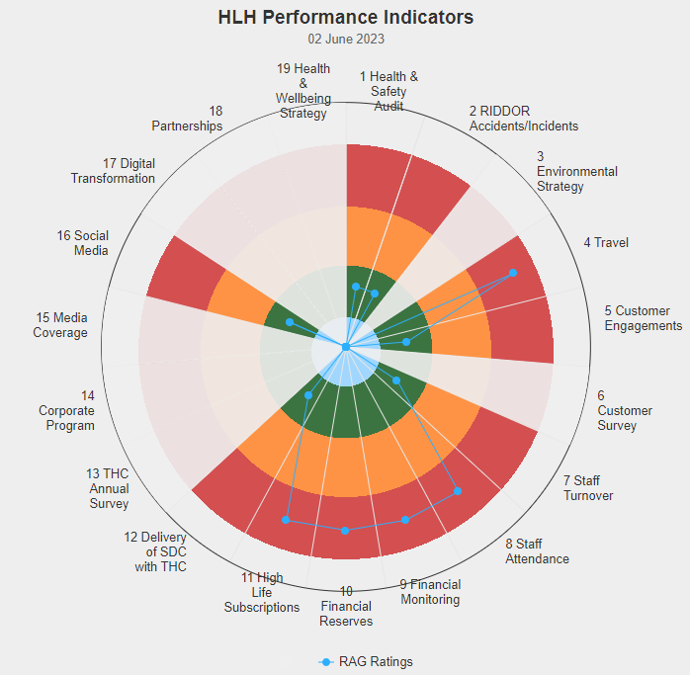 | Nineteen performance indicators (PIs) are used by the High Life Highland Board to assess the overall performance of the charity.  The PIs are RAG rated (allocated a "Red", "Amber" or "Green" status) so that it is easy to see at a glance how the organisation is performing. Most of the PIs are RAG rated every quarter throughout the year, with some (such as partnership working with NHSH for example) being considered annually so greyed out sectors on this radar diagram mean that the PI is to be considered at a future HLH Board meeting.

Appendix B
HLH Performance Indicators - Detail Q4 2022/23

Business Plan Outcome | Performance Indicator | Reporting Frequency | RAG Rating Definition | RAG Rating Q1 22/23 | RAG Rating Q2 22/23 | RAG Rating Q3 22/23 | RAG Rating Q4 22/23 | Summary of Quarter Four Performance
1. Seek to continuously improve standards of health and safety. | 1. External health and safety audit. | Annual. | - Green = the external audit does not raise systemic issues.  - Amber = the external audit highlights common actions to be addressed across the company.  - Red = the external audit raises systemic (i.e. applying across multiple sites) H&S issues. | N/A | N/A | N/A | Green | An audit of six HLH locations took place in October 2022. An update was provided to the Health and Safety and Environmental Compliance Committee at its May 2023 meeting. The annual health and safety report is scheduled for the June HLH Board meeting.

Business Plan Outcome | Performance Indicator | Reporting Frequency | RAG Rating Definition | RAG Rating Q1 22/23 | RAG Rating Q2 22/23 | RAG Rating Q3 22/23 | RAG Rating Q4 22/23 | Summary of Quarter Four Performance
1. Seek to continuously improve standards of health and safety. | 2. RIDDOR accidents/incidents. | Quarterly. | - Red = number of RIDDOR reports per quarter is above 20.  - Amber = number of RIDDOR reports per quarter is between 10 and 20  - Green = number of RIDDOR reports per quarter is less than 10. | Green | Green | Green | Green | There was one accident reported under the RIDDOR regulations during Q4. This was considered by the Health and Safety and Environmental Compliance Committee at its May 2023 meeting.

Performance Indicator 2 - RIDDOR accidents/incidents
The graph below tracks the number of accidents and incidents reported under the Reporting of Injuries, Diseases and Dangerous Occurrences Regulations (RIDDOR). There was one RIDDOR incident reported in Q4 2022/23.
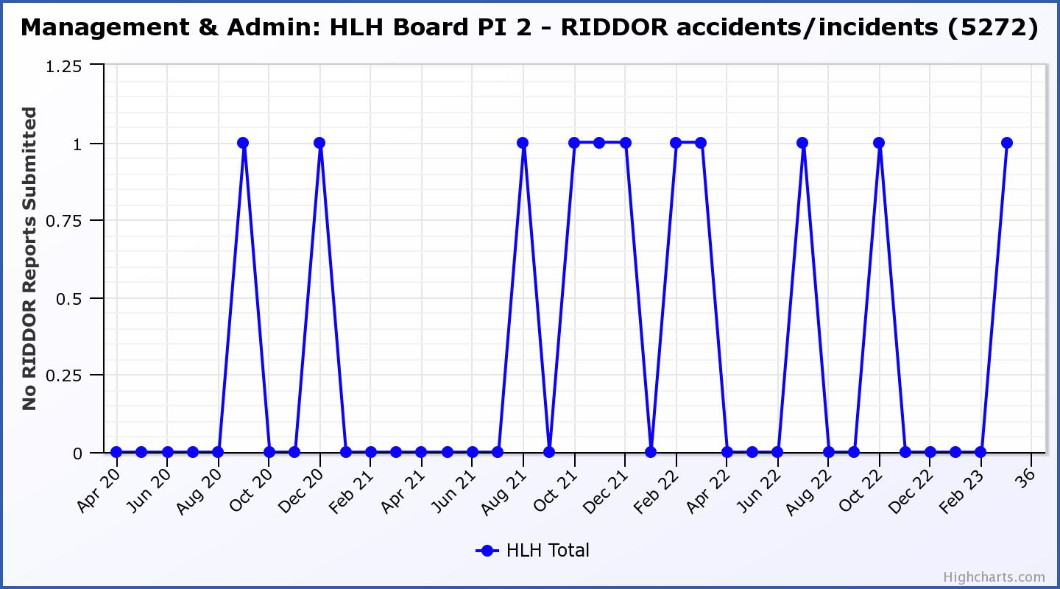

Business Plan Outcome | Performance Indicator | Reporting Frequency | RAG Rating Definition | RAG Rating Q1 22/23 | RAG Rating Q2 22/23 | RAG Rating Q3 22/23 | RAG Rating Q4 22/23 | Summary of Quarter Four Performance
2. Commit to the Scottish Government’s zero carbon targets and maintain the highest standards in environmental compliance. | 3. The HLH Environmental strategy will be developed in partnership with the Council as it develops its plans. | . |  | NA | NA | NA | NA | N/A - Performance indicators will be identified through the development of these plans and will be aligned with THC’s carbon reduction strategy given the contractual (particularly property) arrangements that there are in place between THC and HLH.

Business Plan Outcome | Performance Indicator | Reporting Frequency | RAG Rating Definition | RAG Rating Q1 22/23 | RAG Rating Q2 22/23 | RAG Rating Q3 22/23 | RAG Rating Q4 22/23 | Summary of Quarter Four Performance
2. Commit to the Scottish Government’s zero carbon targets and maintain the highest standards in environmental compliance. | 4. Travel (a target to reduce by 50% following the pandemic has been set) | Quarterly. | - Green = 400,000 miles p.a. or less  - Amber = up to 5% greater than target  - Red = more than 5% of target. | Red | Red | Red | Red | A ceiling of 400,000 miles p.a. or less was set for this PI, half of the pre-pandemic travel miles. This has been a challenging target to achieve, however, progress has been made and travel for this year has been 56% of pre-pandemic travel.

Performance Indicator 4 – Travel Miles
The graph below shows the travel miles for the previous three years and as can be seen on the graph, there has been a downwards trend throughout 2022/23.
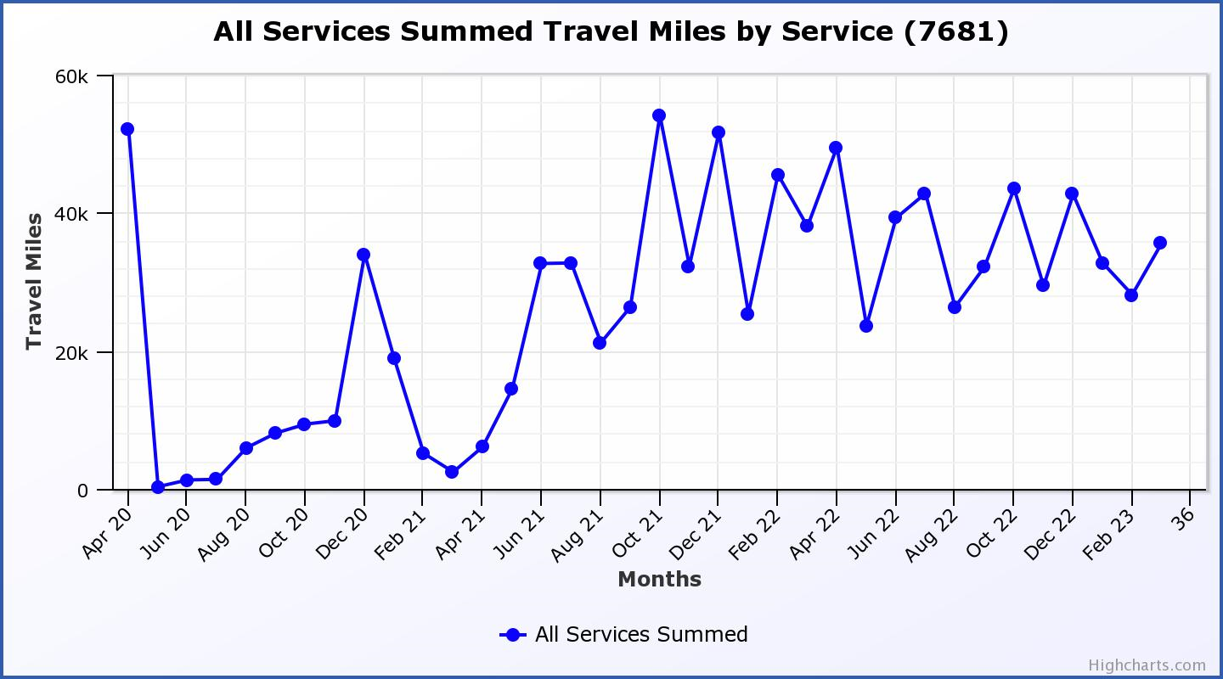

Business Plan Outcome | Performance Indicator | Reporting Frequency | RAG Rating Definition | RAG Rating Q1 22/23 | RAG Rating Q2 22/23 | RAG Rating Q3 22/23 | RAG Rating Q4 22/23 | Summary of Quarter Four Performance
3. Use research and market analysis to develop and improve services to meet customer needs. | 5. Customer engagements. | Quarterly. | - Green = customer numbers are the same as or have increased compared with the corresponding quarter in the previous year  - Amber = customer numbers are less than the corresponding quarter in the previous year.  - Red = customer numbers are more than 5% lower than the corresponding quarter in the previous year. | Green | Green | Green | Green | Customer engagements increased from 1,746,404 in Q4 2021/22 to  2,762,822 in Q4 2022/23.  Customer numbers have recovered to pre-pandemic levels with there having been 446,302 more customer engage-ments in Q4 this year compared with the same quarter in 2019/20.  There is more information in section four of this report.

Performance Indicator 5 - Customer engagements
Customer numbers increased compared with quarter four 2021/22 and are now more than pre-pandemic numbers.
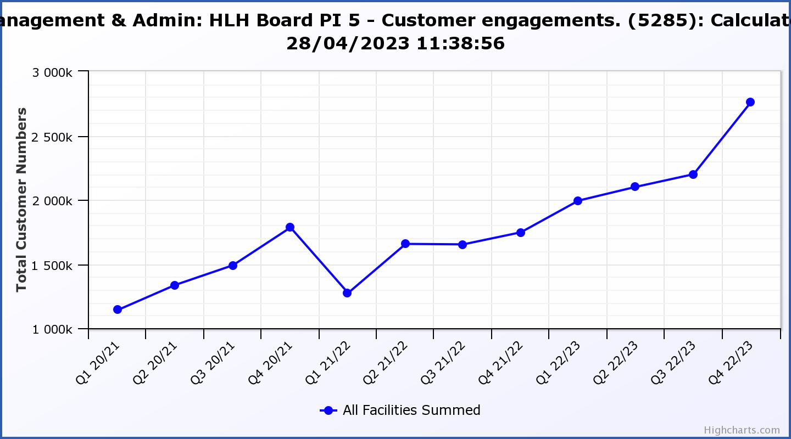

Business Plan Outcome | Performance Indicator | Reporting Frequency | RAG Rating Definition | RAG Rating Q1 22/23 | RAG Rating Q2 22/23 | RAG Rating Q3 22/23 | RAG Rating Q4 22/23 | Summary of Quarter Four Performance
3. Use research and market analysis to develop and improve services to meet customer needs. | 6. Charity-wide customer satisfaction survey. | Annually. | - Green = Services delivered by HLH is above average  - Amber = Services delivered by HLH is average  - Red = Services delivered by HLH is below average. | Green | NA | NA | NA | This performance indicator is scheduled to be reported to the August HLH Board meeting.

Business Plan Outcome | Performance Indicator | Reporting Frequency | RAG Rating Definition | RAG Rating Q1 22/23 | RAG Rating Q2 22/23 | RAG Rating Q3 22/23 | RAG Rating Q4 22/23 | Summary of Quarter Four Performance
4. Increase employee satisfaction, engagement and development to improve staff recruitment and retention. | 7. Staff turnover (resignations as a percentage of posts). | Quarterly. | - Green = 1.6% or less.  - Amber = 1.7 to 2%  - Red = more than 2% | Green | Amber | Green | Green | The number of resignations per month as a percentage of posts was 0.9% in January, 0.6% in February and 1% in March. Please see the HR report elsewhere on this agenda for further information.

Performance Indicator 7 - Staff Turnover (resignations as a percentage of posts)
The graph below shows resignations as a percentage of the number of posts (1% equates to 10.6 staff).

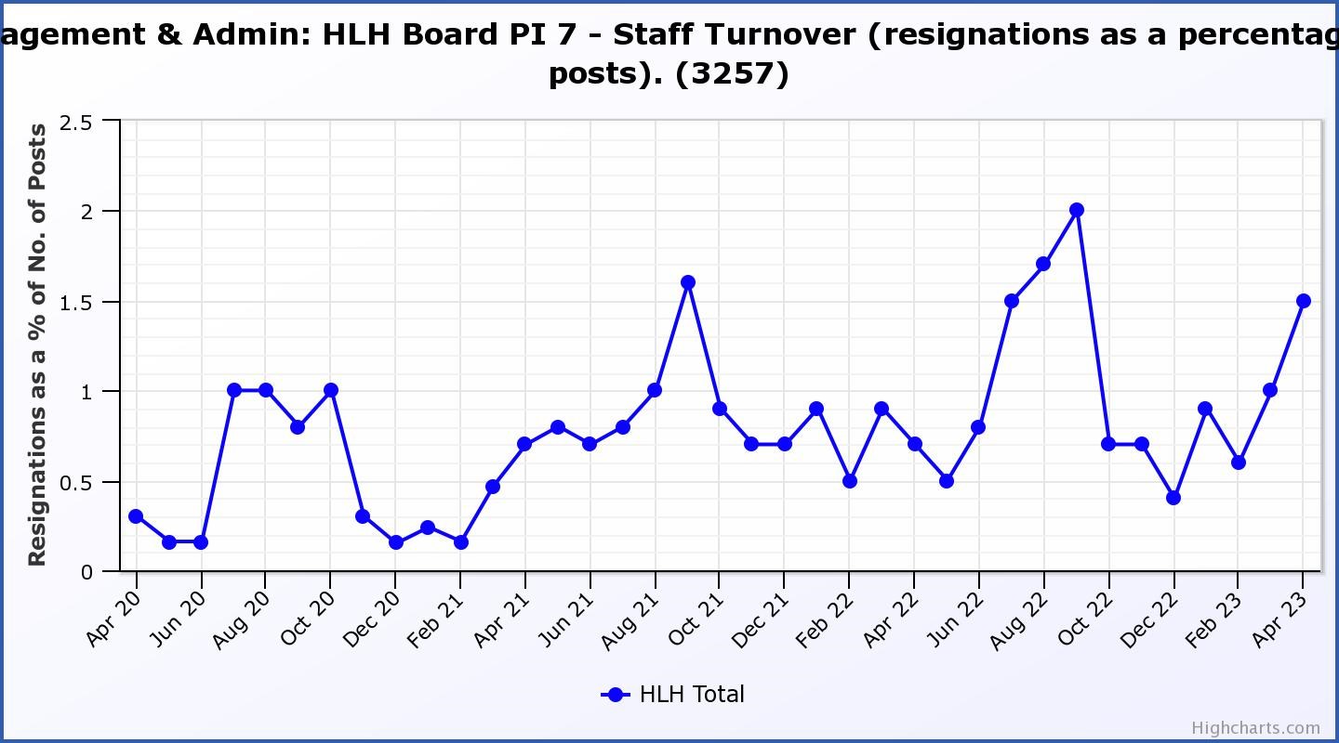

Business Plan Outcome | Performance Indicator | Reporting Frequency | RAG Rating Definition | RAG Rating Q1 22/23 | RAG Rating Q2 22/23 | RAG Rating Q3 22/23 | RAG Rating Q4 22/23 | Summary of Quarter Four Performance
4. Increase employee satisfaction, engagement and development to improve staff recruitment and retention. | 8. Staff attendance rates (RAG ratings based on Office for National Statistics for 2020 of absence rate). | Quarterly. | - Green = attendance rate 98% or higher.  - Amber = attendance rate between 97% and 98%.  - Red = attendance rate less than 97%. | Red | Red | Red | Red | The attendance rate for Q4 was 95.57%. Please see the HR report elsewhere on this agenda for further information.

Performance Indicator 8 - Staff Attendance Rate
Staff attendance rates for Q4 were 95.57%. Please see the HR report elsewhere on this agenda for further information.
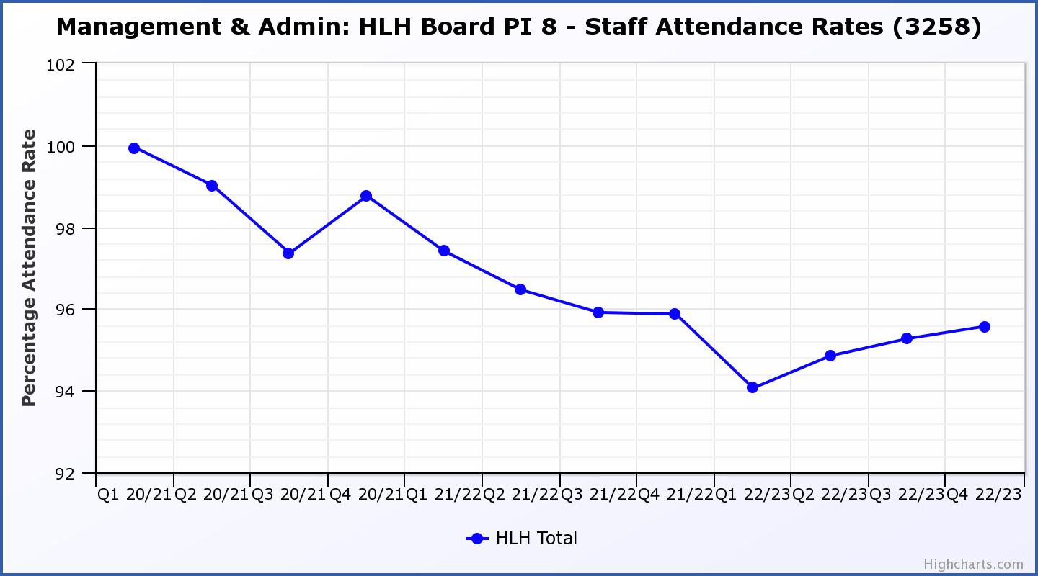

Business Plan Outcome | Performance Indicator | Reporting Frequency | RAG Rating Definition | RAG Rating Q1 22/23 | RAG Rating Q2 22/23 | RAG Rating Q3 22/23 | RAG Rating Q4 22/23 | Summary of Quarter Four Performance
5. Improve the financial sustainability of the company | 9. Financial monitoring. | Quarterly. | An assessment of the year end outturn where:  - Green = delivery of services within budget.  - Amber = delivery of services between break-even and 2% over budget.  - Red = delivery of services over budget above 2%. | Red | Red | Red | Red | There is further information in the Finance Report elsewhere on this agenda.

Performance Indicator 9 - Financial Monitoring
See the Finance Report elsewhere on this agenda for further information.

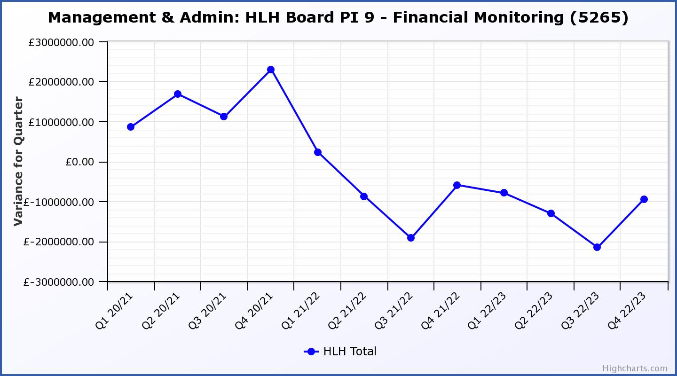

Business Plan Outcome | Performance Indicator | Reporting Frequency | RAG Rating Definition | RAG Rating Q1 22/23 | RAG Rating Q2 22/23 | RAG Rating Q3 22/23 | RAG Rating Q4 22/23 | Summary of Quarter Four Performance  Summary of Quarter Four Performance
5. Improve the financial sustainability of the company | 10. Reserves | Annual. | - Green = meets 3% reserves policy  - Amber = achieves 2% reserves  - Red = fails to achieve 2% reserves policy. | Green | Red | Red | Red | Uncommitted Reserves will be 0% at the end of 2022/23 and, therefore been RAG rated Red.  Please see the finance report elsewhere in this agenda for further information.

Performance Indicator 10 - Financial Reserves
HLH was able to build up reserves to protect services and jobs during 2021/22 based on Government and customer support. Uncommitted Reserves will be 0% at the end of 2022/23 and therefore have been RAG rated Red.
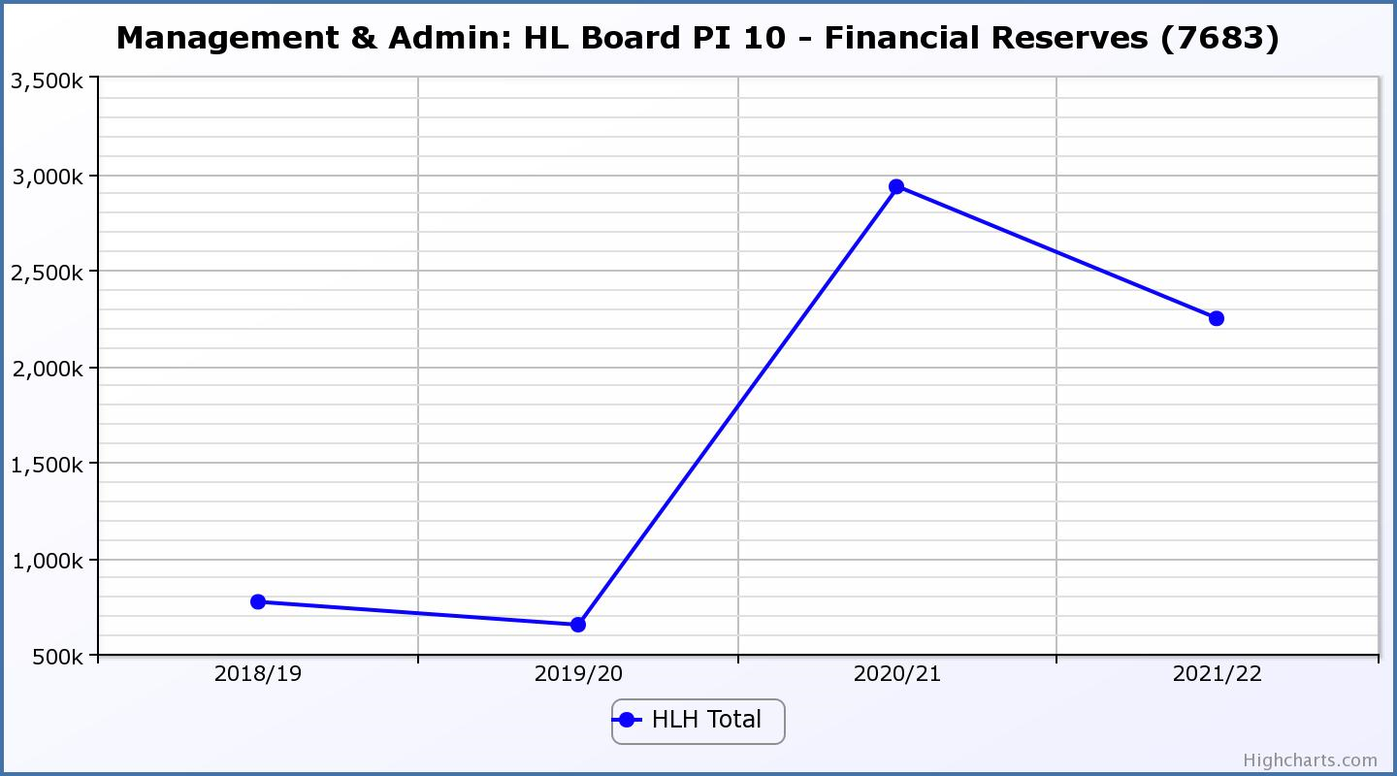

Business Plan Outcome | Performance Indicator | Reporting Frequency | RAG Rating Definition | RAG Rating Q1 22/23 | RAG Rating Q2 22/23 | RAG Rating Q3 22/23 | RAG Rating Q4 22/23 | Summary of Quarter Four Performance
5. Improve the financial sustainability of the company | 11. Number of highlife subscriptions (target is the required number to meet the budget). | Quarterly. | - Green= exceeds budgeted income target.  - Amber = risk of budget target not being met.  - Red = budgeted income target unlikely to be met. | Red | Red | Red | Red | This PI has been RAG rated red because subscriptions have been insufficient to meet the income target for the year.  Subscriptions increased to 17,911 in January and then 18,305 in February falling slightly in March.  For April the number of subscriptions were sufficient to meet the budget target set by the HLH Board (which allowed for a reduction due to the price increase) following the price increase.

Performance Indicator 11 - Number of High Life Subscriptions
Subscriptions continued to increase throughout the last quarter of the year and was particularly good in January and February. The growth in subscriptions, while better than it has ever been, was insufficient to meet the annual income target. In April, subscriptions were sufficient to meet the budgeted income target.

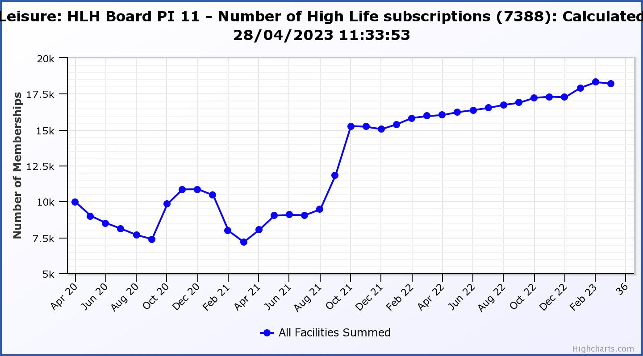

Business Plan Outcome | Performance Indicator | Reporting Frequency | RAG Rating Definition | RAG Rating Q1 22/23 | RAG Rating Q2 22/23 | RAG Rating Q3 22/23 | RAG Rating Q4 22/23 | Summary of Quarter Four Performance
6. Value and strengthen the relationship with THC. | 12. Delivery of the Service Delivery Contract (SDC) with The Highland Council (THC). | Six-monthly. | - Green = agreement of THC’s Education Committee that HLH has met or exceeded the terms of the SDC.  - Amber = agreement of THC’s Education Committee that HLH has met the terms of the SDC but has set some improvement targets.  - Red = agreement of THC’s Education Committee that HLH has not met the terms of the SDC. | NA | Green | NA | Green | The Council’s Education Committee considered the HLH Progress Report at its 1 June 2023 meeting. The committee noted that HLH continues to deliver Public Service Obligations on behalf of the Council as set out in the Service Delivery Contract.

Business Plan Outcome | Performance Indicator | Reporting Frequency | RAG Rating Definition | RAG Rating Q1 22/23 | RAG Rating Q2 22/23 | RAG Rating Q3 22/23 | RAG Rating Q4 22/23 | Summary of Quarter Four Performance
6. Value and strengthen the relationship with THC. | 13. THC’s annual survey of performance and attitudes. | Annual. | - Green = net satisfaction ratings are maintained or improved for three or more areas of HLH work compared with the previous year  - Amber = two or more areas of HLH work receive lower net satisfaction ratings than the previous year.  - Red = all HLH areas of work represented receive lower net satisfaction ratings than the previous year. | NA | NA | NA | NA | The Council has stopped the annual survey which is used to carry out through its citizens panel. This PI will, therefore have to be removed from future reporting. The standard questions which HLH asks when its services conducting surveys will continue to be reported to the HLH Board.

Business Plan Outcome | Performance Indicator | Reporting Frequency | RAG* Rating Definition  (*Red/Amber/Green) | RAG Rating Q1 22/23 | RAG Rating Q2 22/23 | RAG Rating Q3 22/23 | RAG Rating Q4 22/23 | Summary of Quarter Four Performance
7. Develop and deliver the HLH Corporate Programme and seek to attract capital investment. | 14. The HLH corporate programme covers investment; business process improvement; capital and asset management plans and plans will be developed as this area of work is developed. | NA | Should additional performance indicators be identified through the development of these plans they will be added in future. | NA | NA | NA | NA | NA

Business Plan Outcome | Performance Indicator | Reporting Frequency | RAG Rating Definition | RAG Rating Q1 22/23 | RAG Rating Q2 22/23 | RAG Rating Q3 22/23 | RAG Rating Q4 22/23 | Summary of Quarter Four Performance
8. Use research and market analysis to develop and deliver proactive marketing and promotion of HLH and its services. | 15. Media coverage from proactively issued media releases | Six-monthly. | - Green = Positive coverage 95%+  - Amber = Positive coverage 90% - 95%  - Red = Positive coverage 90%- | Green | NA | NA | NA | The media officer post has not been filled and this indicator has not been RAG rated.  It is expected that reporting will recommence at the August 2023 HLH Board meeting.

Business Plan Outcome | Performance Indicator | Reporting Frequency | RAG Rating Definition | RAG Rating Q1 22/23 | RAG Rating Q2 22/23 | RAG Rating Q3 22/23 | RAG Rating Q4 22/23 | Summary of Quarter Four Performance
8. Use research and market analysis to develop and deliver proactive marketing and promotion of HLH and its services. | 16. On-line engagement through social media channels. |  | - Green = 5% increase compared with the same period last year.  - Amber = no increase to 4.9% lower compared with the same period last year.  - Red = more than 5% lower or less compared with the same period last year. | NA | Green | Amber | Green | Social media engagements were 26,292 in Q4 21/22 and 29,832 in Q4 22/23.

Performance Indicator 16 - On-line engagement through social media channels.
On-line engagement through social media channels in Q4 exceeded engagements in Q 4 2021/22.

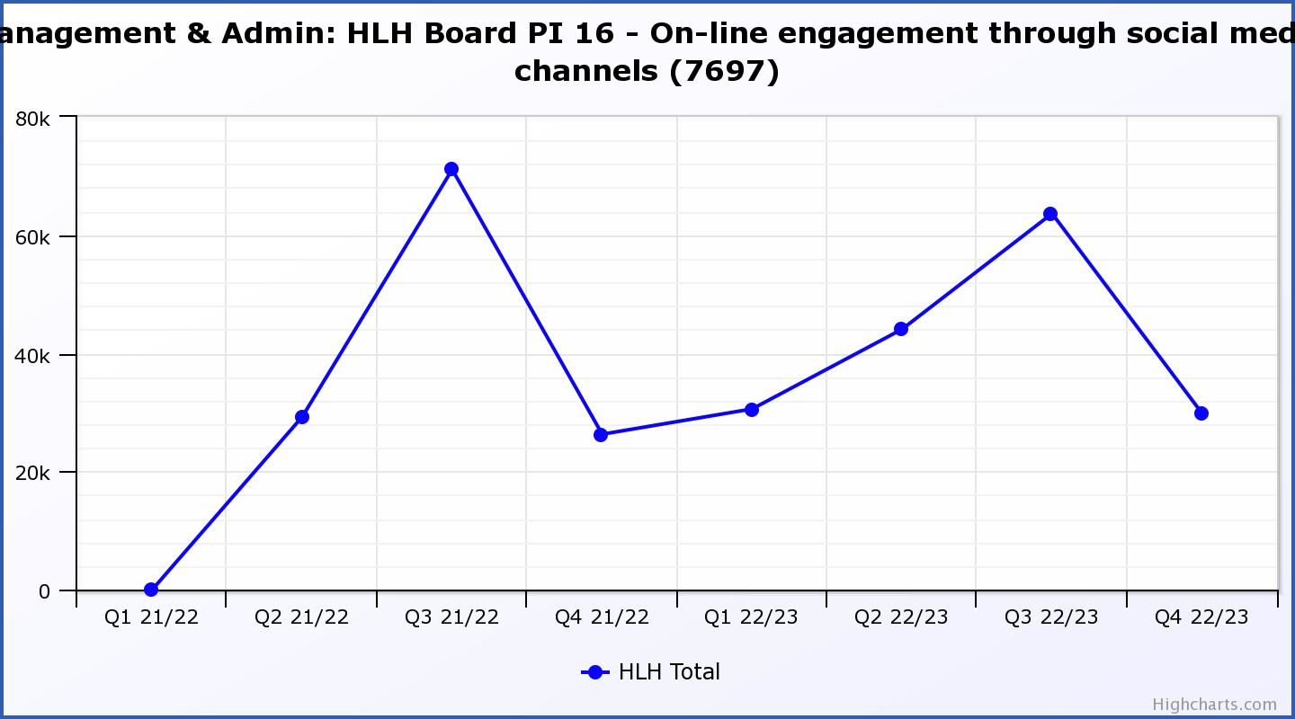

Business Plan Outcome | Performance Indicator | Reporting Frequency | RAG Rating Definition | RAG Rating Q1 22/23 | RAG Rating Q2 22/23 | RAG Rating Q3 22/23 | RAG Rating Q4 22/23 | Summary of Quarter Four Performance
9. Initiate and implement an ICT digital transformation strategy across the charity | 17. The HLH digital transformation strategy is yet to be developed. |  | Should performance indicators be identified through the development of these plans they will be added in future. | NA | NA | NA | NA | NA

Business Plan Outcome | Performance Indicator | Reporting Frequency | RAG Rating Definition | RAG Rating Q1 22/23 | RAG Rating Q2 22/23 | RAG Rating Q3 22/23 | RAG Rating Q4 22/23 | Summary of Quarter Four Performance
10. Develop and strengthen relationships with customers, key stakeholders and partners | New approach to customer survey as per Business Outcome 3 above.  Same as PI 6 - Charity-wide customer satisfaction survey | Quarterly | - | NA | NA | NA | NA | NA

Business Plan Outcome | Performance Indicator | Reporting Frequency | RAG Rating Definition | RAG Rating Q1 22/23 | RAG Rating Q2 22/23 | RAG Rating Q3 22/23 | RAG Rating Q4 22/23 | Summary of Quarter Four Performance
10. Develop and strengthen relationships with customers, key stakeholders and partners | 18. Partnership work with sportscotland and other sports related organisations, NHS Highland and other health related organisations (including Memoranda of Understanding) etc. | Annual | - Green = Growth in partnership working  - Amber = continuation of current level of partnership work  - Red = cancellation of Partnership Agreements | NA | NA | Green | NA | A new four-year partnership agreement, (indicative of a high level of trust in HLH’s sports development programme) was signed by sportscotland, THC and HLH in March 2023.

Business Plan Outcome | Performance Indicator | Reporting Frequency | RAG Rating Definition | RAG Rating Q1 22/23 | RAG Rating Q2 22/23 | RAG Rating Q3 22/23 | RAG Rating Q4 22/23 | Summary of Quarter Four Performance
11. Deliver targeted programmes which support and enhance the physical and mental health and wellbeing of the population and which contribute to the prevention agenda. | 19. An assessment of the RAG rating of the Health and Wellbeing Strategy action plan. |  | - Green = 80% or more of the actions are RAG rated green  - Amber = 60% to 79% of actions are green.  - Red = 59% or less are rated green. | NA | NA | Green | NA | This indicator is scheduled to be considered at the HLH Board meeting in March 2024.

Appendix C
Breakdown of Annual Customer Engagements by each of the HLH areas of work

Total Engagements (in-person and on-line) | 2019/20 | 2020/21 | 2021/22 | 2022/23 | Difference 2019/20-22/23 | % change 2019/20-22/23
Adult Learning | 16,088 | 3,911 | 9,457 | 13,403 | -2,685 | -17%
Archives | 1,306,804 | 1,944,259 | 1,737,618 | 2,558,222 | 1,251,418 | 96%
Arts | 4,525 | 175 | 1,498 | 2,487 | -2,038 | -45%
Leisure | 2,995,583 | 468,555 | 1,402,402 | 2,154,385 | -841,198 | -28%
Libraries | 3,698,919 | 2,251,855 | 2,575,025 | 3,735,491 | 36,572 | 1%
Museums | 264,246 | 95,501 | 260,752 | 231,947 | -32,299 | -12%
Music Tuition | 99,734 | 40,687 | 84,330 | 96,750 | -2,984 | -3%
Outdoor Activities | 2,814 | 217 | 1,082 | 1,123 | -1,691 | -60%
Countryside Rangers | 15,044 | - | 5,122 | 11,302 | -3,742 | -25%
Sports Development | 374,522 | 29,955 | 196,489 | 189,296 | -185,226 | -49%
Youth Work | 71,631 | 24,874 | 54,947 | 73,523 | 1,892 | 3%
Total | 8,849,910 | 4,859,989 | 6,328,722 | 9,067,929 | 218,019 | 2%

Appendix D
Breakdown of Annual In-Person Customer Engagements by each of the HLH areas of work

In-Person Engagements | 2019/20 | 2020/21 | 2021/22 | 2022/23 | Difference 2019/20-22/23 | % Change 2019/20-22/23
Adult Learning | 16,088 | 3,911 | 9,457 | 13,403 | -2,685 | -17%
Archives | 10,575 | 141 | 2,557 | 11,981 | 1,406 | 13%
Arts | 4,525 | 175 | 1,498 | 2,487 | -2,038 | -45%
Countryside Rangers | 15,044 | - | 5,122 | 11,302 | -3,742 | -25%
Leisure | 2,995,583 | 351,453 | 1,402,402 | 2,154,385 | -841,198 | -28%
Libraries | 2,158,130 | 55,567 | 393,036 | 1,366,992 | -791,138 | -37%
Museums | 154,873 | 18,549 | 68,229 | 131,496 | -23,377 | -15%
Music Tuition | 99,734 | 40,687 | 84,330 | 96,750 | -2,984 | -3%
Outdoor Activities | 2,814 | 217 | 1,082 | 1,123 | -1,691 | -60%
Sports Development | 374,522 | 29,955 | 196,489 | 189,296 | -185,226 | -49%
Youth Work | 71,631 | 24,874 | 54,947 | 73,523 | 1,892 | 3%
Total | 5,903,519 | 525,529 | 2,219,149 | 4,052,738 | -1,850,781 | -31%

