|  |  |
| --- | --- |
| HIGH LIFE HIGHLAND  REPORT TO BOARD OF DIRECTORS  31 AUGUST 2023 | AGENDA ITEM 10  REPORT No HLH / /23 |

## **Quarter One Performance Report - Report by Chief Executive**

|  |
| --- |
| **Recommendation** The purpose of this report is to present performance information for the period April to June 2023.  It is recommended that Directors:   1. comment on the report and agree that the overall health check on the charity for that period is rated as amber because of the performance indicators relating to finance, reserves and *high****life*** subscriptions; 2. comment on and note the actions underway to address the amber RAG rating in this report and the Finance and Service Delivery Contract Review reports elsewhere on this agenda; 3. agree the RAG rating definition for travel in section three of this report; and 4. note the work underway to sustain the growth in *high****life*** subscriptions in section three of this report. |

|  |  |
| --- | --- |
| **1.** | **Business Plan Contribution** |
| 1.1 | This report supports all the Business Outcomes from the High Life Highland (HLH) Business Plan 2022-27   1. **Seek to continuously improve standards of health and safety.** 2. **Commit to the Scottish Government’s zero carbon targets and maintain the highest standards in environmental compliance.** 3. **Use research and market analysis to develop and improve services to meet customer needs.** 4. **Increase employee satisfaction, engagement and development to improve staff recruitment and retention.** 5. **Improve the financial sustainability of the company.** 6. **Value and strengthen the relationship with THC.** 7. **Develop and deliver the HLH Corporate Programme and seek to attract capital investment.** 8. **Use research and market analysis to develop and deliver proactive marketing and promotion of HLH and its services.** 9. **Initiate and implement an ICT digital transformation strategy across the charity.** 10. **Develop and strengthen relationships with customers, key stakeholders and partners.** 11. **Deliver targeted programmes which support and enhance the physical and mental health and wellbeing of the population and which contribute to the prevention agenda.** |
| **2.** | **Background** |
| 2.1 | The implementation of the HLH Business Plan 2022-27 is monitored through a set of performance indicators set by the Board to assess the overall performance of the charity. The indicators were set at the HLH Board meeting held on 31 March 2022. |
| **3.** | **Summary of Performance** |
| 3.1 | **Appendix A** contains a summary of performance against the PIs for Q1 2023/24. **Appendix B** provides a list of all of the PIs along with trend information. 10 of the 18 PIs are scheduled for assessment at the August 2023 HLH Board meeting, of those, 5 have been RAG rated green; 3 amber; and 2 red. |
| 3.2 | The indicators that have been RAG rated red are staff attendance and reserves; the amber ones are travel, finance, and *high****life*** subscriptions. |
| 3.3 | PI 4 **Travel** – This PI has been provisionally RAG rated as amber, subject to the approval of the definitions below. There was discussion on the travel performance indicator at the June HLH Board meeting with a summary of the discussion being:   * the organisation should set the green RAG rating to contain travel miles within the 2022/23 level (which is approximately half of the pre-pandemic travel mileage); and * fleet miles should be excluded because of the risk that this would directly impact service delivery (e.g. mobile libraries). |
| 3.4 | Taking account of the above, it is recommended that the following RAG ratings be approved:  i. Green = 451,000 miles p.a. or less  ii. Amber = 451,001 to 541,200 miles p.a.  iii. Red = 541,201 p.a. or more |
| 3.5 | Actual travel in 2022/23 was 450,942 (enterprise car hire; plus car hire; plus “grey fleet” travel). The proposed amber range is 451,000 plus 20%. |
| 3.6 | The travel performance indicator was scheduled for more detailed consideration at this meeting and the travel miles for the past four years can be seen by service in the graph below. Points to note are:   * the aim to reduce travel through the use of Microsoft Teams has worked, with all teams having reduced travel (most by around 50%); * there are higher levels of travel in leisure, which is accounted for by it being the largest team and also because managers have to meet staff on site regularly (managers cover multiple sites); * although the music tuition staff travel to schools to deliver services, the team have reduced travel through planning visits efficiently and increasing blended (in person and on-line) delivery; * active schools staff need to travel to support and mentor volunteers who deliver activity sessions, this is particularly relevant for new volunteers and sports leaders. Active schools staff also provide activities in remote areas of Highland to lessen the travel barriers for participants accessing activities. |

|  |  |
| --- | --- |
| 3.6 | PI 8 **Staff Attendance Rate** – there is work underway to address performance in this area and to review this performance indicator as described in the HR report elsewhere on this agenda. |
| 3.7 | PI 9 **Financial Monitoring** – a year end deficit is forecast and there is further information in the Finance report elsewhere on this agenda. |
| 3.8 | PI 10 **Financial Reserves** – it is anticipated that there will be no reserves by the end of the financial year. This is in the context of additional support and a letter of comfort having been agreed with the Council as part of the current year’s budget; and the discussion which is underway in relation to the review of the Service Delivery Contract. |
| 3.9 | PI 11 **High Life Subscriptions** – while it is reported in the Finance report elsewhere on this agenda that *high****life*** income met the budget target set for quarter 1, the RAG rating is set to exceed the budgeted amount and it has been RAG rated as amber. The number of subscriptions fell during quarter 1 and the work being undertaken to increase subscriptions and the reasons for cancellations have been reviewed (cancellations are around one percent higher than historic levels and the reasons customers gave for cancelling are in the table below). |
| 3.10 | The current actions to increase subscription levels are:     * Membership campaigns designed to encourage growth and retention. * Engagement with and growth of corporate memberships and clients. * Launch of My Gym Discount which engages with 320 companies based in the Highlands. * High Life membership product training to leisure teams and will be rolled out to other HLH services. * Membership sales stand at facility open days and events (inc. 15 UHI events). |



|  |  |
| --- | --- |
| 3.11 | With the cancellation rate having increased from the historic 3% rate a comparison was carried out with the last six months of 2022 (when there was higher than historic levels of growth) and the cancellation reasons are broadly similar. The most recent reasons for cancelling which appear higher than previously are:   * the price increase; * lack of time; and * the climbing wall closure |
| 3.12 | Affordability was more of an issue for customers last year, however, it is likely that the price increase triggered some cancellations which was given as the reason for cancelling. |
| 3.13 | Further work is being undertaken to seek to increase subscriptions includes:   * Delivering group exercise classes at UHI Inverness College (1 September start). This will be for the public and timed before/after the college day and if successful there is a willingness on the part of UHI to develop the offering/HLH presence there over time. * A review of swimming lessons to assess whether there is capacity to add additional activity. * A review of children’s activity programmes similar to swimming lessons. * A review of the summer activity programme and whether charged for activity would be better included in the *high****life*** card. * A review of capacities in classes/activities and promotion of classes with capacity. |
| **4.** | **Performance Indicators for More Detailed Consideration** |
| 4.1 | Each quarter more detailed information is provided on one or more of the performance indicators and the following performance indicators were scheduled for inclusion at the August HLH board meeting:  1. Travel  6. Charity-wide customer satisfaction survey (Via marketing strategy)  10. Reserves (via annual report) |
| 4.2 | The travel and reserves indicators have been covered above and elsewhere on this agenda. |
| 4.3 | **Customer Satisfaction Survey** - Every year each of the HLH areas of work carry out customer surveys which include three standard questions. There are now two full years of data (2021 and 2022). Customers are asked to rate their overall experience of HLH and their experience of staff. For this part of the survey, they are asked to rate their experience as excellent, good, poor or unsatisfactory. Customers are also asked to say whether they would recommend HLH. |
| 4.4 | In calendar years 2021 and 2022 there were broadly similar response levels (2,133 to 2,357). So far in 2023 there have been 358 responses. The questions customers are asked are:   * What is your overall experience of High Life Highland? * How helpful do you find the staff of High Life Highland? * Would you recommend High Life Highland to a friend? |
| 4.5 | The percentage of respondents who rated their overall experience of HLH/staff as excellent or good and who would recommend HLH are as follows:   |  |  |  |  | | --- | --- | --- | --- | | **Calendar year** | **Overall Experience** | **Staff** | **Recommend HLH** | | **2021** | 97% | 97% | 95% | | **2022** | 97% | 98% | 94% | | **2023 ytd** | 95% | 95% | 95% | |
| 4.6 | While the sample size for the current year is small it is on track with results from previous years. In addition to the results above, staff teams receive the responses to the question asking customers why/why would they not recommend HLH. |
| **5.** | **Implications** |
| 5.1 | Resource implications – while this report discusses resources and financial implications, there are no resource implications arising from agreeing the recommendations in this report. |
| 5.2 | Equality implications - there are no new equality implications arising from this report. |
| 5.3 | Legal implications - there are no new legal implications arising from this report. |
| 5.4 | Risk implications - there are no new risk implications arising from this report. |
|  |  |
| **Recommendations** It is recommended that Directors:   1. comment on the report and agree that the overall health check on the charity for that period is rated as amber because of the performance indicators relating to finance, reserves and *high****life*** subscriptions; 2. comment on and note the actions underway to address the amber RAG rating in this report and the Finance and Service Delivery Contract Review reports elsewhere on this agenda; 3. agree the RAG rating definition for travel in section three of this report; and 4. note the work underway to sustain the growth in *high****life*** subscriptions in section three of this report. | |

Designation: Chief Executive

Date: 15 August 2023

Author: Douglas Wilby, Director of Sport and Leisure

**Appendix A**

|  |  |
| --- | --- |
| **HLH Performance Indicators - Summary Q1 2023/24** | Nineteen performance indicators (PIs) are used by the High Life Highland Board to assess the overall performance of the charity.  The PIs are RAG rated (allocated a "Red", "Amber" or "Green" status) so that it is easy to see at a glance how the organisation is performing. Most of the PIs are RAG rated every quarter throughout the year, with some (such as partnership working with NHSH for example) being considered annually so greyed out sectors on this radar diagram mean that the PI is to be considered at a future HLH Board meeting. |

**Appendix B**

**HLH Performance Indicators - Detail Q1 2023/24**

|  |  |  |  |  |  |  |  |  |
| --- | --- | --- | --- | --- | --- | --- | --- | --- |
| **Business Plan Outcome** | **Performance Indicator** | **Reporting Frequency** | **RAG Rating Definition** | **RAG Rating Q1 23/24** | **RAG Rating Q2 23/24** | **RAG Rating Q3 23/24** | **RAG Rating Q4 23/24** | **Summary of Quarter One Performance** |
| **1. Seek to continuously improve standards of health and safety.** | 1. External health and safety audit. | Annual. | 1. Green = the external audit does not raise systemic issues. 2. Amber = the external audit highlights common actions to be addressed across the company. 3. Red = the external audit raises systemic (i.e., applying across multiple sites) H&S issues. | NA |  |  |  | The annual health and safety report was considered at the June HLH Board meeting. The Health and Safety and Environmental Compliance Committee continues to meet to monitor health and safety performance with its most recent meeting having been 7 August 2023. |

|  |  |  |  |  |  |  |  |  |
| --- | --- | --- | --- | --- | --- | --- | --- | --- |
| **Business Plan Outcome** | **Performance Indicator** | **Reporting Frequency** | **RAG Rating Definition** | **RAG Rating Q1 23/24** | **RAG Rating Q2 23/24** | **RAG Rating Q3 23/24** | **RAG Rating Q4 23/24** | **Summary of Quarter One Performance** |
| **1. Seek to continuously improve standards of health and safety.** | 2. RIDDOR accidents/incidents. | Quarterly. | 1. Red = number of RIDDOR reports per quarter is above 20. 2. Amber = number of RIDDOR reports per quarter is between 10 and 20 3. Green = number of RIDDOR reports per quarter is less than 10. | Green |  |  |  | As reported to the Health and Safety and Environmental Compliance Committee at its August 2023 meeting, no incidents were reported under the RIDDOR regulations during Q1. |

**Performance Indicator 2 - RIDDOR accidents/incidents**

The graph below tracks the number of accidents and incidents reported under the Reporting of Injuries, Diseases and Dangerous Occurrences Regulations (RIDDOR). There were no RIDDOR incidents reported in Q1 2023/24.

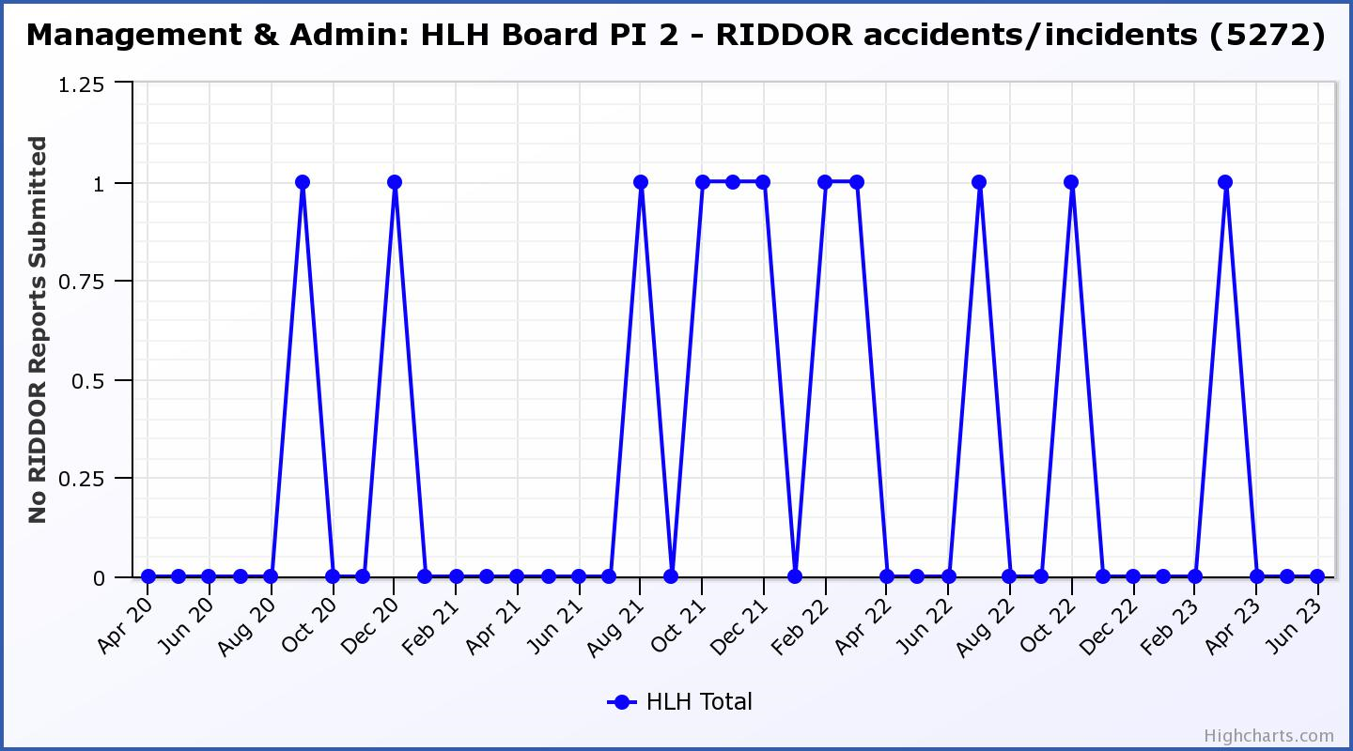

|  |  |  |  |  |  |  |  |  |
| --- | --- | --- | --- | --- | --- | --- | --- | --- |
| **Business Plan Outcome** | **Performance Indicator** | **Reporting Frequency** | **RAG Rating Definition** | **RAG Rating Q1 23/24** | **RAG Rating Q2 23/24** | **RAG Rating Q3 23/24** | **RAG Rating Q4 23/24** | **Summary of Quarter One Performance** |
| **2. Commit to the Scottish Government’s zero carbon targets and maintain the highest standards in environmental compliance.** | 3. The HLH Environmental strategy will be developed in partnership with the Council as it develops its plans. | . |  | NA |  |  |  | N/A - Performance indicators will be identified through the development of these plans and will be aligned with THC’s carbon reduction strategy given the contractual (particularly property) arrangements that there are in place between THC and HLH. |

|  |  |  |  |  |  |  |  |  |
| --- | --- | --- | --- | --- | --- | --- | --- | --- |
| **Business Plan Outcome** | **Performance Indicator** | **Reporting Frequency** | **RAG Rating Definition** | **RAG Rating Q1 23/24** | **RAG Rating Q2 23/24** | **RAG Rating Q3 23/24** | **RAG Rating Q4 23/24** | **Summary of Quarter One Performance** |
| **2. Commit to the Scottish Government’s zero carbon targets and maintain the highest standards in environmental compliance.** | 4. Travel (a target to reduce by 50% following the pandemic has been set) | Quarterly. | 1. Green = 451,000 miles p.a. or less 2. Amber = 451,001 to 541,200 miles p.a. 3. Red = 541,201 p.a. or more   (Quarterly ceiling 112,750) | Amber |  |  |  | Travel miles were 130,598 in Q1 which is 16% above the proposed ceiling (see section three of this report). |

**Performance Indicator 4 – Travel Miles**

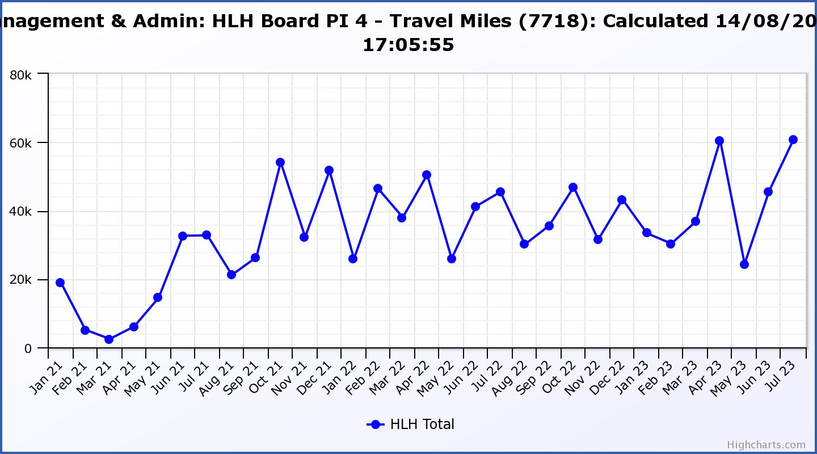

|  |  |  |  |  |  |  |  |  |
| --- | --- | --- | --- | --- | --- | --- | --- | --- |
| **Business Plan Outcome** | **Performance Indicator** | **Reporting Frequency** | **RAG Rating Definition** | **RAG Rating Q1 23/24** | **RAG Rating Q2 23/24** | **RAG Rating Q3 23/24** | **RAG Rating Q4 23/24** | **Summary of Quarter One Performance** |
| **3. Use research and market analysis to develop and improve services to meet customer needs.** | 5. Customer engagements. | Quarterly. | 1. Green = customer numbers are the same as or have increased compared with the corresponding quarter in the previous year 2. Amber = customer numbers are less than the corresponding quarter in the previous year. 3. Red = customer numbers are more than 5% lower than the corresponding quarter in the previous year. | Green |  |  |  | Customer engagements increased from 1,896,853 in Q1 2022/23 to  2,211,297 in Q1 2023/24. The HLH Board considered this PI in more detail at its June 2023 meeting. |

**Performance Indicator 5 - Customer engagements**

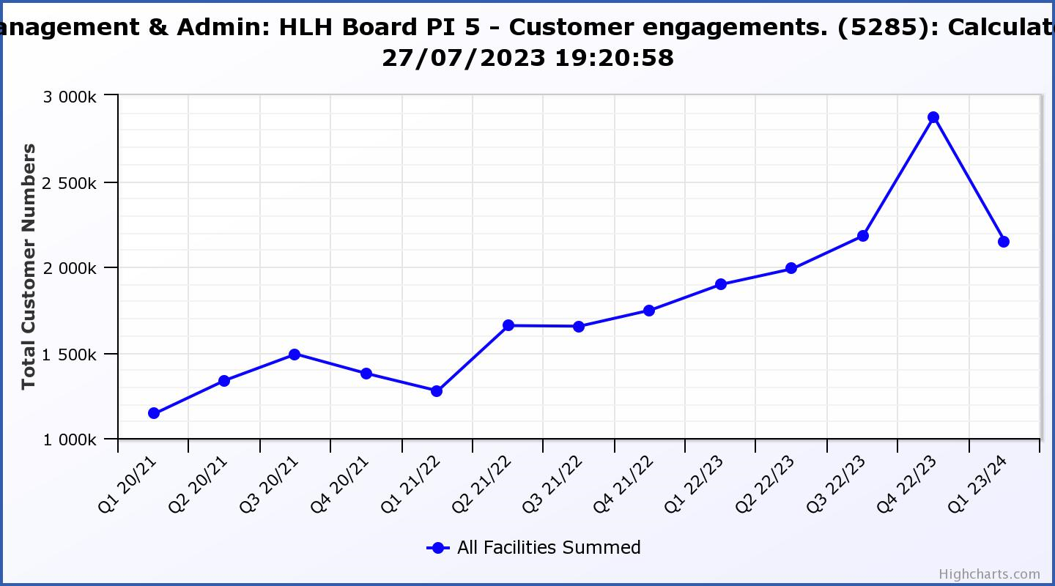

|  |  |  |  |  |  |  |  |  |
| --- | --- | --- | --- | --- | --- | --- | --- | --- |
| **Business Plan Outcome** | **Performance Indicator** | **Reporting Frequency** | **RAG Rating Definition** | **RAG Rating Q1 23/24** | **RAG Rating Q2 23/24** | **RAG Rating Q3 23/24** | **RAG Rating Q4 23/24** | **Summary of Quarter One Performance** |
| **3. Use research and market analysis to develop and improve services to meet customer needs.** | 6. Charity-wide customer satisfaction survey. | Annually. | 1. Green = Services delivered by HLH is above average 2. Amber = Services delivered by HLH is average 3. Red = Services delivered by HLH is below average. | Green |  |  |  | Please see section four of this report for further information. |

|  |  |  |  |  |  |  |  |  |
| --- | --- | --- | --- | --- | --- | --- | --- | --- |
| **Business Plan Outcome** | **Performance Indicator** | **Reporting Frequency** | **RAG Rating Definition** | **RAG Rating Q1 23/24** | **RAG Rating Q2 23/24** | **RAG Rating Q3 23/24** | **RAG Rating Q4 23/24** | **Summary of Quarter One Performance** |
| **4. Increase employee satisfaction, engagement and development to improve staff recruitment and retention.** | 7. Staff turnover (resignations as a percentage of posts). | Quarterly. | 1. Green = 1.6% or less. 2. Amber = 1.7 to 2% 3. Red = more than 2% | Green |  |  |  | The number of resignations per month as a percentage of posts was 1.5% in April, 0.9% in May and 1.1% in June. Please see the HR report elsewhere on this agenda for further information. |

**Performance Indicator 7 - Staff Turnover (resignations as a percentage of posts)**

The graph below shows resignations as a percentage of the number of posts (1% equates to 10.6 staff).

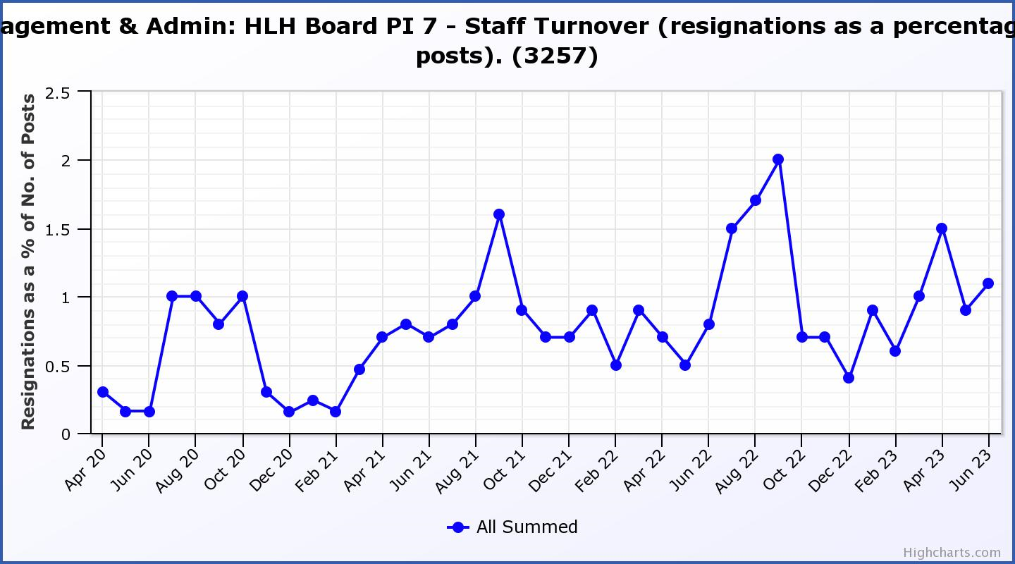

|  |  |  |  |  |  |  |  |  |
| --- | --- | --- | --- | --- | --- | --- | --- | --- |
| **Business Plan Outcome** | **Performance Indicator** | **Reporting Frequency** | **RAG Rating Definition** | **RAG Rating Q1 23/24** | **RAG Rating Q2 23/24** | **RAG Rating Q3 23/24** | **RAG Rating Q4 23/24** | **Summary of Quarter One Performance** |
| **4. Increase employee satisfaction, engagement and development to improve staff recruitment and retention.** | 8. Staff attendance rates (RAG ratings based on Office for National Statistics for 2020 of absence rate). | Quarterly. | 1. Green = attendance rate 98% or higher. 2. Amber = attendance rate between 97% and 98%. 3. Red = attendance rate less than 97%. | Red |  |  |  | The attendance rate for Q1 was 95.72%. Please see the HR report elsewhere on this agenda for further information. |

**Performance Indicator 8 - Staff Attendance Rate**

Staff attendance rates for Q1 were 95.57%. Please see the HR report elsewhere on this agenda for further information.

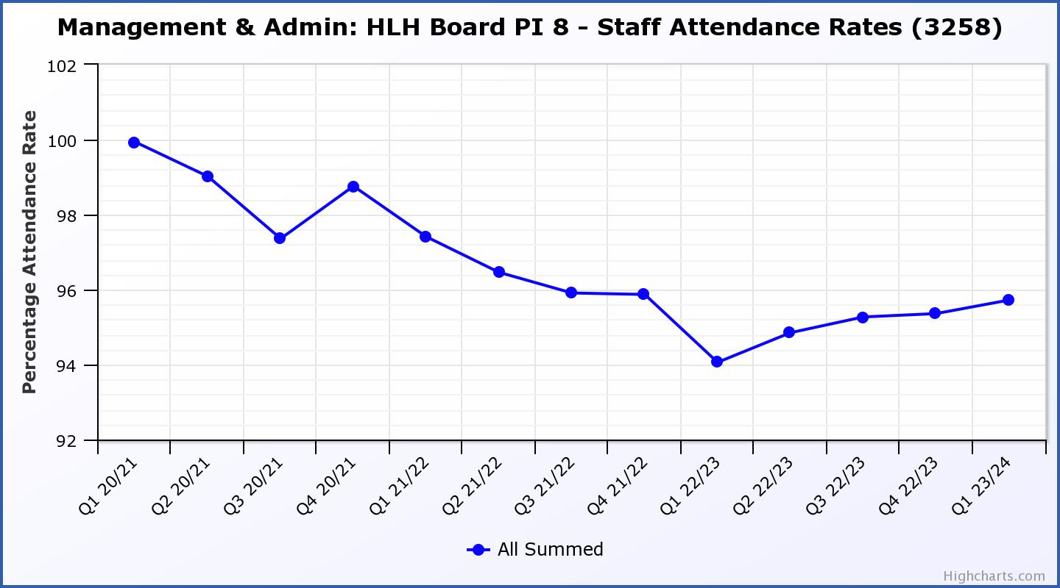

|  |  |  |  |  |  |  |  |  |
| --- | --- | --- | --- | --- | --- | --- | --- | --- |
| **Business Plan Outcome** | **Performance Indicator** | **Reporting Frequency** | **RAG Rating Definition** | **RAG Rating Q1 23/24** | **RAG Rating Q2 23/24** | **RAG Rating Q3 23/24** | **RAG Rating Q4 23/24** | **Summary of Quarter One Performance** |
| **5. Improve the financial sustainability of the company** | 9. Financial monitoring. | Quarterly. | An assessment of the year end outturn where:   1. Green = delivery of services within budget. 2. Amber = delivery of services between break-even and 2% over budget. 3. Red = delivery of services over budget above 2%. | Amber |  |  |  | There is further information in the Finance Report elsewhere on this agenda. |

**Performance Indicator 9 - Financial Monitoring**

This graph shows the actual position at the end of each quarter.

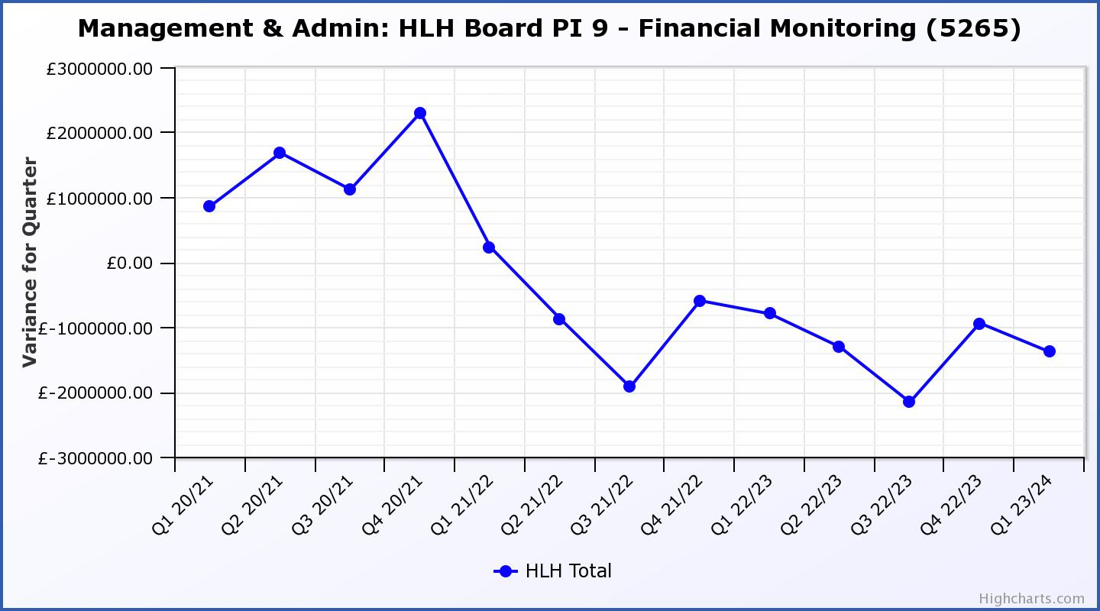

|  |  |  |  |  |  |  |  |  |
| --- | --- | --- | --- | --- | --- | --- | --- | --- |
| **Business Plan Outcome** | **Performance Indicator** | **Reporting Frequency** | **RAG Rating Definition** | **RAG Rating Q1 23/24** | **RAG Rating Q2 23/24** | **RAG Rating Q3 23/24** | **RAG Rating Q4 23/24** | **Summary of Quarter One Performance**  **Summary of Quarter One Performance** |
| **5. Improve the financial sustainability of the company** | 10. Reserves | Annual. | 1. Green = meets 3% reserves policy 2. Amber = achieves 2% reserves 3. Red = fails to achieve 2% reserves policy. | Red |  |  |  | Uncommitted reserves will be 0% at the end of 2023/24 and, therefore RAG rated red.  Please see the Finance report elsewhere in this agenda for further information. |

**Performance Indicator 10 - Financial Reserves**

This graph shows the level of uncommitted, unrestricted reserves at the end of each financial year.

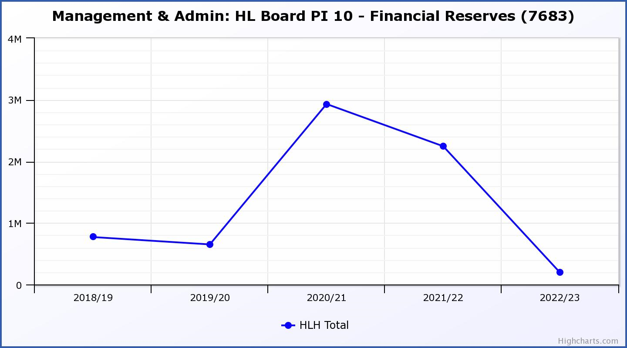

|  |  |  |  |  |  |  |  |  |
| --- | --- | --- | --- | --- | --- | --- | --- | --- |
| **Business Plan Outcome** | **Performance Indicator** | **Reporting Frequency** | **RAG Rating Definition** | **RAG Rating Q1 23/24** | **RAG Rating Q2 23/24** | **RAG Rating Q3 23/24** | **RAG Rating Q4 23/24** | **Summary of Quarter One Performance** |
| **5. Improve the financial sustainability of the company** | 11. Number of *high****life*** subscriptions (target is the required number to meet the budget). | Quarterly. | 1. Green= exceeds budgeted income target. 2. Amber = risk of budget target not being met. 3. Red = budgeted income target unlikely to be met. | Amber |  |  |  | This PI has been RAG rated amber. While it has been reported in the Finance Report elsewhere on this agenda that the budget target for Q1 has been met, the RAG rating has been set to exceed the budget. As can be seen in section three of this report, there is considerable work taking place in this area and there are indications that increases are becoming more difficult to achieve with the number of subscriptions having decreased over Q1. |

**Performance Indicator 11 - Number of High Life Subscriptions**

Subscriptions continued to increase throughout the last quarter of the year and was particularly good in January and February. While it has been reported in the Finance Report elsewhere on this agenda that the income target was met in Q1, the number of subscriptions reduced during Q1.

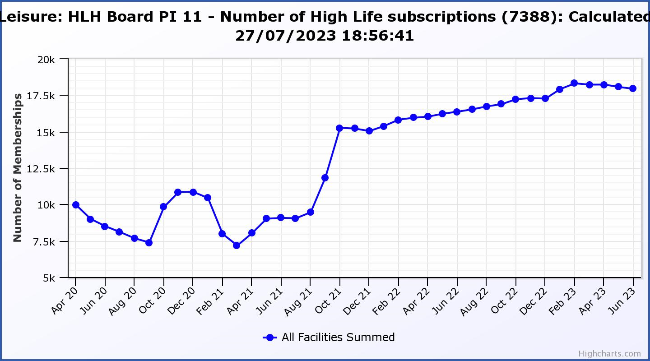

|  |  |  |  |  |  |  |  |  |
| --- | --- | --- | --- | --- | --- | --- | --- | --- |
| **Business Plan Outcome** | **Performance Indicator** | **Reporting Frequency** | **RAG Rating Definition** | **RAG Rating Q1 23/24** | **RAG Rating Q2 23/24** | **RAG Rating Q3 23/24** | **RAG Rating Q4 23/24** | **Summary of Quarter One Performance** |
| **6. Value and strengthen the relationship with THC.** | 12. Delivery of the Service Delivery Contract (SDC) with The Highland Council (THC). | Six-monthly. | 1. Green = agreement of THC’s Education Committee that HLH has met or exceeded the terms of the SDC. 2. Amber = agreement of THC’s Education Committee that HLH has met the terms of the SDC but has set some improvement targets. 3. Red = agreement of THC’s Education Committee that HLH has not met the terms of the SDC. | NA |  |  |  | The Council’s Education Committee considered the HLH Progress Report at its 1 June 2023 meeting. The Committee noted that HLH continues to deliver the Public Service Obligations on behalf of the Council as set out in the Service Delivery Contract. |

|  |  |  |  |  |  |  |  |  |
| --- | --- | --- | --- | --- | --- | --- | --- | --- |
| **Business Plan Outcome** | **Performance Indicator** | **Reporting Frequency** | **RAG* Rating Definition**  **(*Red/Amber/Green)** | **RAG Rating Q1 23/24** | **RAG Rating Q2 23/24** | **RAG Rating Q3 23/24** | **RAG Rating Q4 23/24** | **Summary of Quarter One Performance** |
| **7. Develop and deliver the HLH Corporate Programme and seek to attract capital investment.** | 14.The HLH corporate programme covers investment; business process improvement; capital and asset management plans and plans will be developed as this area of work is developed. | NA | Should additional performance indicators be identified through the development of these plans they will be added in future. | NA |  |  |  | NA |

|  |  |  |  |  |  |  |  |  |
| --- | --- | --- | --- | --- | --- | --- | --- | --- |
| **Business Plan Outcome** | **Performance Indicator** | **Reporting Frequency** | **RAG Rating Definition** | **RAG Rating Q1 23/24** | **RAG Rating Q2 23/24** | **RAG Rating Q3 23/24** | **RAG Rating Q4 23/24** | **Summary of Quarter One Performance** |
| **8. Use research and market analysis to develop and deliver proactive marketing and promotion of HLH and its services.** | 15. Media coverage from proactively issued media releases | Six-monthly. | 1. Green = Positive coverage 95%+ 2. Amber = Positive coverage 90% - 95% 3. Red = Positive coverage 90%- | NA |  |  |  | Reporting will recommence at the December 2023 HLH Board meeting. |

|  |  |  |  |  |  |  |  |  |
| --- | --- | --- | --- | --- | --- | --- | --- | --- |
| **Business Plan Outcome** | **Performance Indicator** | **Reporting Frequency** | **RAG Rating Definition** | **RAG Rating Q1 23/24** | **RAG Rating Q2 23/24** | **RAG Rating Q3 23/24** | **RAG Rating Q4 23/24** | **Summary of Quarter One Performance** |
| **8. Use research and market analysis to develop and deliver proactive marketing and promotion of HLH and its services.** | 16. On-line engagement through social media channels. |  | 1. Green = 5% increase compared with the same period last year. 2. Amber = no increase to 4.9% lower compared with the same period last year. 3. Red = more than 5% lower or less compared with the same period last year. | Green |  |  |  | Social media engagements were 30,569 in Q1 22/23 and increased to 34,445 in Q1 23/24. |

**Performance Indicator 15 - On-line engagement through social media channels.**

On-line engagement through social media channels in Q1 exceeded engagements in Q1 2022/23.

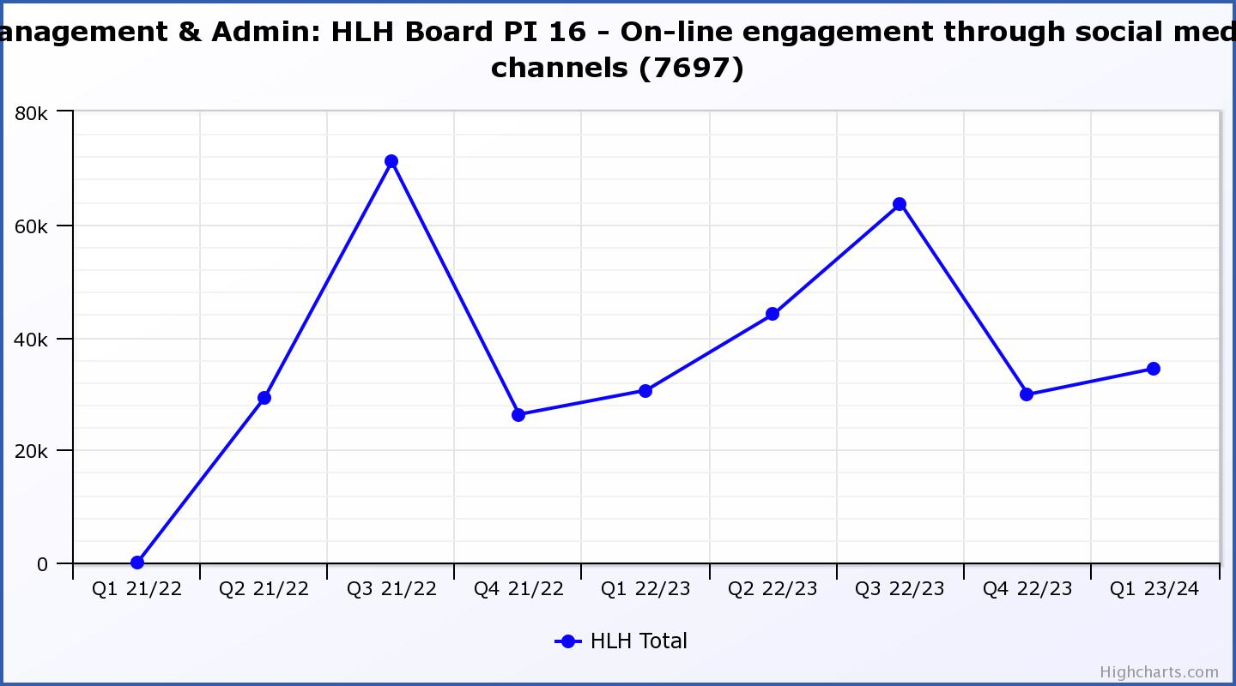

|  |  |  |  |  |  |  |  |  |
| --- | --- | --- | --- | --- | --- | --- | --- | --- |
| **Business Plan Outcome** | **Performance Indicator** | **Reporting Frequency** | **RAG Rating Definition** | **RAG Rating Q1 23/24** | **RAG Rating Q2 23/24** | **RAG Rating Q3 23/24** | **RAG Rating Q4 23/24** | **Summary of Quarter One Performance** |
| **9. Initiate and implement an ICT digital transformation strategy across the charity** | 17. The HLH digital transformation strategy is yet to be developed. |  | Should performance indicators be identified through the development of these plans they will be added in future. | NA |  |  |  | NA |

|  |  |  |  |  |  |  |  |  |
| --- | --- | --- | --- | --- | --- | --- | --- | --- |
| **Business Plan Outcome** | **Performance Indicator** | **Reporting Frequency** | **RAG Rating Definition** | **RAG Rating Q1 23/24** | **RAG Rating Q2 23/24** | **RAG Rating Q3 23/24** | **RAG Rating Q4 23/24** | **Summary of Quarter One Performance** |
| **10. Develop and strengthen relationships with customers, key stakeholders and partners** | New approach to customer survey as per Business Outcome 3 above.  Same as PI 6 - Charity-wide customer satisfaction survey | Quarterly | - | NA |  |  |  | NA |

|  |  |  |  |  |  |  |  |  |
| --- | --- | --- | --- | --- | --- | --- | --- | --- |
| **Business Plan Outcome** | **Performance Indicator** | **Reporting Frequency** | **RAG Rating Definition** | **RAG Rating Q1 23/24** | **RAG Rating Q2 23/24** | **RAG Rating Q3 23/24** | **RAG Rating Q4 23/24** | **Summary of Quarter One Performance** |
| **10. Develop and strengthen relationships with customers, key stakeholders and partners** | 18. Partnership work with **sport**scotland and other sports related organisations, NHS Highland and other health related organisations (including Memoranda of Understanding) etc. | Annual | 1. Green = Growth in partnership working 2. Amber = continuation of current level of partnership work 3. Red = cancellation of Partnership Agreements | NA |  |  |  | A new one-year partnership agreement, (indicative of a high level of trust in HLH’s sports development programme) was signed by **sport**scotland, THC and HLH in March 2023. |

|  |  |  |  |  |  |  |  |  |
| --- | --- | --- | --- | --- | --- | --- | --- | --- |
| **Business Plan Outcome** | **Performance Indicator** | **Reporting Frequency** | **RAG Rating Definition** | **RAG Rating Q1 23/24** | **RAG Rating Q2 23/24** | **RAG Rating Q3 23/24** | **RAG Rating Q4 23/24** | **Summary of Quarter One Performance** |
| **11. Deliver targeted programmes which support and enhance the physical and mental health and wellbeing of the population and which contribute to the prevention agenda.** | 19. An assess-ment of the RAG rating of the Health and Wellbeing Strategy action plan. |  | 1. Green = 80% or more of the actions are RAG rated green 2. Amber = 60% to 79% of actions are green. 3. Red = 59% or less are rated green. | NA |  |  |  | This indicator is scheduled to be considered at the HLH Board meeting in March 2024. |