Roadshow Report

Caitlyn Munro – Highland Youth Convener 2022/2023

Introduction
When I first came into this role, I had 3 main priorities that I wanted to work towards. These were:
- To increase and encourage participation amongst young people
- Visit schools/youth forums/youth groups to meet groups of young people face-to-face and encourage them to speak up in confidence.

- Inspire young people to talk about anything they feel strongly about and reassure them that people do want to hear from them.

- To raise the profile of the Highland Youth Convener role.
- Showcase what the role involves so young people are aware of the youth convener and how the youth convener can help them.

- Create a social media presence as a fun and engaging way for young people to contact the youth convener and find out more about what is happening across the Highlands for young people.

- To support young people in the awareness of mental health support available.
- Promotion of mental health charities/support services in Highland for young people to access.

- Ensure young people know what support is available and how they can access it.

With face-to-face visits becoming easier following the Covid-19 pandemic, a roadshow seemed the perfect way to combine these priorities and get back out to meet the young people of Highland. I felt that meeting the young people was important because the role of the Youth Convener is to represent young people, and it is also important for young people to see that there is someone in a role like this who makes sure that their views and opinions reach and are heard by decision-makers.
The aim of the roadshow was to connect with young people, share stories and experiences, and inspire others to get involved. I knew going into this that not every group would be the same and as open to talk about certain topics. I didn’t want the young people to feel pressured into talking or answering questions and I made that clear to them at the start. For me, getting to know the young people by building their trust and having open, general conversations created a good foundation that led to some positive discussions.
Visits
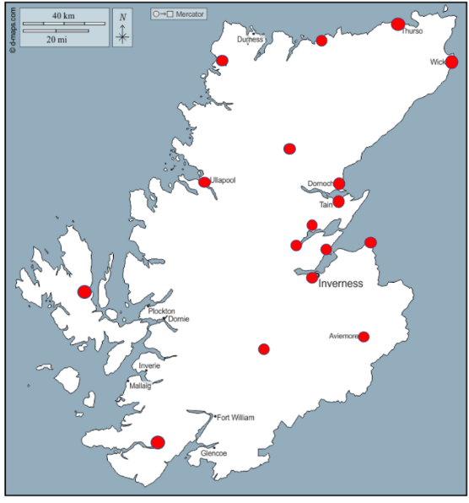
I initially said that I wanted to visit all 29 secondary schools in Highland, but I realised that was quite ambitious in the time frame I had. I set myself a more realistic goal of visiting at least one group of young people (school assembly / youth forum / youth club / pupil council etc) in each of the nine community planning partnership areas. This meant that each area of Highland was included and any more visits on top of the nine would be a bonus.
The red dots on the map represent where I have been to meet groups of young people. In total, 20 visits were completed, and these are listed in the table below.
Area | Group of Young People
Caithness | Thurso High School – lunch group  Wick – Teen Scene youth club
Sutherland | Dornoch Academy – After school club  Farr High School – Pupil Council  Lairg – Disability event  Kinlochbervie – After school club
East Ross | Tain – School assembly / youth forum  Alness – The Place
Mid Ross | Dingwall – Youth Highland  Fortrose Academy – lunch group
Inverness | Charleston Academy – lunch group  Kilchuimen Academy – School assembly  The Bridge – class  Culloden - youth club
Nairn | Nairn – Youth forum
Badenoch & Strathspey | Aviemore – Ukranian Refugee group  Badenoch & Strathspey Youth forum
Lochaber | Ardnamurchan High School – after school club
Skye, Lochalsh & West Ross | Ullapool – youth club  Portree High School – youth forum

Discussions
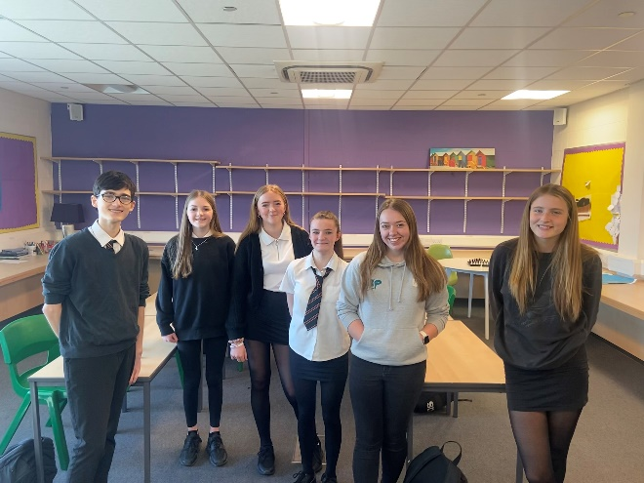
For most of the groups, this was their first time meeting a Youth Convener and many had not heard of the role or knew what it involved. To start the conversations, I told the young people all about the Youth Convener role, emphasising that the role represents young people in all levels of discussion. I explained that a key part of this role is sitting on The Highland Council’s Education Committee and having voting rights (although the Youth Convener no longer has voting rights) however not many young people were aware of this. I made sure that young people were aware that anything I said or voted on was not based on what I thought, it was based on what young people had said so that way the voices of young people were put forward and included in discussions at Education Committee. Telling young people about the role allowed them to have a greater understanding of what it involved, and I feel like it helped them to feel more confident when speaking to me.
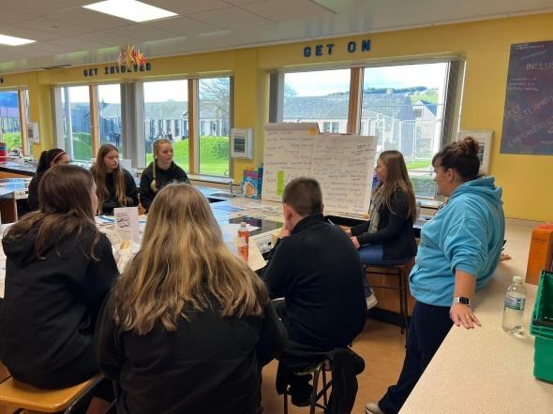
I was keen to find out from the young people if they have any issues where they live. Vaping, bullying, and transport were highlighted as the main issues that impact young people. For some areas vaping was raised as a key issue but for some of the more rural areas, transport was the main issue highlighted. Vaping was talked about at many visits with young people saying that this is becoming a more noticeable around their schools as more S1 and S2 pupils are seen with vapes. We talked a lot about vaping and the reasons behind why this has become such a popular trend among young people. Young people explained that they think a lot of people vape because their friends do it (peer pressure) or because it is seen as a supposedly ‘healthy’ alternative to smoking where vapes have become increasingly accessible to young people. These conversations led to young people talking about how they feel at school with many saying that they will not go to the toilet alone, with many saying they prefer going with a group of friends as they feel safer this way. This again was mentioned at a few different areas which clearly shows the need to work with young people to address this issue.
Discussions around vaping led to discussions about bullying and peer pressure. Many young people had said they felt pressured into vaping by their peers who vaped, but all the young people I spoke to had said they told their peers “No” when offered a vape.
For most areas, transport was talked about as a key issue that young people face. In some areas, young people talked about the lack of additional after-school transport to get home if they stay at an after-school club. Some young people said they simply don’t attend these activities because they can’t get home, or they must rely on their parents to pick them up. This has also had an impact on what clubs are on offer due to poor attendance because of transport issues. Young people also talked about the use of the under-22 free bus pass with many saying that although it’s good to get free travel, young people were questioning “what is the point of the free bus pass if there are no buses for us to use or if there is a limited availability of buses?”

Feedback
Overall, the feedback from the roadshow has been very positive and the idea of visits by the Youth Convener has been welcomed by both staff and young people. The young people said that it was nice to be able to speak to another young person in a post like this, who could pass on their views and opinions to ensure that their voices do get across to decision-makers. Many enjoyed the conversations, and it was great to see the young people asking questions and engaging with the discussions as well. Members of staff said it was great to have the Youth Convener come and visit their young people and talk to them. For many, it was the first time that a Youth Convener had been out to different areas, and this allowed staff and youth workers to get a better understanding of what the Youth Convener does.
I thoroughly enjoyed planning the roadshow and travelling across Highland to meet groups of young people. I think this roadshow was needed after limited face to face contact during Covid and it was great to be able to socialise with everyone I visited. I am really proud and happy that I managed to visit 20 groups of young people from across Highland in the timeframe I had. Hearing the views of young people directly helped inform the work I was doing and allowed me to progress the work effectively with young voices at the core.

