HIGH LIFE HIGHLAND  REPORT TO BOARD OF DIRECTORS  7 DECEMBER 2023 | AGENDA ITEM  REPORT No HLH / /23

Quarter Two Performance Report - Report by Chief Executive

Recommendation

The purpose of this report is to present performance information for the period July to September 2023.

It is recommended that Directors:

- comment on the report and agree that the overall health check on the charity for that period is rated as amber because of the performance indicators relating to finance, reserves and highlife subscriptions;
- comment on and note the actions underway to address the amber RAG rating in this report and the Finance and Service Delivery Contract Review reports elsewhere on this agenda; and
- note the positive response that there was to HLH and the services it provides on behalf of the Council at its Education Committee meeting held on 24 November 2023.

1. | Business Plan Contribution
1.1 | This report supports all the Business Outcomes from the High Life Highland (HLH) Business Plan 2022-27  - Seek to continuously improve standards of health and safety.  - Commit to the Scottish Government’s zero carbon targets and maintain the highest standards in environmental compliance.  - Use research and market analysis to develop and improve services to meet customer needs.  - Increase employee satisfaction, engagement and development to improve staff recruitment and retention.  - Improve the financial sustainability of the company.  - Value and strengthen the relationship with THC.  - Develop and deliver the HLH Corporate Programme and seek to attract capital investment.  - Use research and market analysis to develop and deliver proactive marketing and promotion of HLH and its services.  - Initiate and implement an ICT digital transformation strategy across the charity.  - Develop and strengthen relationships with customers, key stakeholders and partners.  - Deliver targeted programmes which support and enhance the physical and mental health and wellbeing of the population and which contribute to the prevention agenda.
2. | Background
2.1 | The implementation of the HLH Business Plan 2022-27 is monitored through a set of performance indicators set by the Board to assess the overall performance of the charity. The indicators were set at the HLH Board meeting held on 31 March 2022.
3. | Summary of Performance
3.1 | Appendix A contains a summary of performance against the PIs for Q2 2023/24. Appendix B provides a list of all the PIs along with trend information. 12 of the 18 PIs are scheduled for assessment at the December 2023 HLH Board meeting, of those, 7 have been RAG rated green; 2 amber; and 3 red.
3.2 | The indicators that have been RAG rated red are staff attendance, reserves and social media engagements; the amber ones are financial monitoring, and highlife subscriptions.
3.6 | PI 8 Staff Attendance Rate – while RAG rated red, this PI has been improving since Q1 2022. During this reporting period there was absence management training provided by the occupational health provider and managers are seeking to reduce absences. There is further information in the HR report elsewhere on this agenda.
3.7 | PI 9 Financial Monitoring – a year end deficit is forecast and there is further information in the Finance report elsewhere on this agenda.
3.8 | PI 10 Financial Reserves – it is anticipated that there will be no reserves by the end of the financial year. This is being addressed through the discussion with the Council as part of the review of the Service Delivery Contract.
3.9 | PI 11 High Life Subscriptions – there is an improvement in this PI since the previous HLH Board meeting, however, there is a risk of the budget target not being met because of the slower growth earlier in the year. The indicator has, therefore, been RAG rated amber. Subscriptions have been growing since June and in October were 18,581 (previous high was 18,305 in February). As reported to the HLH Board at its August 2023 meeting, the cancellation rate earlier in the year was higher than historic levels and this has reduced back to the previous levels of 3 to 4% over the past four months to October. The financial information relating to subscriptions is contained in the Finance Report elsewhere on this agenda.
4. | Performance Indicators for More Detailed Consideration
4.1 | Each quarter more detailed information is provided on one or more of the performance indicators and the following performance indicators were scheduled for inclusion at the December HLH board meeting.
4.2 | PI 12. Delivery of the Service Delivery Contract (SDC) with THC – The HLH Progress report was considered by the Education Committee at its meeting held on 23 November 2023 where the committee noted that HLH had met the terms of the contract. At the same meeting:  - the Youth Convener presented her action plan for her year in office; and  - there was a report on a strategy for the development of community and sports facilities which set out the principles for the creation of vibrant community hubs in Highland.
4.3  4.3.1 | The contributions made by HLH at the meeting were positively received and the web cast of the meeting can be seen on the following link with the Youth Convener presentation starting at 00:07:16 and the two items relating to HLH starting at 02:23:28: https://highland.public-i.tv/core/portal/webcast_interactive/716532  Having agreed the community and sports facilities strategy the Council plans to discuss it at the Community Planning Partnership Board and develop local plans based on the 29 secondary school catchment areas in the Highlands.
4.4 | PI 15. Media coverage from proactively issued media releases – Since 1 May there have been 118 media releases issued. All of them have resulted in positive media articles being published and there are some examples in Appendix C.
4.5 | PI 16. On-line engagement through social media channels – There were a reduced number of marketing social media engagements in Q2 this year compared with the previous year. There were two factors which contributed to this:  - The City of Inverness Events are not being delivered by HLH this year; and  - The engagement around the trial of giveaways in 2022 was not run this year.
4.6 | To raise engagements, the marketing team is developing the use of animated video content. Based on previous experience this performs well engagement wise and will be used in the upcoming 12 Days of Festive Giveaways promotion which rewards highlife current members through a daily draw to win a free limited time membership for the first 12 days of December. Each winner is posted on social media so members can follow the promotion. (Days 1-11 - win a 1-month free membership, day 12 - win a free 12-month membership).
4.7 | PI 18. Partnership work – There is further information on partnerships in Appendix D which provides an assessment of strategic and service partnerships. The information provided covers more areas of HLH work than is required by the indicator and the overall assessment from the teams is that partnerships and partnership working is going well, including those relating to NHS Highland and sportscotland where the four year partnership agreement is in its first year and is worth over £1m p.a.
5. | Implications
5.1 | Resource implications – while this report discusses resources and financial implications, there are no resource implications arising from agreeing the recommendations in this report.
5.2 | Equality implications - there are no new equality implications arising from this report.
5.3 | Legal implications - there are no new legal implications arising from this report.
5.4 | Risk implications - there are no new risk implications arising from this report.

Recommendation

It is recommended that Directors:

- comment on the report and agree that the overall health check on the charity for that period is rated as amber because of the performance indicators relating to finance, reserves and highlife subscriptions;
- comment on and note the actions underway to address the amber RAG rating in this report and the Finance and Service Delivery Contract Review reports elsewhere on this agenda; and
- note the positive response that there was to HLH and the services it provides on behalf of the Council at its Education Committee meeting held on 24 November 2023.

Designation: Chief Executive

Date: 24 November 2023

Author: Douglas Wilby, Director of Corporate Performance

Appendix A
HLH Performance Indicators - Summary Q2 2023/24  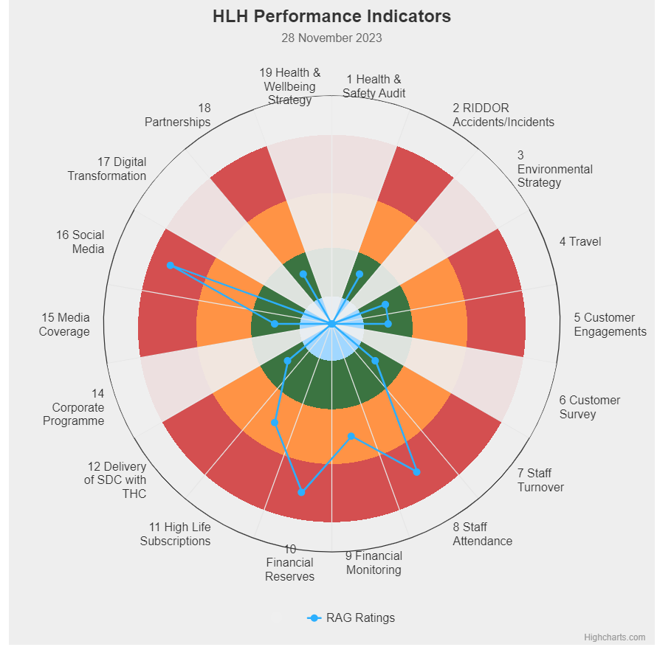 | Eighteen performance indicators (PIs) are used by the High Life Highland Board to assess the overall performance of the charity.  The PIs are RAG rated (allocated a "Red", "Amber" or "Green" status) so that it is easy to see at a glance how the organisation is performing. Most of the PIs are RAG rated every quarter throughout the year, with some (such as partnership working with NHSH for example) being considered annually so greyed out sectors on this radar diagram mean that the PI is to be considered at a future HLH Board meeting.  (Note, the previpus PI, 13, which was the Council’s Citizens Panel survey has discontinued and therefore removed from reporting. Numbering of PIs 14-19 has been retained to avoid costs associated with performance database changes).

Appendix B
HLH Performance Indicators - Detail Q2 2023/24

Business Plan Outcome | Performance Indicator | Reporting Frequency | RAG Rating Definition | RAG Rating Q1 23/24 | RAG Rating Q2 23/24 | RAG Rating Q3 23/24 | RAG Rating Q4 23/24 | Summary of Quarter Two Performance
1. Seek to continuously improve standards of health and safety. | 1. External health and safety audit. | Annual. | - Green = the external audit does not raise systemic issues.  - Amber = the external audit highlights common actions to be addressed across the company.  - Red = the external audit raises systemic (i.e., applying across multiple sites) H&S issues. | Green | NA |  |  | The annual health and safety report was considered at the June HLH Board meeting. The Health and Safety and Environmental Compliance Committee continues to meet to monitor health and safety performance with its most recent meeting having been 7 November 2023.

Business Plan Outcome | Performance Indicator | Reporting Frequency | RAG Rating Definition | RAG Rating Q1 23/24 | RAG Rating Q2 23/24 | RAG Rating Q3 23/24 | RAG Rating Q4 23/24 | Summary of Quarter Two Performance
1. Seek to continuously improve standards of health and safety. | 2. RIDDOR accidents/incidents. | Quarterly. | - Red = number of RIDDOR reports per quarter is above 20.  - Amber = number of RIDDOR reports per quarter is between 10 and 20  - Green = number of RIDDOR reports per quarter is less than 10. | Green | Green |  |  | No incidents were reported under the RIDDOR regulations during Q2.

Performance Indicator 2 - RIDDOR accidents/incidents
The graph below tracks the number of accidents and incidents reported under the Reporting of Injuries, Diseases and Dangerous Occurrences Regulations (RIDDOR). There were no RIDDOR incidents reported in Q2 2023/24.
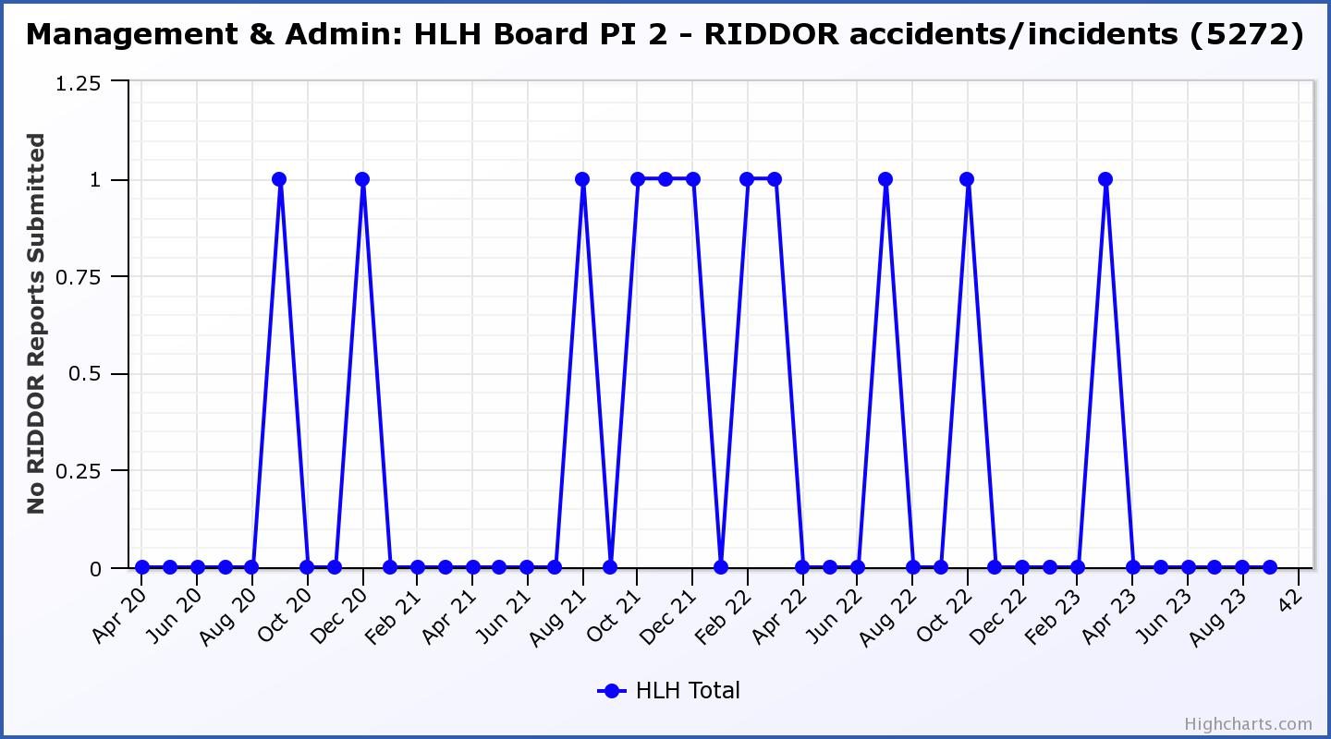

Business Plan Outcome | Performance Indicator | Reporting Frequency | RAG Rating Definition | RAG Rating Q1 23/24 | RAG Rating Q2 23/24 | RAG Rating Q3 23/24 | RAG Rating Q4 23/24 | Summary of Quarter Two Performance
2. Commit to the Scottish Government’s zero carbon targets and maintain the highest standards in environmental compliance. | 3. The HLH Environmental strategy will be developed in partnership with the Council as it develops its plans. | . |  | NA | NA |  |  | N/A - Performance indicators will be identified through the development of these plans and will be aligned with THC’s carbon reduction strategy given the contractual (particularly property) arrangements that there are in place between THC and HLH.

Business Plan Outcome | Performance Indicator | Reporting Frequency | RAG Rating Definition | RAG Rating Q1 23/24 | RAG Rating Q2 23/24 | RAG Rating Q3 23/24 | RAG Rating Q4 23/24 | Summary of Quarter Two Performance
2. Commit to the Scottish Government’s zero carbon targets and maintain the highest standards in environmental compliance. | 4. Travel (a target to reduce by 50% following the pandemic has been set)  (Quarterly ceiling 112,750. Annual ceiling 451,000) | Quarterly. | - Green = 451,000 miles p.a. or less  - Amber = 451,001 to 541,200 miles p.a.  - Red = 541,201 p.a. or more | Amber | Green |  |  | Travel miles were 108,894 in Q2 which is under the quarterly ceiling.  Note that Q1 plus Q2 total is 239,492 and the RAG rating for the first six months is amber. Managers are monitoring travel miles.

Performance Indicator 4 – Travel Miles
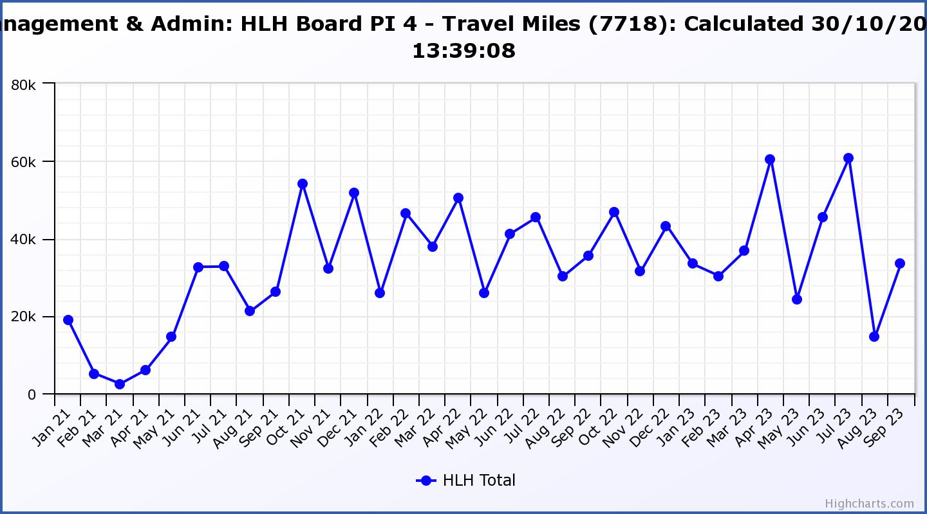

Business Plan Outcome | Performance Indicator | Reporting Frequency | RAG Rating Definition | RAG Rating Q1 23/24 | RAG Rating Q2 23/24 | RAG Rating Q3 23/24 | RAG Rating Q4 23/24 | Summary of Quarter Two Performance
3. Use research and market analysis to develop and improve services to meet customer needs. | 5. Customer engagements. | Quarterly. | - Green = customer numbers are the same as or have increased compared with the corresponding quarter in the previous year  - Amber = customer numbers are less than the corresponding quarter in the previous year.  - Red = customer numbers are more than 5% lower than the corresponding quarter in the previous year. | Green | Green |  |  | Customer engagements increased from 1,987,192 in Q2 2022/23 to  2,797,239 in Q2 2023/24.

Performance Indicator 5 - Customer engagements
The year-on-year growth in customer engagements has been re-established.
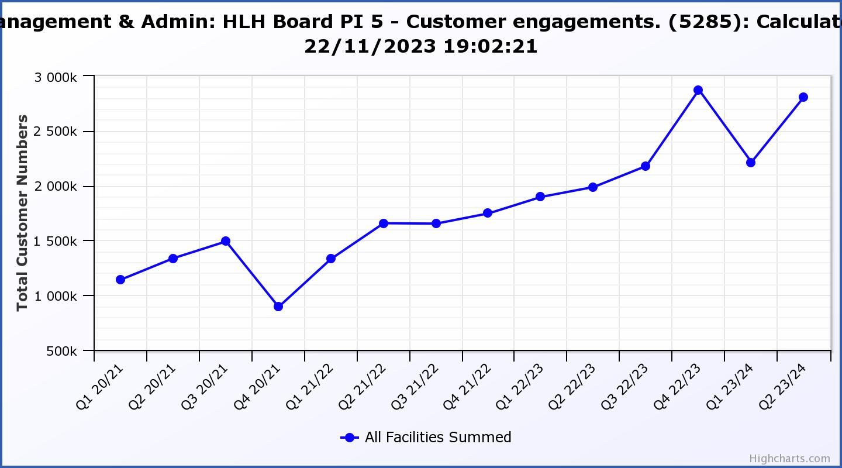

Business Plan Outcome | Performance Indicator | Reporting Frequency | RAG Rating Definition | RAG Rating Q1 23/24 | RAG Rating Q2 23/24 | RAG Rating Q3 23/24 | RAG Rating Q4 23/24 | Summary of Quarter Two Performance
3. Use research and market analysis to develop and improve services to meet customer needs. | 6. Charity-wide customer satisfaction survey. | Annually. | - Green = Services delivered by HLH is above average  - Amber = Services delivered by HLH is average  - Red = Services delivered by HLH is below average. | Green | NA |  |  | This was reported to the HLH Board as part of the Q1 reporting where 95% of respondents rated their overall experience of HLH/staff as excellent or good and 95% said that they would recommend HLH.

Business Plan Outcome | Performance Indicator | Reporting Frequency | RAG Rating Definition | RAG Rating Q1 23/24 | RAG Rating Q2 23/24 | RAG Rating Q3 23/24 | RAG Rating Q4 23/24 | Summary of Quarter Two Performance
4. Increase employee satisfaction, engagement and development to improve staff recruitment and retention. | 7. Staff turnover (resignations as a percentage of posts). | Quarterly. | - Green = 1.6% or less.  - Amber = 1.7 to 2%  - Red = more than 2% | Green | Green |  |  | The number of resignations per month as a percentage of posts was 1.5% in July, 1% in August and 1.3% in September. Please see the HR report elsewhere on this agenda for further information.

Performance Indicator 7 - Staff Turnover (resignations as a percentage of posts)
The graph below shows resignations as a percentage of the number of posts (1% equates to 10 staff).

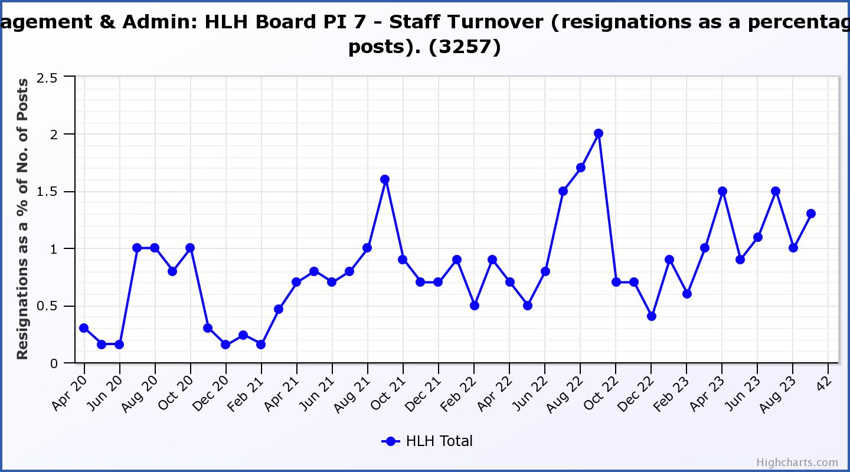

Business Plan Outcome | Performance Indicator | Reporting Frequency | RAG Rating Definition | RAG Rating Q1 23/24 | RAG Rating Q2 23/24 | RAG Rating Q3 23/24 | RAG Rating Q4 23/24 | Summary of Quarter Two Performance
4. Increase employee satisfaction, engagement and development to improve staff recruitment and retention. | 8. Staff attendance rates (RAG ratings based on Office for National Statistics for 2020 of absence rate). | Quarterly. | - Green = attendance rate 98% or higher.  - Amber = attendance rate between 97% and 98%.  - Red = attendance rate less than 97%. | Red | Red |  |  | The attendance rate for Q2 was 95.97%. Please see the HR report elsewhere on this agenda for further information.

The Office for National Statistics (ONS) figure has changed since 2021 when the RAG rating was set and absence levels in the UK for public sector employees in the most recent (2022) ONS report was 3.6%. Absence rates in Scotland are higher than the UK average and the ONS has reported that: “Groups with the highest rates of sickness absence in 2022 included …. people working in care, leisure, or other service occupations” and the UK absence rate in those occupations is 4.3%.

If the RAG ratings were to be based on the UK absence rate for caring, leisure and other service occupations the RAG ratings would be as follows:

i. Green = attendance rate 95.7% or higher.
ii. Amber = attendance rate between 94.6% and 94.7%.
iii. Red = attendance rate less than 93.7%.

This would make the HLH absence rate green, however, rather than adjust the absence rate at this stage, it is considered that the work underway to manage absences be continued and performance in this area continue to be monitored as improvement in this area will contribute positively to HLH’s financial situation. The recording and reporting of absences is labour intensive and this and the ONS figures suggest that there might be value in developing a better way of recording reporting and comparing performance with national information and this will be considered as part of the digital systems work being developed.

Performance Indicator 8 - Staff Attendance Rate
Staff attendance rates for Q2 were 95.97%. Please see the HR report elsewhere on this agenda for further information.
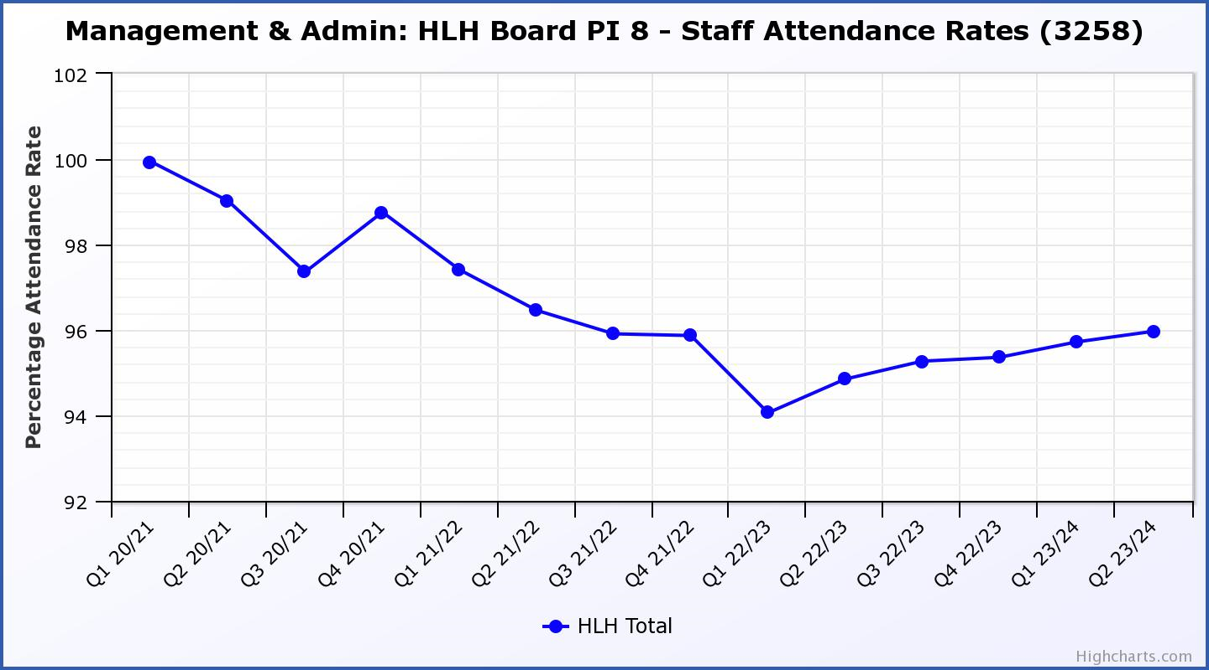

Business Plan Outcome | Performance Indicator | Reporting Frequency | RAG Rating Definition | RAG Rating Q1 23/24 | RAG Rating Q2 23/24 | RAG Rating Q3 23/24 | RAG Rating Q4 23/24 | Summary of Quarter Two Performance
5. Improve the financial sustainability of the company | 9. Financial monitoring. | Quarterly. | An assessment of the year end outturn where:  - Green = delivery of services within budget.  - Amber = delivery of services between break-even and 2% over budget.  - Red = delivery of services over budget above 2%. | Amber | Amber |  |  | There is further information in the Finance Report elsewhere on this agenda.

Performance Indicator 9 - Financial Monitoring
This graph shows the actual position at the end of each quarter.

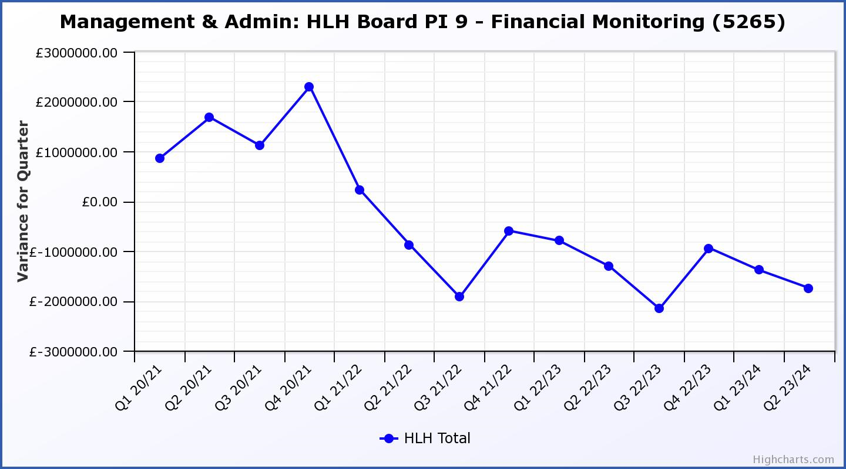

Business Plan Outcome | Performance Indicator | Reporting Frequency | RAG Rating Definition | RAG Rating Q1 23/24 | RAG Rating Q2 23/24 | RAG Rating Q3 23/24 | RAG Rating Q4 23/24 | Summary of Quarter Two Performance
5. Improve the financial sustainability of the company | 10. Reserves | Annual. | - Green = meets 3% reserves policy  - Amber = achieves 2% reserves  - Red = fails to achieve 2% reserves policy. | Red | Red |  |  | Uncommitted reserves will be 0% at the end of 2023/24 and, therefore, RAG rated red.  Please see the Finance report elsewhere in this agenda for further information.
Performance Indicator 10 - Financial Reserves

This graph shows the level of uncommitted, unrestricted reserves at the end of each financial year. Zero reserves are forecast at the year end.

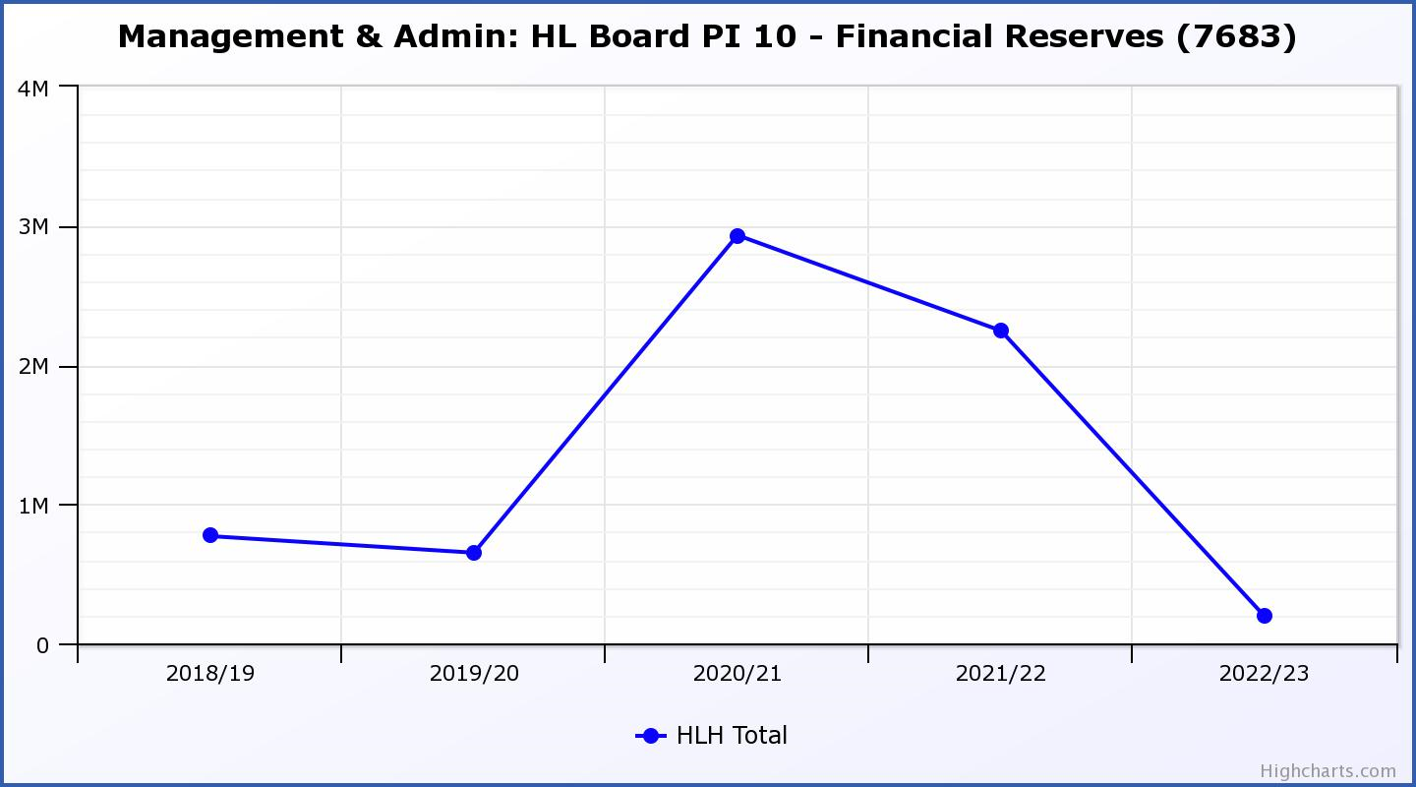

Business Plan Outcome | Performance Indicator | Reporting Frequency | RAG Rating Definition | RAG Rating Q1 23/24 | RAG Rating Q2 23/24 | RAG Rating Q3 23/24 | RAG Rating Q4 23/24 | Summary of Quarter Two Performance
5. Improve the financial sustainability of the company | 11. Number of highlife subscriptions (target is the required number to meet the budget). | Quarterly. | - Green= exceeds budgeted income target.  - Amber = risk of budget target not being met.  - Red = budgeted income target unlikely to be met. | Amber | Amber |  |  | This PI has been RAG rated amber. Please see section three of this report for further information.

Performance Indicator 11 - Number of High Life Subscriptions
Following a period of growth which continued into the start of the calendar year, subscriptions declined during Q1 and this stopped in June. As of October subscriptions were 18,581.

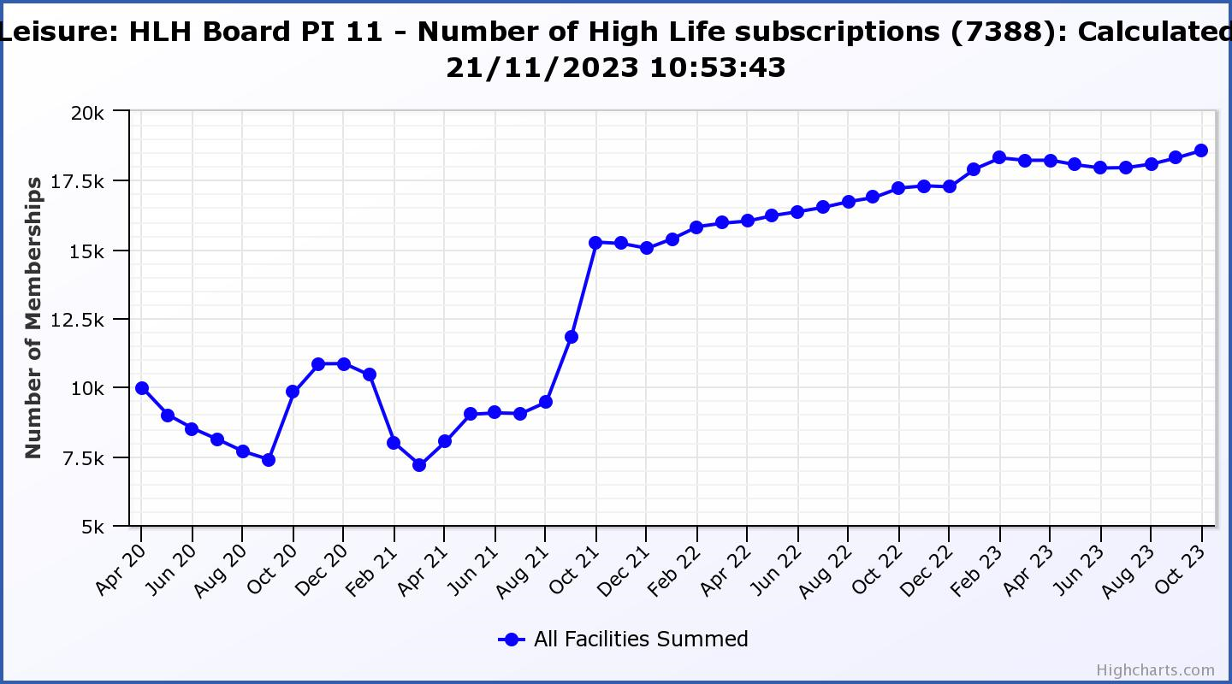

Business Plan Outcome | Performance Indicator | Reporting Frequency | RAG Rating Definition | RAG Rating Q1 23/24 | RAG Rating Q2 23/24 | RAG Rating Q3 23/24 | RAG Rating Q4 23/24 | Summary of Quarter Two Performance
6. Value and strengthen the relationship with THC. | 12. Delivery of the Service Delivery Contract (SDC) with The Highland Council (THC). | Six-monthly. | - Green = agreement of THC’s Education Committee that HLH has met or exceeded the terms of the SDC.  - Amber = agreement of THC’s Education Committee that HLH has met the terms of the SDC but has set some improvement targets.  - Red = agreement of THC’s Education Committee that HLH has not met the terms of the SDC. | NA | Green |  |  | The Council’s Education Committee considered the HLH Progress Report at its 23 November 2023 meeting. The Committee noted that HLH continues to deliver the Public Service Obligations on behalf of the Council as set out in the Service Delivery Contract.

Business Plan Outcome | Performance Indicator | Reporting Frequency | RAG* Rating Definition  (*Red/Amber/Green) | RAG Rating Q1 23/24 | RAG Rating Q2 23/24 | RAG Rating Q3 23/24 | RAG Rating Q4 23/24 | Summary of Quarter Two Performance
7. Develop and deliver the HLH Corporate Programme and seek to attract capital investment. | 14.The HLH corporate programme covers investment; business process improvement; capital and asset management plans and plans will be developed as this area of work is developed. | NA | Should additional performance indicators be identified through the development of these plans they will be added in future. | NA | NA |  |  | NA

Business Plan Outcome | Performance Indicator | Reporting Frequency | RAG Rating Definition | RAG Rating Q1 23/24 | RAG Rating Q2 23/24 | RAG Rating Q3 23/24 | RAG Rating Q4 23/24 | Summary of Quarter Two Performance
8. Use research and market analysis to develop and deliver proactive marketing and promotion of HLH and its services. | 15. Media coverage from proactively issued media releases | Six-monthly. | - Green = Positive coverage 95%+  - Amber = Positive coverage 90% - 95%  - Red = Positive coverage 90%- | NA | Green |  |  | There were 118 proactively released media releases since May 1st 2023 and they all resulted in positive articles being published.

Business Plan Outcome | Performance Indicator | Reporting Frequency | RAG Rating Definition | RAG Rating Q1 23/24 | RAG Rating Q2 23/24 | RAG Rating Q3 23/24 | RAG Rating Q4 23/24 | Summary of Quarter Two Performance
8. Use research and market analysis to develop and deliver proactive marketing and promotion of HLH and its services. | 16. On-line engagement through social media channels. |  | - Green = 5% increase compared with the same period last year.  - Amber = no increase to 4.9% lower compared with the same period last year.  - Red = more than 5% lower or less compared with the same period last year. | Green | Red |  |  | Social media engagements were 44,066 in Q2 22/23 but decreased to 20,288 in Q2 23/24. Please see section 3 above for further information.

Performance Indicator 15 - On-line engagement through social media channels.
On-line engagement through social media channels in Q2 fell compared to engagements in Q2 2022/23 largely due to HLH not operating the Inverness events programme in 2023. Please see section 3 of this report above for further information.

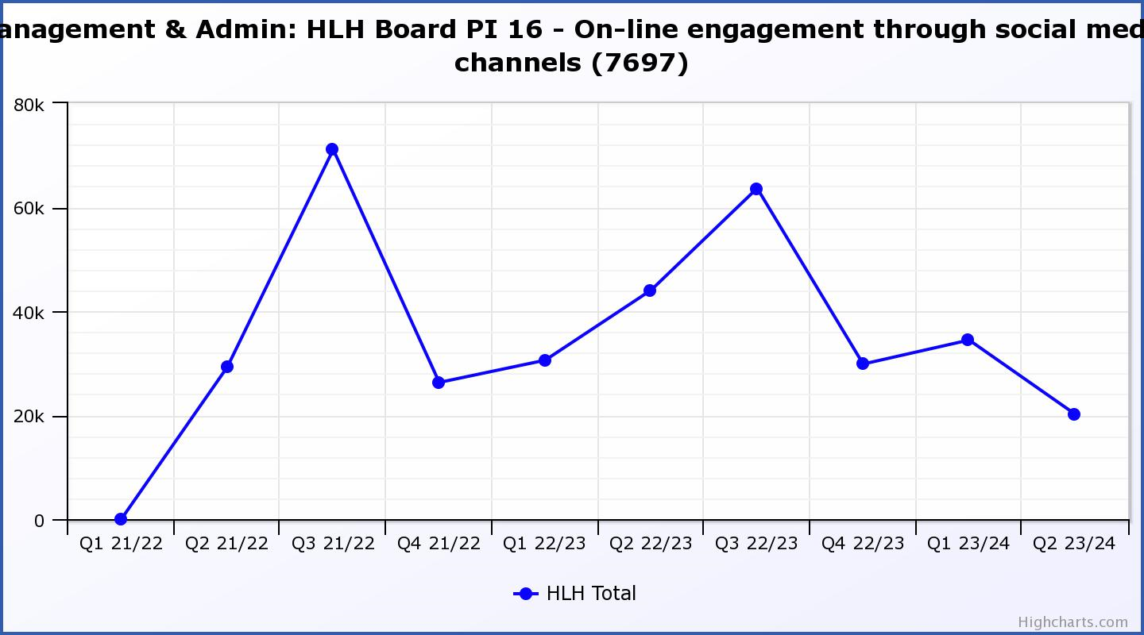

Business Plan Outcome | Performance Indicator | Reporting Frequency | RAG Rating Definition | RAG Rating Q1 23/24 | RAG Rating Q2 23/24 | RAG Rating Q3 23/24 | RAG Rating Q4 23/24 | Summary of Quarter Two Performance
9. Initiate and implement an ICT digital transformation strategy across the charity | 17. The HLH digital transformation strategy is yet to be developed. |  | Should performance indicators be identified through the development of these plans they will be added in future. | NA | NA |  |  | NA

Business Plan Outcome | Performance Indicator | Reporting Frequency | RAG Rating Definition | RAG Rating Q1 23/24 | RAG Rating Q2 23/24 | RAG Rating Q3 23/24 | RAG Rating Q4 23/24 | Summary of Quarter Two Performance
10. Develop and strengthen relationships with customers, key stakeholders and partners | New approach to customer survey as per Business Outcome 3 above.  Same as PI 6 - Charity-wide customer satisfaction survey | Quarterly | - | Green | NA |  |  | NA – this indicator was considered by the HLH Board at its August 2023 meeting.

Business Plan Outcome | Performance Indicator | Reporting Frequency | RAG Rating Definition | RAG Rating Q1 23/24 | RAG Rating Q2 23/24 | RAG Rating Q3 23/24 | RAG Rating Q4 23/24 | Summary of Quarter Two Performance
10. Develop and strengthen relationships with customers, key stakeholders and partners | 18. Partnership work with sportscotland and other sports related organisations, NHS Highland and other health related organisations (including Memoranda of Understanding) etc. | Annual | - Green = Growth in partnership working  - Amber = continuation of current level of partnership work  - Red = cancellation of Partnership Agreements | NA | Green |  |  | Please see Appendix D of this report for a summary of partnership work.

Business Plan Outcome | Performance Indicator | Reporting Frequency | RAG Rating Definition | RAG Rating Q1 23/24 | RAG Rating Q2 23/24 | RAG Rating Q3 23/24 | RAG Rating Q4 23/24 | Summary of Quarter Two Performance
11. Deliver targeted programmes which support and enhance the physical and mental health and wellbeing of the population and which contribute to the prevention agenda. | 19. An assess-ment of the RAG rating of the Health and Wellbeing Strategy action plan. |  | - Green = 80% or more of the actions are RAG rated green  - Amber = 60% to 79% of actions are green.  - Red = 59% or less are rated green. | NA | NA |  |  | This indicator is scheduled to be considered at the HLH Board meeting in March 2024.

Appendix C
Examples of media releases which were reported positively in Highland publications

Photo | Title | Re-issued by
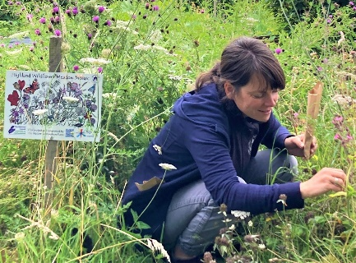 | “Ullapool Village Hall to host an enlightening talk on the Highland Wildflower Meadow Mosaic” | Ross-Shire Journal  The Northern Times  The Highland Times
 | “Highland Youth Parliament: New Chair and Vice Chair announced” | John O'Groat Journal  Inverness Courier  Strathspey Herald  The Highland Times  The Oban Times  Ross-Shire Journal
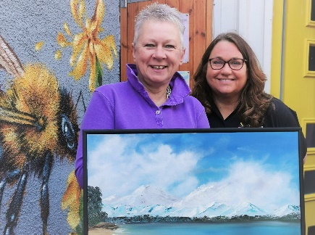 | “Place your bid: Strathpeffer Pavilion Art Fair host ‘silent auction’ of artwork with all proceeds donated to Mikeysline” | The Highland Times  Ross-Shire Journal  Inverness Courier
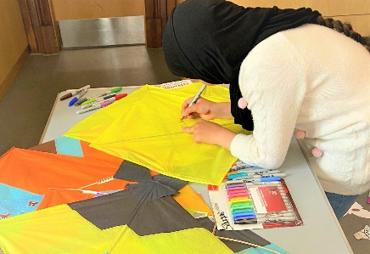 | “Adult Learning for Refugees team hosts traditional kite-making session to inspire hope in Afghan families” | Inverness Courier  The Highland Times  Ross-Shire Journal  The Northern Times
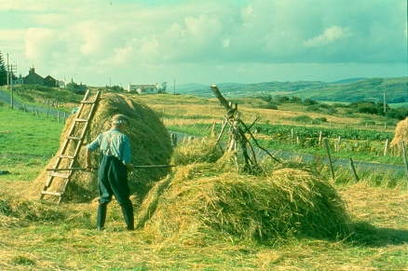 | “New exhibition at Skye and Lochalsh Archive Centre explores 100 years of North Talisker history” | Ross-Shire Journal  The Herald Scotland  The Scotsman  The Oban Times  The Highland Times
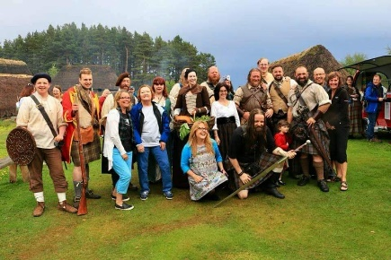 | “Outlander Day is ‘set’ to be a success at Highland Folk Museum” | Strathspey Herald  Press & Journal  The Oban Times  Inverness Courier

Appendix D
Summary of partnership work by each of the HLH areas of work

There are a number of partnerships that High Life Highland is involved in to deliver services and make life better for the people of the Highlands. HLH’s role varies from being the lead organisation, the main supporting partner or working as one of a number of partners in a group. Some partnerships exist because of funding arrangements, with the most significant ones being with sportscotland; NHS Highland; and the Council (for funding for projects which are in addition to the services specified in the Service Delivery Contract).

Adult Learning – The adult learning team continues to deliver much of its work in partnership with other organisations, focusing on the literacy and numeracy aspects of support which people require, including English for speakers of other languages (ESOL) provision. The following represents the more formal and pan Highland partnerships. LEAD Scotland (Learning organisation focus on people with disabilities); Workers Education Association (WEA); University of the Highland and Islands (UHI); Highland Third Sector Interface (HTSI); The Highland Council (THC) (for refugee resettlement projects); Education Scotland (policy and development); Northern Alliance Regional collaborative; Learn North Community Learning and Development; Highland Adult Learning and Development Group, (HLH co-chair with third sector representative).

Archives – In Caithness, the Archives service is a formal subcontractor of Restore Digital, the information management company contracted by the Nuclear Decommissioning Authority to run Nucleus in Wick, the national archive of the British civil nuclear industry and the archive for the County. HLH is currently contracted to deliver all of Nucleus' customer facing service, both in Nucleus and out and about in community settings. The current contract, value £132k pa, comes to an end this year and Restore has submitted a retender application, again with HLH as its subcontractor.

Linked to the Memorandum of Understanding with UHI, Archives collaborates with several sections and individual colleges of UHI on a wide range of activities. The Skye and Lochalsh Archive Centre is currently hosting a UHI internship.

Am Baile continues to work closely with the Inverness Caledonian Thistle Community Trust to consolidate and grow the Inverness Football Memories project and related activities.

All four archive centres also work in informal partnerships with a wide variety of third sector and community groups. These include Eden Court Theatre, Dounreay Heritage Group, HMP Inverness, many schools and residential care homes, museums and heritage societies and many more. The Highland Family History Society has a permanent base in the Highland Archive Centre

Arts - In a partnership with Creative Scotland the Visual Arts Unit manages the Visual Artist and Craft Makers Awards (VACMA) scheme in the Highland, Moray and Western Isles area. VACMA offers small grants to visual artists and craft makers for their creative development at all stages of their career. Each year, approximately thirty artists and makers receive support from the scheme.

The Visual Arts Unit also has a longstanding partnership with the National Galleries of Scotland (NGS). This has resulted in a number of NGS curated exhibitions of the highest quality being shown at Inverness Museum and Art Gallery (IMAG). It also, from time to time, partners with other art institutions to bring high quality art exhibitions to the Highlands, most recently with The Fleming Collection, which resulted in a Glasgow Boys and Girls exhibition at IMAG.

Related to the Memorandum of Understanding with UHI the Unit provides an annual placement for a final year Fine Art undergraduate.

Digital & Technology-The Digital & Technology Team continue to support a number of partnerships including supply and management of the complete IT infrastructure for the Hydro Ness building on behalf of The Highland Council. Work is also carried out on a regular basis to support both Highlands & Islands Enterprise (STEM – Scottish Skills Academy programme) and NHS Highland (Diabetes programme) by way of providing a platform to centrally manage more than 100 iPads.

The team also support the LeisureLink partnership by looking after the system behind the initiative covering 9 Local Authority areas of Scotland and are currently in the process of setting up the tenth new partner: Live Life Aberdeenshire.

Countryside Rangers – The countryside ranger team is involved in a range of project and standing partnerships as follows:

The Green Health Partnership: operates under the branding "Think Health Think Nature" and is one of four area-wide partnerships developed and funded by NatureScot. It aims to encourage more use of the outdoors to tackle physical inactivity, mental health issues and health inequalities. The partnership is made of representatives from High Life Highland (HLH), NHS Highland; NatureScot; The Highland Council; The Cairngorms National Park Authority (CNPA); The University of the Highland and Islands (UHI), The Highland Environment Forum; The Highland Third Sector Interface (HTSI); Paths for All; Forest and Land Scotland and practitioners in the environment, health and social care sectors.

Highland Adapts: is a Highland Council partnership initiative to work with statutory agencies such as NHS Highland, Forestry & Land Scotland and SEPA as well as representatives from communities, businesses, land managers and public sector to facilitate transformational action towards a prosperous, climate ready Highland to look at how the Highlands adapt to climate change.

Highland Environment Forum & Highland biodiversity action plan 2021 - 2026: The Edinburgh Declaration (2021) sets out the aspirations and commitments of the members of the international community, the Scottish Government, its partners, and the wider sub-national community working in biodiversity in delivering for nature over the coming decade. Highland Council signed the Edinburgh Declaration in December 2022. The Highland Nature: Biodiversity action plan 2021 - 2026 is the call to action. This plan was created through surveys and meetings with Highland Environment Forum members and the wider public, and through the commitments undertaken by partners. This work is overseen and coordinated by the Highland Environment Forum’s Biodiversity Working Group.

There is a range of current partner funded projects where the HLH Ranger service is the lead delivery partner:

- HTSI - Mental Health in communities fund- Healthy Minds delivery in Badenoch and Strathspey (lead Saranne Bish)- targeted work with clients who have diagnosed mental illness. Both direct NHS and self-referrals. Partners: NHS; HTSI; CNPA; Forest and Land Scotland.
- Highland Climate Hub – Community funding running Climate Festival activities as a partner across Highland.
- North West Geo-Park – Community Ambassador for the NW Geo-Park and collaboration with Historic Assynt on running small scale interpretation in the area from “Ranger Huts” at key pressure points to raise ecological awareness.
- THC/NatureScot Nature Restoration Fund Project Grant: Highland Wildflower Meadow Mosaic. HLH Ranger service have undertaken the creation of 30-40 wildflower meadow sites across Highland Council Area– just awarded £7,500 towards a further community engagement project in freshwater restoration across Highland for 2024.

Health and Wellbeing – there are a number of partnerships connected to the health and wellbeing work in HLH. These are summarised in bullet format below with more details provided in the text below:

- NHS Highland
  - Health Improvement/Public Health
  - Allied Health Professionals
  - Primary Care (inc. Numerous GP Practices)
  - Operational Units
  - Specialist Health Professionals (e.g. in cardiac rehab, cancer etc)
  - Communications Team
  - Redesign Team
- University of the Highlands and Islands (UHI (University of the Highland and Islands)
  - Researchers (Biomedical Sciences Division and Rural Health and Wellbeing Division);
  - Teaching staff (Inverness UHI)
- Community Leisure UK (CLUK)
  - Chair CLUK Health Group for Scotland
- Community Planning Partnership (locality and thematic groups)
- Highlands and Islands Enterprise
- Parkinsons’ UK
- Samaritans
- Home Energy Scotland
- Versus Arthritis
- Chest Heart and Stroke Scotland
- Change Mental Health
- Velocity
- Diabetes Scotland
- Ability Net
- My Self Management
The key partnership being with NHS Highland, specifically the Health Improvement Team within Public Health as well as Allied Health Professionals, Primary Care and Realistic Medicine teams. There are also strong partnerships with NHS Highland operational units which function across the localities in which HLH delivers services.

Other partnerships include the University of the Highlands and Islands (UHI) including collaborations with both research and teaching staff across the university portfolio such as the Rural Health and Wellbeing Division; the Biomedical Science Division; and the teaching staff at Inverness UHI. Further partnerships are strong with colleagues across the Community Leisure UK Network, HLH currently Chairs the CLUK Scotland Health Group which includes representatives from a large number of culture and leisure trusts from across the country.

HLH is also working in partnership with Highlands and Islands Enterprise to complete a piece of work to identify the social return on investment from some of HLH’s services, it is hoped this work will grow and link across all services following an initial pilot.

Our work in health and wellbeing also involves partnerships with a range of third and charitable sector organisation regarding the support offered to people with a range of long-term health conditions, these partnerships include: Parkinson’s UK, Change Mental Health, Chest Heart and Stroke Scotland and Diabetes Scotland.

HLH also recently worked in partnership with Samaritans to offer our own people support for their personal health and wellbeing through a series of webinars looking at topics including emotional wellbeing, how to listen well and suicide awareness.

Inverness Castle Experience – HLH acts as The Highland Council’s Managing Agent and partner in the design and development of the new visitor attraction which is due to open in 2025.

Leisure – some of the facilities operated by the leisure team are in partnership with community groups who own/manage local facilities. The partnerships include: Tongue and Farr Sports Association; Ullaspool Board; Poolewe Board; Puffin Pool Board; Highland Rugby Club; Leanaig Advisory Forum; Strathpeffer Pavilion Community Trust; Macphail Centre Board. In addition, there are wider partnerships such as with UHI (University of the Highland and Islands) for training with students for the National Pool Lifeguard Qualification and as sports and group exercise instructors. The team also works in partnership with Sportscotland as part of their elite athlete programme and Fitness Training Scotland to upskill our staff in group fitness, strength and conditioning.

Levelling Up Fund Projects – HLH also acts as the Council’s Managing Agent in the delivery of the three Levelling Up Fund projects at Castle Street Energy Centre, Bught Park and the Northern Meeting Park.

Libraries – There are a range of projects ranging from local, area wide and national partnerships including work with UHI to support opportunities for PHD collaborations - libraries are working with a PHD student who is researching how young people and other age groups interact with nature and the environment through the reading of a selection of environmental literature. Work is also underway with an Icelandic PHD student who is spending time engaging with mobile library customers. She is researching how rural communities interact and engage with public services.

‘Meet The Books’ workshops continue at Inverness Library, in collaboration with UHI. This is a series of interactive workshops that introduce students and the wider community to High Life Highland’s special collections, including the Fraser-Mackintosh Library.

In collaboration with UHI a ‘High Life Highland Poetry Award’ was trialled this year and was open to all UHI students. Due to the success of the award, this will now become an annual competition, to encourage a love of literature and to recognise new writing talent.

Work with the Scottish Libraries and Information Council (SLIC) to participate in expansion of the “one card” initiative with other Scottish Library services. This is a national initiative that forms part of the National Libraries Strategy. The initiative allows anyone living in Scotland that is in receipt of a library membership to use it anywhere throughout the country, offering the customer improved convenience and ease of access.

Work with NHS Highland to the support the Near-Me initiative. Near-Me is a national project supporting those without digital connectivity at home to access devices that will enable them to attend online medical appointments. Customers can book a private area within a library where they have free access to an iPad to attend their online appointments. The initiative is currently being delivered at Thurso Library and will shortly be rolled out to other locations including Inverness, Lochcarron, Kinlochleven and Brora.

Museums - Along with four other Highland Museums, Inverness Museum and Art Gallery (IMAG) is participating in a year-long collaboration with Smartify, the sector leading digital platform for museums. This opportunity became available through collaboration with Museums & Heritage Highland and XPO North Digital (support organisation for creative and heritage groups).

Through a formal partnership with Historic Environment Scotland (HES) the Highland Folk Museum (HFM) hosts an HES Trainee Fellowship. This is a full time, craft worker member of staff based at HFM for a period of one year. The Fellow is an HES employee but managed and trained on a day-to-day basis by HFM staff.

HFM also works in informal partnerships with variety of community groups, including providing an outdoor classroom facility for Newtonmore Primary School and collaborates on events and activities for the Badenoch Shinty Memories group. It has recently entered into a new partnership with the Cairngorm Curling Heritage group.

IMAG also has several longstanding and productive collaborative working partnerships with a number of third sector and community groups, including Alzheimer’s Scotland, local Brownie groups, Connecting Carers, WASPS Inverness Creative Academy and many more. A recently established, new partnership is with the Care and Leaming Alliance (CALA), which will result in an exhibition and a programme of related activities.

North Coast Visitor Centre (NCVC) has established a partnership with the Society of Caithness Artists, which has brought about a programme of art exhibitions at the museum. It also enjoys ongoing collaboration with the Dounreay Heritage Group.

Music Tuition – The team is gradually rebuilding relationships with all the main national professional orchestras and other organisations offering opportunities for young people following Covid disruption and staff changes in many of these organisations. It continues to work via Youth Music initiative funding the primary schools' projects with Fèisean nan Gàidheal & Drake Music Scotland

Safeguarding – HLH is a member of the Highland Child Protection Committee (HCPC), Highland Violence Against Women Partnership (HVAWP) and the CHAMPS Board for care experienced young people. These partnerships ensure that HLH is involved and participating in conversations and agendas to support many of the most vulnerable individuals and families in Highland communities.

Sports Development – The main partnership in sport is the partnership with the Highland Council and sportscotland. A new four-year Partnership Agreement has been agreed with sportscotland which runs from April 2023 – April 2027. The £1.12 million pa investment in the partnership from sportscotland is based on 6 priority areas:

- Planning for Sport
- Active Schools
- Community Sport Hubs
- Inclusion
- Places
- Performance
Formal partnerships are also in place with two Sports Governing Bodies. The partnership in place with both the Camanachd Association and Scottish Rugby Union look to support growth in participation across the Highlands. A new formal partnership has also been developed with the Highland Disability Sports organisation to support our inclusion priority.

The Active Highland Partnership has also been further developed with a refresh of the Active Highland Strategy taking place. Working alongside The Highland Council, NHS Highland, sportscotland and Public Health Scotland the refreshed strategy will coordinate a multi-agency response to promoting physical activity in Highland with a focus on those currently facing barriers to being active.

The partnership with the Highland Council (Home to Highland Care Experienced Education Team) supporting care experienced young people is continuing to develop. Working with the Highland Alcohol and Drugs Partnership, with a focus on the Planet Youth initiatives in Dornoch, Golspie and Caithness has seen a £48k investment into the service to deliver against the partnership agreement.

The team also continues to partner with the Scottish Action for Mental Health (SAMH) to support our staff’s wellbeing but to also enable our service to support individuals and communities around mental health issues.

Youth Work – the HLH youth service works closely in many partnerships, increasingly those where additional funding and projects are involved. The following are the more formal ones: Ecologia Trust; THC - My Future My Success; Highland Coastal Communities fund; Young Scot; Youth Scotland; Youth Link Scotland; DofE; Local Authority Youth Work Managers Scotland; Highland Science Skills Academy and Leadership Programme partners.

