HIGH LIFE HIGHLAND  REPORT TO BOARD OF DIRECTORS  26 MARCH 2024 | AGENDA ITEM  REPORT No HLH / /24

Quarter THREE Performance Report - Report by Chief Executive

Recommendation

The purpose of this report is to present performance information for the period October to December 2023.

It is recommended that Directors:

- comment on the report and agree that the overall health check on the charity for that period is rated as amber because of the performance indicators relating to finance, reserves and highlife subscriptions; and
- comment on and note the actions underway to address the amber RAG rating in this report and the Finance and Service Delivery Contract Review reports elsewhere on this agenda.

1. | Business Plan Contribution
1.1 | High Life Highland’s (HLH) purpose is Making Life Better. The HLH Business Plan contains eleven Business Outcomes which support the delivery of this purpose, and this report supports the following highlighted outcomes from the Business Plan:  - Seek to continuously improve standards of health and safety.  - Commit to the Scottish Government’s zero carbon targets and maintain the highest standards in environmental compliance.  - Use research and market analysis to develop and improve services to meet customer needs.  - Increase employee satisfaction, engagement and development to improve staff recruitment and retention.  - Improve the financial sustainability of the company.  - Value and strengthen the relationship with THC.  - Develop and deliver the HLH Corporate Programme and seek to attract capital investment.  - Use research and market analysis to develop and deliver proactive marketing and promotion of HLH and its services.  - Initiate and implement an ICT digital transformation strategy across the charity.  - Develop and strengthen relationships with customers, key stakeholders and partners.  - Deliver targeted programmes which support and enhance the physical and mental health and wellbeing of the population and which contribute to the prevention agenda.
2. | Background
2.1 | The implementation of the HLH Business Plan 2022-27 is monitored through a set of performance indicators set by the Board to assess the overall performance of the charity. The indicators were set at the HLH Board meeting held on 31 March 2022.
3. | Summary of Performance
3.1 | Appendix A contains a summary of performance against the PIs for Q3 2023/24. Appendix B provides a list of all the PIs along with trend information. 10 of the 18 PIs were scheduled for assessment at the March 2024 HLH Board meeting, of those, 4 have been RAG rated green; 3 amber; and 3 red.
3.2 | The indicators that have been RAG rated red are staff attendance, reserves, highlife subscriptions and social media engagements; the amber ones are financial monitoring and travel.
3.3 | PI 8 Staff Attendance Rate – there was an improving trend from Q1 2022/23 up to Q2 2023/24. Staff training in absence management was provided by HLH’s occupational health adviser during Q2. During Q3 absence rates worsened and further action is required to improve this aspect of performance as described in the HR report elsewhere on this agenda.
3.4 | PI 10 Financial Reserves – it is anticipated that there will be no reserves by the end of the financial year. This is being addressed through discussion with the Council as part of the review of the Service Delivery Contract.
3.5 | PI 11 highlife Subscriptions – there has been an improvement in this PI since the previous HLH Board meeting with a good performance in quarter three and so far in quarter four. Overall, this PI has still been RAG rated as red because it is forecast that the annual income will fall short of budget by £75k (1% under the budget target).
3.5.1  3.5.2 | The red RAG rating has been largely due to a slower than anticipated increase in subscriptions which began in February 2023 with subscriptions decreasing slightly over the spring and summer but showing a recovery by September. It was difficult to relate this to any specific cause as was discussed at the August 2023 Board when there were higher-than-normal levels of cancellations. It could be argued that this period coincided with a time when the cost of living was a particular focus, particularly towards the start of the financial year, it was also at the time the Charity closed the climbing wall at Inverness Leisure and introduced charging to some of the ‘School’s Out’ summer programme activities.  Board members should note that to limit any similar issue as far as reasonably practicable in the coming year:  - the proposed annual price increase is lower than the one applied in 2023/24;  - the commitment to proactive campaigns and corporate sales will continue; and  - the summer programme is being priced to further incentivise highlife subscriptions and limit summer [family] cancellations.
3.5.3 | Between September 2023 and February this year subscriptions increased by 893 and recovery has been at a level which means that they are expected to be back on track for the new financial year in April 2024.
3.6 | PI 16 Social Media Engagements – similarly to what was reported in the previous performance report, there has been a reduction in marketing social media engagements when comparing Q3 2023/24 and the same quarter in the previous year. The reasons are the same as were reported last quarter: in 2022/23, the winter events programme and prize giveaways generated a lot of engagements. The Council delivers the events and festivals programme itself now and the prize giveaways have been discontinued. If the social media engagements relating to these are removed from the 2022/23 figures this indicator is RAG rated green with there having been 24,712 engagements in Q3 2022/23 and 24,804 in Q3 this year.
3.7 | PI 4 Travel - during the first three quarters of the year, travel has exceeded the ceiling by 19,815. The tables below detail the travel by each of the HLH areas of work for the first three quarters of 2023/24. The travel miles exceeded the ceiling on music tuition and youth work with other areas of work containing travel within the agreed levels. Both services are working to address this as follows:  - Adult Learning has seen a small increase in travel miles relating to increased workforce development sessions and engagement with learners. This has in turn supported increased performance in the service. The team will continue to review the position and utilise blended learning wherever it is appropriate to do so.  - Youth Work travel has increased from an unusually low baseline in 22/23 resulting from staffing changes and carrying vacancies. We have now returned to a full complement of Youth Development Officers with a corresponding rise in the requirement to travel. This has also supported service improvements such as a 72% increase in achievement awards gained by young people in the last year. In addition, increasingly challenging circumstances for more young people has also increased the need for youth workers to physically engage with young people. All staff are encouraged to share transport whenever possible. Also contributing to the increase in travel milage is the location of this year’s Youth Convenor with the current post holder travelling from Skye to meet with and support young people. This fluctuates annually depending on the location of the current Youth Convenor.  - Music tuition – despite the music tuition team being very aware of minimising travel, so much of their timetabling depends on appropriate access to school premises which allows them to reduce travel as requested. The team will continue to promote the use of online and hybrid delivery to try and reduce pressure on travel targets. There have been tentative discussions with Council colleagues about the potential to access electric vehicles for some of the Music Instructors who have teaching areas which cover large geographical areas but this discussion is at an early stage.
Q1-Q3 | Adult Learning | Archives | Countryside Rangers | Leisure | Libraries | Management & Admin
2022-23 | 11,643 | 8,004 | - | 59,631 | 11,983 | 4,585
2023-24 | 12,782 | 3,812 | 208 | 57,535 | 8,748 | 2,659
Difference | 1,139 | - 4,192 | 208 | - 2,096 | - 3,235 | - 1,926

Q1-Q3 | Museums & Galleries | Music Tuition | Sport Development | Youth Work | Total
2022-23 | 7,878 | 190,051 | 35,588 | 19,657 | 349,608
2023-24 | 3,914 | 208,550 | 31,898 | 39,177 | 369,423
Difference | - 3,964 | 18,499 | - 3,690 | 19,520 | 19,815

3.8 | PI 9 Financial Monitoring – this indicator has been RAG rated as amber throughout the year. In December the forecast year end outturn was a £59k negative variance to budget. Please see the finance report elsewhere on this agenda for further information.
4. | Performance Indicators for More Detailed Consideration
4.1 | Each quarter more detailed information is provided on one or more of the performance indicators. PI 19 Health and Wellbeing Strategy is the indicator which has been scheduled for more detailed consideration at the March meeting and information on this can be seen in the Health and Wellbeing report elsewhere on this agenda.
5. | Implications
5.1 | Resource implications – while this report discusses resources and financial implications, there are no resource implications arising from agreeing the recommendations in this report.
5.2 | Equality implications - there are no new equality implications arising from this report.
5.3 | Legal implications - there are no new legal implications arising from this report.
5.4 | Risk implications - there are no new risk implications arising from this report.

Recommendation

It is recommended that Directors:

- comment on the report and agree that the overall health check on the charity for that period is rated as amber because of the performance indicators relating to finance, reserves and highlife subscriptions; and
- comment on and note the actions underway to address the amber RAG rating in this report and the Finance and Service Delivery Contract Review reports elsewhere on this agenda.

Designation: Chief Executive

Date: 15 March 2024

Author: Douglas Wilby, Director of Corporate Performance

Appendix A
HLH Performance Indicators - Summary Q3 2023/24  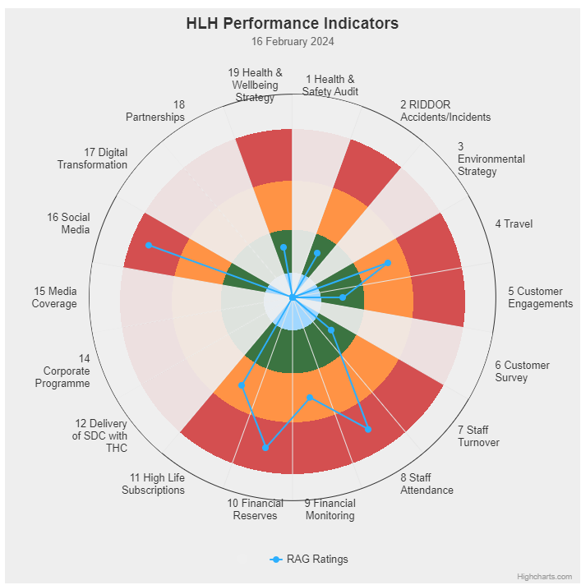 | Eighteen performance indicators (PIs) are used by the High Life Highland Board to assess the overall performance of the charity.  The PIs are RAG rated (allocated a "Red", "Amber" or "Green" status) so that it is easy to see at a glance how the organisation is performing. Most of the PIs are RAG rated every quarter throughout the year, with some (such as partnership working with NHSH for example) being considered annually so greyed out sectors on this radar diagram mean that the PI is to be considered at a future HLH Board meeting.  (Note, the previous PI, 13, which was the Council’s Citizens Panel survey has discontinued and therefore removed from reporting. Numbering of PIs 14-19 has been retained to avoid costs associated with performance database changes).

Appendix B
HLH Performance Indicators - Detail Q3 2023/24

Business Plan Outcome | Performance Indicator | Reporting Frequency | RAG Rating Definition | RAG Rating Q1 23/24 | RAG Rating Q2 23/24 | RAG Rating Q3 23/24 | RAG Rating Q4 23/24 | Summary of Quarter Three Performance
1. Seek to continuously improve standards of health and safety. | 1. External health and safety audit. | Annual. | - Green = the external audit does not raise systemic issues.  - Amber = the external audit highlights common actions to be addressed across the company.  - Red = the external audit raises systemic (i.e., applying across multiple sites) H&S issues. | Green | NA | NA |  | The annual health and safety report was considered at the June 23 HLH Board meeting.  The External health and safety audit was completed in October 2023 with the Health and Safety and Environmental Compliance Committee continuing to meet to monitor progress and health and safety performance with its most recent meeting having been 12 February 2024.

Business Plan Outcome | Performance Indicator | Reporting Frequency | RAG Rating Definition | RAG Rating Q1 23/24 | RAG Rating Q2 23/24 | RAG Rating Q3 23/24 | RAG Rating Q4 23/24 | Summary of Quarter Three Performance
1. Seek to continuously improve standards of health and safety. | 2. RIDDOR accidents/incidents. | Quarterly. | - Red = number of RIDDOR reports per quarter is above 20.  - Amber = number of RIDDOR reports per quarter is between 10 and 20  - Green = number of RIDDOR reports per quarter is less than 10. | Green | Green | Green |  | No incidents were reported under the RIDDOR regulations during Q3.

Performance Indicator 2 - RIDDOR accidents/incidents
The graph below tracks the number of accidents and incidents reported under the Reporting of Injuries, Diseases and Dangerous Occurrences Regulations (RIDDOR). There were no RIDDOR incidents reported in Q3 2023/24.
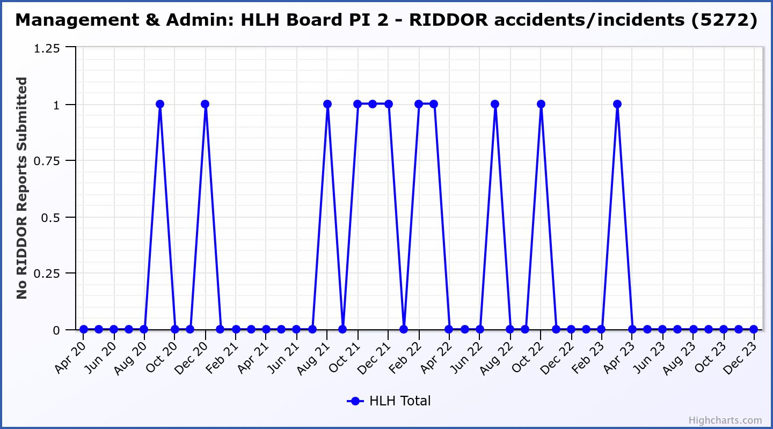

Business Plan Outcome | Performance Indicator | Reporting Frequency | RAG Rating Definition | RAG Rating Q1 23/24 | RAG Rating Q2 23/24 | RAG Rating Q3 23/24 | RAG Rating Q4 23/24 | Summary of Quarter Three Performance
2. Commit to the Scottish Government’s zero carbon targets and maintain the highest standards in environmental compliance. | 3. The HLH Environmental strategy will be developed in partnership with the Council as it develops its plans. | . |  | NA | NA | NA |  | N/A - Performance indicators will be identified through the development of these plans and will be aligned with THC’s carbon reduction strategy given the contractual (particularly property) arrangements that there are in place between THC and HLH.

Business Plan Outcome | Performance Indicator | Reporting Frequency | RAG Rating Definition | RAG Rating Q1 23/24 | RAG Rating Q2 23/24 | RAG Rating Q3 23/24 | RAG Rating Q4 23/24 | Summary of Quarter Three Performance
2. Commit to the Scottish Government’s zero carbon targets and maintain the highest standards in environmental compliance. | 4. Travel  (Quarterly ceiling 112,750. Annual ceiling 451,000) | Quarterly. | - Green = 451,000 miles p.a. or less  - Amber = 451,001 to 541,200 miles p.a.  - Red = 541,201 p.a. or more | Amber | Green | Amber |  | Travel miles were 129,807 in Q3. There is further detail in section three of this report.

Performance Indicator 4 – Travel Miles
Travel has exceeded the ceiling set by 19,815. There is further detail in section three of this report.
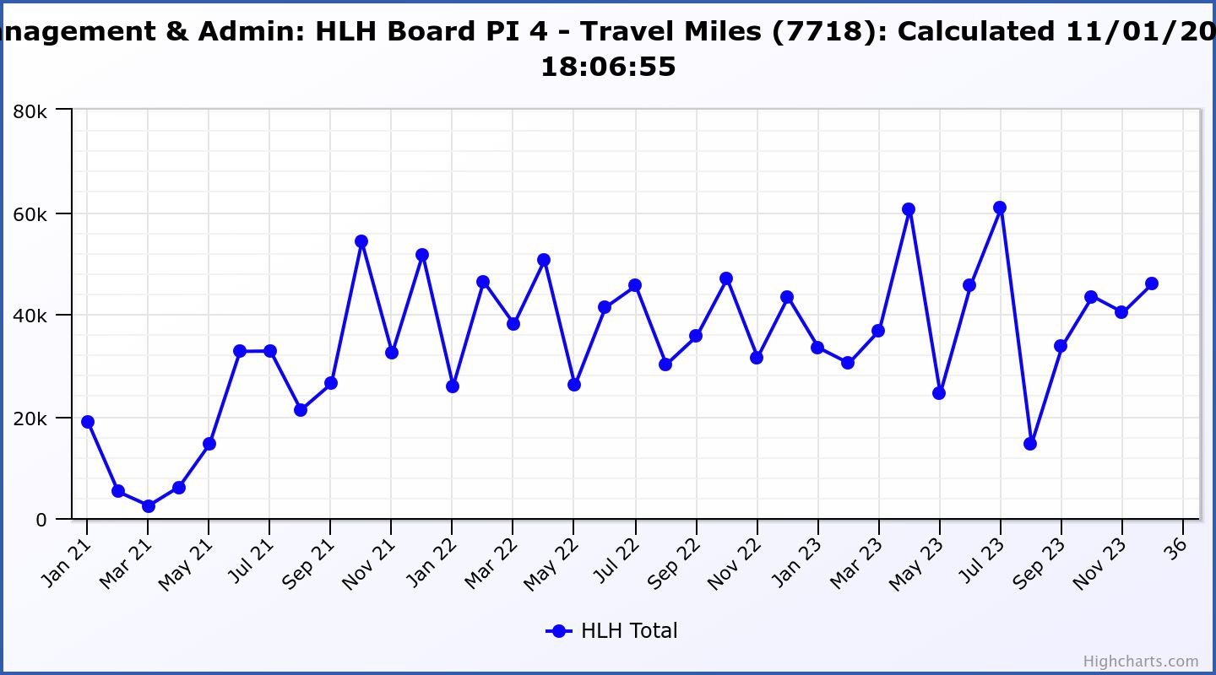
Business Plan Outcome | Performance Indicator | Reporting Frequency | RAG Rating Definition | RAG Rating Q1 23/24 | RAG Rating Q2 23/24 | RAG Rating Q3 23/24 | RAG Rating Q4 23/24 | Summary of Quarter Three Performance
3. Use research and market analysis to develop and improve services to meet customer needs. | 5. Customer engagements. | Quarterly. | - Green = customer numbers are the same as or have increased compared with the corresponding quarter in the previous year  - Amber = customer numbers are less than the corresponding quarter in the previous year.  - Red = customer numbers are more than 5% lower than the corresponding quarter in the previous year. | Green | Green | Green |  | Customer engagements increased from 2,062,724 in Q3 2022/23 to  2,413,236 in Q3 2023/24.

Performance Indicator 5 - Customer engagements
Customer engagements are on target for c.10m this year.
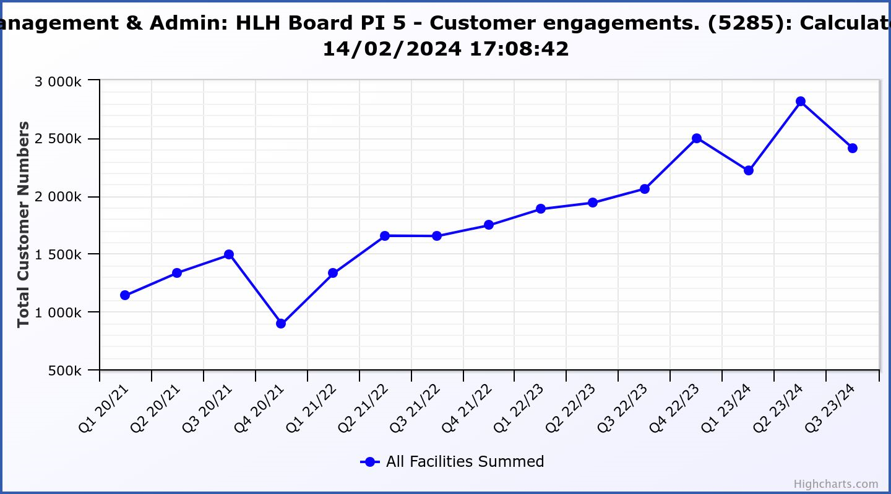

Business Plan Outcome | Performance Indicator | Reporting Frequency | RAG Rating Definition | RAG Rating Q1 23/24 | RAG Rating Q2 23/24 | RAG Rating Q3 23/24 | RAG Rating Q4 23/24 | Summary of Quarter Three Performance
3. Use research and market analysis to develop and improve services to meet customer needs. | 6. Charity-wide customer satisfaction survey. | Annually. | - Green = Services delivered by HLH is above average  - Amber = Services delivered by HLH is average  - Red = Services delivered by HLH is below average. | Green | NA | NA |  | This was reported to the HLH Board as part of the Q1 reporting where 95% of respondents rated their overall experience of HLH/staff as excellent or good and 95% said that they would recommend HLH.

Business Plan Outcome | Performance Indicator | Reporting Frequency | RAG Rating Definition | RAG Rating Q1 23/24 | RAG Rating Q2 23/24 | RAG Rating Q3 23/24 | RAG Rating Q4 23/24 | Summary of Quarter Three Performance
4. Increase employee satisfaction, engagement and development to improve staff recruitment and retention. | 7. Staff turnover (resignations as a percentage of posts). | Quarterly. | - Green = 1.6% or less.  - Amber = 1.7 to 2%  - Red = more than 2% | Green | Green | Green |  | The number of resignations per month as a percentage of posts was 1.1% in October, 0.8% in November and 1.3% in December. Please see the HR report elsewhere on this agenda for further information.

Performance Indicator 7 - Staff Turnover (resignations as a percentage of posts)
The graph below shows resignations as a percentage of the number of posts (1% equates to 10 staff).

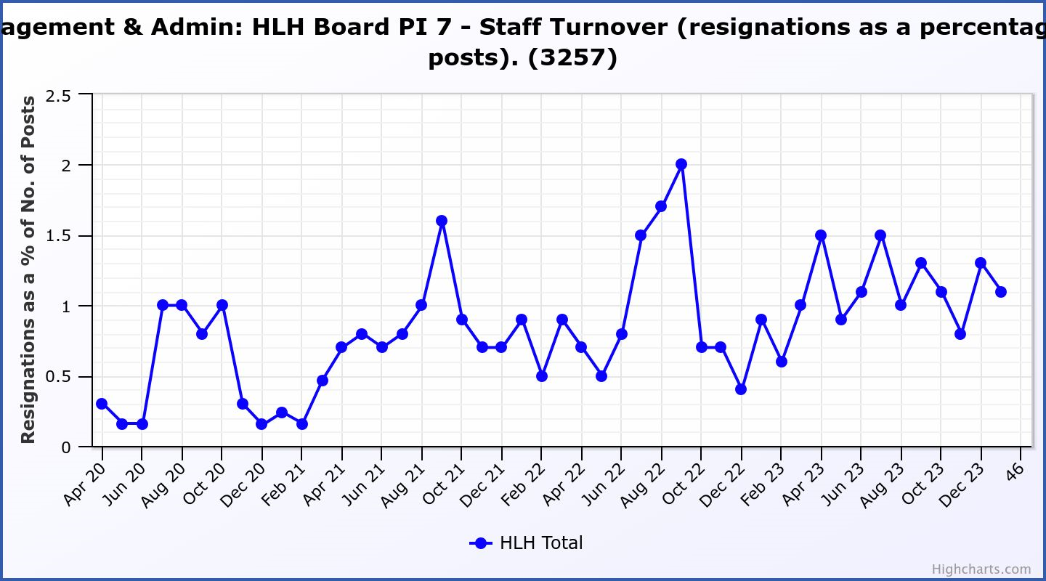

Business Plan Outcome | Performance Indicator | Reporting Frequency | RAG Rating Definition | RAG Rating Q1 23/24 | RAG Rating Q2 23/24 | RAG Rating Q3 23/24 | RAG Rating Q4 23/24 | Summary of Quarter Three Performance
4. Increase employee satisfaction, engagement and development to improve staff recruitment and retention. | 8. Staff attendance rates (RAG ratings based on Office for National Statistics for 2020). | Quarterly. | - Green = attendance rate 98% or higher.  - Amber = attendance rate between 97% and 98%.  - Red = attendance rate less than 97%. | Red | Red | Red |  | The attendance rate for Q3 was 95.59%. Please see the HR report elsewhere on this agenda for further information.

Performance Indicator 8 - Staff Attendance Rate
Staff attendance rates for Q3 were 95.59%. Please see the HR report elsewhere on this agenda for further information.
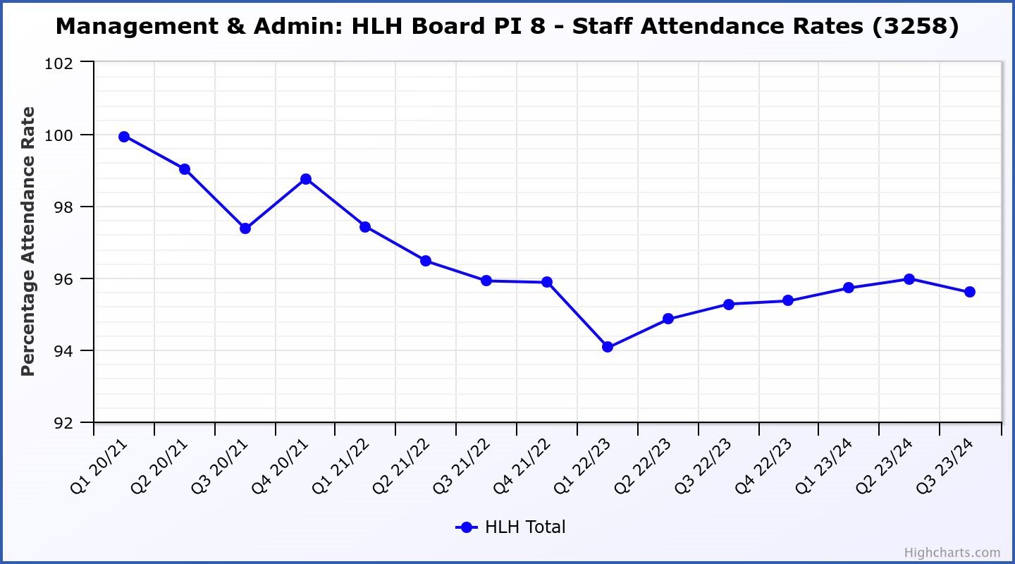

Business Plan Outcome | Performance Indicator | Reporting Frequency | RAG Rating Definition | RAG Rating Q1 23/24 | RAG Rating Q2 23/24 | RAG Rating Q3 23/24 | RAG Rating Q4 23/24 | Summary of Quarter Three Performance
5. Improve the financial sustainability of the company | 9. Financial monitoring. | Quarterly. | An assessment of the year end outturn where:  - Green = delivery of services within budget.  - Amber = delivery of services between break-even and 2% over budget.  - Red = delivery of services over budget above 2%. | Amber | Amber | Amber |  | There is further information in the Finance Report elsewhere on this agenda.

Performance Indicator 9 - Financial Monitoring
This graph shows the position at the end of each quarter.

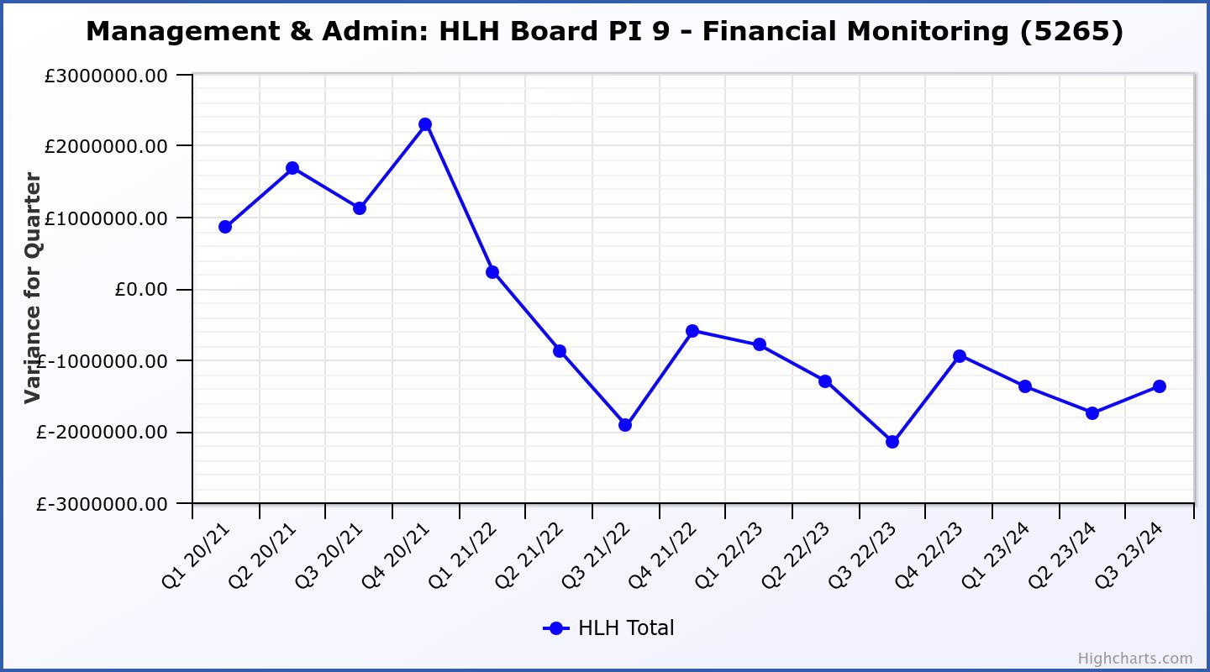

Business Plan Outcome | Performance Indicator | Reporting Frequency | RAG Rating Definition | RAG Rating Q1 23/24 | RAG Rating Q2 23/24 | RAG Rating Q3 23/24 | RAG Rating Q4 23/24 | Summary of Quarter Three Performance
5. Improve the financial sustainability of the company | 10. Reserves | Annual. | - Green = meets 3% reserves policy  - Amber = achieves 2% reserves  - Red = fails to achieve 2% reserves policy. | Red | Red | Red |  | Uncommitted reserves will be 0% at the end of 2023/24 and, therefore, RAG rated red.  Please see the Finance report elsewhere in this agenda for further information.
Performance Indicator 10 - Financial Reserves

This graph shows the level of uncommitted, unrestricted reserves at the end of each financial year. Zero reserves are forecast at the year end.

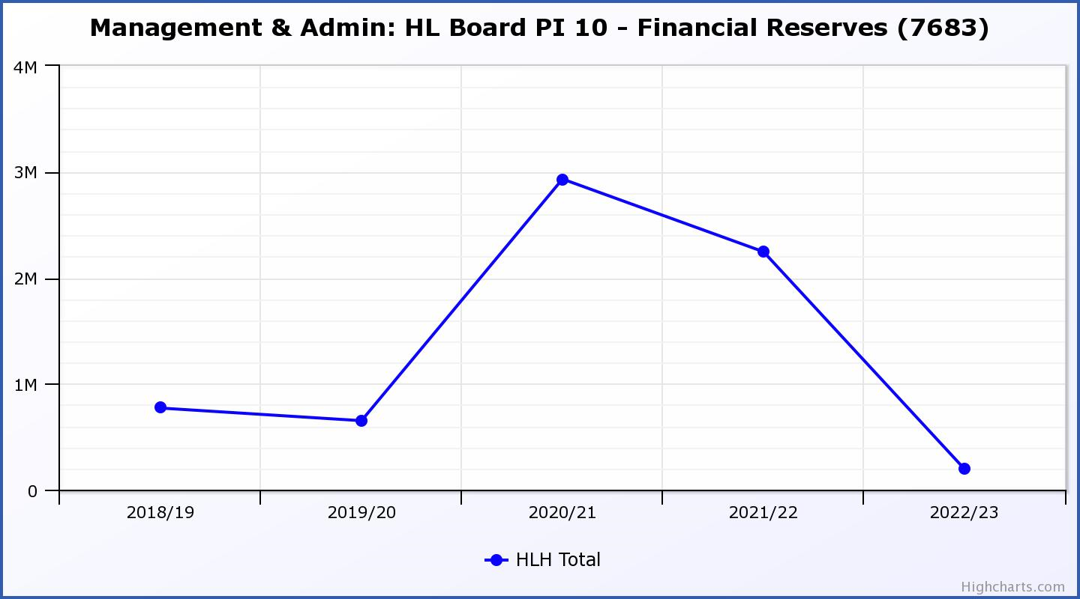

Business Plan Outcome | Performance Indicator | Reporting Frequency | RAG Rating Definition | RAG Rating Q1 23/24 | RAG Rating Q2 23/24 | RAG Rating Q3 23/24 | RAG Rating Q4 23/24 | Summary of Quarter Three Performance
5. Improve the financial sustainability of the company | 11. Number of highlife subscriptions (target is the required number to meet the budget). | Quarterly. | - Green= exceeds budgeted income target.  - Amber = risk of budget target not being met.  - Red = budgeted income target unlikely to be met. | Amber | Amber | Amber |  | Please see section three of this report for further information. Income is forecast to be 1% (£75k) short of the budget.  Please see section three of this report for further information.

Performance Indicator 11 - Number of High Life Subscriptions
As of February, subscriptions were 19,204.

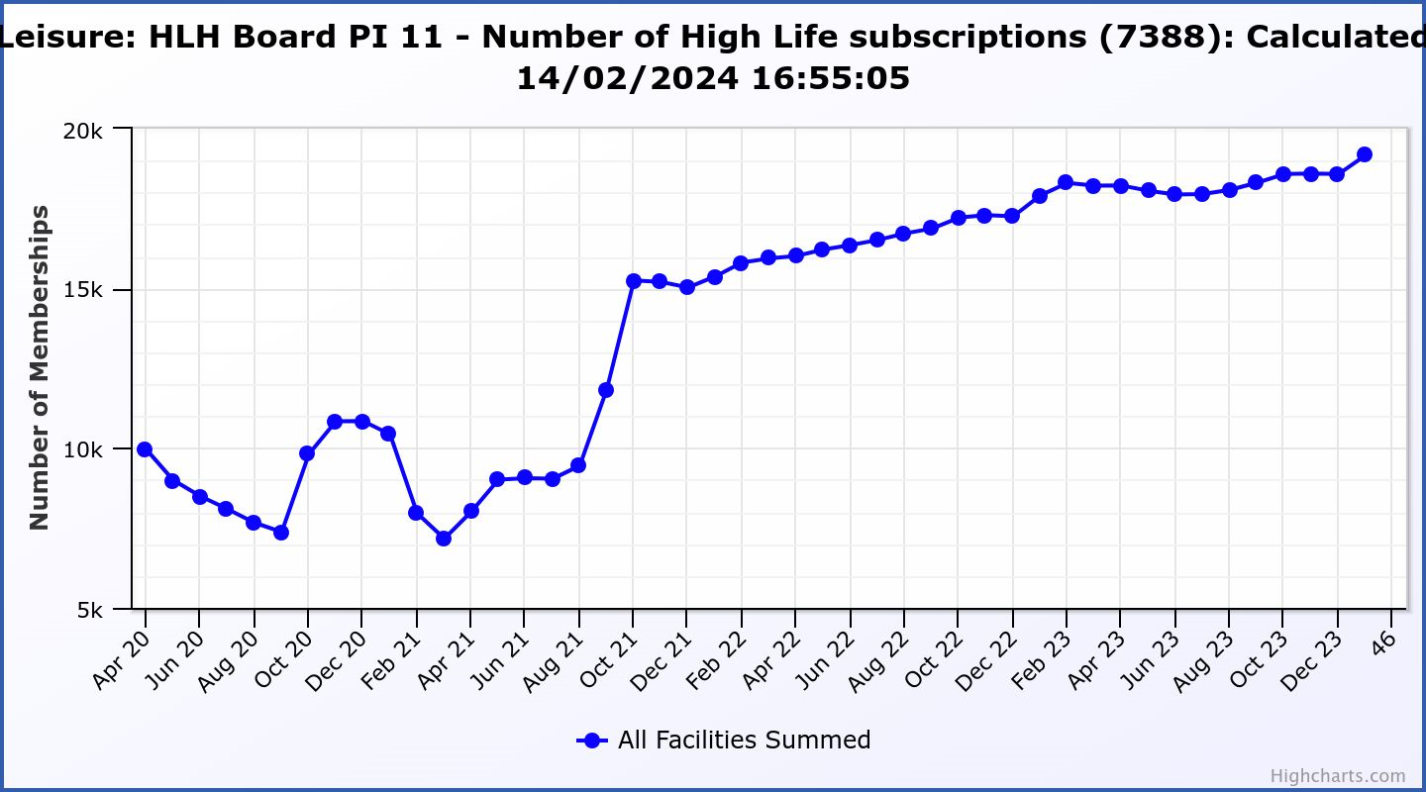

Business Plan Outcome | Performance Indicator | Reporting Frequency | RAG Rating Definition | RAG Rating Q1 23/24 | RAG Rating Q2 23/24 | RAG Rating Q3 23/24 | RAG Rating Q4 23/24 | Summary of Quarter Three Performance
6. Value and strengthen the relationship with THC. | 12. Delivery of the Service Delivery Contract (SDC) with The Highland Council (THC). | Six-monthly. | - Green = agreement of THC’s Education Committee that HLH has met or exceeded the terms of the SDC.  - Amber = agreement of THC’s Education Committee that HLH has met the terms of the SDC but has set some improvement targets.  - Red = agreement of THC’s Education Committee that HLH has not met the terms of the SDC. | NA | Green | NA |  | The Council’s Education Committee considered the HLH Progress Report at its 23 November 2023 meeting. The Committee noted that HLH continues to deliver the Public Service Obligations on behalf of the Council as set out in the Service Delivery Contract.

Business Plan Outcome | Performance Indicator | Reporting Frequency | RAG* Rating Definition  (*Red/Amber/Green) | RAG Rating Q1 23/24 | RAG Rating Q2 23/24 | RAG Rating Q3 23/24 | RAG Rating Q4 23/24 | Summary of Quarter Three Performance
7. Develop and deliver the HLH Corporate Programme and seek to attract capital investment. | 14.The HLH corporate programme covers investment; business process improvement; capital and asset management plans and plans will be developed as this area of work is developed. | NA | Should additional performance indicators be identified through the development of these plans they will be added in future. | NA | NA | NA |  | NA

Business Plan Outcome | Performance Indicator | Reporting Frequency | RAG Rating Definition | RAG Rating Q1 23/24 | RAG Rating Q2 23/24 | RAG Rating Q3 23/24 | RAG Rating Q4 23/24 | Summary of Quarter Three Performance
8. Use research and market analysis to develop and deliver proactive marketing and promotion of HLH and its services. | 15. Media coverage from proactively issued media releases | Six-monthly. | - Green = Positive coverage 95%+  - Amber = Positive coverage 90% - 95%  - Red = Positive coverage 90%- | NA | Green | NA |  | Not recorded, no staff in post. Head of Marketing and Engagement and Media and Content Officer posts have been filled and will take up post in March and April 2024 respectively.

Business Plan Outcome | Performance Indicator | Reporting Frequency | RAG Rating Definition | RAG Rating Q1 23/24 | RAG Rating Q2 23/24 | RAG Rating Q3 23/24 | RAG Rating Q4 23/24 | Summary of Quarter Three Performance
8. Use research and market analysis to develop and deliver proactive marketing and promotion of HLH and its services. | 16. On-line engagement through social media channels. |  | - Green = 5% increase compared with the same period last year.  - Amber = no increase to 4.9% lower compared with the same period last year.  - Red = more than 5% lower or less compared with the same period last year. | Green | Red | Red |  | Social media engagements were 63,639 in Q3 22/23 but decreased to 24,804 in Q3 23/24. If social media posts relating to the Inverness events programme and prize giveaways are excluded from Q3 2022/23 this indicator would be RAG rated green. Please see section three of this report for further information.

Performance Indicator 15 - On-line engagement through social media channels.

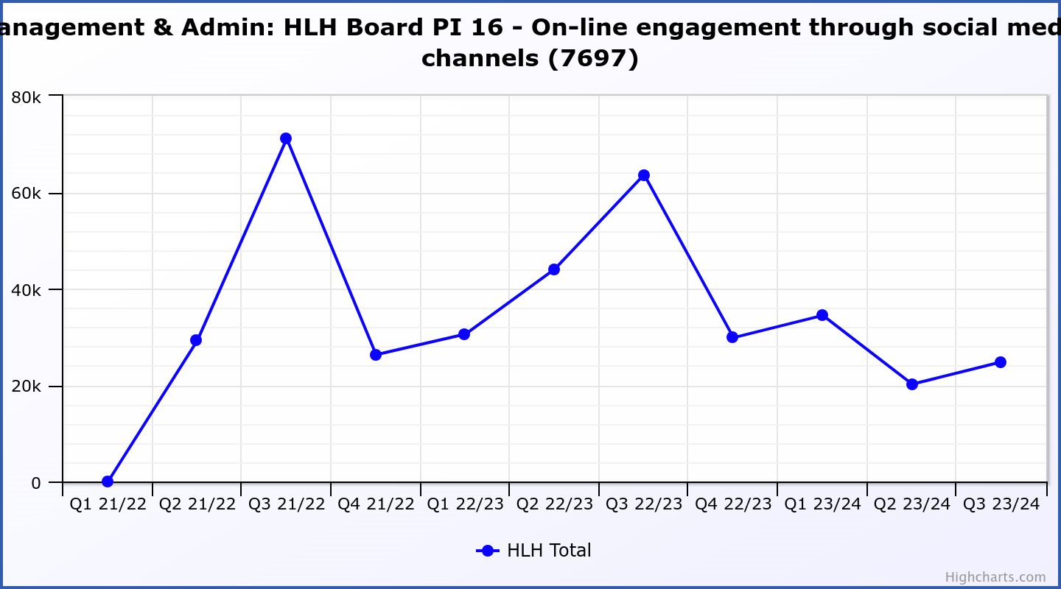

Business Plan Outcome | Performance Indicator | Reporting Frequency | RAG Rating Definition | RAG Rating Q1 23/24 | RAG Rating Q2 23/24 | RAG Rating Q3 23/24 | RAG Rating Q4 23/24 | Summary of Quarter Three Performance
9. Initiate and implement an ICT digital transformation strategy across the charity | 17. The HLH digital transformation strategy is yet to be developed. |  | Should performance indicators be identified through the development of these plans they will be added in future. | NA | NA | NA |  | NA

Business Plan Outcome | Performance Indicator | Reporting Frequency | RAG Rating Definition | RAG Rating Q1 23/24 | RAG Rating Q2 23/24 | RAG Rating Q3 23/24 | RAG Rating Q4 23/24 | Summary of Quarter Three Performance
10. Develop and strengthen relationships with customers, key stakeholders and partners | New approach to customer survey as per Business Outcome 3 above.  Same as PI 6 - Charity-wide customer satisfaction survey | Quarterly | - | Green | NA | NA |  | NA – this indicator was considered by the HLH Board at its August 2023 meeting.

Business Plan Outcome | Performance Indicator | Reporting Frequency | RAG Rating Definition | RAG Rating Q1 23/24 | RAG Rating Q2 23/24 | RAG Rating Q3 23/24 | RAG Rating Q4 23/24 | Summary of Quarter Three Performance
10. Develop and strengthen relationships with customers, key stakeholders and partners | 18. Partnership work with sportscotland and other sports related organisations, NHS Highland and other health related organisations (including Memoranda of Understanding) etc. | Annual | - Green = Growth in partnership working  - Amber = continuation of current level of partnership work  - Red = cancellation of Partnership Agreements | NA | Green | NA |  | NA

Business Plan Outcome | Performance Indicator | Reporting Frequency | RAG Rating Definition | RAG Rating Q1 23/24 | RAG Rating Q2 23/24 | RAG Rating Q3 23/24 | RAG Rating Q4 23/24 | Summary of Quarter Three Performance
11. Deliver targeted programmes which support and enhance the physical and mental health and wellbeing of the population and which contribute to the prevention agenda. | 19. An assessment of the RAG rating of the Health and Wellbeing Strategy action plan. |  | - Green = 80% or more of the actions are RAG rated green  - Amber = 60% to 79% of actions are green.  - Red = 59% or less are rated green. | NA | NA | Green |  | Please see the Health and Wellbeing report elsewhere on this agenda.

