|  |  |
| --- | --- |
| **HIGH LIFE HIGHLAND**  **REPORT TO BOARD OF DIRECTORS 11 DECEMBER 2024** | AGENDA ITEM 12 REPORT No HLH /31/24 |

###### QUARTER TWO PERFORMANCE REPORT - Report by Chief Executive

**Recommendation**

The purpose of this report is to present performance information for the period July to September 2024 (quarter two).

It is recommended that Directors:

1. comment on the report and agree that the overall health check on the charity for that period is rated as amber based on the financial situation and reserves position;
2. note that between the support of THC and the income and efficiency savings made, the position is improving although likely to remain amber until the budget can be balanced and progress can be made towards meeting the 3% reserves policy; and
3. comment on the work towards the development of new performance reporting based on the Board five year strategy.

|  |  |
| --- | --- |
| **1.** | **Business Plan Contribution** |
| 1.1 | High Life Highland’s (HLH) purpose is Making Life Better. The HLH Business Plan contains eleven Business Outcomes which support the delivery of this purpose, and this report supports the following highlighted outcomes from the Business Plan:   1. **Seek to continuously improve standards of health and safety.** 2. **Commit to the Scottish Government’s zero carbon targets and maintain the highest standards in environmental compliance.** 3. **Use research and market analysis to develop and improve services to meet customer needs.** 4. **Increase employee satisfaction, engagement and development to improve staff recruitment and retention.** 5. **Improve the financial sustainability of the company.** 6. **Value and strengthen the relationship with THC.** 7. **Develop and deliver the HLH Corporate Programme and seek to attract capital investment.** 8. **Use research and market analysis to develop and deliver proactive marketing and promotion of HLH and its services.** 9. **Initiate and implement an ICT digital transformation strategy across the charity.** 10. **Develop and strengthen relationships with customers, key stakeholders and partners.** 11. **Deliver targeted programmes which support and enhance the physical and mental health and wellbeing of the population and which contribute to the prevention agenda.** |
| **2.** | **Background** |
| 2.1 | The implementation of the HLH Business Plan 2022-27 is monitored through a set of performance indicators (PIs) set by the Board to assess the overall performance of the charity. The indicators were set at the HLH Board meeting held on 31 March 2022. |

|  |  |
| --- | --- |
| 2.2 | New performance indicators will be developed in line with the new business plan following the boards having developed the five-year strategy on a page as covered elsewhere on this agenda. Three areas of reporting are under consideration as part of that and separate feedback from the HLH Board: customer engagements; *high****life*** subscriptions; and marketing (the new work under development can be seen in **Appendix C** for information and consideration/feedback of the HLH Board). |
| 2.3 | Future performance reporting will change in line with the development of the five-year strategy (separate report elsewhere on this agenda) and this report seeks to provide continuity of reporting so that the Board can continue to assess the performance of the organisation while at the same time showing some of the performance reporting being developed following the Board strategy workshop. New performance reporting will be more fully developed following Board approval of the five-year strategy. |
| **3.** | **Summary of Performance** |
| 3.1 | **Appendix A** contains a summary of performance against the PIs for Q2 2024/25 for the current business plan. **Appendix B** provides a list of all the PIs along with trend information. Ten of the eighteen PIs were scheduled for assessment at the December 2024 HLH Board meeting, of those, seven have been RAG rated green; two amber; and one red. |
| 3.2 | The indicator which has been RAG rated red is financial reserves. The amber ones are staff attendance rates and financial monitoring. |
| 3.3 | PI 8 **Attendance Rates** – the attendance rate has been RAG rated amber and has improved. The focussed effort on the management of long-term absences referred to at the August HLH Board meeting has been reflected in quarter two, and there is further information on this in the HR report elsewhere on this agenda. |
| 3.4 | PI 9 **Financial Monitoring** – This indicator has been RAG rated amber and there is further information in the Finance Report elsewhere on this agenda. |
| 3.5 | PI 10 **Financial Reserves** – This indicator has been RAG rated red. It is anticipated that there will be no reserves by the end of the financial year. This is in the context of additional support and a letter of comfort having been agreed with the Council as part of the current year’s budget and the agreement by THC of the new funding-formula in the revised Service Delivery Contract. |
| **4.** | **Performance Indicators for more detailed consideration** |
| 4.1 | Each quarter more detailed information is provided on one or more of the performance indicators. The indicators which have been scheduled for more detailed consideration at the December meeting are:   * 11. Number of *high****life*** subscriptions * 15. Media coverage from proactively issued media releases (Via marketing presentation) * 16. On-line engagement through social media channels (Via marketing presentation). * 18. Partnership work |
| 4.2 | The **subscriptions** indicator has been RAG rated green, on target. Up to the end of quarter two the income achieved was £4,589,967 against the annual target of £7,986,623 (57.5%) with the in-year performance being as follows: |

|  |  |
| --- | --- |
|  | * year to date target £4,587,881 * actual year to date £4,589,967 * year to date variance +£2,086 (0.05%) |
| 4.3 | Following the strategy workshop held by the HLH Board and HLH (Trading) C.I.C Board, consideration is being given as to how to present subscription information (to the Board and on the staff web site). A draft of what is being developed can be seen in **Appendix C** which provides further information. |
| 4.3 | Following previous comments from the HLH Board on the marketing PIs in the current business plan, these have not been RAG rated and instead, information in **Appendix D** has been provided by the Head of Marketing and Engagement. Feedback on measuring marketing performance from Board directors is welcome at the meeting. (Note, there is also a Marketing and Engagement update presentation elsewhere on this agenda). |
| 4.5 | **Appendix E** contains information on the partnership work taking place across all of the HLH services. It represents a broad picture ranging from small local partnerships to larger ones such as the relationship with sportscotland and NDA for the operation of the archive centre at Nucleus. |
| **5.** | **Implications** |
| 5.1 | Resource implications – while this report discusses resources and financial implications, there are no resource implications arising the recommendations in this report. |
| 5.2 | Equality implications - there are no new equality implications arising from this report. |
| 5.3 | Legal implications - there are no new legal implications arising from this report. |
| 5.4 | Risk implications - there are no new risk implications arising from this report. |
| **Recommendation**  It is recommended that Directors:   1. comment on the report and agree that the overall health check on the charity for that period is rated as amber based on the financial situation and reserves position; 2. note that between the support of THC and the income and efficiency savings made, the position is improving although likely to remain amber until the budget can be balanced and progress can be made towards meeting the 3% reserves policy; and 3. comment on the work towards the development of new performance reporting based on the Board five year strategy. | |

Designation: Chief Executive Date: 28 November 2024

Author: Douglas Wilby, Director of Corporate Performance

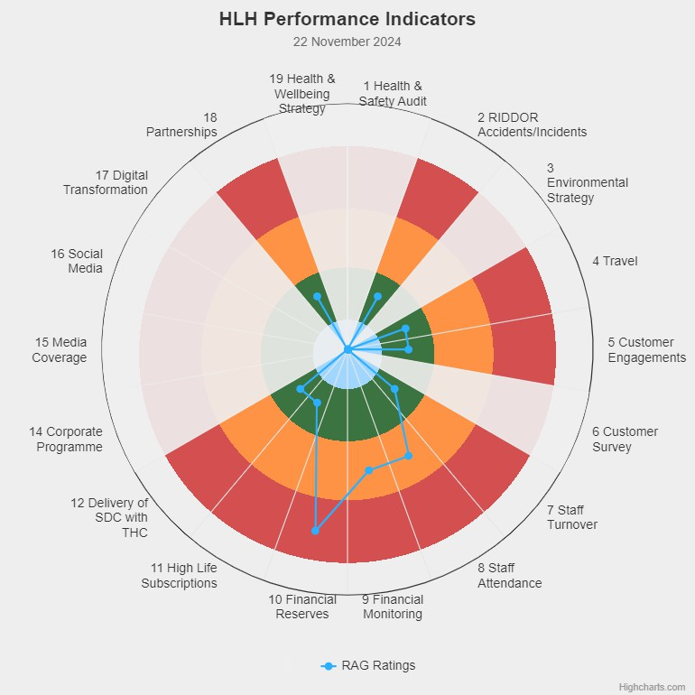**Appendix A**

|  |  |
| --- | --- |
| **HLH Performance Indicators - Summary Q2 2024/25** | Eighteen performance indicators (PIs) are used by the High Life Highland Board to assess the overall performance of the charity.  The PIs are RAG rated (allocated a "Red", "Amber" or "Green" status) so that it is easy to see at a glance how the organisation is performing. Most of the PIs are RAG rated every quarter throughout the year, with some (such as partnership working with NHSH for example) being considered annually so greyed out sectors on this radar diagram mean that the PI is to be considered at a future HLH Board meeting.  (Note, the previous PI, 13, which was the Council’s Citizens Panel survey has discontinued and therefore removed from reporting. Numbering of PIs 14-19 has been retained to avoid costs associated with performance database changes). |

**Appendix B**

**HLH Performance Indicators - Detail Q2 2024/25**

|  |  |  |  |  |  |  |  |  |
| --- | --- | --- | --- | --- | --- | --- | --- | --- |
| **Business Plan Outcome** | **Performance Indicator** | **Reporting Frequency** | **RAG Rating Definition** | **RAG**  **Rating Q1 24/25** | **RAG**  **Rating Q2 24/25** | **RAG**  **Rating Q3 24/25** | **RAG**  **Rating Q4 24/25** | **Summary of Quarter Two Performance** |
| **1. Seek to continuously improve standards of health and safety.** | 1. External health and safety audit. | Annual. | 1. Green = the external audit does not raise systemic issues. 2. Amber = the external audit highlights common actions to be addressed across the company. 3. Red = the external audit raises systemic (i.e., applying across multiple sites) H&S issues. | Green | NA |  |  | The annual health and safety report was considered by the HLH Board at is June 2024 meeting. |

|  |  |  |  |  |  |  |  |  |
| --- | --- | --- | --- | --- | --- | --- | --- | --- |
| **Business Plan Outcome** | **Performance Indicator** | **Reporting Frequency** | **RAG Rating Definition** | **RAG**  **Rating Q1 24/25** | **RAG**  **Rating Q2 24/25** | **RAG**  **Rating Q3 24/25** | **RAG**  **Rating Q4 24/25** | **Summary of Quarter Two Performance** |
| **1. Seek to continuously improve standards of health and safety.** | 2. RIDDOR  accidents/incidents. | Quarterly. | 1. Red = number of RIDDOR   reports per  quarter is above 20.   1. Amber =   number of RIDDOR  reports per  quarter is  between 10  and 20   1. Green =   number of RIDDOR  reports per quarter is less than 10. | Green | Green |  |  | There was one RIDDOR incident reported under the RIDDOR  regulations during Q2 2024/25. |

**Performance Indicator 2 - RIDDOR accidents/incidents**

The graph below tracks the number of accidents and incidents reported under the Reporting of Injuries, Diseases and Dangerous Occurrences Regulations (RIDDOR). There was one RIDDOR incident reported in Q2 2024/25.

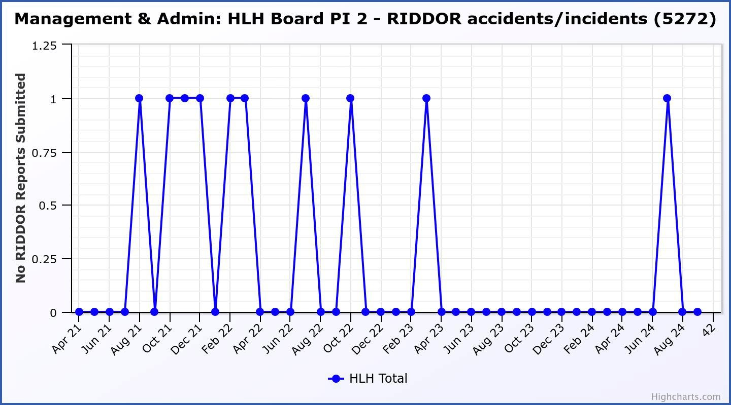

|  |  |  |  |  |  |  |  |  |
| --- | --- | --- | --- | --- | --- | --- | --- | --- |
| **Business Plan Outcome** | **Performance Indicator** | **Reporting Frequency** | **RAG Rating Definition** | **RAG**  **Rating Q1 24/25** | **RAG**  **Rating Q2 24/25** | **RAG**  **Rating Q3 24/25** | **RAG**  **Rating Q4 24/25** | **Summary of Quarter Two Performance** |
| **2. Commit to** | 3. The HLH |  |  | NA | NA |  |  | NA - Performance |
| **the Scottish** | Environmental |  |  |  | indicators will be |
| **Government’s** | strategy will be |  |  |  | identified through |
| **zero carbon** | developed in |  |  |  | the development of |
| **targets and** | partnership with |  |  |  | these plans and |
| **maintain the** | the Council as it |  |  |  | will be aligned with |
| **highest** | develops its |  |  |  | THC’s carbon |
| **standards in** | plans. |  |  |  | reduction strategy |
| **environmental** |  |  |  |  | given the |
| **compliance.** |  |  |  |  | contractual |
|  |  |  |  |  | (particularly |
|  |  | . |  |  | property)  arrangements that |
|  |  |  |  |  | there are in place |
|  |  |  |  |  | between THC and |
|  |  |  |  |  | HLH. |

|  |  |  |  |  |  |  |  |  |
| --- | --- | --- | --- | --- | --- | --- | --- | --- |
| **Business Plan Outcome** | **Performance Indicator** | **Reporting Frequency** | **RAG Rating Definition** | **RAG**  **Rating Q1 24/25** | **RAG**  **Rating Q2 24/25** | **RAG**  **Rating Q3 24/25** | **RAG**  **Rating Q4 24/25** | **Summary of Quarter Two Performance** |
| **2. Commit to the Scottish Government’s zero carbon targets and maintain the highest standards in environmental compliance.** | 4. Travel  (Annual ceiling 451,000) | Quarterly. | i. Green = 451,000 miles  p.a. or less   1. Amber =   451,001 to  541,200 miles p.a.   1. Red = 541,201   p.a. or more | Red | Green |  |  | Travel miles were 105,554 in Q2  2024/25. |

###### Performance Indicator 4 – Travel Miles

Travel is below the ceiling for Q2 24/25.

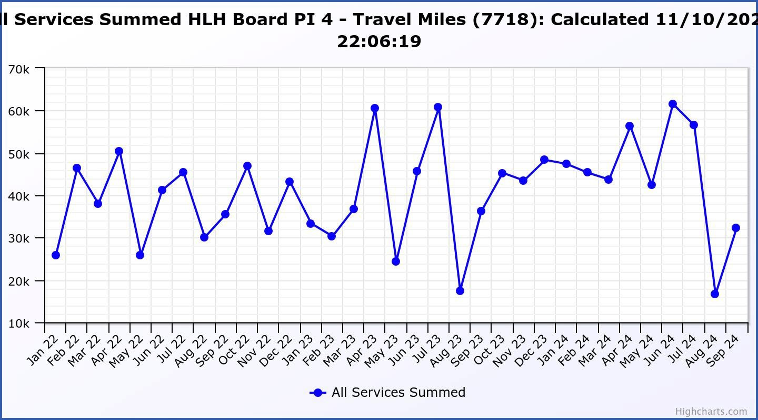

|  |  |  |  |  |  |  |  |  |
| --- | --- | --- | --- | --- | --- | --- | --- | --- |
| **Business Plan Outcome** | **Performance Indicator** | **Reporting Frequency** | **RAG Rating Definition** | **RAG**  **Rating Q1 24/25** | **RAG**  **Rating Q2 24/25** | **RAG**  **Rating Q3 24/25** | **RAG**  **Rating Q4 24/25** | **Summary of Quarter Two Performance** |
| **3. Use**  **research and market analysis to develop and improve services to meet customer needs.** | 5. Customer engagements. | Quarterly. | 1. Green = customer numbers are the same as or have increased compared with the corresponding quarter in the previous year 2. Amber = customer numbers are less than the corresponding quarter in the previous year. 3. Red = customer numbers are more than 5% lower than the corresponding quarter in the previous year. | Green | Green |  |  | Both in-person and digital engagements have increased compared with the same period last financial year. |

|  |  |  |  |  |  |  |  |  |
| --- | --- | --- | --- | --- | --- | --- | --- | --- |
| **Business Plan Outcome** | **Performance Indicator** | **Reporting Frequency** | **RAG Rating Definition** | **RAG**  **Rating Q1 24/25** | **RAG**  **Rating Q2 24/25** | **RAG**  **Rating Q3 24/25** | **RAG**  **Rating Q4 24/25** | **Summary of Quarter Two Performance** |
| **3. Use**  **research and market analysis to develop and improve services to meet customer needs.** | 6. Charity-wide customer satisfaction survey | Annually. | 1. Green = Services delivered by HLH is above average 2. Amber = Services delivered by   HLH is  average   1. Red = Services delivered by HLH is below average. | NA | NA |  |  | NA |

|  |  |  |  |  |  |  |  |  |
| --- | --- | --- | --- | --- | --- | --- | --- | --- |
| **Business Plan Outcome** | **Performance Indicator** | **Reporting Frequency** | **RAG Rating Definition** | **RAG**  **Rating Q1 24/25** | **RAG**  **Rating Q2 24/25** | **RAG**  **Rating Q3 24/25** | **RAG**  **Rating Q4 24/25** | **Summary of Quarter Two Performance** |
| **4. Increase employee satisfaction, engagement and development to improve staff recruitment and retention.** | 7. Staff turnover (resignations as a percentage of posts). | Quarterly. | 1. Green = 1.6% or less. 2. Amber = 1.7 to 2% 3. Red = more than 2% | Green | Green |  |  | The number of resignations per month as a percentage of posts was 1% in July, 1.5% in  August and 1.8% in September. (Note that this would make the RAG rating Amber in September). |

###### Performance Indicator 7 - Staff Turnover (resignations as a percentage of posts)

The graph below shows resignations as a percentage of the number of posts (1% equates to 10 staff).

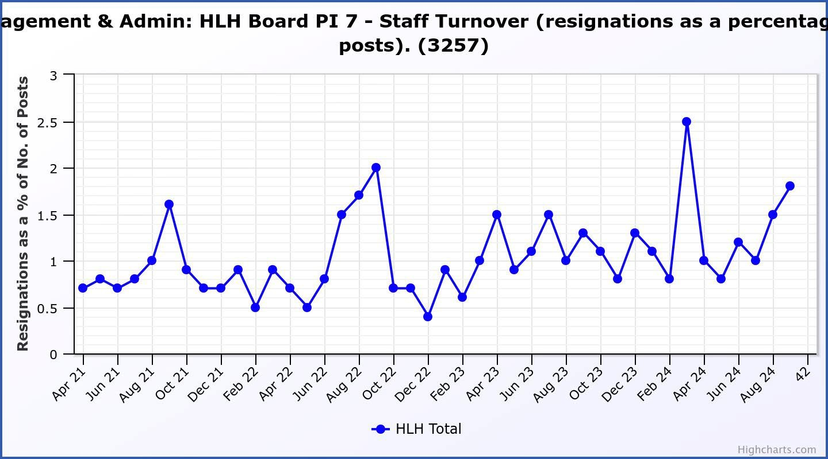

|  |  |  |  |  |  |  |  |  |
| --- | --- | --- | --- | --- | --- | --- | --- | --- |
| **Business Plan Outcome** | **Performance Indicator** | **Reporting Frequency** | **RAG Rating Definition** | **RAG**  **Rating Q1 24/25** | **RAG**  **Rating Q2 24/25** | **RAG**  **Rating Q3 24/25** | **RAG**  **Rating Q4 24/25** | **Summary of Quarter Two Performance** |
| **4. Increase employee satisfaction, engagement and development to improve staff recruitment and retention.** | 8. Staff  attendance rates (RAG ratings based on Office for National Statistics for 2020). | Quarterly. | 1. Green = attendance rate 95.7% or higher. 2. Amber = attendance rate 93.7% to   95.6%.   1. Red = attendance rate less than 93.7%. | Amber | Amber |  |  | The attendance rate for Q2 was 95.35%. Please see the HR report elsewhere on this agenda  for further information. |

###### Performance Indicator 8 - Staff Attendance Rate

Staff attendance rates for Q2 were 95.35%. Please see the HR report elsewhere on this agenda for further information.

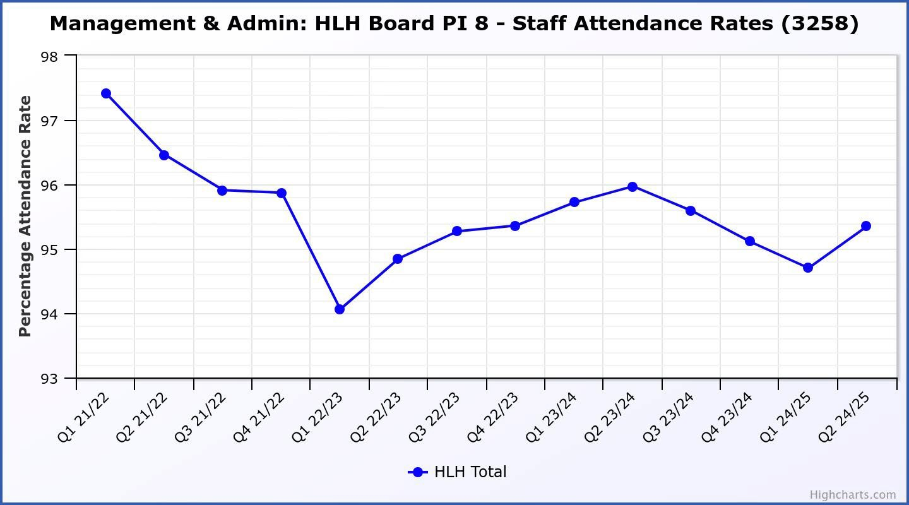

|  |  |  |  |  |  |  |  |  |
| --- | --- | --- | --- | --- | --- | --- | --- | --- |
| **Business Plan Outcome** | **Performance Indicator** | **Reporting Frequency** | **RAG Rating Definition** | **RAG**  **Rating Q1 24/25** | **RAG**  **Rating Q2 24/25** | **RAG**  **Rating Q3 24/25** | **RAG**  **Rating Q4 24/25** | **Summary of Quarter Two Performance** |
| **5. Improve the financial sustainability of the**  **company** | 9. Financial monitoring. | Quarterly. | An assessment of the year end outturn where:   1. Green =   delivery of services within budget.   1. Amber =   delivery of services between  break-even and 2% over budget.   1. Red = delivery of services   over budget above 2%. | Amber | Amber |  |  | The 2024/25 budget is forecast to be delivered over budget with a £246K deficit forecast (0.7%).  There is further information in the Finance Report elsewhere on this agenda. |

###### Performance Indicator 9 - Financial Monitoring

This graph shows the position at the end of each quarter.

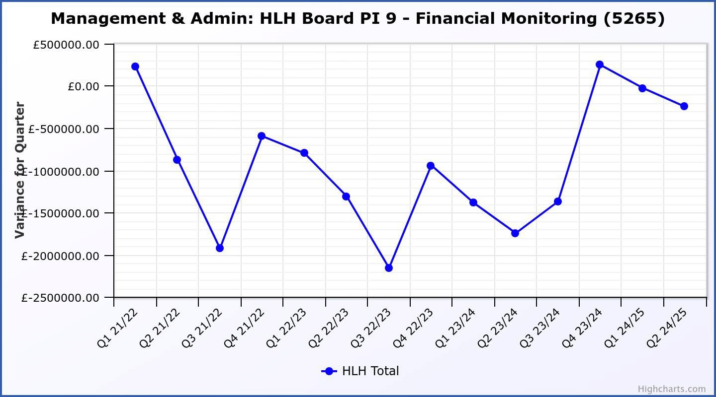

|  |  |  |  |  |  |  |  |  |
| --- | --- | --- | --- | --- | --- | --- | --- | --- |
| **Business Plan Outcome** | **Performance Indicator** | **Reporting Frequency** | **RAG Rating Definition** | **RAG**  **Rating Q1 24/25** | **RAG**  **Rating Q2 24/25** | **RAG**  **Rating Q3 24/25** | **RAG**  **Rating Q4 24/25** | **Summary of Quarter Two Performance** |
| **5. Improve the financial sustainability of the**  **company** | 10. Reserves | Annual. | 1. Green = meets 3% reserves policy 2. Amber = achieves 2% reserves 3. Red = fails to achieve 2% reserves policy. | Red | Red |  |  | Please see the Finance report elsewhere in this agenda for further information. |

###### Performance Indicator 10 - Financial Reserves

This graph shows the level of uncommitted, unrestricted reserves at the end of each financial year.

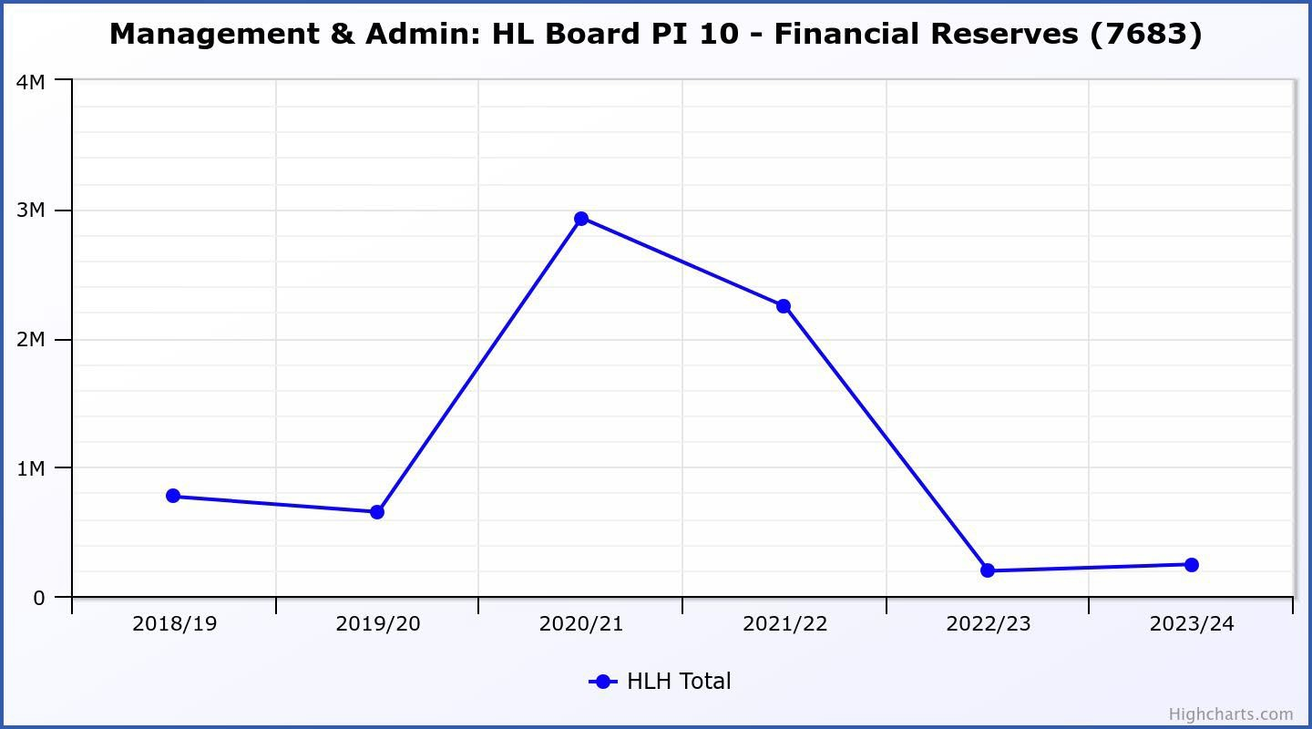

|  |  |  |  |  |  |  |  |  |
| --- | --- | --- | --- | --- | --- | --- | --- | --- |
| **Business Plan Outcome** | **Performance Indicator** | **Reporting Frequency** | **RAG Rating Definition** | **RAG**  **Rating Q1 24/25** | **RAG**  **Rating Q2 24/25** | **RAG**  **Rating Q3 24/25** | **RAG**  **Rating Q4 24/25** | **Summary of Quarter Two Performance** |
| **5. Improve the financial sustainability of the**  **company** | 11. Number of *high****life*** subscriptions (target is the required number to meet the budget). | Quarterly. | 1. Green= exceeds budgeted income target. 2. Amber = risk of budget target not being met. 3. Red = budgeted income target unlikely to be met. | Amber | Green |  |  | Please see draft new subscriptions reporting being developed following the Board and Trading Company “strategy on a page” workshop in **Appendix C.** |

|  |  |  |  |  |  |  |  |  |
| --- | --- | --- | --- | --- | --- | --- | --- | --- |
| **Business Plan Outcome** | **Performance Indicator** | **Reporting Frequency** | **RAG Rating Definition** | **RAG**  **Rating Q1 24/25** | **RAG**  **Rating Q2 24/25** | **RAG**  **Rating Q3 24/25** | **RAG**  **Rating Q4 24/25** | **Summary of Quarter Two Performance** |
| **6. Value and strengthen the relationship with THC.** | 12. Delivery of the Service Delivery Contract (SDC) with The  Highland Council (THC). | Six- monthly. | 1. Green = agreement of THC’s Education Committee that HLH has met or exceeded the terms of the SDC. 2. Amber = agreement of THC’s Education Committee that HLH has met the terms of the SDC but has set some improvement targets. 3. Red = agreement of THC’s Education Committee that HLH has not met the terms of the SDC. | Green | Green |  |  | See note below. |

The Highland Council’s Education Committee considered the HLH Progress Report at its meeting held on 21 November 2024. The focus topic this time round was High Life Highland’s contributions to the national “physical activity for health: framework” and annual reports for countryside rangers, leisure and sports development were included in the report. The Committee noted that HLH continues to deliver Public Service Obligations on behalf of the Highland Council as set out in the Service Delivery Contract. Which can be seen at this link: <https://www.highland.gov.uk/download/meetings/id/84178/8_high_life_highland_progress_report>

|  |  |  |  |  |  |  |  |  |
| --- | --- | --- | --- | --- | --- | --- | --- | --- |
| **Business Plan Outcome** | **Performance Indicator** | **Reporting Frequency** | **RAG* Rating Definition**  **(*Red/Amber/Green)** | **RAG**  **Rating Q1 24/25** | **RAG**  **Rating Q2 24/25** | **RAG**  **Rating Q3 24/25** | **RAG**  **Rating Q4 24/25** | **Summary of Quarter Two Performance** |
| **7. Develop** | 14.The HLH | NA | Should additional | NA | NA |  |  | NA |
| **and deliver** | corporate |  | performance |  |  |  |
| **the HLH** | programme |  | indicators be identified |  |  |  |
| **Corporate** | covers |  | through the |  |  |  |
| **Programme** | investment; |  | development of these |  |  |  |
| **and seek to** | business process |  | plans they will be |  |  |  |
| **attract capital** | improvement; |  | added in future. |  |  |  |
| **investment.** | capital and asset |  |  |  |  |  |
|  | management |  |  |  |  |  |
|  | plans and plans |  |  |  |  |  |
|  | will be developed |  |  |  |  |  |
|  | as this area of |  |  |  |  |  |
|  | work is |  |  |  |  |  |
|  | developed. |  |  |  |  |  |

|  |  |  |  |  |  |  |  |  |
| --- | --- | --- | --- | --- | --- | --- | --- | --- |
| **Business Plan Outcome** | **Performance Indicator** | **Reporting Frequency** | **RAG Rating Definition** | **RAG**  **Rating Q1 24/25** | **RAG**  **Rating Q2 24/25** | **RAG**  **Rating Q3 24/25** | **RAG**  **Rating Q4 24/25** | **Summary of Quarter Two Performance** |
| **8. Use**  **research and market analysis to develop and deliver proactive marketing and promotion of HLH and its services.** | 15. Media  coverage from proactively issued media releases | Quarterly. | 1. Green = Positive coverage 95%+ 2. Amber = Positive coverage 90%   - 95%   1. Red = Positive coverage 90%- | Green | NA |  |  | Please see draft new marketing and engagement reporting being developed following the Board having requested that consideration be given to the best way of reporting marketing performance (**Appendix D).** |

|  |  |  |  |  |  |  |  |  |
| --- | --- | --- | --- | --- | --- | --- | --- | --- |
| **Business Plan Outcome** | **Performance Indicator** | **Reporting Frequency** | **RAG Rating Definition** | **RAG**  **Rating Q1 24/25** | **RAG**  **Rating Q2 24/25** | **RAG**  **Rating Q3 24/25** | **RAG**  **Rating Q4 24/25** | **Summary of Quarter Two Performance** |
| **8. Use**  **research and market analysis to develop and deliver proactive marketing and promotion of HLH and its services.** | 16. On-line engagement through social media channels. |  | 1. Green = 5% increase compared with the same period last year. 2. Amber = no increase to 4.9% lower compared with the same period last year.   ii. Red = more than 5% lower or less  compared with the same period last year. | Red | NA |  |  |  |

|  |  |  |  |  |  |  |  |  |
| --- | --- | --- | --- | --- | --- | --- | --- | --- |
| **Business Plan Outcome** | **Performance Indicator** | **Reporting Frequency** | **RAG Rating Definition** | **RAG**  **Rating Q1 24/25** | **RAG**  **Rating Q2 24/25** | **RAG**  **Rating Q3 24/25** | **RAG**  **Rating Q4 24/25** | **Summary of Quarter Two Performance** |
| **9. Initiate and** | 17. The HLH |  | Should performance | NA | NA |  |  | See note below. It is |
| **implement an** | digital | indicators be |  |  | anticipated that the Board will |
| **ICT digital** | transformation | identified through the |  |  | be able to consider digital |
| **transformation** | strategy is yet to | development of these |  |  | strategy in March 2025. |
| **strategy** | be developed. | plans they will be |  |  |  |
| **across the** |  | added in future. |  |  |  |
| **charity** |  |  |  |  |  |

There was a presentation to the HLH Board on the development of a digital strategy at its 26 March 2024 meeting to set the context for the strategy and seek Director input. It is expected that a draft strategy will be available for the consideration of the HLH Board at its March 2025 meeting. Following desk research and analysis of known planned projects, a survey to all staff has now been completed and subsequent interviews with all Heads of Service is nearing completion. These latest works seeks to understand existing digital utilisation across High Life Highland and identify collective ambitions to make life digitally better for customers and staff. This work will be built into business planning following the Board strategy on a page workshop.



**1. Finance System**

**9. Highland Citizen Portal**

**2. Leisure Management**

**System**

**8. HLH**

**Management System**

HLH DIGITAL STRATEGY

**3. Museums & Archives**

**Systems**

**7. THC / HLH**

**Managed Systems**

**4. Website Development**

**6. Ticketing**

**& EPOS 5. HR &**

**Systems Pensions**

**System**

|  |  |  |  |  |  |  |  |  |
| --- | --- | --- | --- | --- | --- | --- | --- | --- |
| **Business Plan Outcome** | **Performance Indicator** | **Reporting Frequency** | **RAG Rating Definition** | **RAG**  **Rating Q1 24/25** | **RAG**  **Rating Q2 24/25** | **RAG**  **Rating Q3 24/25** | **RAG**  **Rating Q4 24/25** | **Summary of Quarter Two Performance** |
| **10. Develop and strengthen relationships with customers, key stakeholders and partners** | New approach to customer survey as per Business Outcome 3 above.  Same as PI 6 - Charity-wide customer satisfaction survey | Quarterly | - | NA | NA |  |  | NA |

|  |  |  |  |  |  |  |  |  |
| --- | --- | --- | --- | --- | --- | --- | --- | --- |
| **Business Plan Outcome** | **Performance Indicator** | **Reporting Frequency** | **RAG Rating Definition** | **RAG**  **Rating Q1 24/25** | **RAG**  **Rating Q2 24/25** | **RAG**  **Rating Q3 24/25** | **RAG**  **Rating Q4 24/25** | **Summary of Quarter Two Performance** |
| **10. Develop and strengthen relationships with customers, key stakeholders and partners** | 18. Partnership work with **sport**scotland and other sports related organisations, NHS Highland and other health related organisations (including Memoranda of  Understanding) etc. | Annual | 1. Green =   Growth in partnership working   1. Amber = continuation of current level of partnership work 2. Red = cancellation of Partnership Agreements | NA | Green |  |  | **Appendix E** provides an update on partnership work for each of the HLH areas of work. |

|  |  |  |  |  |  |  |  |  |
| --- | --- | --- | --- | --- | --- | --- | --- | --- |
| **Business Plan Outcome** | **Performance Indicator** | **Reporting Frequency** | **RAG Rating Definition** | **RAG**  **Rating Q1 24/25** | **RAG**  **Rating Q2 24/25** | **RAG**  **Rating Q3 24/25** | **RAG**  **Rating Q4 24/25** | **Summary of Quarter Two Performance** |
| **11. Deliver targeted programmes which support and enhance the physical and mental health and wellbeing of the population and which contribute to the prevention**  **agenda.** | 19. An  assessment of the RAG rating of the Health and Wellbeing Strategy action plan. |  | 1. Green = 80% or more of the actions are RAG rated green 2. Amber = 60% to 79% of   actions are green.   1. Red = 59% or less are rated green. | Green | NA |  |  | - |

###### Appendix C

**Performance reporting under development following the HLH Board and HLH (Trading) C.I.C. “Strategy on a Page” workshop.**

Reporting is being developed which allows an assessment of performance based on indicators identified by the Board and Trading Company Directors at the strategy day. This information, along with more detailed management information for service teams, will be available for staff on the staff web site.

Directors are invited to comment on the approach/information provided in this appendix as an example of what is being developed.

In this example for *high****life*** subscriptions a graph showing the number members (a count of the individual subscriptions plus all of the people linked to family subscriptions) will be included (currently 71,469). The measures taken together should help inform decisions on, for example, pricing and the development of the scheme.

###### 123

*highlife* subscriptions - How are we making Li£e B,etter?

Higli Life Highland's P11rpose i& M!aking L!ife Better

Income from highlife subscriptions is the largest source of earned income for us as a charity and we seek to maintain it at a price which is good value fur money for our customers. Earned income is of critical importance to the continued sustainability of High Life Highland, we could not achieve our purpose without it and keeping the subscription price low and seeking to reach as many people in our Highland community as possible is key to delivering our purpose.

**N111mber** of Subscriplio11s

This graph shows the number of subscriptions. At the end of financial year 2023/24 we had 19,440 and at this point in the year we have 19,948. That is an increase of 508 which isa percentage change of +2.6%.



Leiisurn: HLH Boa.rd Ill 11 - Humber of High Lifo subsoriiptio11s (7338),: Calloulated 22/111/202-:1211:12:52

21k

**-**

:zok

;,

:!!

1 k

1.:.-. 18k

II;

i

1

:!

17k

16k

15k

* All Facilities Surnmed

**Hlghchiilrt .oorr**

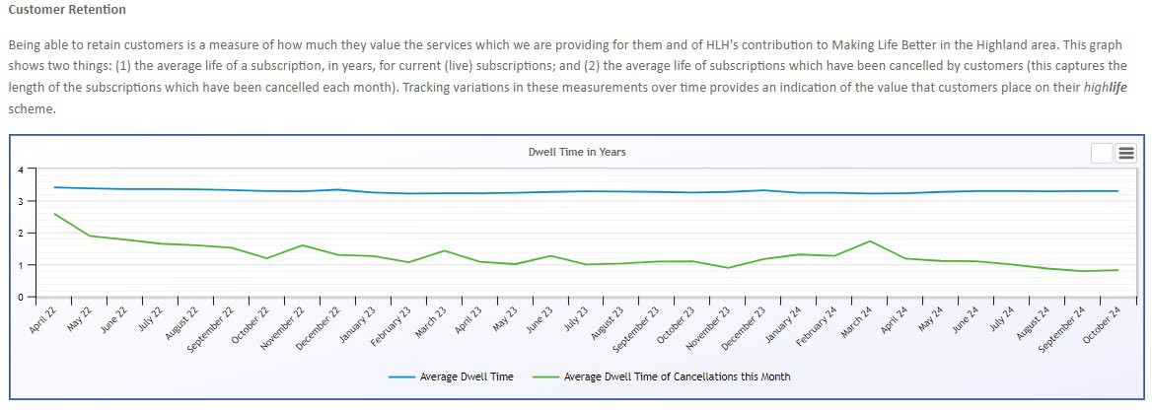

###### Appendix D – Marketing and Engagement Performance Reporting

**Current Marketing & Engagement performance monitoring**

The following Marketing & Engagement based performance indicators (PIs) are reported to the HLH Board:

* Social Media performance (On-line engagement through social media channels / number of engagements)
* Media Coverage (from proactively issued media releases)

These are RAG rated against the same period from previous year. General presentations of marketing and engagement activities covering the aspects above, and more, are delivered twice annually (June and December).

Operationally, the performance of marketing and engagement activities is monitored on a continual basis with an in-depth analysis occurring every month in-department, reported and discussed at every monthly marketing meeting with a view to improving the quality of our output. This includes:

* **Social Media** (main HLH accounts) (vs. previous month): Engagement rate, reach rate, types of post (by media).
* **Media Coverage** (vs. previous month): by service, by media type, by tone, by geography, ‘need to know / flagged issues’.
* **Email Campaigns** (vs. industry average): open rate, click through rate, subscriber rate, unsubscribe rate.
* **Website** (vs. previous month): page views, visits, visitors, traffic source.

###### Membership Campaign performance.

These are reported to the Executive Team each month.

###### Advantages / Disadvantages of current PIs

The current PIs enable us to track output and to ensure that we are delivering consistently in our level of engagement with press and to stakeholders via social media platforms. Tracking media coverage and overall tone of press articles is helpful for gauging HLH’s reputation with the media. Tracking of social media engagement can be somewhat useful for understanding the quality of output (arguably, higher engagement = more engaging content) but can be limited given that our PI does not currently account for tone of engagement.

Both PIs do not provide a clear indication of ROI on our marketing and engagement activities. Additionally, the current RAG rating method of reporting on same period year on year does not provide a clear picture of continuous improvement or decline, whereas reporting against the previous quarter would be more beneficial.

###### Recommendation for future marketing performance reporting

As service/topic specific plans are developed following the approval by the HLH Board of the five year strategy on a page (elsewhere on the agenda) it is proposed that marketing performance be tracked through a six-monthly marketing report to the HLH Board (shifting from a presentation as is currently done to a report). It is proposed that the tone of press coverage be included in this report.

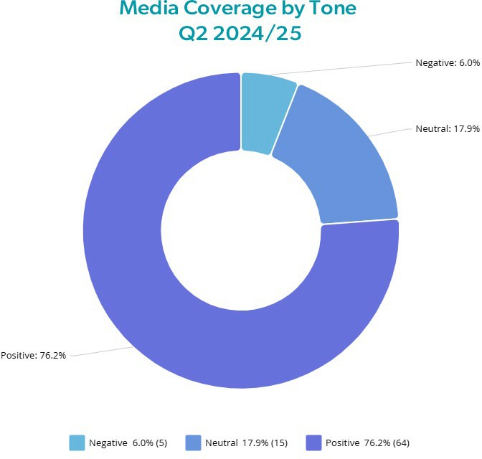**Media coverage tone** will be reported as an indication of performance against strategic objective three: ‘*Demonstrate the unique customer value that HLH offers’*.

There remains validity in tracking the tone of all media coverage relating to High Life Highland as a guide to our reputation with the media and to help understand contributing factors to public perception of the organisation.

RAG ratings will be used to inform an assessment of performance of the organisation with these being set over time. A small number of press articles can impact the RAG rating without there necessarily being an underlying problem so future adjustment might be required and it is proposed that the following definitions be used in the first instance.

RAG status:

1. Green = Positive coverage 90%+
2. Amber = Positive coverage 80%-90%
3. Red = Positive coverage 80%-

Given that there is a subjective nature to press reporting and how this is perceived narrative reporting to the board will also be required to provide background on any activity requiring explanation or highlighting.

**Frequency**: the management team will monitor media coverage tone monthly, and Board reporting will be via the six-monthly marketing update reports.

Media coverage by HLH service and geographic area are also monitored and an example for quarter two can be seen below. This will be used to provide further contextual information for the management team and will be included in the six-monthly HLH Board reports (examples below).

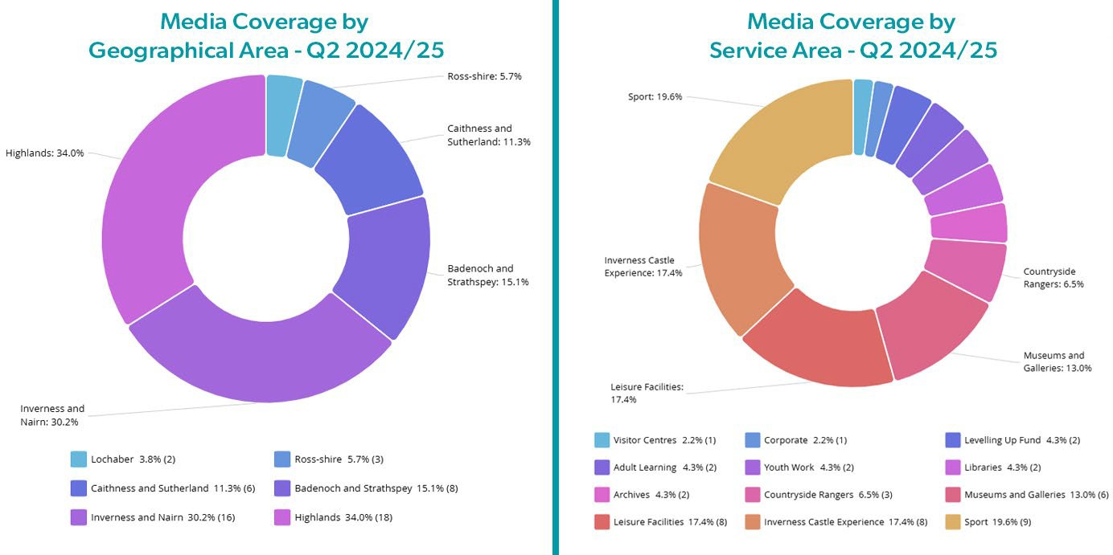

###### On-line engagement through social media channels

We will continue to report on the number of online engagements through HLH’s main social media channels, however, we will track this monthly and include the monthly tracking in the Marketing Reports to the HLH Board to more clearly track trends. Where negative engagements require highlighting we will include this in a narrative alongside an explanation of how it was handled. Aligned with the new strategy, this could be linked to strategic objective three: ‘*Demonstrate the unique customer value that HLH offers’*.

To track progress engagements will be plotted on a scatter chart and it is proposed that the following RAG rating be used:

1. Green = 5% year on year increase.
2. Amber = 0 to 4.9% year on year increase.
3. Red = year on year decrease

**Frequency:** engagements will be recorded and presented monthly and included in the six-monthly HLH Board reports.

Narrative reporting on Return on Advertising Spend will be provided in the Board reports. Advertising is likely to fluctuate depending on seasonality and campaign, therefore, it does not feel useful to create a PI specifically for this.

###### New Performance Indicator ‘Number of users visiting our website’

We will report on our website by documenting number of users who visited the website in a quarter, comparing against the previous quarter. Our aim here is to demonstrate continuous improvement in website development and search engine optimisation.

Within the summary for this PI, we will also indicate the engagement rate (shown as average number of time a user spends on the website, i.e. longer session durations indicate that users are more engaged with the content) and the number of conversions for highlife membership sign-up via website – this will provide some clarity on an improving customer journey, particularly as we move on to upgrading our website platform.

Aligned with the new strategy, this PI could be linked to strategic objective three: ‘*Demonstrate the unique customer value that HLH offers’*.

When the new web site is established a baseline of monthly engagements will be set throughout financial year 2025/26 and improvement targets set thereafter with proposed RAG ratings being based on progress towards an annual target each year thereafter.

RAG status:

1. Green = forecast to maintain or exceed baseline in 2025/26.
2. Amber = forecast to not achieve baseline in 2025/26.
3. Red = forecast to be 5% lower than the 2025/26 baseline.

**Frequency**: this indicator will be recorded monthly and presented in the six-monthly HLH Board Reports.

###### Appendix E Information on partnership working for all HLH areas of work

There are a number of partnerships that High Life Highland is involved in to deliver services and make life better for the people of the Highlands. HLH’s role varies from being the lead organisation, the main supporting partner or working as one of a number of partners in a group. Some partnerships exist because of funding arrangements, with the most significant ones being with **sport**scotland; NHS Highland; and the Council. There is further information on the partnership with NHS Highland in the Health and Wellbeing Report elsewhere on this agenda.

This appendix describes the range of partnerships which HLH is involved in by each of the HLH areas of work.

**Archives –** In Caithness**,** the Archives service is a formal subcontractor of Restore Digital, the information management company contracted by the Nuclear Decommissioning Authority to run Nucleus in Wick, the national archive of the British civil nuclear industry and the archive for the County. HLH is currently contracted to deliver all of Nucleus' customer facing service, both in Nucleus and out and about in community settings. A new contractor has just been appointed to run Nucleus; the new contractor will subcontract HLH continue to deliver customer facing services.

The Archives Service has just established a new partnership with Suffolk Archives, the Norfolk Record Office and Tasglann nan Eilean (the Hebridean Archives) whereby, in an externally funded project, they will research and tell the stories of the Herring Girls, who travelled around Britain’s coastal waters.

Linked to the Memorandum of Understanding with UHI, Archives collaborates with several sections and individual colleges of UHI on a wide range of activities. The Skye and Lochalsh Archive Centre is a regular collaborator with Sabhal Mor Ostaig, including hosting placements an internships.

Am Baile continues to work closely with the Inverness Caledonian Thistle Community Trust to consolidate and grow the Inverness Football Memories project and related activities.

All four archive centres also work in informal partnerships with a wide variety of third sector and community groups. These include Eden Court Theatre, Dounreay Heritage Group, HMP Inverness, many schools and residential care homes, museums and heritage societies and many more. The Highland Family History Society has a permanent base in the Highland Archive Centre

**Countryside Rangers** – The countryside ranger team is involved in a range of projects and standing partnerships as follows:

The Green Health Partnership: operates under the branding "Think Health Think Nature". It aims to encourage more use of the outdoors to tackle physical inactivity, mental health issues and health inequalities. The partnership is made of representatives from High Life Highland (HLH), NHS Highland; NatureScot; The Highland Council; The Cairngorms National Park Authority (CNPA); The University of the Highland and Islands (UHI), The Highland Environment Forum; The Highland Third Sector Interface (HTSI); Paths for All; Forest and Land Scotland and practitioners in the environment, health and social care sectors.

Highland Adapts: partnership initiative to work with agencies such as The Highland Council, NHS Highland, Forestry & Land Scotland and SEPA as well as representatives from communities,

businesses, land managers and public sector to facilitate transformational action towards a prosperous, climate ready Highland to look at how the Highlands adapt to climate change.

Highland Environment Forum & Highland biodiversity action plan 2021 - 2026: The Edinburgh Declaration (2021) sets out the aspirations and commitments of the members of the international community, the Scottish Government, its partners, and the wider sub-national community working in biodiversity in delivering for nature over the coming decade. Highland Council signed the Edinburgh Declaration in December 2022. The Highland Nature: Biodiversity action plan 2021 - 2026 is the call to action. This plan was created through surveys and meetings with Highland Environment Forum members and the wider public, and through the commitments undertaken by partners. This work is overseen and coordinated by the Highland Environment Forum’s Biodiversity Working Group.

There is a range of current projects where the HLH Ranger service is a delivery partner:

* Healthy Minds delivery in Badenoch and Strathspey (lead Saranne Bish)- targeted work with clients who have diagnosed mental illness. Both direct NHS and self-referrals. Partners: NHS; HTSI; CNPA; Forest and Land Scotland.
* Connecting Carers(CC) – The Ranger Service provides green health walks in conjunction with CC for carers in highland communities
* Highland Climate Hub – Climate Festival: Rangers provide activities as a partner across Highland
* Conservation agencies to work on species specific education work and citizen science including Marine Conservation Trust, British Ornithology Trust, Species on the Edge, Butterfly Conservation Trust, Bumblebee conservation trust, Nature.scot, Reptile and Amphibian conservation trust, Royal Botanical Gardens Edinburgh.
* Local Community Volunteer Groups including: Caithness Environmental Volunteers, Sunart Community Trust, Assynt Field Club, Cairngorm Junior Rangers, Cairngorm national trust volunteers, Dunnet Woodland Community Trust, St Johns Mill Community Trust, Culag Community Woodland, Newton Hill Community Woodland
* North West Geo-Park – Community Ambassador for the NW Geo-Park and collaboration with Historic Assynt on running small scale interpretation in the area from “Ranger Huts” at key pressure points to raise ecological awareness.
* THC/NatureScot Nature Restoration Fund Project Grant: Puddles to Ponds project. Awarded

£7,500 towards a community engagement project in freshwater restoration across Highland for 2024. This work is being celebrated in the international pond festival “Ponderful” in November 2024.

**Health and Wellbeing –** the joint Health and Wellbeing post with NHS Highland is vacant. There are a number of partnerships connected to the health and wellbeing work in HLH, most of which can be sustained by service teams in the short-term. At the time of writing, an internal NHSH report had been drafted to make the case for the continuation of the arrangement.

**Leisure** – some of the facilities operated by the leisure team are in partnership with community groups who own/manage local facilities and this is done in partnership with them. The partnerships include: Tongue and Farr Sports Association; Ullaspool Board; Poolewe Board; Puffin Pool Board; Highland Rugby Club; Leanaig Advisory Forum; Strathpeffer Pavilion Community Trust; Macphail Centre Board. Merkinch Community Centre Association, Spectrum Centre Board, Cameron Youth Centre Management Commitee & Charleston Community complex management Comittee In addition, there are wider partnerships such as with UHI (University of the Highland and Islands) for

training with students for the National Pool Lifeguard Qualification and as sports and group exercise instructors. We also work in partnership with Sportscotland as part of their elite athlete programme and Fitness Training Scotland to upskill our staff in group fitness, strength and conditioning.

**Libraries** – There are a range of projects ranging from local, area wide and national partnerships including work with UHI to support opportunities for PHD collaborations - libraries are working with a PHD student who is researching how young people and other age groups interact with nature and the environment through the reading of a selection of environmental literature.

‘Meet The Books’ workshops continue at Inverness Library, in collaboration with UHI. This is a series of interactive workshops that introduce students and the wider community to High Life Highland’s special collections, including the Fraser-Mackintosh Library.

Work with the Scottish Libraries and Information Council (SLIC) to participate in expansion of the “one card” initiative with other Scottish Library services. This is a national initiative that forms part of the National Libraries Strategy. The initiative allows anyone living in Scotland that is in receipt of a library membership to use it anywhere throughout the country, offering the customer improved convenience and ease of access.

Work with NHS Highland to the support the Near-Me initiative. Near-Me is a national project supporting those without digital connectivity at home to access devices that will enable them to attend online medical appointments. Customers are able to book a private area within a library where they have free access to an iPad to attend their online appointments. The initiative is currently being delivered at Thurso Library, Culloden Library and Grantown Library.

Work with the NHS and The Pines Neurodevelopmental Centre, Inverness. An e-book collection has been developed to support those in the Highlands with neurodevelopmental needs. The collection sits on High Life Highland’s e-book platform and is accessible cost free, to anyone with a High Life Highland membership.

**Museums & Galleries** – Inverness Museum & Art Gallery (IMAG) and Highland Folk Museum (HFM**),** in collaboration with a museum in Wales and another in Ireland, is part of an Art Fund UK led, five-year museums’ practice development programme.

IMAG has a longstanding partnership with the National Galleries of Scotland (NGS). This has resulted in a number of NGS curated exhibitions of the highest quality being shown at Inverness Museum and Art Gallery (IMAG). A similar, more recently established partnership with the Fleming Collection is also enabling the musuem to bring high quality art exhibitions to the Highlands. In another partnership with Creative Scotland IMAG manages the Visual Artist and Craft Makers Awards (VACMA) scheme in the Highland, Moray and Western Isles area. VACMA offers small grants to visual artists and craft makers for their creative development at all stages of their career. Each year, approximately thirty artists and makers receive support from the scheme. IMAG also has several longstanding and productive collaborative working partnerships with a number of third sector and community groups, including Alzheimer’s Scotland, local Brownie groups, Connecting Carers, WASPS and many more. A recently established, new partnership is with CALA (Care & Leaming Alliance), which will result in an exhibition and a programme of related activities.

HFM continues to benefit from a well-established partnership with Historic Environment Scotland (HES). HFM also works in informal partnerships with variety of community groups, including providing an outdoor classroom facility for Newtonmore Primary School and collaborates on events

and activities for the Badenoch Shinty Memories group and has recently entered into a new partnership with the Cairngorm Curling Heritage group.

NCVC (North Coast Visitor Centre) has established a partnership with the Society of Caithness Artists, which has brought about a programme of art exhibitions at the museum. It also enjoys ongoing collaboration with the Dounreay Heritage Group and Thurso Historical Society..

**Music Tuition** – We are slowly rebuilding relationships with all the main national professional ensembles, orchestras & other organisations where opportunities arise for Highland young people to experience access to performances from, or often to participate alongside, professional musicians. Budgets constraints within arts organisations can often restrict such activities, but we continue to look for innovative ways to break down potential barriers to participation. We continue to work via Youth Music initiative funding on our primary schools' projects with Fèisean nan Gàidheal & Drake Music Scotland

**Sports Development** – The main partnerships in sport are with the Highland Council and **sport**scotland. We are approaching the mid-point in the four-year Partnership Agreement with sportscotland which runs from April 2023 – April 2027. The £1.12 million investment in the partnership from sportscotland is based on 6 priority areas:

* Planning for Sport
* Active Schools
* Community Sport Hubs
* Inclusion
* Places
* Performance

Formal partnerships are also in place with two Sports Governing Bodies; the Camanachd Association and Scottish Rugby Union. We also have a formal partnership agreement with the Highland Disability Sport to support our inclusion priority. We have several less formal partnerships with Sports Governing Bodies including the Scottish Football Association, Scottish Disability Sport, Table-Tennis Scotland and Scottish Squash which support growth in participation and the development of coaches and volunteers in the Highlands.

The Active Highland Partnership is ongoing and a refreshed Active Highland Strategic paper has been presented to the Community Planning Partnership Board Working alongside The Highland Council, NHS Highland, sportscotland and Public Health Scotland the refreshed strategy will coordinate a multi-agency response to promoting physical activity in Highland with a focus on those currently facing barriers to being active.

We continue to work with the Highland Alcohol and Drugs Partnership, with a focus on the Planet Youth initiatives in Dornoch, Golspie and Caithness that has seen over £50,000 investment into the service to deliver against the partnership agreement which focusses on using sport and physical activity as a way of reducing the risk of alcohol and drugs misuse.

We also continue to partner with SAMH (Scottish Action for Mental Health) to support our staff’s wellbeing but to also enable our service to support individuals and communities around mental health issues.

Our work is reflective and shaped by our connection to Community Planning Partnerships and recently were part of Operation Respect in Inverness which saw the CPP deliver diversionary

activities in the centre of Inverness. The Sports Team had a significant contribution to this through providing cage football in Falcon Square