HIGH LIFE HIGHLAND  REPORT TO BOARD OF DIRECTORS  19 March 2025 | AGENDA ITEM  REPORT No HLH/ /25

HR UPDATE – Report by Chief Executive

Recommendation

This report provides an overview of the charity’s Human Resources performance.

It is recommended Directors note:

- the HR performance information for quarter three, October to December 2024;
- that the former Service Delivery Contract group has reviewed and commented on this report;
- and comment on the Exit Survey 2024;
- the legislation changes relating to PVG; and
- and comment on the work which is underway on the development of an HR Delivery Plan.

1. | Strategy Contribution
1.1 | High Life Highland’s (HLH) purpose is Making Life Better. The HLH Strategy 2025-2030 contains five strategic objectives which support the delivery of this purpose, and this report supports the following highlighted objectives:  - Delivery of affordable, accessible and inclusive services across the region.  - Maximise and grow income to reinvest across services.  - Ensure a consistent high value of delivery across HLH services.  - Commit to the net zero and sustainability agenda.  - Efficient and effective service delivery through our people and processes.
2. | Background
2.1 | At its meeting held on 11 November 2024, the Finance and Audit Committee: “AGREED that the Senior Leadership Team conduct a review around the best way of reporting HR matters to the Board, in consultation with those Directors on the Service Delivery Contract group.” Additional information, pending arranging the meeting with the Directors on the Service Delivery Contract group, was provided in the December 2024 HR report.
2.2 | A draft of this report was circulated to Directors on the former Service Delivery Contract group on 5 February 2025 and a meeting of the group was held on 10 February 2025 where this report was reviewed and amended.
3. | Staffing Establishment
3.1 | Staffing establishment changes are tracked for a number of reasons. including as a check on budget management and also to ensure that the staff database (see below) is being maintained for management information.
3.2 | This graph tracks the number of full time equivalent (FTE) posts in the organisation.  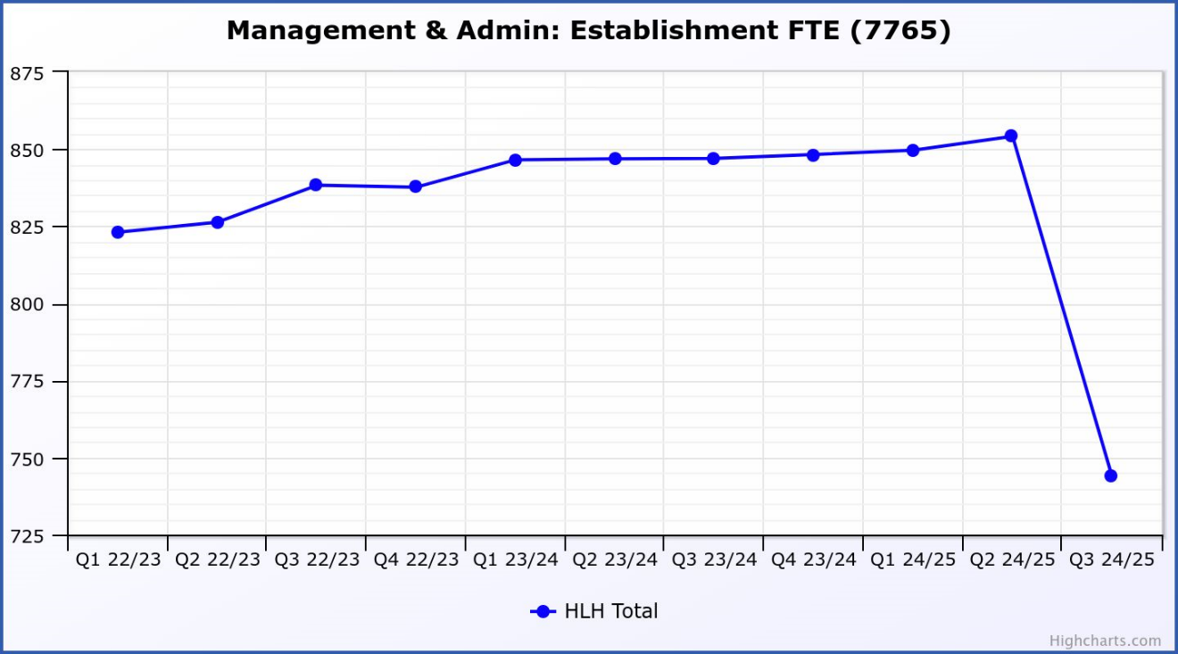
3.3 | The data on this graph reflects the situation following the pandemic where the correct use of relief and casual staff was reviewed, and services then taking the opportunity to offer temporary or permanent contracts to workers where a regularity of hours was identified. This resulted in a gradual increase to the establishment, particularly in Leisure and Adult and Youth Services where traditionally sessional staff were engaged on a relief basis.
3.4 | As noted below, the adult learning and youth work transfer contributed to the significant changes to the establishment in Q3.
3.5 | Over the coming months the creation of new posts for the Castle Experience will show an upturn in the establishment. The staffing establishment change between quarter two 2024/25 and quarter three was as follows:  - Quarter 2 establishment = 854.13 FTE  - Quarter 3 establishment = 743.98 FTE
3.6 | This is a change of -110.15 FTE (13%). Within that the following changes were made:  - Adult learning and youth work transfer to THC -113.09 (including cleanse of obsolete temporary posts within Adult & Youth)  - Inverness Castle Experience posts + 3  - Libraries – deletion of Senior Library Assistant post -0.6  - Sport – creation of Assistant Coach post +0.57  - Other – minor amendments to establishment to meet needs of services -+0.03
3.7 | With all the changes to the establishment being known/understood there are no matters of concern which have been identified for corrective action.
4. | Staff Turnover
4.1 | Staff turnover has been identified as a measure of “Improving User/Service Satisfaction Levels” in the HLH Strategy 2025-30. This graph shows resignations as a percentage of the number of posts (1% equates to 10 staff).
 | 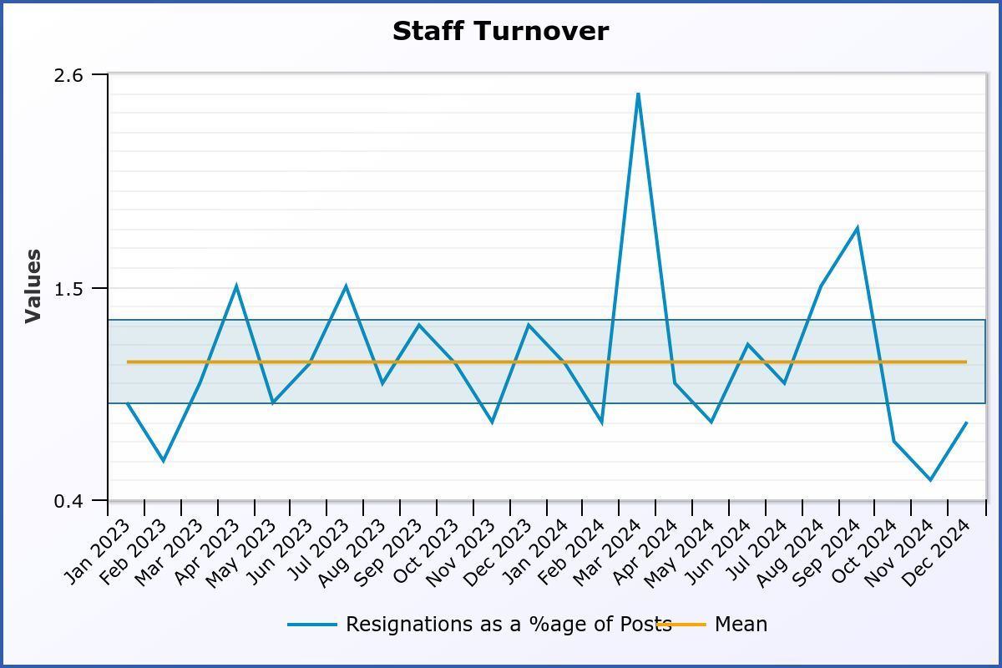
4.2 | As a development on previous reporting the graph shows the mean turnover figure and standard deviation from the mean. It is proposed that deviations out with the standard deviation could be used as a trigger to explore reasons for resignations to identify whether management actions are needed to improve staff satisfaction levels.
4.3 | The number of resignations as a percentage of posts (number in brackets denotes the number of individual resignations) during the quarter was:  - October = 0.7% (7)  - November = 0.5% (5)  - December = 0.8% (8)
4.4 | Staff turnover was steady over Q3. No unusual trends or cause for concern were identified.
5. | Absence Management
5.1 | Absence management has been identified as a success measure in the five-year strategy. A positive and engaged workforce is key to delivery of the strategy objectives. The graph below shows the staff absence rate for all absences along with the mean and standard deviation. As a benchmark, the office for National Statistics (ONS) absence rate for Care, Leisure and Other Service Occupations is used (4.3%). The aim being to maintain the mean absence rate at or below that level. The current mean figure for HLH is 4.52% with the current absence rate being 4.11%.  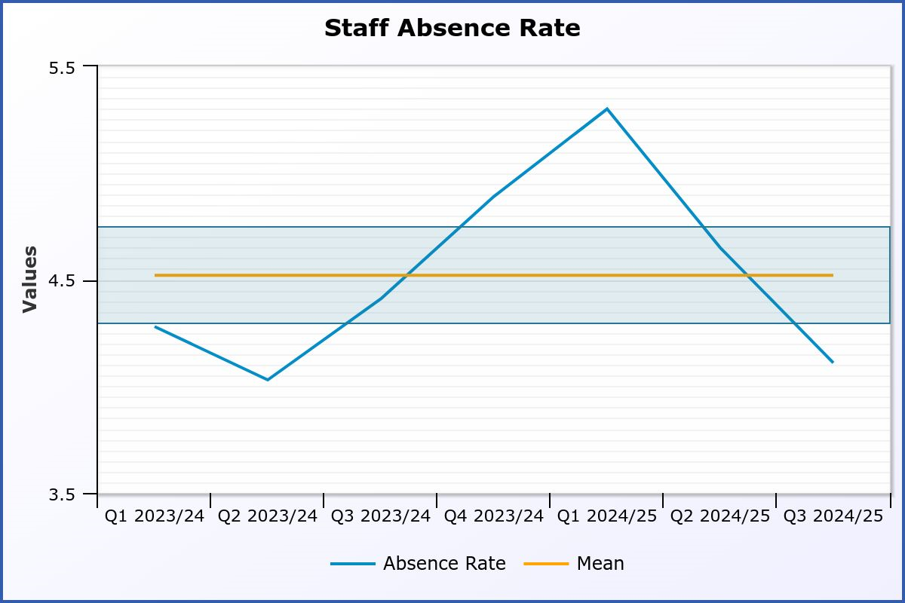
5.2 | The graph below shows the number of long-term absences which occurred in each month. The horizontal line shows the mean and the blue area the standard deviation range. The work of HR and service managers on reducing long-term absences has started to show in the data with the number of long-term absences having been within the standard deviation every month during quarter three.
 | 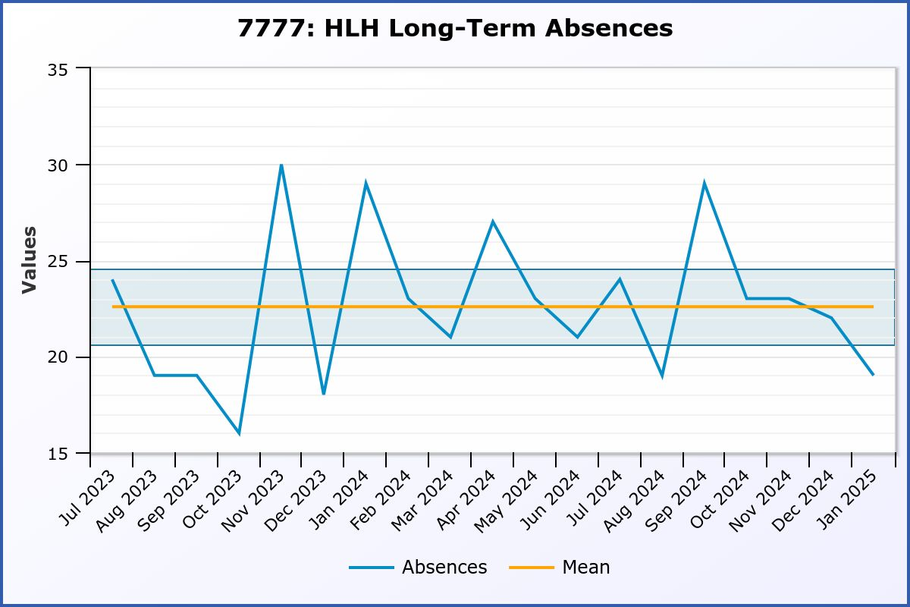
5.3 | The graph below shows the number of short-term absences. It would be normal to expect a seasonal increase in short term absences during the end of quarter three /start of quarter four which does not seem to have materialised this year.  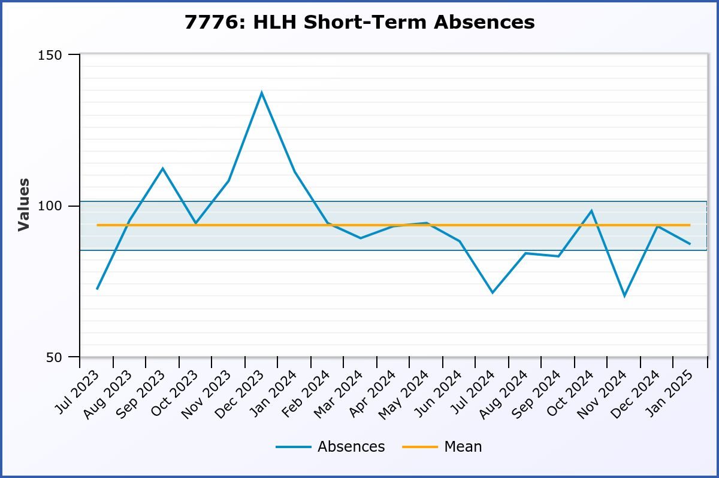
5.4 | During quarter four, the HR Team continues to support colleagues in the absence management of employees with long-term absences using OH referrals, wellness recovery action plans and counselling services to expedite a quicker return to work. The HR team has also been supporting managers to ensure that short term absences are monitored and addressed.
6. | Service Disruption
6.1 | A system for tracking the reasons for disruption to services is being developed and in future this report will include a summary of service disruptions due to staffing matters.
7. | Case Work
7.1 | Monitoring and reporting of case work (use of formal processes and ACAS claims) provides the Board and management team with an indicator of workforce relations as well as ensuring that there is a systematic way of ensuring that the Board is aware of any matters which might have legal, financial or reputational implications.
7.2 | The following two graphs show the number of cases where disciplinary and internal resolution (grievance) procedures have been used.  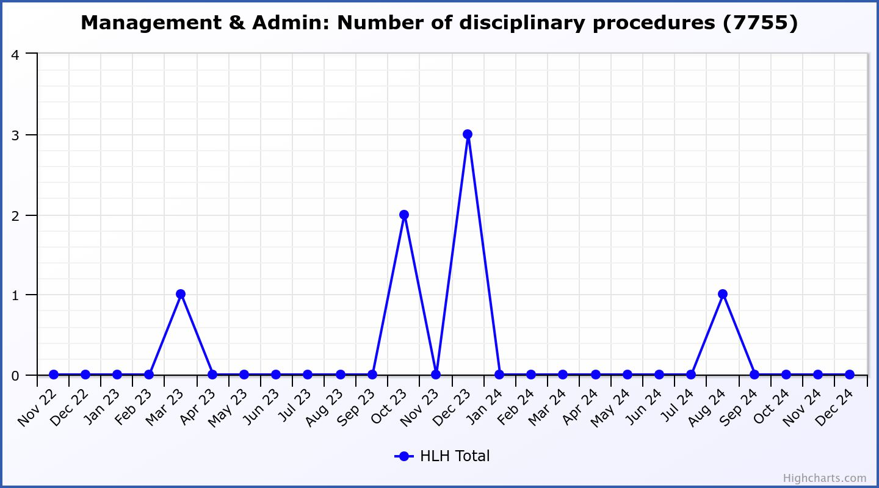  There were no disciplinary investigations carried out during quarter three.
7.3 | 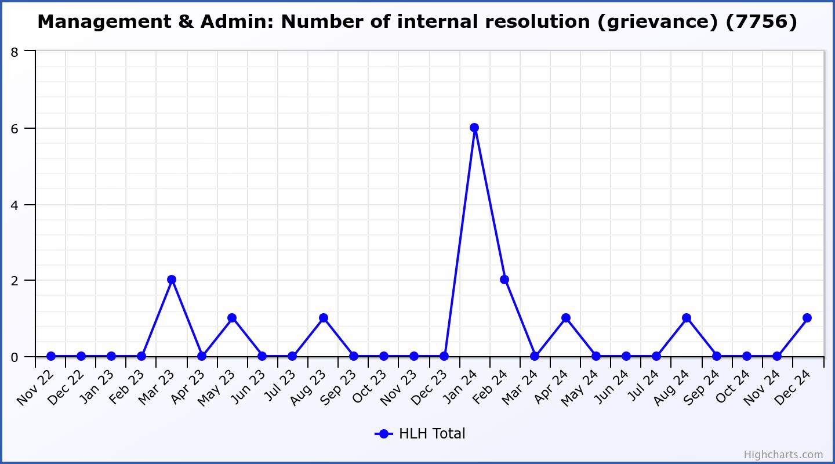  There was one internal resolution in quarter three which was carried forward into Q4.
8. | Conciliation and Tribunal Claims
8.1 | It is proposed that these be reported as they occur, with updates on those which remain live at every Board meeting.
8.2 | There were no conciliation claims during quarter three. There was one early conciliation claim in quarter two. The enquiry was received from ACAS two days before the statutory deadline and no formal claim has been received by HLH. As the claimant has only one month to submit a claim after the ACAS conciliation certificate has been issued it would appear that the claimant is not pursuing the matter any further. HLH has received no further communication from either the claimant or ACAS.
8.3 | There have been no tribunal claims and there are no on-going tribunals.
9 | Industrial Relations
9.1 | HLH recognises the following Trades Unions which it meets quarterly as a Joint Consultation Forum (JCF) for communication and consultation:  - EIS  - GMB  - UNISON  - Unite the Union
9.2 | When the JCF met on 5 December 2024 the following items were discussed:  - Adult learning and youth work transfer  - Inverness Castle update  - Sport and Leisure structure
10. | Exit Surveys Summary – 2024
10.1 | The report on Exit Surveys between 1 January to 31 December 2024 is in Appendix A. Employees are offered the opportunity to respond to the Exit Survey at the time of leaving the Charity. Reminders are then sent after 7 days, 14 days and 24 days. The following key points have been extracted from the summary report. Numbers in brackets show 2023 figures for comparison.
10.2 | In 2024, 129 (162) former employees were invited to complete an exit survey and 45 (63) responded. This equates to a percentage return rate of 35% (39%).
10.3 | Reason for leaving  Of those who completed the survey:  - 27% (48%) Left to take up a new job  - 16% (5%) Change in personal circumstances  - 14% (0%) Breakdown in work relationships/treated unfairly (six people see below)  - 7% (11%) of staff retired  - 7% (3%) returning to study  - 5% (8%) of staff moved away from the area
10.4 | Enjoyment working with HLH  Of those who completed the survey:  - 74% (62%) of staff have enjoyed working for HLH ‘a lot’ or ‘a great deal’  - 26% (38%) of staff would have rated their enjoyment as a “reasonable amount” or less.
10.5 | Remuneration  Considering the current cost-of-living situation but also reflecting the higher-than-normal pay awards over the past 3 years:  - 78% (71%) of staff thought they were ‘reasonably well paid’ or higher  - 22% (27%) of staff thought they were ‘underpaid’ or worse.
10.6 | Working relationships  In general, those who completed the survey had positive working relationships with their colleagues’ and line manager.  - 76% (76%) - relationship with manager ‘good’ or above  - 87% (90%) - relationship with colleagues ‘good’ or above
10.7 | Training  In terms of training offered by HLH, of those completing the survey:  - 71% (53%) thought the training was good or above average.  - 18% (27%) thought training offered to be average.  - 11% (15%) thought training was poor or extremely poor.
10.8 | Work-life-balance  For those completing the survey:  - 36% (27%) never needed to work extra hours (over and above contracted hours)  - 56% (65%) of staff reported working extra hours to undertake the requirements of their job.
10.9 | Following discussion of the 2023 survey by the Board an additional question was added part way through the year to establish whether those that were working additional hours were being paid as overtime.  Of the 16 employees that responded as working additional hours:  - 10 (63%) were paid overtime for the additional hours worked  - 4 (25%) were not paid but claimed the hours back through TOIL/flexitime  - 2 (12%) were not paid and did not claim the hours back
10.10 | HLH as an employer  74% (73%) of those completing the survey rated HLH as a good employer or better (very good, excellent), with 83% (71%) saying they would recommend employment with HLH to a family member or friend. 71% (62%) said they would consider returning to HLH in the future.
10.11 | Follow-up  20% (6%) of staff asked for a separate follow-up with Senior Management/HR – all requests were followed up.
10.12 | In summary, the exit survey continues to provide the Charity with an opportunity to identify and address matters raised through this post employment engagement and to feed back to the appropriate/key persons in the organisation.
10.13 | The HLH response rate of 35% (39%) is above the UK average participation rate for exit interviews, which is between 30% and 35%. While this compares well, means that most employees who leave do so without providing insight as to why. In an attempt to increase this, the wording of the email has been reviewed to say how important the feedback is to HLH and HR will continue to engage with managers to ensure that exiting staff are encouraged to complete and return the surveys.
10.14 | While there has not been any dramatic movement either way with responses received in 2024 compared to 2023, it is positive to note a 12% increase of those completing the survey stating that they enjoyed working for HLH either ‘a lot’ or a ‘great deal’ and a 7% increase in those who state they have been reasonably well paid or higher.
10.15 | There was a shift in the Reasons for Leaving, with a reduction of 21% stating that they were moving to a new job but 14% stating that there was a breakdown in working relationship/they were treated unfairly. Of that 14% (six people), HR is aware of the circumstances leading up to employees leaving and is satisfied that there has been appropriate follow up.
10.16 | Those that have rated the training offered by HLH as good or above average has increased by 18% since 2023.
10.17 | The exit survey results will be presented to the Joint Consultative Forum Trades Union Meeting.
11. | Legislation Changes
11.1 | Disclosure Scotland/Protection of Vulnerable Groups Legislation Change
11.2 | The Disclosure (Scotland) Act became law in July 2024 and aims to:  - Focus on protecting the public, while balancing the need for people to move from offending  - Simplify the process for disclosing criminal history information
11.3 | The following has changed with the introduction of the new legislation:  - A revised Code of Practice  - Appointment of independent Reviewer  - Reforms in applying for removal from barred list  - Guidance to Police Scotland around disclosure of ‘other relevant information’  - Provision of new powers to local councils and integration boards to make referrals to Disclosure Scotland
11.4 | The following will change in relation to disclosure checks:  - Basic disclosure becomes Level 1 Disclosure  - Standard and Enhanced becomes Level 2 Disclosure  - PVG remains known as the PVG Scheme  - Minimum age of 16 years old  - PVG membership will become a legal requirement for all regulated roles with children and protected adults  - lifetime PVG scheme membership will end and be replaced with a time limited membership  - PVG scheme membership will last 5 years before it needs to be renewed  - replacing the concept of ‘regulated work’ with regulated roles as the basis for mandatory PVG scheme membership  - responsible bodies and registered bodies will become accredited bodies and follow the code of practice
11.5 | There will be the following implications for High Life Highland which are being reviewed and managed by the Head of HR:  - HLH currently PVG checks all employees undertaking regulated work, however as a result of the changes detailed above, the HR team is reviewing all posts and post holders to ensure compliance. Whilst Disclosure Scotland is still compiling a list of ‘regulated roles’ the Head of HR is of the opinion that there may only be a small number of additional roles that require PVG checks. For example, age 16-18 Young Leader volunteers.  - Heads of Service and/or Directors of Service managing or directing staff who are carrying out regulated roles.  - It is not anticipated that HLH Board Members will require mandatory PVG checks.  - The changes detailed above require PVG members to renew/update their membership every five years. At a cost of £18 per renewal this will have financial implications on a rolling basis. Once the HR review of PVG membership has been completed there will be a clearer picture as to the initial and ongoing costs of these changes.
12. | Policy Reviews
12.1 | The following HR policies have been considered in line with the review schedule, all were reviewed with an update to include HLH’s purpose, Making Life Better, but otherwise, no changes required:  - Special Leave  - Equal Opportunities  - Whistleblowing  - Overtime  - Redeployment and Redundancy
13. | Human Resources Development Plan
13.1 | One of the Strategic Objectives identified in the Strategy 2025-2030 is “Efficient and effective service delivery through our people and processes.” An HR Delivery Plan for the coming financial year is being developed to support this. At this stage it is considered the plan over the next two years could include the following:  - People database cleanse/update;  - training matrix to be built into people database;  - development of on-line system for the annual staff survey to support analysis of responses and trend analysis (currently underway, February 2025 target);  - transfer of the exit survey to an on-line system to allow more efficient and effective use of data, including trend analysis;  - review of the appraisal framework in the light of the five-year strategy including developing an on-line system to monitor compliance, training needs and as a further information source for staff satisfaction levels;  - development of an on-line absence reporting component into the people database which includes automation of reports for THC payroll;  - development of on-line time recording for non-contracted work;  - exploring opportunities to automate relief staff pay information provision from the people database to THC;  - development of HR reporting (taking content from this report) into new five year strategy format so the non-confidential information is available to staff and managers; and  - audit of HR systems and processes during financial year 2026/27.
13.2 | There will also be a considerable focus on the establishment of the Inverness Castle Experience and timescales for the above will take account of that workload. HR will be supported by the digital and business support team in much of the above.
14. | Staff Engagement/Information Gathering Mechanisms
14.1 | The annual staff survey will provide some more qualitative information to support the on-going monitoring information and as the above projects are developed there will be regular information which can be monitored and tracked from exit surveys and appraisal so the three separate systems can be used to monitor organisational performance and progress towards improving staff satisfaction levels.
14.2 | This year’s staff survey is currently underway, and the outcomes will be reported at the June HLH Board Meeting.
15. | Implications
15.1 | Resource Implications – there are some resource implications arising from this report relating to the five year update requirement of PVG, effective from April 2026. For budget planning purposes this will start to take effect from April 2026.
15.2 | Legal Implications – there are no new legal implications arising from this report.
15.3 | Equality Implications – there are no new equality implications arising from this report.
15.4 | Risk Implications – there are no new risk implications arising from this report.

Recommendation

It is recommended Directors:

- note the HR performance information for quarter three, October to December 2024;
- note that the former Service Delivery Contract group has reviewed and commented on this report;
- note and comment on the Exit Survey 2024;
- note the legislation changes relating to PVG; and
- note and comment on the work which is underway on the development of an HR Delivery Plan.

Designation: Chief Executive

Date: 4 March 2025

Authors: Douglas Wilby
Morven MacLeod, Head of Human Resources

ONS Sickness absence in the UK labour market: 2022 Release date: 26 April 2023. As of 08:01:25 there was no next release date published.

